**Lab 3 Report: Inference Attacks on Deep Neural Networks**

Sui Huang [sh4507@nyu.edu](mailto:sh4507@nyu.edu)

1. **Methodology used to implement the AM algorithm:**

I used gradient decent mythology. The code realized in function named ‘image_optimizer’. Function image_optimizer(image_old, i, lr, print_=True) takes 4 arguments:

**image_old** is the initial image I generated using either random or mean value, and this image is generated using function named ‘generate_x’.

**i:** is the target label we want the initial picture to be updated. For example, i=5, then the target label will be [0,0,0,0,0,1,0,0,0,0]

**lr:** Learing rate

**print_:** whether I want to print the result( disabled in Q4 because it’s too much)

**Code for optimizing gradient and update the image:**

if (prob_new[:,i]-prob_old[:,i]>= 1e-8): (stops when the probability does not increase any more)

gradient = tf.gradients(xs = x, ys = cost) (compute gradient)

image_new = tf.clip_by_value(x - tf.fill([784], step_size)/gradient,0,1) ***(image = image – lr/gradient, clip from 0 to 1 because I don’t want the value exceed the image range)***

image_new, gradient = sess.run([image_new , gradient], feed_dict={x: image, y: generate_y(j).reshape(1,10)}) (session run)

image_new = image_new[0,:,:] (decrease one dimension)

image = image_new (update image to calculate gradients)

I did not use adaptive learning rate. But used different learning rate (as step size) for different initial images.

PART 1: 1e-1，PART 2：1e-2，PART 3&Q4：1e-5

1. **Recovered images for each class (10 per problem) and the computed RMSE for that image. Also indicate the final error.**

**PART 1:** 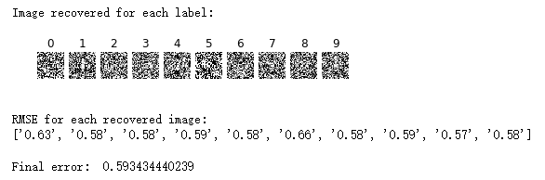

**PART 2:** 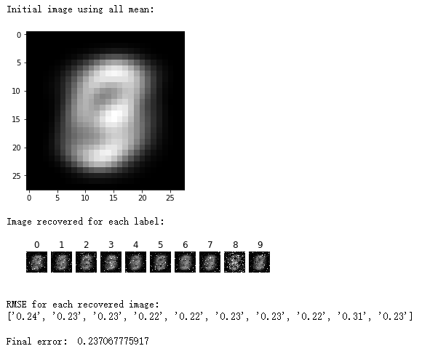

**PART 3:** 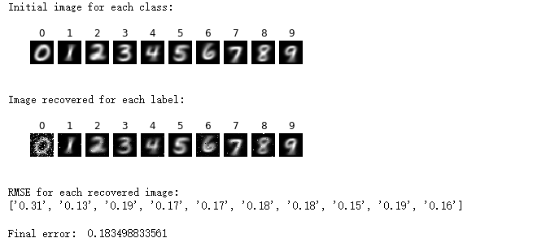

1. **Tabulate the prediction accuracy versus the final error for each value of λ. Also indicate the value of λ used.**

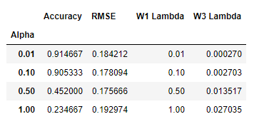

1. **Python code along with any instructions required to execute the code.**

All codes and results can be reproduced using the note book named:’ Inference_ Attacks_on_Deep_Neural Networks’

1. **Some thoughts**

I think I did not do very well in part4. And the result is that adding noise can not increase RMSE in a very large level. Maybe I did the DP wrong. It’s sad because I don’t have more time.