MEMORANDUM |  | 
To: | Dan Castro, Lecturer, Department of Mechanical Engineering, Cal Poly SLO
 | ddcastro@calpoly.edu
From: | Owen May |  | Skylar Robinson
 | obmay@calpoly.edu |  | Srobin26@calpoly.edu
 | Jake Hemsley |  | Paige Tomek
 | hemsley@calpoly.edu |  | ptomek@calpoly.edu
Date: | 05/20/26
RE: | ME 329-13, Project Group 2, Final Design Submission

Attachment List
A: Preliminary Hand Calculations and Concept Development
B: Gear Ratio Development and Preliminary Design Iterations
C: AGMA Gear Stress Calculations
D: Shaft Free Body Diagrams and Shaft Sizing Calculations
E: Bearing Selection and Life Calculations
F: Chain Drive Design Calculations
G: SolidWorks Powertrain Assembly Drawing
H: Shaft 1 Detail Drawing
I: Shaft 2 Detail Drawing

1. Introduction
The objective of this project was to design an ATV powertrain capable of transmitting power from an electric motor to the drive wheels while meeting specified speed, torque, reliability, and manufacturability requirements. The final design consists of an electric motor, a multi-stage gear train, two custom shafts, four rolling-element bearings, and a chain drive system.

The design process began with preliminary calculations to determine the power, torque, and speed requirements needed to achieve the desired vehicle performance. These calculations were used to select a motor and establish the overall transmission ratio. A gear train was then designed to provide the required speed reduction and torque multiplication. Gear stresses were evaluated using AGMA methods, and the resulting loads were used to determine shaft stresses, bearing reactions, and required shaft diameters.

The final design was verified through gear stress analysis, shaft design calculations, bearing life calculations, and chain drive selection. Supporting calculations are provided in Attachments A through F. The completed SolidWorks assembly model is included in Attachment G, while detail drawings for the custom shafts are provided in Attachments H and I.

2. Motor Selection
Motor selection established the foundation for the remainder of the powertrain design. The selected motor was required to provide sufficient power to propel the ATV while maintaining acceptable performance on moderate inclines and uneven terrain. Preliminary vehicle requirements and design assumptions are summarized in Table 1.
Table 1. Motor Selection Parameters.
Motor Type | ME1616 PMAC Water Cooled Motor
Max Payload | 250 lbs
Weight of Entire Vehicle | 500 lbs
Powertrain type | Forward and Stop (no reverse)
Motor Horsepower | 26.8 HP
Motor Speed | 4500 rpm
Input Torque | 33.19 ft lb (45 Nm)
# of Batteries | 1
Battery Voltage | 24 volts
Max Speed | 20mph
Min Speed | 5 mph
Maximum Incline/Decline | 15 degrees
Life | 5 years
Brakes | Manually Operated
Inspection Intervals | Annual
Cost to Produce | $1,700 (motor $1,280)
Gear Ratio | 8

The selected motor was the ME1616 PMAC Water-Cooled Motor. This motor provides a rated output of approximately 26.8 horsepower at an operating speed of 4500 rpm while maintaining a compact package size suitable for ATV integration.

Selection of the motor was based on preliminary vehicle dynamics calculations. These calculations considered vehicle weight, rolling resistance, operating speed, wheel diameter, and maximum grade conditions. The original hand calculations used during concept development are provided in Attachment A.

Preliminary calculations established the required tractive effort, wheel torque, and motor horsepower necessary to satisfy the design requirements. These calculations formed the basis for the gear train design described in the following section.

To verify that the selected motor could satisfy the required operating range, manufacturer performance data were reviewed. The torque-speed relationship for the selected motor is shown in Figure 1.

Figure 1 illustrates the expected decrease in motor torque as rotational speed increases. The curve confirms that the motor can supply the required torque throughout the intended operating range. Motor power output was also reviewed using manufacturer performance data. The resulting power-speed relationship is shown in Figure 2.

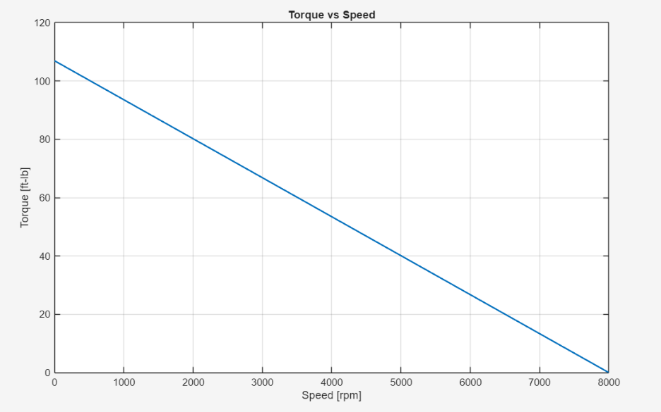
Figure 1. Torque versus Speed Curve for Selected Motor.

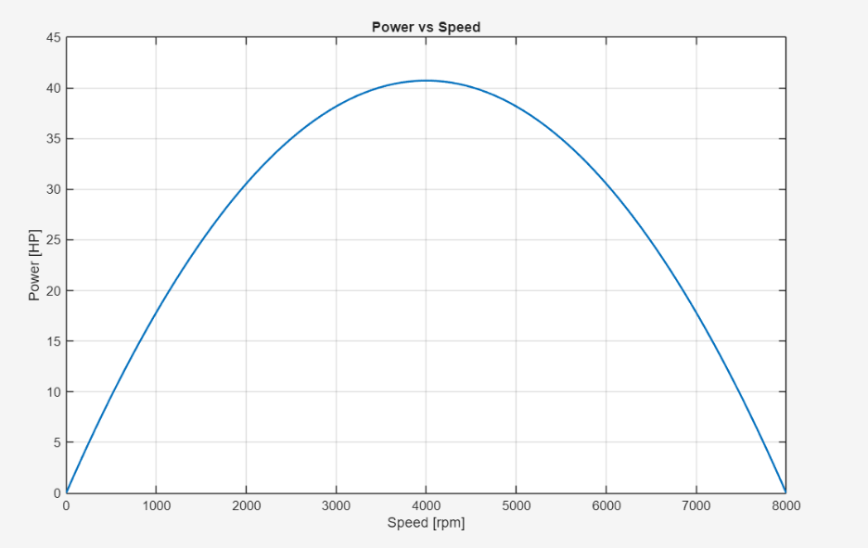
Figure 2. Power versus Speed Curve for Selected Motor.

Figure 2 demonstrates that the motor achieves peak power near its operating range while maintaining sufficient power output for the intended application. The selected motor therefore satisfies the vehicle performance requirements established during preliminary design.

3. Gear Train Design
The selected motor operates at approximately 4500 rpm, which is significantly higher than the desired wheel speed. Consequently, a multi-stage gear reduction system was required to reduce rotational speed while increasing transmitted torque. Based on the preliminary vehicle calculations, an overall reduction ratio of approximately 8:1 was required to achieve the desired operating conditions.

Initial gear ratios were developed through iterative calculations using the relationship between gear tooth count and rotational speed. Several gear combinations were evaluated to achieve the desired overall reduction while maintaining practical gear diameters and tooth counts. Preliminary gear ratio calculations are provided in Attachment B. The final powertrain configuration is shown in Figure 3.
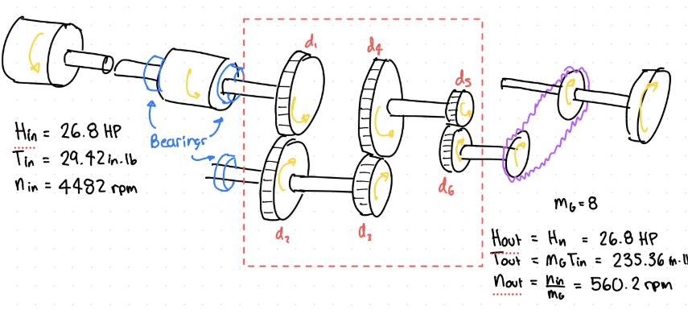
Figure 3. Powertrain Gearing Configuration.

Figure 3 illustrates the complete gear train arrangement used to transmit power from the motor to the final drive system. The design utilizes three gear pairs distributed across two shafts. Each stage contributes a portion of the overall reduction ratio, allowing the desired output speed and torque to be achieved while maintaining manageable gear sizes. The final gear dimensions and operating conditions are summarized in Table 2.
Table 2. Final Gear Parameters.
Gear # | Diameter [in] | Teeth | Pitch [T/in] | Speed [RPM] | Torque [ft-lb]
1 | 3 | 30 | 10 | 4481.8 | 29.43
2 | 6 | 60 | 10 | 2240.9 | 58.86
3 | 4 | 40 | 10 | 2240.9 | 58.86
4 | 8 | 80 | 10 | 1120.45 | 117.72
5 | 2 | 20 | 10 | 1120.45 | 117.72
6 | 4 | 40 | 10 | 560.225 | 235.44

The selected gear train includes a reduction ratio of approximately 2:1 for all gears. As power is transmitted through the gear train, rotational speed decreases while torque increases proportionally. This reduction allows the high-speed, low-torque motor output to be converted into the lower-speed, higher-torque output required for vehicle propulsion.
Gear diameters and tooth counts were selected to avoid interference while maintaining acceptable center distances and packaging requirements. The selected gears also provide adequate contact ratios to ensure smooth power transmission and minimize dynamic loading. Contact ratio calculations were performed for the first two gear meshes and produced values of 1.72 and 1.75, respectively. Both values exceed the minimum recommended value of 1.2, indicating acceptable gear engagement throughout operation.

The resulting gear forces were subsequently used in the AGMA stress analysis and shaft design calculations. These forces served as the basis for determining gear stresses, shaft reactions, bending moments, and bearing loads.

4. Gear Stress Analysis
Gear stresses were evaluated for the first two gear pairs using the AGMA approach. The purpose of this analysis was to verify that the selected gears could safely transmit the required loads without failure due to tooth bending or surface contact fatigue.

The gear analysis used Grade 2 through-hardened steel gears with a hardness of 350 HB. Additional assumptions included 99% reliability, operating temperatures below 250°F, uncrowned teeth, thick rims, commercial enclosed operation, standard surface conditions, and uniform loading. The detailed AGMA calculations and factor selections are provided in Attachment C. The calculated AGMA bending and contact stress results are summarized in Table 3.

Table 3. AGMA Gear Stress Results.
 | Gear 1 | Gear 2 | Gear 3 | Gear 4
σ (psi) | 14769.97362 | 13263.33435 | 14017.31449 | 13351.90006
σ_{(allow)}(psi) | 35824.52341 | 45479.74079 | 45479.74079 | 46509.45491
σ_{c} (psi) | 135927.003 | 136221.2644 | 119118.455 | 119335.079
σ_{c(allow)} (psi) | 139774.1336 | 142020.324 | 142020.324 | 144302.6109
S_{F} | 2.425496777 | 3.428982455 | 3.24454023 | 3.483358527
S_{H} | 1.028302917 | 1.042570883 | 1.192261299 | 1.209222067

Table 3 shows that the calculated bending stresses for Gears 1 through 4 range from 12,084.64 psi to 14,769.97 psi. The allowable bending stresses range from 35,567.25 psi to 46,175.44 psi. These values result in bending factors of safety between 2.41 and 3.82.

The calculated contact stresses range from 119,454.65 psi to 136,221.26 psi. The allowable contact stresses range from 139,058.61 psi to 143,563.90 psi. These values result in contact factors of safety between 1.02 and 1.20.

Since all bending and contact factors of safety are greater than 1.0, the selected gears are expected to withstand the required operating loads. The contact safety factors are lower than the bending safety factors, which indicates that surface contact fatigue is the more limiting design condition for the selected gear pairs. However, the design remains acceptable based on the calculated AGMA safety factors.

The gear forces calculated during this analysis were then used as inputs for shaft design. These forces were applied at the appropriate gear locations to determine bearing reactions, bending moments, and shaft stresses.

5. Shaft Design
The shafts were designed using the gear forces generated during the AGMA gear analysis. These forces were applied to free-body diagrams to determine bearing reactions, internal shear forces, bending moments, and torsional loading. The resulting stress states were then used to determine the minimum shaft diameters required to satisfy the design factor and reliability requirements.

5.1 Shaft Loading Analysis
Two shafts were included within the design scope. The first shaft transmits power directly from the motor to the initial gear reduction stage. The second shaft supports the intermediate gear pairs and transmits the increased torque produced by the reduction system.

Free-body diagrams were developed for each shaft using the calculated tangential and radial gear forces. Bearing reaction forces were determined using static equilibrium relationships. These free-body diagrams and supporting calculations are provided in Attachment D.
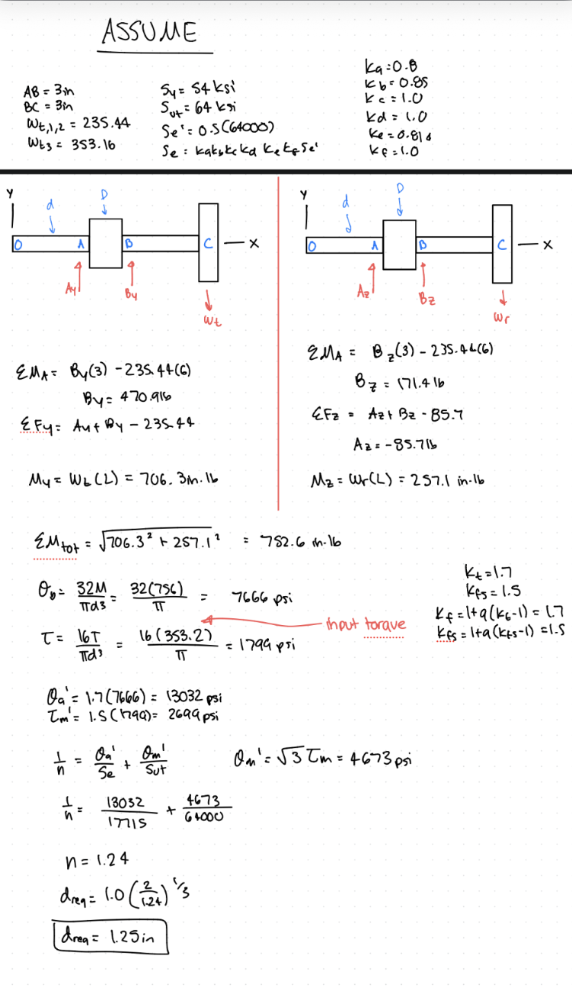
Figure 4. Shaft Free Body Diagrams.

Figure 4 shows the loading conditions used for shaft analysis. Both shafts were analyzed under combined bending and torsional loading conditions generated by the transmitted gear forces.

Using the calculated reaction forces, bending moments were determined at the critical locations along each shaft. These bending moments were combined with transmitted torque to determine the resulting shaft stresses. Stress concentration effects at shoulders and geometric discontinuities were included in the analysis.

Fatigue design methods were used because the shafts experience repeated loading during operation. Material properties, stress concentration factors, reliability factors, and endurance limit modification factors were incorporated into the design calculations. Detailed calculations are included in Attachment D.

5.2 Shaft Sizing Results
The shaft analysis identified the locations of maximum combined stress and the corresponding minimum required shaft diameters. The motor output shaft was found to require a minimum diameter of approximately 1.25 inches. This shaft experiences the highest rotational speed in the system while transmitting the motor output torque to the first gear stage.

The intermediate shaft was found to require a minimum diameter of approximately 1.75 inches. This shaft experiences increased torque resulting from the reduction stages and therefore requires a larger diameter to maintain acceptable stress levels. The final shaft dimensions selected for the design are summarized in Table 4.
Table 4. Final Shaft Dimensions.
Shaft | Function | Min Diameter (in) | Fillet Radius (in)
1 | Motor Output Shaft | 1.25 | .100
2 | Intermediate Reduction Shaft | 1.75 | .125

The selected shaft diameters satisfy the required design criteria while remaining practical for manufacturing and assembly. Standard shaft materials and machining processes can be used to produce both shafts.

Detailed engineering drawings for the final shaft designs are provided in Attachments H and I. These drawings include dimensions, tolerances, keyway geometry, bearing mounting locations, and other features required for manufacturing. The resulting bearing reaction forces from the shaft analysis were subsequently used for rolling-element bearing selection and life calculations.

6. Bearing Selection and Analysis
Rolling-element bearings were selected using the reaction forces determined during the shaft analysis. The calculated bearing loads were used to establish the required bearing life and dynamic load rating for each bearing location. The governing radial load for the motor output shaft was determined to be 501.1 lbf. The governing radial load for the intermediate shaft was determined to be 668.1 lbf. These loads were obtained from the shaft free-body diagrams and reaction force calculations presented in Attachment D.

A design life of five years was specified for the powertrain. The design assumes operation for approximately four hours per day and 250 days per year. An application factor of 1.5 and a reliability of 99 percent were selected for the bearing design. Deep-groove ball bearings were chosen due to their ability to accommodate radial loading, commercial availability, low cost, and ease of integration into the shaft design.

Using the calculated loads and operating conditions, the required dynamic load ratings were determined. The required C10 rating for the motor output shaft bearings was calculated to be 61.23 kN. The required C10 rating for the intermediate shaft bearings was calculated to be 64.8 kN. The bearing life calculations used to determine these requirements are provided in Attachment E.

Based on the calculated requirements, SKF double-row deep-groove ball bearings were selected for all four bearing locations. The selected bearings have a catalog dynamic load rating of 68.9 kN, which exceeds the required values for both shafts. The final bearing selection is summarized in Table 5.

Table 5. Bearing Selection Results.
Bearing Location | Governing Load (lbf) | Required C10 (kN) | Selected C10 (kN)
Shaft 1 Bearing A | 501.1 | 61.23 | 68.9
Shaft 1 Bearing B | 501.1 | 61.23 | 68.9
Shaft 2 Bearing C | 668.1 | 64.8 | 68.9
Shaft 2 Bearing D | 668.1 | 64.8 | 68.9

The selected bearings provide sufficient load capacity and predicted service life while maintaining commonality throughout the design. Using identical bearings at all four locations simplifies manufacturing, assembly, maintenance, and future replacement.

7. Chain Drive Design
A roller chain drive was selected as the final power transmission element between the gearbox output and the driven axle. Chain drives are commonly used in off-road vehicle applications due to their ability to transmit high loads, tolerate minor misalignment, and operate effectively in harsh environments.

The chain was sized using the transmitted horsepower and output speed determined from the gear train analysis. Service factors and design factors were incorporated to account for shock loading and operating variability. Detailed chain calculations are provided in Attachment F.
The design horsepower was determined using the transmitted motor power together with the selected design and service factors. A design factor of 1.5 and a service factor of 1.1 were applied, resulting in a required design horsepower of approximately 41.4 hp.

Using the calculated horsepower and operating speed, a #100 single-strand roller chain was selected as the preliminary design choice. The selected chain has a pitch of 1.25 inches and utilizes 17-tooth sprockets. Because identical sprockets were selected on both shafts, the chain drive provides a 1:1 speed ratio and functions solely as a power transfer mechanism without introducing additional speed reduction. The final chain design parameters are summarized in Table 6.

Table 6. Chain Design Parameters.
Parameter | Value | Units
Chain Number | 100 | N/A
Sprocket Diameter (D) | 2.72 | in
HP Scaled | 43.5 | Hp
Number of Strands | 1 | N/A
HP max | 41.4 | HP
Centerline Distance (C) | 30 | in
Number of Pitches (L/p) | 65 | N/A
Hours Life (h) | 15000 | hours
Sprocket Teeth (N) | 17 | teeth
Chain Length (L) | 81.25 | in
Pitch (p) | 1.25 | in
Factor of Safety (n_d) | 1.5 | N/A

Additional calculations were performed to verify chain length, sprocket geometry, horsepower capacity, and operating life. The resulting scaled horsepower capacity was calculated to be approximately 43.5 hp, which exceeds the required design horsepower of 41.4 hp. Because the available horsepower capacity exceeds the design requirement, the selected #100 roller chain is considered acceptable for the application. The final design provides adequate load capacity while maintaining a compact and commercially available solution for the final drive system. Complete chain sizing calculations and design iterations are included in Attachment F.

8. CAD Model and Manufacturing Documentation
A complete three-dimensional powertrain assembly was developed in SolidWorks to verify component fitment, shaft spacing, gear alignment, bearing placement, and overall packaging constraints. The model includes the motor, gears, shafts, bearings, sprockets, and chain drive used in the final design. The completed assembly model is shown in Figure 5.
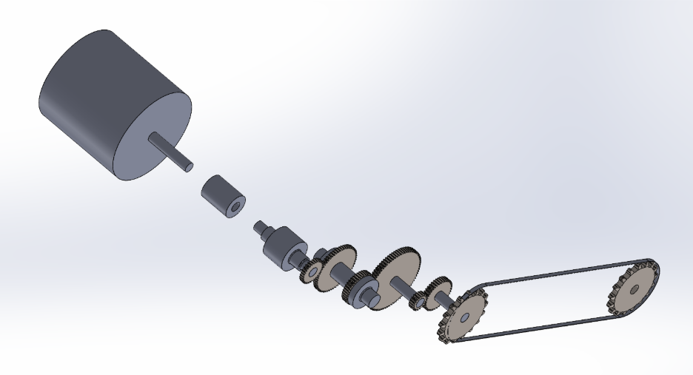
Figure 5. SolidWorks Assembly Model.

Figure 6 illustrates the overall power flow through the system, beginning at the electric motor and continuing through the multi-stage gear reduction system to the final chain drive. The assembly model was used to verify proper gear meshing, bearing placement, shaft spacing, and overall manufacturability of the design. A complete assembly drawing is provided in Attachment G. This drawing serves as the primary reference for future assembly and design refinement activities.

Because the shafts are custom-manufactured components, detailed engineering drawings were developed for both Shaft 1 and Shaft 2. These drawings include all dimensions, shaft diameters, shoulder locations, fillet radii, bearing mounting surfaces, keyway geometry, tolerances, and manufacturing callouts required for fabrication and inspection.

The detail drawing for Shaft 1 is provided in Attachment H. The detail drawing for Shaft 2 is provided in Attachment I. Together, these drawings provide sufficient information for manufacturing, inspection, and future design modifications.

9. Conclusions
A complete ATV powertrain was successfully designed to satisfy the performance requirements established for this project. The final design consists of an ME1616 PMAC water-cooled electric motor, a multi-stage gear reduction system, two custom shafts, four rolling-element bearings, and a final chain drive.

Preliminary vehicle calculations were used to determine the power, torque, and speed requirements necessary to achieve the desired vehicle performance. Based on these requirements, a motor was selected and an overall transmission ratio of approximately 8:1 was developed to convert the high-speed motor output into the lower-speed, higher-torque output required at the final drive.

The first two gear meshes were evaluated using AGMA bending and contact stress methodologies. All calculated bending and contact factors of safety exceeded the minimum acceptable value, indicating that the selected gears are capable of safely transmitting the required loads throughout the design life. The resulting gear forces were subsequently used to determine shaft stresses, bearing reactions, and bearing loading conditions.

Shaft design calculations identified minimum required diameters of 1.25 inches and 1.75 inches for the motor output and intermediate shafts, respectively. Fillet radii were incorporated at shaft shoulders to reduce stress concentrations and improve fatigue performance. Bearing selection was completed using calculated reaction loads and required service life criteria, resulting in the selection of commercially available deep-groove ball bearings. The shafts were further designed to incorporate the bore size necessary as governed by the bearing calculations. A #100 roller chain was selected for the final drive based on transmitted horsepower requirements and service factor considerations.

The completed design represents a feasible and manufacturable powertrain configuration that satisfies the project requirements. Supporting calculations, engineering drawings, and CAD models are included in the attachments and provide sufficient information for future fabrication, testing, and refinement of the design.

Attachment A: Preliminary Hand Calculations and Concept Development

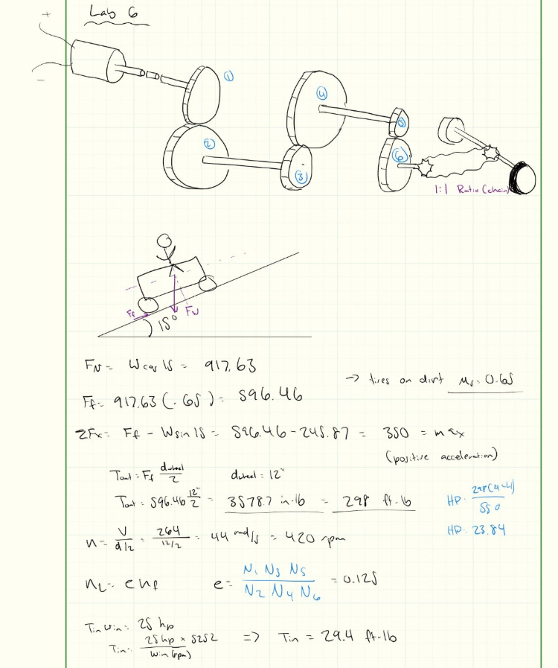

Attachment B: Gear Ratio Development and Preliminary Design Iterations

INPUTS | Values | Units | OUTPUTS | Values | Units
Weight | 750 | lbs | Normal Force | 724.444 | lb
Static Factor | 0.65 | N/A | Friction Force | 470.889 | lb
Wheel diameter | 12 | in | Sum of Forces in X | 276.774 | lb
Max Velocity | 20 | mph | Torque out | 2825.333 | in.lb
Angle | 15 | degrees | Speed | 58.66666667 | Rad/s
omega | 58.6666667 | rad/s | t out | 235.4444131 | ft.lb
velocity in/s | 352 | in/s | hp | 25.11407073 | HP
 |  |  | m (gear ratio) | 8.000172311 | unitless

Attachment C: AGMA Gear Stress Calculations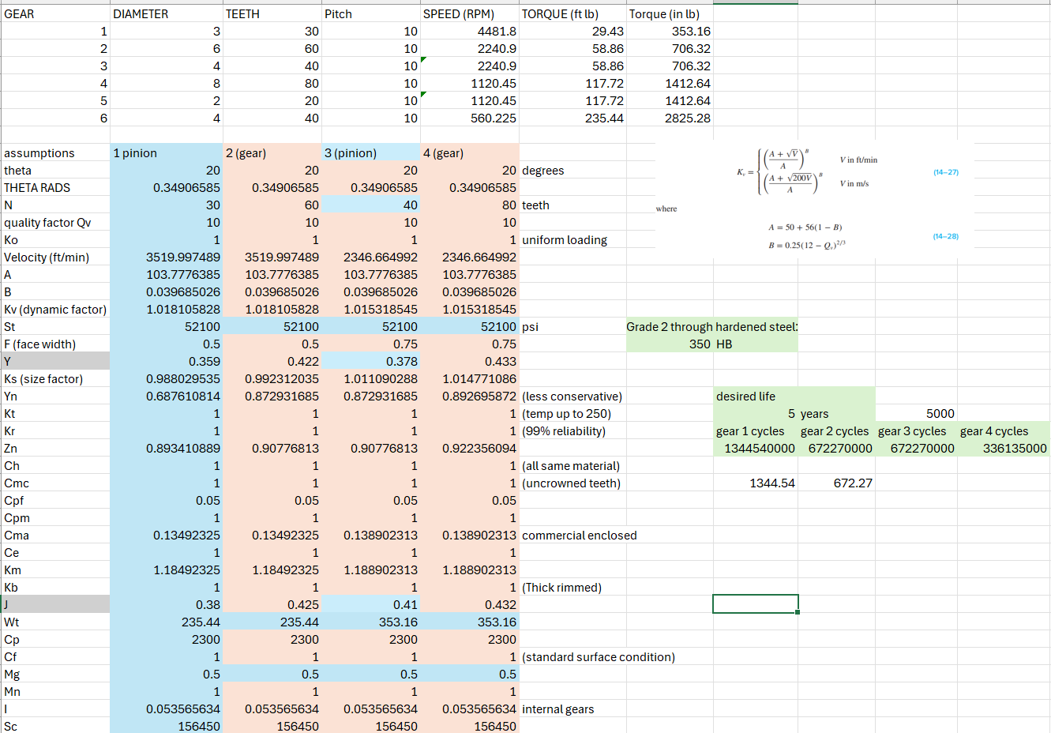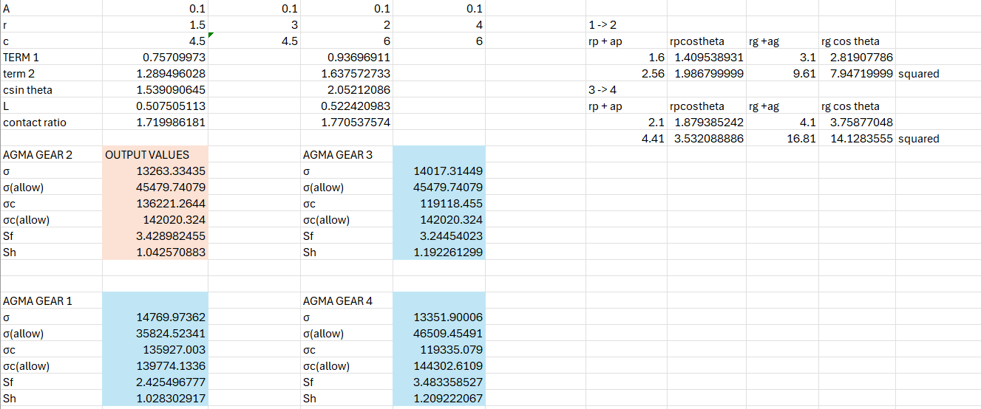

Attachment D.1: Shaft Free Body Diagrams and Shaft Sizing Calculations
Attachment D.2: Shaft Free Body Diagrams and Shaft Sizing Calculations
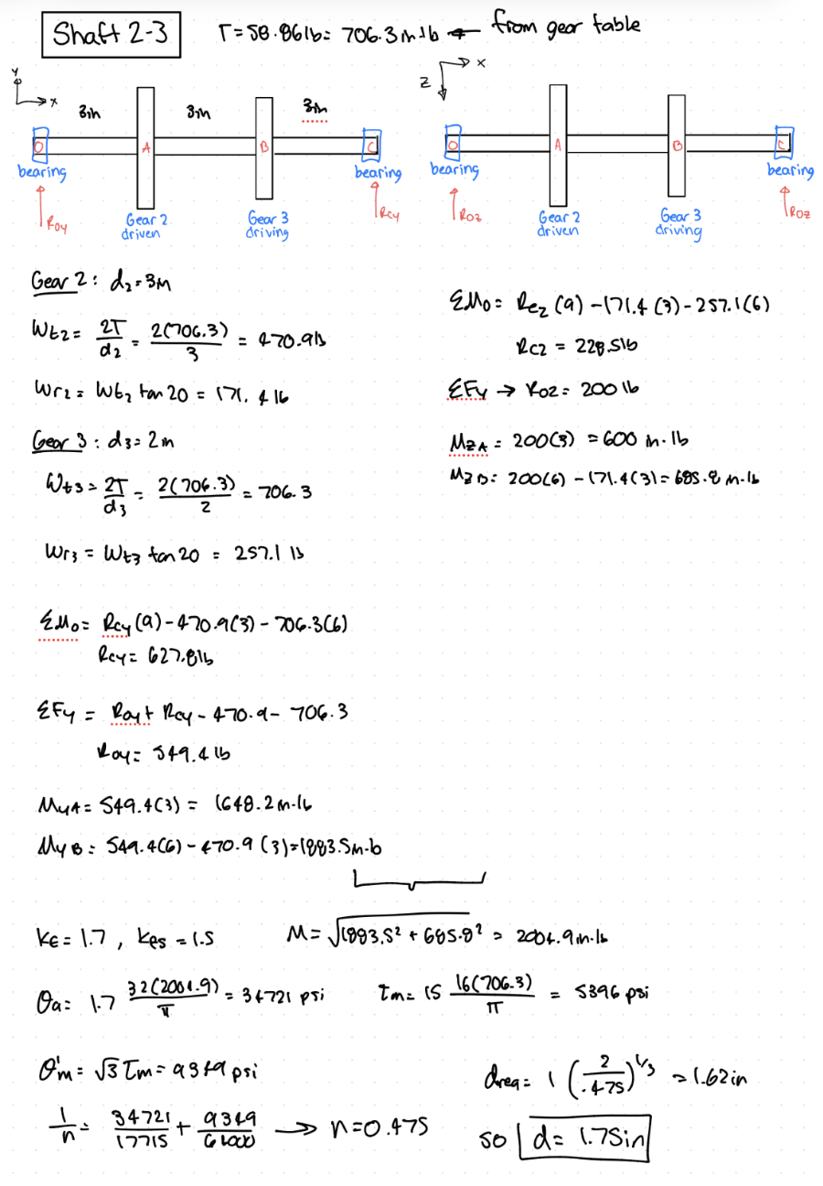

Attachment E: Bearing Selection and Life Calculations
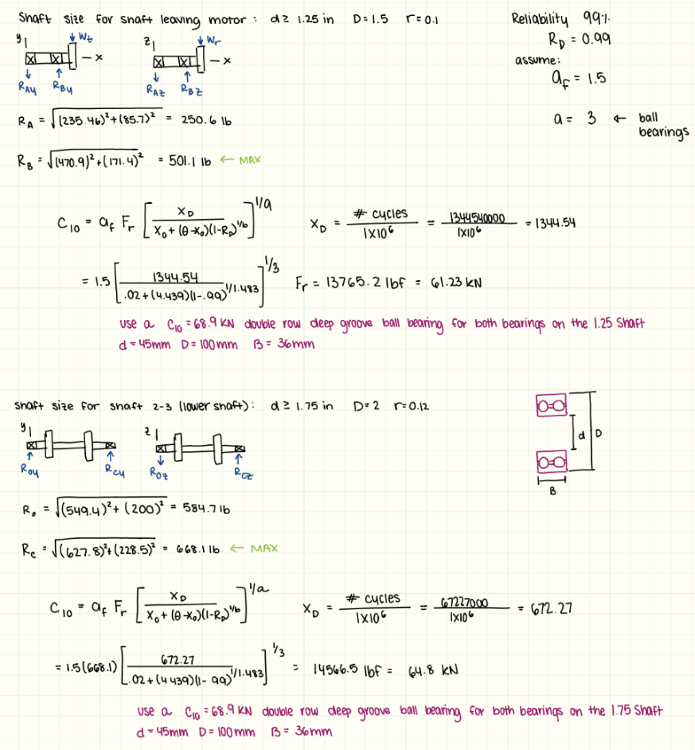

Attachment F: Chain Drive Design Calculations
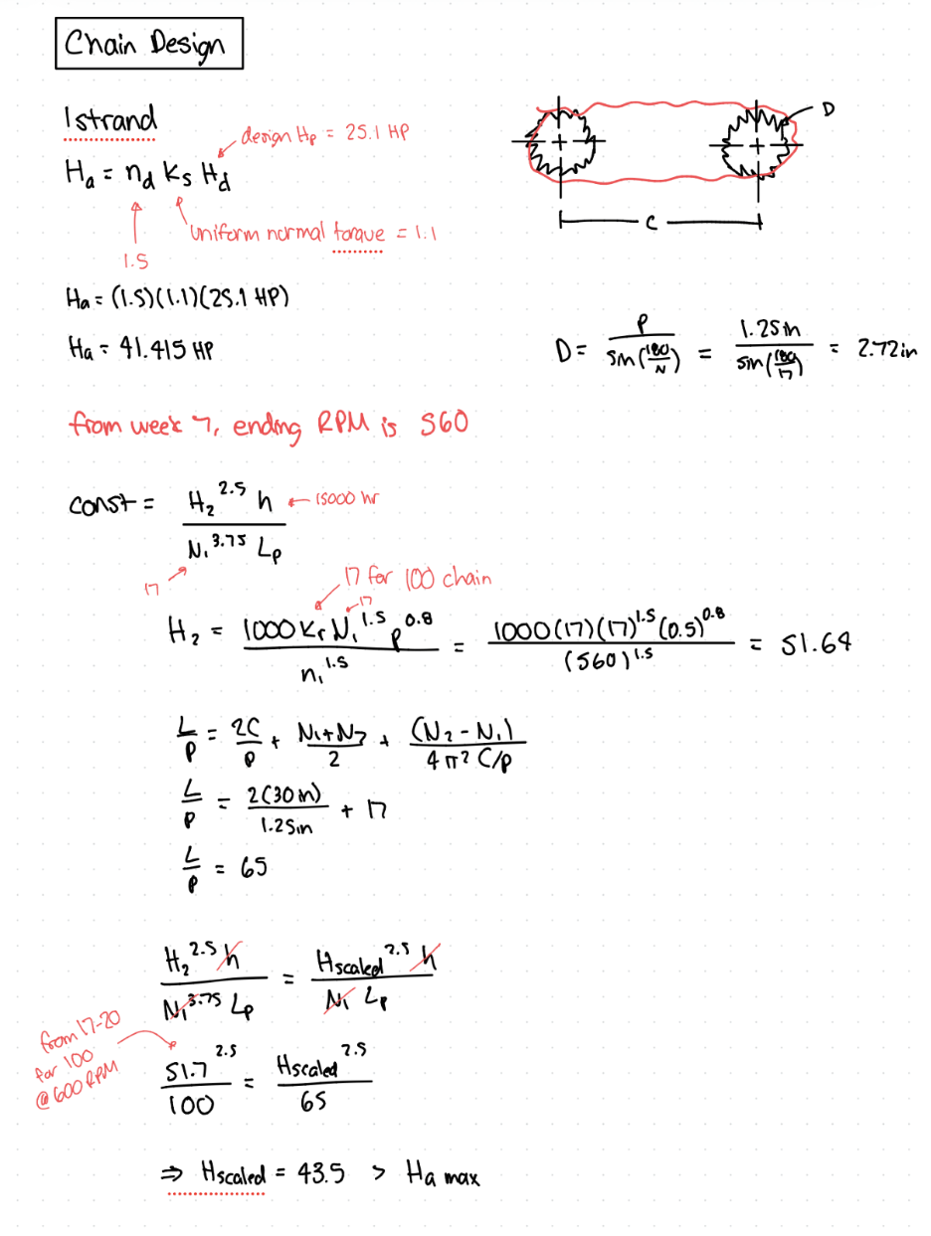

Attachment G: SolidWorks Powertrain Assembly Drawing
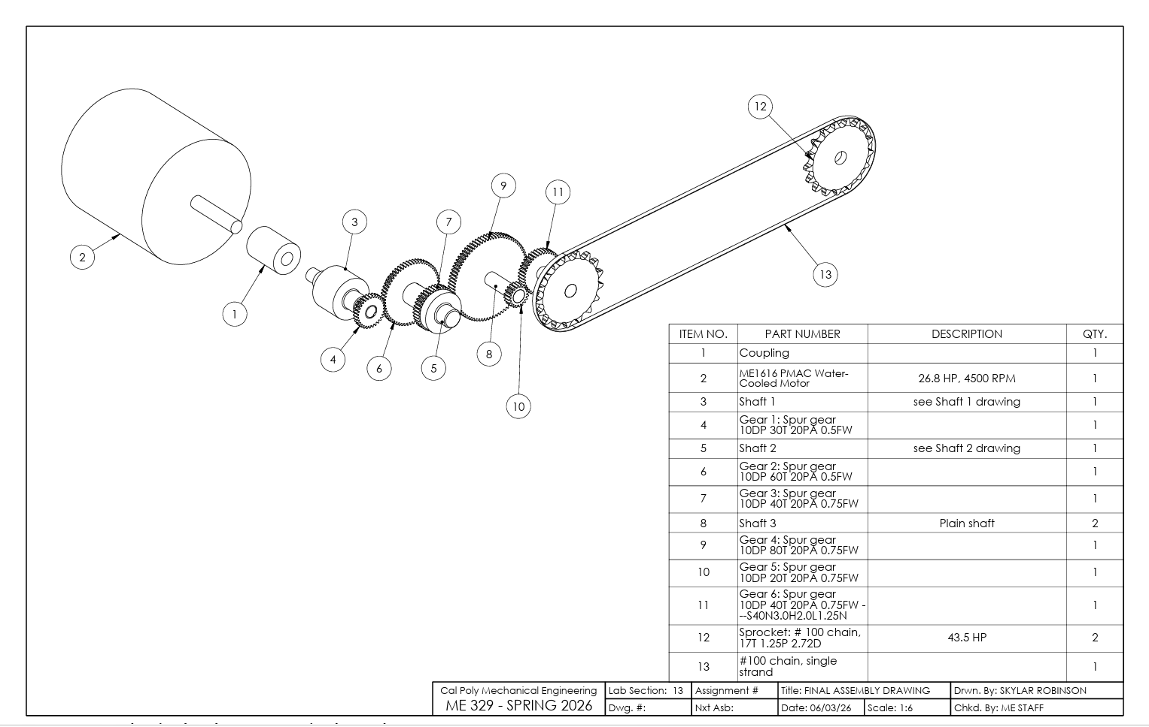

Attachment H: Shaft 1 Detail Drawing
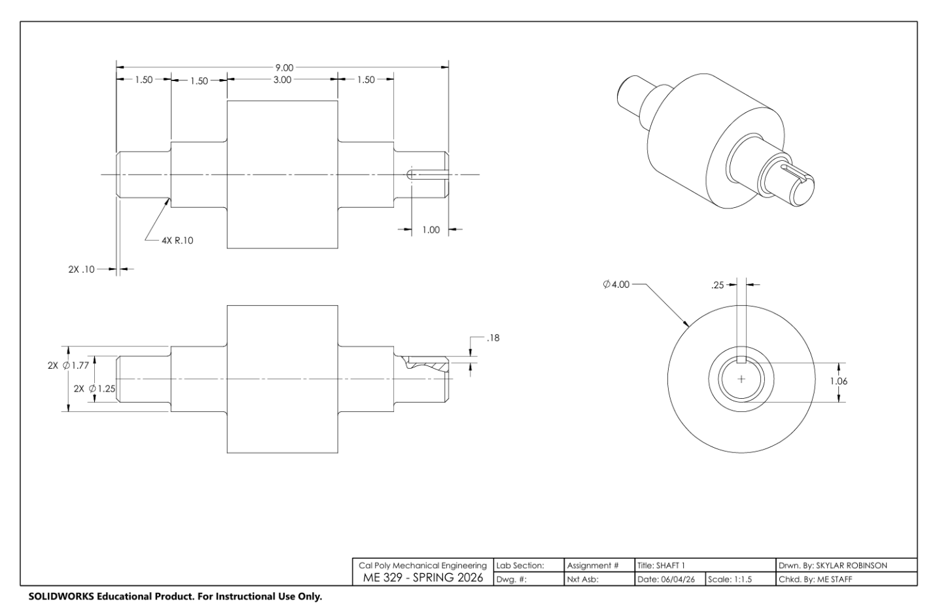
Attachment I: Shaft 2 Detail Drawing
