MEMORANDUM |  | 
To: | Dan Castro, Lecturer, Department of Mechanical Engineering, Cal Poly SLO
 | ddcastro@calpoly.edu
From: | Owen May |  | Skylar Robinson
 | obmay@calpoly.edu |  | Srobin26@calpoly.edu
 | Jake Hemsley |  | Lachlan North
 | hemsley@calpoly.edu |  | linorth@calpoly.edu
Date: | 03/16/26
RE: | ME 328-10, Project Group 2, Final Report

Table of Contents | Page #
Design Overview and Relevant Background | 1-2
Drawings and Assembly
Calculations and Modeling
Deflection Measurements and Other Testing Results
Recommendations for Improvement
Conclusion
Appendix

Attachments List:
- Initial Hand Calculations
- Assembly Drawing for Completed Scooter
- Isometric Part Drawing for “T-Joint”

Note: Attachments B and C are submitted as separate PDF’s

Design Overview and Relevant Background
This project involves the design and construction of a lightweight, PVC-based kart-racing style scooter intended for college-aged riders and a university professor. The objective was to develop a functional, self-driven or push-assisted scooter that is simple, affordable, and manufacturable using readily available materials. Background work included defining load cases, analyzing theoretical stresses and deflections, and developing a SolidWorks assembly. The following sections outline the design constraints, structural analysis, steering configuration, fabrication process, and overall performance of the final prototype.

The primary criteria guiding this design were simplicity, functionality, and cost-effectiveness. The scooter must be constructed primarily from PVC and be capable of supporting expected rider loads while maintaining sufficient stiffness and limited deflection under normal operating conditions. It must clearly function as a scooter configuration and be compact enough to pass through a standard doorway. The design is required to include a steering while avoiding unnecessary complexity. Steering must be controlled directly by the user’s hands or feet without advanced mechanisms, improving reliability and ease of fabrication. Straight PVC members were intentionally used to ensure predictable steering behavior and consistent structural performance, and all load-bearing components rely on structural materials rather than 3D-printed joints to ensure durability during testing and demonstration.

Several challenges may arise during fabrication, particularly in selecting and assembling appropriate PVC joints. Because the structure relies on bonded PVC connections, joint type selection was critical to maintaining alignment, simplicity, and structural integrity. Improper surface preparation or insufficient adhesive strength at jointed sections could lead to failure under load, and maintaining proper geometry during curing was necessary to ensure predictable steering and load distribution. Figure 1 outlines this completed scooter design.

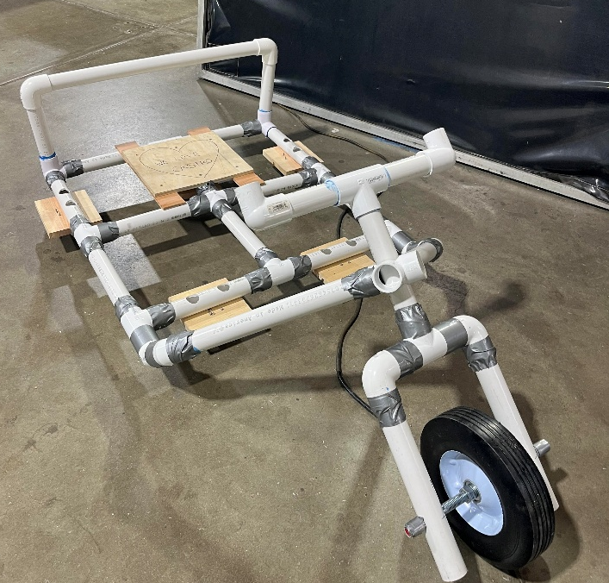
Figure 1. Completed Scooter Isometric.

During operation, the scooter requires two individuals: a rider and a separate “pusher” who acts as the driving force. Coordination between both users is necessary for stability and control. The scooter is also sized for a limited range of users, with an approximate minimum rider height of 5'1" to comfortably reach the handlebars. Safety concerns include slightly exposed screws, potential overstressing under variable loading conditions, and instability on uneven terrain. The scooter is intended for smooth surfaces only and should not be used off-road or at excessive speeds. Users should inspect joints and fasteners before operation and avoid sharp turns at high speeds to reduce the risk of tipping or structural damage.

Drawings and Assembly
During assembly of the scooter, begin by machining the cross joint to ensure it allows for smooth, free rotation in tandem with the steering column. Before proceeding with the rest of the construction, drill two 5/8-inch diameter holes in the PVC steering fork to accommodate the metal rod that will support the wheel. Next, attach the swivel wheels to sturdy pieces of wood or another material capable of supporting the wheel’s weight without fracturing. To secure the wood to the PVC, machine access holes in the PVC to allow for pre-drilling, then pre-drill and screw the PVC into the wood. After completing these preparatory steps, assemble the remainder of the scooter using PVC glue, working from back to front and allowing sufficient time for each joint to set before attaching additional PVC components to ensure proper alignment and structural integrity.

Calculations and Modeling
The scooter was designed to accommodate an adult rider of approximately 155 lbs seated within the scooter while being propelled by a second user from the rear. To ensure safe operation without joint failure or excessive deflection, a factor of safety of approximately 1.5 was applied, resulting in a design load of roughly 220 lbs. Initial hand calculations shown in Attachment A were performed to estimate internal bending moments, axial forces, and deflections in the primary PVC frame members using simplified beam assumptions. These calculations were used to size members, identify critical regions, and estimate expected stress and deflection levels prior to detailed modeling.

Three load cases were evaluated: two normal use cases and one abuse case. The first normal case considered vertical loading from the rider’s weight in seated and standing conditions to design for strength and stiffness. The second normal case evaluated horizontal push forces applied at the rear bar and their combined effect with rider weight, particularly on the steering column and front frame members, which experience bending and axial stresses. The abuse case simulated an impact load from rolling off a curb, introducing elevated forces concentrated primarily at the front wheel assembly and steering connection. Strength was evaluated by ensuring stresses remained below allowable limits for PVC under the factored load, while stiffness was assessed by limiting excessive vertical and lateral deflection that could compromise steering performance or user comfort.

Finite Element Analysis (FEA) simulations were conducted for each load case using the final design schematic, this process and schematic are both shown in Figure 2, below.

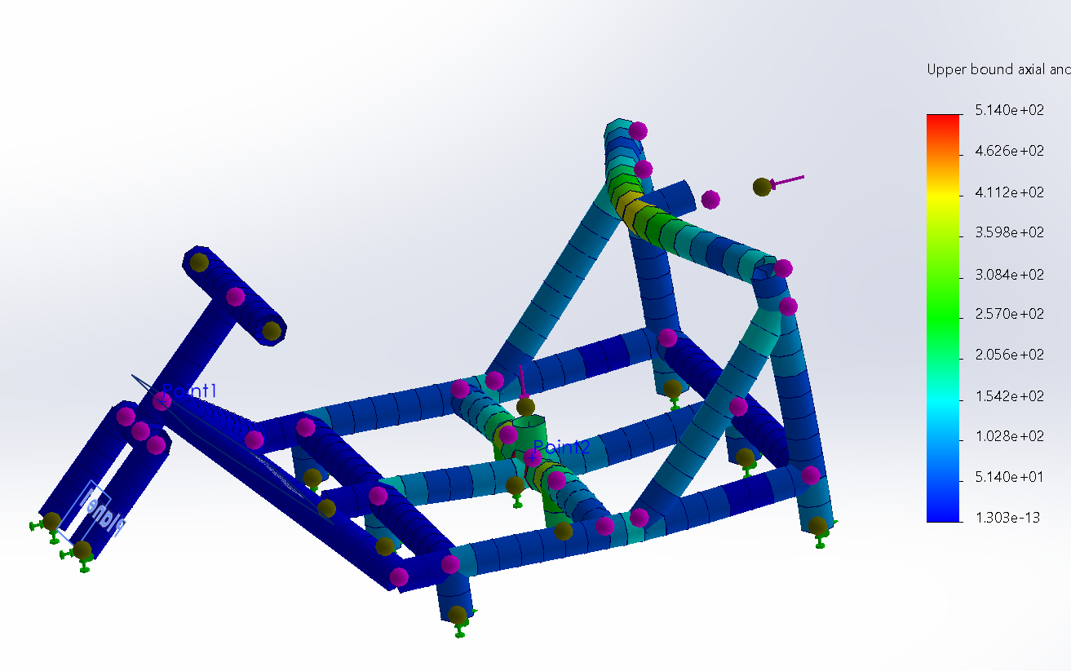
Figure 2. FEA Screen Capture for Loading Case 2.

Within the SolidWorks Simulation, boundary conditions were applied at wheel contact locations and loads were applied at the seat and push bar to replicate realistic force transfer. Results identified peak von Mises stresses and maximum deflections. The most critical region was identified as the four-way PVC joint connecting the steering mechanism to the main body (marked in red, Figure 3) which experienced the highest bending stresses under combined weight, push, and impact loading.
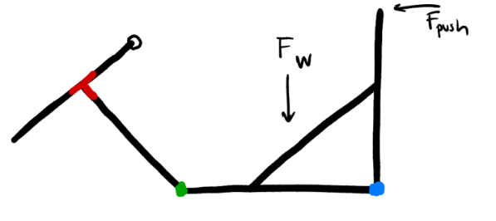 | 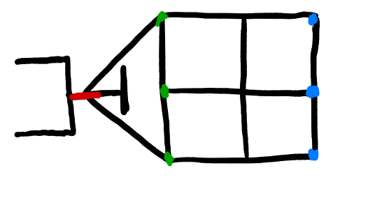
- Critical Points Side View | - Critical Points top View
Figure 3. Critical Points Overview.

The three-way PVC joints at the rear (blue) and the front body connection (green) also experienced stress from vertical and horizontal loading; however, these loads were distributed across multiple members and reinforced by the rear truss, reducing their severity relative to the steering connection. Maximum deflection was observed along longer unsupported spans and near the steering column under combined loading.

Additional analysis was performed on other purchased components. Each of the five wheels was verified to support the 90 lb design load ensuring proper load distribution during operation. The one-foot-long steel axle was evaluated for bending under wheel reaction forces and was determined to have sufficient strength and stiffness to safely resist yielding and excessive deflection. Differences between hand calculations and FEA results were primarily due to idealized assumptions in the beam models; while global stress trends were consistent, FEA captured higher localized stresses at joints and geometric discontinuities. Overall, the comparison validated the design and confirmed that the scooter meets strength, stiffness, and durability requirements under normal and abuse loading conditions.

Deflection Measurements and Other Testing Results
Physical testing was conducted to measure deflection at critical joints identified in the FEA analysis. A known design load was applied at the seat and push bar to replicate normal operating conditions, and deflection was recorded at key connection points. Table 1 compares measured deflections with FEA-predicted displacements. Any differences are attributed to modeling assumptions in the hand calculations and SolidWorks analysis, including idealized supports and simplified joint behavior.

Table 1. Deflection Measurements.
Critical Point Location | FEA Deflection | Actual Deflection
Steering Component Joint | 0 in | ~0.1 in
Connection Joint | 0 in | ~0.1 in
Push Bar Joint | 0.065 in | 0.2 in

The actual deflection values were estimated by applying seated and pushing loads to the scooter and measuring displacement with a ruler. These measurements were used to verify that the FEA deflection analysis remained valid and that the scooter could withstand brief cyclical loading. It is important to note that the FEA analysis predicted no deflection at the steering component and connection joint. This occurred because, after construction of the scooter, it was discovered that the wheel could not properly steer unless force was applied by the driver’s feet. The absence of these forces in the simulation, along with the inclusion of the support truss, resulted in negligible predicted deflection at those locations. After testing, slight deflection was observed in the analyzed joints due to the presence of these additional forces and the removal of the truss in the final design.

Another observation is that the joint that ultimately failed during initial testing was not one of the analyzed locations. The failure occurred at the seating joint and was attributed to the addition of a pulling force combined with the removal of the support truss in construction. The scooter was also observed to fail when pulled rather than pushed. This behavior can be attributed to PVC glue being applied only to joints expected to experience forces during pushing. Following this failure, duct tape and additional PVC glue were applied to ensure stable operation under both pushing and pulling conditions.

Overall, the measured deflection values were slightly larger than those predicted by the FEA simulation. These differences can be attributed to the slightly different PVC size used in construction, the removal of the truss, and the resulting redistribution of forces throughout the structure.

Recommendations for Improvement and Conclusion
Based on the design results and final testing, several potential improvements were identified. One of the primary considerations involves the seating position. Seating placement was not a major focus during the initial structural layout of the scooter, which resulted in the seat being positioned farther back than desired relative to the length of the handlebars. Despite this configuration, the scooter remains steerable and provides a reasonably comfortable ride. Another possible improvement involves the wheel configuration. Incorporating wheels with a locking mechanism would allow the functionality of the scooter to change depending on the desired operation. In its current configuration, the scooter exhibits significant drifting behavior, which was an intentional aspect of the design. However, improved steering control could be achieved by using swivel wheels equipped with a locking mechanism, allowing the scooter to travel with minimal drift when desired.

The design and assembly process also emphasized the importance of maintaining a clear and detailed plan throughout development. While adjustments were successfully made during construction, more detailed planning, particularly regarding the manufacturing process, would improve future iterations. Careful consideration of how joints, wheels, seating components, and other structural elements are attached during the design phase would allow FEA analysis to more accurately reflect the final manufactured product and improve alignment between theoretical modeling and physical construction.

The final PVC scooter demonstrates that a lightweight, functional, and cost-effective vehicle can be designed and fabricated using readily available materials while meeting defined structural and performance requirements. By prioritizing simplicity and structural reliability, the design achieves sufficient strength and stiffness to support anticipated rider loads while remaining relatively compact and maneuverable. The use of straight PVC members and a mechanically simple single wheel steering system simplified both the design and manufacturing processes. Fabrication required careful joint selection, alignment control, and proper bonding techniques, including the use of PVC glue and duct tape, to maintain structural integrity. Overall, the completed prototype reflects a balanced integration of engineering analysis, manufacturability, and practical functionality while fulfilling the original objectives of safety, affordability, and usability for college aged riders and faculty demonstration.

Attachment A1. Initial Hand Calculations
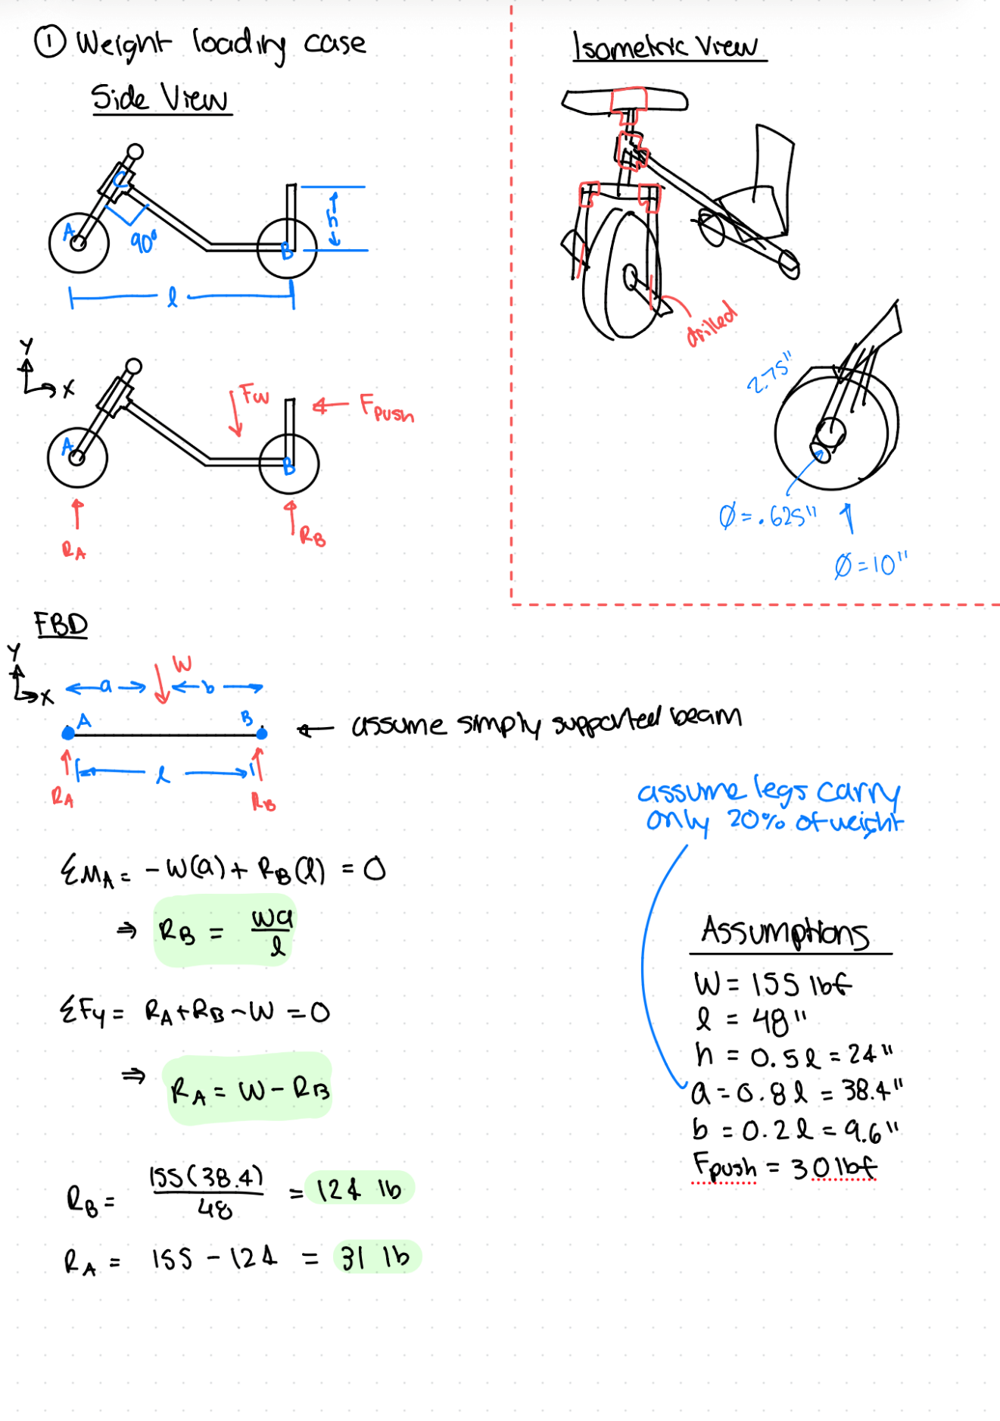

Attachment A2. Initial Hand Calculations
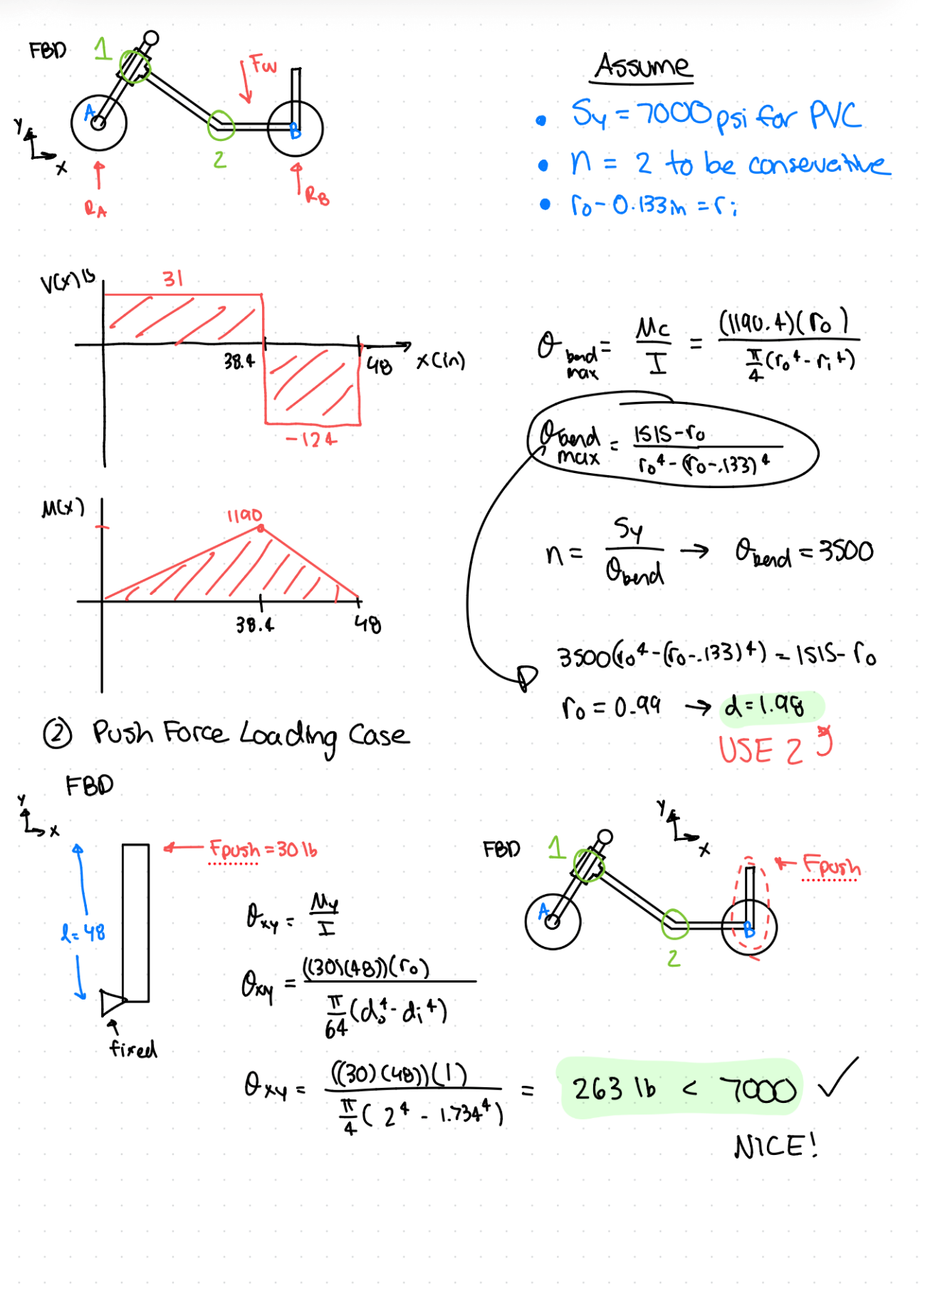

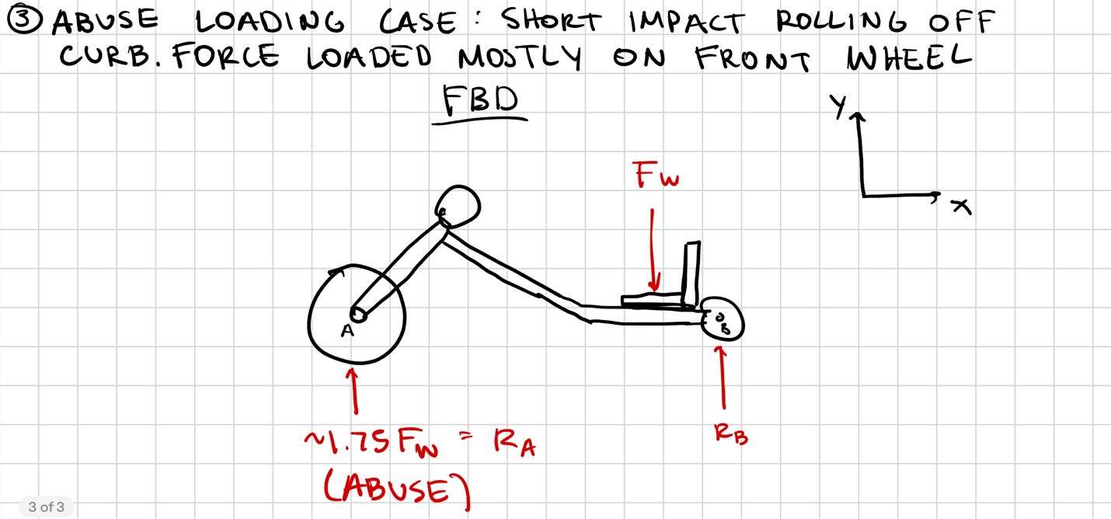
Attachment A3. Initial Hand Calculations

