Raytheon Autonomous Vehicle Competition (AVC)

UAV Team
by
Jack Fleming
Matthew Martin
Skylar Robinson
Viktor Gazibaric

Senior Project
Sponsor: RTX Corporation
California Polytechnic University, San Luis Obispo
College of Engineering



9/23/2026

Project Overview  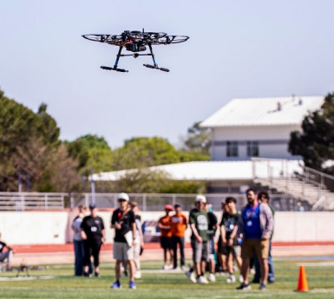  Problem - Raytheon wants to innovate search and rescue operations in difficult terrain by implementing fully autonomous vehicles, and the UAV team will compete in a simulated environment to create an autonomous, GPS-denied UAV that, when given mission intent, will survey the field, locate the desired object, and deliver location instructions to an autonomous UGV within the allocated time.  Stakeholders - RTX Corporation sponsor and mentor Luis Esparza, AVC judges, Cal Poly students (UAV, UGV, Electrical, and Computer Engineering teams), and faculty advisor Rick Lasko. | Key Specifications  These specifications are the most critical to mission success. The UAV must autonomously identify the correct target, navigate accurately, develop a usable map of its surroundings, and reliably communicate with the UGV. If any of these functions fail, the aircraft cannot complete the mission.
  Autonomy | Pass
  Target Identification | Pass
  Communication Accuracy | 99% of messages received
  Navigation Accuracy | < 1 ft
  Map Accuracy | < 1 ft
Scope and Deliverables  The UAV team will deliver:  - Integrated, GPS-denied UAV prototype with guarded rotors, fixed landing gear, safety systems, and mapping systems.  - CAD, drawings, BOM, and analysis results  - Flight, autonomy, endurance, and safety verification results.  - Requirements matrix, test documentation, final report, poster, and competition demonstration. | What’s Next  - Confirm UAV/UGV task allocation and target retrieval concept.  - Complete airframe, propulsion, sensor, power, and communication research.  - Build requirements matrix and verification plan.  - Establish BOM budgets and order long-lead parts.
Raytheon AVC - UAV
Figure 1. Four-Panel Chart summarizing project status.

Overview
RTX sponsors the Raytheon Autonomous Vehicle Competition to give university teams experience designing, integrating, and testing unmanned vehicle systems for a real-world-style mission. The 2026-2027 theme, “Mission Bird Dog,” requires the autonomous vehicle system to receive a natural-language Leader Intent, navigate an outdoor GPS-denied field, identify the correct colored target, avoid non-target objects and obstacles, acquire an NFC message, and communicate the result to the leader. Bonus points are available when the target is retrieved and returned to the designated starting zone.

The Cal Poly UAV team will develop the aerial portion of the system, with the UGV and other disciplines serving as integration partners. The objective of this scope of work is to establish a traceable plan from stakeholder needs through measurable requirements, design activities, and verification. The sponsor’s feedback is requested on the preliminary vehicle architecture, UAV/UGV interface, system safety approach, and proposed prioritization of technical risks.

The following sections summarize existing solution categories, map customer needs to engineering specifications, define measurable targets and verification methods, and document the research base used for design decisions. Appendix A contains the current House of Quality.

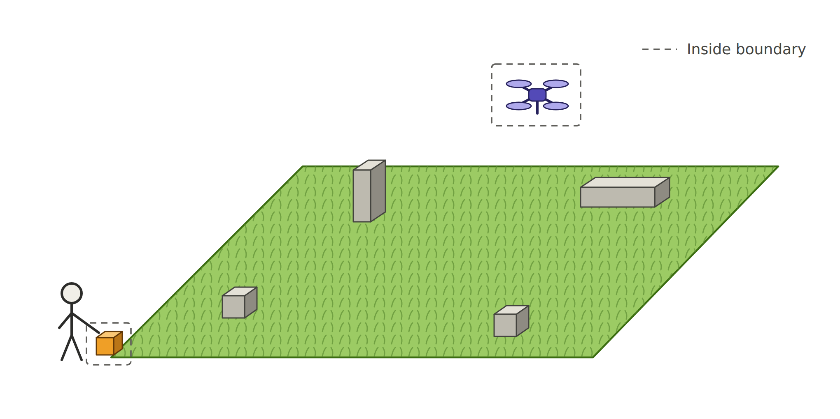
Figure 2. Boundary Sketch

Researched Topics and Existing Solutions
The purpose of this section is to investigate preexisting solutions (or components of solutions) in relation to the Raytheon AVC Competition. This table will be used to learn from existing solutions and build upon their successes. Table 1, seen below, shows three solution types of interest.

Table 1: Existing Solutions
This table details the different types of solutions previously used to address issues most similar to that of the customer and provides examples of their usage.
Solution Type | Description | Examples
High vs. Low RPM motors | Motor KV, propeller diameter, and operating RPM directly affect thrust, efficiency, current draw, vibration, and controllability. Lower-KV motors paired with larger propellers can provide efficient thrust at lower rotational speeds, while higher-KV configurations generally favor smaller propellers and higher rotational speeds. The final propulsion system will be selected based on required thrust-to-weight ratio, endurance, stability, and electrical power constraints. | [11]
Composite and 3D printed frame | A carbon-fiber composite frame provides a strong, lightweight, and stiff structure for supporting the UAV’s motors, electronics, and payload. Its low weight improves flight efficiency, while its flexibility can help absorb mild landing impacts. 3D-printed components can be used for nonstructural mounts, guards, and replaceable joints, allowing the team to quickly prototype, customize, and repair damaged parts without replacing the entire frame. | [16], [20], [21], [22]
LiDAR mapping | Using rotating LiDAR sensor to create 3D point cloud map that creates a rough scan of the area. This sensor is also range culled so that the data it collects is only relevant to movement and does not bog down the compute time of movements. | [12]

Customer Needs

The purpose of this section is to flesh out and understand the customer needs and prject requirements for the autonomous vehicle competition. These needs and requirements are derived from the Raytheon competition rules, FAA regulations, senior project constraints, and team-derived requirements. Relevant engineering specifications are established in greater detail in Table 3.

Table 2: Customer Needs
This table lists the identified customer requirements with justification and assigns a relevant, measurable engineering specification to be used to evaluate the adequacy of the prototype in addressing this need.
Customer Needs | Origin of Requirement | Relevant Engineering Specifications (Spec #) | Justification
Less than 25 lbs | Regulatory constraint | Weight (1), Endurance (8) | The drone must be under 55 lbs, as per FAA regulations.
BOM < $5,000 | Senior Project constraint | Cost (2), Material Selection (10) | The entire project (including both UAV and UGV) must cost less than the allotted $5,000, or we must find alternative funding.
Fully Autonomous | Competition requirement | Autonomy (4), Target ID (6), Communication Accuracy (12) | The drone must be fully autonomous, as outlined in the Raytheon competition rules.
FAA Registered | Regulatory constraint | Weight (1), Safety (5) | The drone must be registered through FAA, and be piloted by a registered drone pilot.
Navigate 15x15 yard field | Competition requirement | Autonomy (4), Map Accuracy (7), Endurance (8), Navigation Accuracy (9) | The drone must be able to navigate a 15 x 15 yard competition field, per Raytheon competition rules.
Object Identification | Competition requirement | Target ID (6), Map Accuracy (7), Navigation Accuracy (9) | The drone must be able to identify an object of interest from a human language command, per Raytheon competition rules.
Surveying/Mapping field | Competition requirement | Map Accuracy (7), Navigation Accuracy (9), Communication Accuracy (12) | The drone must be able to map out the field, know its relative location, and the location of the object of interest.
Communication between vehicles | Competition requirement | Autonomy (4), Communication Accuracy (12) | The drone must be able to communicate location/mapping data to either telemetry computer or UGV, depending on the communication system chosen (TBD).
Battery life ~ 20 minutes | Team-derived requirement | Cost (2), Endurance (8), Repair Time (11) | The drone is given ~20 minutes to complete each task, with a maximum of 7 minutes per run. We estimate that a battery life of around 20 minutes will give us ample time to complete each task.
Adapt to objective changes | Competition requirement | Autonomy (4), Communication Accuracy (12) | Per competition task 3, the drone must be able to receive a human language command that alters the object of interest during the competition run; the drone must be able to adapt to this change.
Smaller than 3 x 3 ft | Competition restraint | Dimensions (3) | Both the drone and the ground vehicle must both be able to fit within a 5 x 5 ft square, per Raytheon competition rules.
Take off & Landing | Competition requirement | Autonomy (4), Safety (5), Repair Time (9) | The drone must be able to take off and land from a specified starting area, per Raytheon competition rules.
Kill switch | Competition requirement | Autonomy (4), Safety (5), Communication Accuracy (12) | The drone must have a “kill switch” that halts all translational motion and allows for manual takeover, per Raytheon competition rules.

Engineering Specifications
The purpose of this section is to detail the engineering specifications referenced in Table 2, and outline the quantitative target values, tolerances, risks, and compliances. The specifications were created from the Raytheon competition rules.

Table 3: Engineering Specifications
This table lists the identified engineering specifications and assigns a specific target value or ability to be used to evaluate the adequacy of the prototype in addressing each need.

Spec # | Spec | Specification Description | Target | Tolerance | Risk  * | Compliance  **
1 | Weight | Verify with SolidWorks models and scales during build. | 25 lbs | Max | H | A, I
2 | Cost | Verify with budget allocation tracked in Excel. | $5000 | Max | L | A
3 | Dimensions | Verify with SolidWorks models and hand measurements during build. | 3 x 3 ft | Max | H | A, I
4 | Autonomy | Test the ability to complete tasks without manual input once given an order. | Pass | Go | H | T
5 | Safety | Test the time to stop motion and take over manual control of the UAV | 3 seconds to terminate motion | Max | M | T
6 | Target ID | Test the ability to complete tasks without manual input once given an order. | Pass | Go | H | T
7 | Map Accuracy | Test ability to complete tasks without manual input once given direction and calculate error to determine compliance with target | 1 ft | Max | H | T, A
8 | Endurance | Analyze power drain by system and test duration of ability to maintain flight. | 20 min | Min | M | A, T
9 | Navigation Accuracy | Test ability to complete tasks without manual input once given direction and calculate error to determine compliance with target | 1 ft | Max | H | T, A
10 | Material Selection | Using FEA to analyze the strength of the material in the UAV and test small portions to inspect for damage before committing to a full build. | Structurally withstand 2x max takeoff weight | Min | H | T, A, I
11 | Repair Time | When repairs are required, determine necessary fixes, measure as/if needed, and test repairs. | 10 min | Max | M | A, I, T
12 | Communication Accuracy | Test ability to complete tasks without manual input once given direction and calculate error to determine compliance with target | 99% of messages received | Min | H | T, A
* Risk of meeting specification: (H) High, (M) Medium, (L) Low
** Compliance Methods: (A) Analysis, (I) Inspection, (S) Similar to Existing, (T) Test

Annotated Bibliography

Books

[1] M. H. Sadraey, Design of Unmanned Aerial Systems. Hoboken, NJ, USA: Wiley, 2020.

- This textbook has a lot of useful information like specific aero sizing sections, a payload and camera topic, and a lot of information on target detection, which covers a lot of the areas that we are working on in this project.

[2] K. P. Valavanis and G. J. Vachtsevanos, Eds., Handbook of Unmanned Aerial Vehicles. Dordrecht, The Netherlands: Springer, 2015, doi: 10.1007/978-90-481-9707-1.

- This handbook pretty much covers everything about UAV’s. It specifically goes into design and construction of UAV’s, kinematics and dynamics, and sensor utilization and localization of objects.

Journal articles

[3] O. Gur and A. Rosen, "Optimizing electric propulsion systems for unmanned aerial vehicles," J. Aircraft, vol. 46, no. 4, pp. 1340–1353, Jul.–Aug. 2009, doi: 10.2514/1.41027.

- This paper builds a full motor/battery/propeller optimization model for a mini UAV in which their setup is basically our problem: weight limit, and stability over speed.

[4] M. Biczyski, R. Sehab, J. F. Whidborne, G. Krebs, and P. Luk, "Multirotor sizing methodology with flight time estimation," J. Adv. Transp., vol. 2020, Art. no. 9689604, Jan. 2020, doi: 10.1155/2020/9689604.

- This paper presents a sizing framework for selecting off the shelf propulsion components (propellers, BLDC motors, ESCs, and batteries) and estimating hover flight times without needing physical testing.

[5] I. Jarraya et al., "GNSS-denied unmanned aerial vehicle navigation: Analyzing computational complexity, sensor fusion, and localization methodologies," Satell. Navig., vol. 6, Art. no. 9, 2025, doi: 10.1186/s43020-025-00162-z.

- This article gives an overview of a ton of different multi-sensor methods, with table overview at the end. It creates a distinction between absolute localization and relative localization, as well as pros and cons of each.

[6] I. Munasinghe, A. Perera, and R. C. Deo, "A comprehensive review of UAV-UGV collaboration: Advancements and challenges," J. Sens. Actuator Netw., vol. 13, no. 6, Art. no. 81, Nov. 2024, doi: 10.3390/jsan13060081.

- Overview of intercommunication between UAV and UGV. Doesn’t really go into specifics, but serves more as an overview

[7] Y. Ding, B. Xin, and J. Chen, "A review of recent advances in coordination between unmanned aerial and ground vehicles," Unmanned Syst., vol. 9, no. 1, pp. 1–21, 2021, doi: 10.1142/S2301385021500084.

- Goes into recent advances in UAV UGV communication. Goes into the challenges related to intercommunication – useful for identifying potential future hurdles.

[8] L. Xin, Z. Tang, W. Gai, and H. Liu, "Vision-based autonomous landing for the UAV: A review," Aerospace, vol. 9, no. 11, Art. no. 634, Oct. 2022, doi: 10.3390/aerospace9110634.

- Outlines different methods of finding a landing spot and using it to aid landing. Includes both static and dynamic cases.

[20] J. Wróbel, K. Jendryka, M. Milewski, A. Kierzkowski, M. Stosiak, O. Prentkovskis, and M. Karpenko, "Experimental modal testing of lightweight composite UAV structures: Methods and key challenges," Machines, vol. 14, no. 4, Art. no. 457, Apr. 2026, doi: 10.3390/machines14040457.

- Demonstrates that while this composite stack-up offers an exceptional strength-to-weight ratio for ultra-lightweight UAV components, it’s extremely low mass makes the dynamic response highly sensitive to boundary conditions and localized mass loading.

Conference papers

[9] J. Strawson, P. Cao, D. Tran, T. Bewley, and F. Kuester, "Monocoque multirotor airframe design with rotor orientations optimized for direct 6-DoF UAV flight control," in Proc. AIAA AVIATION 2021 Forum, Virtual Event, Aug. 2021, Paper AIAA 2021-2431, doi: 10.2514/6.2021-2431.

- Paper shows a single load-bearing shell can distribute motor and flight loads efficiently, integrate components without extra structure, and highlight thin-shell stress behaviors that are directly relevant.

[10] F. Pollet, S. Delbecq, M. Budinger, and J.-M. Moschetta, "Design optimization of multirotor drones in forward flight," in Proc. 32nd Congr. Int. Council Aeronaut. Sci. (ICAS), Shanghai, China, Sep. 2021.

- The paper highlights that airframe drag ($C_{d}$) and downward lift ($C_{l}$) scale with fuselage geometry and directly dictate the drone's tilt angle (angle of attack $α$) during forward flight.

Websites

[11] LIGPOWER, "Drone motor RPM explained: The key to performance," LIGPOWER Blog, Nov. 5, 2025. [Online]. Available: https://www.ligpower.com/blog/drone-motor-rpm-explained.html

- This paper talks about motor theory specifically how to pick accurate rpm ranges for the target goal. This will be important because we need to optimize the rpm of the motor to make it as efficient as possible.

[12] Exyn Technologies, "The differences between online & offline SLAM," Exyn Technologies, Oct. 7, 2024. [Online]. Available: https://www.exyn.com/news/difference-between-online-and-offline-slam

- Production example of a GPS-denied mapping drone that uses both online andapp offline LiDAR to build detailed maps of enclosed areas. Their website has a section specifically on the SLAM method they use, which could be an inspiration for creating our own system that is similar.

[13] NVIDIA, "Isaac ROS Visual SLAM," Isaac ROS Documentation. [Online]. Available: https://nvidia-isaac-ros.github.io/repositories_and_packages/isaac_ros_visual_slam/index.html

- Software package for VSLAM (visual simultaneous localization and mapping), specifically used in GPS-denied environments
Videos

[14] N. Rehm, "The difference between a drone flight controller and flight computer," YouTube. [Online Video]. Available: https://youtu.be/PlKeFj5teo4

- Video explaining the uses of flight controllers and flight computers. It also explains their different use cases and why autonomous drones having both is a good idea. This is relevant for the integration of the autonomous system to our multirotor mapping drone.

[15] Hoarder Sam, "I built a $150 autonomous drone (step by step)," YouTube. [Online Video]. Available: https://youtu.be/uC9hVyqGvDE

- Video explaining the basics of multirotor drone building and how the components work together to create a working drone. Does not have an autonomous aspect, but having a flying drone is the first step in creating one that is autonomous.

[16] M. Grob, "Multicopter 101: From design to flight with PX4," PX4 Autopilot, YouTube. [Online Video]. Available: https://youtu.be/AWzlUBKaMnY

- Video about prioritizing mechanically simple quadrotors, centering mass to avoid wasted thrust, and using rigid materials like carbon fiber or aluminum because software cannot fix structural flex or hardware vibrations.

[17] Electric Aviation, "Multirotor electric aircraft: Design principles," YouTube. [Online Video]. Available: https://youtu.be/zj71OQoRMtc

- Video about the impact of airframe scaling. It demonstrates that maximizing rotor area lowers disk loading, allowing the airframe to move more air mass at lower velocities for vastly improved hover efficiency and flight range.

[18] N. Rehm, "GPS-denied, anti-jam autonomous DIY drone: How it works," YouTube. [Online Video]. Available: https://youtu.be/p8frNNYQNV4

- Video shows a drone using optical shift/accelerometer readings for positioning in GPS-denied environments. This drone also has obstacle detection and an optimal path algorithm integrated to have it move entirely autonomously. The video also explains how he went about creating this drone and the different software he utilized in its creation. This is a great example of technology we could use in creating our mapping system.

[19] OpenCV, "Rethinking drone autonomy in GPS-denied environments – OpenCV Live 217," YouTube. [Online Video]. Available: https://www.youtube.com/live/VfhvwLFGRyE
- Another video of a PhD student presenting his thesis on GPS-denied drone navigation. This includes global localization and obstacle avoidance theory. This is another good example of how we could determine the position of our drone w/o GPS to help construct our map

Datasheets

[21] Ultimaker, "Ultimaker PLA," Technical Data Sheet, v2.00, Apr. 20, 2022.

- This Technical Data Sheet provides essential mechanical and thermal baseline properties for 3D-printed Ultimaker PLA. Because PLA offers high rigidity and tensile strength but lower temperature tolerance and higher brittleness compared to PETG, these anisotropic metrics allow you to run structural finite element analysis (FEA) to determine if PLA is suitable for rigid internal structural ribs or rapid prototype airframe fittings that won't experience high thermal or impact loads.

[22] Ultimaker, "Ultimaker PETG," Technical Data Sheet, v1.00, Apr. 29, 2022.

- This Technical Data Sheet provides essential mechanical properties required for finite element analysis (FEA) to verify that 3D-printed UAV airframe components can withstand flight loads. Additionally, it documents PETG's heat deflection limit and improved chemical/impact toughness over PLA, supporting material selection for lightweight, durable airframe structures.

Appendix A: QFD House of Quality

A QFD (Quality Function Deployment) House of Quality is a visual method used during product design to translate customer needs into measurable, objective, technical specifications. The goals of this are to identify the top needs of the customer, identify specifications, and determine the relationships between them. This was used in developing Table 2 and 3, the customer needs and engineering specifications.

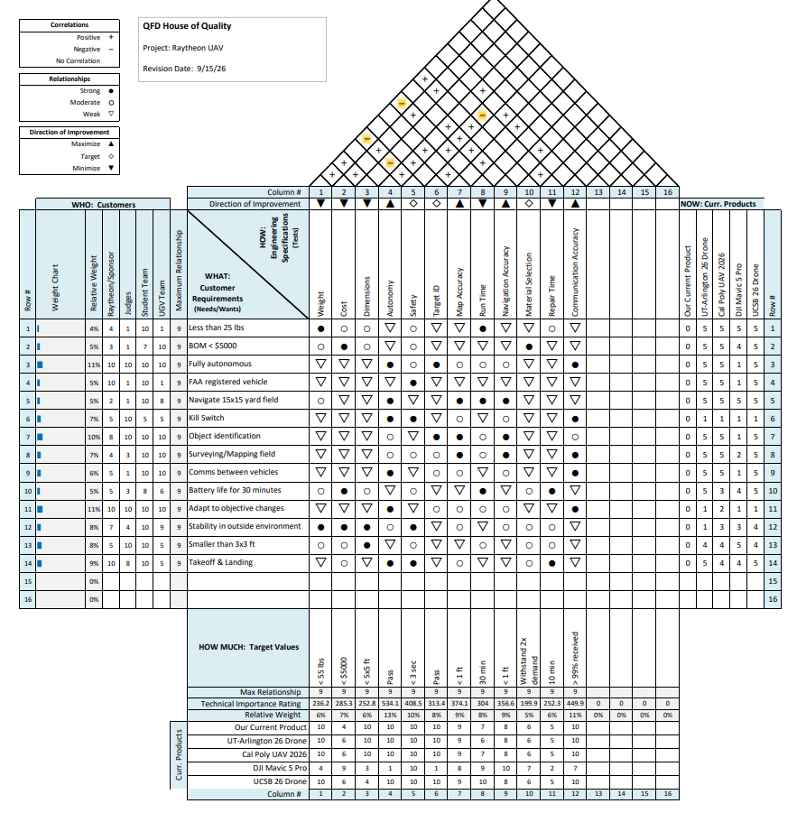
Appendix B: Gantt Chart
The purpose of a Gantt Chart is to visually plan, schedule and track the progress of activities within a project over a specified time frame. This is being used to keep track of deadlines both within the scope of Cal Poly’s senior project, but also to adhere to RTX’s competition deadlines.
