**CST8285 – Assignment 2: Database**

Below is an ERD diagram of our database that shows the relationships between each table.

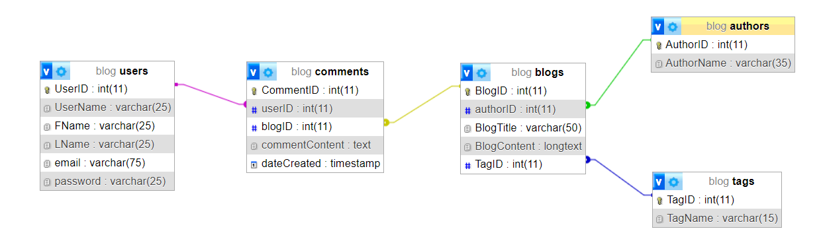

Figure 1: ERD diagram for our database