[RUNWAY](https://www.vogue.com/fashion-shows)

“I’m Not Here to Please an Industry, I’m Here to Challenge It”: A Career-Spanning Conversation with Jonathan Anderson

**Recently, your collections have become more consistent from season to season. There used to be a hard pivot. Is that a personal change, or an industry change, or both?**

I think I just want to reinforce things. I think we do a lot of things, and then they become part of the mainstream, so I think it’s better to actually get your mileage out of each idea.

I also think this job is not only [runway] shows. I think this is the big illusion in this industry, that it’s just about shows, but it’s not, really. It’s about visual merchandising, it’s about stores, it’s about advertising, and those things take up at least 70 percent of my job. The shows are a smaller proportion. And sometimes, people don’t want to hear that. I think they imagine me—

**Off in a high tower.**

—Off in a high tower, trying to be elusive and creative, but in the end, it is a continual dialogue with all levels. You cannot just focus on shows because it’s not just what makes a brand work.

**How do you differentiate between your brands when you’re designing?**

I always say that JW Anderson is a cultural agitator and Loewe is cultural, it processes the culture. JW Anderson is more to agitate, to get things wrong.

**Creatively, how do you sustain the level of productivity you’re at—16 seasonal collections a year between both brands, men’s and women’s—especially when you are touching all of these different components beyond the runways?**

I think you have to be continually curious about things. That’s why I enjoy collaborations. That’s why I enjoy doing what I do, because I am continually trying to find new things. And if you can’t find new things, then don’t do the job. Truly, I think it’s one of those things.

**Your life has certainly changed over this decade. How do you feel that your aesthetics have changed?**

I think my aesthetic has evolved, definitely. I think it’s become more refined or more balanced in a way. I think the overall bones of it are the same. There’s an oddity to it. It’s very textural. There’s always been a focus on craft, and I think that just continues.

**Do you think that craft can or will innovate in the next decade?**

Craft is innovation. Weaving is probably one of the oldest techniques and it’s still going today. I don’t think I own it, I’m just painting it in a different way. When I first joined Loewe I went to the Prado, and I walked down this incredibly long corridor of some of the greatest works in history from the Royal collection. There was a Reubens and a Titian, side by side, both of Adam and Eve. They looked identical. But they were by Reubens and Titian.

I went through a phase where I didn’t believe that fashion was art, but I do believe that it is a reflection of society, so, therefore it is an art form. It is an interpretation, and it is fine to reinvent. If Reubens can reinvent Titian, then this is fine. For me, that’s the history of the universe there, because ultimately it is about the passing of information. I don’t go out to say that I started something and I own it; I just work with things. I think this idea of ownership of design is just ridiculous. I don’t own anything. I make it, I put it out there. That’s it. I move on.

**It has to be a dialogue. The entire history of art is a dialogue with the past, trying to re-establish codes for the future.**

That’s what it’s always been. I think now we’ve become obsessed by the idea of ownership, but the whole point is not to have ownership. Ownership is the most dangerous thing for creativity. Look at John Galliano, one of the greatest designers in history. He was about reinterpreting history. There will never be someone like that again, if we continue in this way. Because it should be about looking at the past in a different way and not about owning something. It is about experiencing it. That is why this job can be so exciting.

**You talked about a 70% versus 30% balance between marketing and designing. How do you want to innovate in those realms, thinking about the next 10 years?**

My whole thing is about putting craft at the forefront. The actual making process, actually why we do these things, and who the people are who are involved. For me, I just want to really explain that these things do not grow on trees. Everyone’s talking about the environment, but I think if we understood the reality of how these things are made, and the people and jobs involved, then we might be able to appreciate [a product] more. I think we need to relish things instead of dispose [of them].

In the next 10 years... Well, it depends on where this industry goes. I feel like there is little respect for craft. Things are just consumed and spit out. I actually work with some of the most incredible craftspeople in the world. They are the people that I want to talk about. I want to use myself as a platform. I mean, I don’t really have anything else to offer. I would rather do things that have merit, and if it takes time, it takes time.



Backstage at Loewe’s fall 2018 showPhotographed by Corey Tenold

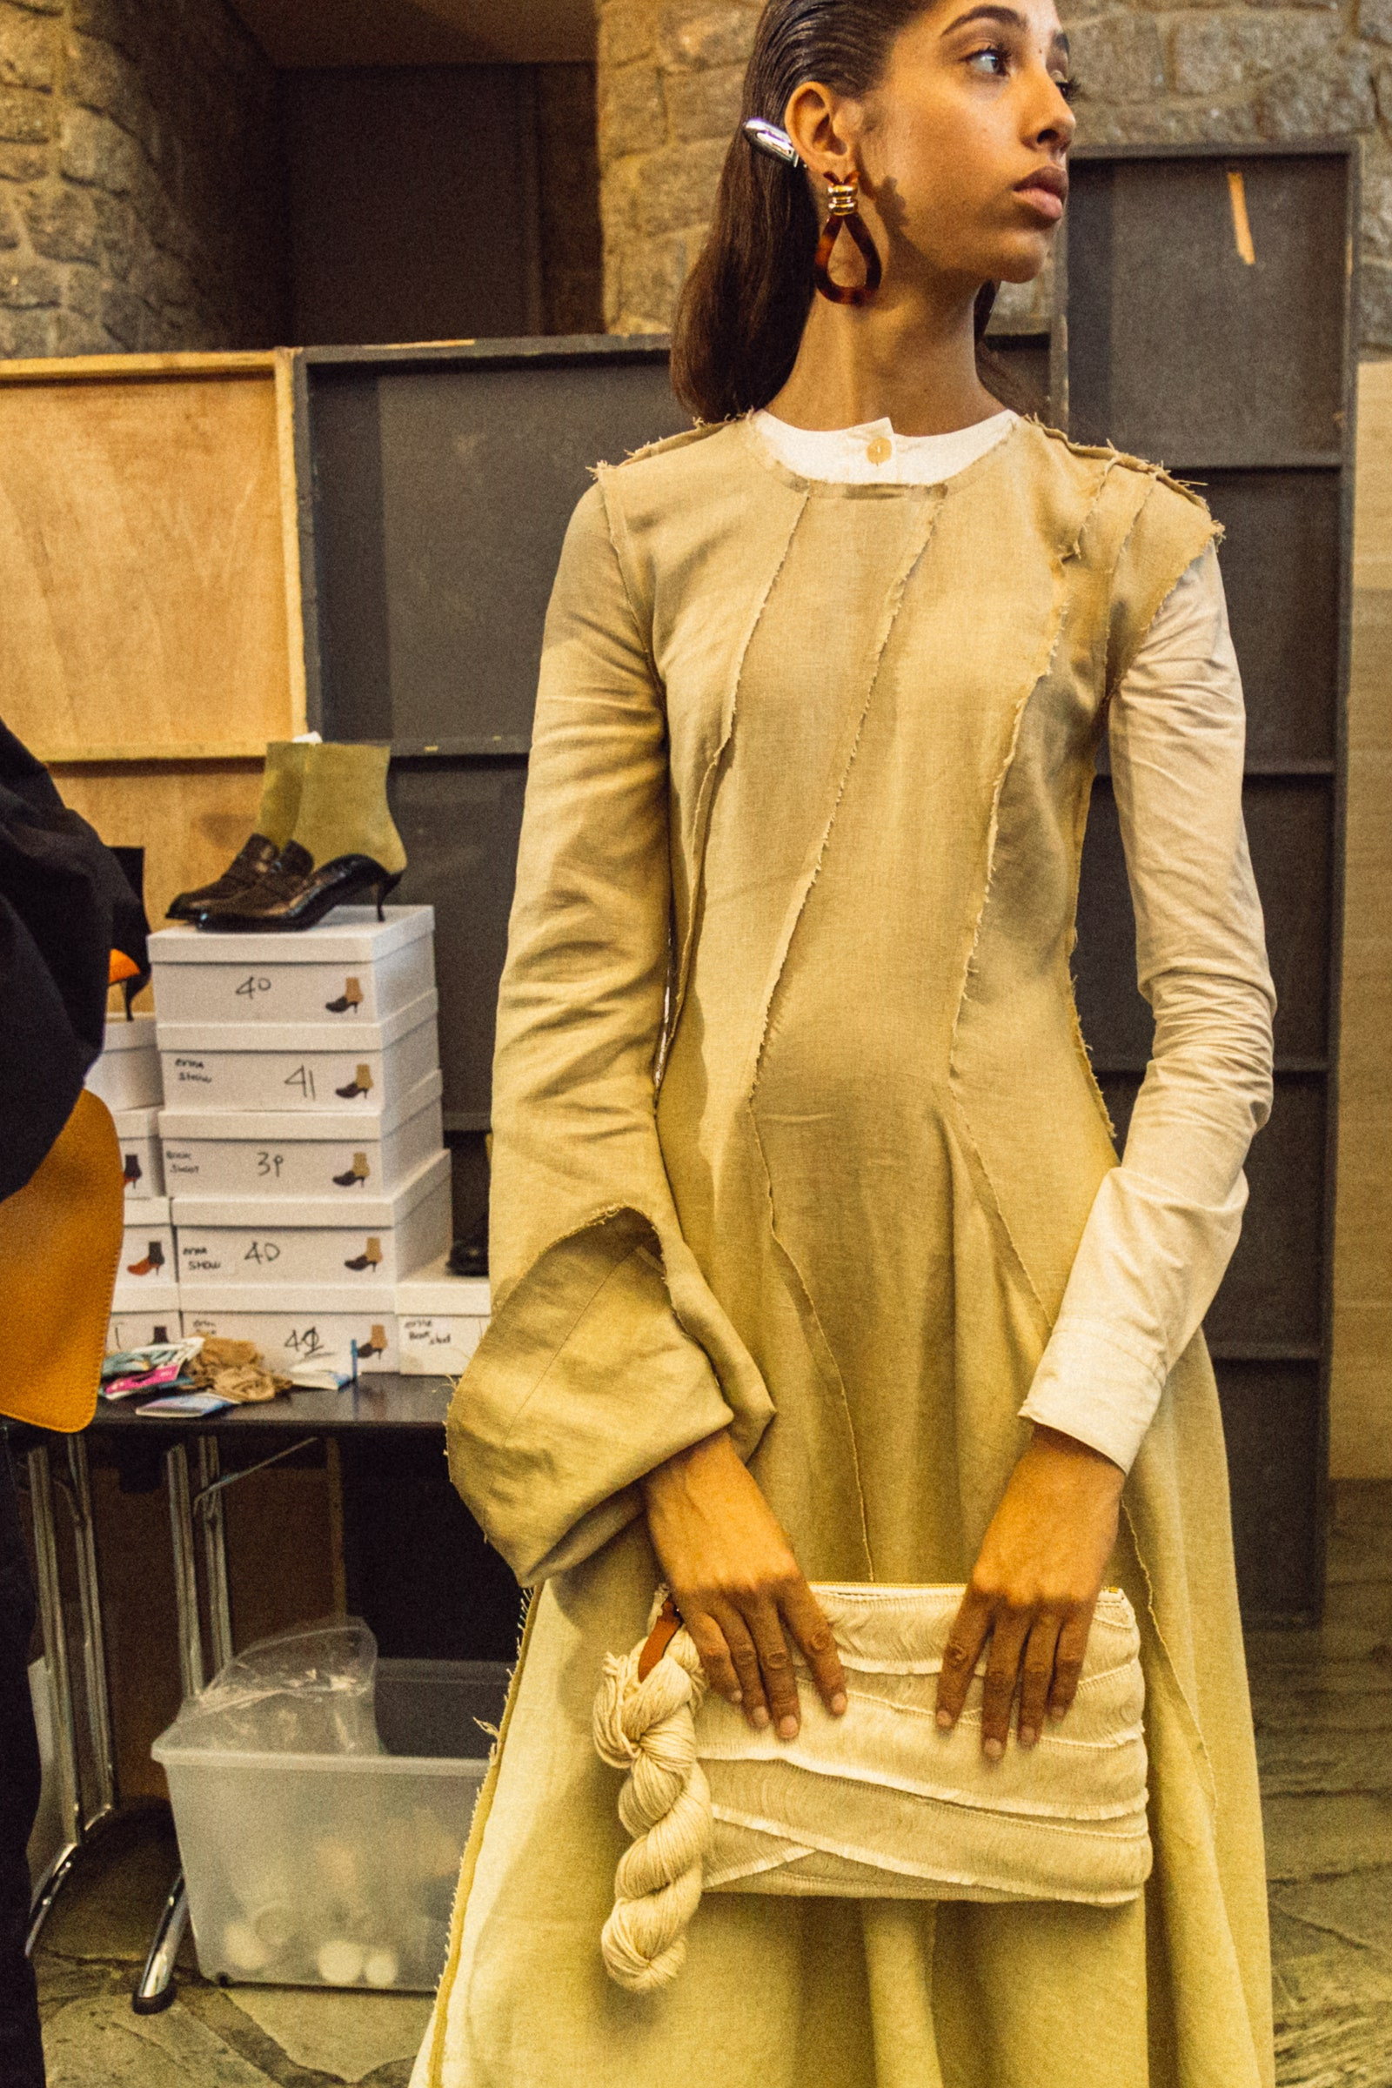

Backstage at Loewe’s spring 2017 showPhotographed by Driely Carter

**We were talking about this the other day, how the ability to collect data so quickly has changed the way that we perceive success.**

That’s how business is trying to work. There are things out there that are successful, or perceived to be so, but that’s just marketing. If you cannot speak about the product that you make and believe in the people that make it, then [it doesn’t] matter if that product is successful or not. It doesn’t make any sense. Sometimes it can be quite difficult, especially if you’re a creative. I see myself as a creative person, and I sometimes get slightly demoralized by where it is now. I find that is probably due to politics, that no one questions politics. They do, but they don’t know how to question it the right way. Life is a spoken mirror and we’re now in a moment where the mirror is incredibly muddied.

**When you speak about politics, you mean fashion industry politics?**

Yeah. I try to stay out of them as much as I can. I just feel like fashion is my job. I go home and I leave it at the back door. I used to take it home [with me] and get very obsessed with it, but when I talk to my parents, they say, “It’s a job,” so, I do the job, I go home, and then I have my own world. It’s my own private world, and that’s it. I give a lot to my work, and I need to keep something.

**Through the projects you’ve done at JW and Loewe, you’ve started to talk about larger issues like politics, sexuality, gender, equality. How important is it for you to participate in these socio-political conversations?**

I don’t believe a brand should have a political viewpoint, because that’s a different thing. I do this as a personal edit, and if the consumer does not like the edit, then I don’t want to sell to them. When I first joined Loewe, I remember we did photographs of Steven Meisel kissing [a man]. That was a scandal at one point, putting those images in some stores. … We work with Visual AIDs. We work with charity organizations, with Knot on My Planet, for example, and we work with local artisans in India. All these different initiatives, they’re not just PR stunts, they are just things I believe in.

There are a lot of things out there that, I think, become a kind of stunt. We’re not here to be carbon neutral just to say it. If we’re going to be carbon neutral, we’re going to do it properly—and it’s not going to happen overnight. But we live in this very strange moment where—and I’ve been at the harsh end of it on many occasions—where people are incredibly angry. I think it has to do with boredom, maybe, or people that are lost in society, or there is not a support system for certain people.

**What do you mean by that?**

The only way I can describe it is recreational outrage. We are outraged by everything. We are more obsessed with failure today than we are with success. Because success is petrifying for people, whereas failure is easy to manage. I find that part of the job, now, incredibly difficult. I like a viewpoint, but I like people who think before they speak. I think there’s a lot of not thinking before we say things. We spit a lot of venom up just to get likes. If society continues in that way, I don’t think creativity can exist. … We should be supporting each other to try to make it in this industry. Anyone who works in fashion will tell you that it’s incredibly difficult. I admire anyone who does it because I know the reality of it and it’s not an easy ride. And I think now that everyone’s a critic...

Designers are not perfect. I say this about every designer. It’s a very difficult moment because you want to try to be creative, and creativity is about taking in the world, and doing it in your way. I think in the end, you have to do what is right for you. I’m not here to please an industry, I’m here to challenge it. I think we have to be challenging things or we will fall into the Victorian era very quickly. That’s quite petrifying because fashion is not about digressing. It’s about going forward. So, I hope in the next 10 years that we become more rational as people, because if not, then what’s the point?

**Do you feel like a success story?**

No. The problem is, I am my toughest critic. If I thought I was a success story, then I would quit and do something else. The success story is never ending. I think, sometimes, I would rather not know where I’m at in a single moment, because I feel the minute you do, then you’ve already climbed that mountain. For me, the mountain is incredibly high. You’ve got to keep the mountain high because if you get to the top, then it’s incredibly boring.

*This interview has been edited and condensed.*