Test Plan - Group 16

“A document listing game or player actions that need to be tested as well as their expected actions. This test plan will be modified throughout the project as new functionality is added to the game. Make sure that your document clearly labels each milestone.”

Milestone 1

|  |  |
| --- | --- |
| **Action/Test Item** | **Expected Result** |
| **Game Controls** | |
| W Key | Move up |
| A Key | Move left |
| S Key | Move down |
| D Key | Move right |
| F Key | Interactions (Picking up items, Enter/Leave Grotto) You must be beside the object to interact |
| R Key | Restart game |
| Esc | Exit game |
| **Game Mechanics** | |
| Item Collection and Respawn | Find a Magical Fruit (orange and grows on trees) or a Coffee Bean (brown and grows on bushes), press F to pick it up. Item should disappear, after 5-15 seconds, it will respawn in the same location. |
| Textbox Visibility | Textbox will appear/disappear when the player is close/far away to an item. Textbox will disappear after the item is picked up. After item respawn, the textbox should be restored too. |
| Collisions | * Player can walk across the bridge but not the river. * Player cannot exit the bounds of the game. * Player cannot walk through the tree trunk, but can walk through and behind the leaves. * Player collides with various objects in the grotto. |
| Biome Switching | Walk into the cave entrance - the screen should fade while maintaining the same background, and the screen will fade back in with the player in the home grotto. Character movement should not be possible during this process, essentially the screen should be frozen. |

Suggested Game Test Plan:

1. Ensure that you run the game with the instructions in the README
2. Player should spawn at the entrance of the grotto in the top right

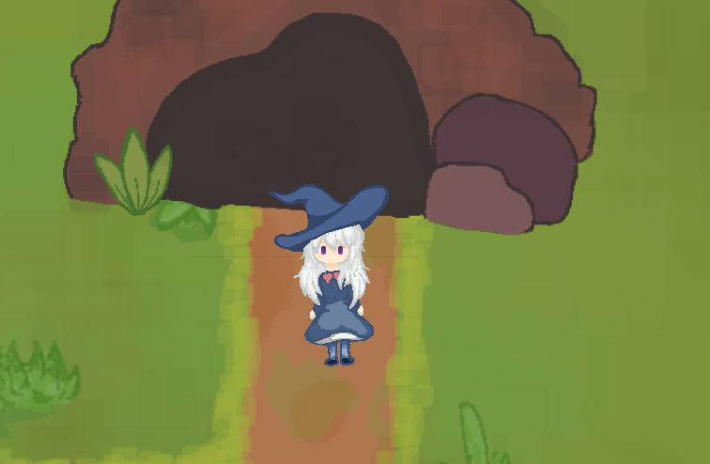

1. Use the WASD keys to move to the trees on the left and bottom. You should see a textbox with “F to interact” appear when you are next to a tree with a fruit on it.

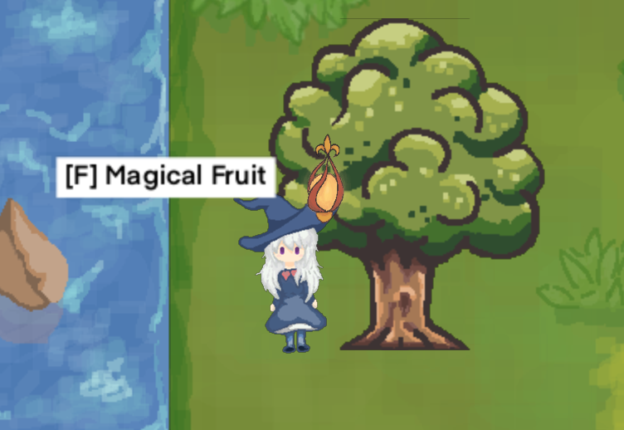

1. Press F to collect fruit on trees. Fruit will respawn after a random time. Observe that the text in the window header updates with your inventory items.
2. Notice how the collision handling allows the user to walk behind and in front of the tree as the rendering layers update.

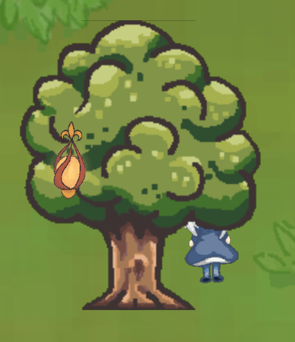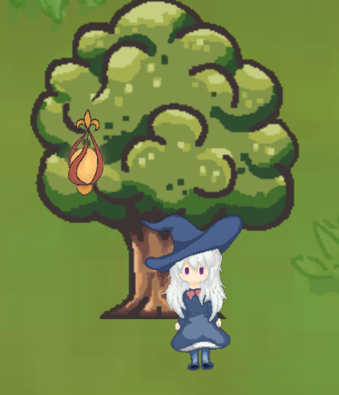

1. Head over to the bush next to the river, collect some of the coffee beans, which have the same random respawn and inventory update as the magical fruit.

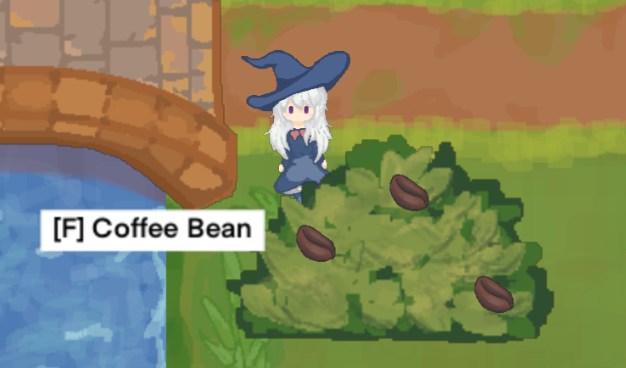

1. Check out our bridge by walking across it, notice how you cannot go into the river at any point.

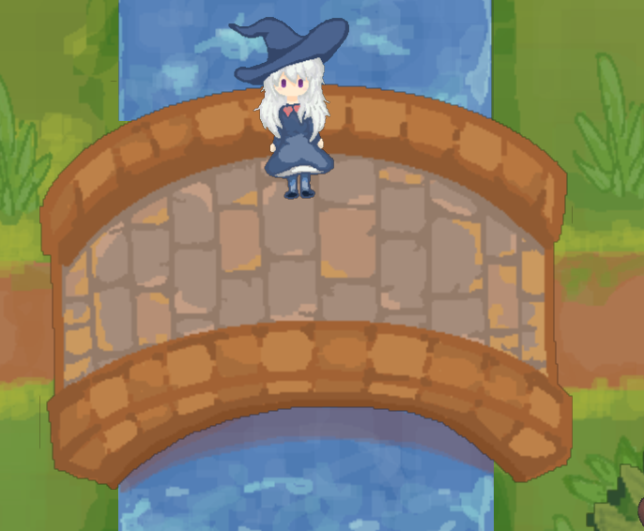

1. Head back to the grotto entrance and click “F” to enter the grotto. Notice the nice fading transition as you go from the forest into the grotto.

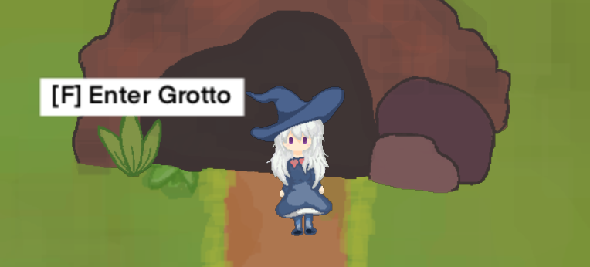

1. Walk around the grotto and test out the collision boundaries - none of the objects are currently interactable, but will be added in future milestones.

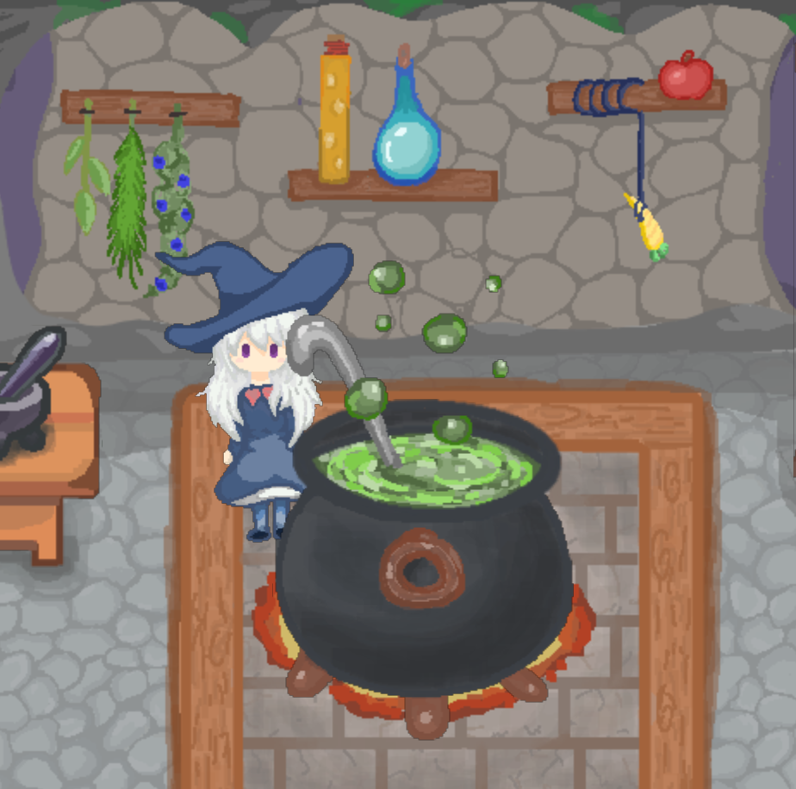

1. Exit the game with ESC, rerun the game and the window header text should indicate inventory persistence, so the items you collected in the game state remain.