**SOP Transfer fastq.gz files from Basespace to Compute Canada**

Requires the Illumina software ‘bs’ & ‘bs-cp’ to be installed in the home directory; For details see Appendix A

**Step 1: Get run & analysis IDs from Basespace website**

Example:

Download fastq from CSF_6samples_2018-11-20

1. Go to website, choose Menu/My Data/Projects folder, get **project ID through URL**

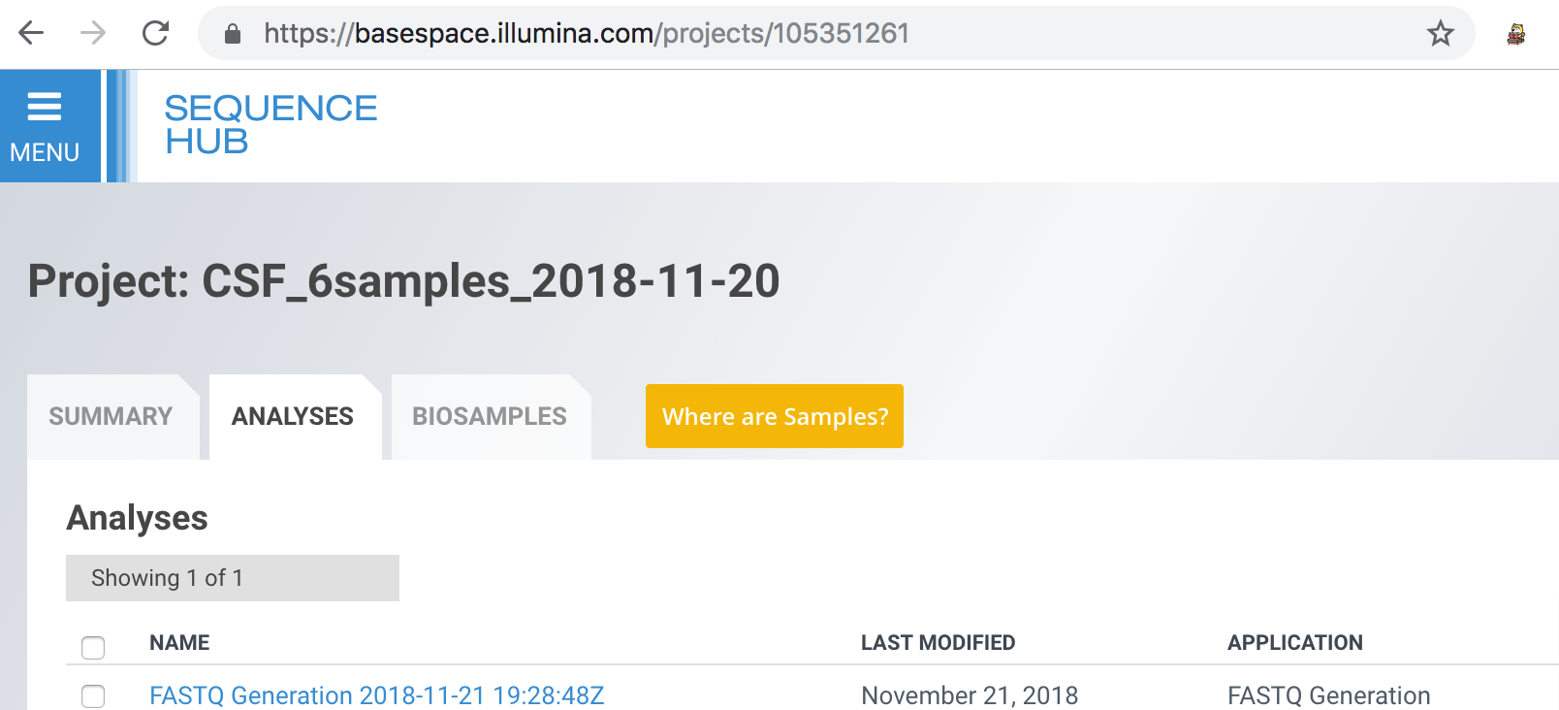

Project ID: https://basespace.illumina.com/projects/105351261  (project ID is 105351261)

1. Choose Menu/My Data/Analyses folder, click the above analysis name to get app session ID through URL

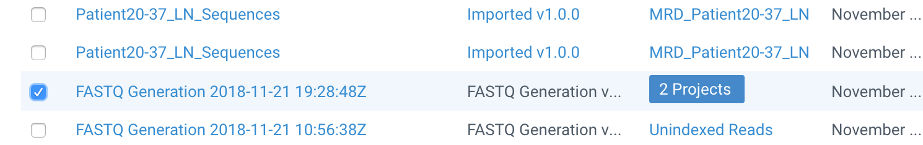

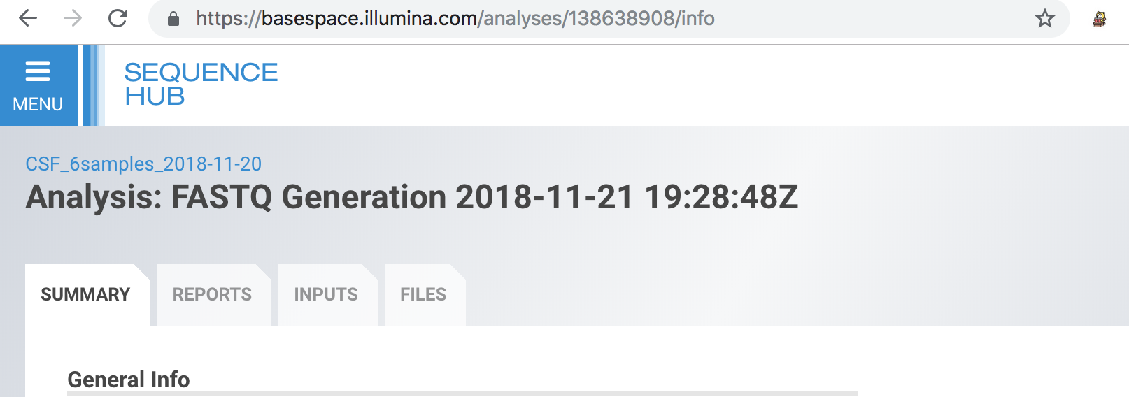

FASTQ Generation app session ID: https://basespace.illumina.com/analyses/138638908/info (App session ID is 138638908)  
  
**Step 2: Create a text file with the list of FASTQ datasets**

Access Sharcnet:

$ ssh smkeller@orca.computecanada.ca

$ cd /work/def-smkeller/

Example below using the Project and app sessions IDs from CSF_6samples_2018-11-20:

$ bs list datasets --project-id=105351261 -F Id -F AppSession.Id | grep $138638908 | cut -f -2 -d " " | cut -f 2 -d " " > download.txt

#Run22 MRD_Daisy_Sona_UntilRelapse

$ bs list datasets --project-id= 108650830 -F Id -F AppSession.Id | grep $144643634 | cut -f -2 -d " " | cut -f 2 -d " " > download.txt

#Run23_ JenkinsWylde

$ bs list datasets --project-id=113006986 -F Id -F AppSession.Id | grep $150865792 | cut -f -2 -d " " | cut -f 2 -d " " > download.txt

#Run24_CSF

$ bs list datasets --project-id= 116803689 -F Id -F AppSession.Id | grep $157252096 | cut -f -2 -d " " | cut -f 2 -d " " > download.txt

#Run25_JenkinsWylde_v2

$ bs list datasets --project-id= 119067155 -F Id -F AppSession.Id | grep $161027118 | cut -f -2 -d " " | cut -f 2 -d " " > download.txt

**Step 3: Transfer files from Basespace to Sharcnet**

Loop the dataset IDs from the text file through the bs download, the fastq files are in the ds.* folders

$ while read p; do bs download datasets -i $p -o $p; done < download.txt

**Appendix A**

**Installing bs & bs-cp**

Step 1: Go to Sharcnet:

HINT: @orca.sharcnet.ca has changed to @orca.computecanada.ca

$ ssh smkeller@orca.computecanada.ca

$ ssh smkeller@dtn.sharcnet.ca

https://docs.computecanada.ca/wiki/Orca

Step 2: go to your home/work directory to install followings:

cd /work/def-smkeller/

$ mkdir $HOME/bin

#command line interface

$ wget "https://api.bintray.com/content/basespace/BaseSpaceCLI-EarlyAccess-BIN/latest/\$latest/amd64-linux/bs?bt_package=latest" -O $HOME/bin/bs

$ chmod u+x $HOME/bin/bs

#copy function

$ wget https://api.bintray.com/content/basespace/BaseSpace-Copy-BIN/\$latest/linux/bscp?bt_package=develop -O $HOME/bin/bs-cp

$ chmod u+x $HOME/bin/bs-cp

$ bs auth

After this step, terminal will give you a URL link:



Copy the link and authenticate it via your browser, then:

:)