CS 4420 Assignment 06: Majority Voting with Pipes
Skyler Fokine

1. Process Interaction Diagram
The judge (parent process) creates N pipes and then forks N voters (child processes). Voter i writes its vote into pipe i only, and the judge reads one vote from every pipe each round before announcing the majority decision. After the last round, each voter exits and the judge calls wait() for all of them.
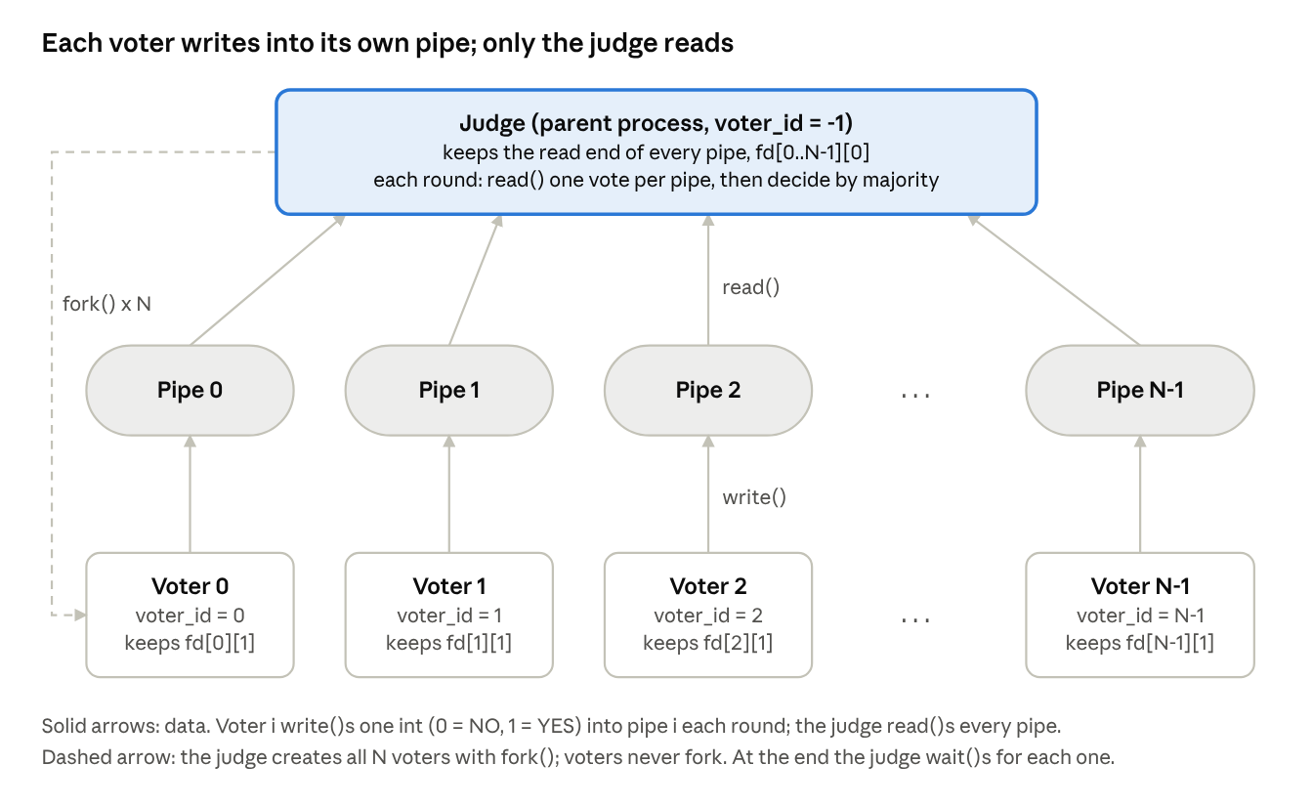
Figure 1. How the judge and voters communicate through pipes

2. How to Compile and Run
- Open a terminal in the folder containing majority_vote.c.
- Compile the program:
gcc -Wall -Wextra -o majority_vote majority_vote.c
- Run the program:
./majority_vote
- When prompted, enter the number of voters (3 or more) and the max number of rounds (1 or more), separated by a space, then press Enter. For example, 5 3 runs 5 voters for 3 rounds.

3. Screenshots
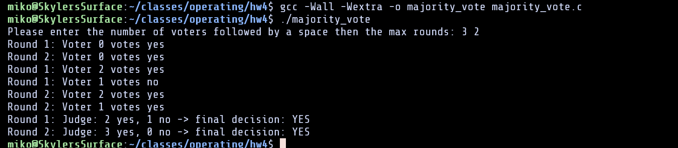
Figure 2. Compiling the program
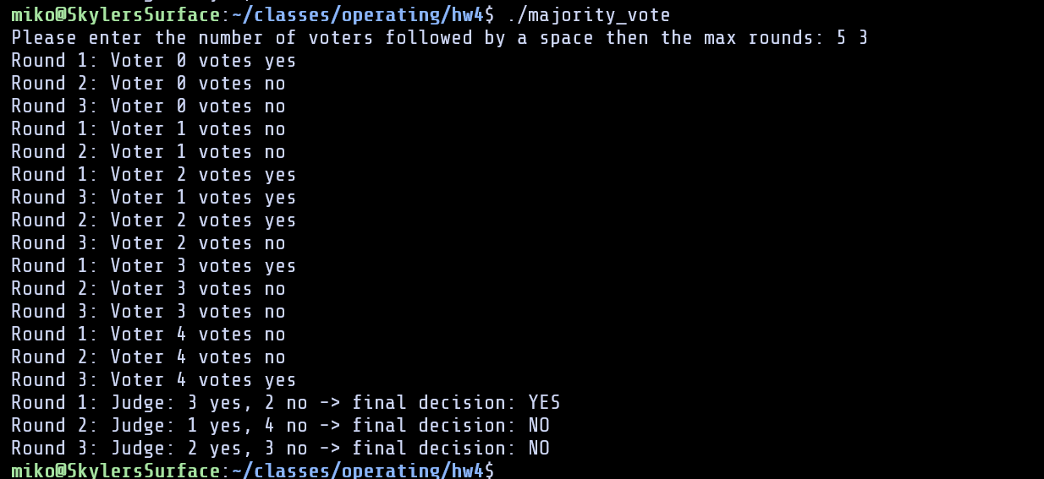
Figure 3. 5 voters, 3 rounds
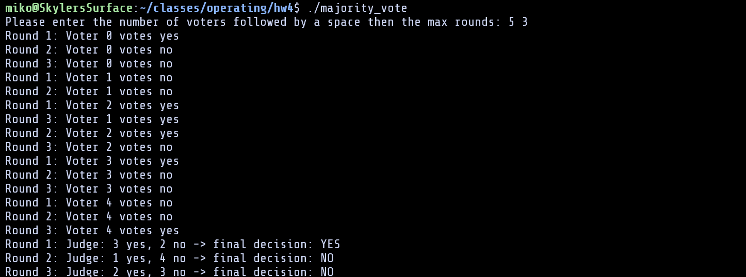
Figure 4. 4 voters, 3 rounds

