EDA: COVID-19 and International Travel Restrictions

Skyler Gray

12/7/2021

| **Continent** | **Number of Countries** | **n** |
| --- | --- | --- |
| Africa | 48 | 964 |
| Asia | 46 | 934 |
| Europe | 38 | 801 |
| North America | 17 | 335 |
| Oceania | 8 | 123 |
| South America | 12 | 246 |

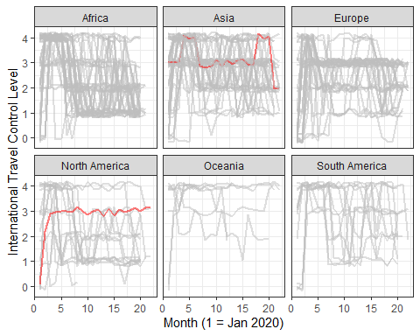

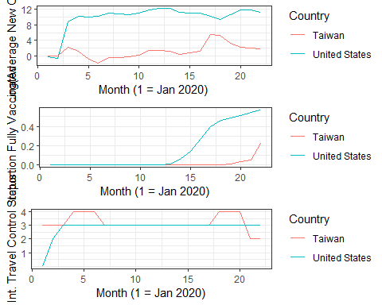

# Results

| **Coefficient** | **Estimate** | **Lower 95%** | **Upper 95%** |
| --- | --- | --- | --- |
| (Intercept) | 1.286 | 1.033 | 1.542 |
| Continent: Asia | 0.288 | 0.166 | 0.407 |
| Continent: Europe | -0.332 | -0.505 | -0.148 |
| Continent: North America | -0.303 | -0.453 | -0.161 |
| Continent: Oceania | 1.298 | 1.064 | 1.541 |
| Continent: South America | 0.258 | 0.083 | 0.437 |
| Reporting Full Vaccinations | 0.204 | 0.083 | 0.328 |
| Has New Cases | 0.673 | 0.441 | 0.898 |
| Log(Population Density) | -0.045 | -0.087 | -0.004 |
| Median Age | 0.068 | -0.022 | 0.157 |
| Log(GDP Per Capita) | 0.069 | -0.001 | 0.141 |
| Time (1 = Jan 2020) | -0.355 | -0.432 | -0.279 |
| Log(Average New Cases) | 0.267 | 0.184 | 0.351 |
| Proportion Fully Vaccinated | 0.100 | 0.054 | 0.147 |
| Time:Log(Average New Cases) | -0.217 | -0.333 | -0.101 |
| Delta3 | 1.130 | 1.047 | 1.215 |
| Delta4 | 1.807 | 1.719 | 1.898 |
| Delta5 | 2.782 | 2.684 | 2.876 |