Temperature Effects on Egg-to-Adult Viability of *Drosophila sp.*

Skyler Richmond

4/6/2021

BIOL 461

WVU TECH

**Abstract**

Extreme temperatures often have harsh effects on insects like the *Drosophila* species when it comes to reproduction processes and viability of offspring. This study analyses data obtained through dryad submissions of multiple papers to corroborate the effects that temperature has on the egg-to-adult viability or hatching of *Drosophila* species eggs. The relationship between the two variables is analyzed using an ANOVA, X-Y scatter plot, Pearson Correlation Test and more. Climate warming is a factor that many species including *Drosophila sp.* must learn to adapt to but the extent to which adaptation is needed can be dependent on many things. As a result of interference of temperature in reproduction, the *Drosophila* species must learn to adapt or migrate away from extreme temperatures to avoid future extinction and continue reproduction efforts.

**Introduction**

Extreme temperatures can affect not only survival of offspring but viability of eggs of the *Drosophila* species. Over time, evolution can mold the species to adapt to the extreme temperatures while allowing natural selection to eliminate species to create for better viability. Sometimes species choose to migrate out of an area when the temperatures become too much to withstand, which is more common in higher than lower temperatures. The adaptation and acclimation to temperatures varies for higher and lower temperatures with the *Drosophila* species experiencing much different selective pressures at different intervals that can impact the distribution and overall abundance of the species. As climates change, certain species are more equipped to withstand that change and can quickly adapt to meet the needs of their new environment.

Across the *Drosophila* species, there are differences in the preference of temperatures at which to perform reproduction altogether. Some species of *Drosophila* like *D. yakuba* prefer warmer temperatures and females across all the species prefer higher temperatures than males (Cooper et al. 2018). Overall, when it comes to extreme temperatures, the species experiences affects with fertility and survivorship of eggs (Singh and Prasad 2015). Egg viability is not dependent on one sex or the other more so but on the ability of both sexes to adapt to the temperature variations and produce eggs that are capable of hatching (Singh and Prasad 2015). Upper thermal limits have been shown to be positively related to optimal performance in many insects. As the Earth is constantly changing climatically with more increases in temperature than ever, adaptation and acclimation become vital.

Climate warming due to pollution, burning of fossil fuels, and countless other sources will require the *Drosophila* species to make changes in thermoregulation and reproduction means in order to be able to mitigate the effects and survive. The exact extent of how much the *Drosophila* species can adapt to the ongoing climate change can be dependent on the environment they are reared in and the life stage they are in when exposed to the change in temperature (Heerwaarden et al. 2015). Tropical and subtropical species are closer to upper thermal limits making their adaptive capacity not as high as their temperate counterparts, thereby making them more vulnerable to the effects of climate change (Heerwaarden et al. 2015). The ability of the *Drosophila* species to reproduce eggs that have high egg-to-adult viability or capability of hatching in high temperatures like what can come with climate warming is the focus of this research.

**Material and Methods**

**Data and Temperature Calculations**

The data for this analysis came from the *Drosophila* species studied in many different experiments. Data was taken from the dryad article “Low evolutionary potential for egg-to-adult viability in *Drosophila melanogaster* at high temperatures'' testing the mean egg-to-adult viability in different thermal conditions with high quantified as 25.6 degrees Celsius, under low at 12.8 degrees Celsius, and benign at 24 degrees Celsius. More data was from the dryad article “Egg viability, mating frequency and male mating ability evolve in populations of *Drosophila melanogaste*r selected for resistance to cold shock” with the temperature quantified as 25 degrees Celsius selecting only the neither-shocked population. As well as from the dryad article “Local adaptation of reproductive performance during thermal stress” and from the dryad article “Maladaptive combination of traits contributes to the maintenance of a *Drosophila* hybrid zone”. Some data was taken from the dryad article “ Evidence for lower plasticity in CTMAX at warmer developmental temperatures'' and from the dryad article “Does local adaptation along a latitudinal cline shape plastic responses to combined thermal and nutritional stress?”. All the data was put together in the R Console using the rbind() function for further analysis (R Core Team 2020).

**X-Y Scatter Plot and Linear Regression Analysis**

An X-Y scatter plot was generated from the samples in the R Console (R Core Team 2020). The x-axis showed the percent hatching and the y-axis showed the temperature in degrees Celsius. From this plotted data, a line of best fit was found and linear regression analysis was performed to show the trend between eggs hatching and temperature.

**Pearson Correlation Test**

A Pearson correlation test was performed between the x-axis of eggs hatching and y-axis of temperature variables via the R Console with the package “ggpubr” and function cor() using a confidence interval of 95% (R Core Team 2020). This analysis was then plotted using the same package in the R Console with the correlation coefficient to show significance being below 0.30 (R Core Team 2020).

**Mean and Standard Deviation of Data Set**

The mean and standard deviation of the total eggs hatching was performed using the mean() and sd() functions in the R Console (R Core Team 2020). The results of these functions are shown in a table.

**ANOVA of Data Set**

An ANOVA of the data set was performed using the aov() function in the R Console and the results of this function are shown in a table (R Core Team 2020).

**Results**

**X-Y Scatter Plot**

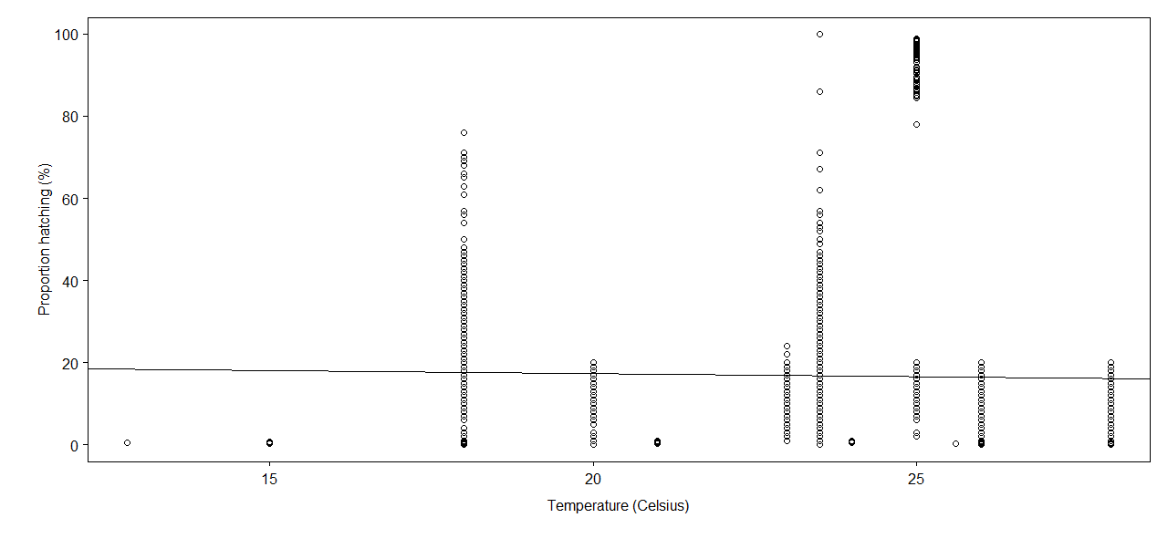

*Figure 1: X-Y Scatter Plot of proportion of hatching in percent compared to the temperate in degrees Celsius for all the data.*

The linear model for this X-Y scatter plot shows a multiple R2  value of 0.1% and an adjusted R2 value of 0.05% and a p-value of 0.13.

**Pearson Correlation Test**

**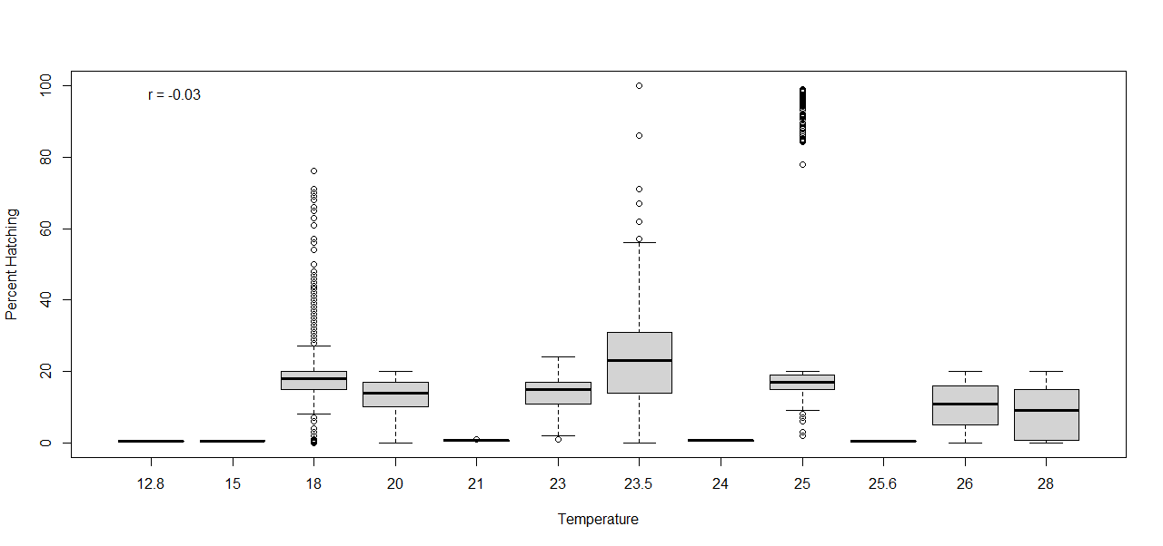***Figure 2: Pearson Correlation Test between the percent of eggs hatching and the temperature in degrees Celsius for all the data with a confidence interval of 95%.*

The calculated correlation value was -0.03 with a p-value of 0.13.

**Mean and Standard Deviation**

|  |  |  |
| --- | --- | --- |
|  | **Mean** | **Standard Deviation** |
| **Egg-to-Adult Viability** | 16.95% | 15.87% |

*Table 1: Mean and standard deviation of the egg-to-adult viability for all the data.*

**ANOVA**

|  |  |  |
| --- | --- | --- |
|  | **Percent Hatching** | **Residuals** |
| **Sum of Squares** | 29.32 | 28109.43 |
| **Degrees of Freedom** | 1 | 2244 |
| **Residual Standard Error** | 3.54 |  |

*Table 2: ANOVA for the egg-to-adult viability in respect to the temperature in degrees Celsius for all the data.*

**Discussion**

The prevalence of extreme heat events and climate warming has been increasing over time, making the need to be able to adapt and survive in these conditions a necessity. The *Drosophila* species egg-to-adult viability showed differentiation at low and high temperatures. The line of best fit of the scatter plot demonstrated that the egg-to-adult viability does not increase when the temperature increases with R2 values that are too low to be significant and a p-value of 0.13 which is higher than the 0.05 value of cutoff for significance (Figure 1). The linear models and X-Y scatter plot for this data demonstrates that there was not an increase in the egg-to-adult viability with increasing temperatures. The p-value in the Pearson Correlation Test was above the cut off of significance at 0.13 demonstrating there was no significance in the correlation between temperature and egg-to-adult viability and lots of variation in the boxplots at every temperature (Figure 2). The mean egg-to-adult viability across all the temperature ranges was at a low 16.95% with a standard deviation of 15.87% making a majority of the *Drosophila* offspring unviable across the various temperatures, indicating potentially weak zygotes (Table 1). The sum of squares of the ANOVA for the data shows there is variation in the data but not segregated toward any extremes and the standard error was only a low value of 3.54 (Table 2). The data combined for this research showed no direct correlation between an increase in temperature making the egg-to-adult viability increase. The analyses performed in this paper did not show that temperature was correlated to egg-to-adult viability but that could be a results of combining multiple data sets that did not explore a large range of temperatures. The egg-to-adult viability did not increase with temperatures that can come from climate warming which indicates a concern for the future of the species. Furthermore, temperature has been found to be a significant factor in many other studies.

Thermal stress is often an issue that species must deal with in nature and can be a source of evolutionary pressure. The *Drosophila* species must perform local adaptations in order to avoid extinction in the current ever-changing climate for any chance at survival (Porcelli et al. 2017). The effect that temperature has on reproduction efforts of the *Drosophila* species can be far surpassing egg-to-adult viability making it an area in need of research considering the ever evident effects climate warming. Different species within *Drosophila* appear to have different preferences for temperatures as well as different levels in ability to adapt to high temperatures (Cooper et al. 2017). Studies find that temperate species of *Drosophila* were the most able to form a plastic response to changes in temperature and thrive in low and high temperatures (Kellerman and Sgro 2018). The abundance and distribution of the *Drosophila* species will be dependent on how well they can fare in extreme temperatures that come with climate change. The research included demonstrated that *Drosophila* species ability to evolve to continue to reproduce in changing environmental temperature is not accurately determined based just on the temperature effect on egg-to-adult viability alone indicating the need for further research in this area.

**References**

Chakraborty, A., Sgrò, C.M. & Mirth, C.K. 2020. Does local adaptation along a latitudinal cline shape plastic responses to combined thermal and nutritional stress?. Evolution 74: 2073–2087.

Cooper, B.S., Sedghifar, A., Nash, W.T., Comeault, A.A. & Matute, D.R. 2018. A Maladaptive combination of traits contributes to the maintenance of a *Drosophila* hybrid zone. Current Biology 28: 2940-2947.e6.

Heerwaarden, B. van, Malmberg, M. & Sgrò, C.M. 2016. Increases in the evolutionary potential of upper thermal limits under warmer temperatures in two rainforest Drosophila species. *Evolution* 70: 456–464.

Kellermann, V. & Sgrò, C.M. 2018. Evidence for lower plasticity in CTMAX at warmer developmental temperatures. J Evol Biol 31: 1300–1312.

Kristensen, T.N., Overgaard, J., Lassen, J., Hoffmann, A.A. & Sgrò, C. 2015. Low evolutionary potential for egg-to-adult viability in *Drosophila melanogaster* at high temperatures. *Evolution* 69: 803–814.

Porcelli, D., Gaston, K.J., Butlin, R.K. & Snook, R.R. 2017. Local adaptation of reproductive performance during thermal stress. *J Evol Biol* 30: 422–429.

R Core Team. 2020. R: A language and environment for statistical computing. *R Foundation for Statistical Computing.*

Singh, K., Kochar, E. & Prasad, N.G. 2015. Egg viability, mating frequency and male mating ability evolve in populations of *Drosophila melanogaster* selected for resistance to cold shock. *PLOS ONE* 10: e0129992. Public Library of Science.