EECS 3241: Project 1

Skyler Layne (212166906, cse23170)

1 February 2016

Problem 1

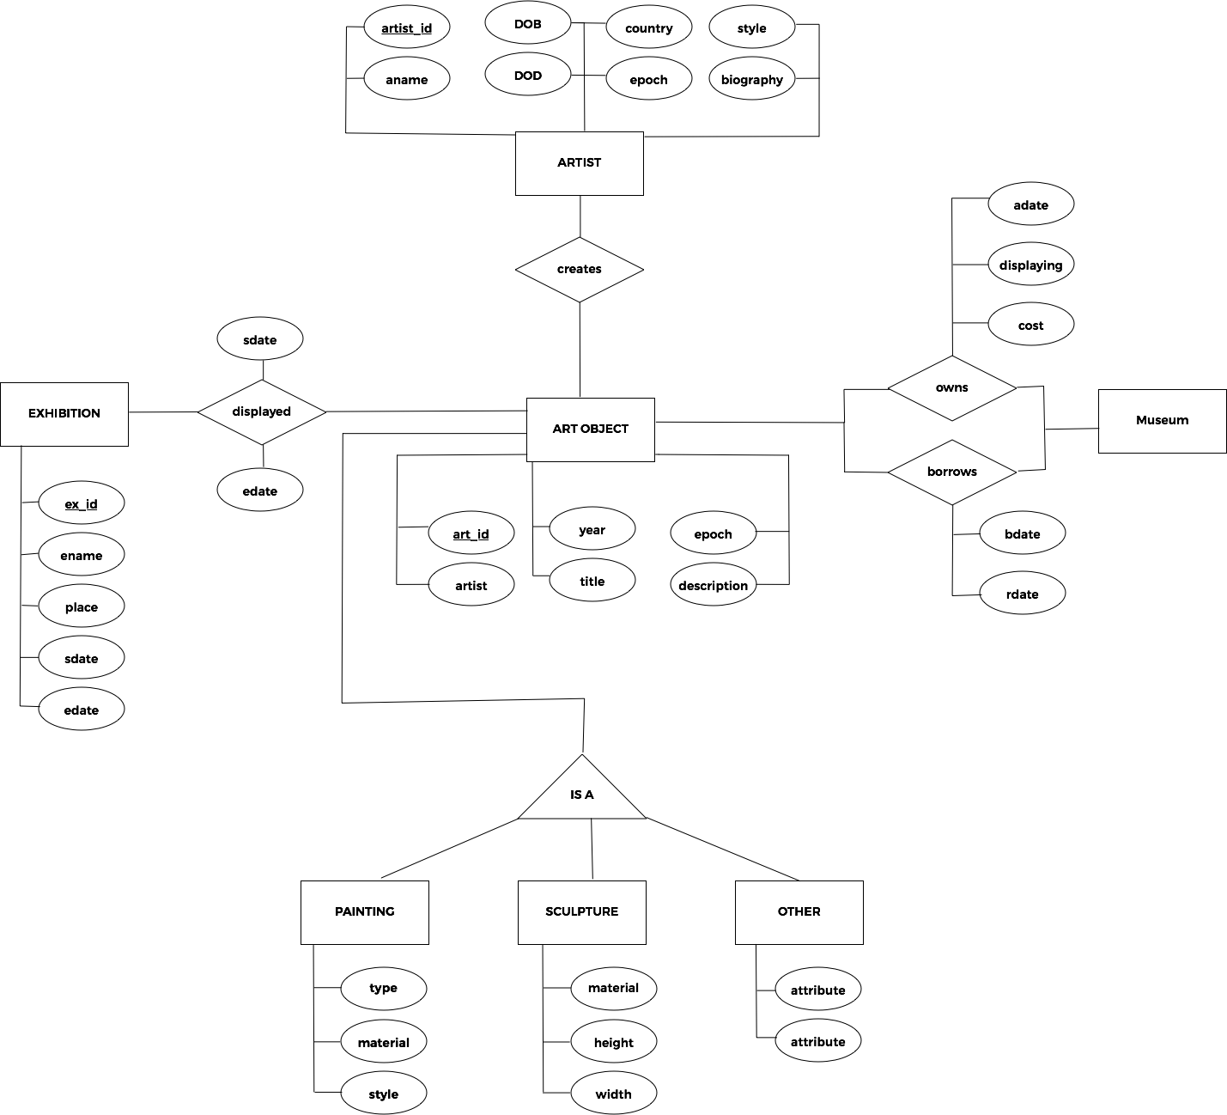

Problem 2

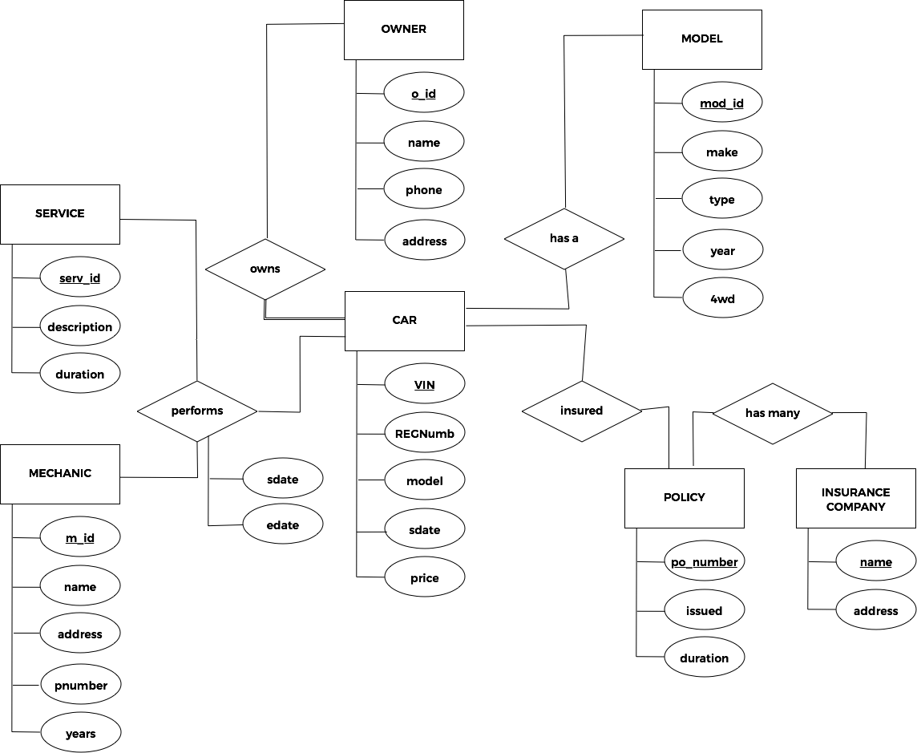

Problem 3

SYSCAT.COLUMNS

DB20000I The UPDATE COMMAND OPTIONS command completed successfully.

describe select * from SYSCAT.COLUMNS

Column Information

Number of columns: 56

Name Data type Schema Name

SQL type Type length Column name length Lob length schema length Data type name length

-------------------- ----------- ------------------------------ ------ ---------- --------- ------ ------------------ --------

448 VARCHAR 128 TABSCHEMA 9 0 SYSIBM 6 VARCHAR 7

448 VARCHAR 128 TABNAME 7 0 SYSIBM 6 VARCHAR 7

448 VARCHAR 128 COLNAME 7 0 SYSIBM 6 VARCHAR 7

500 SMALLINT 2 COLNO 5 0 SYSIBM 6 SMALLINT 8

448 VARCHAR 128 TYPESCHEMA 10 0 SYSIBM 6 VARCHAR 7

448 VARCHAR 128 TYPENAME 8 0 SYSIBM 6 VARCHAR 7

496 INTEGER 4 LENGTH 6 0 SYSIBM 6 INTEGER 7

500 SMALLINT 2 SCALE 5 0 SYSIBM 6 SMALLINT 8

449 VARCHAR 11 TYPESTRINGUNITS 15 0 SYSIBM 6 VARCHAR 7

497 INTEGER 4 STRINGUNITSLENGTH 17 0 SYSIBM 6 INTEGER 7

409 CLOB 0 DEFAULT 7 65536 SYSIBM 6 CLOB 4

452 CHARACTER 1 NULLS 5 0 SYSIBM 6 CHARACTER 9

500 SMALLINT 2 CODEPAGE 8 0 SYSIBM 6 SMALLINT 8

449 VARCHAR 128 COLLATIONSCHEMA 15 0 SYSIBM 6 VARCHAR 7

449 VARCHAR 128 COLLATIONNAME 13 0 SYSIBM 6 VARCHAR 7

452 CHARACTER 1 LOGGED 6 0 SYSIBM 6 CHARACTER 9

452 CHARACTER 1 COMPACT 7 0 SYSIBM 6 CHARACTER 9

492 BIGINT 8 COLCARD 7 0 SYSIBM 6 BIGINT 6

449 VARCHAR 254 HIGH2KEY 8 0 SYSIBM 6 VARCHAR 7

449 VARCHAR 254 LOW2KEY 7 0 SYSIBM 6 VARCHAR 7

496 INTEGER 4 AVGCOLLEN 9 0 SYSIBM 6 INTEGER 7

501 SMALLINT 2 KEYSEQ 6 0 SYSIBM 6 SMALLINT 8

501 SMALLINT 2 PARTKEYSEQ 10 0 SYSIBM 6 SMALLINT 8

500 SMALLINT 2 NQUANTILES 10 0 SYSIBM 6 SMALLINT 8

500 SMALLINT 2 NMOSTFREQ 9 0 SYSIBM 6 SMALLINT 8

492 BIGINT 8 NUMNULLS 8 0 SYSIBM 6 BIGINT 6

449 VARCHAR 128 TARGET_TYPESCHEMA 17 0 SYSIBM 6 VARCHAR 7

449 VARCHAR 128 TARGET_TYPENAME 15 0 SYSIBM 6 VARCHAR 7

449 VARCHAR 128 SCOPE_TABSCHEMA 15 0 SYSIBM 6 VARCHAR 7

449 VARCHAR 128 SCOPE_TABNAME 13 0 SYSIBM 6 VARCHAR 7

449 VARCHAR 128 SOURCE_TABSCHEMA 16 0 SYSIBM 6 VARCHAR 7

449 VARCHAR 128 SOURCE_TABNAME 14 0 SYSIBM 6 VARCHAR 7

453 CHARACTER 10 DL_FEATURES 11 0 SYSIBM 6 CHARACTER 9

453 CHARACTER 8 SPECIAL_PROPS 13 0 SYSIBM 6 CHARACTER 9

452 CHARACTER 1 HIDDEN 6 0 SYSIBM 6 CHARACTER 9

496 INTEGER 4 INLINE_LENGTH 13 0 SYSIBM 6 INTEGER 7

500 SMALLINT 2 PCTINLINED 10 0 SYSIBM 6 SMALLINT 8

452 CHARACTER 1 IDENTITY 8 0 SYSIBM 6 CHARACTER 9

452 CHARACTER 1 ROWCHANGETIMESTAMP 18 0 SYSIBM 6 CHARACTER 9

452 CHARACTER 1 GENERATED 9 0 SYSIBM 6 CHARACTER 9

409 CLOB 0 TEXT 4 2097154 SYSIBM 6 CLOB 4

452 CHARACTER 1 COMPRESS 8 0 SYSIBM 6 CHARACTER 9

481 DOUBLE 8 AVGDISTINCTPERPAGE 18 0 SYSIBM 6 DOUBLE 6

481 DOUBLE 8 PAGEVARIANCERATIO 17 0 SYSIBM 6 DOUBLE 6

500 SMALLINT 2 SUB_COUNT 9 0 SYSIBM 6 SMALLINT 8

500 SMALLINT 2 SUB_DELIM_LENGTH 16 0 SYSIBM 6 SMALLINT 8

496 INTEGER 4 AVGCOLLENCHAR 13 0 SYSIBM 6 INTEGER 7

449 VARCHAR 254 IMPLICITVALUE 13 0 SYSIBM 6 VARCHAR 7

449 VARCHAR 128 SECLABELNAME 12 0 SYSIBM 6 VARCHAR 7

452 CHARACTER 1 ROWBEGIN 8 0 SYSIBM 6 CHARACTER 9

452 CHARACTER 1 ROWEND 6 0 SYSIBM 6 CHARACTER 9

452 CHARACTER 1 TRANSACTIONSTARTID 18 0 SYSIBM 6 CHARACTER 9

500 SMALLINT 2 PCTENCODED 10 0 SYSIBM 6 SMALLINT 8

449 VARCHAR 128 QUALIFIER 9 0 SYSIBM 6 VARCHAR 7

409 CLOB 0 FUNC_PATH 9 2048 SYSIBM 6 CLOB 4

449 VARCHAR 254 REMARKS 7 0 SYSIBM 6 VARCHAR 7

quit

DB20000I The QUIT command completed successfully.

Database Partition Groups

“A database partition group is a set of one or more database partitions defined as belonging to a database. When you want to create tables for the database, you first create the database partition group where the table spaces will be stored, then you create the table space where the tables will be stored.”1

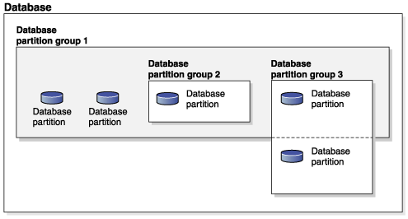

Figure 1. Database partition groups in a database1

References:

[1] https://www-01.ibm.com/support/knowledgecenter/SSEPGG_9.7.0/com.ibm.db2.luw.admin.partition.doc/doc/c0004888.html