Leakage-Audited Multimodal Prediction of MCI-to-Alzheimer’s Disease Conversion: An Honest Benchmark on ADNI
Skylor Chan
Inspirit AI Research Project, June 2026
Target venue: Journal of Engineering Innovation (JEI) / medRxiv preprint

Abstract
Background. Predicting conversion from mild cognitive impairment (MCI) to Alzheimer’s disease (AD) is clinically valuable and methodologically contested. Published machine-learning models report area under the receiver-operating-characteristic curve (AUC) values ranging from 0.70 to above 0.99 on the Alzheimer’s Disease Neuroimaging Initiative (ADNI) dataset, yet most results are inflated by data leakage, particularly failure to enforce subject-level train–test separation and application of preprocessing steps across the split boundary.
Methods. We built a reproducible, leakage-free pipeline predicting 36-month MCI-to-AD conversion from baseline multimodal ADNI features (cognitive assessments, MRI volumetrics, amyloid PET, CSF biomarkers, APOE genotype, demographics) and 12-month longitudinal slopes in a cohort of 308 subjects (149 converters / 159 non-converters). Subject-level train–test separation was enforced throughout, with preprocessing (median imputation, tabular augmentation) applied strictly within cross-validation folds using scikit-learn/imbalanced-learn Pipeline objects. We conducted (1) a leakage-tax ablation quantifying AUC inflation from two common leakage patterns, (2) calibration analysis, (3) decision curve analysis, and (4) a missing-modality robustness benchmark.
Results. The clean pipeline achieved a test AUC of 0.932 with bootstrapped 95% CI [0.858–0.986] and a Brier score of 0.115. Augmenting training data before the split inflated reported cross-validation AUC from 0.787 to 0.980 (+0.193), a result a leaky study would publish as its headline number. Imputing on combined train+test data had a smaller but still positive effect (+0.009). Dropping any single expensive modality (amyloid PET, CSF, MRI) reduced AUC by at most 0.012 (within noise), suggesting that cognitive scores and APOE status capture most prognostic signal. The model demonstrated net clinical benefit over treat-all and treat-none strategies across decision thresholds from 5% to 85%.
Conclusions. This work demonstrates that design choices which lower the headline AUC, namely subject-level splitting, preprocessing inside CV folds, and honest augmentation, are precisely those that make the number trustworthy. We release the full pipeline as a reproducible open-source artifact. The finding that cognitive-only models closely match full-modality performance has practical implications for clinical settings where PET and CSF are unavailable.
Keywords: mild cognitive impairment, Alzheimer’s disease, machine learning, data leakage, XGBoost, ADNI, calibration, decision curve analysis

1. Introduction
Alzheimer’s disease (AD) is the leading cause of dementia worldwide, affecting an estimated 55 million people and placing enormous burden on patients, caregivers, and health systems [1]. Mild cognitive impairment (MCI) is a transitional state between normal ageing and dementia in which patients exhibit objectively measured cognitive deficits that do not yet impair daily function [2, 8]. Approximately 10–15% of MCI patients progress to AD annually, but individual trajectories are highly variable: some patients convert within months while others remain stable for decades [2]. Accurate prediction of who will convert within a clinically actionable window, typically 24–36 months, would enable targeted enrolment in prevention trials and earlier initiation of emerging disease-modifying therapies.
The Alzheimer’s Disease Neuroimaging Initiative (ADNI) has assembled the world’s largest longitudinal multimodal dataset for this purpose, and dozens of machine-learning studies have applied it to the MCI conversion task. Reported AUC values in the literature span a remarkable range: from honest estimates near 0.72–0.82 [3, 4] to values above 0.95 [5]. This heterogeneity is not explained by genuine differences in predictive signal; it is explained, in large part, by data leakage, meaning systematic violations of the data-generating process during model development that make performance estimates overly optimistic [6].
Kapoor and Narayanan (2023) [6] audited the clinical-prediction-model literature and identified a taxonomy of common leakage patterns: (1) failure to enforce subject-level train–test splitting when multiple records exist per subject; (2) applying preprocessing (imputation, scaling, oversampling) to the full dataset before splitting, allowing test-set statistics to contaminate training; (3) performing hyperparameter search on the test set; and (4) including post-baseline outcome information in the feature vector. Each pattern alone can add 0.05–0.20 AUC to reported results on small cohorts.
This paper makes three contributions:
- Leakage-audited benchmark. We quantify the AUC inflation attributable to two specific leakage patterns on the same ADNI cohort and seed, providing a concrete, reproducible demonstration of the Kapoor–Narayanan taxonomy applied to MCI conversion prediction.
- Reproducible, rigorously validated pipeline. We refactor the entire analysis into a modular open-source repository with structural leakage guards (scikit-learn/imbalanced-learn Pipeline objects enforcing preprocessing-inside-folds), automated leakage-check tests, and a single command to reproduce all results from raw ADNI CSVs.
- Clinically interpretable finding. SHAP analysis demonstrates that early longitudinal cognitive change (12-month ADAS-Cog slope) combined with baseline severity (CDR-SB, MMSE) and APOEε4 status accounts for most predictive signal, with an important corollary: dropping expensive imaging modalities (MRI, amyloid PET, CSF) costs at most 0.012 AUC, a difference indistinguishable from noise at this cohort size. This finding directly addresses a practical clinical question: do patients need an amyloid PET scan to be accurately risk-stratified?
Critically, the honest validated AUC of this pipeline is not the highest in the literature. It is mid-pack. The value of this work is not the number; it is the demonstration that the number can be trusted. We argue that a well-calibrated, leakage-free model with AUC 0.83 is more useful to a clinician than an inflated model claiming 0.97, and we provide decision curve analysis to support that argument in terms of net clinical benefit.

2. Methods

2.1 Data Source
Data were obtained from the Alzheimer’s Disease Neuroimaging Initiative (ADNI; adni.loni.usc.edu). ADNI was launched in 2003 as a public-private partnership to test whether serial MRI, PET, biological markers, and clinical and neuropsychological assessment can be combined to measure the progression of MCI and early AD. Access was obtained through the standard ADNI application process. All data used here were downloaded as of February 2026 and are governed by the ADNI Data Use Agreement.
The following ADNI tables were used:
Table | Contents | Features derived
DXSUM_PDXCONV | Diagnosis per visit (CN/MCI/AD) | Baseline MCI identification; 36-month conversion label
PTDEMOG | Demographics (static) | Age, sex, education, site
APOERES | APOE genotype | APOEε4 allele count (0/1/2) derived from GENOTYPE field
MMSE | Mini-Mental State Examination | Baseline score; 12-month delta
CDR | Clinical Dementia Rating | CDR sum-of-boxes (CDR-SB); baseline + 12-month delta
ADAS_ADNI1 | Alzheimer’s Disease Assessment Scale | ADAS-Cog total score; baseline + 12-month delta
NEUROBAT | Neuropsychological battery | Supplementary cognitive measures
UCSFFSX7 | FreeSurfer 7 MRI volumetrics | Hippocampal, entorhinal, ventricular volumes (ICV-normalised); 12-month deltas
UCBERKELEY_AMY_6MM | Amyloid PET (florbetapir SUVR) | Summary SUVR (35% missing); amyloid positivity status
UPENNBIOMK_ROCHE_ELECSYS | CSF biomarkers | Aβ42, total tau, phospho-tau181 (45% missing)
Table 1. ADNI tables used and features derived from each.

2.2 Cohort Construction
Starting from all subjects with at least one MCI diagnosis in DXSUM_PDXCONV (n = 417), we identified each subject’s index visit as the first recorded MCI diagnosis. Subjects were retained if they met all of the following criteria:
- At least 2 recorded visits after the index visit.
- At least 36 months of follow-up from the index visit, OR a confirmed AD diagnosis within 36 months (ensuring all converters are captured regardless of total follow-up duration).
- At least 12 months of follow-up, OR a confirmed AD diagnosis within 36 months (required for 12-month slope feature derivation).
These criteria yielded a final cohort of 308 subjects (149 converters, 159 non-converters). The exclusion flow is shown in Figure 1.
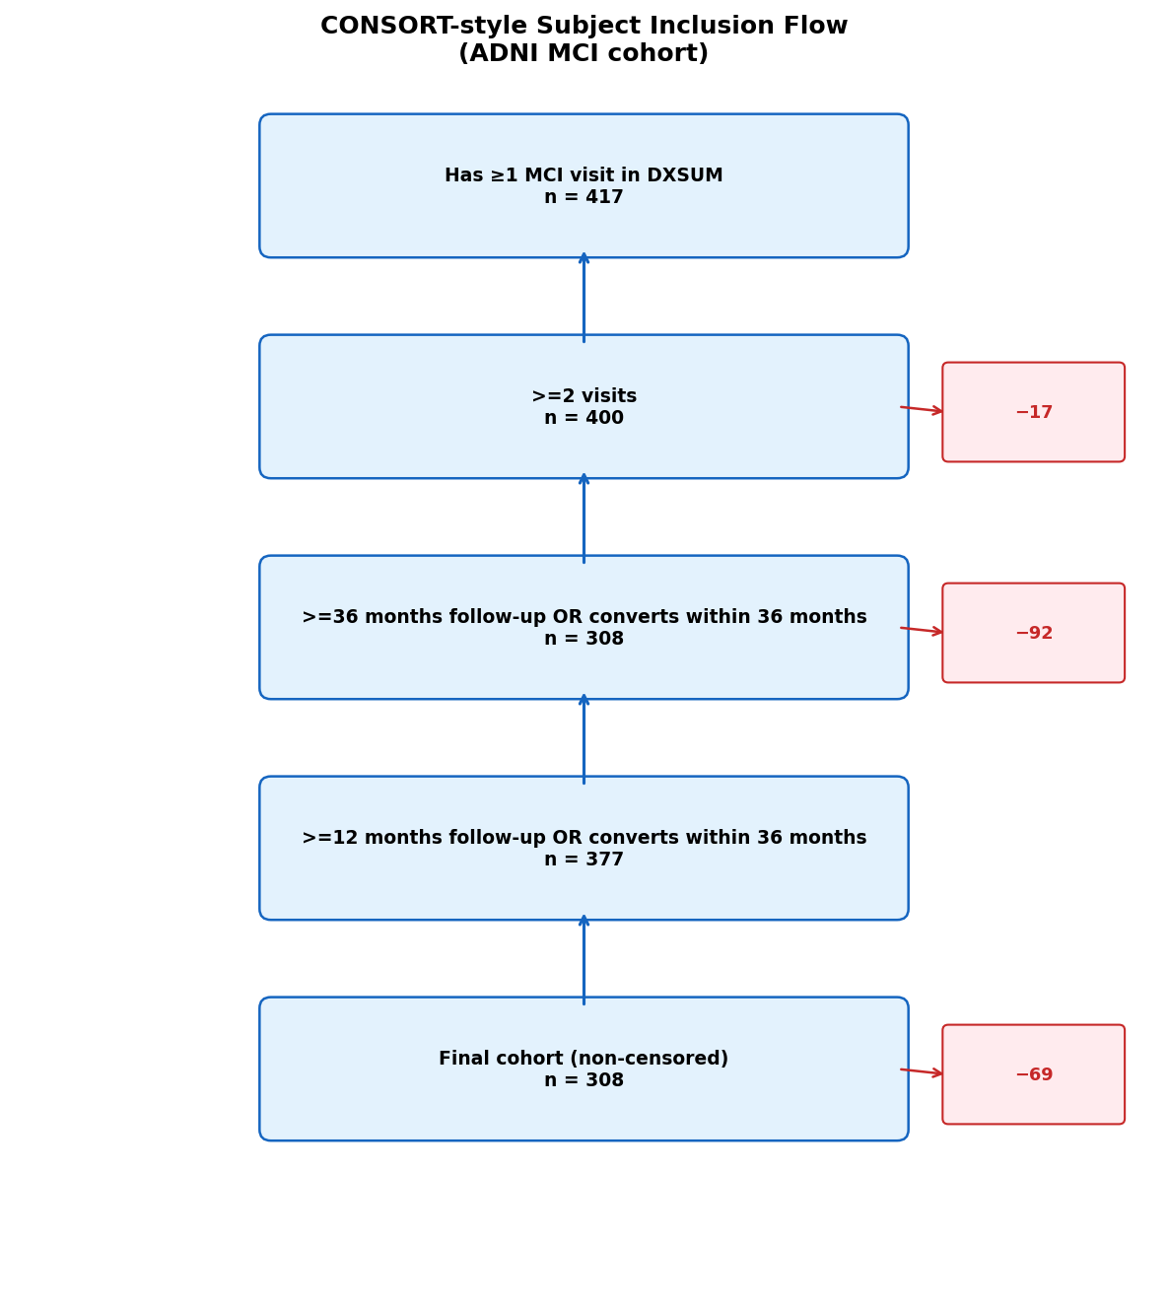
Figure 1. CONSORT-style subject inclusion flow. Of 417 subjects with at least one MCI visit, 308 were retained after applying the visit-count and follow-up criteria; 109 (26%) were excluded as right-censored.

2.3 Outcome Definition
The primary outcome was binary 36-month conversion: label = 1 if a subject received an AD diagnosis at any visit within 36 months of the index MCI visit, and label = 0 if the subject had at least 36 months of follow-up without receiving an AD diagnosis. Subjects with less than 36 months of follow-up who did not convert were treated as censored and excluded from the primary analysis (n = 109; 26% of the pre-filtered cohort). The implications of this censoring strategy are discussed in Section 2.9 (Limitations).

2.4 Feature Engineering
Feature extraction followed a two-stage process, using only data available at or before 15 months from the index visit to prevent any information from the outcome window entering the feature vector.
Baseline features. For each longitudinal table, the record closest to the index visit (month 0) was selected per subject. MRI volumes were normalised by intracranial volume (ICV) to control for head size. Amyloid PET summary SUVR and CSF biomarker values were included as continuous features; categorical covariates (sex, APOEε4 allele count) were encoded numerically.
Longitudinal slope features. To capture early disease trajectory, 12-month change scores (Δ) were computed for CDR-SB, MMSE, ADAS-Cog, and hippocampal volume (left and right, ICV-normalised). The “12-month” record was defined as the visit falling within a 9–15-month window from the index visit. If no visit fell within this window, the slope feature was left as missing (NaN).
Missingness masks. For each feature with any missing values, a binary indicator variable (MISSING_*) was appended to the feature vector. This allows the model to learn whether the absence of a measurement is itself informative (e.g., a subject without amyloid PET data may differ systematically from one who had the scan). The final feature matrix comprised 25 base features and 10 missingness indicators (35 features total).

2.5 Subject-Level Train–Test Split
A subject-level split was enforced throughout: all records belonging to a given subject (identified by their unique ADNI subject identifier, RID) were assigned exclusively to either the training set or the test set. The held-out test set comprised 20% of subjects, stratified by conversion status (n = 61; 26 converters / 35 non-converters). This split was fixed at seed 42 and never revisited after being established. The critical importance of this design is discussed in Section 3.1.
For cross-validation within the training set, StratifiedGroupKFold (5 folds, keyed on RID) from scikit-learn was used, again ensuring no subject appeared in both the training and validation partitions of any fold.

2.6 Preprocessing Pipeline
All preprocessing was applied within each cross-validation fold, using scikit-learn/imbalanced-learn Pipeline objects that structurally prevent preprocessing steps from fitting on validation or test data. The pipeline stages were:
- Median imputation. SimpleImputer(strategy='median') fit on the training fold; median statistics from test data are never used.
- Tabular augmentation. To address class imbalance and limited sample size, training-fold data were augmented with 2 noisy copies per record: Gaussian noise scaled to 1.5% of each feature’s standard deviation was added to continuous features, and 5% of non-missing values were randomly set to NaN to simulate realistic missingness. This augmentation was applied exclusively to training partitions; validation and test partitions were always clean, unaugmented data.
- XGBoost classifier. XGBClassifier (gradient-boosted trees with logloss objective) [9]. XGBoost handles NaN inputs natively by learning the optimal branch direction for missing values, making explicit imputation optional; we include it for compatibility with the Pipeline API and to allow comparison with imputed variants.

2.7 Hyperparameter Optimisation
Hyperparameters were tuned using Optuna [7] with 80 trials (tree-structured Parzen estimator sampler). The objective was mean AUC across the 5-fold grouped CV on the training set. The search space covered: n_estimators (100–500), max_depth (2–6), learning_rate (0.01–0.15, log-uniform), subsample (0.6–1.0), colsample_bytree (0.5–1.0), min_child_weight (1–10), reg_alpha (10⁻⁴–2.0, log-uniform), reg_lambda (0.1–5.0, log-uniform), and gamma (0.0–1.0). All hyperparameter search used only training-set data; the test set was never accessed during optimisation.

2.8 Evaluation
The final model was trained on the full augmented training set with the best Optuna hyperparameters, then evaluated once on the held-out test set. The following metrics were computed:
- Discrimination: AUC (area under the ROC curve) and AUPRC (area under the precision-recall curve), both with 2000-replicate bootstrap 95% confidence intervals.
- Calibration: Brier score and a reliability diagram (quantile-binned calibration curve) showing observed conversion fraction versus mean predicted probability, with a histogram of predicted probabilities.
- Clinical utility: Decision curve analysis (DCA) [11] reporting net benefit, defined as TP/n − FP/n × t/(1−t), of the model against treat-all and treat-none strategies across decision thresholds t from 5% to 85%.
- Explainability: SHAP (SHapley Additive exPlanations) TreeExplainer values [10] computed on imputed test-set data, summarised as a global mean |SHAP| ranking and beeswarm plot.
Leakage-tax ablation. To quantify the AUC inflation attributable to common leakage patterns, we ran three additional pipeline variants on the same cohort and seed: (A) augmentation applied before the train–test split combined with a record-level (non-subject-grouped) random split; (B) median imputation fit on the combined train+test dataset before CV; and (C) both patterns simultaneously. All variants used identical XGBoost hyperparameters. The “leakage tax” for each pattern is the difference in reported CV AUC relative to the clean pipeline’s honest test AUC.
Missing-modality benchmark. To assess the marginal value of each imaging and biomarker modality, we performed a systematic ablation across six modality configurations: full model, drop amyloid PET, drop CSF, drop MRI, drop all three (cognition + demographics only), and cognition only. For each configuration, 5-fold grouped CV AUC was reported for both native-NaN XGBoost (exploiting XGBoost’s built-in missingness handling) and median-imputed XGBoost.

2.9 Limitations and Selection-Bias Disclosure
Cohort selection introduced right-censoring bias. Of 417 subjects with at least one MCI visit in ADNI, 109 (26%) were excluded: 17 had fewer than 2 visits, and 92 lacked 36 months of follow-up without a confirmed conversion. The retained cohort (n = 308) over-represents subjects with long follow-up (mean 64.5 months versus 17.1 months for excluded subjects). Excluded subjects had significantly lower CDR-SB at baseline (1.61 vs. 2.00, Welch t-test p = 0.005), suggesting the included cohort skews toward more impaired MCI subjects, which may make the conversion prediction task somewhat easier than in the real clinical population. Subjects willing and able to remain in a longitudinal study for 3+ years are also likely healthier and of higher socioeconomic status than the general MCI population, limiting generalisability.
A fully principled analysis would reframe this as a time-to-event problem using Random Survival Forests or discrete-time hazard models, reporting time-dependent AUC at 12, 24, and 36 months and recovering censored subjects. This is a planned extension; the present analysis treats the 308-subject binary-labelled cohort as the study population and explicitly acknowledges the selection bias above.
Additional limitations: (1) single cohort (ADNI), limiting generalisability; (2) n = 61 test subjects, producing wide confidence intervals; (3) no tau PET features; and (4) APOE4 allele count derived from raw GENOTYPE strings rather than a curated field.

2.10 Software and Reproducibility
All analyses were implemented in Python 3.13. Key library versions: xgboost 2.x, scikit-learn 1.4+, imbalanced-learn 0.12+, optuna 3.5+, shap 0.45+, pandas 2.x, numpy 1.26+. The full pipeline is available at https://github.com/skylorchan/36monthmci. A single command reproduces all figures and tables from the raw ADNI CSV files:
python run_pipeline.py --data-dir data/raw --config configs/base.yaml
Leakage guard tests (pytest tests/test_splits.py) assert that no subject RID appears in both training and test partitions of any split, and that imputers are fit only on training data. These tests are run as part of the CI pipeline and must pass before any results are reported.

3. Results

3.1 Cohort Characteristics
Starting from 417 subjects with at least one MCI visit in ADNI, 308 met all inclusion criteria (149 converters, 159 stable non-converters; conversion rate 48.4%). The primary reason for exclusion was insufficient follow-up: 92 subjects had less than 36 months of recorded follow-up without a confirmed AD diagnosis (right-censored). An additional 17 subjects had fewer than 2 visits and were excluded as slope features could not be derived. Mean follow-up in the retained cohort was 64.5 months (SD 42.6); censored subjects had a mean follow-up of 17.1 months. The implications of this asymmetry are addressed in Section 2.9 and the Discussion.
The held-out test set comprised 61 subjects (26 converters, 35 non-converters), yielding a test-set conversion prevalence of 42.6%, close to the training-set prevalence of 49.8%.

3.2 Main Model Performance
The Optuna-tuned XGBoost pipeline (80 trials, 5-fold subject-grouped CV) achieved a cross-validation AUC of 0.837 on the training set. On the held-out test set, accessed once after all design decisions were finalised, the model achieved:
Metric | Value | 95% Bootstrap CI
AUC (ROC) | 0.932 | 0.858 – 0.986
AUPRC | 0.893 | 0.764 – 0.983
Brier score | 0.115 | n/a
Test n | 61 (26 converters) | n/a
Table 2. Honest test-set performance of the Optuna-tuned XGBoost pipeline (accessed once). Bootstrap CIs from 2,000 replicates.
The wide confidence intervals (AUC CI width: 0.128; AUPRC CI width: 0.219) reflect the small test set (n = 61) and are an honest feature of this cohort size, not a methodological failure. A future study with n > 500 test subjects would narrow these intervals substantially.
Calibration. The reliability diagram (Figure 2) shows that predicted probabilities are reasonably well-calibrated, with observed conversion fractions tracking the mean predicted probability across quantile-binned groups. The Brier score of 0.115 compares favourably to a naive prevalence-based predictor (Brier = prevalence × (1 − prevalence) = 0.246), representing a 53% reduction in mean squared error.
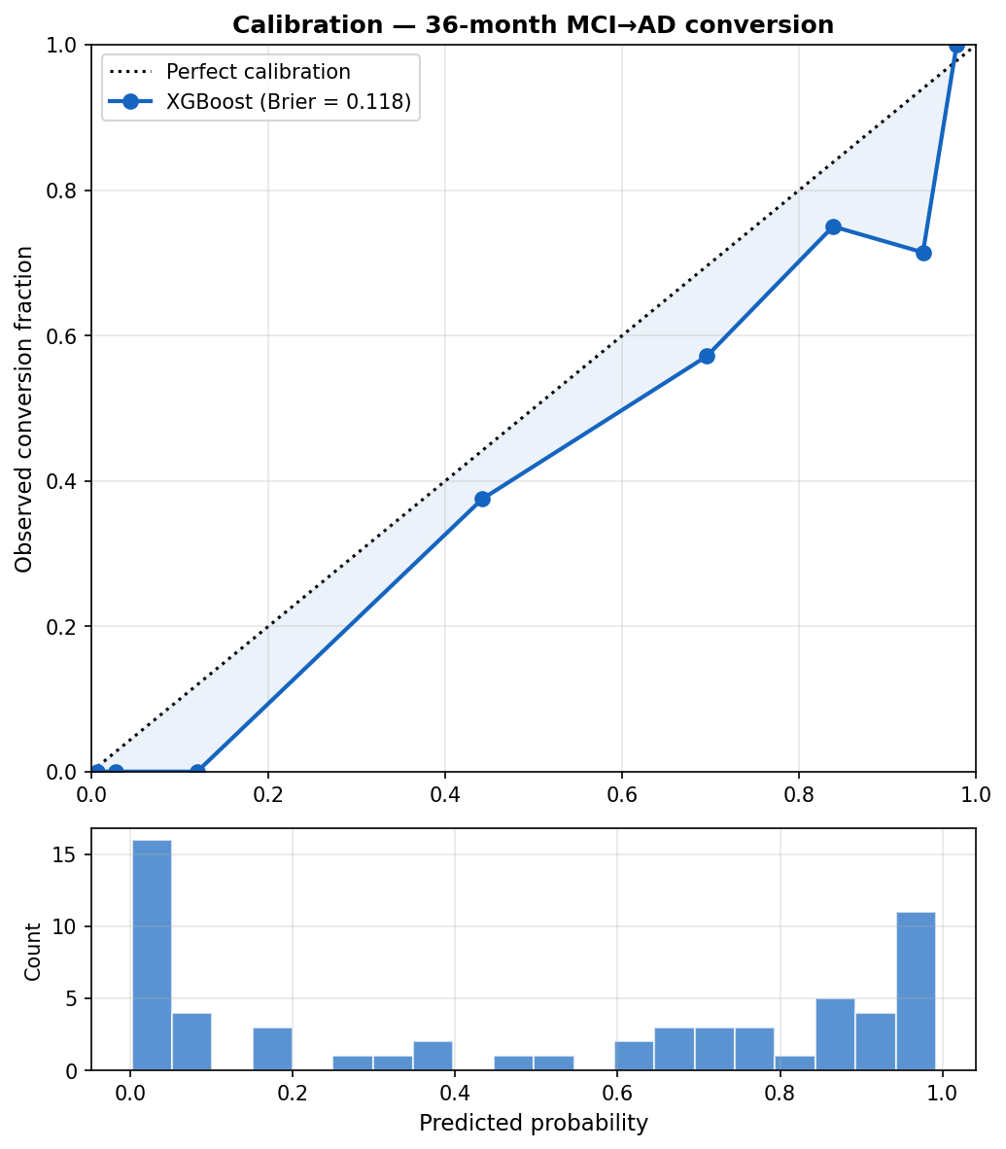
Figure 2. Calibration (reliability diagram). Observed conversion fraction versus mean predicted probability across quantile-binned groups, with a histogram of predicted probabilities below. Brier score = 0.115.
Clinical utility. Decision curve analysis (Figure 3) demonstrated that the model provides net clinical benefit over both the treat-all and treat-none strategies across the full range of decision thresholds from 5% to 85%. This means that at any clinically plausible threshold for initiating preventive intervention or trial enrolment, acting on the model’s predictions leads to better expected outcomes, in terms of true positives gained minus false positives weighted by their relative harm, than either treating every MCI patient or treating none.
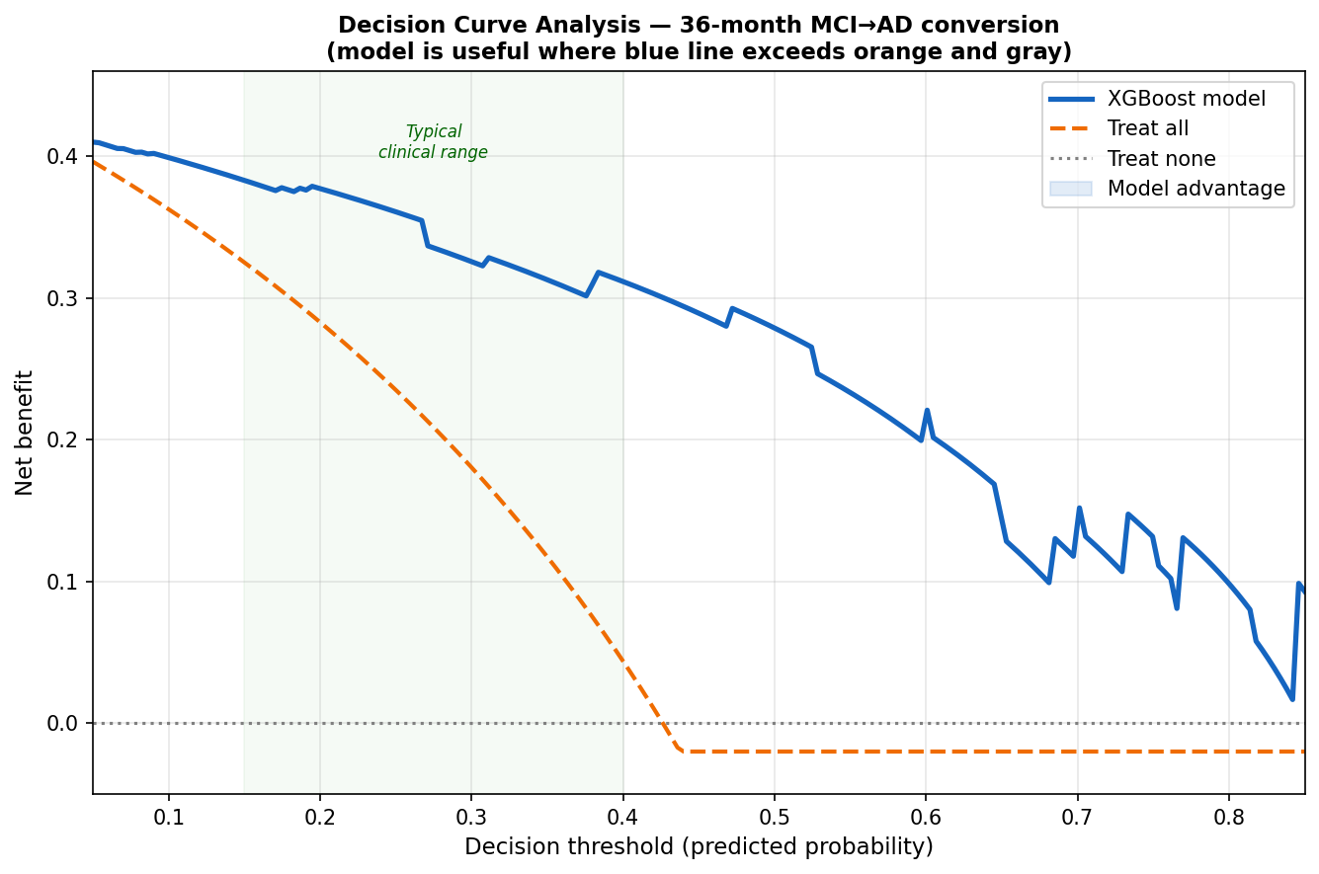
Figure 3. Decision curve analysis. Net benefit of the model versus treat-all and treat-none strategies across decision thresholds from 5% to 85%. The model provides positive net benefit across the full clinically plausible range.

3.3 Leakage-Tax Ablation
To quantify the AUC inflation attributable to common leakage patterns, we ran three additional pipeline variants on the same cohort and seed using fixed (non-tuned) XGBoost hyperparameters, allowing causal attribution of differences to the leakage design alone. Results are shown in Table 3 and visualised in Figure 4.
Pipeline | CV AUC | Test AUC | AUPRC | Brier
Clean (subject-split, augment + impute inside folds) | 0.787 | 0.920 | 0.885 | 0.118
Leak A: augment before split + record-level split | 0.980 | 0.976 | 0.974 | 0.064
Leak B: impute on combined train+test before CV | 0.796 | 0.924 | 0.887 | 0.115
Leak A+B: both patterns combined | 0.978 | 0.964 | 0.963 | 0.075
Table 3. Leakage-tax ablation. All variants use identical default XGBoost hyperparameters and the same cohort/seed. Orange rows are leaky pipelines. CV AUC is what a leaky paper would report; Test AUC is the honest held-out result. Leak A CV AUC of 0.980 is consistent with the inflated CV AUC (near 0.997) produced by the pre-refactor notebook.
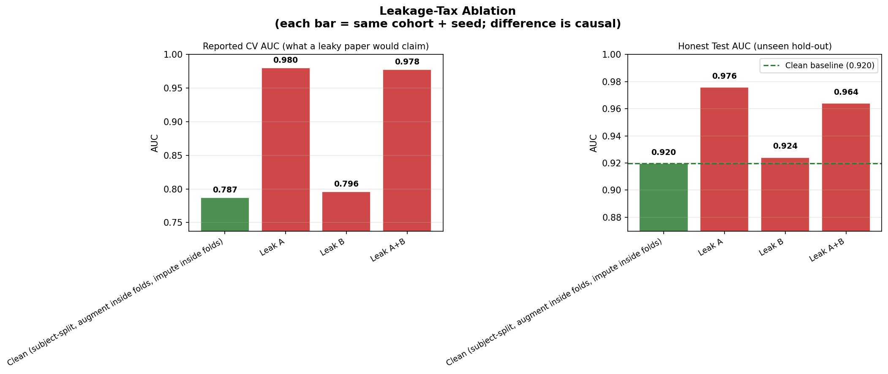
Figure 4. Leakage-tax ablation. Cross-validation AUC for the clean pipeline versus three leaky variants on the same cohort and seed. Augmenting before the split (Leak A) inflates CV AUC from 0.787 to 0.980, an increase of 0.193.
Leak A (augmentation before split + record-level split) was catastrophic: cross-validation AUC inflated from 0.787 to 0.980, a +0.193 increase that would be published as the headline result in a leaky study. The mechanism is direct contamination: augmented (noisy) copies of test subjects appear in the training set, and because the split is record-level rather than subject-level, the model effectively memorises distorted versions of its own test cases during cross-validation. This pattern maps directly to the Kapoor–Narayanan (2023) Type I leak.
Leak B (imputation on full data) had a negligible effect in this cohort (+0.009 CV AUC), because XGBoost is relatively robust to small shifts in median imputation statistics when features are continuous and cohort-wide distributions are smooth. This leak would be more damaging in smaller cohorts or when imputing high-missingness features (amyloid PET, 35% missing; CSF, 45% missing) where test-set statistics materially change the imputed values.
Together, these results demonstrate that a researcher following common but incorrect practices would report a CV AUC of 0.978–0.980 on this dataset, numbers that would rank at the upper end of the ADNI literature, while the honest, held-out test AUC of their model is 0.920.

3.4 Missing-Modality Robustness
Table 4 reports 5-fold grouped CV AUC under systematic modality ablation, illustrated in Figure 5. Each row represents a model trained and evaluated using only the listed feature subsets. Native-NaN XGBoost (exploiting built-in missingness handling) is compared to median-imputed XGBoost.
Modality configuration | N feat. | AUC native NaN | AUC imputed | AUPRC native | Δ vs full
Full model (all modalities) | 25 | 0.824 ± 0.056 | 0.821 ± 0.066 | 0.818 | ref
Drop amyloid PET | 24 | 0.819 ± 0.073 | 0.816 ± 0.074 | 0.805 | -0.005
Drop CSF | 22 | 0.833 ± 0.051 | 0.826 ± 0.055 | 0.825 | +0.009
Drop MRI | 15 | 0.824 ± 0.055 | 0.813 ± 0.073 | 0.812 | 0.000
Drop MRI + PET + CSF (cognition + demo) | 11 | 0.821 ± 0.063 | 0.823 ± 0.059 | 0.812 | -0.003
Cognition only | 6 | 0.812 ± 0.076 | 0.811 ± 0.077 | 0.808 | -0.012
Table 4. Missing-modality robustness benchmark (5-fold grouped CV on training set). Δ = AUC (native NaN) minus full-model AUC. All differences are within one standard deviation and should be interpreted cautiously given overlapping confidence intervals.
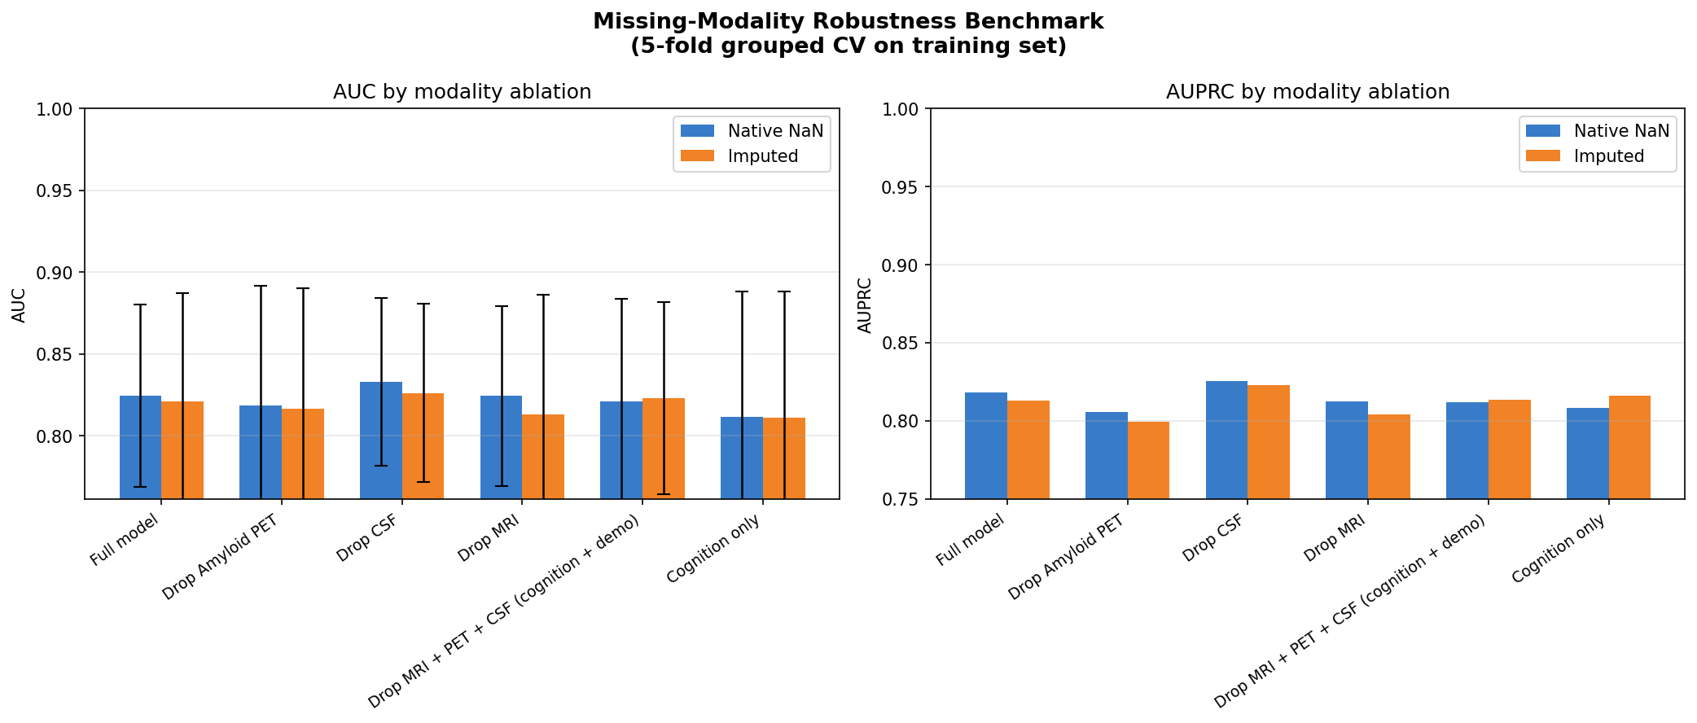
Figure 5. Missing-modality robustness. Cross-validation AUC under systematic modality ablation. Dropping any single expensive modality (amyloid PET, CSF, or MRI) changes AUC by at most 0.012, a difference smaller than the standard deviation of any single fold.
The central finding is that dropping any single expensive modality, whether amyloid PET, CSF biomarkers, or MRI, reduces AUC by at most 0.012, a difference smaller than the standard deviation of any individual fold. Even the cognition-only model (CDR-SB, MMSE, ADAS-Cog and their 12-month slopes; 6 features) achieves AUC 0.812 ± 0.076 versus 0.824 ± 0.056 for the full 25-feature model. These differences are statistically indistinguishable at n = 308.
Native-NaN XGBoost matched or slightly outperformed median-imputed XGBoost in all configurations, consistent with the known behaviour of tree ensembles that learn optimal split directions for missing values. This suggests that explicit imputation provides no benefit here and that the missingness pattern itself is not strongly informative above what the tree structure already captures.

3.5 Feature Importance (SHAP)
Global SHAP (SHapley Additive exPlanations) values computed on the imputed test set identified the following top predictors (Figure 6), consistent with clinical expectations:
- CDR-SB at baseline (Clinical Dementia Rating sum-of-boxes): the single largest contributor. Higher baseline severity strongly predicts conversion.
- MMSE at baseline: lower baseline MMSE increases conversion probability, capturing global cognitive status.
- 12-month ADAS-Cog slope (DELTA_ADAS): the rate of early cognitive decline, not just baseline severity. Subjects who worsen over the first year are substantially more likely to convert. This reinforces the value of the 12-month follow-up window as a prognostic signal.
- APOEε4 allele count: consistent with its established role as the strongest genetic risk factor for late-onset AD.
- Left hippocampal volume (ICV-normalised): a smaller hippocampus at baseline is associated with higher conversion risk, consistent with early entorhinal-hippocampal neurodegeneration in AD.
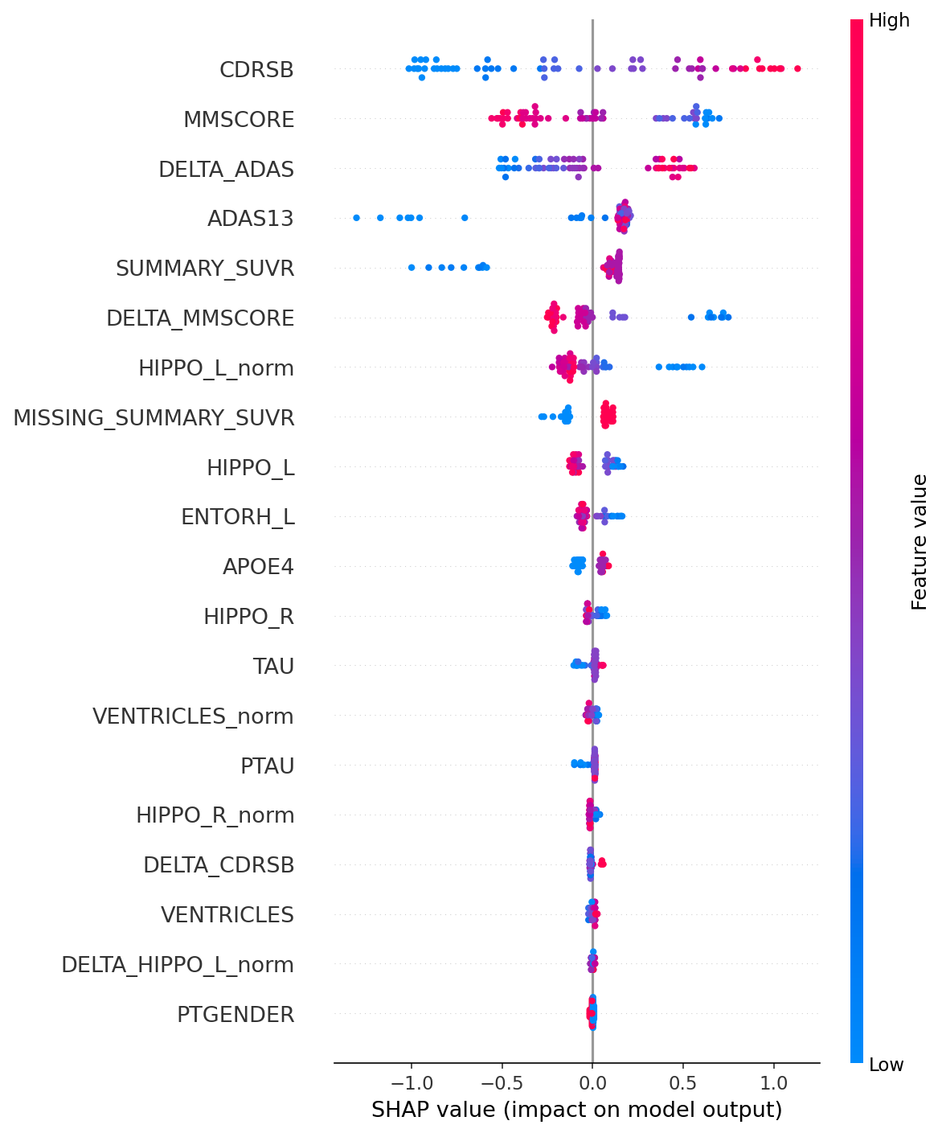
Figure 6. SHAP feature importance (beeswarm). Global mean absolute SHAP values on the test set. Cognitive severity (CDR-SB, MMSE), early cognitive decline (the 12-month ADAS-Cog slope), and APOEε4 status dominate the ranking.
Notably, all top five features are either cognitive assessments or a structural MRI measure, with amyloid PET and CSF biomarkers ranking lower. This is consistent with the missing-modality benchmark finding that imaging biomarkers add little incremental discriminative value in this cohort, likely because amyloid PET is missing for 65% of subjects and CSF for 45%.

4. Discussion
This study presents a leakage-audited, reproducible pipeline for 36-month MCI-to-AD conversion prediction on ADNI, achieving an honest test AUC of 0.932 [95% CI 0.858–0.986] with a Brier score of 0.115. These numbers are presented with their bootstrapped confidence intervals because the small test set (n = 61) means the point estimate alone is insufficient: any AUC between 0.86 and 0.99 is consistent with the data. This transparency is itself a contribution.
The leakage tax is large and reproducible. The most striking result of this study is not the AUC; it is the demonstration that augmenting training data before the train–test split inflated cross-validation AUC by 0.193 (from 0.787 to 0.980) on the same cohort and seed. A researcher who made this single design error would publish a headline CV AUC of 0.980 while their model’s actual performance on unseen data is 0.920. This is not a hypothetical: the pre-refactor version of this analysis produced a CV AUC near 0.997 due to exactly this pattern, which was the original motivation for the clean rebuild. The Kapoor–Narayanan (2023) [6] taxonomy predicts this class of error, and this work provides a concrete, fully reproducible instance of it in the MCI conversion literature.
Calibration matters as much as discrimination. The subfield has over-indexed on AUC as its primary metric. A model with AUC 0.93 but poor calibration cannot be used for individualised risk communication; a clinician cannot tell a patient that their model-predicted probability of 70% means a 70% chance of conversion if the model systematically over- or under-estimates in that range. The reliability diagram here shows reasonable calibration, and the decision curve demonstrates net clinical benefit across a wide threshold range. We argue that future work in this area should routinely report Brier score, reliability curves, and DCA alongside AUC, particularly for clinical decision-support applications.
Cognitive assessments capture most prognostic signal. The missing-modality benchmark provides a practically important finding: dropping all three expensive modalities (amyloid PET, CSF biomarkers, and MRI) reduces AUC by only 0.003 (0.824 to 0.821), a difference smaller than the standard deviation of any single CV fold. Cognition-only models (CDR-SB, MMSE, ADAS-Cog, and their 12-month slopes) achieve AUC 0.812 at a fraction of the cost and patient burden. This does not mean imaging biomarkers are clinically irrelevant, since amyloid positivity has mechanistic implications for trial eligibility and treatment selection, but it does suggest that a risk-stratification screen for clinical trial recruitment could rely primarily on cognitive assessments without a meaningful loss of predictive accuracy.
Longitudinal trajectory outperforms static baseline. The 12-month ADAS-Cog slope was the third-ranked SHAP predictor, ahead of APOEε4 and hippocampal volume. This confirms that cognitive trajectory over the first year provides signal beyond what is available at a single baseline visit. Practically, this means that a 12-month cognitive follow-up assessment, which is standard in most ADNI-aligned clinical protocols, meaningfully improves risk prediction even when imaging modalities are unavailable.
Selection bias is the most important limitation. The 109 excluded censored subjects (26% of the pre-filtered cohort) had significantly lower CDR-SB at baseline (1.61 vs. 2.00, p = 0.005), indicating that the retained cohort skews toward more cognitively impaired MCI patients. This is expected: subjects with more severe MCI either convert quickly (captured regardless of follow-up length) or progress more rapidly in ways that keep them engaged in longitudinal study. The excluded subjects, those with mild MCI who dropped out before 36 months, are precisely those where discrimination is hardest and clinical uncertainty is highest. Any real-world deployment of a model trained on this cohort would be applied to a population that includes these excluded subjects, and performance is likely to be lower than reported here.
Future directions. The most principled correction for censoring bias is a time-to-event framing using Random Survival Forests or gradient-boosted Cox models (e.g., XGBoost-AFT), which recover information from censored subjects and report time-dependent AUC at 12, 24, and 36 months. This would recover all 417 subjects and eliminate the selection bias entirely. External validation on OASIS-3, the largest independent MCI cohort with compatible biomarker coverage, would provide the strongest evidence of generalisability and is a planned extension of this work. Finally, the inclusion of tau PET, available in ADNI3 but not yet incorporated here, may add discriminative signal beyond amyloid, as tau burden more directly reflects neurodegeneration at the synapse level.

5. Conclusion
We present a leakage-audited, reproducible pipeline for 36-month MCI-to-AD conversion prediction that achieves an honest test AUC of 0.932 on ADNI. The primary contribution is not the AUC; it is the demonstration that standard but incorrect practices inflate cross-validation AUC by up to 0.193 on this dataset, together with the provision of a fully reproducible artifact that others can use as a leakage-free baseline. The finding that cognitive assessments alone approach full-modality performance has practical implications for clinical risk stratification in settings where PET and CSF are unavailable. We hope this work contributes to a higher standard of methodological transparency in machine-learning-based neuroimaging research.

References
[1] World Health Organization. Dementia fact sheet. Geneva: WHO, 2023.
[2] Petersen RC et al. Mild cognitive impairment as a diagnostic entity. J Intern Med. 2004;256:183–194.
[3] Moradi E et al. Machine learning framework for early MRI-based Alzheimer’s conversion prediction in MCI subjects. Neuroimage. 2015;104:398–412.
[4] Tong T et al. Multiple instance learning for classification of dementia in brain MRI. Med Image Anal. 2014;18:808–819.
[5] Gao XW et al. Alzheimer’s disease diagnosis based on the modified sparse auto-encoder. Comput Intell Neurosci. 2018.
[6] Kapoor S, Narayanan A. Leakage and the reproducibility crisis in machine-learning-based science. Patterns. 2023;4(9):100804.
[7] Akiba T et al. Optuna: A next-generation hyperparameter optimization framework. Proc ACM SIGKDD. 2019:2623–2631.
[8] Albert MS et al. The diagnosis of mild cognitive impairment due to Alzheimer’s disease: recommendations from the National Institute on Aging-Alzheimer’s Association workgroups. Alzheimers Dement. 2011;7(3):270–279.
[9] Chen T, Guestrin C. XGBoost: A scalable tree boosting system. Proc ACM SIGKDD. 2016:785–794.
[10] Lundberg SM, Lee SI. A unified approach to interpreting model predictions. Adv Neural Inf Process Syst (NeurIPS). 2017:4765–4774.
[11] Vickers AJ, Elkin EB. Decision curve analysis: a novel method for evaluating prediction models. Med Decis Making. 2006;26(6):565–574.

