W E E K 1 0 · S O C C A S E S T U D Y
Wazuh SIEM Setup &
Alert Monitoring
SOC Case Study - Building & Monitoring a Security Operations Lab
Name: Mah Noor
Intern ID: DG/AUGUST/CYBER/077
Email: mahnnorchaudary@gmail.com
Lab: VirtualBox - Wazuh v4.14.9 + Ubuntu 24.04 (Snort IDS)
Date: 28 October 2026

DG INTERNS HUB - CYBER SECURITY INTERNSHIP WEEK 10 SUBMISSION

Task 1: Understanding Wazuh

1. What is Wazuh?
Wazuh is a free, open-source security platform that combines SIEM (Security Information and Event Management) and XDR (Extended Detection and Response). It collects logs and security data from computers and servers, analyzes them with detection rules, and shows the results as alerts on a web dashboard. It also does file integrity monitoring, vulnerability detection, configuration assessment (CIS benchmarks), and malware/rootkit detection.

2. Wazuh Manager (Server)
The Manager is the brain of Wazuh. It receives data from all agents, decodes the logs, and checks them against thousands of rules. When a rule matches, it creates an alert with a rule ID and a severity level (0 to 15). It also manages agents (registration, keys, configuration). In my lab the Manager runs inside the Wazuh VM (192.168.56.103) together with the Wazuh Indexer, which stores and searches the alerts.

3. Wazuh Agent
The Agent is a small program installed on each monitored endpoint. It reads local logs (for example /var/log/auth.log), watches important files, collects system inventory, and sends everything securely to the Manager. In my lab the agent is installed on the Ubuntu Snort VM (snort-agent, 192.168.56.102).

4. Wazuh Dashboard
The Dashboard is the web interface (https://<manager-ip>) where a SOC analyst views alerts, filters events, checks agent status, and opens modules such as Threat Hunting, File Integrity Monitoring, MITRE ATT&CK, Vulnerability Detection and Configuration Assessment.

5. SIEM vs IDS
Point | SIEM (e.g. Wazuh) | IDS (e.g. Snort)
Main job | Collect, correlate and analyze logs from many sources | Inspect network traffic and detect attacks
Data source | Logs from hosts, servers, devices, apps, other tools | Network packets
Output | Alerts, dashboards, reports, compliance data | Alerts about suspicious traffic
Scope | Whole environment (central view) | One network segment or sensor
Response | Can trigger active responses and feeds investigation | Detects only (IPS mode can block)

6. How Wazuh helps a SOC analyst
- One central place to see alerts from all endpoints, so the analyst does not check each machine by hand.
- Severity levels and rule IDs help to prioritize which alert to investigate first.
- Shows who, what, when and where: user, source IP, file path, command and timestamp.
- Detects failed logins, brute force, privilege use (sudo), file changes, vulnerabilities and weak configuration.
- MITRE ATT&CK mapping helps to understand the attacker technique behind an alert.
- Can collect other tools’ logs (for example Snort) so all evidence is in one dashboard.

7. Wazuh vs Snort: basic differences
Point | Wazuh | Snort
Type | SIEM + XDR (host and log based) | Network IDS/IPS
Looks at | Logs, files, processes, configuration, vulnerabilities | Network packets and traffic patterns
Needs agent? | Yes, agent on each endpoint | No, sensor on the network path
Detects | Failed logins, file changes, privilege escalation, misconfiguration | Port scans, ping sweeps, exploits, malicious traffic
Dashboard | Built in (search, filters, MITRE, compliance) | No dashboard by itself (text logs)
Together | Wazuh can read Snort alerts and show them with host events | Provides the network-side detection

Conclusion: Snort sees what travels over the network, Wazuh sees what happens inside the endpoint. Using both gives a SOC analyst a fuller picture.

Task 2: Wazuh Setup
Environment: Wazuh v4.14.9 virtual machine (official OVA, Amazon Linux 2023) imported into VirtualBox. Resources: 4 CPU, 6 GB RAM. Network: Adapter 1 Host-only (192.168.56.103) and Adapter 2 NAT.
Note: I first tried the all-in-one installer on my Ubuntu Snort VM, but the dashboard package failed to install because of disk-space errors in that VM. I therefore used the official Wazuh OVA for a clean setup, and kept the Snort VM as the monitored endpoint.

Installation / setup
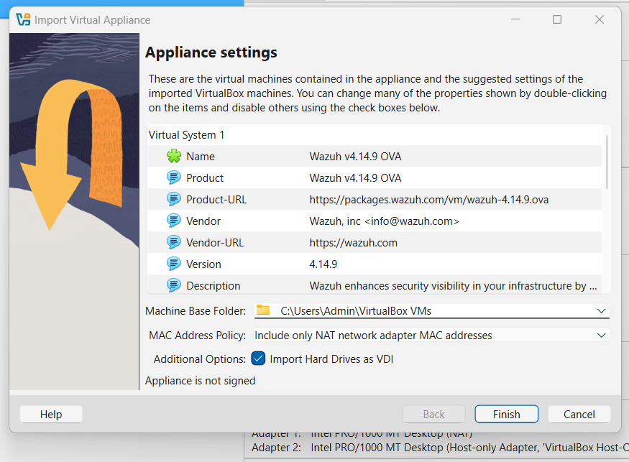
Figure 2.1: Importing the Wazuh v4.14.9 OVA into VirtualBox
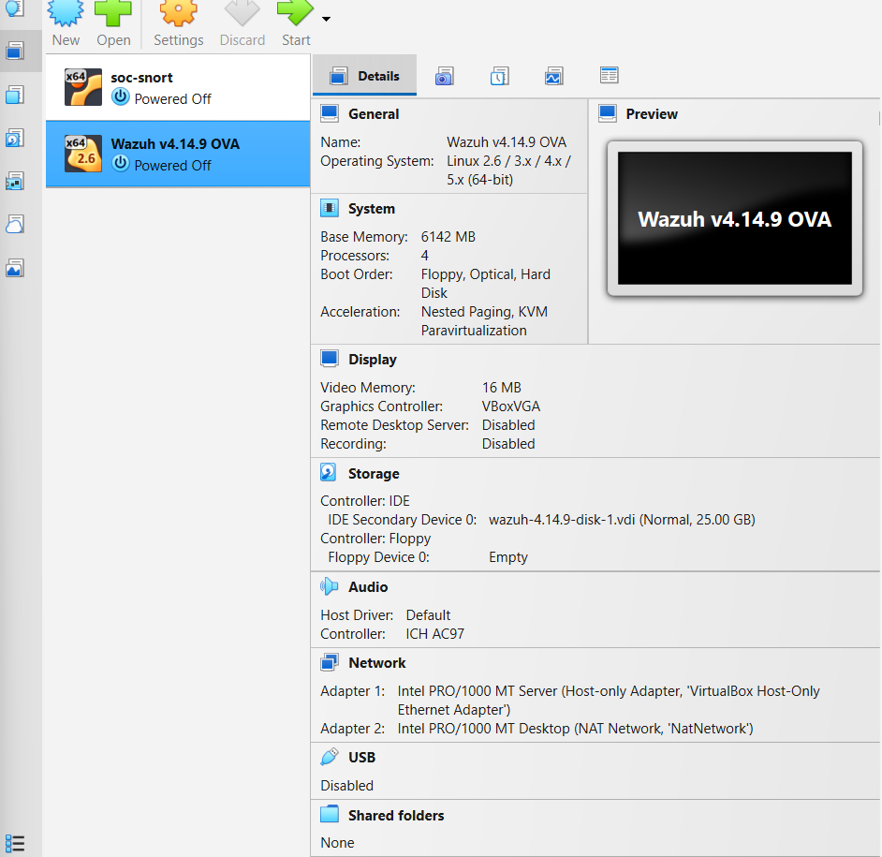
Figure 2.2: Wazuh VM settings (6 GB RAM, Host-only + NAT adapters)

Wazuh services
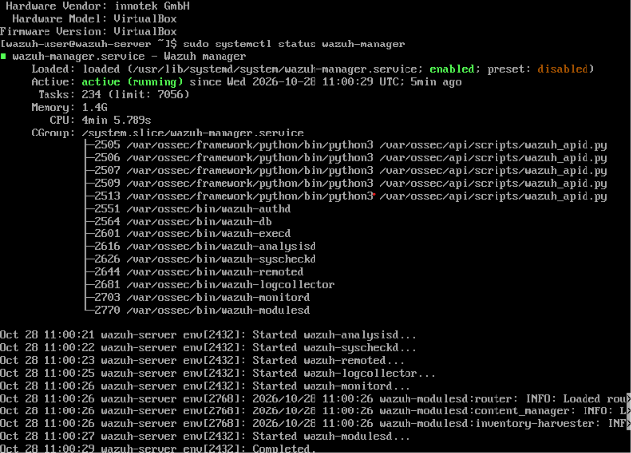
Figure 2.3: wazuh-manager service is active (running)
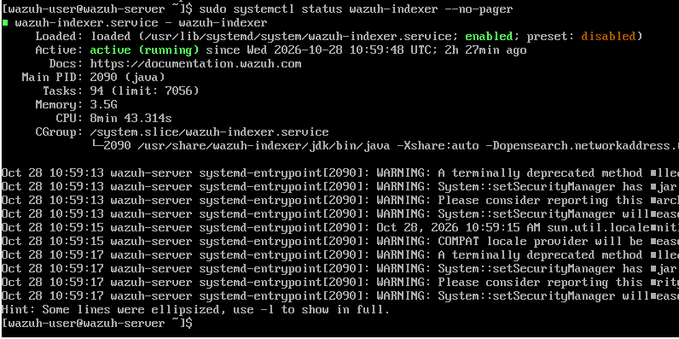
Figure 2.4: wazuh-indexer service is active (running)
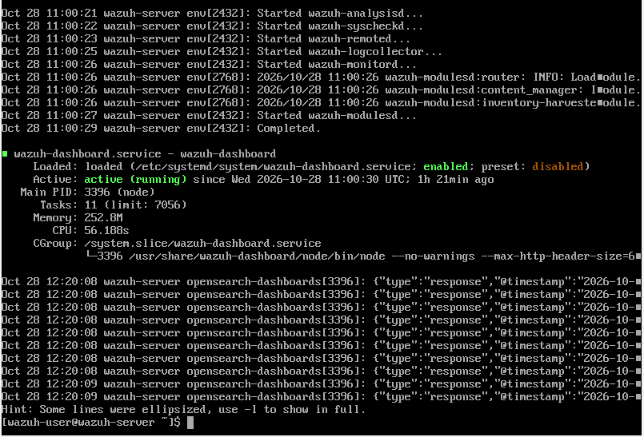
Figure 2.5: wazuh-dashboard service is active (running)

System information
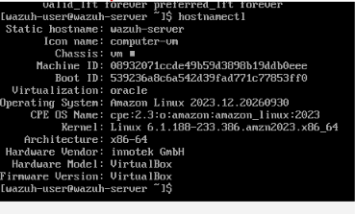
Figure 2.6: hostnamectl (wazuh-server, Amazon Linux 2023)
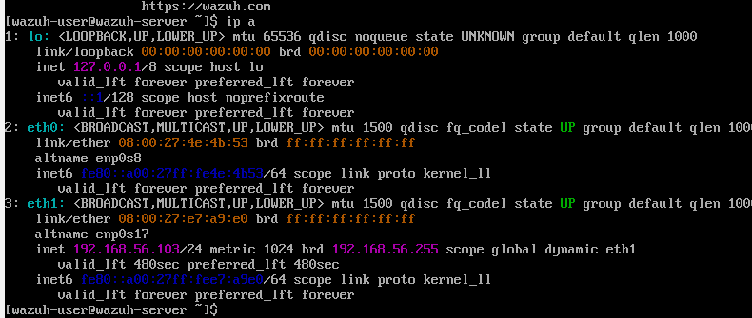
Figure 2.7: IP address of the Wazuh server (192.168.56.103)

Dashboard login and exploration
I opened https://192.168.56.103 and logged in with the admin account. I explored the main sections: Overview (agents summary and last 24 hours alerts), Endpoints, Threat Hunting, File Integrity Monitoring, Configuration Assessment, Vulnerability Detection and MITRE ATT&CK.
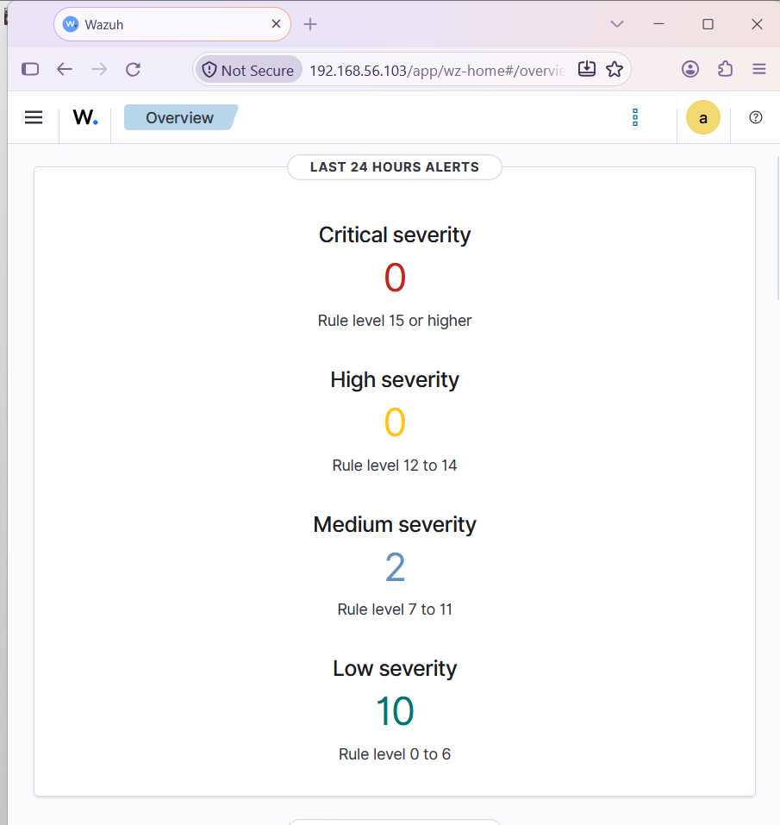
Figure 2.8: Wazuh dashboard Overview

Task 3: Deploy Wazuh Agent
The Wazuh agent (v4.14.9) was installed on the Ubuntu 24.04 Snort VM (hostname soc-snort, 192.168.56.102) from the Wazuh APT repository, with WAZUH_MANAGER set to 192.168.56.103 and agent name snort-agent. The agent service was enabled and started with systemctl.
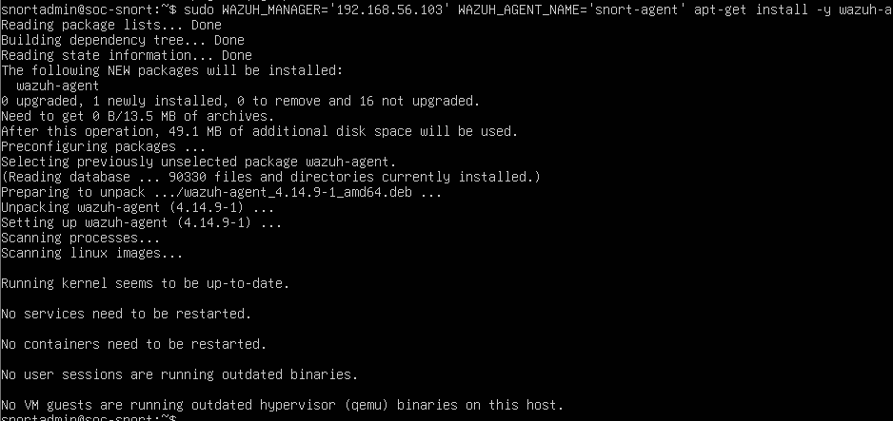
Figure 3.1: Wazuh agent package installed on the Snort VM
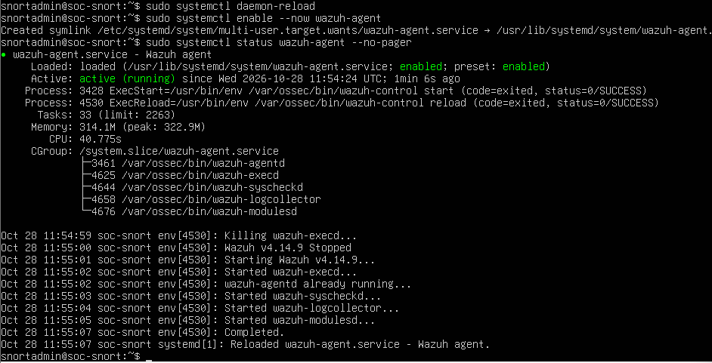
Figure 3.2: wazuh-agent service active (running)
Verification chain: Agent (soc-snort) → Manager (wazuh-server) → Dashboard. The dashboard shows the agent as Active.
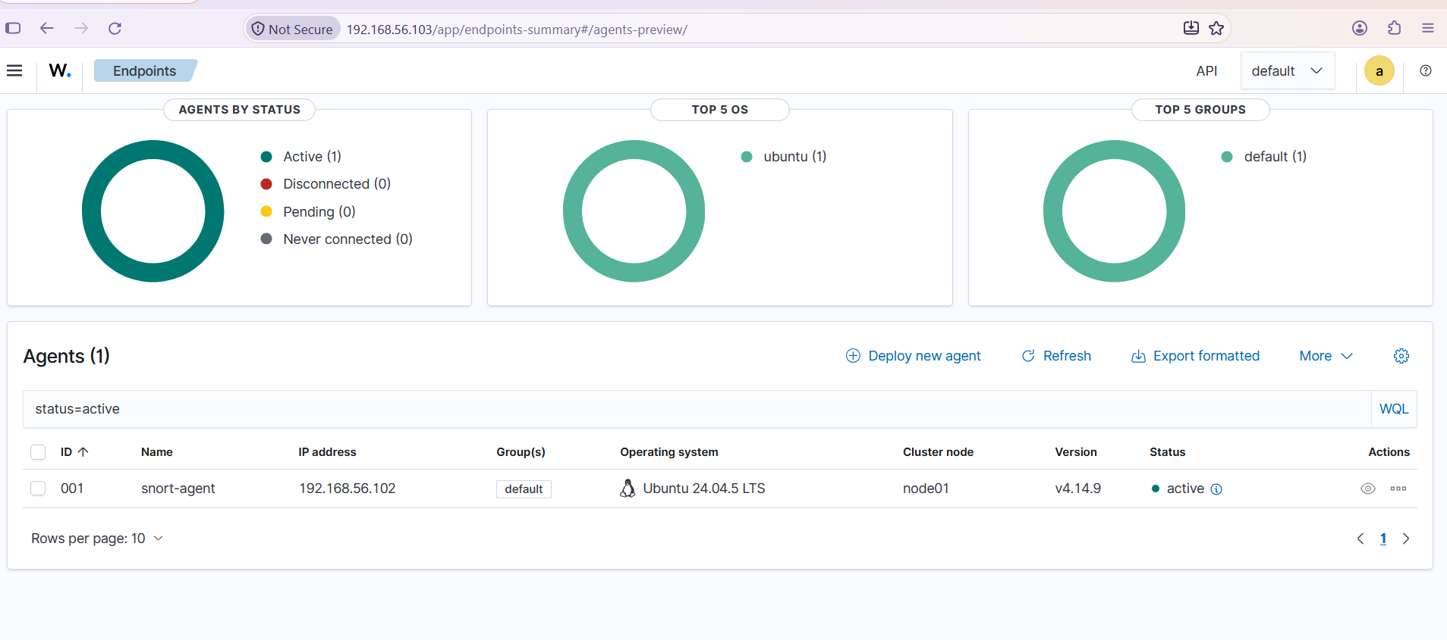
Figure 3.3: Endpoints Summary: snort-agent (001) is active
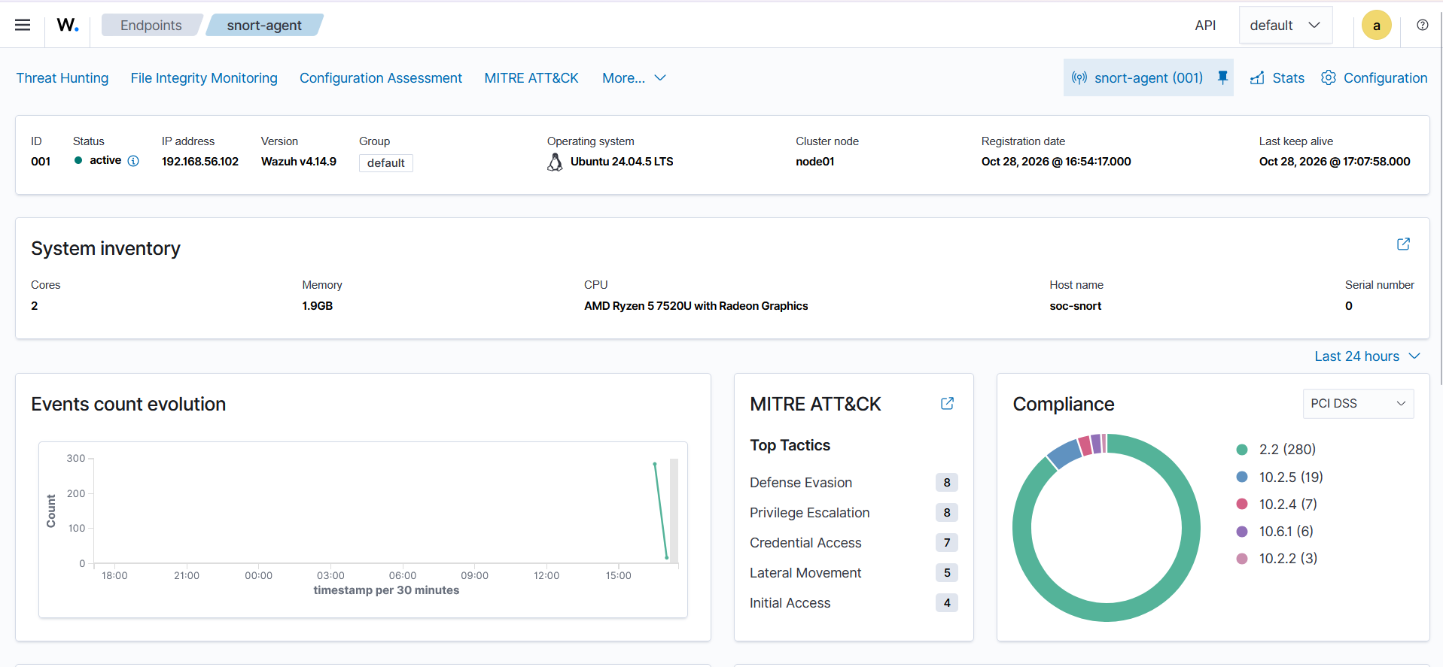
Figure 3.4: Agent details and system inventory in the dashboard

Task 4: Generate Security Events
All events were generated safely inside my own lab (Snort VM and the host machine on the host-only network):
- Failed logins: su fakeuser, and ssh wronguser@localhost / ssh wronguser@192.168.56.102 with wrong passwords.
- Successful login and authentication: normal login on the VM and sudo ls /root (PAM session events).
- File creation / modification / deletion: /tmp/fim_test.txt, monitored in real time by Wazuh FIM (syscheck).
- Network activity: ping to the Snort VM from the host, detected by Snort.
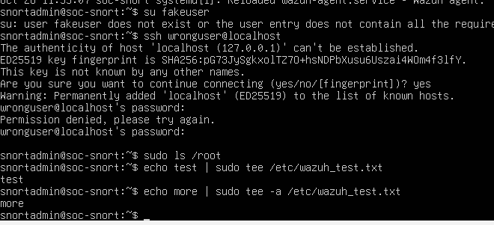
Figure 4.1: Failed su/ssh attempts, sudo, and file creation on the Snort VM
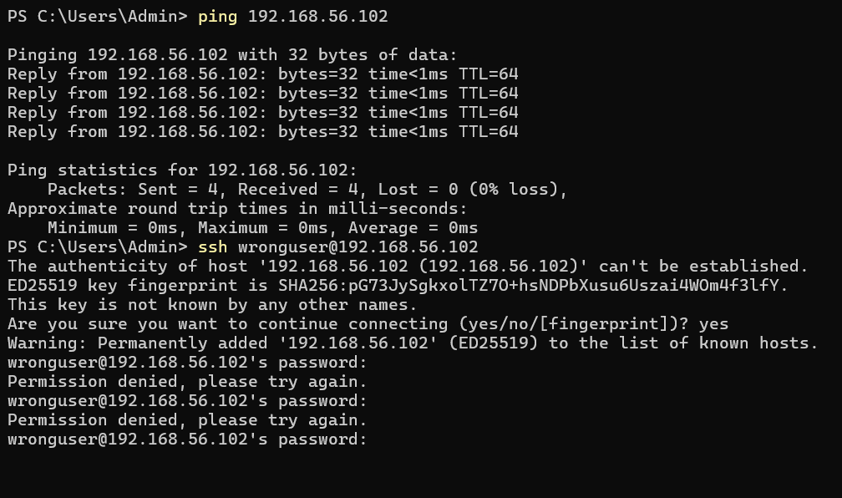
Figure 4.2: Failed SSH logins with wrong user from the host machine
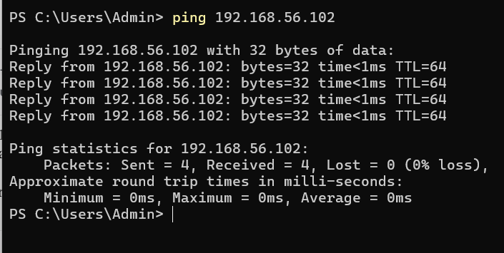
Figure 4.3: Network activity (ping) to 192.168.56.102

How Wazuh displayed these events
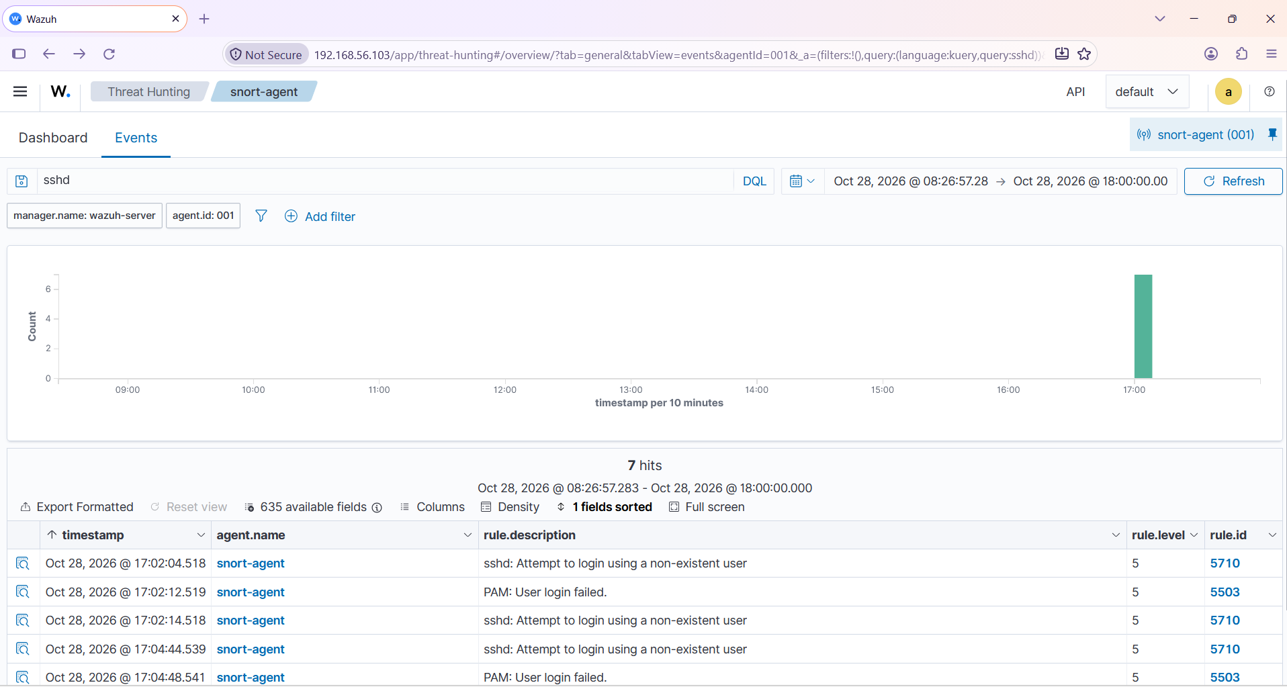
Figure 4.4: Failed SSH logins detected (rule 5710 and 5503)
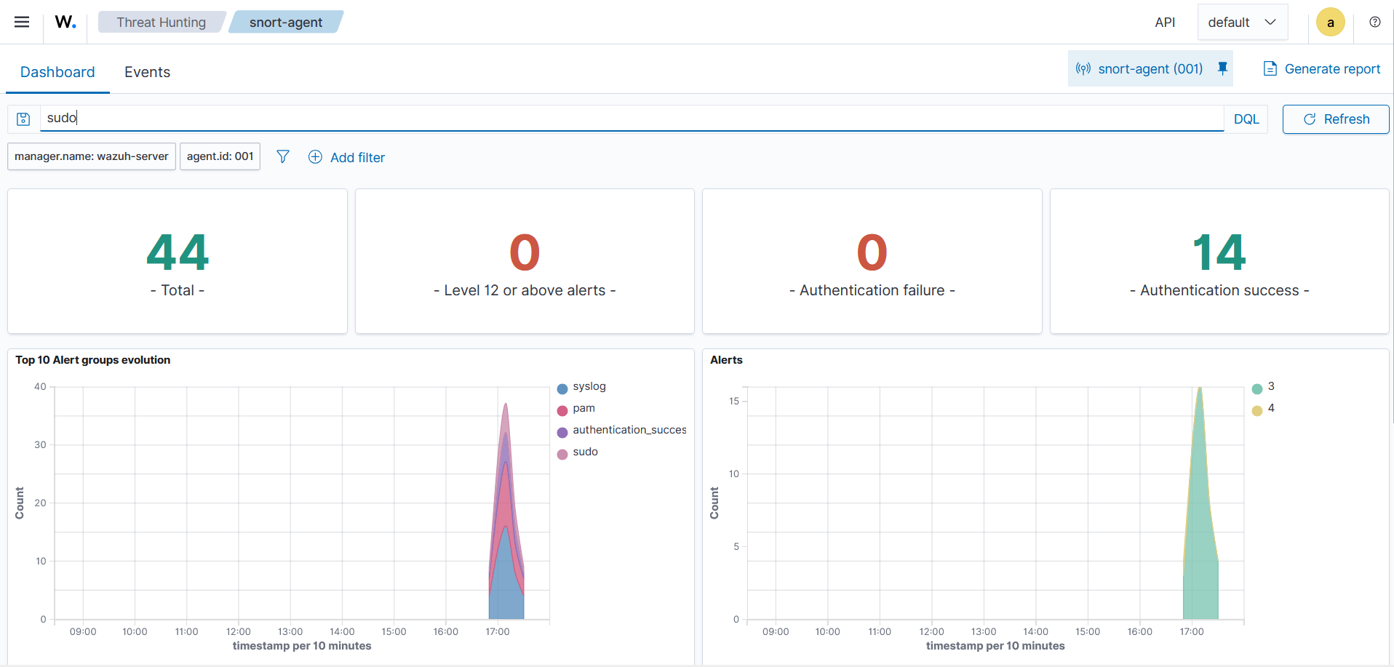
Figure 4.5: sudo / PAM authentication events (44 alerts)
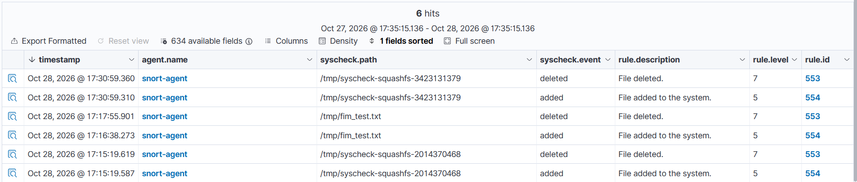
Figure 4.6: File Integrity Monitoring: file added (554) and deleted (553)

Task 5: Alert Investigation
Ten alerts from agent snort-agent (001) were analyzed. Times are as shown in the Wazuh dashboard (local time, 28 Oct 2026). Alert IDs are my reference numbers (A01 to A10); each alert is also identified by its rule ID and timestamp.
Alert ID | Date/Time | Agent | Source | Event | Rule ID | Severity | Description | Analyst Observation
A01 | 28 Oct 17:02:04 | snort-agent (001) | sshd / auth.log | SSH login, invalid user | 5710 | 5 (Low) | sshd: Attempt to login using a non-existent user | First failed SSH try with user wronguser. Test from my own lab.
A02 | 28 Oct 17:02:12 | snort-agent (001) | PAM / auth.log | PAM authentication | 5503 | 5 (Low) | PAM: User login failed. | PAM confirms the failed authentication that followed A01.
A03 | 28 Oct 17:02:14 | snort-agent (001) | sshd / auth.log | SSH login, invalid user | 5710 | 5 (Low) | sshd: Attempt to login using a non-existent user | Repeated attempt in 10 seconds shows a pattern of guessing.
A04 | 28 Oct 17:04:44 | snort-agent (001) | sshd / auth.log | SSH login, invalid user | 5710 | 5 (Low) | sshd: Attempt to login using a non-existent user | Second round of attempts from the host machine (192.168.56.1 on host-only network).
A05 | 28 Oct 17:04:48 | snort-agent (001) | PAM / auth.log | PAM authentication | 5503 | 5 (Low) | PAM: User login failed. | Failed password for the invalid user; no successful login followed.
A06 | 28 Oct 17:16:38 | snort-agent (001) | syscheck (FIM) | File created: /tmp/fim_test.txt | 554 | 5 (Low) | File added to the system. | Expected: this is the test file I created for the FIM test.
A07 | 28 Oct 17:17:55 | snort-agent (001) | syscheck (FIM) | File deleted: /tmp/fim_test.txt | 553 | 7 (Medium) | File deleted. | Same test file removed; Wazuh rates deletion higher than creation.
A08 | 28 Oct 17:34:27 | snort-agent (001) | Snort alert.fast | Snort IDS event | 20101 | 6 (Low) | IDS event. | Snort log line (ICMP Ping Detected) was read by the Wazuh agent.
A09 | 28 Oct 17:34:39 | snort-agent (001) | Snort alert.fast | Snort IDS alert, first time | 20100 | 8 (Medium) | First time this IDS alert is generated. | First Snort alert of this type from 192.168.56.1 to 192.168.56.102; confirms Snort to Wazuh works.
A10 | 28 Oct 17:34:39 | snort-agent (001) | Snort alert.fast | Snort IDS alert, first time | 20100 | 8 (Medium) | First time this IDS alert is generated. | Second first-time Snort alert (ping detection rule), same source and target.

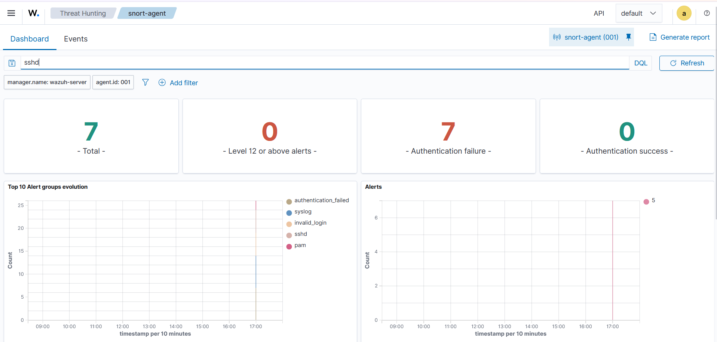
Figure 5.1: Wazuh Events table (sshd search, 7 hits)

Detailed investigation: repeated SSH login attempts with a non-existent user
- Selected alerts: A01 to A05 (rule 5710 sshd invalid user, rule 5503 PAM login failed).
- What happened: Several SSH login attempts used the user name wronguser, which does not exist on soc-snort. Each attempt created a pair of alerts: sshd (5710) and PAM (5503).
- Who/where: Target is soc-snort (192.168.56.102). Attempts came from localhost and from my host machine (192.168.56.1) on the host-only network.
- Why it matters: Guessing user names is typical of brute-force or password-guessing activity (MITRE ATT&CK T1110, Credential Access). In a real network, many attempts in a short time from one IP would need blocking.
- Result: All attempts failed. No successful login followed, no privilege use, and no new files related to these attempts. This was my own controlled test, so it is a true detection of a simulated attack.
- Analyst action: Block the source IP at the firewall, review auth.log for the same IP, disable password login or use fail2ban/key-based SSH.

Task 6: Wazuh + Snort
Workflow:
Snort IDS | Alert log | Wazuh Agent | Wazuh Manager | Dashboard | SOC Analyst
Detects ICMP ping (rule sid 1000001) | /var/log/snort/snort.alert.fast | Reads the file with a localfile block (snort-fast) | Decodes and applies IDS rules 20100 / 20101 | Threat Hunting > Events (rule group ids) | Investigates and decides on action

Steps done:
- Snort (Week 9) on soc-snort writes alerts to /var/log/snort/snort.alert.fast.
- The Wazuh agent was already installed on the same VM, so no log forwarding service was needed.
- In /var/ossec/etc/ossec.conf I added a localfile block with log_format snort-fast and location /var/log/snort/snort.alert.fast, then restarted wazuh-agent.
- I pinged 192.168.56.102 from the host machine. Snort wrote "ICMP Ping Detected" alerts and Wazuh showed them under rule group ids.
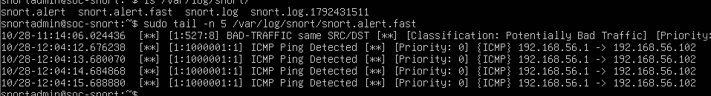
Figure 6.1: Snort alerts in snort.alert.fast (ICMP Ping Detected, 192.168.56.1 to 192.168.56.102)
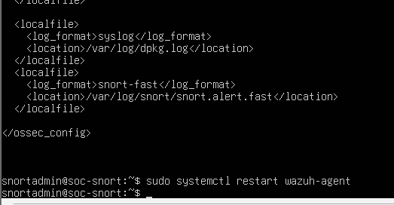
Figure 6.2: ossec.conf localfile block for the Snort alert log
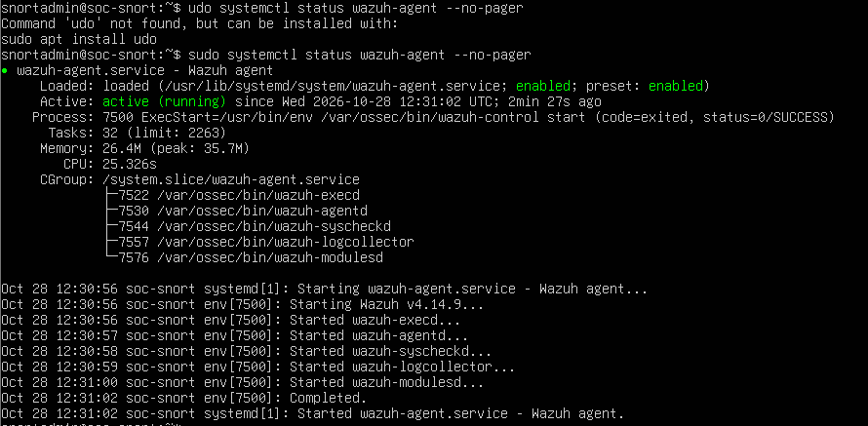
Figure 6.3: wazuh-agent running after the configuration change
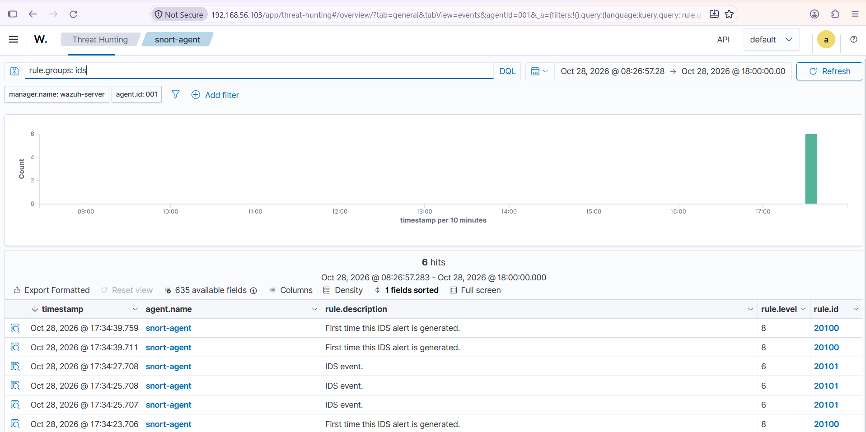
Figure 6.4: Snort alerts inside Wazuh (rule.groups: ids, rules 20100 and 20101)

Task 7: SOC Incident Investigation
Incident: Repeated SSH login attempts using a non-existent user on soc-snort (simulated in my lab).
Section | Details
Detection | Wazuh rules 5710 (sshd: attempt to login using a non-existent user) and 5503 (PAM: user login failed) on agent snort-agent (001). 7 authentication failures were counted in the dashboard.
Initial analysis | Alerts appeared in pairs within seconds. The user name wronguser does not exist on the host. Source: localhost and 192.168.56.1. No successful authentication followed the failures.
Evidence | Wazuh Threat Hunting events (rule 5710 / 5503), /var/log/auth.log on soc-snort, PowerShell and terminal screenshots of the failed attempts (Task 4).
Severity assessment | Low (rule level 5). Raises to Medium or High if there are many attempts per minute, a valid user is targeted, or a login succeeds.
Possible impact | If real: attacker could guess a valid account, gain shell access, then escalate privileges and move to other hosts. Here: none, test only.
Containment | Block the source IP in the firewall, temporarily disable password SSH login, lock any targeted accounts, and enable fail2ban or Wazuh active response.
Recovery | Verify no unauthorized login (last, auth.log), reset passwords if needed, use SSH keys, restrict SSH to trusted IPs, keep the system patched, confirm alerts stop.
Lessons learned | Authentication logs give early warning. Pair alerts (sshd + PAM) confirm the same event. Add alert thresholds, monitor SSH constantly, and correlate with network alerts from Snort.

Task 8: SOC Analyst Dashboard Summary
Monitored environment: 1 Wazuh server (192.168.56.103) and 1 monitored endpoint, snort-agent (Ubuntu 24.04, 192.168.56.102). Data from the Threat Hunting dashboard of snort-agent.
Metric | Value
Total alerts (Threat Hunting, snort-agent) | 358
Critical alerts (level 15+) | 0
High alerts (level 12 to 14) | 0
Medium alerts (level 7 to 11) | 129
Low alerts (level 0 to 6) | 177
Authentication events | 7 failures, 14 successes
File integrity events | 6 (files added/deleted in /tmp, incl. /tmp/fim_test.txt)
Most important detected event | Repeated SSH login attempts with a non-existent user (rules 5710 / 5503)
Agent status | 1 active, 0 disconnected, 0 pending
Snort-related events | 6 IDS alerts (rules 20100, 20101): ICMP Ping Detected
Note: Severity counts are taken from the Wazuh Overview dashboard (last 24 hours): 0 critical, 0 high, 129 medium and 177 low (306 alerts). The total of 358 is taken from the Threat Hunting events view of agent snort-agent (001); the two views cover slightly different time windows, so the severity buckets do not add up exactly to the total.

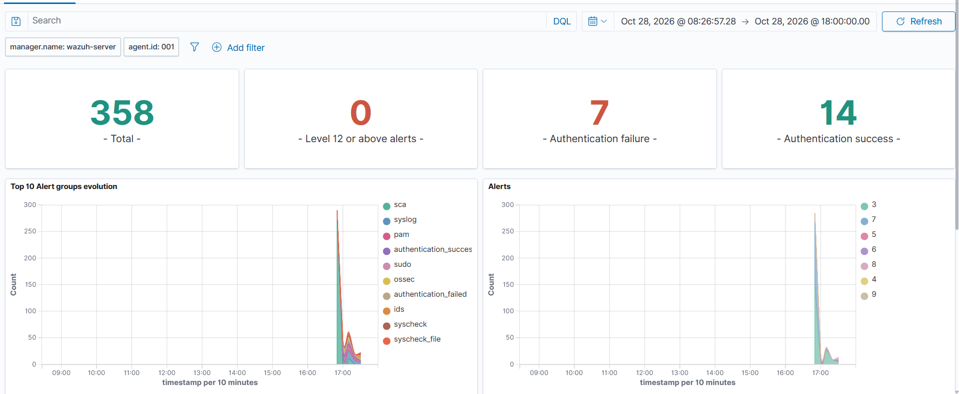
Figure 8.1: Threat Hunting summary (358 alerts, 7 failures, 14 successes)
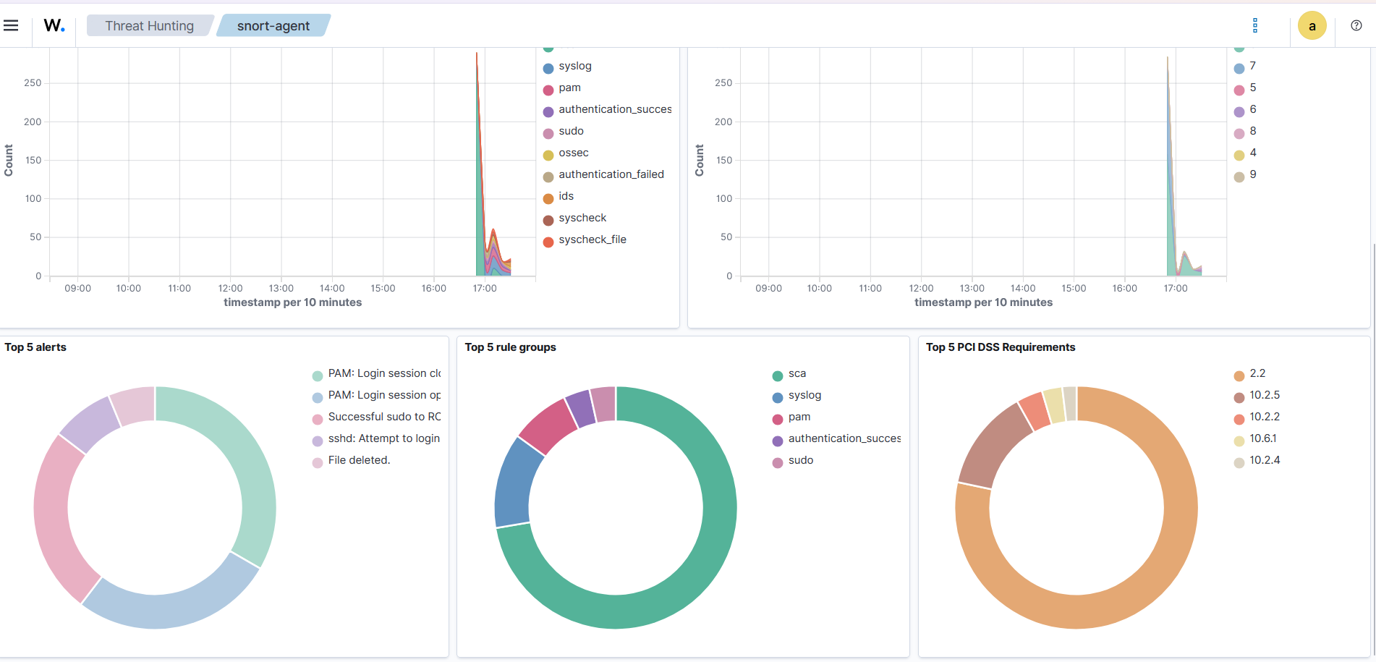
Figure 8.2: Top 5 alerts and rule groups
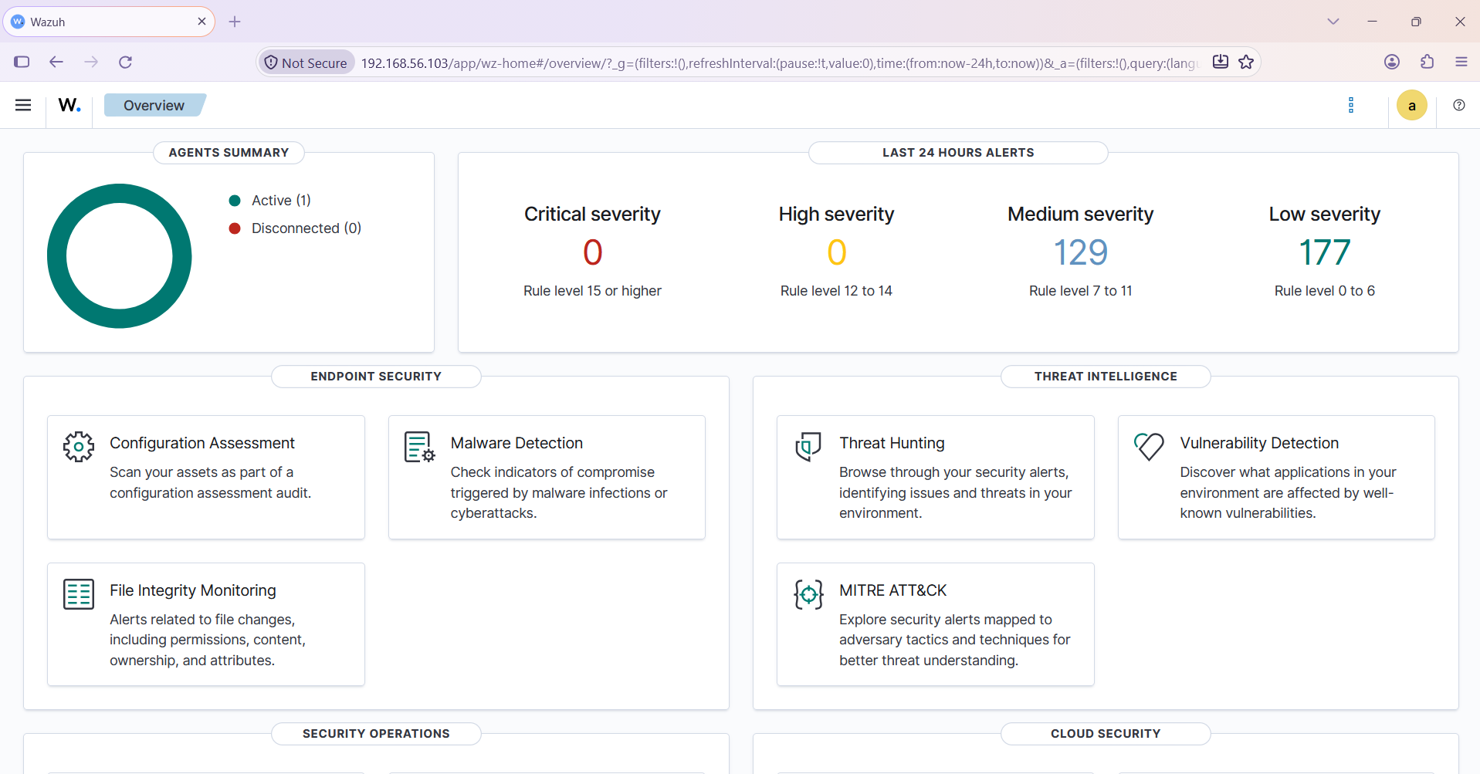
Figure 8.3: Overview: agents summary and alerts by severity

