
DG INTERNS HUB
Cybersecurity Internship Program
WEEK 2 ASSIGNMENT REPORT
Advanced Networking, Traffic Analysis & Security Concepts
Submitted by: Moonlight
BS Information Technology (Cybersecurity)
The Learning Hub College, University of Punjab
Pakistan
Report Date: 27 August 2026
Tools Used: Wireshark | Nmap | Cisco Packet Tracer

Table of Contents
1. Introduction and Objective
2. Part 1 – Theory
2.1 Task 1: Ports and Services
2.2 Task 2: Networking Devices (Router, Switch, Firewall)
2.3 Task 3: Network Security Basics (MITM, DoS, Packet Sniffing)
3. Part 2 – Practical Work
3.1 Task 4: Packet Analysis using Wireshark
3.2 Task 5: Network Scanning using Nmap
3.3 Task 6: Packet Tracer LAN Setup
3.4 Task 7: Man-in-the-Middle (MITM) Concept Simulation
4. Tools Used – Summary
5. Learnings and Conclusion

1. Introduction and Objective
This report is written for Week 2 of the DG Interns Hub Cybersecurity Internship. The goal of this week was to move a step ahead from basic networking and get hands-on with real tools. In this task, I studied important networking concepts like ports, routers, switches and firewalls, and then I practiced using tools such as Wireshark, Nmap and Cisco Packet Tracer. I also learned about common network attacks like Man-in-the-Middle (MITM), Denial of Service (DoS) and Packet Sniffing, and how we can prevent them.
All the practical work shown in this report was done by me on my own laptop, inside safe and legal environments. For example, I only scanned scanme.nmap.org, which is a website made by the Nmap team especially for people to practice scanning on. I did not scan or attack any device that I do not own or have permission for.

2. Part 1: Theory

2.1 Task 1: Ports and Services
A port is like a small door number on a computer. When data comes to a computer over the internet, the IP address tells the data which computer to go to, and the port number tells it which application on that computer should receive it. For example, when you open a website, your browser talks to port 80 or port 443 on the web server. Ports are divided into two main types based on protocol: TCP (Transmission Control Protocol), which makes sure data arrives fully and in order, and UDP (User Datagram Protocol), which is faster but does not guarantee delivery. Below is a table of 20 common ports with their protocol, service name and simple usage.
Port No. | Protocol | Service | Usage (in simple words)
20 | TCP | FTP (Data) | Transfers files as part of active FTP sessions
21 | TCP | FTP (Control) | Sends commands to control file transfers
22 | TCP | SSH | Lets admins log in to a remote machine securely
23 | TCP | Telnet | Old remote login method, sends data in plain text
25 | TCP | SMTP | Sends email between mail servers
53 | TCP/UDP | DNS | Turns website names into IP addresses
67 | UDP | DHCP (Server) | Gives out IP addresses to devices on a network
68 | UDP | DHCP (Client) | Receives an IP address from the DHCP server
69 | UDP | TFTP | Simple file transfer, mostly used for device configs
80 | TCP | HTTP | Loads normal, unencrypted websites
110 | TCP | POP3 | Downloads email from a mail server to a device
119 | TCP | NNTP | Used for newsgroup/discussion services
123 | UDP | NTP | Keeps computer clocks in sync over the network
143 | TCP | IMAP | Reads email while keeping it stored on the server
161 | UDP | SNMP | Lets admins monitor routers, switches and servers
389 | TCP | LDAP | Looks up user and directory information
443 | TCP | HTTPS | Loads websites with encryption (secure browsing)
445 | TCP | SMB | Shares files and printers on Windows networks
3306 | TCP | MySQL | Lets applications talk to a MySQL database
3389 | TCP | RDP | Lets a user remotely control a Windows desktop

2.2 Task 2: Networking Devices

Router
A router is a device that connects two or more different networks together and decides the best path for data to travel between them. It works at Layer 3 (Network Layer) of the OSI model and uses IP addresses to move data from one network to another. A simple real-world example is the Wi-Fi router at home: it connects your home network to your Internet Service Provider's network, so all your devices can reach the internet.

Switch
A switch connects multiple devices inside the same local network (LAN) and forwards data only to the exact device it is meant for, using MAC addresses. It works at Layer 2 (Data Link Layer). A real-world example is an office network, where a switch connects all computers, printers and other devices in one room or building so they can share files with each other quickly.

Firewall
A firewall is a security device (or software) that checks incoming and outgoing traffic and decides what to allow and what to block, based on a set of rules. It acts like a guard standing at the entrance of a network. A real-world example is a company firewall that blocks unknown or unsafe websites and stops hackers from getting into the internal network.

Router vs Switch – Key Difference
- A router connects different networks together; a switch connects devices inside one single network.
- A router uses IP addresses to send data; a switch uses MAC addresses.
- A router works at Layer 3 of the OSI model; a switch works at Layer 2.
- A router is normally used at the edge of a network (connecting to the internet); a switch is used inside the local network.

2.3 Task 3: Network Security Basics
Network security means protecting a computer network and the data flowing through it from unauthorized access, misuse, or attacks. It includes tools, rules and practices such as firewalls, encryption, strong passwords, and monitoring, all working together to keep data safe and private.

Man-in-the-Middle (MITM) Attack
In a MITM attack, an attacker secretly places themselves between two devices that are communicating, such as a victim and a website or router. The attacker can then read, or even change, the data being sent, without either side realizing it. It works on the idea of intercepting traffic before it reaches its real destination.
Prevention: Always use HTTPS websites, use a VPN on public Wi-Fi, avoid untrusted or open networks, and keep software updated.

Denial of Service (DoS) Attack
In a DoS attack, the attacker sends a huge amount of traffic or requests to a server or network, more than it can handle. This overloads the system so that real, genuine users cannot access the service anymore. If many computers are used together to do this, it is called a DDoS (Distributed Denial of Service) attack.
Prevention: Use firewalls and rate-limiting, use load balancers, and use DDoS protection services offered by cloud providers.

Packet Sniffing
Packet sniffing means capturing and reading the data packets that travel across a network. Tools like Wireshark can be used for this. It is not always bad — network admins use it to fix problems — but attackers can use it to steal usernames, passwords or other private information if the data is not encrypted.
Prevention: Use encrypted connections (HTTPS, VPN, WPA2/WPA3 Wi-Fi), and avoid sending sensitive data over public or unknown networks.

3. Part 2: Practical Work

3.1 Task 4: Packet Analysis using Wireshark
For this task, I opened Wireshark, started a live capture on my Wi-Fi network, then visited a few websites such as google.com, and finally stopped the capture so I could study the traffic. Wireshark shows every packet with its source IP, destination IP, protocol and length, which makes it very useful to understand what is really happening on a network.
The first screenshot below shows the raw, unfiltered capture. I can see different kinds of traffic such as TCP, ICMPv6 (Neighbour Solicitation) and MDNS, along with the source and destination addresses for each packet.
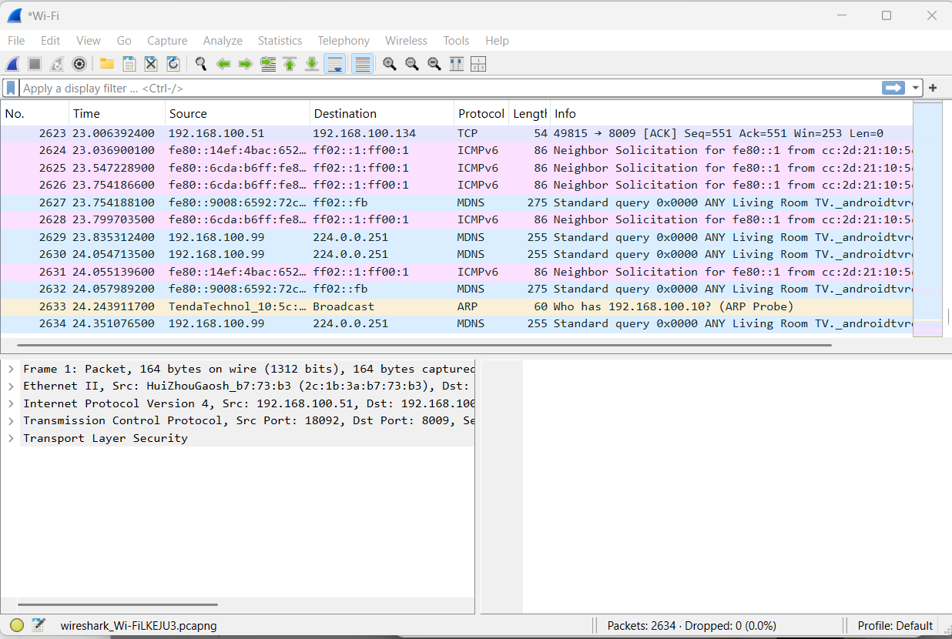
Figure 1: Live packet capture in Wireshark showing mixed traffic (TCP, ICMPv6, MDNS)
Next, I applied the filter "dns" to see only DNS traffic. DNS is the service that turns a website name like www.google.com into an IP address. In the screenshot, my computer (192.168.100.51) sends a DNS query for www.google.com, and the router (192.168.100.1) replies back with the matching IP addresses (A and AAAA records).
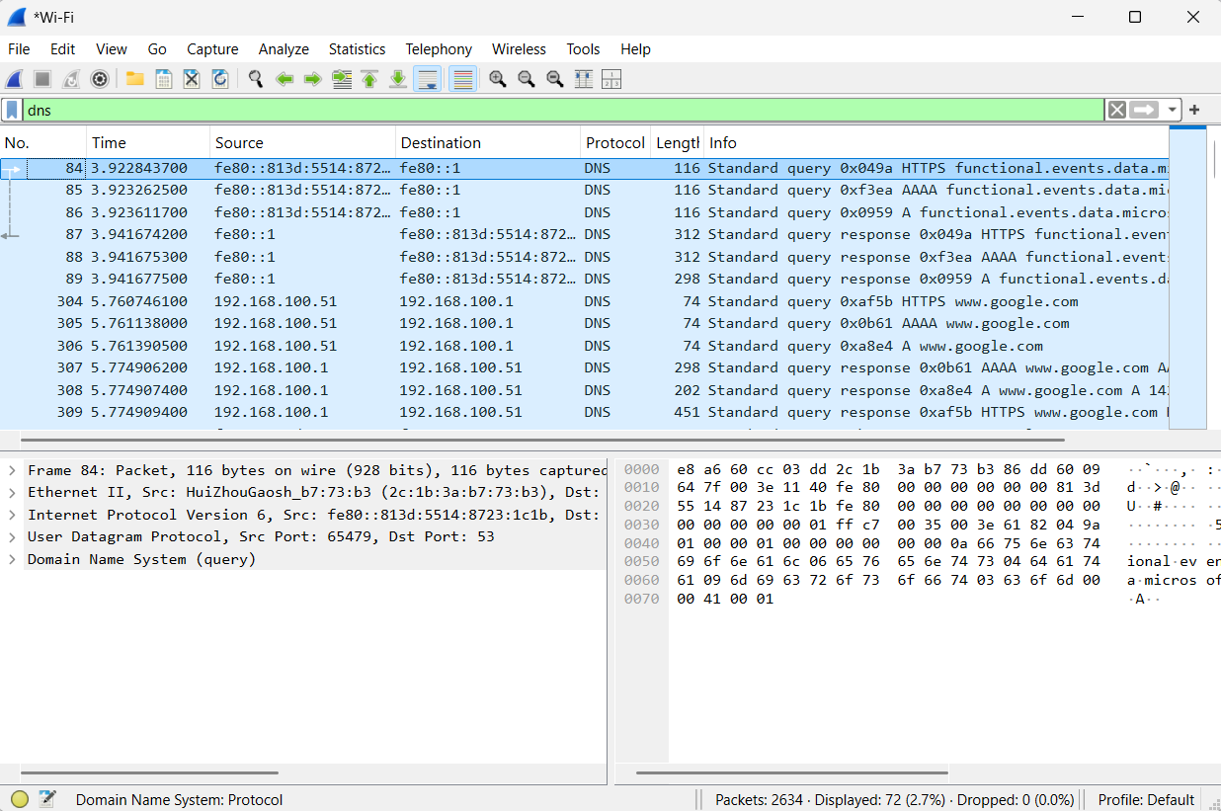
Figure 2: DNS query and response captured for www.google.com
Finally, I applied the filter "tls" to look at encrypted web traffic. TLS is the security layer used by HTTPS. Here I can see "Application Data" packets flowing between my machine and different servers, and one packet even shows a TLS "Client Hello" that contains the server name (SNI) being requested. This confirms that the browsing traffic was encrypted and protected.
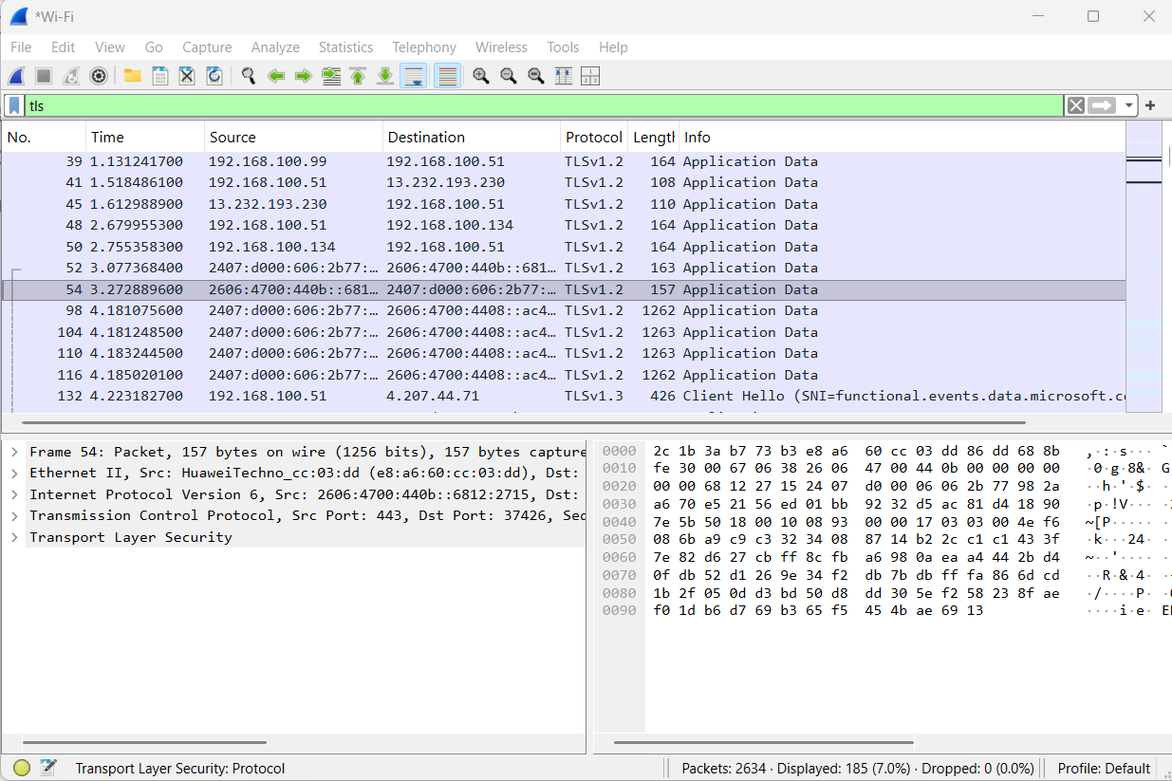
Figure 3: TLS-encrypted traffic (HTTPS) captured between client and server

What I identified from this task
- DNS requests: my PC (192.168.100.51) querying for domains such as www.google.com
- HTTPS/TLS traffic: encrypted Application Data packets and a Client Hello with SNI
- Source and destination IPs: local addresses like 192.168.100.51 / 192.168.100.1, and public server IPs

3.2 Task 5: Network Scanning using Nmap
Before scanning, I first checked that my internet connection and DNS were working properly by pinging 8.8.8.8 and google.com. Both replied successfully with 0% packet loss, which confirmed my network was ready for the scan.
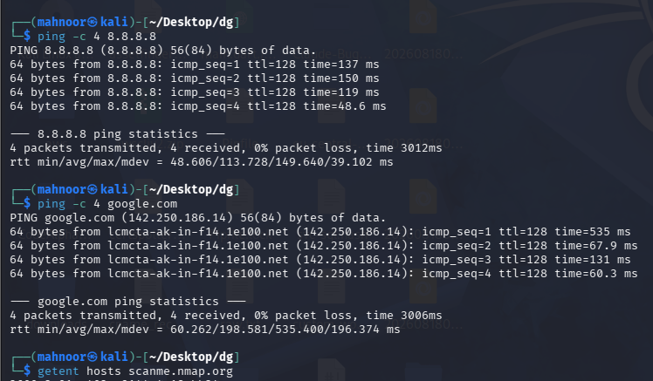
Figure 4: Connectivity check using ping before running Nmap
For the actual scan, I used scanme.nmap.org, which is the official, legal target provided by the Nmap project for practice. My first command checked the 20 most common ports:
nmap -Pn -T4 --top-ports 20 scanme.nmap.org
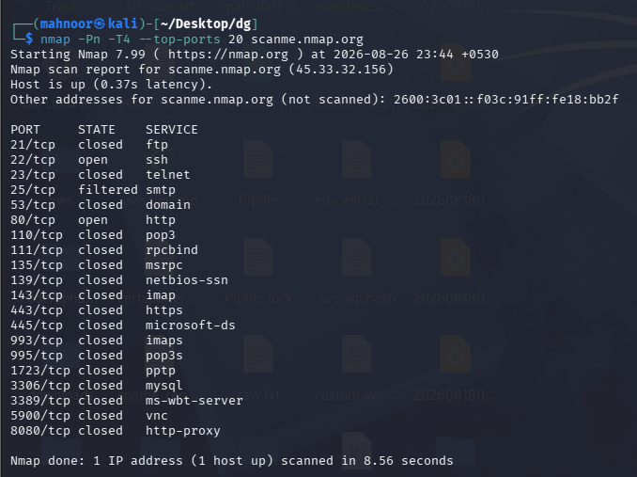
Figure 5: Nmap scan of the top 20 ports on scanme.nmap.org
Port | State | Service
21/tcp | closed | ftp
22/tcp | open | ssh
23/tcp | closed | telnet
25/tcp | filtered | smtp
53/tcp | closed | domain
80/tcp | open | http
443/tcp | closed | https
3389/tcp | closed | ms-wbt-server

Next, I added the -sV flag, which tells Nmap to also detect the exact software version running behind each open port. This is more detailed than a plain scan:
nmap -Pn -T4 -sV --top-ports 20 scanme.nmap.org
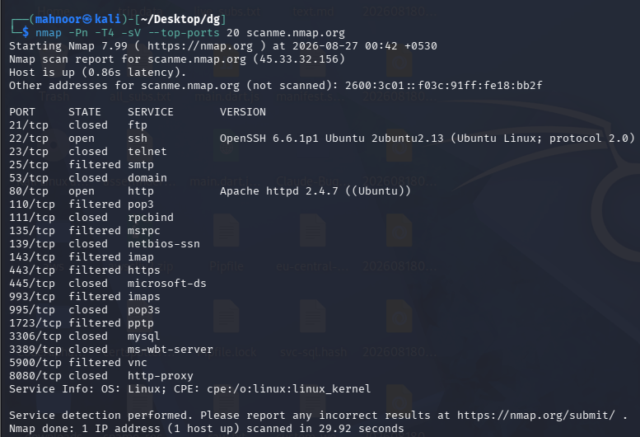
Figure 6: Service and version detection scan (-sV) on scanme.nmap.org
Port | State | Service | Version / Note
22/tcp | open | ssh | OpenSSH 6.6.1p1 (Ubuntu Linux)
80/tcp | open | http | Apache httpd 2.4.7 (Ubuntu)

As an extra step, I also ran a focused scan on just three important ports (22, 80 and 443) with version detection, to practice narrowing down a scan instead of checking every port:
nmap -Pn -T4 -sV -p 22,80,443 scanme.nmap.org
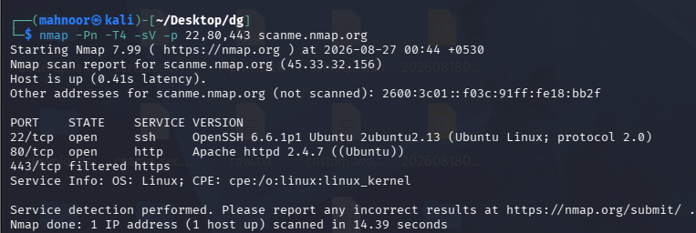
Figure 7: Focused Nmap scan on ports 22, 80 and 443

What I identified from this task
- Open ports on scanme.nmap.org: 22 (SSH) and 80 (HTTP)
- Services and versions: OpenSSH 6.6.1p1 on Ubuntu, and Apache httpd 2.4.7 on Ubuntu
- Port 443 (HTTPS) was closed/filtered, meaning the server does not serve encrypted web traffic on that host

3.3 Task 6: Packet Tracer LAN Setup
For this task, I used Cisco Packet Tracer to build a very small local area network (LAN) with two computers connected through one switch. This is the most basic building block of any office or home network.
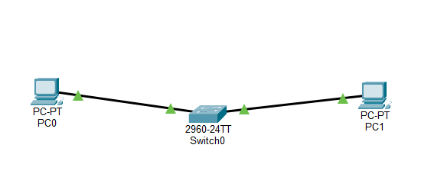
Figure 8: LAN topology – PC0 and PC1 connected through Switch0
I gave each PC a static IP address from the same subnet (192.168.1.0/24) so that they could talk to each other directly through the switch, without needing a router.
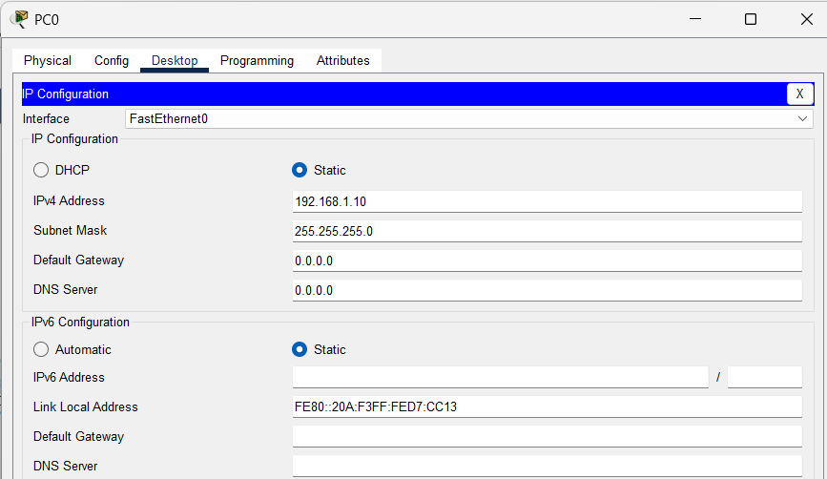
Figure 9: IP configuration of PC0 (192.168.1.10)
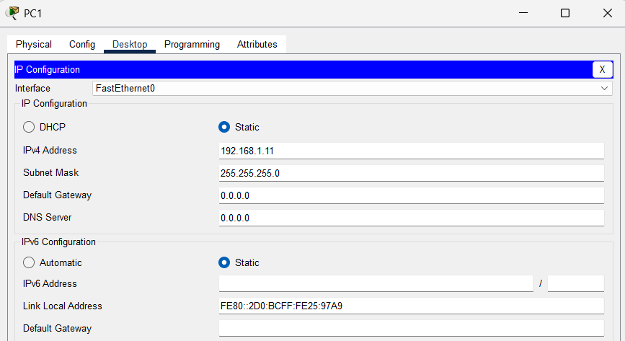
Figure 10: IP configuration of PC1 (192.168.1.11)
After the IP addresses were set, I tested the connection by pinging PC1 from PC0's command prompt. The ping was successful, which proved that both computers were correctly connected and configured on the same LAN.

What I learned from this task
- How to add end devices and a switch in Packet Tracer and cable them together
- How to assign static IP addresses and a subnet mask to a device
- How the ping command is used to test basic connectivity between two devices

3.4 Task 7: Man-in-the-Middle (MITM) Concept Simulation
This task was only a safe, conceptual simulation to understand how a MITM attack looks from a network point of view — no real attack tool was used. I built a small network with a Victim PC, an Attacker PC, a Switch and a Router, so that both PCs sit on the same LAN and the router represents the gateway to the outside world (for example, the internet).
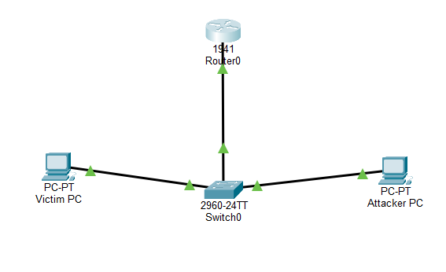
Figure 11: MITM lab topology – Victim PC and Attacker PC connected via Switch to Router0
I assigned static IP addresses to each device so the topology matches a real small office network: the Victim PC, the Attacker PC, and the Router acting as the default gateway.
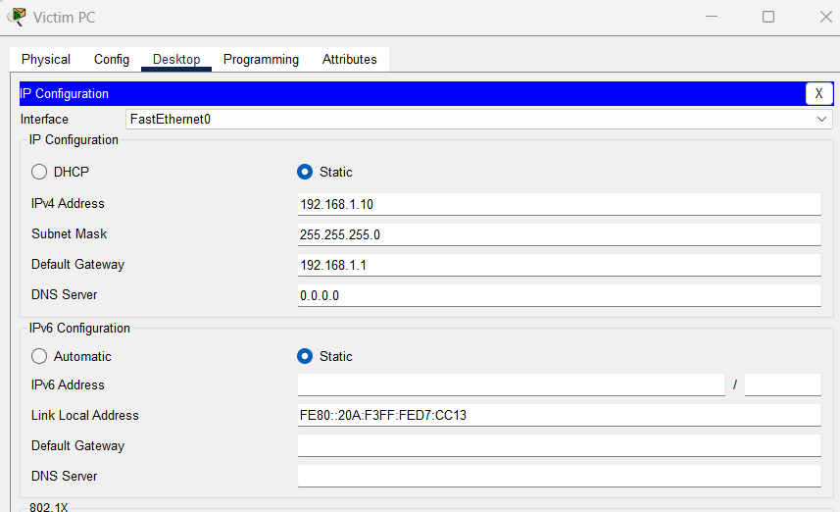
Figure 12: Victim PC IP configuration (192.168.1.10, gateway 192.168.1.1)
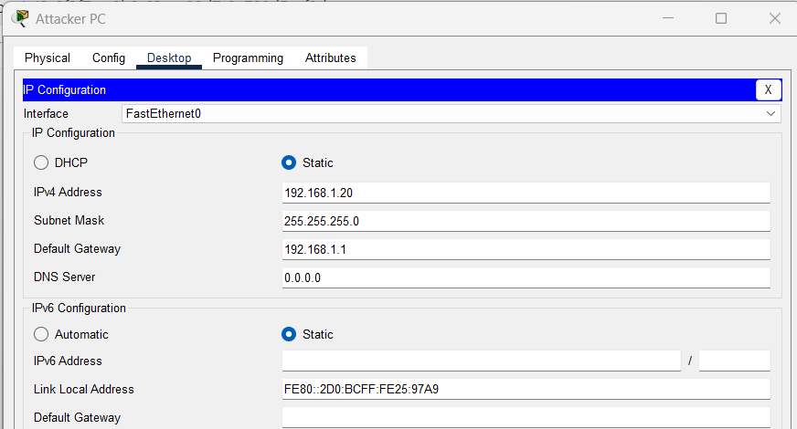
Figure 13: Attacker PC IP configuration (192.168.1.20, gateway 192.168.1.1)
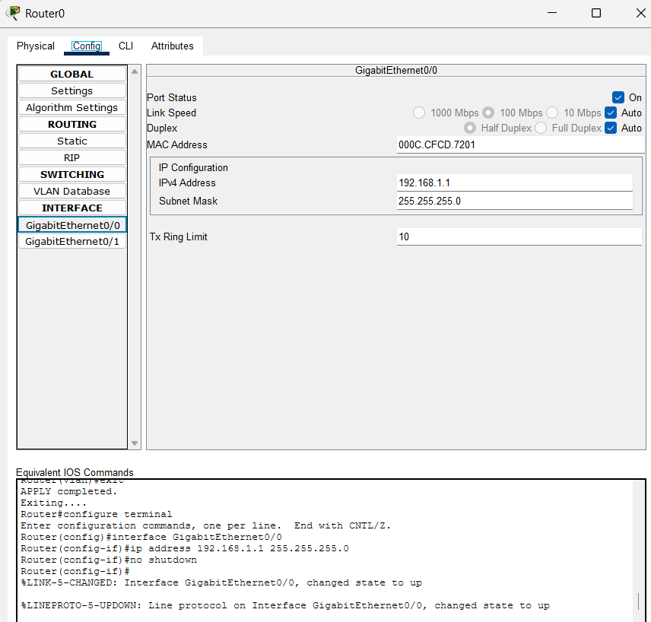
Figure 14: Router0 configuration on interface GigabitEthernet0/0 (192.168.1.1)
Once the addressing was in place, I tested basic reachability. First a quick ping check confirmed replies were coming back correctly on the network:
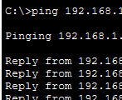
Figure 15: Initial ping reply check on the LAN
Then I ran a full ping test from the Victim PC to the Router (gateway) and observed the traffic from the Attacker PC's side as well. Both showed successful replies with 0% packet loss, confirming that the Victim, Attacker and Router could all communicate normally over the shared switch — this is exactly the kind of shared network an attacker would need to be positioned on to attempt a MITM attack in real life.
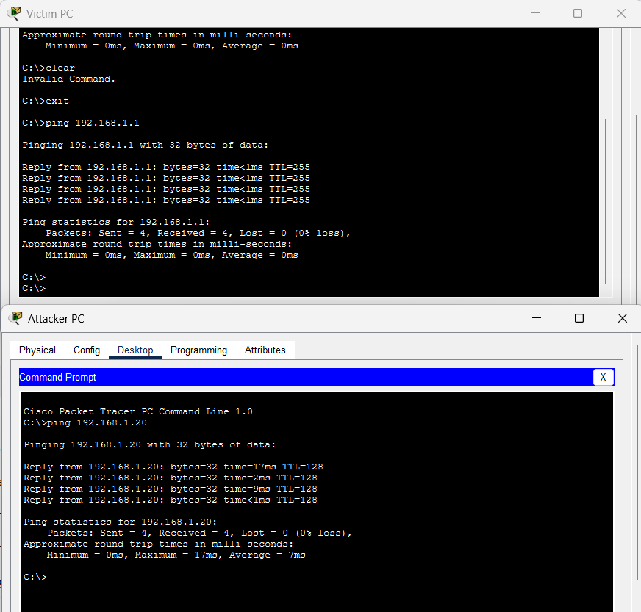
Figure 16: Ping results from Victim PC and Attacker PC confirming connectivity on the shared LAN

What is MITM (in simple words)
Man-in-the-Middle means an attacker gets a position in the middle of two devices that are talking to each other, such as a victim's computer and the router. Because normal traffic on a switch can sometimes be intercepted (for example using ARP spoofing in a real attack), the attacker can quietly read or alter the data passing between the victim and the internet, without the victim knowing anything is wrong.

How the attacker sits in between
In this simulation, the Attacker PC, Victim PC and Router are all connected to the same switch, which means they all share the same local network. In a real attack, the attacker would trick the switch and the victim's computer into sending traffic through the attacker's machine first, before it goes to the router. My lab only shows the network layout and normal connectivity, not the actual interception technique, to keep the exercise safe.

Real-world example
A very common real-world example is public Wi-Fi, such as in a cafe or airport. An attacker connected to the same Wi-Fi can try to position themselves between other users and the Wi-Fi router, and capture unencrypted data such as login details.

Risks of MITM
- Data theft: private messages, files or personal information can be read by the attacker
- Password capture: login credentials can be stolen if the connection is not encrypted
- Session hijacking: an attacker could take over an already logged-in session

Prevention
- Use HTTPS websites, which encrypt the data between the browser and the server
- Use a VPN, especially on public or unknown Wi-Fi networks
- Avoid using open, unsecured Wi-Fi for sensitive activities like online banking
- Keep operating systems and browsers updated with the latest security patches

4. Tools Used – Summary

Wireshark
A free packet-capturing and analysis tool. I used it to capture live traffic on my network and study DNS requests and encrypted (TLS/HTTPS) traffic.

Nmap
A free network scanning tool. I used it to check open ports and detect running services and their versions on the safe practice target scanme.nmap.org.

Cisco Packet Tracer
A free network simulation tool by Cisco. I used it to build small LAN topologies, assign IP addresses, and test connectivity with the ping command, including a safe conceptual MITM topology.

5. Learnings and Conclusion
This week's task helped me understand networking concepts in a much more practical way compared to just reading theory. By using Wireshark, I learned how real traffic looks on the wire and how DNS and HTTPS actually work behind the scenes. By using Nmap, I learned how scanning is done responsibly on a target that allows it, and how open ports and service versions can reveal information about a server. By using Cisco Packet Tracer, I got hands-on practice with building small networks, assigning IP addresses, and testing connectivity.
I also learned the basic concepts behind common attacks such as MITM, DoS and packet sniffing, along with simple, practical ways to prevent them, such as using HTTPS, VPNs and firewalls. Overall, Week 2 gave me a stronger foundation in both networking and basic cybersecurity concepts, and I am looking forward to building on these skills in the coming weeks.

