DG INTERNS HUB
CYBERSECURITY INTERNSHIP PROGRAM

WEEK 1 ASSIGNMENT REPORT
Networking Fundamentals

Prepared by: Mah Noor
Cohort: DG Interns Hub – Cybersecurity Track
Submission Date: 22 August 2026

Table of Contents

1. Objective 3
2. The OSI Model 3
3. The TCP/IP Model 4
4. Core Networking Protocols 5
5. IP Addressing 6
6. Practical Work – Network Commands 7
7. Practical Work – Cisco Packet Tracer Simulation 8
8. Key Learnings 10

PART 1

Objective
The goal of Week 1 of the DG Interns Hub Cybersecurity Internship is to build a strong foundation in computer networking and to understand how real-world systems communicate with each other. Since networking is the backbone of every cybersecurity discipline — from penetration testing to incident response — this week focuses on the theoretical models that describe network communication, the protocols that make the internet function, and hands-on practice using real network commands and Cisco Packet Tracer.
This report documents the theoretical research and practical exercises completed during Week 1, including screenshots of live command output and a simulated network built in Cisco Packet Tracer.
PART 2

The OSI Model
The Open Systems Interconnection (OSI) Model is a conceptual framework that standardizes how different networking systems communicate, dividing the process into seven distinct layers. Each layer has a specific function and hands off data to the layer above or below it.
Layer | Function | Real-Life Example
7. Application | Provides network services directly to end-user applications. | Web browsers, email clients (e.g., loading a webpage)
6. Presentation | Translates, encrypts, and compresses data for the application layer. | SSL/TLS encryption, JPEG/PNG image formatting
5. Session | Establishes, manages, and terminates connections (sessions) between devices. | A video call staying connected during a Zoom meeting
4. Transport | Ensures reliable, end-to-end delivery of data; handles segmentation. | TCP ensuring a file download arrives complete and in order
3. Network | Handles logical addressing and routing of packets across networks. | A router deciding the best path for data between cities
2. Data Link | Handles physical addressing (MAC) and error detection on the local link. | A switch forwarding frames to the correct device on a LAN
1. Physical | Transmits raw bits over a physical medium (cables, radio waves). | Ethernet cables, Wi-Fi signals, fiber optics

Understanding the OSI Model helps in troubleshooting network issues by isolating the layer where a problem occurs — for example, a cable fault is a Physical Layer issue, while a website not loading despite an active connection could be an Application Layer issue.

The TCP/IP Model
The TCP/IP Model is the practical, four-layer model that the modern internet actually runs on. It condenses the seven OSI layers into four, but achieves the same overall purpose: enabling reliable communication between devices.
TCP/IP Layer | OSI Equivalent | Examples
4. Application | Combines OSI's Application, Presentation, and Session layers | HTTP, HTTPS, FTP, DNS, SMTP
3. Transport | Same as OSI Transport Layer | TCP, UDP
2. Internet | Equivalent to OSI Network Layer | IP, ICMP, ARP
1. Network Access | Combines OSI's Data Link and Physical layers | Ethernet, Wi-Fi (802.11)

Comparison Summary:
- The OSI Model is a theoretical, 7-layer reference model used mainly for teaching and troubleshooting.
- The TCP/IP Model is a practical, 4-layer model that is actually implemented in real networks and the internet.
- Every protocol used in TCP/IP (like HTTP, TCP, IP) maps onto one or more layers of the OSI Model.

Core Networking Protocols
Task 3 required studying four essential protocols that power everyday internet communication.

HTTP / HTTPS
What it does: HTTP (HyperText Transfer Protocol) governs how web browsers and servers exchange data such as webpages. HTTPS is the secure version, encrypting the data using SSL/TLS so it cannot be intercepted or tampered with.
Where it is used: Every time a website is visited (e.g., https://www.google.com), the browser uses HTTPS to securely request and receive the page content.

FTP (File Transfer Protocol)
What it does: FTP is used to transfer files between a client and a server over a network, supporting uploading, downloading, and directory management.
Where it is used: Website administrators use FTP (or its secure version SFTP) to upload files to a web server, and organizations use it to share large files internally.

DNS (Domain Name System)
What it does: DNS translates human-readable domain names (like google.com) into machine-readable IP addresses (like 142.250.190.14), acting as the 'phonebook of the internet.'
Where it is used: Used every time a URL is typed into a browser — the DNS system resolves it to the correct server IP address before the connection is made.

DHCP (Dynamic Host Configuration Protocol)
What it does: DHCP automatically assigns IP addresses, subnet masks, gateways, and DNS servers to devices joining a network, removing the need for manual configuration.
Where it is used: Home routers and office networks use DHCP so that every laptop, phone, or IoT device connecting to Wi-Fi automatically receives a valid, unique IP address.

IP Addressing

What is an IP Address?
An IP (Internet Protocol) address is a unique numerical label assigned to every device connected to a network. It allows devices to locate and communicate with each other, similar to how a postal address identifies a house. The most common formats are IPv4 (e.g., 192.168.1.10) and IPv6 (a longer, hexadecimal format designed to handle the growing number of internet-connected devices).

Public vs. Private IP Addresses
Type | Description | Example Range
Private IP | Used within local networks (homes, offices); not routable on the internet. | 192.168.0.0 – 192.168.255.255
Public IP | Assigned by an ISP; unique across the entire internet and used to communicate externally. | Assigned dynamically by ISP

Basic Subnetting Concept
Subnetting is the process of dividing a large network into smaller, more manageable sub-networks (subnets). This is done using a subnet mask (e.g., 255.255.255.0), which separates the IP address into a network portion and a host portion.
- It improves network performance by reducing broadcast traffic.
- It enhances security by isolating groups of devices from one another.
- Example: 192.168.1.0/24 with subnet mask 255.255.255.0 allows for 254 usable host addresses on that subnet.

PART 3

Network Commands
The following commands were executed in the terminal/command prompt to observe real network behavior, and the output was captured via screenshot.

1. ping google.com
Purpose: Tests connectivity to a remote host and measures round-trip time by sending ICMP echo requests.
📷 SCREENSHOT
Terminal output of 'ping google.com' showing reply times and packet statistics
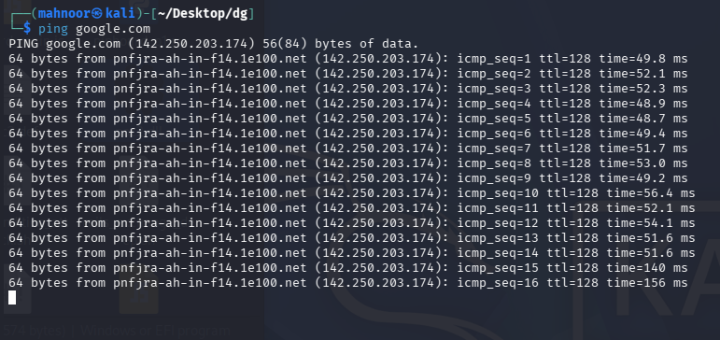

2. ipconfig / ifconfig
Purpose: Displays the current network configuration of the device — including IP address, subnet mask, and default gateway (ipconfig on Windows, ifconfig on Linux/macOS).
📷 SCREENSHOT
Terminal output of 'ipconfig' or 'ifconfig' showing IP address, subnet mask, and gateway
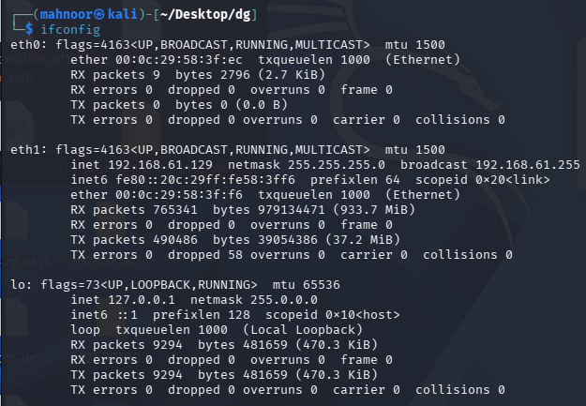

3. tracert google.com
Purpose: Traces the path data takes across multiple routers/hops to reach the destination server, useful for diagnosing where connectivity issues occur.
📷 SCREENSHOT
Terminal output of 'tracert google.com' showing each hop to the destination
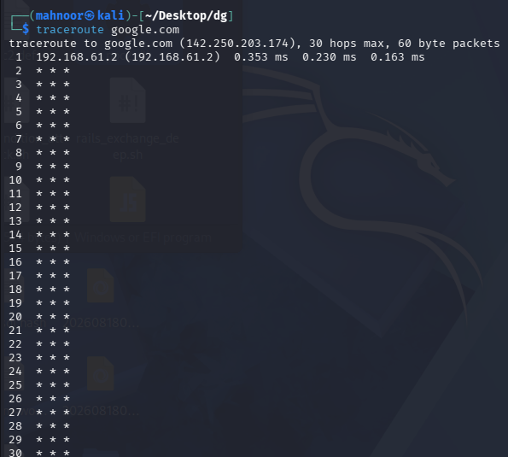

Network Simulation – Cisco Packet Tracer
A simple network was built and tested in Cisco Packet Tracer (free tool from Cisco NetAcad) to apply the theoretical concepts learned in Part 1.

Step 1: Installation
Created a free Cisco NetAcad account and downloaded/installed Cisco Packet Tracer.
📷 SCREENSHOT
Packet Tracer installed and open on the desktop
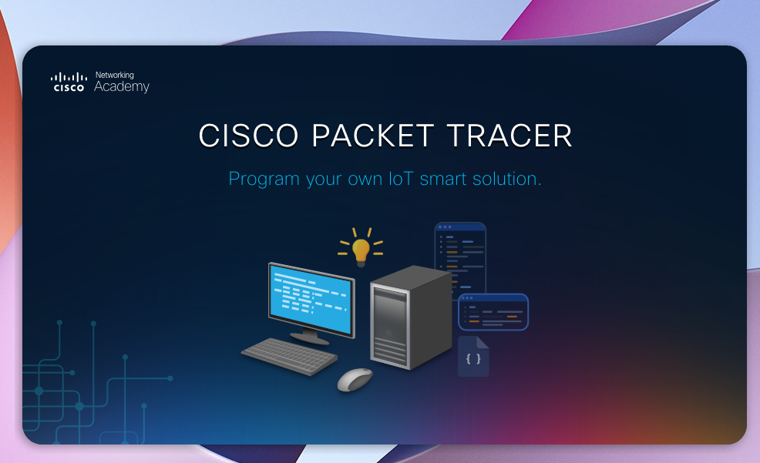

Step 2 & 3: Building and Connecting the Network
A basic topology was built consisting of a PC connected to a Switch, which is connected to a Router, using Copper Straight-Through cables:
- PC → Switch (Copper Straight-Through)
- Switch → Router (Copper Straight-Through)
📷 SCREENSHOT
Packet Tracer workspace showing PC – Switch – Router topology with cable connections
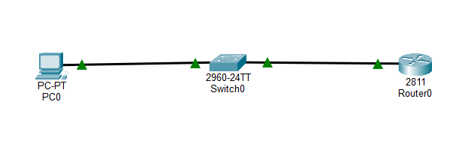

Step 4: IP Configuration
Device | IP Address | Subnet Mask / Gateway
PC | 192.168.1.10 | Subnet: 255.255.255.0 | Gateway: 192.168.1.1
Router | 192.168.1.1 | Interface configured as default gateway

📷 SCREENSHOT
PC and Router IP configuration windows in Packet Tracer showing the values above
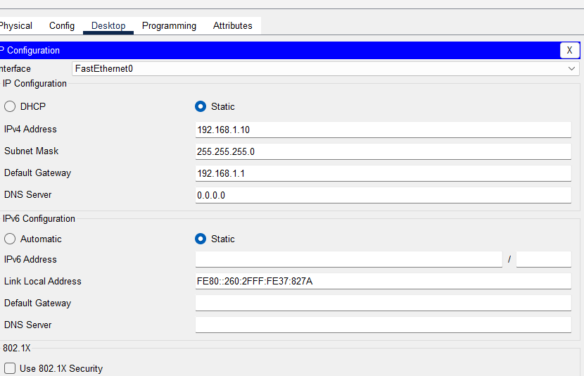

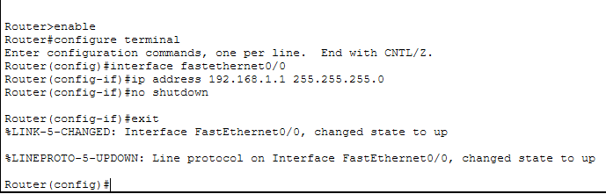

Step 5: Connectivity Test
From the PC's Command Prompt (within Packet Tracer), the command ping 192.168.1.1 was run to confirm that the PC could successfully reach the Router. A successful reply confirms the network was configured correctly.
📷 SCREENSHOT
Packet Tracer PC command prompt showing successful 'ping 192.168.1.1' replies
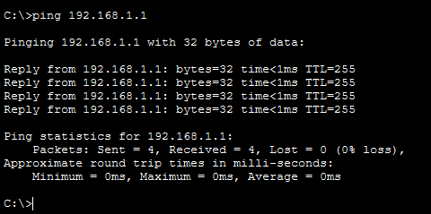

PART 4

Key Learnings
Completing Week 1 of the DG Interns Hub Cybersecurity Internship provided a solid, practical grounding in networking fundamentals. The key outcomes were:
- A clear understanding of how the OSI and TCP/IP models describe the journey of data across a network.
- Familiarity with core protocols (HTTP/HTTPS, FTP, DNS, DHCP) and their real-world roles.
- The ability to interpret IP addressing, distinguish public vs. private IPs, and grasp basic subnetting.
- Hands-on experience running real diagnostic commands (ping, ipconfig/ifconfig, tracert).
- Practical experience designing and testing a simple network topology in Cisco Packet Tracer.

This foundation in networking is essential for the cybersecurity path ahead — every future topic, from firewalls to penetration testing, builds directly on these fundamentals.

