

Functional Safety Concept Lane Assistance

**Document Version: [Version]**

**Template Version 1.0, Released on 2017-06-21**



# Document history

|  |  |  |  |
| --- | --- | --- | --- |
| Date | Version | Editor | Description |
| 6/7/18 | 1.0 | Yue | First attempt |
|  |  |  |  |
|  |  |  |  |
|  |  |  |  |
|  |  |  |  |

# Table of Contents

Document history

Table of Contents

Purpose of the Functional Safety Concept

Inputs to the Functional Safety Analysis

Safety goals from the Hazard Analysis and Risk Assessment

Preliminary Architecture

Description of architecture elements

Functional Safety Concept

Functional Safety Analysis

Functional Safety Requirements

Refinement of the System Architecture

Allocation of Functional Safety Requirements to Architecture Elements

Warning and Degradation Concept

# Purpose of the Functional Safety Concept

# Inputs to the Functional Safety Concept

## Safety goals from the Hazard Analysis and Risk Assessment

|  |  |
| --- | --- |
| **ID** | **Safety Goal** |
| Safety_Goal_01 | The oscillating torque to the steering wheel from the LDW function shall be limited. |
| Safety_Goal_02 | Lane Keeping Assistance (LKA) function shall apply an oscillating steering torque when driver leaving the steering wheel with both hands |
| Safety_Goal_03 | Lane Keeping Assistance (LKA) function shall apply an oscillating steering torque and deactivated when the sensor cannot detect road |
| Safety_Goal_04 | Lane Keeping Assistance (LKA) function shall apply an oscillating steering torque and deactivated when the road mark is not clear. |

## Preliminary Architecture

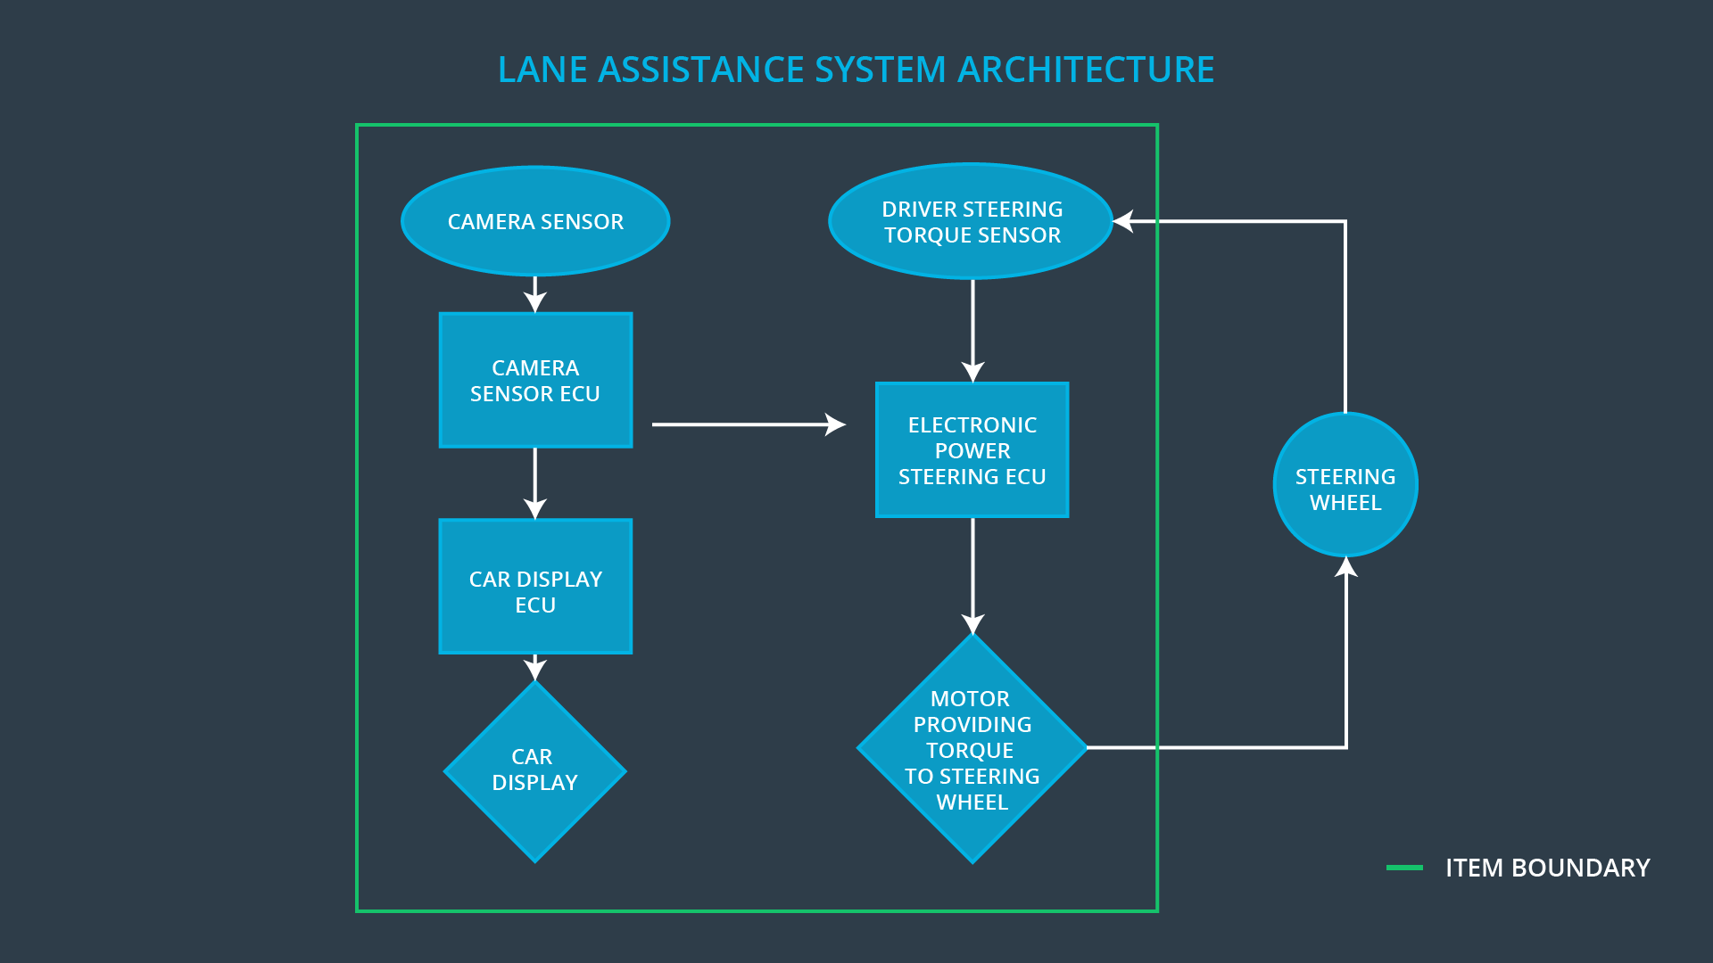

### Description of architecture elements

|  |  |
| --- | --- |
| **Element** | **Description** |
| Camera Sensor | Collect road images data. |
| Camera Sensor ECU | Identifying accidental departure from the road and sending information to the Car Display ECU and the Electronic Power Steering ECU. |
| Car Display | Display information to the driver. |
| Car Display ECU | Generate messages based on the information from the Camera Sensor ECU. |
| Driver Steering Torque Sensor | Measure the torque of the steering wheel. |
| Electronic Power Steering ECU | Ensure lane departure warning oscillating torque amplitude is below max torque amplitude. |
| Motor | Providing torque to steering wheel. |

# Functional Safety Concept

The functional safety concept consists of:

* Functional safety analysis
* Functional safety requirements
* Functional safety architecture
* Warning and degradation concept

## Functional Safety Analysis

|  |  |  |  |
| --- | --- | --- | --- |
| **Malfunction ID** | **Main Function of the Item Related to Safety Goal Violations** | **Guidewords (NO, WRONG, EARLY, LATE, MORE, LESS)** | **Resulting Malfunction** |
| Malfunction_01 | Lane Departure Warning (LDW) function shall apply an oscillating steering torque to provide the driver a haptic feedback | MORE | The torque amplitude applied by the system is above the limit. |
| Malfunction_02 | Lane Departure Warning (LDW) function shall apply an oscillating steering torque to provide the driver a haptic feedback | MORE | The torque frequency applied by the system is above the limit |
| Malfunction_03 | Lane Keeping Assistance (LKA) function shall apply the steering torque when active in order to stay in ego lane | LATE | The torque is applied too late and did not give the driver enough time to react. |

## Functional Safety Requirements

Lane Departure Warning (LDW) Requirements:

|  |  |  |  |  |
| --- | --- | --- | --- | --- |
| **ID** | **Functional Safety Requirement** | **ASIL** | **Fault Tolerant Time Interval** | **Safe State** |
| Functional  Safety  Requirement  01-01 | The Electronic Power Steering ECU shall ensure that the oscillating torque amplitude requested by the LDW function is below Max_Torque_Amplitude | C | 50ms | LDW will set the oscillating torque amplitude to 0. |
| Functional  Safety  Requirement  01-02 | The electronic power steering ECU shall eusure that the lane departure warning oscillating torque frequency is below Max_Torque_Frequency | C | 50ms | LDW will set the oscillating torque frequency to 0. |

Lane Departure Warning (LDW) Verification and Validation Acceptance Criteria:

|  |  |  |
| --- | --- | --- |
| **ID** | **Validation Acceptance**  **Criteria and Method** | **Verification Acceptance**  **Criteria and Method** |
| Functional  Safety  Requirement  01-01 | Test and validate that the Max_Torque_Amplitude chosen is low enough that the driver dose not lost control of the car. | Verify that the system does turn off in time if Max_Torque_Amplitude is exceeded. |
| Functional  Safety  Requirement  01-02 | Test and validate that the Max_Torque_Frequency chosen is low enough that the driver dose not lost control of the car. | Verify that the system does turn off in time if Max_Torque_Frequency is exceeded. |

**[Instructions: Fill in the functional safety requirements for the lane keeping assistance]**

Lane Keeping Assistance (LKA) Requirements:

|  |  |  |  |  |
| --- | --- | --- | --- | --- |
| **ID** | **Functional Safety Requirement** | **ASIL** | **Fault Tolerant Time Interval** | **Safe State** |
| Functional  Safety  Requirement  02-01 | The electronic power steering ECU shall ensure that the lane keeping assistance torque is applied for only Max_Duration. | B | 500ms | Turn off the system. |

Lane Keeping Assistance (LKA) Verification and Validation Acceptance Criteria:

|  |  |  |
| --- | --- | --- |
| **ID** | **Validation Acceptance**  **Criteria and Method** | **Verification Acceptance**  **Criteria and Method** |
| Functional  Safety  Requirement  02-01 | Test and validate that the Max_Duration | Verify that the system does turn off and warn the driver if the Max_Duration is exceeded. |

## Refinement of the System Architecture

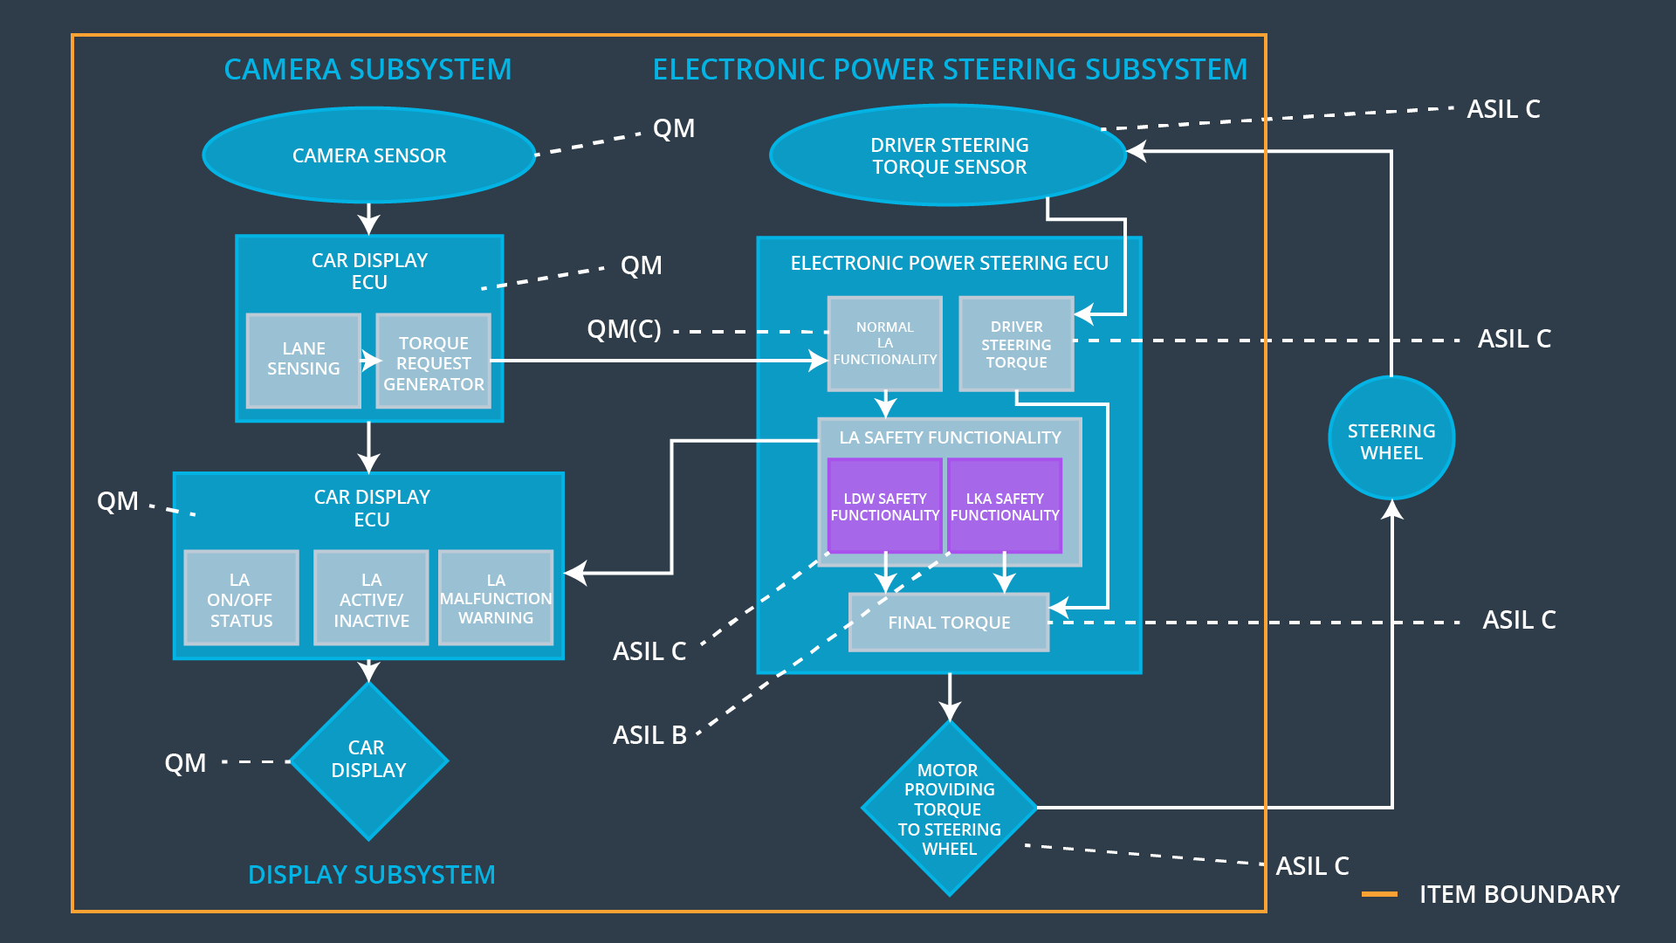

## Allocation of Functional Safety Requirements to Architecture Elements

|  |  |  |  |  |
| --- | --- | --- | --- | --- |
| **ID** | **Functional Safety Requirement** | **Electronic Power Steering ECU** | **Camera ECU** | **Car Display ECU** |
| Functional  Safety  Requirement  01-01 | The electronic power steering ECU shall ensure that the lane departure warning oscillation torque amplitude is below Max_Torque_Frequency | **X** |  |  |
| Functional  Safety  Requirement  01-02 | The electronic power steering ECU shall eusure that the lane departure warning oscillating torque frequency is below Max_Torque_Frequency | **X** |  |  |
| Functional  Safety  Requirement  02-01 | The electronic power steering ECU shall ensure that the lane keeping assistance torque is applied within Max_Duration | **X** |  |  |

## Warning and Degradation Concept

|  |  |  |  |  |
| --- | --- | --- | --- | --- |
| **ID** | **Degradation Mode** | **Trigger for Degradation Mode** | **Safe State invoked?** | **Driver Warning** |
| WDC-01 | Turn off the torque and warning. | Malfunction_01  Malfunction_02 | YES | Warning light on dashboard with warning noise. |
| WDC-02 | Turn system off and warning. | Malfunction_03 | YES | Warning light on dashboard with warning noise. |