

Technical Safety Concept Lane Assistance

**Document Version: [Version]**

**Template Version 1.0, Released on 2017-06-21**



# Document history

|  |  |  |  |
| --- | --- | --- | --- |
| Date | Version | Editor | Description |
| 2018/9/26 | 1.0 | Jiang Yue | First attempt |
|  |  |  |  |
|  |  |  |  |
|  |  |  |  |
|  |  |  |  |

# 

# Table of Contents

Document history

Table of Contents

Purpose of the Technical Safety Concept

Inputs to the Technical Safety Concept

Functional Safety Requirements

Refined System Architecture from Functional Safety Concept

Functional overview of architecture elements

Technical Safety Concept

Technical Safety Requirements

Refinement of the System Architecture

Allocation of Technical Safety Requirements to Architecture Elements

Warning and Degradation Concept

# Purpose of the Technical Safety Concept

**[Instructions: Answer what is the purpose of a technical safety concept?]**

The Technical Safety Concept defines how the subsystems interact at the message level and describes how the ECUs communicate with each other.

# Inputs to the Technical Safety Concept

## Functional Safety Requirements

|  |  |  |  |  |
| --- | --- | --- | --- | --- |
| **ID** | **Functional Safety Requirement** | **ASIL** | **Fault Tolerant Time Interval** | **Safe State** |
| Functional  Safety  Requirement  01-01 | The Electronic Power Steering ECU shall ensure that the oscillating torque amplitude requested by the LDW function is below Max_Torque_Amplitude | C | 50 ms | LDW will set the oscillating torque amplitude to 0. |
| Functional  Safety  Requirement  01-02 | The electronic power steering ECU shall eusure that the lane departure warning oscillating torque frequency is below Max_Torque_Frequency | C | 50 ms | LDW will set the oscillating torque frequency to 0. |
| Functional  Safety  Requirement  02-01 | The electronic power steering ECU shall ensure that the lane keeping assistance torque is applied within Max_Duration | B | 500 ms | Turn off the system and warning. |

## Refined System Architecture from Functional Safety Concept

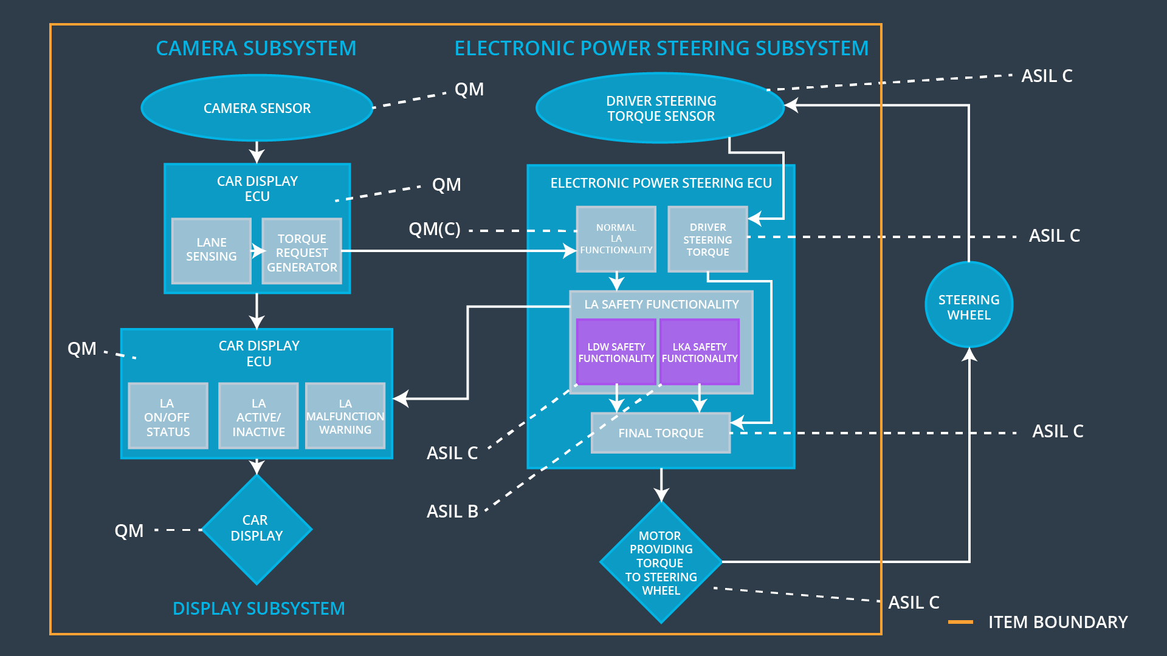

### Functional overview of architecture elements

|  |  |
| --- | --- |
| **Element** | **Description** |
| Camera Sensor | Capture road image data and send to Camera sensor ECU. |
| Camera Sensor ECU - Lane Sensing | Identifying accidental departure from the road and sending information to the Car Display ECU |
| Camera Sensor ECU - Torque request generator | Generator torque and send to Electronic Power Steering ECU |
| Car Display | Display the messages and warnings send from Car Display ECU to the driver |
| Car Display ECU - Lane Assistance On/Off Status | Indicate the status of the Lane Assistance Functionality |
| Car Display ECU - Lane Assistant Active/Inactive | Indicate if the Lane Assistance Functionality is active |
| Car Display ECU - Lane Assistance malfunction warning | Indicate if the Lane Assistance Functionality is malfunction |
| Driver Steering Torque Sensor | Measure the steering wheel torque applied by the driver |
| Electronic Power Steering (EPS) ECU - Driver Steering Torque | Measure the steering wheel torque applied by the EPS |
| EPS ECU - Normal Lane Assistance Functionality | Receive torque request from Camera Sensor ECU |
| EPS ECU - Lane Departure Warning Safety Functionality | Send malfunction warning to Car Display ECU. send LDW Torque Request and LDW Action Status to Final Torque ensure the torque amplitude and frequency is below limit. |
| EPS ECU - Lane Keeping Assistant Safety Functionality | Receive Primary_LDW_Torque_Request and ensure Assistance function is not exceed Max_Duration |
| EPS ECU - Final Torque | Combine torque request and send to motor |
| Motor | Apply torque to steering wheel |

# Technical Safety Concept

## Technical Safety Requirements

**Lane Departure Warning (LDW) Requirements:**

Functional Safety Requirement 01-01 with its associated system elements

(derived in the functional safety concept)

|  |  |  |  |  |
| --- | --- | --- | --- | --- |
| **ID** | **Functional Safety Requirement** | **Electronic Power Steering ECU** | **Camera ECU** | **Car Display ECU** |
| Functional  Safety  Requirement  01-01 | The lane keeping item shall ensure that the lane departure oscillating torque amplitude is below Max_Torque_Amplitude | X |  |  |

Technical Safety Requirements related to Functional Safety Requirement 01-01 are:

|  |  |  |  |  |  |
| --- | --- | --- | --- | --- | --- |
| **ID** | **Technical Safety Requirement** | **ASIL** | **Fault Tolerant Time Interval** | **Architecture Allocation** | **Safe State** |
| Technical  Safety  Requirement  01 | The LDW safety component shall ensure that the amplitude of the 'LDW_Torque_Request' sent to the 'Final electronic power steering Torque' component is below 'Max_Torque_Amplitude. | C | 50 ms | LDW Safety | LDW torque amplitude shall set to 0. |
| Technical  Safety  Requirement  02 | As soon as the LDW function deactivates the LDW feature, the 'LDW Safety' software block shall send a signal to the car display ECU to turn on a warning light. | C | 50 ms | LDW Safety | LDW torque amplitude shall set to 0. |
| Technical  Safety  Requirement  03 | As soon as a failure is detected by the LDW function, it shall deactivate the LDW feature and the 'LDW_Torque_Request' shall be set to zero. | C | 50 ms | LDW Safety | LDW torque amplitude shall set to 0. |
| Technical  Safety  Requirement  04 | The validity and integrity of the data transmission for 'LDW_Torque_Request' signal shall be ensured. | C | 50 ms | Data Transmission Integrity Check | LDW torque amplitude shall set to 0. |
| Technical  Safety  Requirement  05 | Memory test shall be conducted at start up of the EPS ECU to check for any faults in memory. | A | ignition cycle | Memery Test | LDW torque amplitude shall set to 0. |

Functional Safety Requirement 01-2 with its associated system elements

(derived in the functional safety concept)

|  |  |  |  |  |
| --- | --- | --- | --- | --- |
| **ID** | **Functional Safety Requirement** | **Electronic Power Steering ECU** | **Camera ECU** | **Car Display ECU** |
| Functional  Safety  Requirement  01-02 | The lane keeping item shall ensure that the lane departure oscillating torque frequency is below Max_Torque_Frequency | X |  |  |

Technical Safety Requirements related to Functional Safety Requirement 01-02 are:

|  |  |  |  |  |  |
| --- | --- | --- | --- | --- | --- |
| **ID** | **Technical Safety Requirement** | **ASIL** | **Fault Tolerant Time Interval** | **Architecture Allocation** | **Safe State** |
| Technical  Safety  Requirement  01 | The LDW safety component shall ensure that the amplitude of the 'LDW_Torque_Request' sent to the 'Final electronic power steering Torque' component is below 'Max_Torque_ Frequency | C | 50 ms | LDW Safety | LDW torque frequency shall set to 0. |
| Technical  Safety  Requirement  02 | As soon as the LDW function deactivates the LDW feature, the 'LDW Safety' software block shall send a signal to the car display ECU to turn on a warning light. | C | 50 ms | LDW Safety | LDW torque frequency shall set to 0. |
| Technical  Safety  Requirement  03 | As soon as a failure is detected by the LDW function, it shall deactivate the LDW feature and the 'LDW_Torque_Request' shall be set to zero. | C | 50 ms | LDW Safety | LDW torque frequency shall set to 0. |
| Technical  Safety  Requirement  04 | The validity and integrity of the data transmission for 'LDW_Torque_Request' signal shall be ensured. | C | 50 ms | Data Transmission Integrity Check | LDW torque frequency shall set to 0. |
| Technical  Safety  Requirement  05 | Memory test shall be conducted at start up of the EPS ECU to check for any faults in memory. | A | ignition cycle | Memery Test | LDW torque frequency shall set to 0. |

**Lane Keeping Assistance (LKA) Requirements:**

Functional Safety Requirement 02-1 with its associated system elements

(derived in the functional safety concept)

|  |  |  |  |  |
| --- | --- | --- | --- | --- |
| **ID** | **Functional Safety Requirement** | **Electronic Power Steering ECU** | **Camera ECU** | **Car Display ECU** |
| Functional  Safety  Requirement  02-01 | The lane keeping item shall ensure that the lane keeping assistance torque is applied for only Max_Duration | X |  |  |

Technical Safety Requirements related to Functional Safety Requirement 02-01 are:

|  |  |  |  |  |  |
| --- | --- | --- | --- | --- | --- |
| **ID** | **Technical Safety Requirement** | **ASIL** | **Fault Tolerant Time Interval** | **Allocation to Architecture** | **Safe State** |
| Technical  Safety  Requirement  01 | The lane keeping item shall ensure that the lane keeping assistance torque is applied less than Max_Duration | B | 500 ms | LKA Safety | LKA torque request shall set to 0 |
| Technical  Safety  Requirement  02 | As soon as the LKA function deactivates the LKA feature, the 'LKA Safety' software block shall send a signal to the car display ECU to turn on a warning light. | B | 500 ms | LKA Safety | LKA torque request shall set to 0 |
| Technical  Safety  Requirement  03 | As soon as a failure is detected by the LDW function, it shall deactivate the LDW feature and the 'LKA_Torque_Request' shall be set to zero. | B | 500 ms | LKA Safety | LKA torque request shall set to 0 |
| Technical  Safety  Requirement  04 | The validity and integrity of the data transmission for 'LKA_Torque_Request' signal shall be ensured. | B | 500 ms | Data Transmission Integrity Check | LKA torque request shall set to 0 |
| Technical  Safety  Requirement  05 | Memory test shall be conducted at start up of the EPS ECU to check for any faults in memory. | B | ignition cycle | Memery Test | LKA torque request shall set to 0 |

## Refinement of the System Architecture

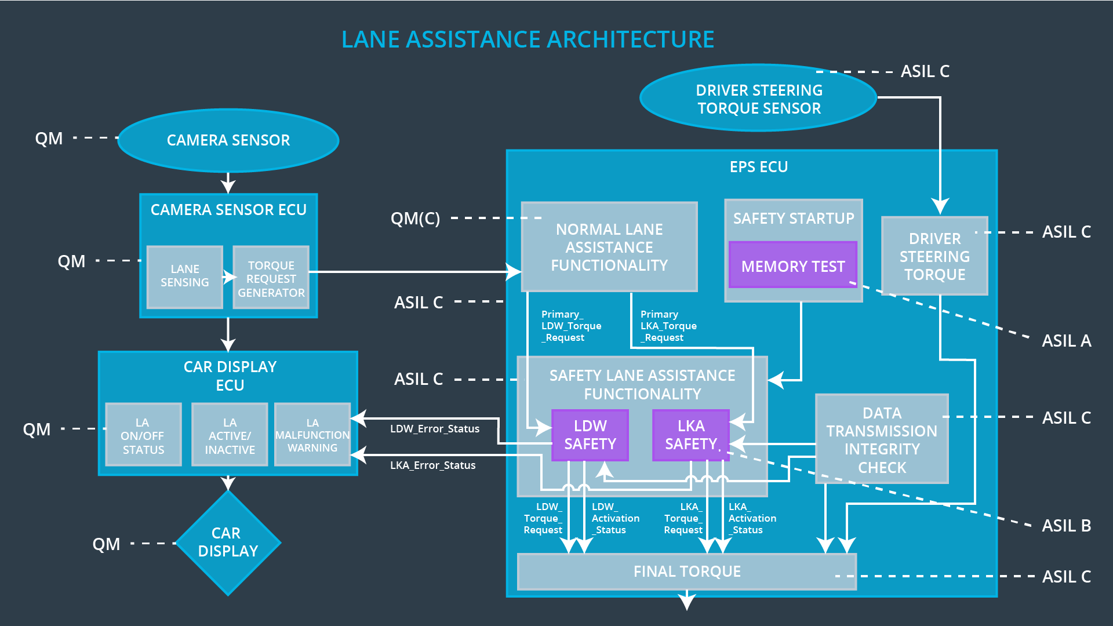

## Allocation of Technical Safety Requirements to Architecture Elements

|  |  |  |  |  |
| --- | --- | --- | --- | --- |
| **ID** | **Functional Safety Requirement** | **Electronic Power Steering ECU** | **Camera ECU** | **Car Display ECU** |
| Technical  Safety  Requirement  01-01-01 | The LDW safety component shall ensure that the amplitude of the 'LDW_Torque_Request' sent to the 'Final electronic power steering Torque' component is below 'Max_Torque_Amplitude. | **X** |  |  |
| Technical  Safety  Requirement  01-01-02 | As soon as the LDW function deactivates the LDW feature, the 'LDW Safety' software block shall send a signal to the car display ECU to turn on a warning light. | **X** |  |  |
| Technical  Safety  Requirement  01-01-03 | As soon as a failure is detected by the LDW function, it shall deactivate the LDW feature and the 'LDW_Torque_Request' shall be set to zero. | **X** |  |  |
| Technical  Safety  Requirement  01-01-04 | The validity and integrity of the data transmission for 'LDW_Torque_Request' signal shall be ensured. | **X** |  |  |
| Technical  Safety  Requirement  01-01-05 | Memory test shall be conducted at start up of the EPS ECU to check for any faults in memory. | **X** |  |  |
| Technical  Safety  Requirement  01-02-01 | The LDW safety component shall ensure that the amplitude of the 'LDW_Torque_Request' sent to the 'Final electronic power steering Torque' component is below 'Max_Torque_ Frequency | **X** |  |  |
| Technical  Safety  Requirement  01-02-02 | As soon as the LDW function deactivates the LDW feature, the 'LDW Safety' software block shall send a signal to the car display ECU to turn on a warning light. | **X** |  |  |
| Technical  Safety  Requirement  01-02-03 | As soon as a failure is detected by the LDW function, it shall deactivate the LDW feature and the 'LDW_Torque_Request' shall be set to zero. | **X** |  |  |
| Technical  Safety  Requirement  01-02-04 | The validity and integrity of the data transmission for 'LDW_Torque_Request' signal shall be ensured. | **X** |  |  |
| Technical  Safety  Requirement  01-02-05 | Memory test shall be conducted at start up of the EPS ECU to check for any faults in memory. | **X** |  |  |
| Technical  Safety  Requirement  02-01-01 | The lane keeping item shall ensure that the lane keeping assistance torque is applied less than Max_Duration | **X** |  |  |
| Technical  Safety  Requirement  02-01-02 | As soon as the LKA function deactivates the LKA feature, the 'LKA Safety' software block shall send a signal to the car display ECU to turn on a warning light. | **X** |  |  |
| Technical  Safety  Requirement  02-01-03 | As soon as a failure is detected by the LDW function, it shall deactivate the LDW feature and the 'LKA_Torque_Request' shall be set to zero. | **X** |  |  |
| Technical  Safety  Requirement  02-01-04 | The validity and integrity of the data transmission for 'LKA_Torque_Request' signal shall be ensured. | **X** |  |  |
| Technical  Safety  Requirement  02-01-05 | Memory test shall be conducted at start up of the EPS ECU to check for any faults in memory. | **X** |  |  |

## Warning and Degradation Concept

|  |  |  |  |  |
| --- | --- | --- | --- | --- |
| **ID** | **Degradation Mode** | **Trigger for Degradation Mode** | **Safe State invoked?** | **Driver Warning** |
| WDC-01 | Turn off the torque and warning. | Malfunction_01  Malfunction_02 | YES | Warning light on dashboard with warning noise. |
| WDC-02 | Turn system off and warning. | Malfunction_03 | YES | Warning light on dashboard with warning noise. |