es1

Inherit shell functions in the two possible ways

1. As a shell function defined in parent shell
2. As a shell variable defined in parent shell

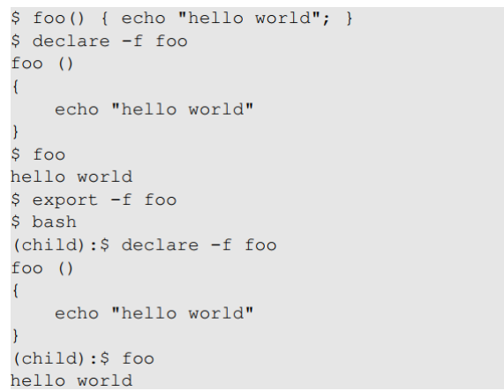

child non viene mostrato come scritta

export **-f** foo → questo lo esporta funzione

export foo → questo lo esporta come variabile

// esport come variabile, ma nel figlio prende come shell function :O

[06/14/21]seed@VM:~$ foo='() { echo "hello world"; }'

[06/14/21]seed@VM:~$ export foo

[06/14/21]seed@VM:~$ bash_shellshock

[06/14/21]seed@VM:~$ foo

hello world

[06/14/21]seed@VM:~$