Climate and water policy shape the groundwater-constrained growth frontier of a dryland metropolis: The case of Phoenix, Arizona

Josh Gilman^{1,*}, Jianguo Wu^{1,2,*}, Emilio Politti³, Sylvia Tramberend³

¹ School of Life Sciences, Arizona State University, Tempe, AZ 85287, USA

² School of Sustainability, Arizona State University, Tempe, AZ 85287, USA
³ International Institute for Applied Systems Analysis (IIASA), Schloßpl. 1, 2361 Laxenburg, Austria

*Corresponding author email: Jcgilman@asu.edu

*Corresponding author phone numbers: 208-246-9770

Josh Gilman ORCiD: 0000-0003-0468-2785

Jianguo Wu ORCiD: 0000-0002-1182-3024
Emilio Politti ORCiD: 0000-0003-2981-0325
Sylvia Tramberend ORCiD: 0000-0002-7024-1075

Abstract
Substantial urban expansion is expected in global drylands, where scarce water supplies are becoming increasingly uncertain. Although often portrayed as an external demographic forecast or a fixed carrying capacity, urban development capacity is a conditional outcome of hydrology, sustainability standards, and policy choices. We conceptualize development capacity as a groundwater-constrained population growth frontier, or the relationship between population and the number of years groundwater pumping can be sustained. We explore how this frontier changes under increasingly stringent groundwater sustainability standards, climate-related reductions in river flows, and policies. Using the WaterSim5 model, we simulated 24,300 factorial combinations of population growth, river flows, and water policies for the Phoenix Metropolitan Region, Arizona, through 2060. The median projected population declined from about 9.1 to 4.5 million as the number of years groundwater pumping could be sustained increased from 45 to 100 years, with the largest declines occurring above 80 years. Reduced river flows further contracted the frontier, although effects varied across groundwater standards and alternative policies. Agriculture-to-urban water transfers produced the clearest expansion of the feasible population range, but no tested policy portfolio eliminated the contraction associated with more stringent sustainability standards and reduced river flows. Under the most stringent sustainability standard evaluated—100 years of groundwater pumping sustained after 2060—the best-case upper bound of the frontier was about 5.8 million people, compared to a current regional population of about 5 million. The growth frontier framework offers a potentially transferable approach for studying urban sustainability in dryland regions.

Keywords: Dryland urban sustainability; urban water management; groundwater sustainability; population growth frontier; climate adaptation; exploratory modeling

1. Introduction
Drylands—including hyper-arid, arid, semi-arid, and dry sub-humid areas—cover 41% of the global land surface and are home to about 38% of the world’s population (MEA 2005; Mirzabaev et al. 2022). Water scarcity is a defining feature of drylands, which constrains ecosystem processes, agricultural production, and urban development and poses grand challenges for human well-being and sustainable development (MEA 2005). Despite water limitations, population growth in drylands is projected to outpace that in humid regions, potentially adding 1.3 billion people by 2050 (van der Esch et al. 2017). Much of the population growth in drylands will be associated with urbanization (He et al. 2021). At the same time, climate change continues to alter surface water flows and groundwater recharge in drylands, thereby further exacerbating water scarcity (Mirzabaev et al. 2022). In other words, drylands will most likely experience faster urbanization than humid regions in the coming decades. Thus, whether, and under what conditions, urban growth can remain compatible with long-term water security in drylands is a central sustainability problem.
A key premise for dryland sustainability is ensuring sufficient water for the long-term well-being of nature and society (Gleick 1998). This will require decision-making that considers multiple, often conflicting, priorities for water use, including: (1) preserving water stored in aquifers and reservoirs; (2) sustaining natural water flows to rivers, deltas, and wetlands; (3) allocating water to a growing urban population; and (4) using water for agricultural and industrial production. Strategies to satisfy the water demands of developing regions fall into two general categories: supply augmentation and demand management. For much of the 20th century, the prevailing strategy in drylands was to develop new water sources by constructing dams, aqueducts, and pipelines to store, treat, and transport water (Gleick 2003; Sternberg 2016; Wang et al. 2025). However, the future potential of this approach may be limited because it is capital-intensive and can have negative ecological impacts. Moreover, many freshwater sources in drylands have already been developed (Gleick 2003; UNEP 2006). Thus, it is increasingly recognized that demand management is a powerful and necessary tool for aligning water supply with demand (Gleick 2003; UN-Water 2021b, a). Maintaining the sustainability of drylands will require strong conservation measures to ensure that the water demands of developing cities do not exceed the regional capacity to supply water over the long term (Liu and Wu 2022b; Gilman and Wu 2024; Gilman et al. 2025; Wang et al. 2025). However, urbanization is facing increasing challenges of water insecurity worldwide (He et al. 2021).
Most of the 1 to 2 billion people affected by water scarcity globally reside in drylands (Stringer et al. 2021), where water stress is expected to become even more severe in the coming decades (Elouafi 2025). A key sustainability question for dryland cities is, therefore, how demand management and supply augmentation policies interact with climate change and population growth. To address this question, the Phoenix Metropolitan Area (PMA), one of the fastest-growing urban regions in the United States, provides an instructive case. Urbanization in this desert region, in terms of both population and urban land area, has followed an exponential growth trajectory since 1912, relying on groundwater and surface water from the Colorado River and the Salt and Verde Rivers (Wu et al. 2011; Gilman and Wu 2024). The availability and distribution of these water sources have interacted with socioeconomic dynamics, climate change, and policy to shape the speed and scale of urbanization. Over the past century, groundwater has served as a primary source of water, a physical reserve to buffer surface-water shortages, and an institutionally recognized indicator of development feasibility. Previous studies highlight that existing per-capita water use could not be sustained under many climate scenarios without significantly increasing groundwater withdrawals (Gober et al. 2010) and that business-as-usual growth and management could deplete groundwater even without extreme drought (Gober et al. 2011; Sampson et al. 2011).
Phoenix is a quintessential example of the “Cadillac Desert” (Reisner 1986), where large-scale hydrological engineering projects and extensive use of groundwater and imported surface water have supported rapid urban expansion amid groundwater depletion, ecological degradation, and growing socioeconomic uncertainties (Sabo et al. 2010; Gilman and Wu 2024; Schulze and Meerow 2025). Such rapid urban growth certainly cannot last forever anywhere. Resilient urbanization, especially in drylands, requires sustaining groundwater resources, which are necessary to buffer climatic variability and enhance long-term water security (Famiglietti 2014; Gleeson et al. 2020; Jenerette 2025). But the PMA and other cities in the arid American Southwest have long suffered from groundwater depletion (Bolin et al. 2010; Sabo et al. 2010; Gober et al. 2016; Gilman and Wu 2024). To ensure future water security of the PMA and other similar dryland cities, it is imperative to understand how supply and demand management strategies could offset the growing water demands of urban populations.
The main goal of this study is to explore the factors influencing the capacity for urban population growth in the PMA, including groundwater conditions, climate-related changes in surface-water availability, and water-use policies. To this end, we address three specific questions: (1) What is the overall form of the population growth frontier under increasingly stringent standards for groundwater sustainability? (2) How do climate-related reductions in surface-water availability alter the growth frontier? (3) How do alternative water policies or their combinations reshape the growth frontier? Addressing these questions is not only vital for anticipatory, sustainable urban planning and governance in the PMA, but also has useful implications for other dryland cities under similar development pressures.

2. Methods

2.1 Study area
The PMA is an agglomeration of 20 cities in central Arizona, USA, including Phoenix, Tempe, Scottsdale, Paradise Valley, Fountain Hills, Surprise, Gilbert, Chandler, Glendale, and Mesa (Fig. 1). The region has experienced one of the fastest rates of urban expansion in the United States during the past several decades (Wu et al. 2011), surging from under one million people in 1970 to about 5 million residents today (U. S. Census Bureau 1973, 2026). Located in the Sonoran Desert, the PMA receives an annual average of 180 mm of precipitation (Whitford and Duval 2020). The PMA has three main physical water inputs: the Salt-Verde River System (29% of total supply), the Colorado River System (32% of total supply), and the regional aquifer (38% of total supply) (ADWR 2024b). Unregulated groundwater pumping throughout the 1950s-1970s prompted the state of Arizona to pass the Groundwater Management Act of 1980, which prohibited agricultural expansion and set limits on groundwater pumping. As part of this framework, the Assured Water Supply Rules require new urban development projects in the PMA to demonstrate a water supply that is physically, legally, and continuously available for 100 years.
Today, the municipal sector accounts for roughly 51% of the total regional water use (ADWR 2024b), reflecting the rapid urban development in the PMA over the last 50 years. Swimming pools, irrigated lawns, artificial ponds, and golf courses have been part of the water-intensive “oasis” lifestyle that is ingrained in the cultural fabric of the PMA (Larson and Perrings 2013; Hirt et al. 2017). Consequently, per-capita water use is higher than in the neighboring metropolitan area of Tucson. At the same time, per capita water use has decreased significantly over the last three decades in the PMA due to water use efficiency legislation (Hirt et al. 2017). The agricultural sector uses roughly 30% of regional water supplies, reflecting another regional goal of agricultural production. The industrial sector uses roughly 8% of regional water supplies, which may increase due to the planned construction of water-intensive chip manufacturing plants like Intel (Shead 2021).
In the last five years, water levels of Lake Mead have reached historically low levels due to overallocation, drought, and climate change. This has triggered the Drought Contingency Plan, cutting approximately 21% of Colorado River deliveries to the PMA. Limited water supplies that support diverse, often conflicting, regional priorities in this region are under increasing pressure from human overuse and climate change (Bolin et al. 2010; Gober et al. 2011; Gilman and Wu 2024). Continuing rapid urban expansion, maintaining agricultural production, preserving water-intensive lifestyles, and conserving the regional water supply are mutually exclusive objectives in the PMA. Thus, deciding which objectives to prioritize in the future is necessary for regional planning, and will require an anticipatory planning process that includes various stakeholders with diverse backgrounds. Historically, institutions in the PMA have conserved water by increasing municipal water use efficiency and transferring agricultural water rights to the municipal sector. However, additional changes will be required to meet future challenges. Implementing these changes requires an adequate understanding of the interactive impacts of climate and policy on urban and agricultural development, which is currently lacking.
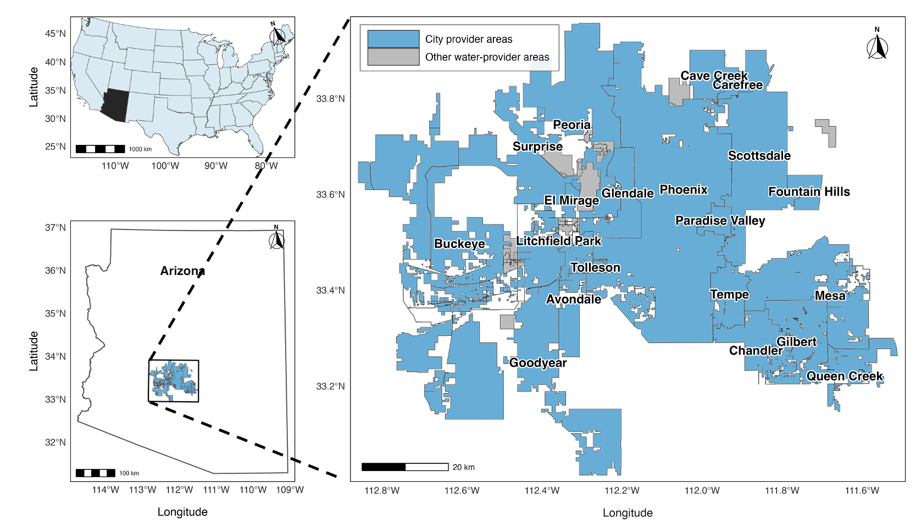
Fig. 1 Location map of the Phoenix Metropolitan Area (PMA), Arizona, the United States, and its constituent cities.

2.2 WaterSim—A simulation model of urban water planning for the PMA
WaterSim5 is an urban water planning model that was developed for metropolitan Phoenix (Gober et al. 2011; Sampson et al. 2011; Sampson et al. 2016). It represents the metropolitan water system through individual water providers, each with its own population, water demand, water rights, and water-supply portfolio. The model simulates how these providers use available surface water, groundwater, reclaimed water, and other supplies under regional allocation rules and selected policy interventions, with outputs available at both provider and regional scales. Detailed descriptions of the model structure, its evolution, and prior validation and sensitivity analyses are available in previous studies (Gober et al. 2011; Sampson et al. 2011; Sampson et al. 2016).
WaterSim5’s primary indicator of regional groundwater sustainability is defined as ‘the regional average number of years that provider groundwater pumping can continue before the total groundwater credits reach zero’ (Sampson et al. 2016). Groundwater credits represent quantities of groundwater available for pumping by regional providers under regional water rights and allocation rules, including credits accrued through groundwater recharge and storage (Sampson et al. 2016; ADWR 2024a). They therefore represent an institutionally defined measure of groundwater availability rather than an estimate of the water physically stored in the aquifer. Hereafter, we refer to this metric as the groundwater sustainability indicator (GSI), expressed as the number of years groundwater pumping can be sustained. We used the GSI as the principal constraint on urban development capacity, as it integrates cumulative effects of population demand, surface-water availability, recharge, provider allocation rules, and policy interventions (Bolin et al. 2010; Sampson et al. 2016; Gleeson et al. 2020).

2.3 Scenario design and modeling workflow
To address our research questions, we conducted a full-factorial simulation experiment using WaterSim5. We systematically varied seven experimental factors: population growth, climate-related surface water conditions, environmental-flow allocation, municipal water-use efficiency, agricultural water-use efficiency, agricultural-to-urban water transfer, and water-supply augmentation (Table 1; Figure 2). These were selected due to their relevance to the PMA and global drylands (Gober et al. 2016; Sampson et al. 2016; Sampson et al. 2020; He et al. 2021). Here, a scenario represents one experimental combination containing exactly one level of each factor, and the complete set of scenarios constitutes the scenario ensemble. Because the design was fully factorial, every possible combination of factor levels was represented once, producing 75 × 2 × 2 × 3 × 3 × 3 × 3 = 24,300 scenarios.
Population growth was varied using WaterSim5’s population growth input, which scales each provider’s forecasted population growth relative to the model forecast (Sampson et al. 2016). We evaluated 75 levels ranging from 2% to 150% of forecasted growth in 2-percentage-point increments. The 75 levels were selected to characterize the population–GSI relationship across a wide range of population growth rates and at a sufficiently fine resolution; the corresponding growth-frontier analysis is described in section 2.4. Climate effects on surface water supply were represented by two paired river flow conditions applied jointly to the Colorado River and the Salt-Verde River Systems. This was done because our objective was to compare the overall effects of climate-related changes in surface-water availability, not to estimate the independent effects of each river system. The experimental levels and basis for their selection for all experimental factors can be found in Table 1.
Each of the 24,300 scenarios was simulated independently in WaterSim5 from 2000 through 2060 using its designated factor levels as model inputs. The outputs used in this study were provider-level population, GSI, and water storage in Lake Mead, Lake Powell, and the Salt-Verde reservoir system. We calculated regional population by summing provider-level population outputs and combined the model outputs with the scenario and factor levels that generated them to create a single simulation dataset. This dataset provided the basis for the analyses described in Section 2.4.

TODO: LABELS FOR AWUE!!!! FIX THEM!
TODO: FIX THE DATA REPOSITORY ASSOCIATED WITH THIS PAPER! CLEANSE IT.
TODO: FIX FIG. 2

Table 1 Factorial design of the WaterSim5 scenario ensemble. The total number of scenarios is 75 (PG) × 2 (CRSWC) × 3 (MWUE) × 3 (AWUE) × 3 (AWT) × 3 (SA) × 2 (EF) = 24,300.
Factor | Number of levels | Factor levels and interpretation | Basis for selected factor levels
Population growth (PG) | 75 | 2–150% of forecasted population growth in 2-percentage-point increments; 100% = forecasted growth. | Levels selected to characterize the population–GSI relationship (Section 2.4).
Climate-related surface water conditions (CRSWC) | 2 | Reference-flow condition: Colorado River = 100%; Salt-Verde River = 105%. Reduced-flow condition: Colorado River = 70%; Salt-Verde River = 85%. | Paired conditions were informed by studies indicating substantial potential declines in Colorado River flows and comparatively smaller and more variable changes in Salt-Verde River flows (Udall and Overpeck 2017; Broman et al. 2020; Woodhouse and Udall 2022).
Environmental-flow allocation (EF) | 2 | 0 AF; approximately 80,000 AF (98.7 million m³) allocated to the Colorado River Delta. | The 80,000-AF level was selected to approximate the scale of the 70,000-AF U.S. environmental-water commitment to the Colorado River Delta under Minute 323 (IBWC 2017).
Municipal water-use efficiency (MWUE) | 3 | Approximately 3.2%, 25%, and 45% reductions in municipal water use resulting from increased water use efficiency. | The three levels were intended to represent no additional change, continuation of the historical decline in Phoenix per-capita water use, and a more aggressive reduction relative to that historical trend (Gober et al. 2016; Hirt et al. 2017).
Agricultural water-use efficiency (AWUE) | 3 | Approximately 0%, 10%, and 20% reductions in agricultural water use. | The upper level of 20% is consistent with documented and modeled agricultural water savings of approximately 15–20% in Arizona and the western United States (Christian-Smith et al. 2012; Lahmers and Eden 2018)
Agricultural-to-urban water transfer (AWT) | 3 | Approximately 0%, 50%, and 100% transfer of agricultural water rights. | The levels span the full range of water transfer. Significant reallocation through agriculture-to-urban transfer has been a historical trend in the PMA (Bolin et al. 2010).
Water supply augmentation (SA) | 3 | Approximately 0%, 10%, and 20% increase in water supply. | The upper value of 20% is based on the value of 21% used in a previous WaterSim study (Gober et al. 2016). Supply augmentation can be represented by coastal desalination, which has repeatedly been proposed as a means of augmenting Arizona’s water supply (Ela and McEvoy 2012; Wilder et al. 2016)

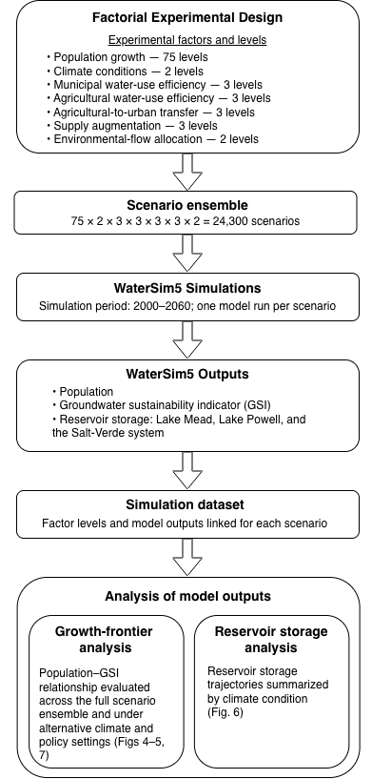
Fig. 2 Simulation modeling workflow: the factorial experimental design, the WaterSim5 simulations, and the analysis of the growth frontier and water storage.

2.4 Analysis of model outputs
Using the simulation model dataset, we analyzed the relationship between the projected regional population and GSI at the end of the model simulation (2060), which we refer to here as the groundwater-constrained growth frontier. The frontier does not represent a single, fixed limit on urban growth. Rather, it shows how much regional population growth is compatible with groundwater pumping being sustained for different lengths of time. After characterizing the growth frontier across the full range of modeled GSI values (Fig. 4), we analyzed it using minimum GSI thresholds. For a minimum GSI threshold T, a scenario met the requirement when its 2060 GSI was greater than or equal to T (GSI ≥ T). The threshold analysis shifted the focus from which regional populations were associated with particular GSI values to how much population could be supported while sustaining groundwater pumping for at least a specified number of years.

We used GSI thresholds for two analyses that systematically compared the growth frontier across the levels of each climate and policy factor. To compare the levels of a given factor, we examined each level separately while retaining all 75 population levels and all combinations of the remaining five climate and policy factors. The full 24,300-scenario dataset contained 324 climate-policy combinations, each comprising all 75 population levels. Accordingly, each level of a two-level factor was represented by 162 combinations (12,150 scenarios), whereas each level of a three-level factor was represented by 108 combinations (8,100 scenarios). Thus, levels of a given factor were compared across the same population levels and the same combinations of the remaining factors.
First, we evaluated the growth frontier in terms of the population compatible with each minimum GSI threshold under different climate and policy conditions. For each climate–policy combination and each minimum GSI threshold from 79 to 98 years, we identified the highest tested 2060 regional population that met the threshold. We used 79–98 because that was the longest contiguous range over which the median and interquartile ranges could be calculated for all factor levels. At thresholds above 98, some of the climate–policy combinations failed to meet the GSI requirement even at the lowest population. Below 79, some of the climate–policy combinations still met the GSI threshold even at the highest population. We then calculated the median and interquartile range of the maximum qualifying populations for each factor level and plotted them as lines and shaded ribbons, respectively (Fig. 5).
Second, we evaluated the growth frontier in terms of how many climate and policy combinations could support each modeled population while meeting each minimum GSI threshold. For each factor level, at each modeled 2060 regional population and minimum GSI threshold from 60–100 years, we calculated the percentage of combinations of the other five climate and policy factors whose GSI met or exceeded the threshold. Higher percentages indicate that the same population and groundwater-sustainability requirement were met across a wider set of modeled [climate and policy] conditions, whereas lower percentages indicate a narrower set of conditions. We visualized these percentages across the population–GSI threshold space using heatmaps (Fig. 6).
For the reservoir storage analysis, the annual storage in acre-feet outputted by WaterSim was converted to percentage of total storage capacity and summarized by climate condition. Within a given climate condition, Lake Mead and Lake Powell storage did not vary across any population and policy combinations in the scenario ensemble. In contrast, Salt-Verde storage varied across scenarios within climate conditions; therefore, the trajectories shown in Fig. 7 for the Salt-Verde system represent the mean across population and policy combinations. Additional variation in Salt-Verde storage across population and policy settings can be found in Fig. S2.

3. Results

3.1 Frequency distribution of the groundwater sustainability indicator across all scenarios
The 24,300 scenarios show a wide range of GSI values at the end of the simulation (Fig. 3). The wide-ranging and uneven frequency distribution reflects both the factorial design of scenarios and the model’s response to the tested input ranges. The design generated many scenarios containing one or more protective policy interventions, while no tested scenario produced a GSI value below approximately 40 years.
Overall, the frequency distribution is neither symmetric nor linear, with a large portion of the ensemble falling between roughly 65 and 98 years and a pronounced cluster near the 100-year upper bound. In general, low GSI values were associated primarily with the combinations of high population demand, reduced river flows, and weak policy interventions for curbing water demand or augmenting water supply. Conversely, scenarios with GSI values near 100 years had mostly lower population levels, more favorable climate conditions, and multiple water sustainability policy interventions.
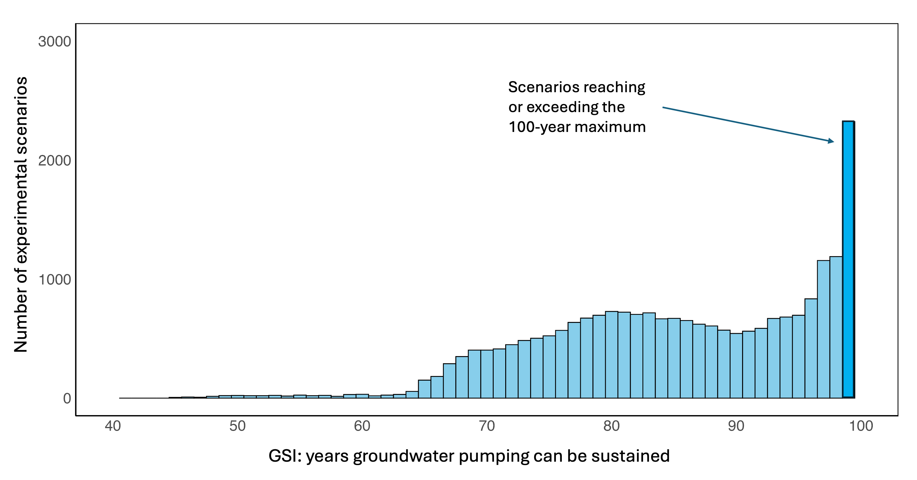
Fig. 3 Frequency distribution of the groundwater sustainability indicator (GSI) across the 24,300 scenarios based on WaterSim5 simulations from 2000 to 2060, where GSI is expressed as the number of years groundwater pumping can be sustained at the end of the simulation (2060). Scenario counts reflect the experimental setup, not the probability of future outcomes.

3.2 The overall form of the groundwater-constrained growth frontier
The results of simulations show a strong, nonlinear tradeoff between population and GSI in 2060 (Fig. 4). Projected population declined as GSI increased, with the decline accelerating sharply once the GSI exceeded approximately 80 years. The median population dropped from approximately 9.1 million at a GSI value of 45 years to about 4.5 million at a GSI value of 100 years. Projected population also varied noticeably among scenarios at a given GSI value, as indicated by the vertical band in Fig. 4.
The fan-shaped pattern indicates that differences among climate and policy combinations become more consequential as GSI increases, whereas the narrowing near 100 years reflects the smaller and more restricted set of scenarios capable of attaining that condition. For GSI values at approximately 45-70 years, the relatively narrow bands indicate that scenarios producing such low GSI values generally converged on high population outcomes. For GSI values between 70 and 95, the wide bands indicate that different combinations of population growth, climate conditions, and water policies produced the same GSI values. As the GSI approached 100 years, the contracted bands indicate that only a subset of scenarios—generally involving lower populations and stronger water-management conditions—attained GSI values near 100 years. The local fluctuations in the median and distribution bands, particularly between about 55 and 80 years, reflect changes in the composition of scenarios at each GSI value, as well as discrete policy levels and nonlinear interactions among the seven factors in Table 1.
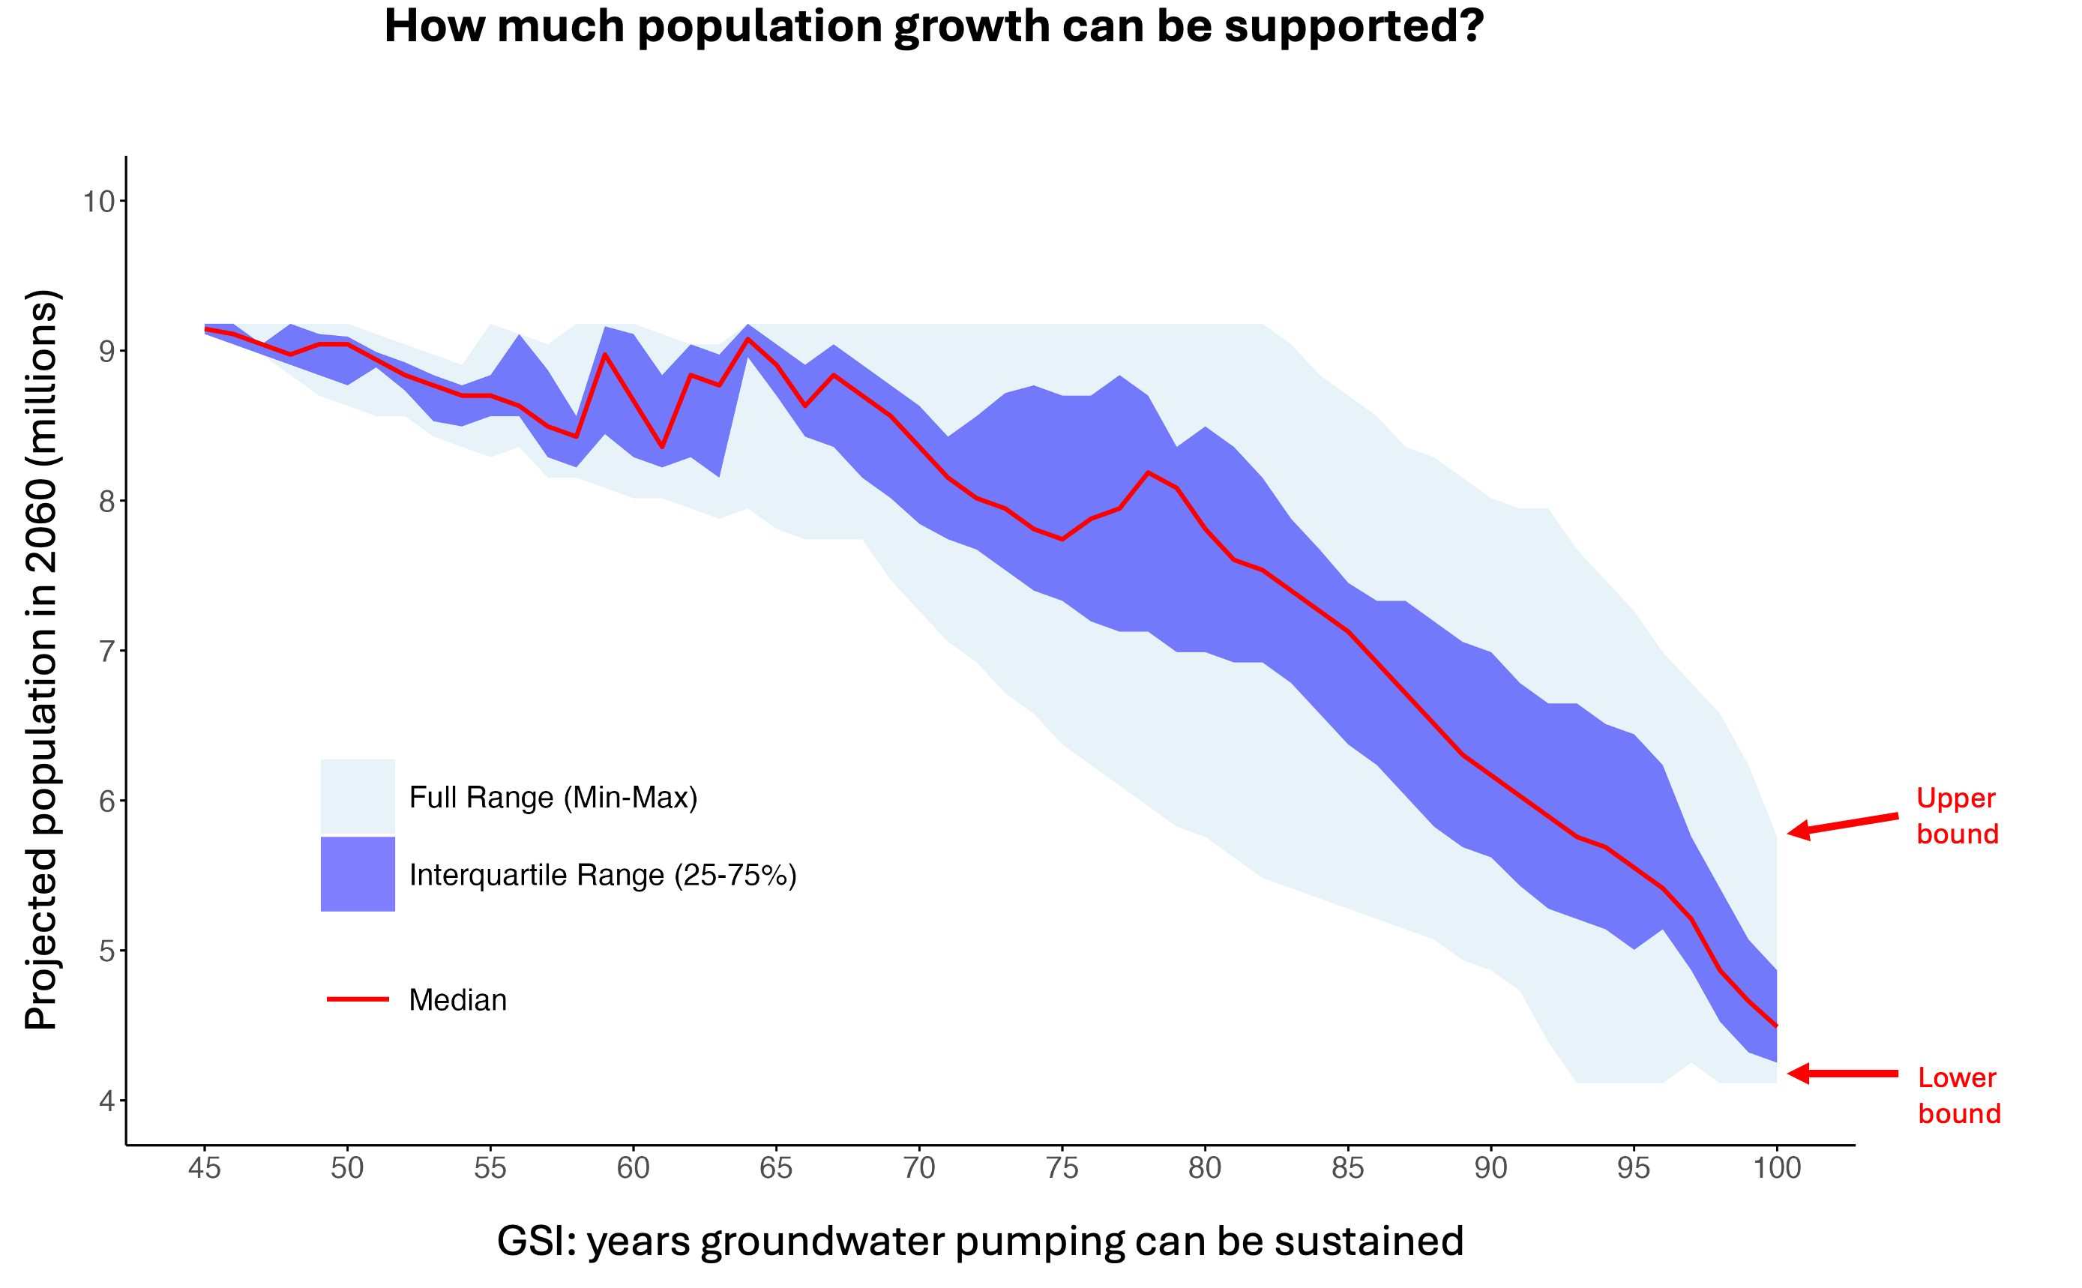
Fig. 4 Groundwater-constrained growth frontier across the full scenario ensemble. The solid red line is the median projected population; the dark band is the interquartile range; and the light band is the full modeled range at each GSI value (not a confidence interval). The vertical band width represents the spread of projected population values (not the number of scenarios).

3.3 Climate and policy influences on the groundwater-constrained growth frontier

3.3.1 Differences in maximum supportable population across water policies
Across increasingly stringent [minimum] groundwater sustainability requirements, the [median] [maximum] supportable population decreased [for all tested climate and policy experimental factors] (Fig. 5), retaining the same inverse relationship between population and GSI that [defined the growth frontier] in Fig. 4. The shaded ribbons show that the maximum supportable population varied across climate–policy combinations, even under the same minimum groundwater sustainability requirements. This variation generally decreased as minimum groundwater sustainability requirements became more stringent. The position of the growth frontier also differed across experimental factors.
Increasing the percentage of agricultural water transferred to the municipal sector consistently raised the median maximum supportable population across the entire range of minimum groundwater sustainability requirements (Fig. 5). Across all experimental factors, agricultural water transfer produced the clearest and largest expansion of the growth frontier, with an approximate 1.3 million difference in median supportable population between 0% and 100% transfer at the 79-year threshold. Although the separation persisted, the differences among factor levels diminished somewhat as the minimum groundwater sustainability requirement increased.
Changes in municipal water use efficiency also produced large changes in the position of the growth frontier relative to other factors, but the changes were non-monotonic (Fig. 5). The intermediate efficiency level, corresponding to a 25% reduction in per capita water use, consistently had a lower median maximum supportable population than either the 3.2% or 45% reduction level. The highest efficiency level, corresponding to a 45% reduction in per capita water use, was associated with higher median populations than the 3.2% reduction level under more stringent groundwater sustainability requirements (~86–98 years), but lower populations under less stringent requirements (79–85 years).
Of the remaining policies, supply augmentation produced the largest differences in the growth frontier, with 10% and 20% increases in supply generally supporting larger populations, particularly under less stringent groundwater sustainability requirements (Fig. 5). Altering agricultural water-use efficiency produced comparatively small changes in median maximum supportable population, with substantial overlap in the median curves across the three efficiency levels (Fig. 5). Environmental-flow allocation also produced little visible change in the growth frontier, with the 80,000 AF and 0 AF allocation conditions producing nearly identical growth frontiers. However, these results did not include the effects of environmental flows on ecological conditions, agricultural production, or other social and environmental outcomes. Thus, they apply only to projected metropolitan population under the evaluated GSI values.

3.3.2 Feasibility of population growth across climate and policy settings
Overall, the heatmaps in Fig. 6 divide the population-groundwater space diametrically into two contrasting regions: in the lower-left robust-feasibility region, most or all scenarios supported lower population levels while meeting lower GSI thresholds; in the upper-right low- or non-feasibility region, few or no scenarios supported higher population levels while simultaneously meeting higher GSI thresholds. The diagonal transition zone between the two regions delineates the groundwater-constrained growth frontier identified in the preceding analyses. The position, width, and color gradient of the transitional zone were also varied across factor levels, reflecting how the same population and groundwater sustainability requirements can be met by many, few, or no climate–policy combinations, depending on the climate and policy settings (Fig. 6). Consistent with results shown in Fig. 5, agricultural-to-urban water transfers produced the clearest expansion of the growth frontier among all the policies, while municipal water-use efficiency showed substantial but non-monotonic differences. Supply augmentation produced smaller expansions, whereas agricultural water-use efficiency and environmental-flow allocation showed comparatively little change. At each GSI threshold, the upper boundary of the nonzero cells marks the highest tested population attained by at least one qualifying scenario and thus represents a best-case frontier within the tested scenario space. At the 100-year GSI threshold, this best-case upper bound was approximately 5.8 million people.

3.3.3 Climate-related differences
Our simulation results show that reduced river flows due to climate change generally decreased the median maximum supportable population, especially under less stringent groundwater sustainability requirements (Fig. 5). The maximum population curves converged as groundwater sustainability requirements became more stringent. Consistent with this result, the heatmaps in Fig. 6 show that reduced flows generally decreased the proportion of policy combinations meeting the same population and groundwater sustainability requirements. The trajectories of water storage in reservoirs across the Salt-Verde and Colorado River Systems can provide additional evidence of how reduced river flows impact the regional water system (Fig. 7). The reduced-flow condition generally lowered reservoir storage, with the clearest divergence between the climate conditions occurring in Lake Mead and Lake Powell. Salt-Verde storage remained nearly identical.

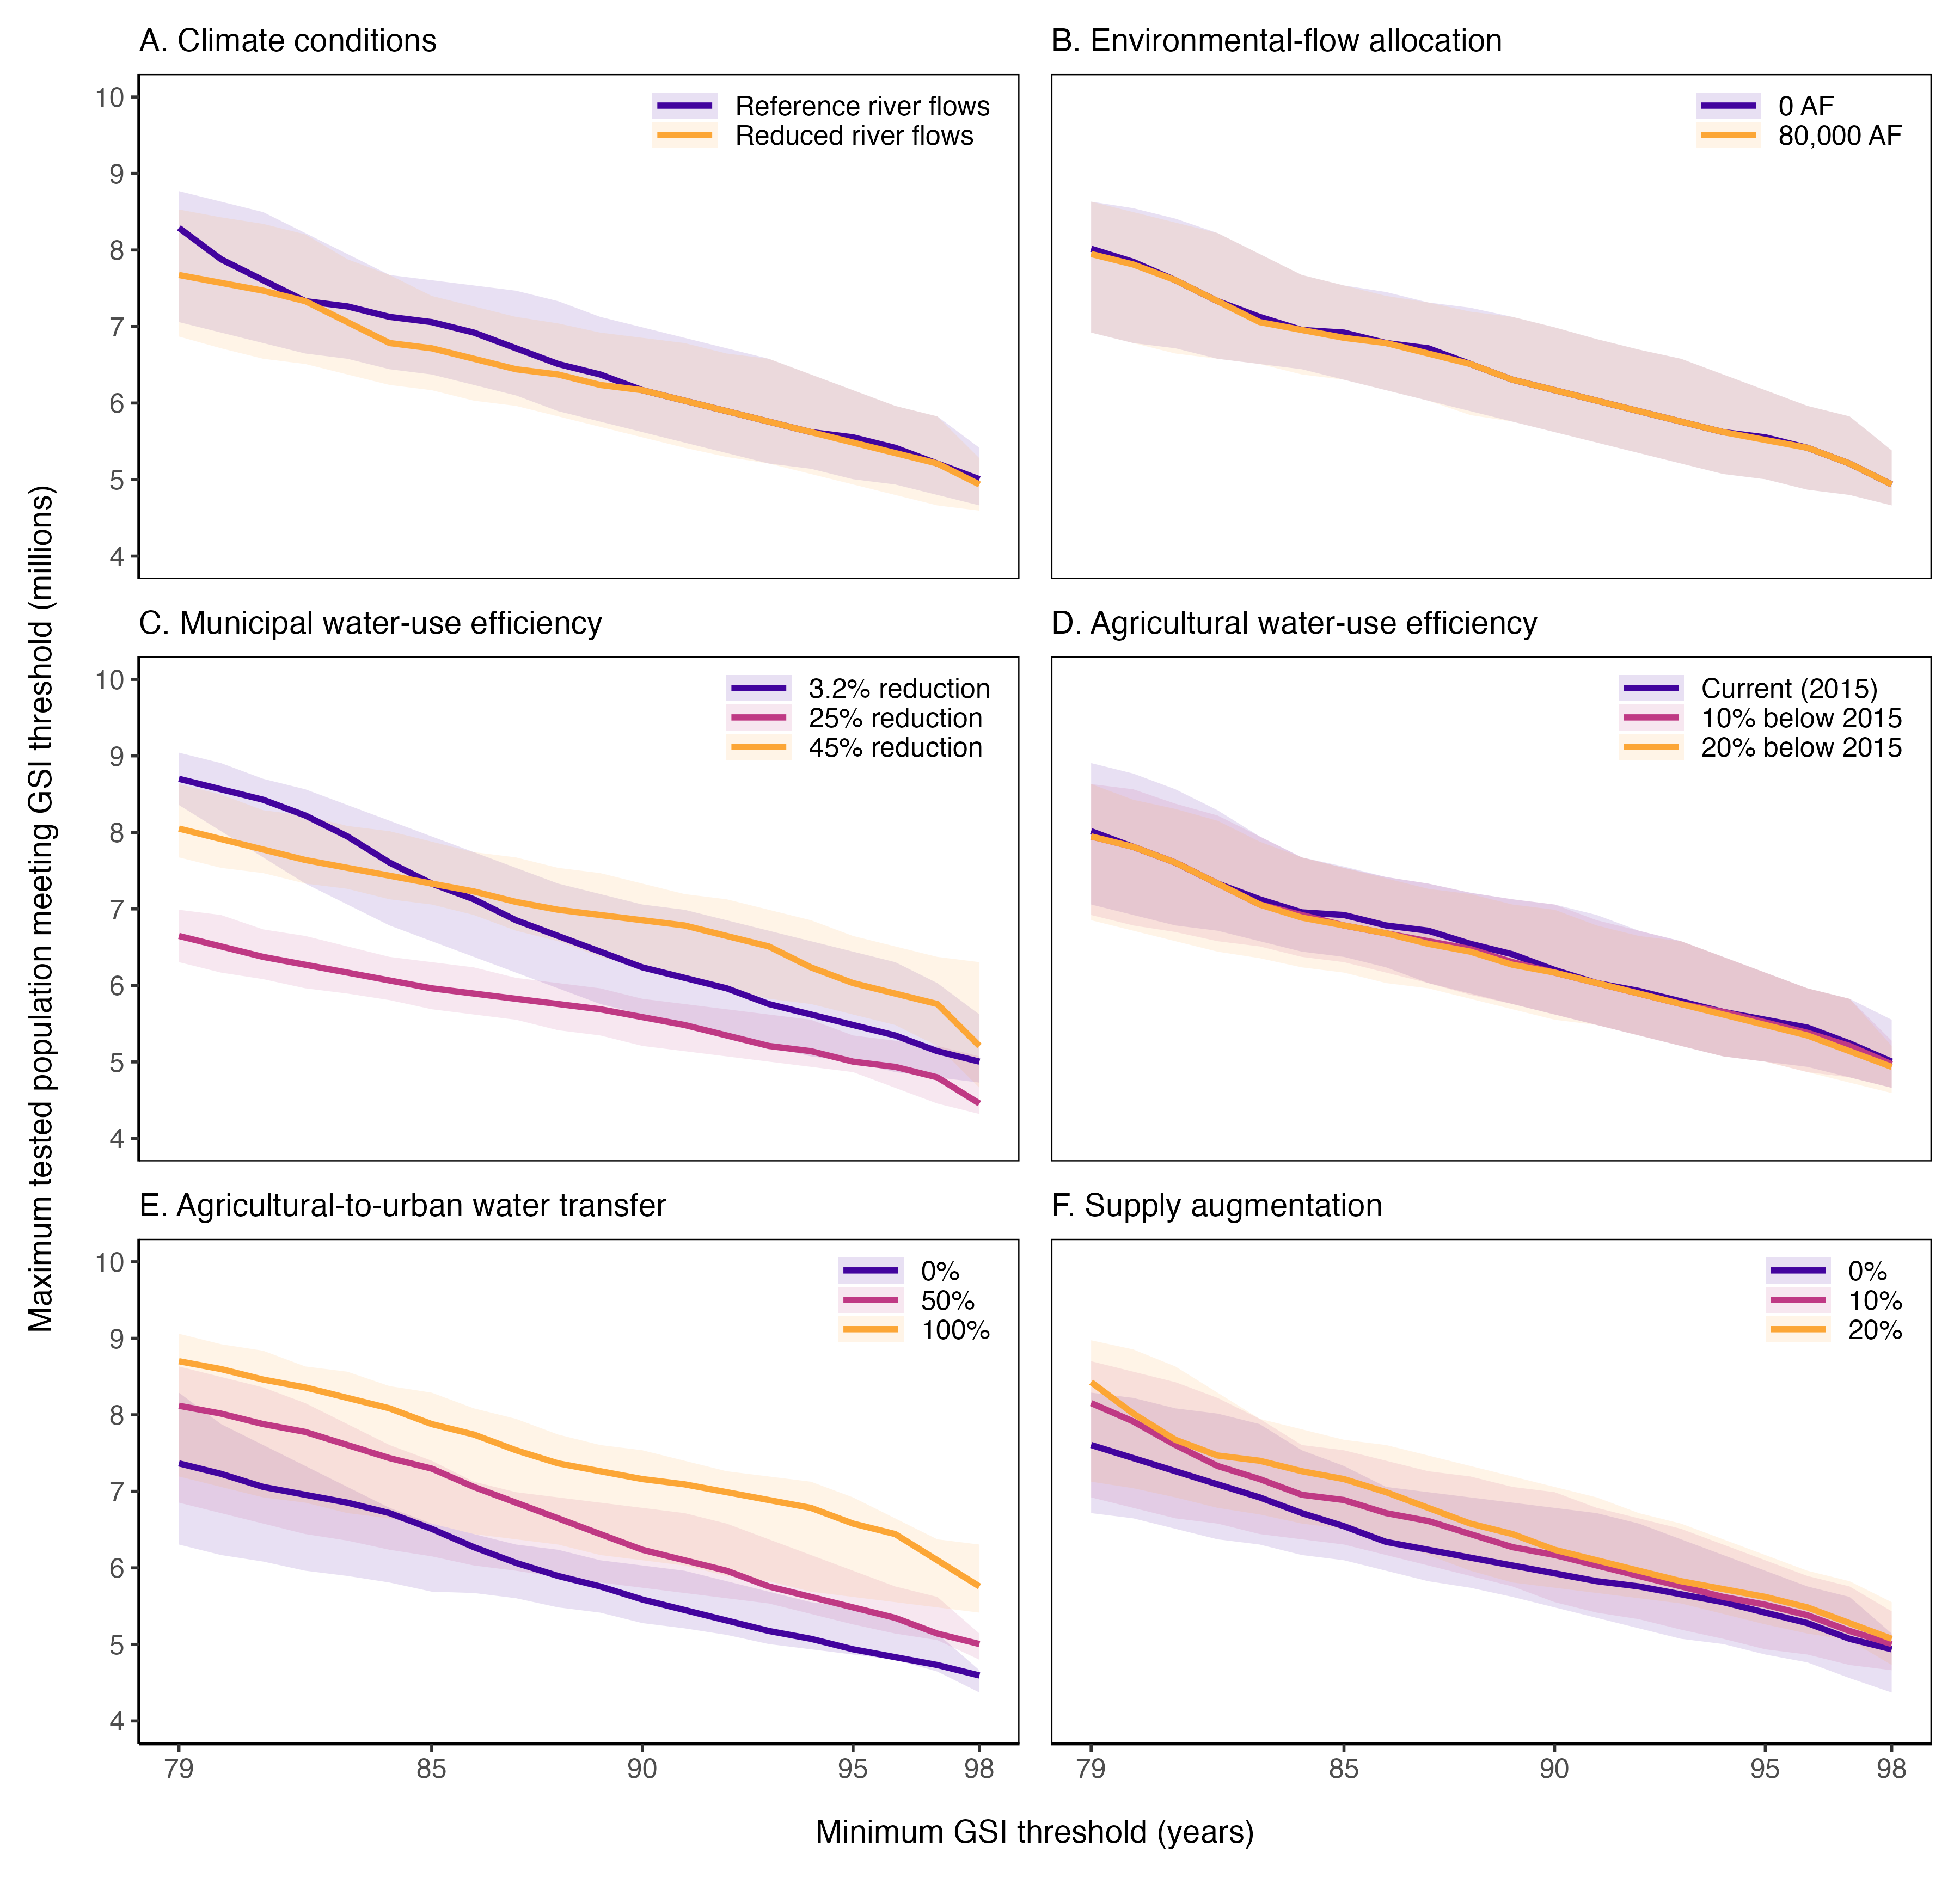
Fig. 5 Groundwater-constrained population growth frontier across climate and policy factor levels. Panels show climate conditions, environmental-flow allocation, municipal water-use efficiency, agricultural water-use efficiency, agricultural-to-urban water transfer, and supply augmentation. The x-axis shows the minimum GSI threshold, defined as the minimum number of years groundwater pumping must remain sustainable, and the y-axis shows the maximum modeled 2060 regional population meeting that requirement. For each GSI threshold, colored lines show the median maximum qualifying population for the indicated factor level, and shaded ribbons show the corresponding interquartile range across factorial combinations of the other five climate and policy factors. Each level of a two-level factor is summarized across 162 combinations of the other five climate and policy factors, and each level of a three-level factor across 108 combinations. Ribbons represent variation across the modeled factorial combinations, not confidence intervals.

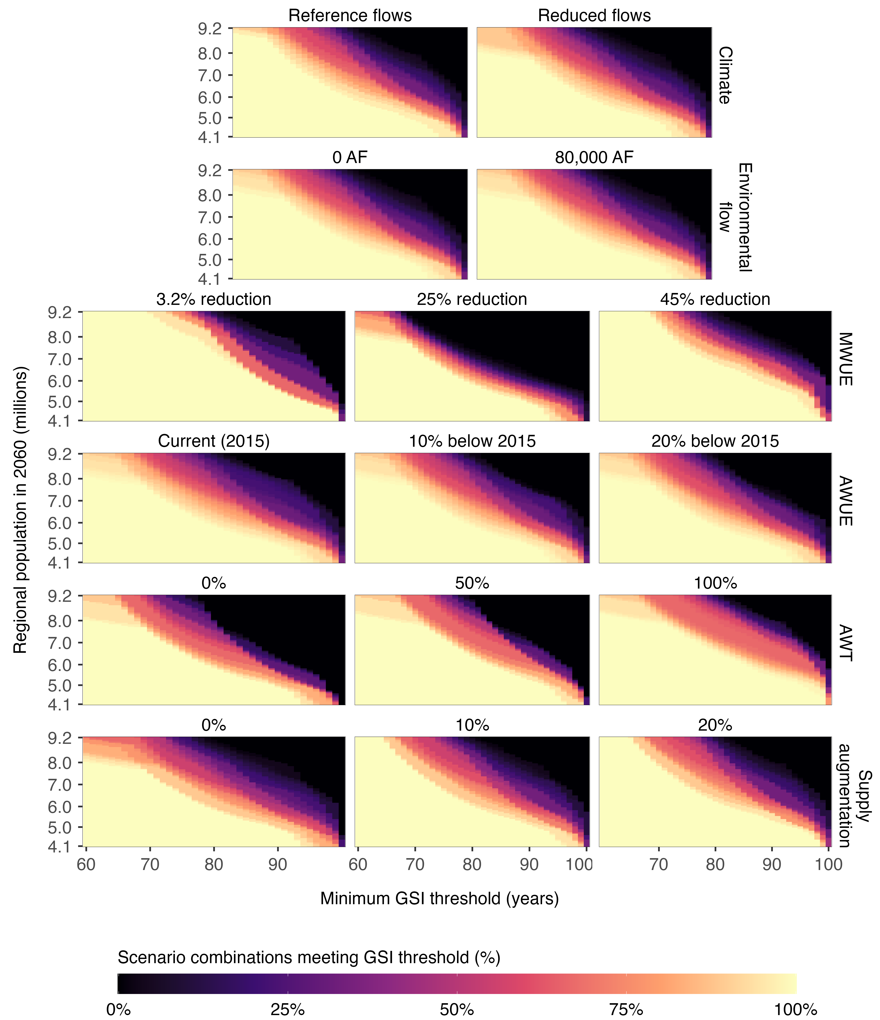
Fig. 6 Percentage of modeled climate-policy combinations meeting minimum GSI thresholds across climate and policy factor levels. Each panel represents one factor level while retaining all combinations of the other five climate and policy factors. The x-axis shows the minimum GSI threshold, defined as the minimum number of years groundwater pumping must be sustained, and the y-axis shows modeled regional population in 2060. Each cell shows the percentage of the corresponding 162 combinations for a two-level factor or 108 combinations for a three-level factor whose 2060 GSI met or exceeded the threshold. Lighter colors indicate that a larger proportion of scenarios met the threshold; darker colors indicate that fewer did. These percentages represent conditional feasibility within the modeled factorial scenario space, not probabilities of future outcomes.

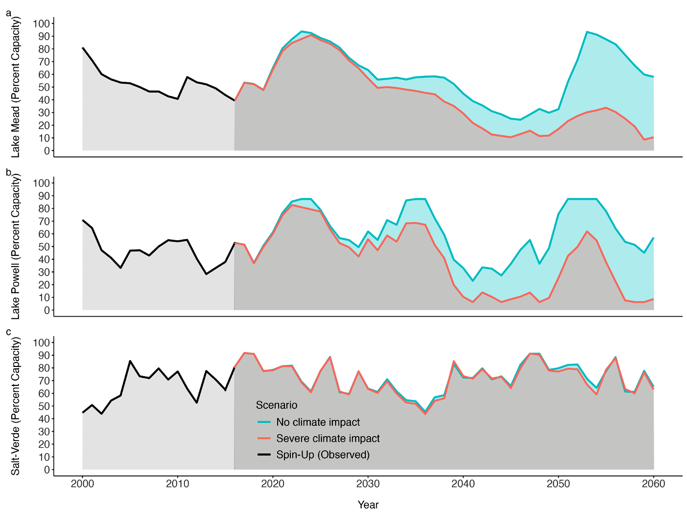
Fig. 7 Modeled percentage of storage capacity in Lake Mead, Lake Powell, and the Salt-Verde reservoir system between 2000 and 2060, under reference and reduced-flow climate conditions. Data before 2000 were historical observations.

4. Discussion

4.1 How does the population growth frontier evolve under increasingly stringent standards for groundwater sustainability?
The overall form of the groundwater-constrained population growth frontier in the PMA is nonlinear (Fig. 4) and governance-dependent (Figs. 5–6). The projected population and the number of years groundwater pumping can be sustained in 2060 (GSI) exhibit strong nonlinear tradeoffs. Importantly, these tradeoffs become especially evident as GSI exceeds approximately 80 years, at which point only substantially lower populations are feasible. The location of the growth frontier depends not only on the stringency of the groundwater-sustainability standards but also on the interactions of climatic conditions and water use policies.
While narrow distributions at low GSI values indicate that these scenarios are concentrated at relatively high population levels, wider distributions under intermediate groundwater conditions indicate that climate and policy combinations can produce markedly different population outcomes at the same GSI value (Fig. 4). The distributions narrowed again near the 100-year criterion because it can only be met by a restricted set of predominantly low-population scenarios. The upper and lower boundaries reflect the range of population growth rates tested within the scenario ensemble, rather than the absolute limits on metropolitan population in the region. The threshold analyses extend these findings: maximum supportable population varied across climate–policy combinations even under the same groundwater sustainability requirement (Fig. 5), while the proportion of combinations meeting the same population and GSI requirements varied across factor levels (Fig. 6). Thus, metropolitan development capacity should not be represented by a single carrying-capacity value.
Challenges of groundwater’s buffering role are evident: less stringent standards for sustainability allow pumping to offset short-term surface-water shortages, but may accelerate depletion of groundwater reserves. More stringent standards limit this buffering capacity but are necessary for long-term groundwater sustainability—a goal that requires limiting water demand associated with population growth and implementing stronger water-management measures. Previous WaterSim studies similarly found that groundwater can compensate for reductions in surface water availability, but greater reliance on groundwater can contribute to longer-term depletion in the PMA (Gober et al. 2010; Gober et al. 2011; Gober et al. 2016; Sampson et al. 2016). Our results extend the previous finding by varying population growth rate across 75 levels, allowing us to resolve the population–GSI relationship as a growth frontier.

4.2 How do climate-related reductions in surface-water availability alter the growth frontier?
Climate-related reductions in surface water, primarily decreased flows of the Colorado and Salt-Verde rivers, generally contracted the growth frontier, particularly under less stringent groundwater sustainability requirements (Fig. 5). The reductions also decreased the proportion of policy combinations satisfying the same population and groundwater requirements (Fig. 6). Climate impacts on the growth frontier varied across GSI and alternative water policies. The climate-related contraction was likely driven by changes in the Colorado River system. Compared to the Salt-Verde System, differences in water storage between the reference and reduced-flow conditions were more pronounced in Lake Mead and Lake Powell (Fig. 7), which is important because Lake Mead storage levels govern shortage-related reductions in Arizona's Colorado River water allocation (U. S. Department of the Interior 2007; U. S. Bureau of Reclamation 2020). Yet, the population growth compatible with groundwater requirements also depended upon policy choices. Policies expanded or contracted the growth frontier, and more stringent groundwater sustainability requirements limited the extent to which groundwater could buffer surface-water shortages to support population growth. These results are characteristic of coupled human-water systems in drylands: climate change tends to exacerbate water shortages and narrow the range of feasible development and management options (White et al. 2015; Gober et al. 2016; Mirzabaev et al. 2022).
Climate-induced results here should be interpreted as an exploratory comparison rather than a probability-weighted climate projection because they do not represent the full range or likelihood of future hydrological conditions. Previous studies projected that severe and persistent droughts would be plausible in the southwestern United States in coming decades (Overpeck and Udall 2010; Cook et al. 2015). Earlier WaterSim-based research also indicated that megadroughts accelerated groundwater depletion and increased outcome uncertainties, while combined policy interventions could improve the sustainability of groundwater supplies (Gober et al. 2016). Our study more explicitly demonstrates how climatic pressures could affect the groundwater-constrained population frontier, thereby shaping the decision space for institutional interventions.

4.3 How do alternative water-policy settings reshape the growth frontier?
Our results show that the alternative water-policy settings shifted the frontier in different and rather complex ways. No individual policy or combination of multiple policies was able to eliminate the population contraction associated with higher GSI values and reduced river flows (Figs. 5–6). Nevertheless, some policies or their combinations could substantially alter both the location of the frontier and the proportion of scenario combinations capable of meeting GSI thresholds, indicating the important role of institutions in improving dryland water sustainability.
Among all the tested water policies, agricultural-to-urban water transfers produced the clearest expansion of the growth frontier. This comparatively large effect is not surprising, given agriculture’s large share of regional water use and the magnitude of transfers tested. Considering that transfers reallocate existing water rather than creating new supplies, such transfers may impose costs on agricultural production, rural livelihoods, and cultural values. With the expected intensification of competition between urban and agricultural water uses under climate change and urbanization (Flörke et al. 2018), agricultural-to-urban water transfers should be viewed as a trade-off, rather than an inherently sustainable pathway (Bolin et al. 2010). Municipal water-use efficiency can reduce demand (Richter 2023), but the non-monotonic trend indicates that its contribution likely depends on the broader management context. Agricultural efficiency produced comparatively small changes in the growth frontier, which is expected, considering the relatively small effect of the tested efficiency changes on total regional water use. Similar reasoning also applies to the comparatively small effect of environmental-flow allocation. Supply augmentation was able to expand the growth frontier appreciably, but may entail substantial financial, energy, infrastructure, and environmental costs (Wang et al. 2025). General costs may be higher in Phoenix due to its inland location and associated transportation requirements (Ela and McEvoy 2012; Wilder et al. 2016).
Overall, our study suggests that priority should be given to effective policy combinations rather than individual policies, to overall robustness rather than a simple ranking of interventions. Policy comparisons should consider not only how far an intervention expands the growth frontier, but also how consistently it performs and what costs or risks it transfers across sectors, places, and generations-i.e., the sustainability of the regional landscape (Wu 2013; Gilman and Wu 2023; Wu et al. 2025).

4.4 Implications for anticipatory planning
With rising environmental and socioeconomic uncertainties worldwide, anticipatory governance becomes increasingly important for achieving urban sustainability (Levin et al. 2022). Anticipatory governance, defined as “a broad-based capacity extended through society that can act on a variety of inputs to manage rapid change such that management is still possible” (Guston 2014), emphasizes preparation, foresight, responsiveness, adaptability, and institutional learning under deep uncertainty. Through exploratory modeling, which is most useful when it clarifies choices rather than presenting a single forecast, we have demonstrated how science can support anticipatory urban planning and governance. Specifically, our results can help decision makers in the PMA better understand how different standards for groundwater sustainability and climate change could affect the growth frontier and how policy interventions could reduce the anticipated risk of water shortage and enhance urban sustainability in the region.
The broader relevance of our study is more methodological than factual. Because water rights, infrastructure, aquifers, institutions, and governance arrangements are place-specific, WaterSim5 cannot be transferred directly to another city without substantial localization and reparameterization (Sampson et al. 2016). Nevertheless, because most sustainability challenges facing dryland cities around the world are often related to water scarcity (Liu and Wu 2022b; Elouafi 2025; Jenerette 2025), these urban regions need to evaluate development expectations against uncertain water supplies. These evaluations need to provide a clear indication of how sustainability standards and policy portfolios jointly define growth feasibility. As groundwater can buffer short-term water-supply shortages, its long-term availability is generally considered a key indicator of urban water sustainability in dryland regions. The groundwater-constrained population growth frontier demonstrated in this study offers a potentially transferable framework for other dryland cities.

4.5 Limitations and future research priorities
WaterSim5 is a deterministic model, and the 24,300 designed scenarios are not independent observations. Thus, their frequencies represented the modeled scenario space rather than real-world probabilities. The growth frontier identified the highest tested populations compatible with specified GSI levels, not demographic forecasts or evidence of economic, political, or social feasibility. It should also be noted that this analysis evaluates GSI as a snapshot in 2060 and that attaining a given GSI value at that point does not imply that the same groundwater condition would persist in the decades that follow. In addition, our climate design lumped changes in the Colorado and Salt-Verde River systems, with only two climate conditions up to 2060. This choice limited the attribution and representation of longer-term hydroclimatic uncertainty. Finally, our analysis focused on population and GSI without evaluating possible effects on agriculture, ecosystem services, energy use, infrastructure costs, livelihoods, or equity, all of which are important to urban sustainability (Wu 2014; Jenerette 2025).
Future studies should aim to distinguish main effects from interactions of multiple environmental and socioeconomic factors, with an emphasis on explaining non-monotonic patterns among the qualifying scenarios revealed in our study. This may be done through scenario-level analyses, such as variance decomposition, matched comparisons, and global sensitivity analysis (Pianosi et al. 2016; Liu and Wu 2022a). Broader scenario ensembles should also be explored, incorporating multiple hydrologic traces and drought sequences, separating the effects of the Colorado and Salt-Verde River systems, and extending the study beyond 2060.

5. Conclusions
In this study, we conceptualized urban development capacity as the groundwater-constrained population growth frontier, or the relationship between population and the number of years that groundwater pumping can be sustained at the end of the model simulation. The resulting growth frontier was strongly non-linear and varied according to climate and policy scenarios. In other words, the urban development capacity of the PMA was shaped jointly by the interactions among water availability, sustainability objectives, climate conditions, and management choices. Under the most stringent groundwater sustainability standard, i.e., scenarios where groundwater pumping could be sustained for 100 years beyond 2060, the best-case upper bound of the frontier was about 5.8 million people. Given that the current population is around 5 million, this result underscores the limited additional population growth that is compatible with the most stringent groundwater sustainability standard evaluated in the modeled scenario ensemble.
In the face of mounting climate impacts and socioeconomic uncertainties, our exploratory modeling offers a practical framework for evaluating how alternative definitions of groundwater sustainability and policy portfolios constrain or expand the prospects for urban development in the Phoenix region and beyond. In the growth frontier framework, GSI can be used to set standards for groundwater sustainability, while policy options can be used to explore how those standards might be met in the context of climate change. Although the agricultural-to-urban water transfer policy produced the clearest expansion of the population growth frontier, it remains unclear whether this could transfer costs and risks to other sectors and places. Thus, our findings about the growth frontier should inform—but not replace—a broader evaluation of human well-being, ecosystem services, spatial interactions, and intergenerational consequences in the PMA. The groundwater-based growth frontier framework, however, may be applicable to many other dryland cities worldwide.

Declaration of competing interests
The authors declare no competing interests related to this manuscript.

Data availability
The WaterSim5 simulation outputs for the 24,300 scenarios, together with the supporting documentation (e.g., experimental design; variable descriptions) and the R scripts used to generate figures, are available in the following publicly accessible GitHub repository: https://github.com/skynet-2020/WaterSim_publication.

Acknowledgments
We would like to thank Ray Quay and David Sampson for providing access to the WaterSim5 model and for general guidance on running it and interpreting its outputs. Part of this work was performed under the auspices of the Young Scientists Summer Program (YSSP) of the International Institute of Applied Systems Analysis (IIASA), supported by a fellowship from the National Academies of Sciences, Engineering, and Medicine (NASEM) US Committee for IIASA, with funds from the National Science Foundation (NSF Award OISE 2113484). This work was also supported by a Central Arizona-Phoenix Long-Term Ecological Research (CAP LTER) Graduate Grant.

Author contributions
JG: conceptualization; formal analysis; methodology; data curation; visualization; writing – original draft; writing – review & editing
JW: conceptualization; writing – original draft; writing – review & editing; supervision
EP: writing – review & editing; supervision
ST: writing – review & editing; supervision

References
Arizona Department of Water Resources (2024a) Water Storage Permit Application Guide. Arizona Department of Water Resources, Phoenix, Arizona. https://www.azwater.gov/sites/default/files/2024-11/WS%20Permit%20App%20GUIDE_revised_FINAL.pdf. Accessed 12 August 2026
Arizona Department of Water Resources (2024b) Supply and Demand Water Dashboard. https://www.azwater.gov/supply-demand. Accessed 1 October 2024
Bolin B, Seetharam M, Pompeii B (2010) Water resources, climate change, and urban vulnerability: a case study of Phoenix, Arizona. Local Environ 15:261-279. https://doi.org/10.1080/13549830903575604
Christian-Smith J, Cooley H, Gleick PH (2012) Potential water savings associated with agricultural water efficiency improvements: a case study of California, USA. Water Policy 14:194-213.
Cook BI, Ault TR, Smerdon JE (2015) Unprecedented 21st century drought risk in the American Southwest and Central Plains. Sci Adv 1:e1400082. https://doi.org/10.1126/sciadv.1400082
Ela WP, McEvoy J (2012) Desalination in Arizona: Challenges, applications and prospects. In: Megdal SB, Varady RG, Eden S (eds) Shared Borders, Shared Waters: Israeli-Palestinian and Colorado River Basin Water Challenges. CRC Press/Balkema, Leiden, The Netherlands, pp 247-262. 10.1201/b13076
Elouafi I (2025) Drylands under pressure: Science and solutions for global stability. Science 387:eadv6563. https://doi.org/10.1126/science.adv6563
Famiglietti JS (2014) The global groundwater crisis. Nat Clim Chang 4:945-948. https://doi.org/10.1038/nclimate2425
Flörke M, Schneider C, McDonald RI (2018) Water competition between cities and agriculture driven by climate change and urban growth. Nat Sustain 1:51-58. https://doi.org/10.1038/s41893-017-0006-8
Gilman J, Wu J (2023) The interactions among landscape pattern, climate change, and ecosystem services: progress and prospects. Reg Environ Change 23:67. https://doi.org/10.1007/s10113-023-02060-z
Gilman J, Wu J (2024) Identifying broken linkages coupling water availability and dryland urbanization for sustainability: The case of the Phoenix metropolitan region, USA. J Environ Manage 352:120097. https://doi.org/10.1016/j.jenvman.2024.120097
Gilman J, Hill J, Wang X, Wu J (2025) Re-envisioning par for the course: an assessment of desert golf sustainability from a landscape perspective. Int J Sustain Dev World Ecol 32:80–95. https://doi.org/10.1080/13504509.2024.2405818
Gleeson T, Cuthbert M, Ferguson G, Perrone D (2020) Global groundwater sustainability, resources, and systems in the Anthropocene. Annu Rev Earth Planet Sci 48:431-463. https://doi.org/10.1146/annurev-earth-071719-055251
Gleick PH (1998) Water in crisis: Paths to sustainable water use. Ecol. Appl. 8:571-579. 10.1890/1051-0761(1998)008[0571:WICPTS]2.0.CO;2
Gleick PH (2003) Global Freshwater Resources: Soft-Path Solutions for the 21st Century. Science 302:1524-1528. 10.1126/science.1089967
Gober P, Kirkwood CW, Balling RC, Ellis AW, Deitrick S (2010) Water Planning Under Climatic Uncertainty in Phoenix: Why We Need a New Paradigm. Ann. Am. Assoc. Geogr. 100:356-372. http://doi.org/10.1080/00045601003595420
Gober P, Wentz EA, Lant T, Tschudi MK, Kirkwood CW (2011) WaterSim: a simulation model for urban water planning in Phoenix, Arizona, USA. Environment and Planning B: Urban Analytics and City Science 38:197-215. https://doi.org/10.1068/b36075
Gober P, Sampson DA, Quay R, White DD, Chow WT (2016) Urban adaptation to mega-drought: Anticipatory water modeling, policy, and planning for the urban Southwest. Sustainable cities and society 27:497-504.
Guston DH (2014) Understanding ‘anticipatory governance’. Soc Stud Sci 44:218-242. https://doi.org/10.1177/0306312713508669
He C, Liu Z, Wu J, Pan X, Fang Z et al (2021) Future global urban water scarcity and potential solutions. Nat Commun 12:4667. https://doi.org/10.1038/s41467-021-25026-3
Hirt P, Snyder R, Hester C, Larson K (2017) Water consumption and sustainability in Arizona: A tale of two desert cities. J. Southwest 59:264-301. http://doi.org/10.1353/jsw.2017.0017
International Boundary Water Commission (2017) Minute No. 323: Extension of Cooperative Measures and Adoption of a Binational Water Scarcity Contingency Plan in the Colorado River Basin. Minute No. 323. International Boundary and Water Commission, Ciudad Juarez, Chihuahua
Jenerette GD (2025) Resilient urbanization for water limited environments. Cambridge Prisms: Drylands 2:e2. https://doi.org/10.1017/dry.2024.7
Lahmers T, Eden S (2018) Water and Irrigated Agriculture in Arizona. University of Arizona Water Resources Research Center, Tucson, Arizona. Accessed
Larson EK, Perrings C (2013) The value of water-related amenities in an arid city: The case of the Phoenix metropolitan area. Landsc Urban Plan 109:45-55. https://doi.org/10.1016/j.landurbplan.2012.10.008
Levin SA, Anderies JM, Adger N, Barrett S, Bennett EM et al (2022) Governance in the face of extreme events: Lessons from evolutionary processes for structuring interventions, and the need to go beyond. Ecosystems 25:697-711. https://doi.org/10.1007/s10021-021-00680-2
Liu L, Wu J (2022a) Scenario analysis in urban ecosystem services research: Progress, prospects, and implications for urban planning and management. Landsc Urban Plan 224:104433. https://doi.org/10.1016/j.landurbplan.2022.104433
Liu Z, Wu J (2022b) Landscape-based solutions are needed for meeting water challenges of China’s expanding and thirsty cities. Landsc. Ecol. 37:2729-2733. doi: 10.1007/s10980-022-01536-3
MEA (2005) Ecosystems and Human Well-being: Desertification Synthesis. World Resources Institute, Washington, DC.
Mirzabaev A, Stringer LC, Benjaminsen TA, Gonzalez P, Harris R et al (2022) Cross-Chapter paper 3: Deserts, semiarid areas and desertification. In: Pörtner H-O, Roberts DC, Tignor M et al (eds) Climate Change 2022: Impacts, Adaptation and Vulnerability. Contribution of Working Group II to the Sixth Assessment Report of the Intergovernmental Panel on Climate Change. Cambridge University Press, Cambridge (UK), pp 2195–2231. https://doi.org/10.1017/9781009325844.020
Overpeck J, Udall B (2010) Dry times ahead. Science 328:1642-1643. https://doi.org/10.1126/science.1186591
Pianosi F, Beven K, Freer J, Hall JW, Rougier J et al (2016) Sensitivity analysis of environmental models: A systematic review with practical workflow. Environ Model Softw 79:214-232. https://doi.org/10.1016/j.envsoft.2016.02.008
Reisner M (1986) Cadillac Desert: The American West and Its Disappearing Water. Penguin Books, New York.
Richter BD (2023) Decoupling urban water use from population growth in the Colorado River basin. Journal of Water Resources Planning and Management 149:04022082.
Sabo JL, Sinha T, Bowling LC, Schoups GHW, Wallender WW et al (2010) Reclaiming freshwater sustainability in the Cadillac Desert. Proc Natl Acad Sci U S A 107:21263-21270. https://doi.org/10.1073/pnas.1009734108
Sampson DA, Escobar V, Tschudi MK, Lant T, Gober P (2011) A provider-based water planning and management model - WaterSim 4.0 - For the Phoenix Metropolitan Area. J. Environ. Manage. 92:2596-2610. http://doi.org/10.1016/j.jenvman.2011.05.032
Sampson DA, Quay R, White DD (2016) Anticipatory modeling for water supply sustainability in Phoenix, Arizona. Environ Sci Policy 55:36-46. https://doi.org/10.1016/j.envsci.2015.08.014
Sampson DA, Cook EM, Davidson MJ, Grimm NB, Iwaniec DM (2020) Simulating alternative sustainable water futures. Sustain. Sci. 15:1199-1210. https://doi.org/10.1007/s11625-020-00820-y
Schulze P, Meerow S (2025) Navigating cross-scalar challenges in adapting to climate change: insights from water planning in the Phoenix Metropolitan Area. Mitig Adapt Strateg Glob Chang 30:65. https://doi.org/10.1007/s11027-025-10246-5
Shead S (2021) Why Intel and TSMC are building water-dependent chip factories in one of the driest U.S. states. CNBC. https://www.cnbc.com/2021/06/04/why-intel-tsmc-are-building-water-dependent-chip-plants-in-arizona.html. Accessed 13 August 2026
Sternberg T (2016) Water megaprojects in deserts and drylands. Int J Water Resour Dev 32:301-320. https://doi.org/10.1080/07900627.2015.1012660
Stringer LC, Mirzabaev A, Benjaminsen TA, Harris RM, Jafari M et al (2021) Climate change impacts on water security in global drylands. One Earth 4:851-864. https://doi.org/10.1016/j.oneear.2021.05.010
U. S. Bureau of Reclamation (2020) Review of the Colorado River Interim Guidelines for Lower Basin Shortages and Coordinated Operations for Lake Powell and Lake Mead. U.S. Department of the Interior, Bureau of Reclamation. https://www.usbr.gov/ColoradoRiverBasin/documents/7d/7.D.Review_FinalReport_12-18-2020.pdf. Accessed
U. S. Census Bureau (1973) 1970 Census of Population: Characteristics of the Population, Volume I, Part 4, Arizona. U.S. Department of Commerce, Washington, DC. https://www2.census.gov/prod2/decennial/documents/1970a_az-04.pdf. Accessed 12 August 2026
U. S. Census Bureau (2026) Slow Growth Impacts Nation's Largest Counties Hardest. U.S. Census Bureau, Washington, DC. https://www.census.gov/newsroom/press-releases/2026/2025-popest-metro-micro-counties.html. Accessed 12 August 2026
U. S. Department of the Interior (2007) Record of Decision: Colorado River Interim Guidelines for Lower Basin Shortages and the Coordinated Operations for Lake Powell and Lake Mead. U.S. Department of the Interior, Washington, DC. https://www.usbr.gov/lc/region/programs/strategies/RecordofDecision.pdf. Accessed
UN-Water (2021a) UN-Water analytical brief: Water Use Efficiency. Geneva, Switzerland. https://www.unwater.org/publications/un-water-analytical-brief-water-use-efficiency. Accessed
UN-Water (2021b) Progress on change in water-use efficiency. Global status and acceleration needs for SDG indicator 6.4.1. United Nations, Rome. https://openknowledge.fao.org/items/09c6ea93-96b2-4614-b41f-50c38ab59cef. Accessed 3 June 2023
United Nations Environment Programme (UNEP) (2006) Global Deserts Outlook. United Nations Environment Programme, Nairobi, Kenya. https://www.unep.org/resources/report/global-deserts-outlook. Accessed 15 August 2026
van der Esch S, ten Brink B, Stehfest E, Bakkenes AS, Bouwman A et al (2017) Exploring future changes in land use and land condition and the impacts on food, water, climate change and biodiversity: scenarios for the UNCCD Global Land Outlook. PBL Netherlands Environmental Assessment Agency, Hague, Netherlands. https://www.unccd.int/sites/default/files/2018-06/pbl-2017-exploring-future-changes-in-land-use-and-land-condition-2076.pdf. Accessed
Wang X, Liu Z, Wu J (2025) Inter-basin water transfer and water security: A landscape sustainability science perspective. J Environ Manage 390:126326. https://doi.org/10.1016/j.jenvman.2025.126326
White DD, Keeler LW, Wiek A, Larson KL (2015) Envisioning the future of water governance: A survey of central Arizona water decision makers. Environmental Practice 17:25-35.
Whitford WG, Duval BD (2020) The ecology of desert systems. Academic Press, London (UK).
Wilder MO, Aguilar-Barajas I, Pineda-Pablos N, Varady RG, Megdal SB et al (2016) Desalination and water security in the US–Mexico border region: assessing the social, environmental and political impacts. Water International 41:756-775. 10.1080/02508060.2016.1166416
Wu J, Jenerette GD, Buyantuyev A, Redman CL (2011) Quantifying spatiotemporal patterns of urbanization: The case of the two fastest growing metropolitan regions in the United States. Ecol Complex 8:1-8. https://doi.org/10.1016/j.ecocom.2010.03.002
Wu J (2013) Landscape sustainability science: ecosystem services and human well-being in changing landscapes. Landsc. Ecol. 28:999-1023. https://doi.org/10.1007/s10980-013-9894-9
Wu J (2014) Urban ecology and sustainability: The state-of-the-science and future directions. Landsc Urban Plan 125:209-221. https://doi.org/10.1016/j.landurbplan.2014.01.018
Wu J, Addai J, Consolata M, Gao Z, Martin E et al (2025) Landscape sustainability science and the Sustainable Development Goals. Geogr Sustain 6:100309. https://doi.org/10.1016/j.geosus.2025.100309

