Supplementary Material

Climate and water policy shape the groundwater-constrained growth frontier of a dryland metropolis: The case of Phoenix, Arizona

Josh Gilman^{1,*}, Jianguo Wu^{1,2,*}, Emilio Politti³, Sylvia Tramberend³

¹ School of Life Sciences, Arizona State University, Tempe, AZ 85287, USA

² School of Sustainability, Arizona State University, Tempe, AZ 85287, USA
³ International Institute for Applied Systems Analysis (IIASA), Schloßpl. 1, 2361 Laxenburg, Austria

*Corresponding author emails: Jcgilman@asu.edu; Jingle.Wu@asu.edu
*Corresponding author phone numbers: 208-246-9770; 602-543-6240

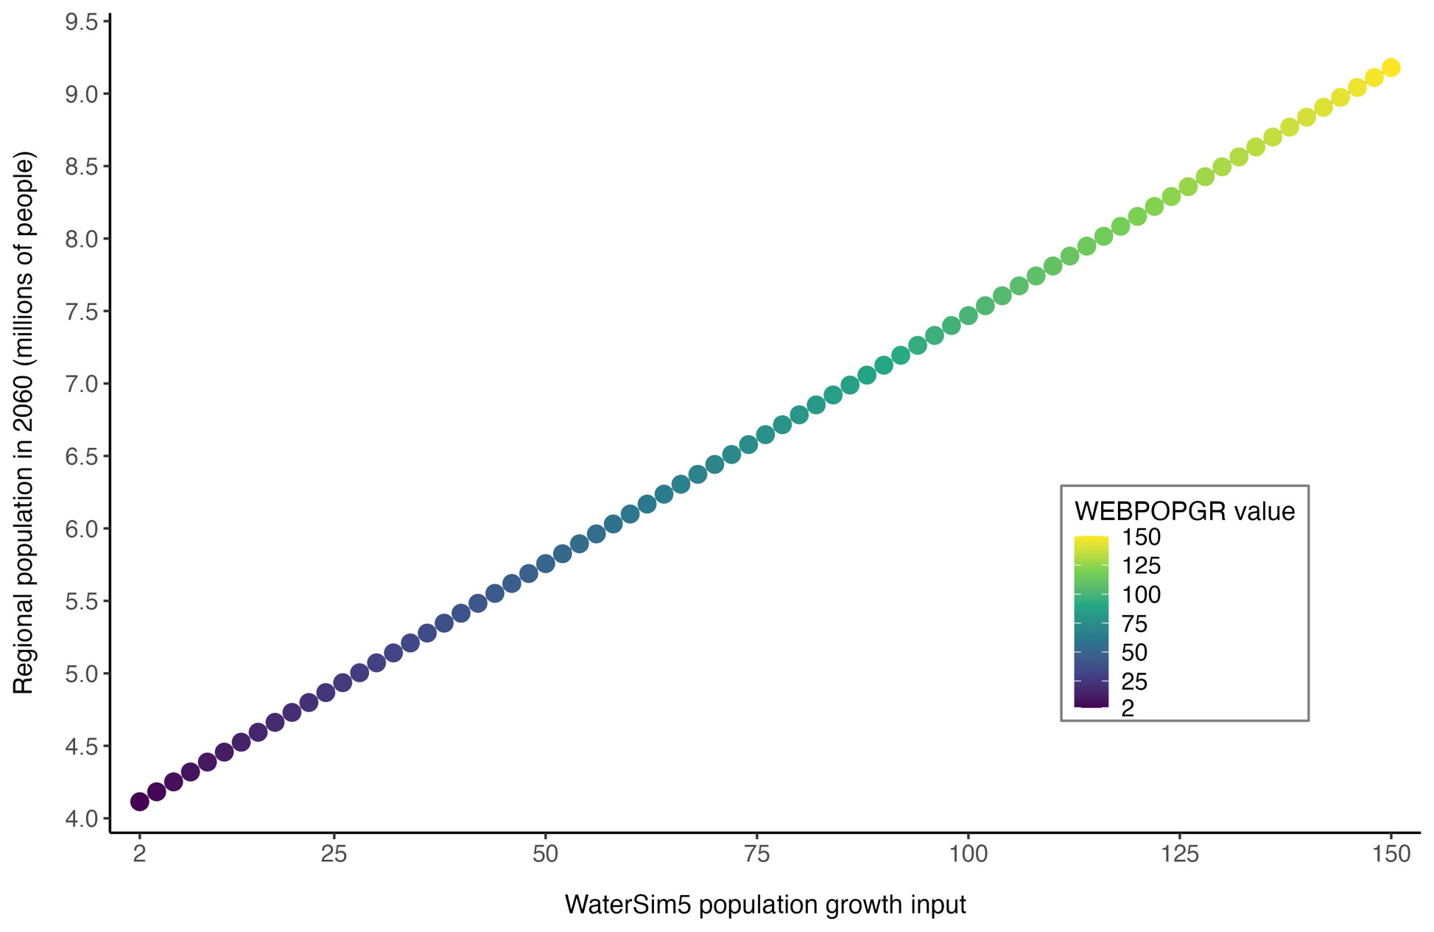
Fig. S1 Relationship between the WaterSim5 population growth input values (WEBPOPGR; % of forecasted growth) and the corresponding regional population projected for the year 2060. Each point represents one of the 75 population growth input values used in the scenario ensemble.
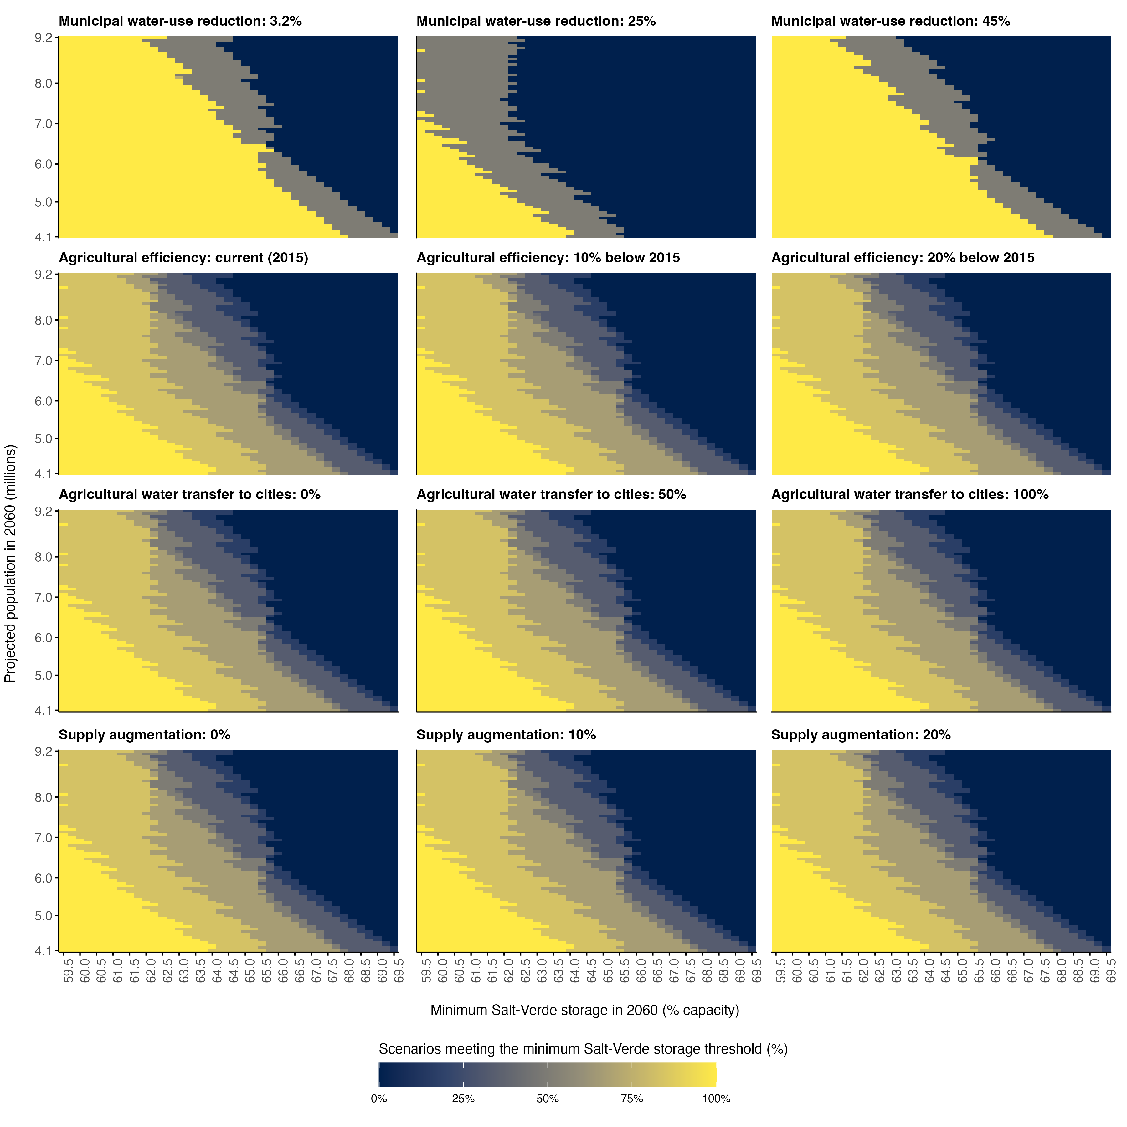
Fig. S2 Relationships among Salt-Verder River System storage, population growth, and alternative water policies. From top to bottom, rows represent four policies: municipal water-use efficiency, agricultural efficiency, agricultural-to-urban water transfer, and supply augmentation. From left to right, columns show the three levels of each policy (water-use efficiency was expressed as a reduction in water use, Table 1). Within each panel, the labeled policy level was held constant while climate, environmental-flow allocation, and the other three policies varied. The X-axis shows the minimum Salt–Verde reservoir-system storage threshold in 2060, expressed as a percentage of storage capacity. For each projected population (Y-axis) and minimum storage threshold (X-axis), cell color shows the percentage of the remaining scenarios in that panel with Salt–Verde storage values that met or exceeded that threshold. Lighter colors indicate that a larger proportion of scenarios met the threshold; darker colors indicate that fewer did.

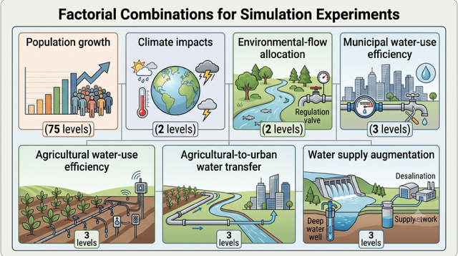
Fig. S3 Visual representation of the inputs used to generate the 24,300 scenarios. This figure was generated using Google Gemini Pro on August 7, 2026.

