**Easy Langa API**

1. **User Login:**

URL: Post on <http://betaeasy.langa.tv/api/login>

**Request Parameter:**

|  |  |
| --- | --- |
| email | Email of user |
| password | User password |

**Response Parameter:**

|  |  |
| --- | --- |
| result | Detail for user / fail message |
| status | Success/fail |

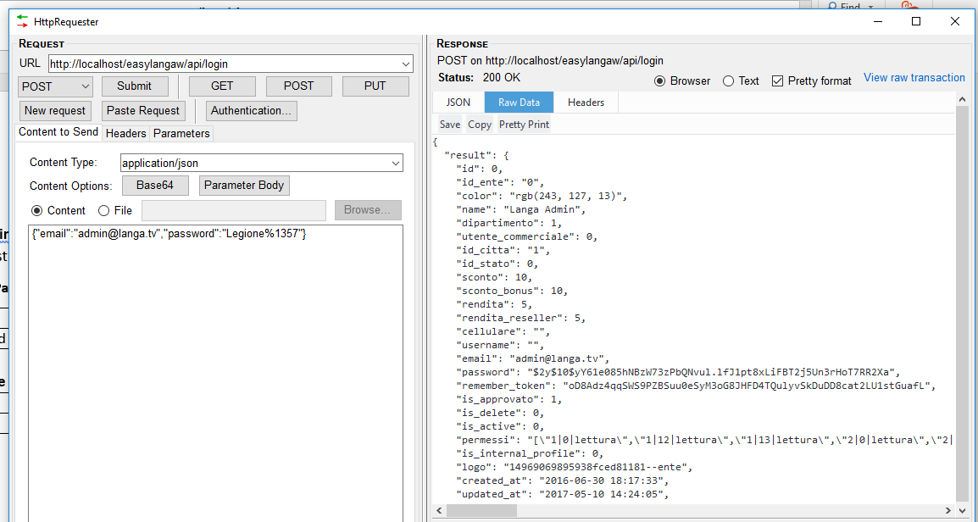

1. **Get All Menu:**

URL: Post on <http://betaeasy.langa.tv/api/getmenulist>

**Request Parameter:**

|  |  |
| --- | --- |
| api_token | Pass api_token that get in login api |
| langcode | Pass the current language code(en,it…) |
| device_id | Device id that generated from device |
| device_type | 0:IOS, 1 : Android |

**Response Parameter:**

|  |  |
| --- | --- |
| result | list for menu / fail message |
| status | Success/fail |

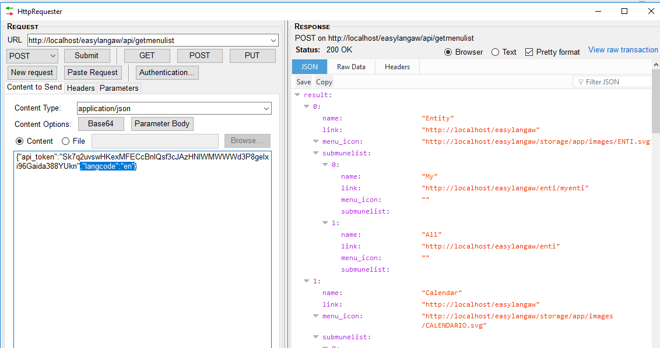

1. **Get All Language:**

URL: Post on <http://betaeasy.langa.tv/api/getlanguages>

**Request Parameter:**

|  |  |
| --- | --- |
| api_token | Pass api_token that get in login api |
| device_id | Device id that generated from device |
| device_type | 0:IOS, 1 : Android |

**Response Parameter:**

|  |  |
| --- | --- |
| result | list for language |
| status | Success/fail |

1. **Get Notifications:**

URL: Post on <http://betaeasy.langa.tv/api/getnotification>

Note: Notification is display in the top box with count of total notifications

**Request Parameter:**

|  |  |
| --- | --- |
| api_token | Pass api_token of user that get in login api |
| device_id | Device id that generated from device |
| device_type | 0:IOS, 1 : Android |

**Response Parameter:**

|  |  |
| --- | --- |
| notifications | All the notifications |
| alert | All the alert notifications |
| totalnotifications | Total notification |
| totalalert | Total alert |
| status | Success/fail |

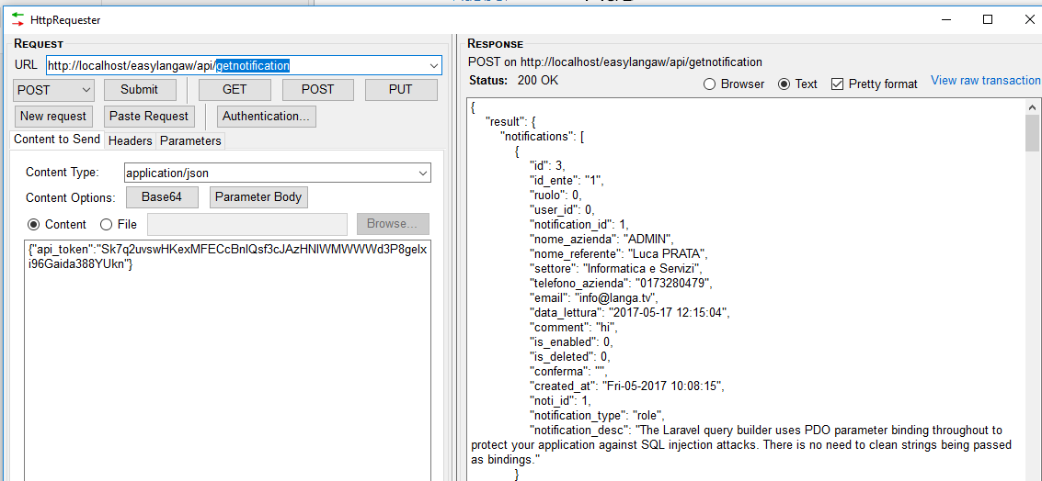

1. **Get Alert Notifications (for Belt):**

URL: Post on <http://betaeasy.langa.tv/api/getalertnotification>

Note: Notification is display in the top with multiple colour and this is one day notifications.

**Request Parameter:**

|  |  |
| --- | --- |
| api_token | Pass api_token of user that get in login api |
| device_id | Device id that generated from device |
| device_type | 0:IOS, 1 : Android |

**Response Parameter:**

|  |  |
| --- | --- |
| notifications | All the notifications of today |
| alert | All the alert notifications of today |
| totalnotifications | Total notification |
| totalalert | Total alert |
| status | Success/fail |

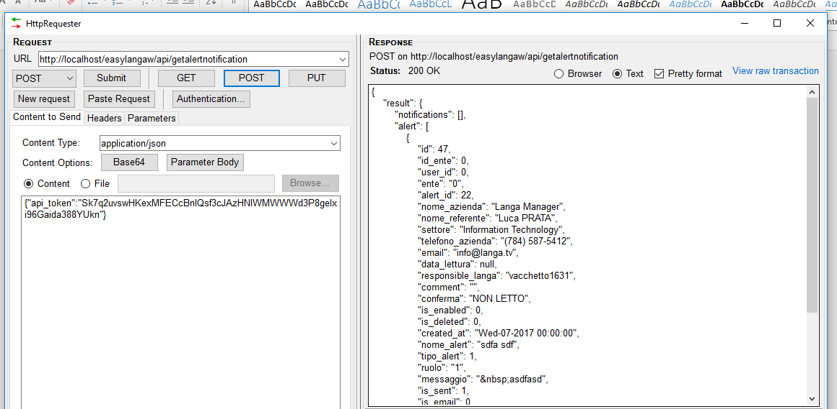

1. **Close Notifications (from Belt):**

URL: Post on <http://betaeasy.langa.tv/api/notificationclose>

Note: Notification is close than not display there

**Request Parameter:**

|  |  |
| --- | --- |
| api_token | Pass api_token of user that get in login api |
| notification_id | Get from the previous getnotification api that pass here |
| device_id | Device id that generated from device |
| device_type | 0:IOS, 1 : Android |

**Response Parameter:**

|  |  |
| --- | --- |
| status | success/fail |

1. **Close Alert (from Belt):**

URL: Post on <http://betaeasy.langa.tv/api/alertclose>

Note: Alert is close than not display there

**Request Parameter:**

|  |  |
| --- | --- |
| api_token | Pass api_token of user that get in login api |
| alert_id | Get from the getalertnotification api that pass here |
| device_id | Device id that generated from device |
| device_type | 0:IOS, 1 : Android |

**Response Parameter:**

|  |  |
| --- | --- |
| status | success/fail |

1. **Replay/Comment Alert (from Belt):**

URL: Post on <http://betaeasy.langa.tv/api/alertcomment>

**Request Parameter:**

|  |  |
| --- | --- |
| api_token | Pass api_token of user that get in login api |
| message | Replay comments or message |
| alert_id | Get from the getalertnotification api that pass here |
| device_id | Device id that generated from device |
| device_type | 0:IOS, 1 : Android |

**Response Parameter:**

|  |  |
| --- | --- |
| status | success/fail |

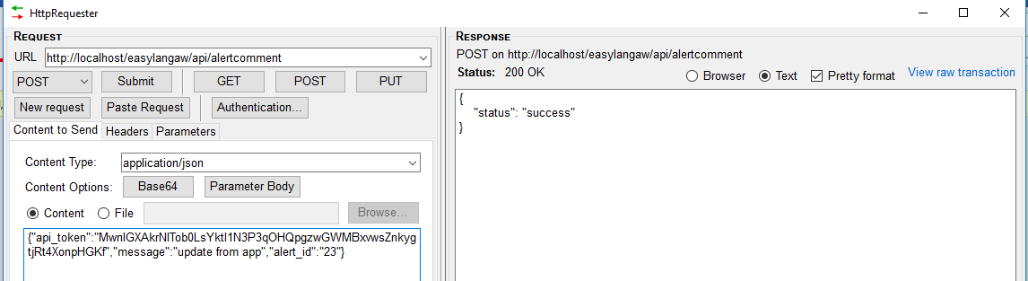

1. **Make as Read Alert (from Belt):**

URL: Post on <http://betaeasy.langa.tv/api/readalert>

**Request Parameter:**

|  |  |
| --- | --- |
| api_token | Pass api_token of user that get in login api |
| alert_id | Get from the getalertnotification api that pass here |
| device_id | Device id that generated from device |
| device_type | 0:IOS, 1 : Android |

**Response Parameter:**

|  |  |
| --- | --- |
| status | success/fail |



1. **Update User Profile**

URL: Post on [http://betaeasy.langa.tv/api/userprofileupdate](http://betaeasy.langa.tv/api/readalert)

**Request Parameter:**

|  |  |
| --- | --- |
| api_token | Pass api_token of user that get in login api |
| name | User name |
| email | User email address |
| discount | discount |
| discount_bonus | Discounted bonus |
| revenue | Revenue |
| revenue_reseller | Reseller revenue |
| password | password |
| device_id | Device id that generated from device |
| logo | Input file logo(image) |
| device_type | 0:IOS, 1 : Android |

**Response Parameter:**

|  |  |
| --- | --- |
| status | success/fail |
| message | Profile updated successfully. |

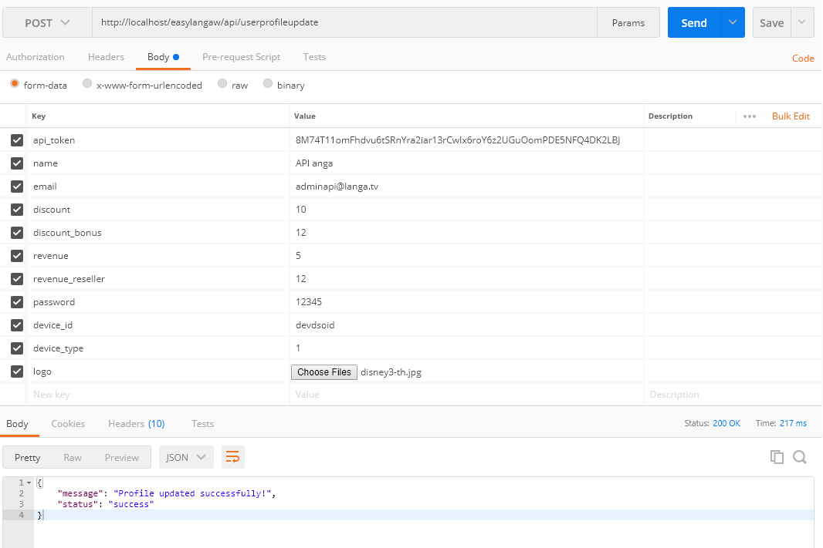

1. **Register Step One**

URL: Post on http://betaeasy.langa.tv/api/registerstepone

**Request Parameter:**

|  |  |
| --- | --- |
| name | User name (first/last name) |
| email | User email address |
| password | password |
| device_id | Device id that generated from device |
| device_type | 0:IOS, 1 : Android |

**Response Parameter:**

|  |  |
| --- | --- |
| status | success/fail |
| result | Detail for user with user Id |

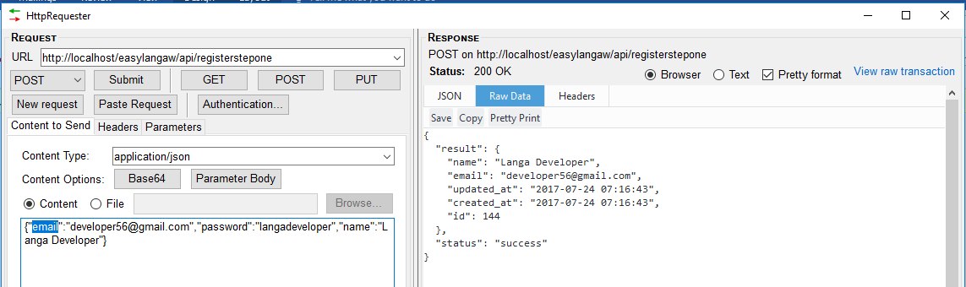

1. **Register Step Two**

URL: Post on <http://betaeasy.langa.tv/api/registersteptwo>

Note: That API also inset in entity

**Request Parameter:**

|  |  |
| --- | --- |
| phone | User phone no |
| location | Address of user/entity |
| user_id | User id that get from 1st step response |
| usertype | Client, Reseller, Commercials (call user type api) |
| device_id | Device id that generated from device |
| device_type | 0: IOS, 1: Android |

**Response Parameter:**

|  |  |
| --- | --- |
| status | success/fail |
| result | Detail for user with user Id |

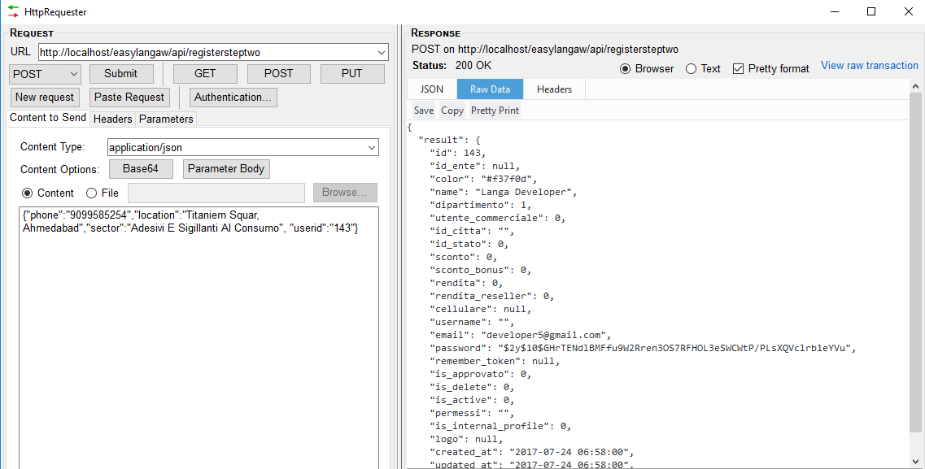

1. **Get User Type**

URL: Post on <http://betaeasy.langa.tv/api/getusertype>

**Request Parameter:**

|  |  |
| --- | --- |
| device_id | Device id that generated from device |
| device_type | 0:IOS, 1 : Android |

**Response Parameter:**

|  |  |
| --- | --- |
| status | success/fail |
| result | Detail for All User Types with permissions |

1. **Get Department**

URL: Post on http://betaeasy.langa.tv/api/getdepartments

**Request Parameter:**

|  |  |
| --- | --- |
| device_id | Device id that generated from device |
| device_type | 0: IOS, 1: Android |

**Response Parameter:**

|  |  |
| --- | --- |
| status | success/fail |
| result | Detail for All User Types with permissions |

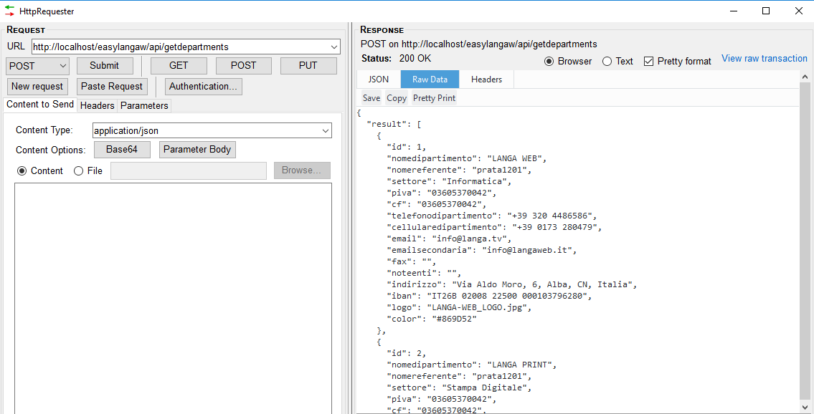

1. **Get Sector**

URL: Post on http://betaeasy.langa.tv/api/getsectors

**Request Parameter:**

|  |  |
| --- | --- |
| device_id | Device id that generated from device |
| device_type | 0: IOS, 1: Android |

**Response Parameter:**

|  |  |
| --- | --- |
| status | success/fail |
| result | List of all sectors |

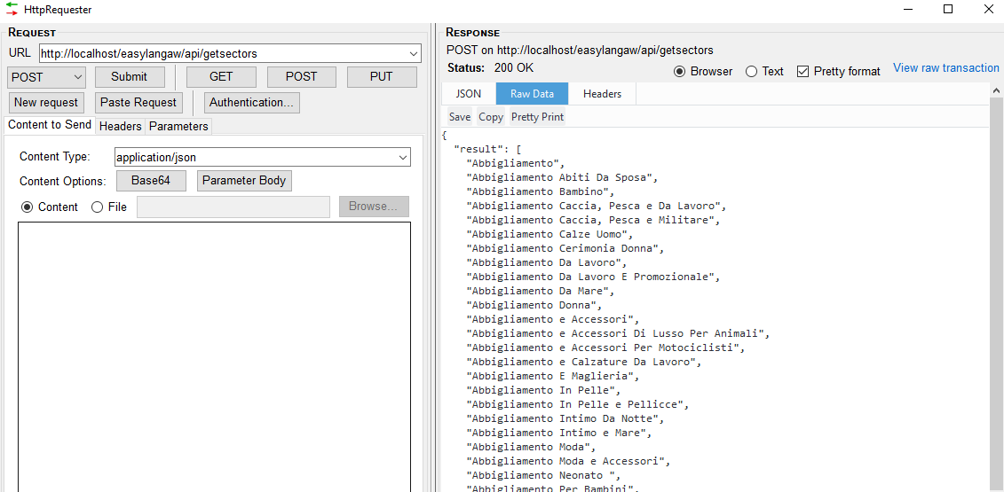

1. **Get Package of Department**

URL: Post on http://betaeasy.langa.tv/api/getdepartmentspackage

**Request Parameter:**

|  |  |
| --- | --- |
| department_id | Department id from (getdepartment api) |
| device_id | Device id that generated from device |
| device_type | 0: IOS, 1 : Android |

**Response Parameter:**

|  |  |
| --- | --- |
| status | success/fail |
| result | List of all sectors |

1. **Get Dashboard Module**

URL: Post on http://betaeasy.langa.tv/api/getDashboardModules

**Request Parameter:**

|  |  |
| --- | --- |
| api_token | Pass api_token of user that get in login api |
| device_id | Device id that generated from device |
| device_type | 0: IOS, 1: Android |

**Response Parameter:**

|  |  |
| --- | --- |
| status | success/fail |
| result | List of all active dashboard widget menu |

