Movie Ticket Booking Platform (MTBP) — Architecture & Design Document

# Document Control

* **Title:** Movie Ticket Booking Platform (MTBP) — Architecture & Design
* **Version:** 1.0
* **Author:** Sonil Kumar
* **Date:** 2025-10-02
* **Status:** Review
* **Distribution List:** Theatre Owners & Movie Viewers
* **Revision History**
* v1.0 — Initial template — 2025-10-02 — Sonil

# Table of Contents

1. Executive Summary
2. Scope & Objectives

3. Stakeholders & Roles

4. Business Requirements (Functional)

5. Non-Functional Requirements (NFRs)

6. Architecture Overview

* 6.1 Context Diagram (C4 — Level 1)
* 6.2 Container Diagram (C4 — Level 2)
* 6.3 UML Diagrams For Full Flow Understanding of MTBP
* Deployment Diagrams (CI / CD)

7. Detailed Design

* 7.1 API Gateway & Edge Architecture
* 7.2 Microservices: Service-Level Responsibilities
* 7.3 Data Modeling (High-Level)
* 7.4 Messaging & Eventing (Kafka)
* 7.5 Security Considerations
* 7.6 Observability & Monitoring
* 7.7 Resilience & Fault Tolerance

8. Platform Provisioning & Hosting

* 8.1 Cloud/Hybrid strategy
* 8.2 Region, AZ, and multi-GEO considerations
* 8.3 Sizing & capacity planning
* 8.4 Infrastructure as Code (IaC)

9. Data Management & Transactions

* 9.1 Data modelling (ER / high-level schema)
* 9.2 Transactional guarantees & patterns
* 9.3 Eventual consistency and compensating transactions
* 9.4 Backups, retention & archival

10. COTS & Enterprise Systems

11. CI/CD, Release Management & Rollout Strategy

12. Scalability, Availability & Resilience

13. Performance & Capacity Planning

14. Security, Compliance & Privacy

15. Operational Readiness & Runbooks

16. Cost Estimates & Licensing

17. Risk Assessment & Mitigation

18. Stakeholder Management & Decision Logs

19. Appendices

* A. Glossary
* B. Contact matrix
* C. Important Links

1. Executive Summary

The **Movie Ticket Booking Platform (MTBP)** is a highly scalable, resilient, and globally deployable platform designed to enable end customers to search, browse, and book movie tickets online. The platform caters to multiple stakeholders including:

* **End Customers:** Moviegoers who search movies, select theatres, and book seats.
* **Theatre Partners:** Operators providing show schedules, seat inventory, and venue details via APIs or portal interfaces.
* **MTBP Admins:** Platform operators managing theatre onboarding, promotions, and analytics.

**Key Capabilities:**

1. **Real-time Seat Booking:** Allows customers to view live seat availability and confirm bookings without conflicts, supporting high-concurrency scenarios.
2. **Partner Integrations:** Seamlessly integrates with existing theatre IT systems and supports onboarding new partners with a flexible API/portal.
3. **Payment Gateway Integration:** Ensures secure and compliant payments using multiple third-party providers.
4. **Localization & Geo-scaling:** Supports multi-language, multi-currency, and city-level regional content for international expansion.
5. **Observability & Metrics:** Comprehensive monitoring with real-time dashboards (Grafana), alerting, and logging (Prometheus & Loki).
6. **Event-driven Architecture:** Uses Kafka for asynchronous inter-service communication, enabling scalability, loose coupling, and resilience.
7. **High Availability & Resilience:** Designed for **99.99% uptime**, with automated failover, multi-region deployment, and disaster recovery.

**Business Benefits:**

* Streamlined booking experience increases customer engagement and conversion rates.
* Flexible partner onboarding reduces integration costs and time-to-market.
* Scalable infrastructure supports rapid expansion into new cities and countries.
* Robust security and compliance architecture minimizes operational risk.

2. Scope & Objectives

### In Scope

The MTBP project will deliver:

1. **Core Booking System**
   * Movie search by location, theatre, date, or genre.
   * Real-time seat selection and reservation.
   * Ticket confirmation and refund workflows.
2. **Partner Integration Framework**
   * APIs for existing theatre systems.
   * Web portal for manual data entry for new theatre partners.
   * Automated reconciliation of theatre inventory and show schedules.
3. **Customer Management**
   * Registration, profile management, loyalty, and preferences.
4. **Payment Processing**
   * Integration with multiple third-party payment gateways (PCI-DSS compliant).
   * Support for multi-currency and local payment methods.
5. **Admin & Reporting**
   * Analytics dashboards for bookings, revenue, cancellations, and theatre utilization.
   * Partner performance and audit reporting.
6. **Observability**
   * Metrics collection, logging, tracing, and alerting.
   * Dashboards for business and operational monitoring.

### Out of Scope

* Third-party analytics integrations not directly required for booking operations.
* Offline theatre-only ticketing or kiosk-based management (unless explicitly onboarded).

### Objectives

* Deliver a **secure, resilient, and highly available** booking platform capable of scaling horizontally.
* Enable **fast onboarding of new theatres** and movie content.
* Support **internationalization** with localization of languages, currencies, and content.
* Provide **observability, monitoring, and alerting** for operational excellence.
* Ensure **regulatory compliance** (PCI-DSS, GDPR, local payment laws) across geographies.
* Facilitate a **robust CI/CD pipeline** and blue/green deployment strategy for seamless releases.

3. Stakeholders & Roles

The success of the **Movie Ticket Booking Platform (MTBP)** depends on clear roles, responsibilities, and active engagement from all stakeholders. Below is a detailed breakdown of key stakeholders:

### 3.1 Product Owner

* **Role:** Represents the business and end-customer interests.
* **Responsibilities:**
  + Define product vision, roadmap, and feature priorities.
  + Approve functional requirements and user stories.
  + Engage with marketing, theatre partners, and finance teams for alignment.
* **Decision Authority:** Final sign-off on product features, business requirements, and release priorities.

### 3.2 Enterprise Architect

* **Role:** Oversees enterprise-wide technology alignment and architectural compliance.
* **Responsibilities:**
  + Define architectural principles, design patterns, and non-functional requirements.
  + Ensure platform scalability, high availability, and security compliance.
  + Review technical decisions from Solution Architects.
* **Decision Authority:** Approves high-level technology choices and enterprise integration patterns.

### 3.3 Solution Architect

* **Role:** Designs end-to-end system solutions and ensures implementation aligns with architecture.
* **Responsibilities:**
  + Design service decomposition, data flows, and integration patterns.
  + Approve API contracts, microservice boundaries, and CI/CD pipelines.
  + Review technical design documents submitted by engineering teams.
* **Decision Authority:** Sign-off on solution-level architecture and design decisions.

### 3.4 Engineering Leads

* **Roles:** Lead respective engineering disciplines (Frontend, Backend, Data, Platform).
* **Responsibilities:**
  + Ensure implementation follows coding standards and architecture guidelines.
  + Plan and deliver sprint work aligned with the product roadmap.
  + Conduct peer code reviews and ensure high-quality code.
* **Decision Authority:** Technical decisions within their domain (e.g., tech stack, libraries, frameworks).

### 3.5 QA & SRE (Site Reliability Engineering)

* **Role:** Ensure platform quality, reliability, and operational readiness.
* **Responsibilities:**
  + Develop test plans, automation suites, and conduct performance testing.
  + Monitor system availability, error rates, and SLO/SLA adherence.
  + Implement alerting, incident response, and disaster recovery procedures.
* **Decision Authority:** Can halt release if critical issues are found; approve operational readiness.

### 3.6 Security & Compliance

* **Role:** Ensure adherence to security standards and regulatory requirements.
* **Responsibilities:**
  + Review and approve secure authentication/authorization mechanisms.
  + Conduct vulnerability assessments, penetration testing, and audits.
  + Ensure PCI-DSS, GDPR, and regional payment compliance.
* **Decision Authority:** Final approval for production readiness from a security perspective.

### 3.7 Theatre Partnership Managers

* **Role:** Manage relationships with theatre owners and content providers.
* **Responsibilities:**
  + Onboard new theatre partners and coordinate data integration.
  + Ensure show schedules, pricing, and inventory data are accurate.
  + Monitor partner performance metrics and feedback.
* **Decision Authority:** Authorize theatre onboarding and data integration approvals.

### 3.8 Payment Gateway / Vendor Teams

* **Role:** Provide payment processing services and integration support.
* **Responsibilities:**
  + Ensure secure transaction processing and tokenization compliance.
  + Support integration of multiple payment methods, currencies, and refunds.
  + Provide operational metrics, SLAs, and reconciliation reports.
* **Decision Authority:** Approve integration approach and transaction settlement rules.

### 3.9 Regional Operations Teams

* **Role:** Manage platform operations across geographies.
* **Responsibilities:**
  + Ensure platform availability and performance in each region.
  + Coordinate deployments, maintenance, and localized content updates.
  + Handle local support, incident response, and compliance reporting.
* **Decision Authority:** Local operational decisions affecting uptime, scaling, and regional content.

4. Business Requirements (Functional)

These below requirements, the platform must do to meet the needs of **end customers, theatre partners, and administrators**. Grouped into logical domains for clarity.

### 4.1 Customer-Facing Features

#### 4.1.1 Movie Discovery

* **Description:** Customers can search and browse movies by city, theatre, genre, language, date, and showtime.
* **Key Capabilities:**
  + Location-based search with map view.
  + Filter by genre, language, popularity, ratings.
  + Personalized recommendations based on viewing history.
* **User Story:** *As a moviegoer, I want to find available movies and showtimes quickly so that I can plan my visit efficiently.*

#### 4.1.2 Seat Selection & Booking

* **Description:** Real-time seat availability and booking confirmation.
* **Key Capabilities:**
  + Display live seat map for each theatre and show.
  + Allow customers to select multiple seats in one booking.
  + Prevent double-booking using **inventory locking** (via API or Kafka events).
  + Support refunds, cancellations, and partial booking modifications.
* **User Story:** *As a customer, I want to select my preferred seats and book them instantly to avoid conflicts.*

#### 4.1.3 Payment Processing

* **Description:** Secure, multi-channel payments integrated with third-party gateways.
* **Key Capabilities:**
  + Support multiple payment methods: credit/debit cards, wallets, UPI, local payment methods.
  + Multi-currency support for international customers.
  + Generate receipts, confirmations, and transaction logs.
* **User Story:** *As a customer, I want to pay securely and receive instant confirmation of my ticket purchase.*

#### 4.1.4 Customer Account & Loyalty

* **Description:** Profile management, loyalty points, and preferences.
* **Key Capabilities:**
  + Register/login via email, mobile, or OAuth2 providers (e.g., Google, Facebook).
  + View booking history, upcoming shows, and loyalty points.
  + Save preferences for preferred theatres or genres.
* **User Story:** *As a customer, I want to manage my profile and loyalty points to get personalized offers.*

### 4.2 Theatre Partner Features

#### 4.2.1 Partner Onboarding

* **Description:** Onboard both legacy and new theatres via portal/API.
* **Key Capabilities:**
  + Upload theatre metadata, show schedules, pricing, and seat layouts.
  + Validate data consistency and completeness.
* **User Story:** *As a theatre partner, I want to quickly register and update theatre information to start selling tickets.*

#### 4.2.2 Inventory Management

* **Description:** Manage seat availability and pricing dynamically.
* **Key Capabilities:**
  + Real-time seat availability updates.
  + Automated synchronization with MTBP inventory service.
* **User Story:** *As a theatre partner, I want to ensure my inventory is accurately reflected on the platform.*

### 4.3 Admin Features

#### 4.3.1 Operational Management

* **Description:** Central administration for platform operations.
* **Key Capabilities:**
  + Manage users, theatre partners, and show schedules.
  + Monitor platform performance, bookings, payments, and disputes.
  + Generate reports and analytics for revenue, utilization, and partner performance.
* **User Story:** *As an admin, I want to monitor and manage all platform operations to ensure smooth business functioning.*

#### 4.3.2 Pricing, Promotions & Refunds

* **Description:** Admin can manage discounts, promotions, and handle refunds.
* **Key Capabilities:**
  + Apply region-specific or theatre-specific promotions.
  + Define automated refund rules based on cancellations.
  + Track promotional effectiveness via dashboards.
* **User Story:** *As an admin, I want to create promotions and manage refunds to enhance customer satisfaction and drive sales.*

### 4.4 Integration Features

#### 4.4.1 Partner System Integration

* **Description:** Interface with theatre legacy systems.
* **Key Capabilities:**
  + REST APIs or batch data ingestion for show schedules and inventory.
  + Event-driven updates using Kafka for inventory or booking events.
* **User Story:** *As a system, I want to synchronize theatre inventory and bookings in real-time to prevent inconsistencies.*

#### 4.4.2 Payment Gateway Integration

* **Description:** Multi-gateway support with fallback.
* **Key Capabilities:**
  + Automatic retry and reconciliation for failed payments.
  + Multi-region support and failover to alternate gateways.
* **User Story:** *As a system, I want to process payments reliably to maintain revenue and customer trust.*

### 

### 

### 

### 

### 

### 4.5 Priority Matrix

| **Feature Domain** | **Priority** | **Rationale** |
| --- | --- | --- |
| Seat Selection & Booking | High | Core business capability |
| Payment Processing | High | Critical for revenue and trust |
| Movie Discovery | Medium | Enhances customer experience |
| Partner Onboarding | High | Essential for scaling platform coverage |
| Customer Account & Loyalty | Medium | Increases retention and engagement |
| Admin Dashboards | Medium | Required for operations oversight |
| Promotions & Refunds | Medium | Business flexibility and customer satisfaction |
| System Integrations | High | Ensures real-time inventory & payment accuracy |

## 

## 

## 

## 

## 

## 

## Functional Requirement Traceability Table (FRTT)

| **#** | **Functional Requirement** | **Responsible Service / Component** | **API / Integration Point** | **Primary Stakeholder** |
| --- | --- | --- | --- | --- |
| 1 | Search movies by city & theatre | Customer Service | /movies/search | End Customer |
| 2 | Showtimes & seat-map visualization | Inventory Service / Theatre Service | /inventory/showtimes, /theatre/shows | End Customer, Theatre Partner |
| 3 | Real-time seat availability & reservations | Booking Service, Inventory Service | /booking/reserve, Kafka Events InventoryUpdated | End Customer, Theatre Partner |
| 4 | Multi-currency pricing, promotions & refunds | Payment Service, Admin Service | /payment/charge, /promotions/apply, /payment/refund | End Customer, Admin |
| 5 | Partner onboarding portal & APIs | Theatre Partner Service | /partner/onboard, /partner/update | Theatre Partner, Admin |
| 6 | Admin dashboards & reporting | Admin Service, Grafana dashboards | Internal REST APIs, Grafana | Admin, Product Owner |
| 7 | Audit trails & payment reconciliation | Payment Service, Booking Service | /payment/transactions, Kafka Events BookingCreated/Cancelled | Admin, Finance Team |
| 8 | Integration with payment gateways | Payment Service | External Payment Gateway APIs | Payment Gateway Teams |
| 9 | Partner system integration | Theatre Partner Service | REST / SOAP / Batch APIs | Theatre Partner Managers |
| 10 | Loyalty and profile management | Customer Service | /customer/profile, /customer/loyalty | End Customer |

5. Non-Functional Requirements (NFRs)

These are measurable, enforceable, and critical for platform stability, scalability, and compliance.

### 5.1 Availability

* **Target SLA:** 99.99% uptime per region.
* **Implementation Considerations:**
  + Multi-AZ deployment per region to handle single-zone failures.
  + Multi-region active-active failover for disaster recovery.
  + Automated health checks, load balancing, and traffic rerouting.
  + Redundant service instances for all microservices and supporting databases.
* **Rationale:** Ensures high reliability for end customers and theatre partners, minimizing booking conflicts and downtime.

### 5.2 Performance

* **Target Metrics:**
  + 95th percentile response time for search queries: < 300ms.
  + End-to-end booking flow (seat selection → confirmation → payment): < 1.5s under normal load.
  + Payment processing and reconciliation: < 2s under peak load.
* **Implementation Considerations:**
  + Caching layer for frequently queried data (e.g., movies, theatre info).
  + Asynchronous processing for non-critical workflows (Kafka for event-driven updates).
  + Database indexing, read replicas, and query optimization.
* **Rationale:** Enhances customer experience, reduces abandonment, and supports high-volume transactions during peak hours.

### 5.3 Scalability

* **Horizontal Scalability:** All services should scale independently based on load.
* **Peak Load Targets:** Support up to ~50,000–100,000  **peak** (RPS) without degradation.
* **Implementation Considerations:**
  + Containerized microservices with auto-scaling policies.
  + Event-driven architecture using Kafka to decouple service dependencies.
  + Partitioned databases or sharding to distribute load.
* **Rationale:** Supports expansion to multiple cities/countries and high traffic events (e.g., blockbuster releases).

### 5.4 Security

* **Authentication & Authorization:**
  + OAuth2 / OpenID Connect for secure login (end customers, admins, partners).
  + Role-based access control (RBAC) for API and admin portal access.
* **Data Protection:**
  + PCI-DSS compliance for payment card data.
  + Encryption of sensitive data at rest (AES-256) and in transit (TLS 1.2+).
* **Operational Security:**
  + Secure API endpoints, input validation, and logging of access attempts.
  + Periodic security audits and penetration testing.
* **Rationale:** Ensures customer trust, regulatory compliance, and protection of platform integrity.

### 5.5 Localization

* **Languages:** Support multiple languages including English, local languages per country.
* **Currency:** Support multiple currencies and regional payment methods.
* **Locale-specific Content:** Date, time, and number formatting according to region.
* **Implementation Considerations:**
  + Configuration-driven internationalization (i18n) in UI and backend services.
  + Locale-based content delivery using microservice configuration or CDN.
* **Rationale:** Enhances usability, customer adoption, and international expansion readiness.

### 5.6 Observability

* **Metrics:** Collect metrics at service-level (Prometheus) and business-level (number of bookings, revenue, cancellations).
* **Logging:** Centralized logging (Loki) with structured log formats for auditing and debugging.
* **Tracing:** End-to-end distributed tracing to track booking and payment workflows.
* **Alerting:** Configurable alerts for SLA breaches, errors, or abnormal patterns.
* **Runbooks:** Documented operational procedures for common incidents.
* **Rationale:** Enables proactive monitoring, incident resolution, and platform reliability.

### 5.7 Reliability & Resilience

* **Circuit Breakers:** Prevent cascading failures in microservices.
* **Retries with Exponential Backoff:** For transient failures in downstream services.
* **Failover:** Automatic failover for critical services (DB replicas, multi-region services).
* **Data Consistency:** Eventual consistency using asynchronous messaging, compensating transactions for critical workflows.
* **Rationale:** Ensures platform stability under partial failures and high load scenarios.

**Summary of Rational Numbers for MTBP NFRs:**

| **Parameter** | **Recommended Value** |
| --- | --- |
| Peak Load (RPS) | 100,000 RPS globally |
| Average Load (RPS) | 5,000 RPS |
| Search Latency | < 300 ms (95th percentile) |
| Booking Flow Latency | < 1.5 s |
| Payment Processing Latency | < 2 s |
| SLA / Availability | 99.99% uptime |
| Scaling | Horizontal autoscaling for all microservices |
| Multi-region Deployment | Yes, active-active with failover |

6. Architecture Overview

# We have created a C4 Design repository in Github to maintain the diagrams maintenance. GitHub Repository Link: <https://github.com/skynovicecoder/mtbp-c4-diagrams>

# 6.1 Context Diagram (C4 — Level 1)

**Purpose:** Shows the **MTBP system in its environment**, highlighting interactions with users, partners, and external systems.

**Key Entities:**

* **Users:** End customers (moviegoers) interacting with web or mobile apps.
* **Theatre Partners:** External systems providing show schedules and seat inventory.
* **MTBP Admins:** Internal operators managing the platform.
* **External Systems:**
  + Payment Gateways (PCI-DSS compliant)
  + Identity Provider (OKTA / OAuth2)
  + Observability tools (Grafana, Prometheus, Loki)

**Interactions:**

* Users access the MTBP via web/mobile apps → routed through Load Balancer → API Gateway → microservices.
* Theatre partners integrate via REST APIs or portals.
* Payment services interact with external payment gateways.
* Observability systems collect metrics and logs from all microservices.

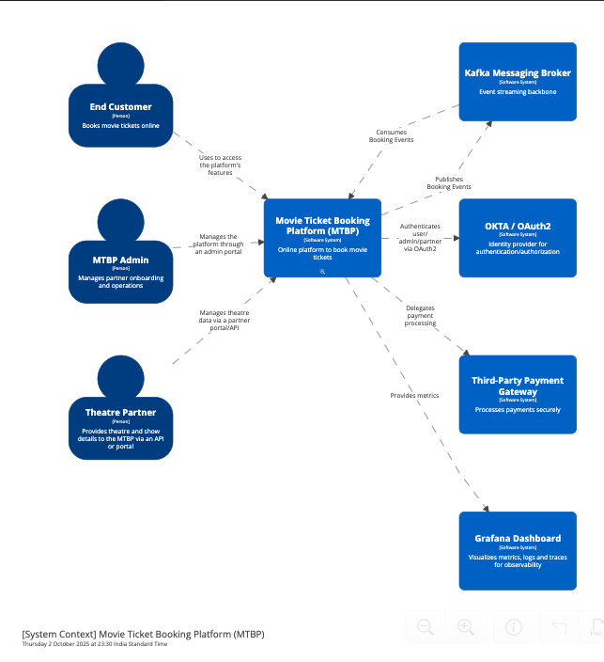

# 6.2 Container Diagram (C4 — Level 2)

**Purpose:** Shows the **internal containers** of MTBP — how major services and databases are structured.

**Key Containers:**

* **Load Balancer (Nginx / ALB)**: Handles incoming traffic and distributes requests.
* **API Gateway (Spring Cloud Gateway)**: Routes requests to microservices, performs authentication via OKTA.
* **Microservices (Spring Boot):**
  + **Customer Service:** Manages user profiles and loyalty.
  + **Theatre Partner Service:** Manages theatre data and partner onboarding.
  + **Inventory Service:** Manages seat availability and inventory events.
  + **Booking Service:** Handles booking creation, cancellation, and events.
  + **Payment Service:** Processes payments, refunds, and reconciliation.
* **Databases (PostgreSQL):**
  + Customer DB, Theatre DB, Inventory DB, Booking DB, Payment DB.
* **Messaging Layer (Kafka):**
  + Asynchronous communication for events like booking created, inventory reserved, payment success/failure.
* **Observability:**
  + Prometheus (metrics), Loki (logs), Grafana (dashboards).

**Interactions:**

* Users/admins → LB → API Gateway → respective microservices → DB or Kafka.
* Services publish/subscribe to Kafka for decoupled event-driven communication.
* Metrics/logs pushed to Prometheus/Loki → Grafana dashboards.

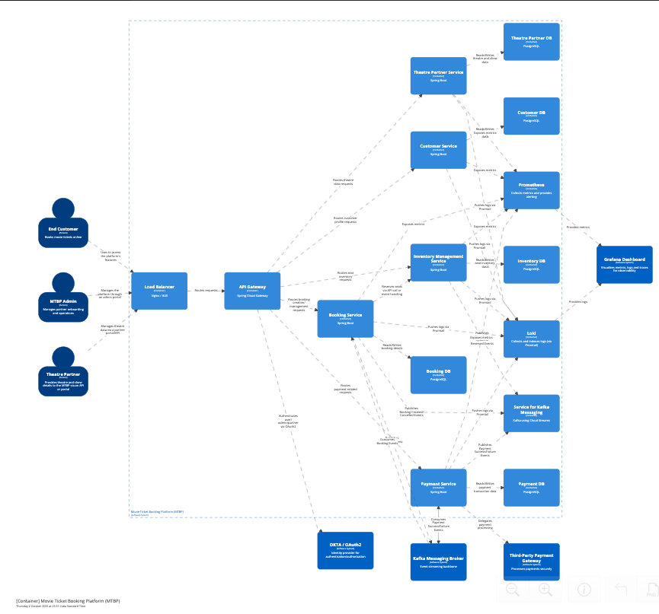

# 6.3 UML Diagrams For Full Flow Understanding of MTBP

# 

# 6.4 Deployment Diagrams (CI / CD)

Multi-region deployment: Active-active setup per region.  
Service containers running in Kubernetes with autoscaling.  
Kafka cluster for event streaming (multi-broker).  
Observability stack: Prometheus, Loki, Grafana with alerting.  
CI/CD integration: GitHub Actions / Jenkins pipelines with canary or blue-green deployments.  
  
**CI (Continuous Integration) Workflow**  
  
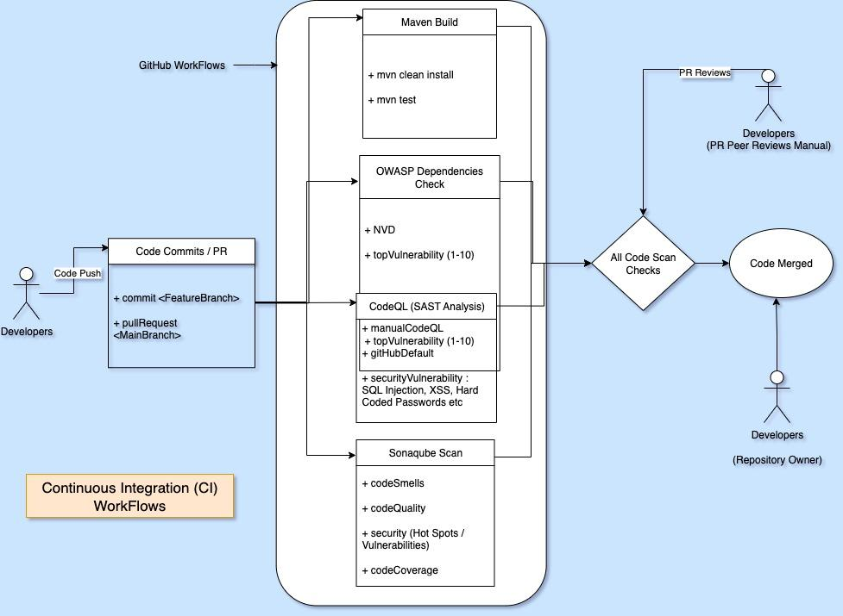

# 

# CD (Continuous Deployments) Workflow

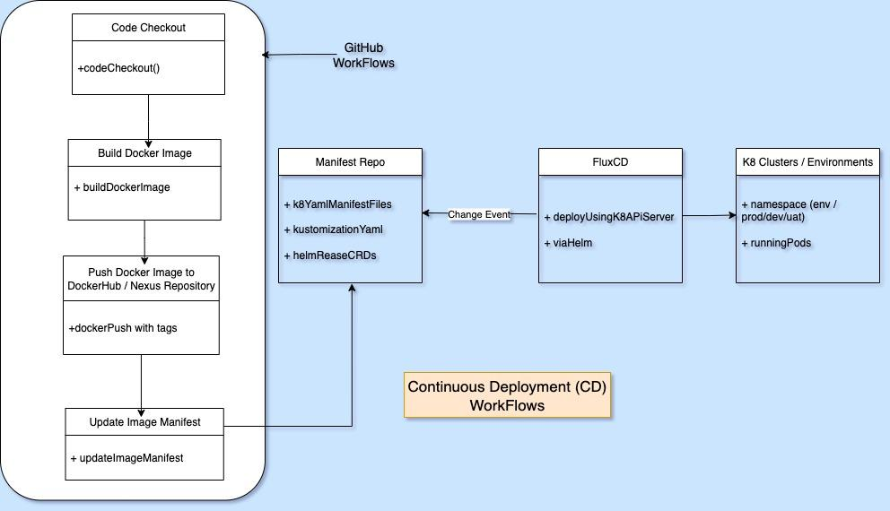

7. Detailed Design

This section details how each MTBP microservice is implemented, integrated, and monitored, including data flows, API definitions, and architectural patterns.

### 7.1 API Gateway & Edge Architecture

The **API Gateway & Edge layer** acts as the **front-door** to the MTBP ecosystem, providing secure, scalable, and controlled access to backend microservices. It ensures **consistent cross-cutting concerns** such as authentication, authorization, rate-limiting, observability, and request routing.

### Objectives of the API Gateway Layer

1. **Unified Entry Point** – A single domain and endpoint for external clients (customers, theatres, admins, partners).
2. **Security Enforcement** – Enforce OAuth2/OpenID Connect tokens via OKTA, validate JWTs, manage roles and permissions.
3. **Traffic Management** – Apply throttling, rate limiting, and request shaping to protect backend services.
4. **Routing & Composition** – Route to correct microservice or aggregate multiple services for composite responses.
5. **Resiliency & Fault Tolerance** – Apply retries, circuit breakers, and caching where applicable.
6. **Observability Hooks** – Request tracing, logging, and metrics collection for monitoring.
7. **Geo-aware Routing** – Direct requests to the nearest region (multi-geo deployments).

### Architecture Components

| **Component** | **Responsibility** |
| --- | --- |
| **Load Balancer (Nginx / ALB)** | First edge entry point; distributes traffic across API Gateway nodes. |
| **API Gateway (Spring Cloud Gateway / Kong / Apigee)** | Enforces policies (auth, rate limiting, logging, request transformation) and routes to microservices. |
| **AuthN/AuthZ via OKTA** | Validates OAuth2/OpenID Connect tokens; integrates with RBAC policies. |
| **WAF (Web Application Firewall)** | Protects against common attacks (SQL injection, XSS, DDoS). |
| **Edge Caching/CDN** | Static assets (UI, images, posters) cached at edge locations for performance. |
| **Service Registry (Eureka/Consul)** | Dynamic discovery of backend services for routing. |
| **Circuit Breaker Layer (Resilience4j)** | Handles degraded dependencies gracefully. |

### Request Flow

1. **Client Initiates Request** End-customer or partner sends HTTPS requests (e.g., booking tickets, fetching showtimes).
2. **Load Balancer Receives Traffic** Balancer (e.g., AWS ALB, Nginx ingress) distributes incoming requests across healthy API Gateway instances.
3. **API Gateway Processing**
   * **Authentication/Authorization:** Validates access token via OKTA.
   * **Rate Limiting:** Applies per-user, per-service, or per-geo quotas.
   * **Request Transformation:** Converts external API schema to internal service schema if needed.
   * **Routing:** Forwards request to appropriate microservice (e.g., Booking Service, Payment Service).
4. **Microservice Execution** Microservice processes requests, interacts with DB/event bus, and returns responses.
5. **Response Returned** API Gateway aggregates responses if required, applies response transformations, and returns to clients.

### Security Considerations

* **Transport Encryption:** All external and internal communication is TLS 1.2+/mTLS enabled.
* **OAuth2/OpenID Connect:** Access tokens validated at the gateway.
* **WAF Protection:** OWASP Top-10 covered at the edge.
* **Rate Limiting:** Prevent brute-force and abusive traffic.
* **API Keys & Contracts:** Third-party partners (theatre systems, payment gateways) integrate via signed API contracts.

### Deployment Considerations

* **Multi-Geo API Gateways**: Each geo hosts its own API Gateway cluster for latency optimization.
* **Blue/Green & Canary Deployments**: API Gateway supports routing specific traffic percentages to new versions.
* **Autoscaling**: Horizontal scaling based on request throughput (RPS).
* **Resiliency**: Circuit breakers and fallback responses for degraded services.

### Example API Gateway Policies

| **Policy** | **Description** |
| --- | --- |
| **Auth Policy** | Enforce JWT validation via OKTA; reject expired/invalid tokens. |
| **Quota Policy** | Limit 100 requests/sec per user in peak hours. |
| **Transformation Policy** | Map external /book request into internal BookingService.createBooking() payload. |
| **Observability Policy** | Inject trace IDs into every request, push logs to Loki, metrics to Prometheus. |

### 7.2 Microservices: Service-Level Responsibilities

| **Service** | **Responsibilities** |
| --- | --- |
| **Customer Service** | Manage user profiles, authentication/authorization (via OKTA), loyalty points, preferences, registration/login, and profile updates. |
| **Theatre Partner Service** | Onboard theatre partners, manage theatre metadata, show schedules, seat layouts, and validate partner data. |
| **Inventory Service** | Maintain real-time seat availability, manage seat reservations, publish inventory events (Kafka), handle seat blocking and release. |
| **Booking Service** | Handle booking creation, updates, cancellations, seat allocation, event publishing (BookingCreated/Cancelled), and booking reconciliation. |
| **Payment Service** | Process payments and refunds, integrate with third-party payment gateways, maintain payment audit logs, handle transaction reconciliation. |
| **API Gateway** | Route requests to microservices, enforce authentication/authorization, throttling, and rate-limiting. |
| **Load Balancer** | Distribute incoming traffic, perform health checks, and ensure high availability. |
| **Observability Services** | Prometheus collects metrics, Loki collects logs, Grafana dashboards provide visualization. |

### 

### 

### 

### 7.2 API Contracts (High-Level Examples) We can refer Swagger OpenAPI Documentation also for this, going forward: <https://mbtp.com/swagger-ui/index.html>

#### 7.2.1 Customer Service

* **POST /api/v1/customer** : Register new user.
* **GET /api/v1/customer/{id}**: Fetch user profile.
* **PATCH /api/v1/customer/{id}**: Update user profile.
* **GET /api/v1/customer**: Fetch list of users profile.
* **DELETE /api/v1/customer/{id}**: Delete user profile.

#### 7.2.2 Booking Service

* **POST /api/v1/booking/customer/{id}/show/{id}**: Create new booking (seat selection + payment reference).
* **PUT /api/v1/booking/{id}/cancel**: Cancel booking.
* **POST /api/v1/bookings/bulk/numberOfTicketsReq/#/customer/{id}/show/{id}**: Bulk Booking.

#### 7.2.3 Show Service

* **POST /api/v1/show**: Create a show.
* **PATCH /api/v1/shows/update/{showId}**: Update show details
* **DELETE /api/v1/show/{showId}**: Delete show by Id.

#### 7.2.4 Payment Service

* **POST /api/v1/payment/charge**: Initiate payment.
* **POST /api/v1/payment/refund**: Refund a transaction.
* **GET /api/v1/payment/{id}**: Retrieve payment status.

**Note:** Event-driven interactions are handled via Kafka topics, e.g., BookingCreated, InventoryUpdated, PaymentSuccess, PaymentFailure.

### 7.3 Data Modeling (High-Level)

| **Entity** | **Key Attributes** | **Related Service** |
| --- | --- | --- |
| Customer | id, name, email, mobile, loyaltyPoints | Customer Service |
| Theatre | id, name, location, shows | Theatre Partner Service |
| Show | id, movieId, theatreId, startTime, endTime, seatMap | Theatre/Inventory Service |
| Booking | id, customerId, showId, seats, status, paymentId | Booking Service |
| Payment | id, bookingId, amount, status, gatewayResponse | Payment Service |

**Database Considerations:**

* **PostgreSQL** for relational consistency.
* **Caffeine** for In-Memory & **Redis** for distributed caching.
* **Partitioning / Sharding** by theatre or city for scalability.
* **Read replicas** for read-heavy operations like search.

### 7.4 Messaging & Eventing (Kafka)

* **Kafka Topics & Event Flows**
  + InventoryUpdated: Inventory Service → Booking Service (seat changes).
  + BookingCreated: Booking Service → Inventory Service (reserve seats).
  + PaymentSuccess / PaymentFailure: Payment Service → Booking Service (update booking status).
* **Rationale:** Decouples services, supports eventual consistency, and allows horizontal scaling.

### 7.5 Security Considerations

* **Authentication / Authorization**
  + OAuth2 / OpenID Connect via OKTA for all users (customers, admins, partners).
  + JWT-based access tokens for inter-service calls.
* **Data Protection**
  + Sensitive data encrypted at rest (AES-256).
  + TLS 1.2+ for in-transit data.
* **Compliance**
  + PCI-DSS for card payments.
  + Audit logs for all financial and critical operations.

### 7.6 Observability & Monitoring

* **Metrics**: Number of bookings, payment transactions, seat reservations, API latency per endpoint.
* **Logging**: Centralized structured logs via Loki; correlation IDs for tracing booking/payment workflows.
* **Tracing**: Distributed tracing using OpenTelemetry across microservices.
* **Alerts**: SLA breaches, error rates, failed payments, and high-latency events.
* **Runbooks**: Documented operational steps for incidents like DB failure, payment gateway outage, Kafka broker down.
* **Monitoring**: Grafana Dashboards..

### 7.7 Resilience & Fault Tolerance

* **Circuit breakers** and fallback strategies at service level.
* **Retries with exponential backoff** for transient errors.
* **Multi-region active-active deployments** to handle zone/region failures.
* **Compensating transactions** for eventual consistency in booking/payment flows.

### 

### 7.8 CI/CD & Deployment

* **Pipeline:** GitHub Actions / Jenkins → Build → Test → Containerize → Deploy to Kubernetes (Blue/Green or Canary).
* **Observability Integration:** Prometheus, Loki, and Grafana monitoring included in deployment pipelines.
* **Rollback Strategy:** Versioned Helm charts with automated rollback on health check failures.

8. Platform Provisioning & Hosting

This section addresses **how MTBP is hosted, scaled, and provisioned**, ensuring high availability, performance, and maintainability.

### 8.1 Cloud / Hybrid Strategy

**Options Considered:**

* **Public Cloud (AWS / GCP / Azure):** Fully managed services for databases, Kubernetes, messaging, storage, and observability.
* **Hybrid Cloud:** Core sensitive services (e.g., payment reconciliation, financial audit data) can be hosted on private cloud/data center for compliance, while customer-facing services are on public cloud for scalability.

**Rationale:**

* Cloud-native architecture allows **elastic scaling** based on peak load (e.g., blockbuster movie releases).
* Managed services reduce operational overhead for database, Kafka, and monitoring.
* Hybrid strategy allows compliance with **regional data sovereignty requirements**.

### 8.2 Region & Multi-Geo Considerations

* **Multi-region deployment:** Active-active setup across regions to support availability SLA of 99.99%.
* **Data locality:** Store user and booking data regionally to reduce latency and comply with local regulations.
* **Failover & Disaster Recovery:**
  + Cross-region replication for critical databases (PostgreSQL replicas).
  + Multi-region Kafka cluster for event replication.
  + Load balancer with geo-routing to direct users to the nearest healthy region.

**Rationale:** Ensures **low-latency access**, compliance with **data localization laws**, and **resilient disaster recovery**.

### 8.3 Sizing & Capacity Planning

* **Microservices:**
  + Autoscaling based on **CPU/memory usage** and **RPS per service**.
  + Typical baseline: 3–5 replicas per service per region; scale to 50+ replicas for peak events.
* **Databases:**
  + PostgreSQL instances with **read replicas** and **partitioned tables** (by theatre or city) to handle high transaction throughput.
  + Estimate: 100K RPS peak globally → scale writes with sharding, reads via replicas.
* **Messaging (Kafka):**
  + 3–5 broker clusters per region, with replication factor ≥ 3 for durability.
  + Topics partitioned based on theatre or city for parallel consumption.
* **Storage & Cache:**
  + Object storage (S3/GCS/Azure Blob) for media content (posters, trailers).
  + Redis or Memcached for caching frequently accessed data (movies, showtimes, seat maps).

**Rationale:** Ensures platform can handle **peak loads**, maintain SLA, and prevent bottlenecks during high-demand periods.

### 8.4 Infrastructure as Code (IaC)

* **Tools:** Terraform / CloudFormation / Pulumi for provisioning cloud resources.
* **Benefits:**
  + Version-controlled infrastructure for repeatable deployments.
  + Automated setup of clusters, networking, databases, messaging, observability.
  + Supports multi-region and multi-environment (dev, staging, prod) setups.
* **Implementation Example:**
  + Define Kubernetes clusters, node pools, auto-scaling policies, VPC/subnets, managed DB instances, and Kafka clusters in IaC scripts.
  + CI/CD pipelines trigger infrastructure provisioning before deploying services.

**Rationale:** Enables **consistent, repeatable, and auditable deployments**, reducing human error and speeding up multi-region provisioning.

9. Data Management & Transactions

This section explains how **data is structured, managed, and protected** across MTBP microservices, ensuring **consistency, availability, and resilience**.  
  
**9.1 Data modelling (ER / high-level schema)**

**High-Level Data Entities:**

| **Entity** | **Key Attributes** | **Description** |
| --- | --- | --- |
| **Customer** | id, name, email, phone, loyaltyPoints | End customer information and preferences |
| **Theatre** | id, name, location, partnerId, screens | Theatre metadata and partner association |
| **Screen / Show** | id, theatreId, movieId, startTime, endTime, seatMap | Represents show schedules and seating layouts |
| **Booking** | id, customerId, showId, seatNumbers, status, paymentId | Tracks bookings, status (confirmed, cancelled, pending) |
| **Payment** | id, bookingId, amount, currency, status, gatewayResponse | Payment transactions and audit trail |
| **Inventory** | showId, seatNumber, status | Real-time seat availability and reservation tracking |

**Notes:**

* **PostgreSQL** is used for relational consistency.
* **Partitioning / Sharding:** by theatre, city, or show to handle high volume and reduce contention.
* **Indexes:** on frequently queried attributes like showId, customerId, and status for performance.

### 9.2 Transactional Guarantees

* **Booking & Inventory Updates:**
  + Use **ACID transactions** within a single service (e.g., Booking Service writing to Booking DB and Inventory Service writing to Inventory DB).
  + **Two-phase commit avoided** across microservices to prevent blocking; rely on event-driven compensation.
* **Payment Processing:**
  + Payment service guarantees **idempotent operations** to prevent duplicate charges.
  + Transaction records are persisted before invoking external payment gateway APIs.

**Rationale:** Ensures **data correctness** while maintaining **high throughput** and scalability.

### 9.3 Eventual Consistency

* **Asynchronous Messaging (Kafka):**
  + Booking Service publishes BookingCreated → Inventory Service consumes → updates seat reservations.
  + Payment Service publishes PaymentSuccess/Failure → Booking Service updates booking status.
* **Compensating Transactions:**
  + If payment fails after booking, booking is cancelled and inventory is released.
  + Ensures **system state converges to a consistent outcome** without blocking all services.

**Rationale:** Supports **high concurrency**, **scalable microservices**, and **resilient operations** during peak loads.

### 9.4 Backups & Archival

* **Backups:**
  + Daily full backups of all PostgreSQL databases.
  + Incremental backups every 15 minutes for high-transaction tables (Booking, Payment, Inventory).
  + Cross-region backup storage for disaster recovery.
* **Archival:**
  + Older transactional data (>1 year) moved to cost-effective object storage (S3/GCS/Azure Blob) for audit and analytics.
  + Archived data is still queryable via analytics pipelines.
* **Retention Policies:**
  + Payment & booking history: 7 years (for compliance and audits).
  + Logs and observability data: 90 days in hot storage, >1 year in cold storage.

10. COTS & Enterprise Systems

MTBP relies on **trusted third-party systems and tools** for identity management, payment processing, observability, secrets, and CI/CD. This ensures **compliance, reliability, and maintainability**.  
  
**10.1 Identity & Access Management (IAM)**

* **System:** OKTA (or equivalent enterprise IAM)
* **Purpose:** Authentication, authorization, and user lifecycle management.
* **Features:**
  + OAuth2 / OpenID Connect support for web, mobile, and API access.
  + Role-Based Access Control (RBAC) for admins, partners, and internal services.
  + Single Sign-On (SSO) for employees and theatre partners.
  + Audit logs for all identity-related operations.
* **Rationale:** Centralized IAM ensures **security, regulatory compliance, and simplified user management**.

### 10.2 Payment Gateways

* **Systems:** Stripe, Razorpay, PayU, or other PCI-DSS compliant providers.
* **Purpose:** Secure payment processing and reconciliation.
* **Features:**
  + Multi-currency and international payment support.
  + Refunds, chargebacks, and recurring payments.
  + Integration via REST APIs and webhooks for real-time updates.
  + Payment audit logs for compliance.
* **Rationale:** Outsourcing payments reduces PCI scope and leverages enterprise-grade reliability.

### 10.3 Observability & Monitoring

* **Systems:** Prometheus (metrics), Loki (logs), Grafana (dashboards)
* **Purpose:** End-to-end observability of all services, events, and infrastructure.
* **Features:**
  + Service-level and business-level metrics collection.
  + Centralized logging with correlation IDs.
  + Distributed tracing for booking/payment flows.
  + Alerts and automated runbooks for incident response.
* **Rationale:** Enables **proactive monitoring, SLA enforcement, and rapid troubleshooting**.

### 10.4 Secret & Configuration Management

* **Systems:** HashiCorp Vault, AWS Secrets Manager, or equivalent.
* **Purpose:** Secure storage and retrieval of credentials, API keys, and certificates.
* **Features:**
  + Dynamic secrets for databases and APIs.
  + Role-based access to secrets.
  + Automatic secret rotation and auditing.
* **Rationale:** Prevents accidental exposure of sensitive information and ensures compliance.

### 10.5 CI/CD & DevOps

* **Systems:** GitHub Actions, Jenkins, GitLab CI, ArgoCD, or equivalent.
* **Purpose:** Automate build, test, containerization, and deployment pipelines.
* **Features:**
  + Multi-environment (dev, staging, prod) pipelines.
  + Automated unit, integration, and load testing.
  + Blue/Green or Canary deployments to minimize downtime.
  + Integration with IaC (Terraform/CloudFormation) for repeatable provisioning.
* **Rationale:** Ensures **rapid, reliable, and auditable deployments**, supporting multi-region operations.

### 10.6 Enterprise Resource Planning (ERP)

* **Systems:** SAP / Oracle ERP / NetSuite (optional depending on scale)
* **Purpose:** Manage financials, accounting, and partner/vendor operations.
* **Integration:**
  + Payment reconciliation reports exported from Payment Service.
  + Theatre partner onboarding and commission management.
  + Automated journal entries and compliance reporting.
* **Rationale:** Provides **enterprise-grade financial management and auditability** without reinventing the wheel.

11. CI/CD, Release Management & Rollout Strategy

This section outlines the **end-to-end DevOps and release process** for MTBP, ensuring **high-quality deployments, minimal downtime, and controlled feature releases**.

### 11.1 Build Pipeline with Quality Gates

* **CI/CD Pipeline Tools:** GitHub Actions, Jenkins, GitLab CI, or equivalent.
* **Pipeline Steps:**
  1. **Code Checkout & Compilation:** Build microservices (Java Spring Boot) and front-end artifacts (React/Angular).
  2. **Unit & Integration Testing:** Run automated JUnit / Selenium / Cypress tests.
  3. **Static Code Analysis:**
     + Code quality: SonarQube
     + Security: OWASP Dependency Checks, CodeQL SAST scans
  4. **Containerization:** Build Docker images for all microservices.
  5. **Artifact Storage:** Push images to private container registry.
  6. **Deployment to Test/Staging:** Automated deployment to Kubernetes test clusters.
  7. **Acceptance Testing & Performance Validation:** Load testing to validate SLA targets.
  8. **Quality Gates:** Only pass to production if:
     + All tests pass
     + Code quality meets thresholds
     + Security checks are cleared

**Rationale:** Ensures only **high-quality, compliant code** reaches production.

### 11.2 Deployment Strategy

* **Blue-Green Deployment:**
  + Maintain two identical production environments (Blue & Green).
  + Deploy new version to inactive environment.
  + Switch traffic via Load Balancer once validation passes.
  + Rollback possible by reverting traffic to the previous environment.
* **Canary Deployment:**
  + Deploy new version to a small subset of users/services.
  + Monitor performance, logs, and errors.
  + Gradually increase traffic if metrics are within SLA.
* **Feature Flags:**
  + Enable/disable new features dynamically without redeploying.
  + Useful for A/B testing or gradual rollout to select geographies or customer segments.

**Rationale:** Minimizes user impact, allows safe testing, and provides fast rollback if issues occur.

### 11.3 Release Across Geos

* **Multi-Region Deployment:**
  + Staged rollout by region to monitor local SLAs and performance.
  + Regional traffic routing via Geo-DNS or Load Balancer configuration.
* **Data Migration & Synchronization:**
  + Use database replication and Kafka for cross-region data consistency.
* **Rollback & Observability:**
  + Rollback plans per region.
  + Metrics, tracing, and logging monitored for anomalies before expanding rollout.

**Rationale:** Ensures controlled release, compliance with local regulations, and reliable cross-region operations.

### 11.4 CI/CD & Release Observability

* **Automated Alerts:** For failed builds, failing tests, or SLA breaches in canary deployments.
* **Monitoring Integration:** Prometheus & Grafana dashboards track:
  + Deployment health
  + Service response times
  + Error rates
  + Traffic patterns during rollout
* **Audit & Reporting:** Every deployment and feature flag change is logged for compliance.

**11.5 Sonarqube Cloud Link**<https://sonarcloud.io/project/overview?id=skynovicecoder_movie-ticket-booking-platform>  
  
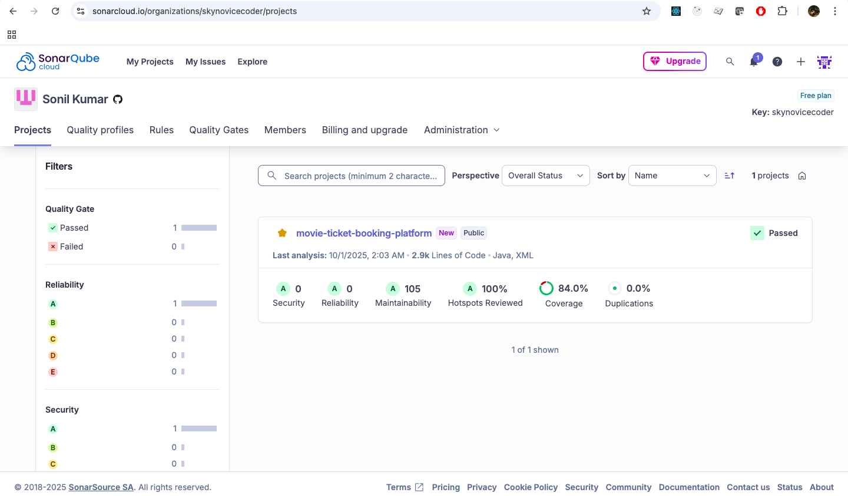  
  
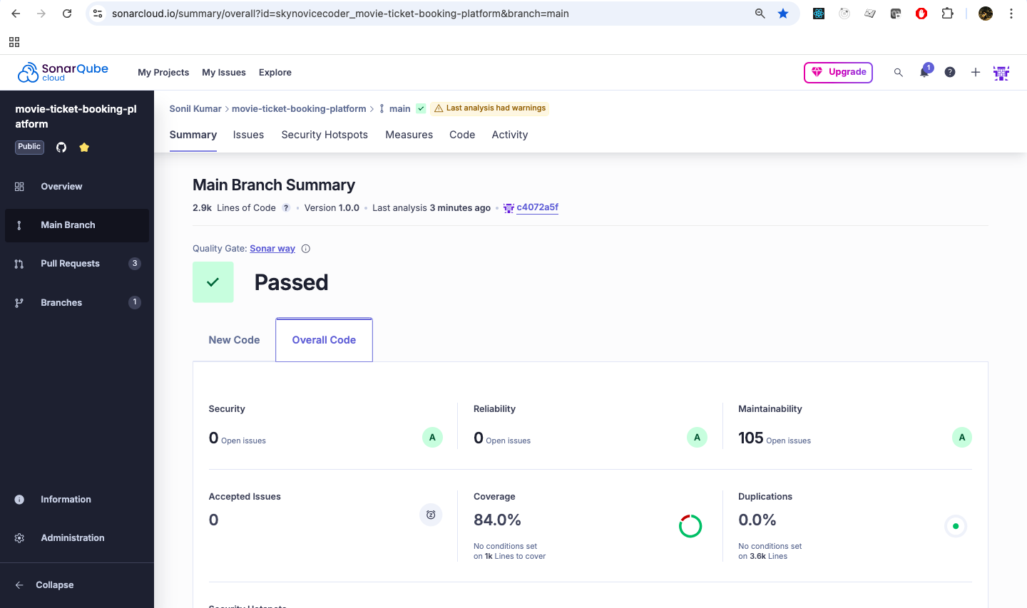

**11.6 GitHub Actions : WorkFlows**

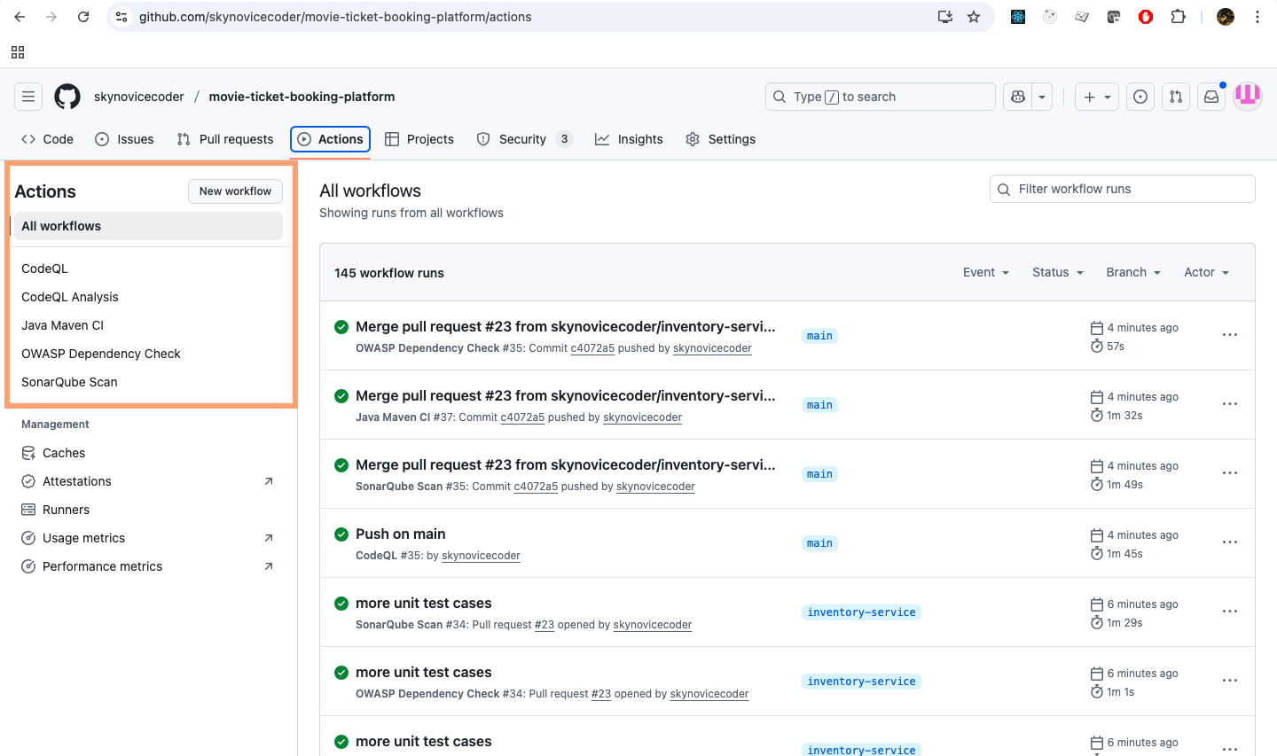  
  
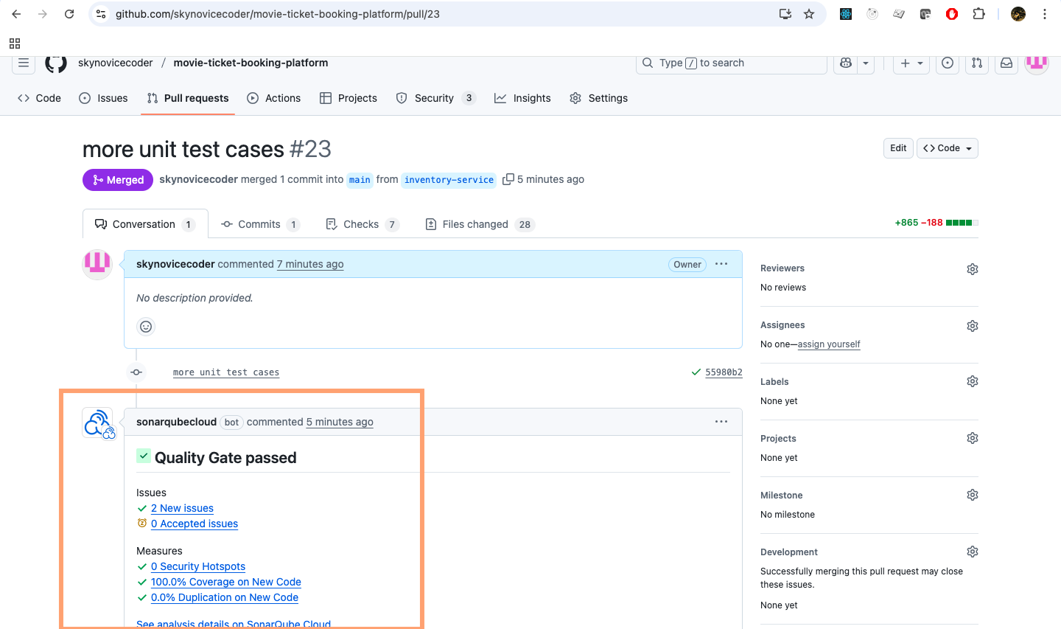

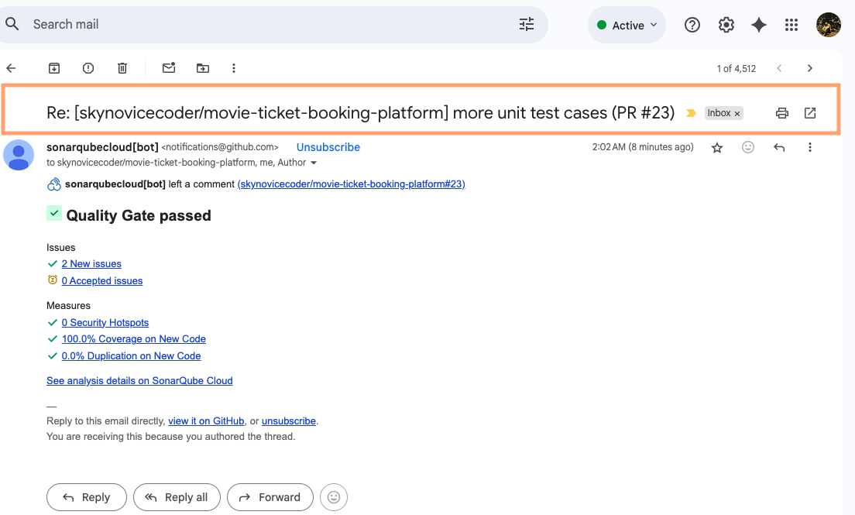

12. Scalability, Availability & Resilience

This section describes the **strategies and architectural patterns** implemented to ensure MTBP **can handle high load, recover from failures, and maintain SLA compliance (99.99% uptime)**.

### 12.1 Horizontal Scaling

* **Microservices:**
  + Deployed as **stateless containers** in Kubernetes, allowing autoscaling based on CPU, memory, or request metrics.
  + Example: Booking Service scaled up during blockbuster releases to handle up to **100,000 RPS globally**.
* **Databases:**
  + PostgreSQL reads replicas for read-heavy operations (search, seat availability).
  + Partitioned or sharded tables for write-heavy services (Booking, Payment, Inventory).
* **Caching:**
  + Redis/Memcached for frequently accessed data (showtimes, seat maps) to reduce DB load.

**Rationale:** Horizontal scaling ensures **elastic capacity** to meet peak loads without service degradation.

### 12.2 Partitioning / Sharding

* **Booking & Inventory DBs:**
  + Sharded by **theatreId or city** to distribute load and prevent hotspots.
* **Kafka Topics:**
  + Partitioned by theatre or showId for parallel consumption and high throughput.
* **Session / Cache Data:**
  + Distributed caches keyed by region or user segment to avoid bottlenecks.

**Rationale:** Data partitioning reduces contention, supports concurrency, and improves system throughput.

### 12.3 Circuit Breakers, Retries & Resilience Patterns

* **Circuit Breakers:**
  + Protect downstream services from cascading failures.
  + Example: Payment Service failures temporarily open the circuit to prevent Booking Service overload.
* **Retries with Exponential Backoff:**
  + Handle transient errors in inter-service calls or external APIs (payment gateway, partner APIs).
* **Fallback Mechanisms:**
  + Graceful degradation if services are unavailable (e.g., show alternate theatre options).
* **Bulkhead Isolation:**
  + Service instance isolation to prevent failures from impacting unrelated workflows.

**Rationale:** Ensures **high reliability and graceful degradation** under partial failure conditions.

### 12.4 Disaster Recovery Strategy

* **Multi-Region Deployment:**
  + Active-active regions for high availability.
  + Automatic failover using Load Balancer / Geo-DNS in case of regional outages.
* **Data Replication:**
  + PostgreSQL cross-region replication for critical tables.
  + Kafka multi-broker replication across regions.
* **Backup & Restore:**
  + Automated daily full backups + incremental backups every 15 minutes.
  + Retention and archival policies to comply with audit requirements.
* **Runbooks & Automated Recovery:**
  + Predefined runbooks for service failures, DB failover, or Kafka broker outage.
  + Automation scripts for restoring service with minimal downtime.

**Rationale:** Guarantees **data durability, SLA compliance, and business continuity** during disasters.

13. Performance & Capacity Planning

This section outlines the **strategy for testing, measuring, and planning capacity** to ensure MTBP handles both normal traffic and peak demand with high availability and performance.

### 13.1 Performance Tests

* **Types of Tests:**
  + **Load Testing:** Simulate normal and peak user traffic to validate service response times.
    - Example: Search API 95th percentile < 300ms.
    - Booking flow end-to-end < 1.5s under normal load.
  + **Stress Testing:** Push services beyond expected peak to identify breaking points and bottlenecks.
  + **End-to-End Flow Testing:** Simulate real user journeys (search → seat selection → booking → payment).
  + **Integration Testing:** Ensure payment gateways, Kafka messaging, and partner APIs perform under load.
* **Tools:** JMeter, Gatling, Locust, or k6 for HTTP and event-driven testing.

**Rationale:** Ensures **platform performance meets SLAs** and identifies potential bottlenecks before production release.

### 13.2 Capacity Plans for Big Premieres

* **Peak Load Estimation:**
  + Historical data + marketing projections used to forecast peak RPS.
  + Example: Blockbuster releases may generate **~100,000 RPS globally**, concentrated in top cities.
* **Service Scaling:**
  + Horizontal autoscaling for microservices based on CPU, memory, or request metrics.
  + Pre-warm additional Kubernetes pods for anticipated peak.
* **Database Scaling:**
  + Sharded and partitioned DBs to distribute write-heavy traffic.
  + Read replicas for read-intensive operations like movie searches and showtimes.
* **Caching Strategies:**
  + Redis/Memcached to serve frequently requested data (movie listings, seat maps).
  + Preload caches before anticipated peak.
* **Messaging & Event Handling:**
  + Kafka partitions tuned for parallel consumption.
  + Producer/consumer throughput monitored and scaled to avoid bottlenecks.
* **Observability & Alerts:**
  + Dashboards to monitor latency, error rates, and queue depth.
  + Auto-trigger alerts for thresholds exceeding SLA during premieres.

**Rationale:** Ensures **predictable, reliable performance** even during extreme load conditions without impacting user experience.

14. Security, Compliance & Privacy

This section describes **security controls, compliance measures, and privacy practices** to safeguard customer data, payment information, and platform operations.

### 14.1 Regulatory Compliance

* **PCI-DSS (Payment Card Industry Data Security Standard):**
  + All cardholder data handled by Payment Service and third-party gateways.
  + No sensitive card data stored on MTBP databases; tokenization used.
  + Regular audits and logging of all payment operations.
* **GDPR / Data Privacy Compliance:**
  + Customer data processed in accordance with regional data protection laws.
  + Data subject rights enforced: access, deletion, and portability.
  + Region-specific data storage for EU and other regulated geographies.
* **Audit & Reporting:**
  + Centralized logging of security-sensitive operations (login, payment, booking).
  + Reports generated for compliance audits, data breaches, or internal reviews.

### 

### 

### 

### 14.2 Transport & Data Encryption

* **In-Transit:**
  + TLS 1.2+ enforced for all client-service and inter-service communication.
  + Mutual TLS (mTLS) for sensitive microservice interactions (e.g., Booking ↔ Payment).
* **At-Rest:**
  + AES-256 encryption for databases, caches, and backups.
  + Encrypted storage for logs containing sensitive identifiers.
* **Key Management:**
  + Keys managed via **HashiCorp Vault / AWS KMS / Azure Key Vault**.
  + Automated key rotation and auditing enabled.

### 14.3 Identity & Access Management (IAM) Best Practices

* **Authentication:**
  + OAuth2/OpenID Connect via OKTA for all users (customers, admins, partners).
  + Multi-factor authentication (MFA) for admin and partner portal access.
* **Authorization:**
  + Role-Based Access Control (RBAC) at API and service layer.
  + Principle of least privilege enforced for service accounts and users.
* **Secrets Management:**
  + No credentials hard-coded in services.
  + Secrets fetched dynamically from a secure vault at runtime.

### 14.4 Penetration Testing & Security Reviews

* **Internal Security Testing:**
  + Automated SAST/DAST scans integrated into CI/CD pipelines.
  + Dependency vulnerability scanning (OWASP, CodeQL).
* **External Penetration Testing:**
  + Periodic third-party pen-tests on platform endpoints, APIs, and admin portals.
  + Remediation plan documented and executed before production releases.
* **Security Monitoring:**
  + Anomalous access patterns, failed login attempts, and suspicious activity logged and alerted.

15. Operational Readiness & Runbooks

This section defines **how MTBP is monitored, supported, and recovered** in case of failures or incidents, including **on-call responsibilities, playbooks, and communication procedures**.

### 15.1 On-Call & Incident Playbooks

* **On-Call Structure:**
  + 24/7 coverage split across SRE and Engineering teams.
  + Rotation schedule for **primary**, **secondary**, and **escalation** contacts.
  + Responsibilities defined per service (Booking, Payment, Inventory, Customer, Theatre Partner).
* **Incident Playbooks:**
  + Predefined step-by-step procedures for common incidents:
    - Payment Gateway failures
    - Kafka broker outages
    - Database failover or replica lag
    - Booking Service high-latency issues
  + Include **detection triggers, mitigation steps, and rollback procedures**.
  + Integrated with alerting systems (Prometheus Alerts, Grafana dashboards).

### 15.2 Root Cause Analysis (RCA) Templates

* **Purpose:** Standardized RCA for post-incident review and continuous improvement.
* **Template Sections:**
  + Incident Summary
  + Timeline of Events
  + Impact Analysis (users, revenue, systems)
  + Root Cause
  + Corrective & Preventive Actions
  + Lessons Learned
  + Approval & Distribution
* **Process:**
  + RCAs completed within 48 hours of incident resolution.
  + Shared with stakeholders and retained for compliance/audit purposes.

### 

### 

### 

### 15.3 Status Page & Communication

* **Public/Private Status Page:**
  + Displays **real-time platform health**: booking service, payment processing, inventory, and partner integrations.
  + Provides **incident notifications** and historical uptime SLA metrics.
* **Communication Channels:**
  + Slack/MS Teams channels for internal alerts and escalations.
  + Email/SMS notifications for critical incidents.
  + Status updates posted to external stakeholders and partner theatres if affected.

### 15.4 Observability Integration for Operations

* **Metrics & Dashboards:**
  + Microservice-level metrics (request rates, error rates, latency).
  + Infrastructure metrics (CPU, memory, disk usage).
  + Business KPIs (booking count, payment success/failure).
* **Logging & Tracing:**
  + Centralized logging via Loki.
  + Distributed tracing for end-to-end booking/payment flows.
  + Correlation IDs to link user requests across services.
* **Alerting & Escalation:**
  + Threshold-based and anomaly detection alerts.
  + Automated escalation to on-call engineers with clear runbooks.

16. Cost Estimates & Licensing

This section provides a **high-level estimate of the costs** associated with running MTBP and identifies **opportunities for cost efficiency**.

### 16.1 Cloud Infrastructure Costs

* **Compute:**
  + Kubernetes clusters running microservices (Booking, Payment, Inventory, Customer, Theatre Partner).
  + Autoscaling ensures cost efficiency by scaling down during off-peak periods.
* **Databases:**
  + Managed PostgreSQL instances with read replicas.
  + Partitioning and sharding for optimized usage.
* **Messaging & Event Streaming:**
  + Managed Kafka clusters per region.
  + Cost depends on number of brokers, partitions, and replication factor.
* **Storage & Caching:**
  + S3/GCS/Azure Blob for media content and backups.
  + Redis/Memcached clusters for caching.

**Estimation Approach:**

* Based on **RPS, peak concurrency, and storage requirements**.
* Includes **multi-region deployment** for high availability.

### 16.2 COTS & Licensing Costs

| **System** | **Licensing Model** | **Estimated Cost Considerations** |
| --- | --- | --- |
| **Identity (OKTA)** | SaaS subscription per user / per app | Cost scales with number of admin/partner users and integrations |
| **Payment Gateway** | Transaction fees + gateway subscription | Depends on RPS, payment volume, and international transactions |
| **Observability (Grafana, Loki, Prometheus)** | Open source / Enterprise subscription | Enterprise edition recommended for SLA support & alerting |
| **Secrets Management (Vault / KMS)** | Subscription per instance or cloud-managed | Key management and rotation included |
| **ERP / Financial Systems** | Annual license + implementation | Optional depending on scale; used for partner reconciliation & accounting |

### 16.3 Cost Optimization Strategies

1. **Autoscaling & Spot Instances:**
   * Use cloud autoscaling for microservices and worker nodes.
   * Use spot/preemptible instances for non-critical workloads (analytics, batch jobs).
2. **Right-Sizing Resources:**
   * Monitor actual CPU/memory usage and adjust instance types accordingly.
   * Avoid over-provisioning for low-traffic regions.
3. **Data Lifecycle Management:**
   * Archive cold data to cost-effective storage (S3 Glacier / Azure Cool Blob).
   * Retention policies aligned with compliance requirements.
4. **Consolidated Licensing:**
   * Enterprise-wide licenses for observability, CI/CD, and IAM to reduce per-instance costs.
5. **Cloud Savings Plans / Reserved Instances:**
   * Prepay or commit to long-term instances for predictable workloads to reduce costs.

17. Risk Assessment & Mitigation

This section provides a structured view of **potential risks** to MTBP and outlines **proactive measures** to minimize impact on business and technical operations.

### 17.1 Top Risks

| **Risk Category** | **Description** | **Potential Impact** |
| --- | --- | --- |
| **Traffic Spikes / Peak Loads** | Sudden surge in bookings during blockbuster releases or promotional campaigns. | Service degradation, high latency, failed bookings, SLA breaches. |
| **Payment Gateway Failures** | Outages or delays in third-party payment providers. | Payment failures, lost revenue, customer dissatisfaction. |
| **Partner Integration Issues** | Theatre API downtime or incorrect inventory data. | Booking errors, seat overbooking, poor user experience. |
| **Data Loss / Database Outage** | DB corruption, misconfiguration, or region failure. | Loss of bookings, payment records, and inventory data. |
| **Security Breaches / Data Leakage** | Unauthorized access, compromised credentials, or malware. | Customer data exposure, PCI/GDPR compliance violations, reputational damage. |
| **Infrastructure Failures** | Network outages, cloud provider disruptions, or Kubernetes cluster failures. | Partial or full service unavailability, SLA breaches. |
| **Operational Errors** | Misconfigurations, deployment issues, or human error. | Service downtime, failed releases, degraded performance. |

### 

### 

### 17.2 Mitigation Plans

| **Risk** | **Mitigation Strategy** |
| --- | --- |
| **Traffic Spikes / Peak Loads** | Horizontal scaling, partitioned DBs, caching, pre-warmed pods, load testing, autoscaling policies. |
| **Payment Gateway Failures** | Implement retries with exponential backoff, fallback to alternate gateways, asynchronous reconciliation, alerting & runbooks. |
| **Partner Integration Issues** | Circuit breakers, retries, monitoring of partner APIs, validation of inventory updates, compensating transactions. |
| **Data Loss / Database Outage** | Multi-region replication, automated backups, incremental backups, disaster recovery plans, failover procedures. |
| **Security Breaches / Data Leakage** | IAM best practices, encryption in transit & at rest, regular penetration testing, secrets management, audit trails. |
| **Infrastructure Failures** | Multi-region deployment, load balancer failover, Kubernetes self-healing, automated monitoring & alerting. |
| **Operational Errors** | Standardized CI/CD pipelines, QA/staging validation, rollback strategies, runbooks, and SRE oversight. |

18. Stakeholder Management & Decision Logs

This section outlines the **approach to engaging stakeholders**, documenting **architectural and product decisions**, and ensuring alignment between **business, product, and technical teams**.

### 18.1 Architectural Decision Records (ADRs) with Rationale

* **Purpose:** Document **key technical and architectural decisions**, along with alternatives considered and trade-offs.
* **Structure of an ADR:**
  + **Title:** Brief description of the decision.
  + **Context:** Why the decision is needed.
  + **Decision:** Chosen solution or approach.
  + **Alternatives Considered:** Other approaches with pros/cons.
  + **Consequences:** Impact on architecture, operations, costs, and users.
  + **Status:** Proposed, Accepted, Deprecated, or Superseded.
* **Example ADRs for MTBP:**
  + Choice of **PostgreSQL** over NoSQL for transactional consistency.
  + Decision to use **Kafka for event-driven communication**.
  + Adoption of **OKTA for centralized identity management**.
  + Implementation of **Blue/Green & Canary deployments** for release management.

**Rationale:** ADRs provide **traceable and auditable decision-making**, especially critical in multi-stakeholder enterprise environments.

### 18.2 Stakeholder Engagement Model

* **Key Stakeholders:**
  + Product Owner
  + Enterprise & Solution Architects
  + Engineering Leads (Frontend, Backend, Data, Platform)
  + QA & SRE teams
  + Security & Compliance
  + Theatre Partnership Managers
  + Payment Gateway / Vendor teams
  + Regional Operations Teams
* **Engagement Approach:**
  + **Regular Steering Meetings:** Align business objectives, prioritize features, and approve architectural changes.
  + **Design Reviews:** Solution Architects present high-level and detailed designs for review and feedback.
  + **Decision Logs & ADR Repository:** All technical decisions are documented, version-controlled, and accessible to stakeholders.
  + **Change Control Board (CCB):** Reviews major changes impacting SLA, compliance, or multi-region deployments.
  + **Communication Channels:**
    - Slack/Teams for real-time operational updates
    - Email for formal announcements
    - Shared dashboards for observability, performance, and release status
* **Escalation Model:**
  + Tiered escalation for critical issues impacting platform availability, payments, or data integrity.
  + Defined SLA for stakeholder notifications and decision closure.

19. Appendices

This section provides **supporting information, glossary and contact points** to aid understanding and implementation of MTBP.

### 19.1 Glossary

| **Term** | **Definition** |
| --- | --- |
| **MTBP** | Movie Ticket Booking Platform |
| **RPS** | Requests Per Second, used to measure system load |
| **C4** | Context, Container, Component, and Code diagrams framework |
| **ADR** | Architectural Decision Record |
| **SLA** | Service Level Agreement |
| **PCI-DSS** | Payment Card Industry Data Security Standard |
| **GDPR** | General Data Protection Regulation |
| **RBAC** | Role-Based Access Control |
| **CI/CD** | Continuous Integration and Continuous Deployment |

### 19.2 Key Contacts

| **Role** | **Contact** | **Responsibilities** |
| --- | --- | --- |
| Product Owner | [Name/Email] | Feature prioritization, business requirements |
| Enterprise Architect | [Name/Email] | High-level architecture guidance, ADR oversight |
| Solution Architect | [Name/Email] | Technical design, component-level review |
| Engineering Leads | [Name/Email] | Implementation guidance, code quality enforcement |
| SRE / QA | [Name/Email] | Production readiness, testing, incident response |
| Security & Compliance | [Name/Email] | Audits, security policies, pen-testing |
| Theatre Partnership Managers | [Name/Email] | Partner onboarding, API integration |
| Payment Gateway Vendors | [Name/Email] | Payment integration, SLA coordination |

### 19.2 Important Links

Architecture & Design Artifacts

**C4 Architecture Diagrams Repository**  
<https://github.com/skynovicecoder/mtbp-c4-diagrams>  
Contains:

* C4 Context, Container, Component, and Code-level diagrams
* UML Diagrams (ER, Sequence, Class)
* Architecture Decision Records (ADRs)

**Code Base**

<https://github.com/skynovicecoder/movie-ticket-booking-platform>  
Contains microservices source code for:

* Backend
* Frontend
* Infrastructure & DevOps

SonarQube Security Scan Links:  
<https://sonarcloud.io/project/overview?id=skynovicecoder_movie-ticket-booking-platform>  
  
Document Repository  
<https://github.com/skynovicecoder/mtbp-c4-diagrams/tree/main/docs>  
  
**Design & Governance Documents**  
 Contains:

* High-Level & Low-Level Design Documents
* CI/CD Flow Diagrams
* Release Notes & Runbooks
* Compliance Checklists (PCI-DSS, GDPR, ISO27001)

**Operational Docs**  
 Contains:

* Monitoring Dashboards & On-call Schedules
* RCA Templates
* Incident Response Playbooks