MINISTRY OF EDUCATION OF THE REPUBLIC OF BELARUS
Educational Institution
«Yanka Kupala State University of Grodno»
Faculty of Mathematics and Informatics
Department of Modern Programming Technologies

ZHOU HANTIAN

NCAA Finals Statistics

Course Work Paper
of the 3rd year student of the specialty

6-05-0612-01 «Software engineering»

Supervisor:
A. Karkanitsa, Ph.D in Technical Science, Associate Professor, Head of the Department of Modern Programming Technologies _____________

Student: ZHOU HANTIAN

Grodno, 2025
TABLE OF CONTENTS
6-05-0612-01 «Software engineering» 1
INTRODUCTION 3
CHAPTER 1 ANALYSIS OF THE TASK AND INPUT / OUTPUT DATA 4
1.1 Subject Area: NCAA Finals Statistics 4
1.2 Description of Input Data Files 5
1.2.1 Game Data Files (NCAAdata*.txt) 5
1.2.2 Command Script Files (NCAAinfo*.txt) 6

1.3 Required Output: Log Files (NCAAlog*.txt) 7

1.4 Functional Requirements 7

1.5 Non‑Functional Requirements 8

1.6 Conclusions on Chapter 1 9

CHAPTER 2 DESIGN OF THE NCAA STATISTICS CONSOLE APPLICATION 10
2.1 Overall Application Architecture 10
2.2 Data Model 11
2.2.1 NCAAGame Struct 11
2.2.2 Global State 11
2.3 File Selection Module 12
2.4 Data Import and Normalization 12
2.5 Sorting Algorithm 13
2.6 Logging and Output Handling 14
2.7 Command Processing Module 15
2.7.1 year Command 15
2.7.2 titles Command 16
2.7.3 margin Command 17
2.8 Program Startup 18
2.9 Conclusions on Chapter 2 18

INTRODUCTION

Today, even simple educational programming tasks are usually based on realistic data-processing scenarios. The coursework project considered in this document is a small console application that processes historical NCAA basketball finals data and answers search queries from a script file.
The application reads game results for NCAA championship finals (year, winning and runner-up schools, and scores), stores them in memory, sorts the games by year, and then processes search commands of different types:
- finding champion or runner-up for a given year;
- counting titles and runner-up appearances for a given school;
- computing average victory margins over a range of years.
Unlike a full-scale information system, this coursework is a compact, self-contained C# console application that focuses on:
- working with structured text files;
- applying sorting and searching algorithms to arrays / lists of structs;
- formatting and logging output exactly as required;
- basic modularization of the code into functions.
The present document describes the problem domain and basic requirements (Chapter 1) and the design and architecture of the application (Chapter 2). More advanced aspects (deployment, UI design, etc.) are intentionally omitted as they are out of scope for this coursework.

CHAPTER 1
ANALYSIS OF THE TASK AND INPUT / OUTPUT DATA

1.1 Subject Area: NCAA Finals Statistics

The subject area of the coursework is statistics of NCAA basketball championship games (finals). Each record in the main data files describes a single NCAA final game, including:
- year – year of the final game;
- name of one school (first school);
- score of the first school;
- name of the other school (second school);
- score of the second school.

Depending on the data file, the records may describe:
- Women’s NCAA Champions (e.g. NCAAdata.txt, NCAAdata1.txt);
- Men’s NCAA Champions (e.g. NCAAdata2.txt).
For each final game there is always exactly one champion (school with higher score) and one runner-up (school with lower score). The application needs to derive the champion and runner-up from the scores in each line.
This project provides an excellent opportunity to explore and master C#'s comprehensive file I/O capabilities. Through implementing various file operations such as reading structured data, parsing tab-delimited formats, and generating formatted output files, we gain practical experience with stream handling, text processing, and file system management. The complexity of managing multiple file types simultaneously (data files, command files, and log files) demonstrates real-world scenarios where robust file handling is essential for application reliability and data integrity.

1.2 Description of Input Data Files

1.2.1 Game Data Files (NCAAdata*.txt)

The project can work with three game data files:
- NCAAdata.txt – women’s NCAA champions (basic sample, 8 records);
- NCAAdata1.txt – women’s NCAA champions (extended sample, 21 records);
- NCAAdata2.txt – men’s NCAA champions (42 records).
- General structure:
- Line 1 – header line Example: Women’s NCAA Champions: 8 The label part (before :) is later echoed into the log file.
- Line 2 – separator line of dashes, to be ignored.
- Lines 3..N – game records, tab‑separated in the actual files used by the C# program: year<TAB>winnerCandidate1<TAB>score1<TAB>winnerCandidate2<TAB>score2

From each data line the program must:
- parse year and both school names and scores;
- decide which school is champion and which is runner-up by comparing two scores;
- store the canonical record in memory as:
- year – integer;
- champion – string (school with higher score);
- runner_up – string (school with lower score);
- score_C – integer (champion’s score);
- score_R – integer (runner-up’s score).
Data records are not guaranteed to be sorted by year in the file. After reading all valid records, the program sorts them in ascending order by year.

1.2.2 Command Script Files (NCAAinfo*.txt)

The project can work with three command script files:
- NCAAinfo.txt;
- NCAAinfo1.txt;
- NCAAinfo2.txt;

Each file contains search commands, one per line, in tab-separated form. Supported command types:
- Year lookup: year<TAB><year><TAB><1|2>
  - If flag is 1: output champion for that year.
  - If flag is 2: output runner-up for that year.
- Titles statistics for a school: titles<TAB><school name>
  - Count how many times the school appears as champion.
  - Count how many times the school appears as runner_up.
  - School name may contain spaces but is provided as one tab‑separated token.
- Average margin over a range of years: margin<TAB><startYear><TAB><numYears>
  - Find the game with year startYear.
  - Compute numYears consecutive margins starting from that year.
  - Each margin = absolute difference |score_C – score_R| for that game.
  - Output average margin and the year range.
The commands file is guaranteed to be syntactically correct. The program processes commands sequentially in the order they appear; commands are not stored in memory beyond the current line.

1.3 Required Output: Log Files (NCAAlog*.txt)

For each selected group of data and info files, the program must generate a corresponding log file:
- For group A: NCAAlog.txt;
- For group B: NCAAlog1.txt;
- For group C: NCAAlog2.txt.

The log must contain:
- Three header lines:
  - Programmer: Zaki Malik
  - CS 1044 Spring 2009 Project 6
  - <label from data file header> – only the label part before :.
- For each processed command:
  - a separator line of dashes (------------------------------------------------------------);
  - a numbered echo of the original command line, prefixed with a 3‑digit, zero‑filled command number (001, 002, …);
  - one or more result lines according to the command type.
Numbering must increment by 1 for each command in the script. The style of messages must conform to the original specification (matching exact phrases like Champion:, Runner-up:, not found, Average Margin).

1.4 Functional Requirements

The main functional requirements of the application are:
- Read game data from a selected data file.
- Ignore header and separator lines, and parse valid game records.
- Automatically determine champion and runner-up by comparing scores.
- Store all valid games in memory using a suitable data structure.
- Sort games by year in ascending order (using insertion sort).
- Read and process commands from a selected script file line by line.
- For year commands:
  - search by year;
  - output champion or runner-up name depending on the flag;
  - output "<year> not found" if the year is absent in the data.
- For titles commands:
  - count championships and runner-up results for the given school name;
  - output counts in a fixed format, even if both counts are zero.
- For margin commands:
  - find index of the game with startYear in the sorted list;
  - if not found – output "<year> not found";
  - otherwise, compute the average of absolute margins for up to numYears consecutive games starting from startYear;
  - format output as Average Margin <start>-<end>: <value with 1 decimal>.
- Write all outputs both to console and to the log file.
- Close the log file correctly after finishing processing.

1.5 Non‑Functional Requirements

- Language and platform: C# console application (.NET).
- Simplicity: no graphical user interface; all interaction via console.
- Portability: can run on any platform where .NET and file system paths are available.
- Readability: clear identifiers, basic modular structure, simple functions.
- Deterministic behavior: the same input files must always produce the same log files.
- Error handling: basic handling of missing years in year and margin commands; assume that file formats are valid as per assignment.

1.6 Conclusions on Chapter 1

- The coursework task is a small, focused data‑processing application centered around NCAA final game statistics. The program must:
- read and normalize sports data from multiple input files;
- sort records by year;
- support three query types (year, titles, margin) driven by script files;
- generate log files whose content and formatting closely follow the original CS 1044 specification.
- This defines the scope and functional requirements that guide the design described in Chapter 2.

CHAPTER 2
DESIGN OF THE NCAA STATISTICS CONSOLE APPLICATION

2.1 Overall Application Architecture

The application follows a simple console, file‑based architecture with minimal modularization. It is organized as a single public class TestClass containing:
- Data model definition (struct NCAAGame);
- Functions for:
  - reading and parsing game data (LoadDataContent);
  - sorting data (NCAAGameSort);
  - reading and processing commands (LoadCommandContent);
  - selecting which files to use (SelectFiles);
  - handling output (WriteOutput);
  - formatting command numbers (FormatCommandNumber);
- Entry point wrapper (Boot), called externally to start the program.
- The program interacts with the file system only:
- input: NCAA data files and command script files in the ../static/ directory;
- output: log files also in ../static/.

No network communication or database is used. All game records are stored in a List<NCAAGame> in memory.
From a logical viewpoint, the architecture can be split into the following modules:
- File selection and configuration;
- Data import and normalization;
- Sorting;
- Command processing (year, titles, margin);
- Logging and console output.

2.2 Data Model

2.2.1 NCAAGame Struct

The core data model of the application is a struct NCAAGame:
- int score_C – champion score;
- int score_R – runner-up score;
- string champion – champion school name;
- string runner_up – runner-up school name;
- int year – final game year.
This struct represents a normalized record of a final game, after deciding which school is champion and which is runner-up.
All game records from the selected NCAA data file are transformed into NCAAGame instances and stored in a List<NCAAGame>.

2.2.2 Global State

The following static fields support application behavior:
- static StreamWriter logWriter – current log file writer (shared by all functions);
- static int commandCount – sequential number of processed commands;
- static string dataHeader – first header line from the data file, later echoed into the log.

File configuration fields:
- static string dataFileSrc – name of the selected NCAA data file (NCAAdata*.txt);
- static string infoFileSrc – name of the selected command script file (NCAAinfo*.txt);
- static string logFileSrc – name of the output log file (NCAAlog*.txt);

2.3 File Selection Module

The function SelectFiles() implements the interaction for choosing which group of test files to process:
- It displays a simple menu with three options:
  - A – NCAAdata.txt, NCAAinfo.txt, NCAAlog.txt;
  - B – NCAAdata1.txt, NCAAinfo1.txt, NCAAlog1.txt;
  - C – NCAAdata2.txt, NCAAinfo2.txt, NCAAlog2.txt.
- It reads the user’s choice from the console and sets:
  - dataFileSrc;
  - infoFileSrc;
  - logFileSrc.
- If the user enters an invalid option, group A is selected by default and a warning is printed.
This module isolates configuration and allows reusing the same logic for different test datasets without changing code.

2.4 Data Import and Normalization

The function LoadDataContent(string fileSRC) is responsible for reading and parsing game data:
- If fileSRC is null or empty, it defaults to "../static/NCAAdata.txt". In actual usage, LoadDataContent is called with "../static/" + dataFileSrc.
- It reads all lines from the specified file:
  - stores the first line into dataHeader for later use in the log header;
  - iterates over all lines, including header and separator, but only accepts data lines that pass a structure check.
- Each line is split by the tab character t into parts.
- A valid game record is identified by parts.Length - 1 == 4, i.e. there are exactly 5 fields:
  - parts[0] – year;
  - parts[1] – first school name;
  - parts[2] – first school score (string);
  - parts[3] – second school name;
  - parts[4] – second school score (string).
- The function converts scores to integers and compares them:
  - If parts[2] < parts[4]: Champion = parts[3], champion score = parts[4]; Runner-up = parts[1], runner-up score = parts[2].
  - Else: Champion = parts[1], champion score = parts[2]; Runner-up = parts[3], runner-up score = parts[4].
- A new NCAAGame struct is created and added to result.
- After reading all lines, NCAAGameSort(result) is called to sort the list by year.

LoadDataContent returns a sorted List<NCAAGame> ready for searching.
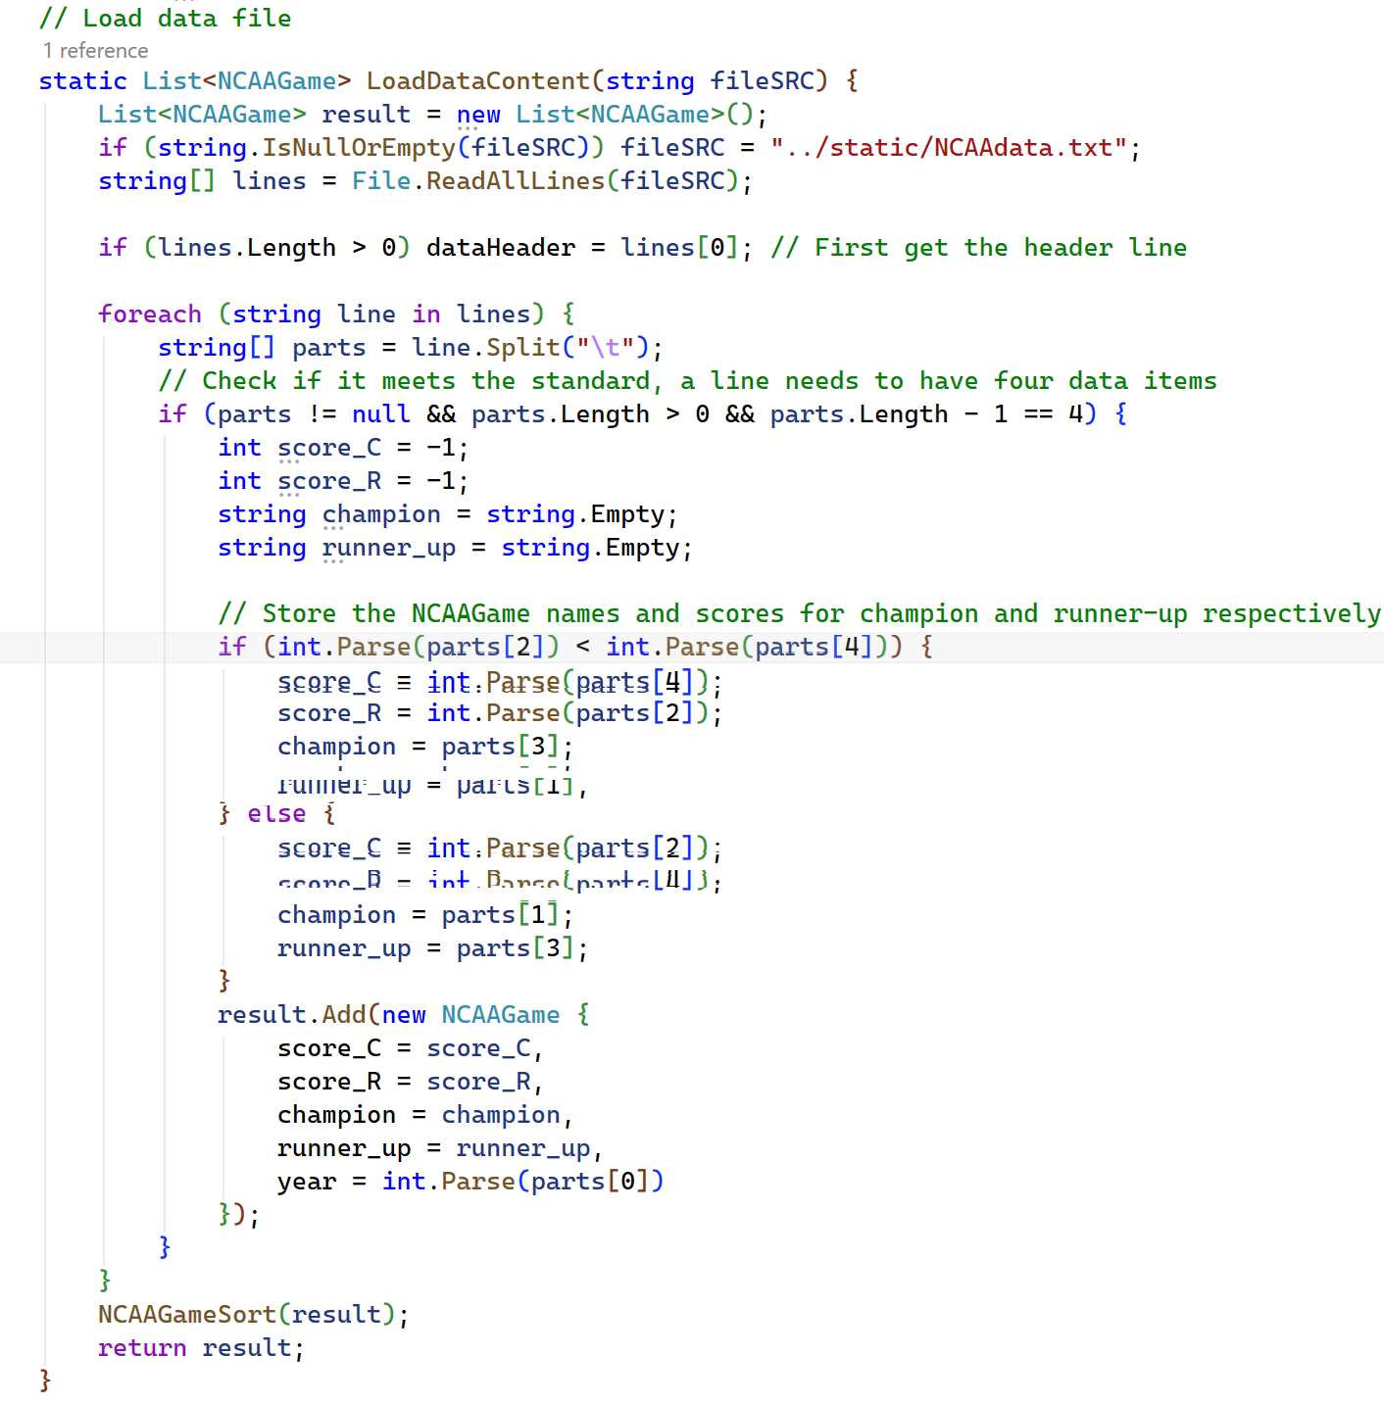
This function illustrates the data-normalization workflow: it parses the raw tab-delimited input, determines the champion/runner-up from the scores, builds the corresponding NCAAGame objects, orders them, and finally returns the result.

2.5 Sorting Algorithm

The function NCAAGameSort(List<NCAAGame> NCAAGameList) implements insertion sort over the NCAAGame list:
- For i from 1 to gameList.Count - 1:
  - store gameList[i] in a temporary variable item;
  - compare item.year with previous elements’ years;
  - shift larger elements one position to the right;
  - insert item at the proper position.
This guarantees that, after execution, the list is sorted in ascending order by year. Using insertion sort matches the educational goal of practicing a basic array sorting algorithm.
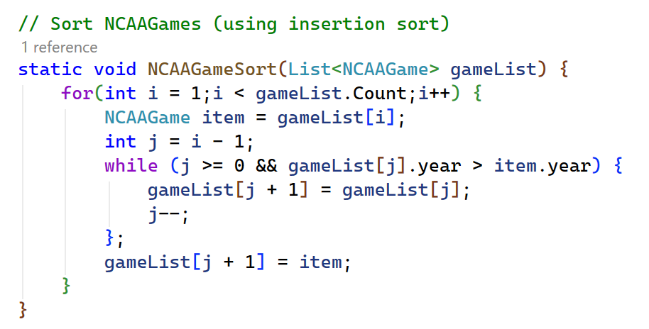
This function presents a standard insertion sort tailored to arrange NCAAGame records by year. It keeps a sorted part of the list and places each new record into its proper position.

2.6 Logging and Output Handling

The helper function WriteOutput(string text) centralizes output:
- Prints text to the console using Console.WriteLine(text);
- If logWriter is not null, also writes text to the log file.

The function FormatCommandNumber(int number) formats the command counter into a 3‑digit string:
- Numbers < 10 → "00X";
- Numbers < 100 → "0XX";
- Numbers >= 100 → standard decimal string.

This ensures that command lines in the log start with properly zero‑padded IDs, e.g.:
- 001 year 1988 2
- 002 titles Tennessee

2.7 Command Processing Module

The core processing is implemented in LoadCommandContent(string fileSRC):
- Calls LoadDataContent("../static/" + dataFileSrc) to obtain the sorted list gameList.
- Opens fileSRC (e.g. "../static/" + infoFileSrc") and reads all lines.
- Creates a log file writer for "../static/" + logFileSrc.
- Writes standard header lines to the log:
- Programmer: Zaki Malik
- CS 1044 Spring 2009 Project 6
- <part of dataHeader before ":" and space>
- For each line in the command file:
- Split line by t into parts;
- Increment commandCount;
- Output separator line of dashes;
- Format and write command echo line: <3-digit number> <original line>;
- Dispatch by parts[0] ("year", "titles", "margin").
- After processing all commands, writes a final separator line, closes the log file, and prints the log path to the console.

Below, each command type is detailed.

2.7.1 Command year

Format: year<TAB><year><TAB><type> where:
- <year> – integer final year to search for;
- <type> – integer option:
  - 1 – output champion;
  - 2 – output runner-up.

Processing logic:
- Parse type as int from parts[2];
- Parse year as int from parts[1];
- Initialize hasData = false;
- Iterate over all NCAAGame entries in gameList:
  - If item.year == year:
    - If type == 2: WriteOutput("Runner-up: " + item.runner_up);
    - Else if type == 1: WriteOutput("Champion: " + item.champion);
    - Set hasData = true and break.

After the loop:
- If !hasData: WriteOutput(year + " not found");

This matches the behavior in the sample logs (NCAAlog.txt, NCAAlog2.txt).
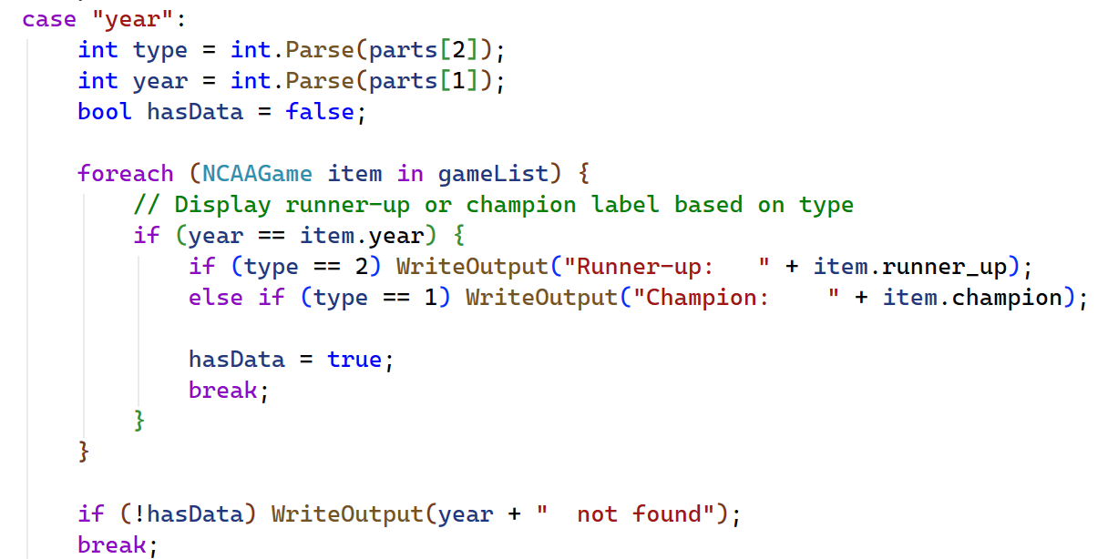
This code performs a straightforward search on the ordered list of games to locate a given year, then returns the champion or runner-up as indicated by the type parameter. It also handles cases where the requested year is not in the data.

2.7.2 Command titles

Format: titles<TAB><school name>
Processing logic:
- Initialize countChampion = 0, countRunnerup = 0;
- name = parts[1] (school name);
- For each NCAAGame item in gameList:
- hasChampion = (name == item.champion);
- hasRunnerup = (name == item.runner_up);
- If hasRunnerup: countRunnerup++;
- Else if hasChampion: countChampion++;

(Note: If a school could hypothetically be both champion and runner-up in the same record, runner-up takes precedence due to `if/else if`, but in actual data such cases do not occur.)
- Finally, output:
Titles: <countChampion> Runner-up: <countRunnerup>
This provides statistics even if both values are zero, as required.
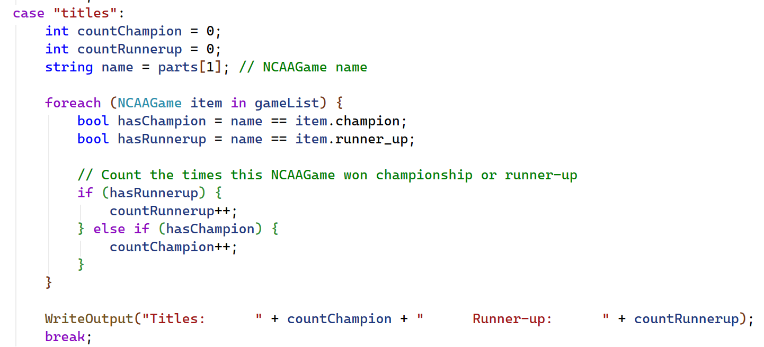
This code scans the whole game list to tally how often a chosen school appears as champion and as runner-up. It relies on string comparisons, conditional counting, and produces the results in a set format.

2.7.3 Command margin

Format: margin<TAB><startYear><TAB><numYears>
Processing logic:
- Parse startYear and numYears from parts[1] and parts[2].
- Find the starting index of startYear in gameList:
- Initialize startIndex = -1;
- Loop through gameList until item.year == startYear is found;
- If found, startIndex = i and break.
- If startIndex == -1:
- Output startYear + " not found".
- Else:
- Initialize double totalMargin = 0; int count = 0;
- For i from 0 to numYears - 1:
  - currentIndex = startIndex + i;
  - If currentIndex < gameList.Count:
    - Compute margin = Math.Abs(item.score_C - item.score_R);
    - Add to totalMargin; increment count.
- Compute average = totalMargin / count;
- endYear = startYear + count - 1;
- Output:
Average Margin <startYear>-<endYear>: <average with one decimal>.
This implements the average margin calculation as specified in the original assignment and demonstrated in NCAAlog.txt and NCAAlog2.txt.
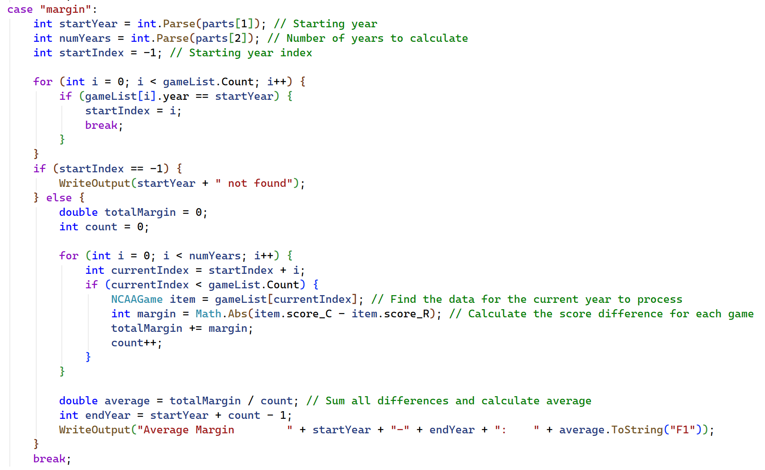
This code computes the average victory margin for a selected range of years. It iterates through the array, checks boundaries, accumulates the margins, and outputs the result in formatted form.

2.8 Program Startup

The public method Boot() starts the application:
- Calls SelectFiles() – user chooses file group A/B/C.
- Calls LoadCommandContent("../static/" + infoFileSrc) – processing starts based on chosen files.
This separation allows the TestClass to be embedded into a larger project or invoked from a Main method as needed.

2.9 Conclusions on Chapter 2

The coursework application is designed as a lightweight, modular C# console program that:
- imports and normalizes NCAA finals data into a simple NCAAGame struct;
- sorts games by year using insertion sort;
- processes three types of script commands (year, titles, margin);
- writes standardized log files while echoing all output to the console;
- supports multiple test datasets with a small file selection module.

The design deliberately focuses on fundamental programming concepts (file I/O, collections, sorting, simple search and aggregation, formatted output) rather than on complex architectures or infrastructure, which is appropriate for a course work project of limited scope.

