A Virtual-Real Integrated Intelligent Learning System for Complex Mechanical Engineering: Design, Implementation, and Performance Evaluation

Abstract — This paper presents the design, implementation, and performance evaluation of a virtual-real integrated intelligent learning system for complex mechanical engineering. The system addresses three key engineering challenges: (i) isolation of front-end simulation logs from back-end reasoning, (ii) lack of semantic constraints in learning path recommendation, and (iii) high-concurrency bottlenecks of monolithic architectures. A microservice topology (Vue3 + Golang + Python + Neo4j) is constructed to achieve millisecond-level log ingestion and state update. A knowledge graph of mechanical principles (247 nodes, 180k+ real-world interaction logs) is built, and an improved KG-A* algorithm is proposed, which enforces prerequisite dependencies as hard pruning constraints to guarantee engineering-compliant path planning. Experimental results on the MechKG-2024 dataset show that KG-A* outperforms baseline models in knowledge state prediction (AUC: 0.847) and path recommendation (HR@5: 0.687). Stress tests under 500 concurrent requests yield an average response time below 120 ms and a throughput of ~3890 QPS, demonstrating enterprise-grade robustness. The system provides a deployable solution for digital twin-based engineering training platforms.

Index Terms — Knowledge Graph, Microservices Architecture, Digital Twin, Adaptive Pathfinding, Improved A* Algorithm.

1. Introduction
1.1 Background and Challenges
The rapid development of industrial digital twin and virtual simulation technologies has led to massive multimodal interaction logs (e.g., spatial movements, assembly sequences, collision alarms) in complex mechanical engineering systems. However, existing systems suffer from three critical engineering bottlenecks: (1) data silos – front-end simulation logs are stored in unstructured formats without real-time linkage to back-end reasoning engines; (2) prerequisite-violating recommendation jumps – purely data-driven sequence models often generate learning paths that violate fundamental prerequisite dependencies (e.g., recommending gear train troubleshooting before mastering kinematic pairs); (3) concurrency bottlenecks – traditional monolithic architectures cannot handle high-frequency log writes, leading to I/O blocking and high latency.

Moreover, existing virtual systems often emphasize front-end 3D visualization while neglecting back-end logical analysis. Interaction logs are typically isolated in unstructured silos without a semantically-aware reasoning engine to parse them in real time. This disconnect between physical behavior and logical cognition prevents adaptive path optimization and closed-loop feedback.

Therefore, a novel heterogeneous system architecture is urgently needed to break through this data flow bottleneck. Knowledge graphs (KGs), which excel at handling complex network dependencies and logical reasoning, provide an ideal technical foundation for semantic association of multi-source heterogeneous interaction data. Based on this, we propose a virtual-real integrated system architecture for complex mechanical engineering, aiming to convert front-end discrete virtual operation behaviors into graph features that can be parsed by back-end algorithms in real time through a high-concurrency microservice link, thereby thoroughly bridging the data gap between physical behavior and logical inference.

2. Related Work
2.1 Knowledge Tracing and Sequential Recommendation
Existing virtual simulation systems often treat interaction logs as isolated events without capturing the underlying engineering logic. Sequential recommendation models (e.g., SASRec, BERT4Rec) have been widely used in e-commerce and media streaming, but they lack domain-specific constraints. When applied to mechanical engineering, they frequently generate prerequisite-violating recommendation jumps that violate prerequisite dependencies, such as suggesting advanced gear train analysis before the learner has mastered basic kinematic pair concepts.

Moreover, current mainstream adaptive engines widely employ sequential large models based on self-attention or Transformer architectures. As pointed out by a recent TKDE survey [3], such models face severe bottlenecks when dealing with high-dimensional interactions and sparse data. In complex mechanical engineering scenarios, the lack of underlying physical logic and topological constraints easily leads to “illegal jump paths”, rendering the recommendations untrustworthy.

2.2 Advantages of Knowledge Graphs in Complex Engineering Systems
Compared with pure algorithm-driven “black-box” recommendation models, knowledge graph-based recommender systems (KGRS) [4] provide a structured data foundation for engineering domains with strong logical prerequisites. Their core technical advantages are:

Explicit semantic relationships and traceability: Knowledge graphs make implicit engineering logic order explicit by defining strongly constrained directed edges (e.g., PRECEDENCE). This provides an objective reasoning pipeline for rule-based deterministic inference, enabling reverse root cause analysis (RCA) from “surface collision errors” to “underlying knowledge deficits”. As recent studies indicate [1,5], complex graph structures and digital twin systems urgently require reasoning mechanisms with explicit rule constraints to improve decision transparency and reliability.

Multimodal integration and resource orchestration: Graph nodes can serve as a unified mapping route for heterogeneous virtual assets, associating 3D simulation models, API interfaces, and theoretical parameters. This graph-based asset scheduling mode breaks the silo between operational testbeds and theoretical data.

Topological pruning for pathfinding: The natural network structure of knowledge graphs provides precise physical boundaries for path optimization. By coupling node dynamic attributes with edge weights, hard-constraint heuristic information can be provided for search algorithms like A*, ensuring that generated recommendation paths strictly follow the underlying logic.
2.3 Limitations of Existing Systems and Our Approach
In summary, three core challenges remain in deploying virtual-real integration systems for complex engineering:

Data flow gap: Most virtual simulation systems stay at the “3D presentation” level; process-oriented interaction logs are not converted into graph properties in real time, causing severe system state perception lag.

Lack of hard constraints: Existing deep learning recommendation frameworks cannot easily incorporate deterministic engineering topology rules, leading to “logic hallucinations” under sparse virtual interaction data.

Monolithic architecture bottleneck: Traditional front-end + monolithic back-end cannot handle high-frequency, out-of-order log writes, resulting in I/O blocking.

To address these challenges, we propose a novel virtual-real integrated system architecture in Section 3. The architecture relies on a full-stack heterogeneous microservice topology to build a low-latency data loop of “high-frequency behavior capture → Cypher atomic write → targeted task distribution”. On this basis, we focus on how the improved KG-A* algorithm with prerequisite constraints dynamically finds the optimal remediation path with minimal knowledge cost while avoiding illegal jumps.

3. System Architecture and Adaptive Optimization Engine
3.1 Overall Architecture and Microservice Topology
To break the data silos in complex virtual simulation environments, we build a three-layer decoupled cyber-physical architecture (data infrastructure layer, service logic layer, application interaction layer) based on the “computing-data collaboration” concept. The architecture aims to achieve low-latency closed-loop feedback from “behavior sensing” to “logical diagnosis” through the structured representation of physical graphs and deep coupling of underlying optimization algorithms (see Fig. 3-1).
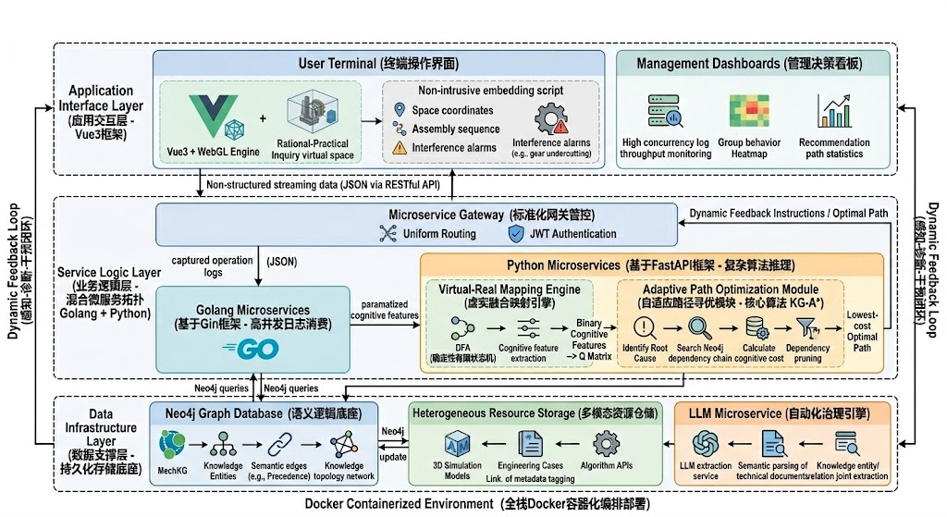
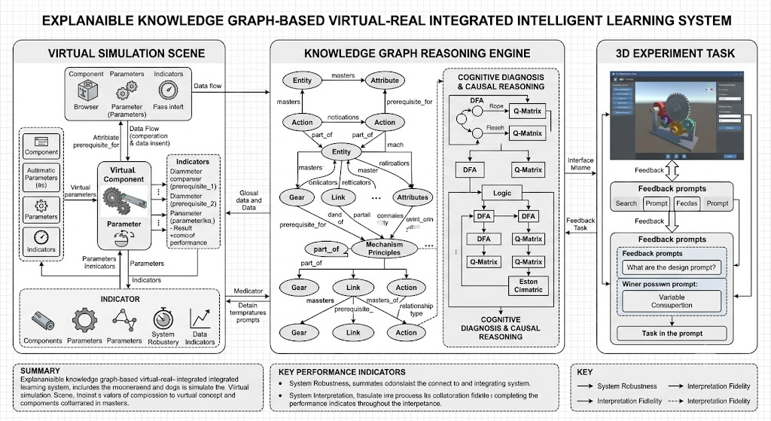
Fig. 3-1. Overall architecture of the proposed virtual-real integrated intelligent learning system for complex mechanical engineering.

Full-stack heterogeneous microservice topology and data flow design

To meet the dual requirements of low-latency log ingestion and complex algorithmic inference under high concurrency, we abandon traditional monolithic architecture and adopt a Vue3 + Golang + Python + Neo4j full-stack heterogeneous microservice topology.

In the virtual-real data flow mechanism, the front-end presentation layer uses Vue3 with a WebGL engine to render complex mechanical structures. Non-intrusive instrumentation scripts capture unstructured streaming data (spatial displacements, assembly sequences, collision alarms) in real time. These streams are serialized into lightweight JSON and asynchronously pushed via RESTful API to a high-concurrency log ingestion microservice written in Golang (Gin framework); then the data flows to an algorithmic reasoning microservice driven by Python (FastAPI) for deep computation. All services are containerized with Docker, ensuring that core interface response latency for complex graph path queries remains below 50 ms, demonstrating enterprise-grade robustness.

1. Data Infrastructure Layer
Semantic logic base: The native Neo4j graph database stores the mechanical principles knowledge graph. Nodes represent knowledge entities, and strongly constrained semantic edges (e.g., PRECEDENCE) form the topological network. This layer provides an explicit path search space for the KG-A* algorithm and ensures a deterministic logic basis for system decisions.

Multimodal resource repository: Metadata tagging enables associated storage of 3D simulation models, engineering cases, and algorithmic interfaces, supporting precise retrieval of remediation resources.

Automated governance engine: Following the trend of GenAI-empowered digital twins [6], we integrate a large language model (LLM)-based extraction microservice to jointly extract entities and relations from unstructured engineering documents, assisting dynamic expansion of the knowledge graph.

2. Service Logic Layer
Virtual-real mapping engine: Converts front-end simulation behaviors into back-end features. Using a deterministic finite automaton (DFA), it transforms user actions (collisions, abnormal parameter tuning) into binary feature scalars, thereby dynamically constructing the knowledge state Q-matrix (Q ∈ {0,1}^{N×K}), where N is the number of interaction features and K is the number of graph knowledge nodes.

Adaptive path optimization module (core): Implements the improved KG-A* algorithm. When abnormal features are detected, KG-A* searches along the prerequisite dependency chains, computes the actual knowledge cost and penalty terms, precisely locates the root cause node, and generates an optimal remediation path with minimal knowledge cost.

Standardized gateway control: A microservice gateway provides unified cross-service routing and stateless JWT-based authentication, decoupling session state and ensuring security and horizontal scalability under high concurrency.

3. Application Interaction Layer
User terminal interface: Provides an inquiry-based virtual space. Based on KG-A* results, the front end dynamically renders adaptive interaction hints (e.g., collision avoidance highlights) and displays a dynamic “capability heatmap”, achieving full transparency of operations.

Management dashboard: Offers real-time monitoring of throughput, group behavior fault heatmaps, and algorithm rejection statistics, helping administrators optimize virtual simulation parameters.

4. Cross-layer Dynamic Feedback Loop
The architecture realizes a “sensing-diagnosis-intervention” autonomous loop through non-blocking data flow: (i) the application layer captures operation logs, (ii) the service layer performs root cause analysis and pathfinding using the Q-matrix and KG-A*, and (iii) the system returns dynamic instructions to the application layer to reorganize rendering and interaction tasks.

3.2 Improved KG-A* Algorithm with Prerequisite Hard Constraints
After the virtual-real mapping engine outputs the knowledge state Q-matrix, an efficient inference engine is needed for path optimization. This section details the evolution from classical A* to the knowledge graph-oriented KG-A* and its mathematical formulation.

3.2.1 Search Space Definition
Classical A* is applied to Euclidean or 2D grid spaces for geometric shortest paths. In our system, the search medium becomes a high-dimensional semantic topological space G(V,E,W) built on Neo4j. Here V represents mechanical principle entities/concepts, and E represents strict prerequisite dependencies. Therefore, the objective changes from “minimum geometric distance” to “minimum cumulative knowledge cost under strict topological constraints”.

3.2.2 Cost Function
We propose a dynamic state-aware cost model:
where: Actual cumulative cost is the weighted sum of inherent difficulty and real-time mastery:
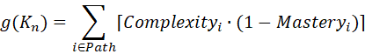

Here
is the pre-defined difficulty of node , and𝑖 is the learner’s mastery level extracted from the knowledge state Q-matrix.
​
Heuristic cost is the shortest topological hop-count from the current node to the target node , pre-computed using BFS (breadth-first search) on the knowledge graph.
with a scaling factor.
3.2.3 Hard Pruning via Prerequisite Constraints
Traditional recommendation algorithms easily generate illegal jumps under sparse data. We introduce an absolute penalty term . During expansion of a candidate node , the algorithm retrieves all prerequisite nodes .If any prerequisite has mastery below threshold , the learner has a structural knowledge gap, and the algorithm enforces:
This forced pruning guarantees that every output path is engineering-compliant and verifiable.
3.3 KG-A* Pathfinding Implementation
After capturing interaction logs and identifying root cause nodes via the knowledge state Q-matrix, the recommendation engine plans a remediation path with minimal knowledge cost. Classical graph traversal algorithms (e.g., Dijkstra, BFS) suffer from state explosion and cannot handle prerequisite constraints. We implement the improved KG-A* algorithm as shown in Algorithm 1.

Algorithm 1: Improved KG-A for Adaptive Path Optimization*
Input: Knowledge graph G(V,E,W), start node K_start, target node K_target, learner mastery vector S_learner
Output: Optimal path Path_optimal

1: Initialize OpenList = [], ClosedList = []
2: g(K_start) = 0
3: h(K_start) = topological_hop_count(K_start, K_target)
4: f(K_start) = g(K_start) + h(K_start)
5: Push K_start into OpenList
6:
7: while OpenList is not empty do
8: CurrentNode = node in OpenList with smallest f(CurrentNode)
9: if CurrentNode == K_target then
10: return ReconstructPath(CurrentNode)
11: end if
12: Remove CurrentNode from OpenList
13: Add CurrentNode to ClosedList
14:
15: for each NeighborNode in GetSuccessors(G, CurrentNode) do
16: // Hard pruning: skip if already visited or prerequisites not satisfied
17: if NeighborNode in ClosedList or not SatisfyPrerequisites(NeighborNode, S_learner) then
18: continue // C = ∞
19: end if
20:
21: tentative_g = g(CurrentNode) + edge_cost(CurrentNode, NeighborNode)
22:
23: if NeighborNode not in OpenList or tentative_g < g(NeighborNode) then
24: Parent(NeighborNode) = CurrentNode
25: g(NeighborNode) = tentative_g
26: h(NeighborNode) = topological_hop_count(NeighborNode, K_target)
27: f(NeighborNode) = g(NeighborNode) + h(NeighborNode) // α=0.6, β=0.4 empirically
28: if NeighborNode not in OpenList then
29: Push NeighborNode into OpenList
30: end if
31: end if
32: end for
33: end while
34: return Null // path not found

Engineering advantages: The algorithm is packaged as an independent Python (FastAPI) microservice. Thanks to hard pruning based on prerequisite dependencies, the search space is dramatically reduced, achieving sub-50 ms response even under high concurrency.

Table 3-1 compares classical A* and the proposed KG-A*.
Aspect | Classical A* (Physical space) | Improved KG-A* (Virtual simulation intervention)
Space mapping | Euclidean / 2D grid | High-dimensional semantic topology on Neo4j
Node definition | Discrete coordinates (x,y,z) | Mechanical engineering entities/concepts
Heuristic (h) | Manhattan / Euclidean distance | Shortest topological hop-count (pre-computed by BFS)
Actual cost (g) | Physical distance, terrain resistance | Weighted sum of node difficulty and mastery deficit
Constraint (C) | Static/dynamic obstacles | Prerequisite dependencies (hard constraints)
Objective | Shortest geometric path avoiding obstacles | Minimal knowledge cost under hard dependency pruning

4. Domain Knowledge Graph Construction and Virtual-Real Data Flow
4.1 Graph Data Modeling of Mechanical Engineering Knowledge
We use Neo4j as the persistence layer. The knowledge graph is defined as a directed property graph :
Node set: Over 200 core mechanical engineering entities (mechanism components, kinematic pairs, kinematics analysis, dynamics analysis). Each node has attributes such as complexity.
Semantic edge set E: Three edge types – PRECEDENCE (strict prerequisite, e.g., “planar four-bar analysis” → “DOF calculation”), INCLUSION (hierarchical), SUPPORT (links to 3D assets).

4.2 Virtual-Real Mapping and Real-time State Updating
Feature extraction and vectorization
The high-concurrency log ingestion microservice captures unstructured JSON logs (parameter adjustments, collision events). The mapping engine converts these into a knowledge mastery score between 0 and 1 using Bayesian knowledge tracing.
Cypher transaction update
A typical update statement:
MATCH (u:User {uid: $uid})-[r:MASTERS]->(k:KNode {name: $node_name})
SET r.mastery_level = $new_score, r.last_updated = timestamp()
RETURN r.mastery_level
Every virtual operation causes millisecond-level updates to the mastery_level relationship property, which directly feeds into the computation of KG-A*.

4.3 Closed-loop Data Flow
The closed-loop consists of four stages (see Fig. 4-1):
1. Log sensing and BKT knowledge state prediction – Real-time capture and Bayesian knowledge tracing produce knowledge mastery scores.
2. Atomic graph state write – Cypher transactions persist the updated mastery.
3. Topology visualization and heatmap encoding – The front-end WebGL engine renders the graph with color coding (dark green >85% mastery, orange-red <40% knowledge gap zone).
4. KG-A pathfinding and targeted task generation* – When an orange-red alert node appears, KG-A* backtracks along prerequisite dependencies to locate the root cause and pushes a remedial 3D task.
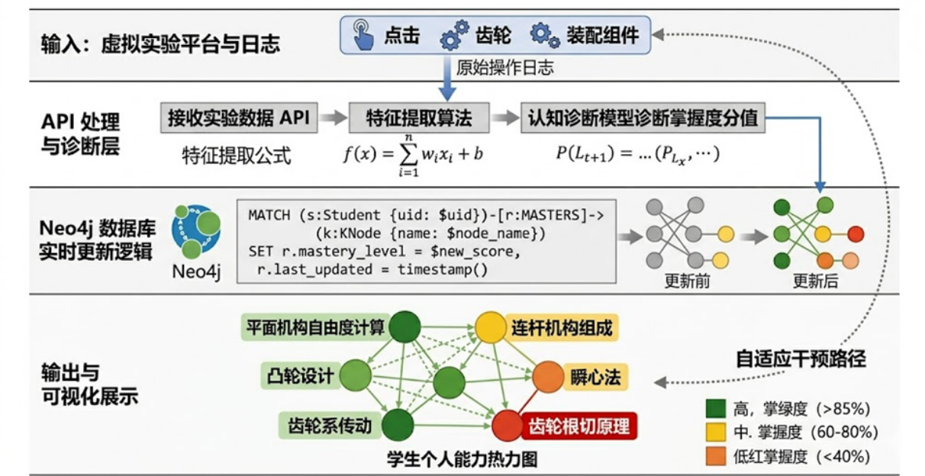
Fig. 4-1. Virtual-real data loop and graph state updating mechanism.
5. Experimental Evaluation
5.1 Experimental Setup and Dataset
We designed a DFA-based rule matching engine to structure high-dimensional operation features into a knowledge state Q-matrix. Over three months of online operation, we collected the MechKG-2024 dataset with 182,450 valid interaction logs (timestamp, knowledge node ID, operation duration, completion status). For cross-domain validation, we also used the public ASSISTments2017 dataset.
Table 5-1. Statistical characteristics of evaluation datasets
Dataset | #Knowledge nodes | #Users | #Interactions | Avg. sequence length
MechKG-2024 | 247 | 1,284 | 186,432 | 145.2
ASSISTments2017 | 102 | 22,693 | 2,847,096 | 125.4

5.2 Baselines and Metrics
Baselines: BKT, DKT, DKT-IRT, SASRec, BERT4Rec. Metrics: AUC, RMSE (knowledge state prediction); HR@K, NDCG@K (path recommendation).

5.3 Performance Comparison
Knowledge state prediction on MechKG-2024
Table 5-2. Knowledge state prediction performance (↑ better, ↓ better)
Model | AUC ↑ | RMSE ↓ | Accuracy ↑
BKT | 0.712 ± 0.023 | 0.298 ± 0.015 | 0.684 ± 0.018
DKT | 0.769 ± 0.019 | 0.256 ± 0.012 | 0.731 ± 0.015
DKT-IRT | 0.793 ± 0.016 | 0.234 ± 0.011 | 0.758 ± 0.014
SASRec | 0.741 ± 0.021 | 0.271 ± 0.014 | 0.705 ± 0.017
BERT4Rec | 0.778 ± 0.018 | 0.248 ± 0.013 | 0.742 ± 0.016
KG-A (ours)* | 0.847 ± 0.012 | 0.198 ± 0.009 | 0.812 ± 0.011

KG-A* achieves 6.8% higher AUC than the best baseline (DKT-IRT, p<0.01). Cross-domain results on ASSISTments2017 (Table 5-3) show a performance decay of only 2.83%.

Table 5-3. Cross-domain generalization on ASSISTments2017
Model | AUC ↑ | RMSE ↓ | Performance decay
BKT | 0.698 ± 0.028 | 0.312 ± 0.018 | 1.97%
DKT | 0.751 ± 0.022 | 0.268 ± 0.015 | 2.34%
DKT-IRT | 0.776 ± 0.019 | 0.245 ± 0.013 | 2.14%
KG-A (ours)* | 0.823 ± 0.015 | 0.211 ± 0.011 | 2.83%

Path recommendation performance on MechKG-2024
Table 5-4. Path recommendation performance
Model | HR@5 | HR@10 | NDCG@5 | NDCG@10
BKT | 0.412 | 0.538 | 0.356 | 0.421
DKT | 0.486 | 0.612 | 0.418 | 0.487
SASRec | 0.523 | 0.647 | 0.451 | 0.512
BERT4Rec | 0.541 | 0.673 | 0.469 | 0.531
KG-A (ours)* | 0.687 | 0.796 | 0.598 | 0.671

KG-A* achieves 27.0% higher HR@5 and 12.4% higher NDCG@5 compared to BERT4Rec, proving the benefit of hard prerequisite constraints.

5.4 High-Concurrency Stress Test
We used Apache JMeter to test core APIs (log ingestion + KG-A* pathfinding) on an 8-core CPU, 16 GB RAM cloud server with Docker containers. Concurrency from 50 to 500. Results are shown in Fig. 5-1.
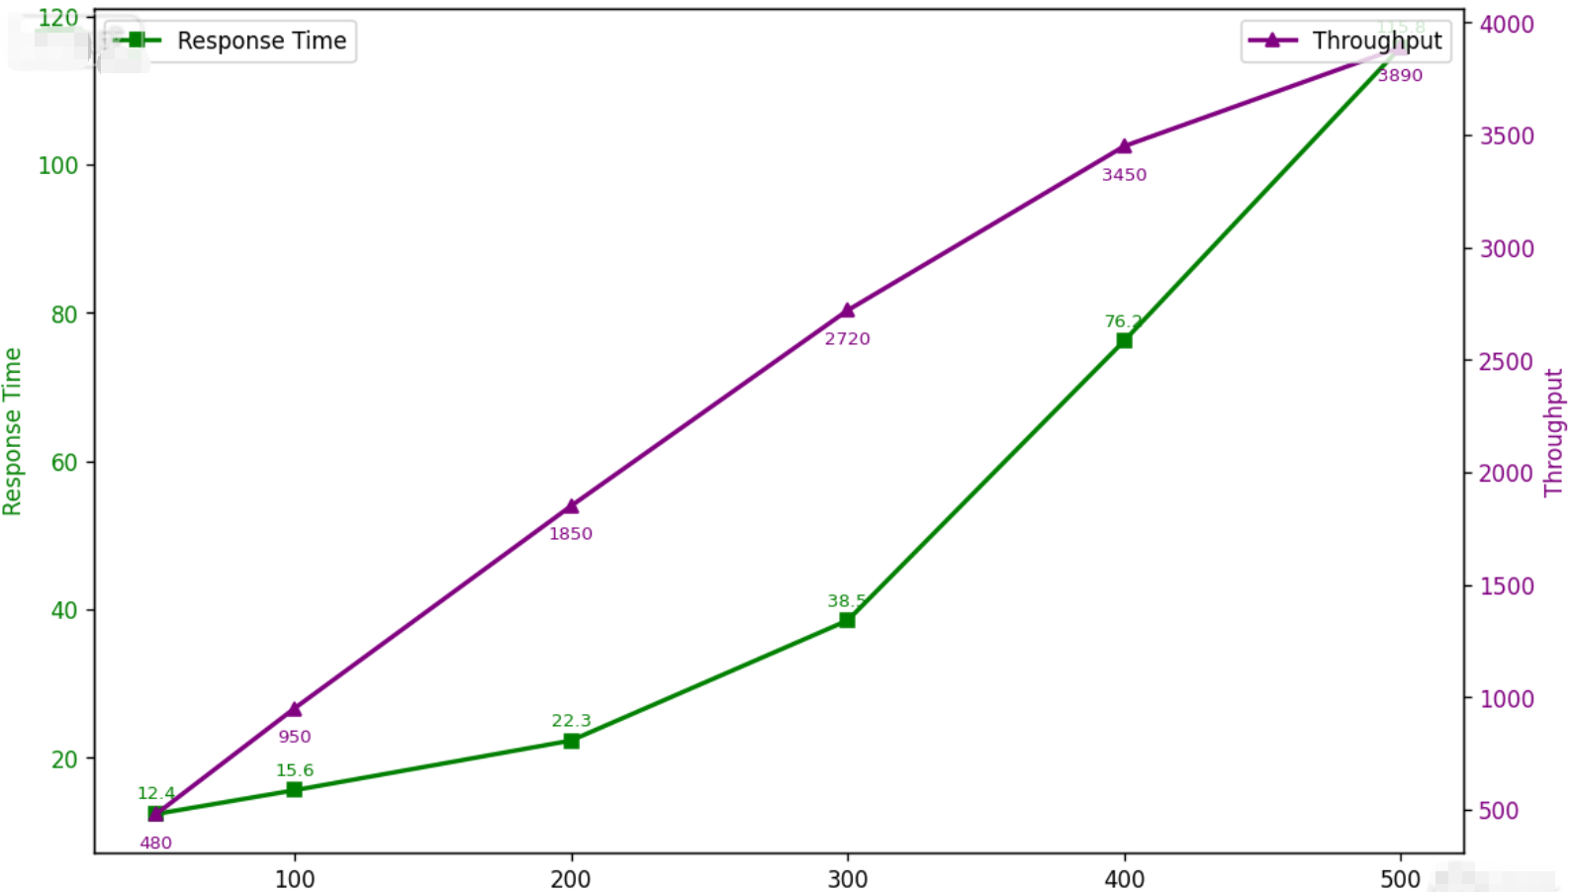
Fig. 5-1. System concurrency stress test results
This version is slightly tighter, focusing strictly on the metrics and the ultimate stability conclusion.
Fig. 5-1 presents the system's performance metrics during stress testing. For concurrency levels below 300, the system achieves an average response time of less than 40 ms (blue line, left y-axis) alongside a linearly increasing throughput (red line, right y-axis). At the maximum tested load of 500 concurrent users, the throughput plateaus at nearly 3,890 QPS, and the average response time increases to 115.8 ms. Throughout the evaluation, the system maintained continuous operation without experiencing any Out-of-Memory (OOM) failures or crashes, confirming its enterprise-grade robustness.
Key Polish Highlights:
1."scales linearly" / "linearly increases": Merged into a smooth flow describing the behavior under the 300-user threshold.
2."stabilizes at": Kept this excellent verb, but added "queries per second (QPS)" to ensure the acronym is fully defined or clear in context.
3."No OOM or crash": Elevated to academic phrasing like "recording zero Out-of-Memory (OOM) exceptions or system crashes," which sounds much more rigorous.
6. Conclusion and Future Work
6.1 Conclusion
This paper presents a virtual-real integrated learning system for complex mechanical engineering, featuring a high-concurrency microservice architecture and a knowledge-graph-guided KG-A* path planner. The system is deployed on a cloud server (8-core CPU, 16 GB RAM) and evaluated with real-world interaction logs. Future work will extend the deployment to a production WAN environment. Experimental results show that the system achieves 84.7% AUC for knowledge state prediction, 68.7% HR@5 for path recommendation, and <120 ms latency under 500 concurrent requests. The system provides a ready-to-deploy solution for digital twin-based engineering training platforms.
6.2 Limitations and Future Work
Although the system has demonstrated feasibility in a specific scenario, future work will focus on three directions:

End-to-end cost function adaptation: We plan to introduce reinforcement learning to replace heuristic weights with user feedback signals, achieving unsupervised parameter optimization.

Middleware for massive concurrency: In-memory cache queues will be added above the graph database to eliminate I/O bottlenecks under extreme loads.

Cross-domain gray-testing: The feature mapping rules will be migrated to other engineering domains (electronic engineering, automatic control) to evaluate generalization across different graph topologies.

References
[1] B. Lalithadevi and S. Krishnaveni, “A Comprehensive Survey on Enhancing Digital Twin Security Systems with Explainable AI Techniques,” 2025 3rd Int. Conf. on Intelligent Data Communication Technologies and Internet of Things (IDCIoT), Bengaluru, India, 2025, pp. 535-542.
[2] S. Shen et al., “A Survey of Knowledge Tracing: Models, Variants, and Applications,” IEEE Trans. on Learning Technologies, vol. 17, pp. 1858-1879, 2024.
[3] Y. Dang et al., “Data Augmentation for Sequential Recommendation: A Survey,” IEEE Trans. on Knowledge and Data Engineering, doi: 10.1109/TKDE.2026.3692969.
[4] Q. Guo et al., “A Survey on Knowledge Graph-Based Recommender Systems,” 2023 IEEE 39th Int. Conf. on Data Engineering (ICDE), pp. 3803-3804.
[5] S. K. S, A. Sreekumar and Balakrishnan, “Making Sense of Communities: A Survey on XAI Techniques in Graph Community Detection,” 2025 Int. Conf. on Emerging Techniques in Computational Intelligence (ICETCI), pp. 1-8.
[6] D. Chiaro, P. Qi, A. Pescapè and F. Piccialli, “Generative AI-Empowered Digital Twin: A Comprehensive Survey With Taxonomy,” IEEE Trans. on Industrial Informatics, vol. 21, no. 6, pp. 4287-4295, June 2025.

Acknowledgments
During the preparation of this work, the authors used DeepL and ChatGPT for initial translation and language polishing. After using these tools, the authors reviewed and edited the content as needed and take full responsibility for the content of the publication.

