Telnet whu.edu.cn 25

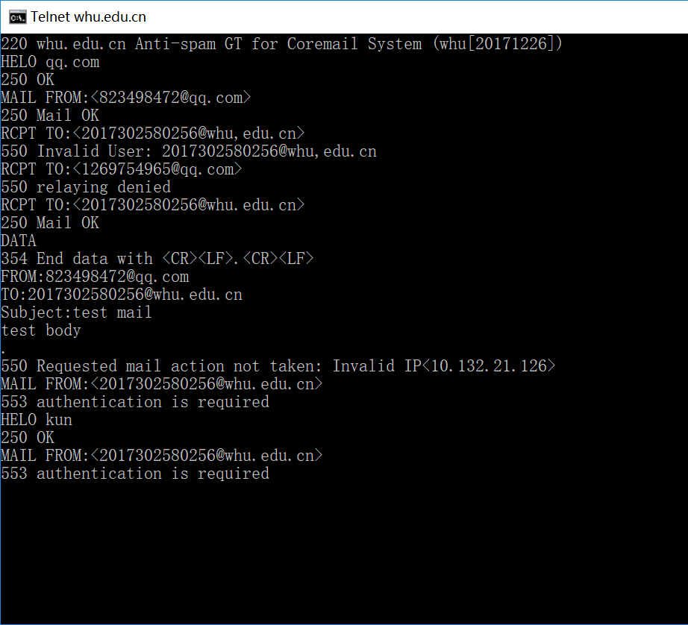

P3

Application layer protocol:DNS HTTP

Transport layer protocol:TCP UDP

P5

1. Yes, because the status code is 200. The time of giving the response is 2008.05.07, Tuesday.
2. The last modified time is 2005.12.10, Saturday.
3. The number of bytes is 3874.
4. It’s “<!doc”. It allows keeping alive because the status of connection is “Keep-Alive”.

P9

 





B.



P10

First, we consider the propagation delay in the link. =10/300000000=0.03 us

If we choose a non-persistent http connection, then the total time is as below:



=

If we choose a persistent http connection, then the total time is as below:



=

P22



Client-Server Model

|  |  |  |  |
| --- | --- | --- | --- |
| N u | 300kps | 700kps | 2Mps |
| 10 | 7680 | 7680 | 7680 |
| 100 | 51200 | 51200 | 51200 |
| 1000 | 51200 | 51200 | 51200 |

P2P Model

|  |  |  |  |
| --- | --- | --- | --- |
| N u | 300kps | 700kps | 2Mps |
| 10 | 7680 | 7680 | 7680 |
| 100 | 25904 | 15616 | 7680 |
| 1000 | 47559 | 21525 | 7680 |