

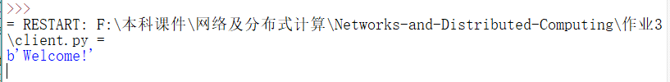

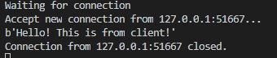

P4

A.01011100&01100101=11000001

So, ones-complement code is 00111110

B.11011010&01100101=01000000

So, ones-complement code is 10111111

C.01011101&01100100=11000001

So, ones-complement code is 00111110, which is same as A’s ones-complement code

P15



So, N is 2251 at least

P22

[(k-4)%1024,(k+4-1)%1024]

First, we suppose that all ACKs from receiver have been gotten by the sender including (k-1)’s ACKs, then, the seq in sender must be [k%1024,k+4-1%1024]

Second, we suppose that none of ACKs from receiver have been gotten by the sender, then, the seq in sender must be [(k-4)%1024,(k-1)%1024]

So, the result is [(k-4)%1024,(k+4-1)%1024]

P39

No. Because the capacity of link is limit. When sender’s speed gets increase, the router can’t transfer more packages out of the link’s speed which will be lost and retransmissions. So, in 3-46b, the maximum of out speed is R/3. The same reason for the 3-46c. If half of packets will be retransmissions, the maximum of speed will not extend R/4.

P45



B.

