2.

a.

PGA:

[['TCU015' 'TCU029' 'TCU076' 'TCU082' 'TCU089']

[0.3775 0.42566 1.0932 0.78508 1.10448]]

b.

[['TCU015' 'TCU029' 'TCU076' 'TCU082' 'TCU089']

[0.33 0.33 0.33 0.33 0.33 ]

[0.5071157 0.43136512 0.34810176 0.35183384 0.52333039]

[0.41195649 0.52075238 0.6067314 0.46446896 0.63201662]

[0.51708002 0.84600185 0.79250456 0.45804343 0.82174841]

[0.72823291 0.6403888 0.61576415 0.62774251 0.77555783]

[0.85489295 0.50475484 0.76052745 0.70057824 0.87541036]

[0.60082556 0.54958044 0.7677986 0.91064786 0.94632844]

[0.51929934 0.56862319 0.58699853 1.01910314 0.72789355]

[0.66083791 0.86415134 0.451123 0.76815671 0.49679501]

[0.70540557 0.76451184 0.34254146 0.84495162 0.49111437]

[0.45487099 0.66962289 0.29774016 0.74633585 0.46733792]

[0.50292616 0.70131344 0.30676567 0.57936276 0.40936622]

[0.51848408 0.71146416 0.2555704 0.43539179 0.46256549]

[0.51615152 0.68704153 0.260384 0.48675714 0.45910399]

[0.55528411 0.60607936 0.25466422 0.54012155 0.41204803]

[0.49712874 0.55055491 0.31445003 0.60337739 0.40556199]

[0.40783489 0.50049154 0.34965313 0.42232004 0.41577515]

[0.52185836 0.42235128 0.34747106 0.33595823 0.39461197]

[0.53071301 0.37523162 0.30558402 0.37340807 0.40627314]

[0.51214315 0.35856413 0.27511478 0.44272599 0.36117071]

[0.43944894 0.33255798 0.22419499 0.40191409 0.33243334]

[0.44361584 0.31077453 0.20475934 0.43811777 0.31013917]

[0.47760774 0.30984066 0.22516641 0.42548737 0.33330728]

[0.50315262 0.30675484 0.21700358 0.38998466 0.26530235]

[0.52462119 0.30259305 0.19338503 0.33680198 0.27078593]

[0.50949355 0.26724823 0.16604029 0.34793958 0.23606803]

[0.43233805 0.27603876 0.15416577 0.34002124 0.21229157]

[0.35280469 0.27272962 0.1410951 0.32257494 0.21615578]

[0.32026215 0.2569757 0.13715142 0.30962001 0.21023523]

[0.31829193 0.24278499 0.13602052 0.30224687 0.18926912]

[0.30520244 0.24621593 0.13511434 0.31502006 0.18402544]

[0.30105819 0.23117256 0.13488236 0.35345646 0.189569 ]

[0.35042685 0.22847247 0.13514334 0.34095586 0.19185668]

[0.37563203 0.22150907 0.13750665 0.28608567 0.18752123]

[0.36931375 0.22502122 0.1549487 0.25215365 0.18250032]

[0.33901318 0.23200492 0.1502221 0.21314609 0.17648553]

[0.31394386 0.22690926 0.14450232 0.1984777 0.16140569]

[0.29021068 0.2036235 0.13582478 0.20905712 0.14296716]

[0.26835712 0.19404122 0.13591178 0.21924711 0.12989225]

[0.24754529 0.20754168 0.13631049 0.23279915 0.12659353]

[0.25234628 0.23858259 0.13818084 0.21740382 0.13728651]

[0.29838595 0.24304891 0.14115309 0.23735544 0.14156199]

[0.29714041 0.26578653 0.14427759 0.21898749 0.12986655]

[0.25501853 0.26314734 0.14670614 0.18316025 0.1251798 ]

[0.21803733 0.25374777 0.14788054 0.16427307 0.11901078]

[0.20100741 0.24264288 0.14770655 0.17098419 0.10892613]

[0.17883681 0.23462381 0.14618418 0.18070687 0.1010949 ]

[0.17915386 0.24136389 0.14342216 0.19764692 0.08539816]

[0.17512284 0.21393663 0.13993519 0.21681968 0.09740205]

[0.16864603 0.20577545 0.14039191 0.206422 0.10201168]

[0.16948394 0.20067979 0.13436041 0.19911376 0.09689653]

[0.17944826 0.19369609 0.12837965 0.19679018 0.0882856 ]

[0.20207178 0.18439803 0.12727774 0.1926363 0.08478125]

[0.23001716 0.20055798 0.12585686 0.1876776 0.08580942]

[0.25615084 0.21915411 0.12376903 0.1802785 0.07922056]

[0.27551331 0.21958044 0.12100701 0.17085438 0.07084954]

[0.28341683 0.21641341 0.11773753 0.1532523 0.06408932]

[0.27927258 0.21215011 0.11409833 0.13838919 0.05644658]

[0.26518666 0.20005045 0.1101619 0.14016757 0.0511772 ]

[0.24285753 0.18502738 0.10822631 0.13949257 0.04966922]

[0.21824115 0.17179083 0.10621098 0.14420463 0.05040608]

[0.19797282 0.16261458 0.10383318 0.14905948 0.05091159]

[0.19022783 0.15812796 0.1011654 0.15039651 0.05095443]

[0.18685355 0.1572144 0.09831638 0.1508768 0.05062885]

[0.19004666 0.15812796 0.09530788 0.15362875 0.05091159]

[0.19231128 0.15948816 0.09217614 0.1556278 0.0515799 ]

[0.19145073 0.16074685 0.0889864 0.15670522 0.05267662]

[0.19405504 0.16188373 0.08577492 0.15688695 0.05463871]

[0.19967129 0.1628988 0.08252719 0.15639367 0.05742334]

[0.20238883 0.16367026 0.07929395 0.15543309 0.06132182]

[0.20569517 0.16393417 0.07644494 0.1543427 0.06588005]

[0.21126613 0.16362965 0.07374816 0.15310951 0.0694358 ]

[0.21543302 0.16279729 0.07117462 0.15165565 0.07127794]

[0.21837702 0.16129499 0.06861558 0.14996814 0.07093522]

[0.21987167 0.15898062 0.06608554 0.14813783 0.0693844 ]

[0.21984903 0.16375146 0.0635845 0.1461907 0.06772219]

[0.21876201 0.16919225 0.0612067 0.14513925 0.06732805]

[0.2203246 0.17331344 0.05890864 0.14449021 0.06614566]

[0.22410651 0.17619625 0.05665407 0.14349068 0.06435493]

[0.22723168 0.17798277 0.054472 0.14219259 0.06132182]]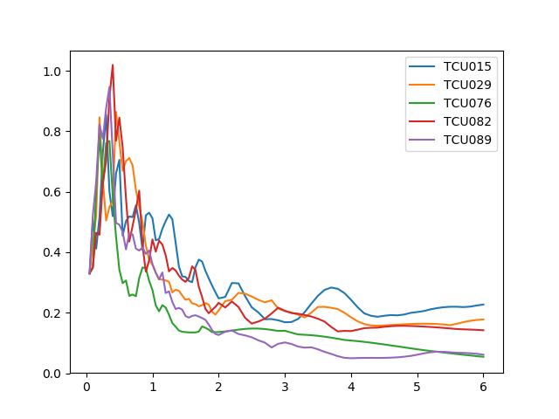

c.

αy：αy is defined as the first yield seismic force amplification factor that is dependent on the structure types and design method.

Fu：the seismic force reduction factor. This is based on the equal displacement principle between the elastic and the EPP systems for the long period range and the equal energy principle for short periods.

1.4：the constant 1.4 means the over-strength factor between the ultimate and the first yield force.

d.

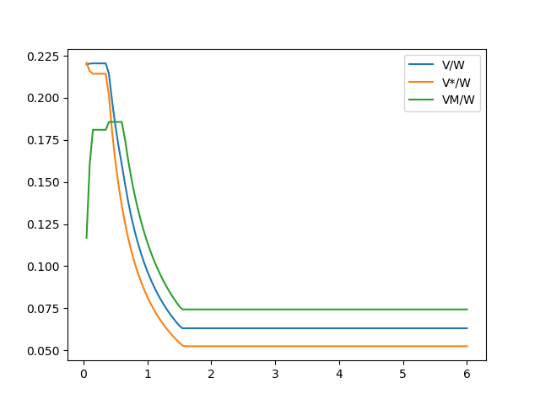

e.

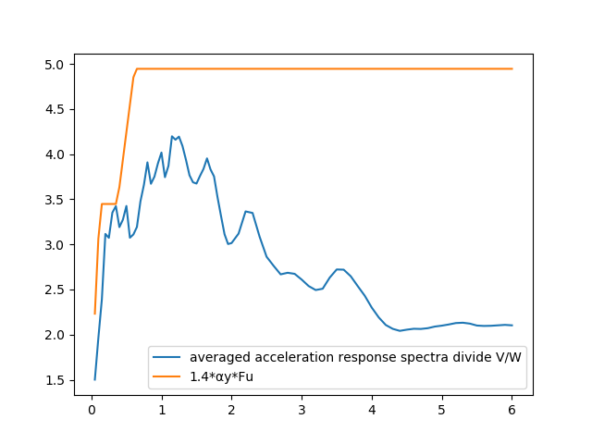

f.

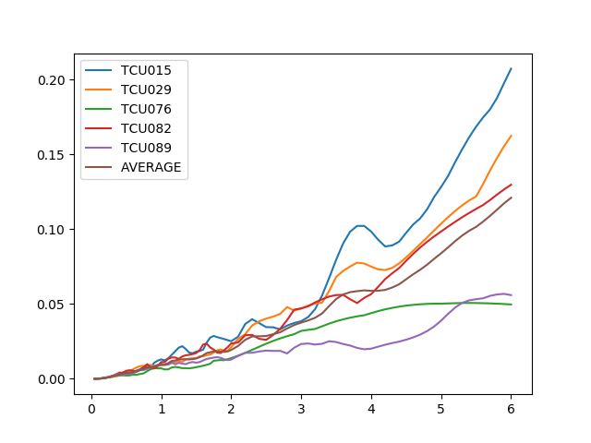

g.

