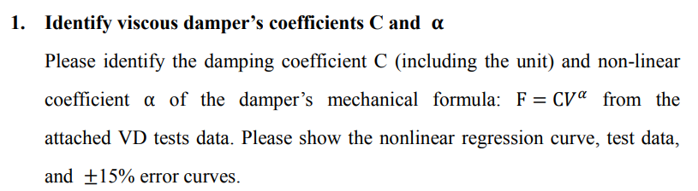

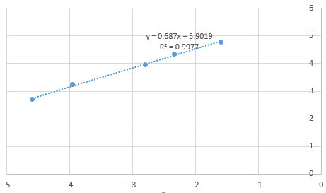



clc; clear; close all;

filename = 'VD tests(revised).xlsx';

sheet = 1;

disp005 = xlsread(filename, sheet, 'B3:B3739');

force005 = xlsread(filename, sheet, 'C3:C3739');

disp01 = xlsread(filename, sheet, 'E3:E3957');

force01 = xlsread(filename, sheet, 'F3:F3957');

disp03 = xlsread(filename, sheet, 'H3:H3773');

force03 = xlsread(filename, sheet, 'I3:I3773');

disp05 = xlsread(filename, sheet, 'K3:K4002');

force05 = xlsread(filename, sheet, 'L3:L4002');

disp1 = xlsread(filename, sheet, 'N3:N3759');

force1 = xlsread(filename, sheet, 'O3:O3759');

x = [dis(disp005, 0.05) dis(disp01, 0.1) dis(disp03, 0.3) dis(disp05, 0.5) dis(disp1, 1)].';

y = [force(force005) force(force01) force(force03) force(force05) force(force1)].';

alpha_ = 0.687;

lnC = 5.9019;

vel = 0 : 0.0001 : 0.25;

f = exp(5.9019) * vel .^ 0.687;

figure;

theory = plot(vel, f, 'k');

hold on;

test_data = plot(x, y, 'r*');

hold on;

error_range = plot(vel, 1.15 * f, 'r:', vel, 0.85 * f, 'r:');

title('');

xlabel('Velocity (mm/sec)');

ylabel('Force (tf)');

legend([theory, test_data, error_range(1)], '理論值', '試驗值', '15%誤差範圍', 'Location', 'southeast');

function *output* = dis(*input*, *f*)

output = max(abs(diff(input) * f));

end

function *output* = force(*input*)

output = max(abs(input));

end

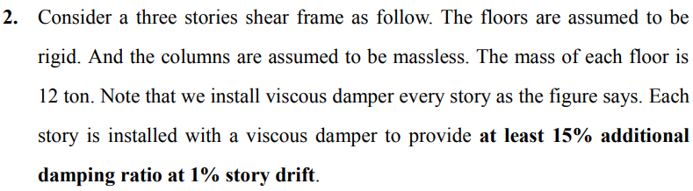

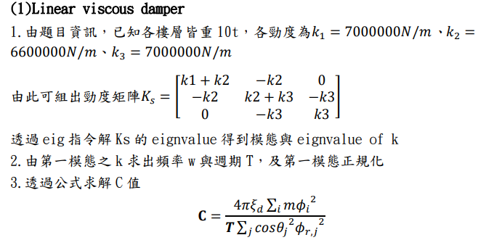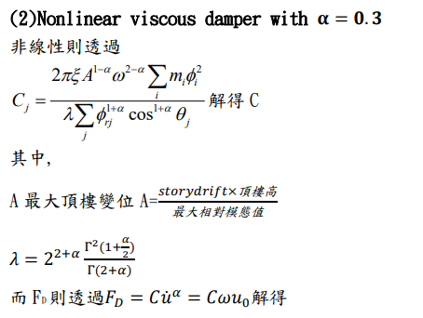





clc; clear; close all;

m = 12;

k1 = 7e3;

k2 = 6.6e3;

k3 = 7e3;

ks = [

k1 + k2, -k2, 0;

-k2, k2 + k3, -k3;

0, -k3, k3;

];

[modeshape, eig_k] = eig(ks);

omega = sqrt(eig_k(1, 1) / m);

period = 2 * pi / omega;

modeshape_normailzed = modeshape(:, 1) / modeshape(3, 1);

xi_d = 0.15;

cos_theta = 4 / 5;

next_reduce_prev = [

1, 0, 0;

-1, 1, 0;

0, -1, 1;

];

relative_modeshape = next_reduce_prev * modeshape_normailzed;

c_linear = 4 * pi * xi_d * m * sum(modeshape_normailzed .^ 2) / (period * (cos_theta ^ 2) * sum(relative_modeshape .^ 2))

*% 302*

story_drift = 0.01;

h = 3;

u0 = story_drift * h * cos_theta;

*% linear*

FD_linear = c_linear * u0 * omega

*% 77*

*% =========================*

*% nonlinear*

alpha_ = 0.3;

A = story_drift * h / max(relative_modeshape);

lamda = 2 ^ (2 + alpha_) * gamma(1 + alpha_ / 2) ^ 2 / gamma(2 + alpha_);

c_nonlinear = 2 * pi * xi_d * A ^ (1 - alpha_) * omega ^ (2 - alpha_) * sum(m * (modeshape_normailzed .^ 2)) / (lamda * sum(relative_modeshape .^ (1 + alpha_) * cos_theta ^ (1 + alpha_)))

*% 88*

FD_nonlinear = c_nonlinear * (omega * u0) ^ alpha_

*% 58*

*% =========================*

*% nonlinear*

alpha_ = 0.7;

A = story_drift * h / max(relative_modeshape);

lamda = 2 ^ (2 + alpha_) * gamma(1 + alpha_ / 2) ^ 2 / gamma(2 + alpha_);

c_nonlinear = 2 * pi * xi_d * A ^ (1 - alpha_) * omega ^ (2 - alpha_) * sum(m * (modeshape_normailzed .^ 2)) / (lamda * sum(relative_modeshape .^ (1 + alpha_) * cos_theta ^ (1 + alpha_)))

*% 180*

FD_nonlinear = c_nonlinear * (omega * u0) ^ alpha_

*% 69*





**Since viscous damper don’t provide stiffness, periods have no change.**

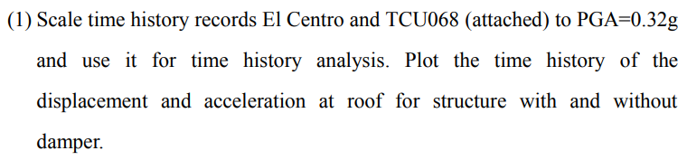

**Linear viscous damper**



**Nonlinear viscous damper with**

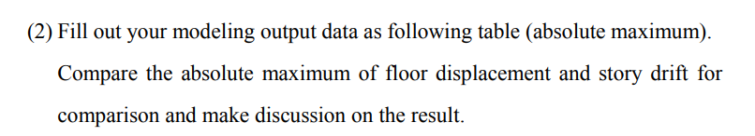

**Linear viscous damper**





