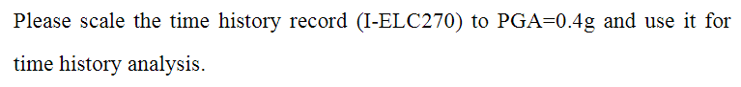



clc; clear; close all;

ag = filename_to_array('I-ELC270_gal_l00Hz', 2, 2);

tn = 0.01 : 0.01 : 5;

tn_length = length(tn);

acceleration = zeros(1, tn_length);

for index = 1 : tn_length

[~, ~, a_array] = newmark_beta(ag, 0.01, 0.05, tn(index), 'average');

acceleration(1, index) = max(abs(a_array));

end

acceleration_normal = acceleration / acceleration(1, 1) * 0.4;

acceleration_normal(tn == 2.5)

figure;

plot(tn, acceleration_normal);

xlabel('T(sec)');

ylabel('SaD(g)');

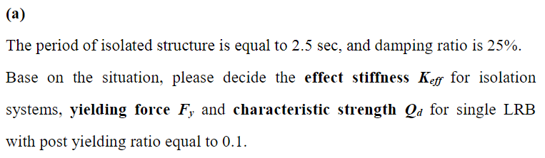

已知：

* TeD = 2.5sec
* Damping Ratio = 25%
* Post Yielding Ratio = 0.1



由反應譜可知 SaD

* TeD => SaD = 0.2324
* W = 35.53421364 (from ETABS)

由以上資訊經迭代可得

* Keff for isolation systems = 22.8801 tf/m
* Fy for single LRB = 0.2791 tf
* Qd for single LRB = 0.2512 tf

clc; clear; close all;

SaD = 0.2324;

TeD = 2.5;

DampingRatio = 0.25;

*% SaD = 0.195;*

*% TeD = 3;*

*% DampingRatio = 0.3;*

W = 35.53421364;

postYieldingRatio = 0.1;

LRBs = 9;

dleta = 0.000001;

g = 9.81;

KeD = W / ((TeD / (2 * pi)) ^ 2) / g;

if DampingRatio <= 0.02

BS = 0.8;

B1 = 0.8;

elseif 0.02 < DampingRatio && DampingRatio <= 0.05

BS = (DampingRatio - 0.02) / 0.03 * (1 - 0.8) + 0.8;

B1 = (DampingRatio - 0.02) / 0.03 * (1 - 0.8) + 0.8;

elseif 0.05 < DampingRatio && DampingRatio <= 0.1

BS = (DampingRatio - 0.05) / 0.05 * (1.33 - 1) + 1;

B1 = (DampingRatio - 0.05) / 0.05 * (1.25 - 1) + 1;

elseif 0.1 < DampingRatio && DampingRatio <= 0.2

BS = (DampingRatio - 0.1) / 0.1 * (1.6 - 1.33) + 1.33;

B1 = (DampingRatio - 0.1) / 0.1 * (1.5 - 1.25) + 1.25;

elseif 0.2 < DampingRatio && DampingRatio <= 0.3

BS = (DampingRatio - 0.2) / 0.1 * (1.79 - 1.6) + 1.6;

B1 = (DampingRatio - 0.2) / 0.1 * (1.63 - 1.5) + 1.5;

elseif 0.3 < DampingRatio && DampingRatio <= 0.4

BS = (DampingRatio - 0.3) / 0.1 * (1.87 - 1.79) + 1.79;

B1 = (DampingRatio - 0.3) / 0.1 * (1.7 - 1.63) + 1.63;

elseif 0.4 < DampingRatio && DampingRatio <= 0.5

BS = (DampingRatio - 0.4) / 0.1 * (1.93 - 1.87) + 1.87;

B1 = (DampingRatio - 0.4) / 0.1 * (1.75 - 1.7) + 1.7;

elseif 0.5 < DampingRatio

BS = 1.93;

B1 = 1.75;

end

B = B1;

DD = g / (4 * pi ^ 2) * SaD * TeD ^ 2 / B;

*% syms Qd; % be careful performance issue.*

*% Kd = KeD - Qd / DD;*

*% Ku = Kd / postYieldingRatio;*

*% Dy = Qd / (Ku - Kd);*

*% ATD = 4 * Qd * (DD - Dy);*

*% solQd = double(solve(DampingRatio == ATD / (2 * pi * KeD * DD ^ 2), Qd))*

Qd = dleta;

nextDampingRatio = 0;

while abs(nextDampingRatio - DampingRatio) > dleta

Kd = KeD - Qd / DD;

Ku = Kd / postYieldingRatio;

Dy = Qd / (Ku - Kd);

ATD = 4 * Qd * (DD - Dy);

nextDampingRatio = ATD / (2 * pi * KeD * DD ^ 2);

Qd = Qd + dleta;

end

B

DD

KeD

*% Fy1 = Ku * Dy / LRBs*

singleKu = Ku / LRBs

singleKd = Kd / LRBs

singleQd = Qd / LRBs

singleKeD = KeD / LRBs

DampingRatio

singleKu = Ku / LRBs

Fy = (Qd + Kd * Dy) / LRBs

postYieldingRatio

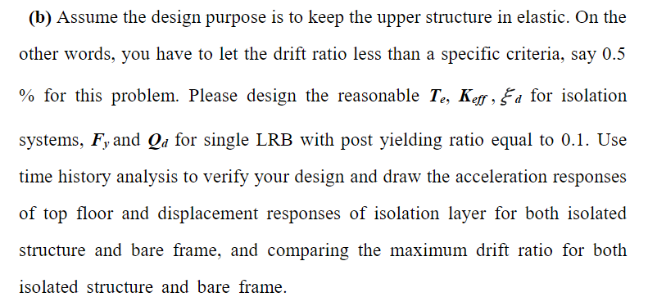

假設初始設計目標：

* TeD = 3sec
* Damping Ratio = 20%
* Post Yielding Ratio = 0.1



* TeD => SaD = 0.195
* W = 35.53421364 (from ETABS)

由以上資訊經迭代可得：

* Keff for isolation systems = 15.8889 tf/m
* Fy for single LRB = 0.1897 tf
* Qd for single LRB = 0.1707 tf

程式碼邏輯同第二題

接著進入模型，模擬 LRB 性質

* 首先，底下加一層隔震墊。

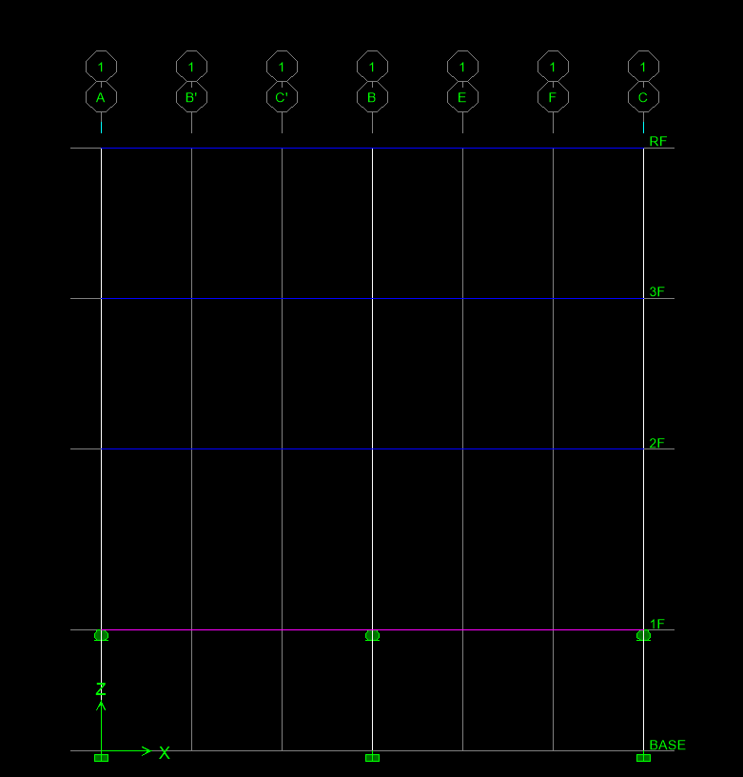

* 設定 LRB 性質
* 由於 ETABS 9 U1 方向不能 fix 所以是在模型頂端設定 roller。

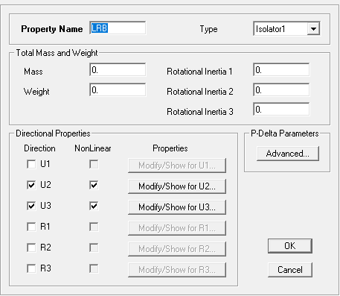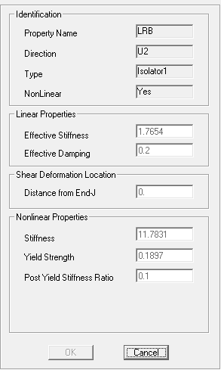

* 輸入正規化後的地震歷時

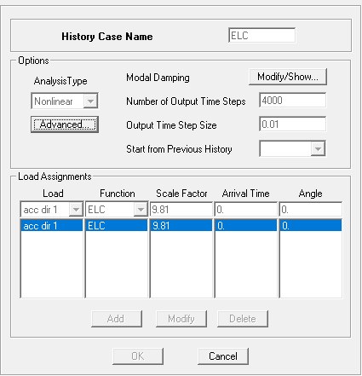

* 畫出頂樓加速度歷時



* 隔震墊位移歷時



* Maximum Drift Ratio



* 遲滯迴圈



clc; clear; close all;

periods = filename_to_array('DA_BARE_v1', 3, 1, 10);

acce_bare = filename_to_array('DA_BARE_v1', 3, 3, 10);

disp_iso = filename_to_array('DA_ISO_v3', 3, 2, 10);

acce_iso = filename_to_array('DA_ISO_v3', 3, 3, 10);

force_hysteresis = filename_to_array('hysteresis_v2', 3, 2, 10);

disp_hysteresis = filename_to_array('hysteresis_v2', 3, 3, 10);

figure;

plot(periods, acce_bare, periods, acce_iso);

title('RF acceleration responses');

xlabel('T(sec)');

ylabel('acceleration(m/s^2)');

legend('bare frame', 'isolated structure', 'Location', 'northeast');

figure;

plot(periods, disp_iso);

title('displacement responses of isolation layer');

xlabel('T(sec)');

ylabel('displacement(m)');

figure;

plot(disp_hysteresis, force_hysteresis);

title('hysteresis loop');

xlabel('displacement(m)');

ylabel('force(tf)');

axis([-0.15 0.35 -0.4 0.6]);

附錄：

function *data* = filename_to_array(*filename*, *total_col*, *array_col*, *headlines*)

*%*

*% 適用於被動控制給的 file_input.*

*%*

*% @since 3.1.0*

*% @param {string} [filename] 檔案名稱.*

*% @param {number} [total_col] 總共有幾欄.*

*% @param {number} [array_col] 要回傳第幾欄.*

*% @param {number} [headlines] 忽略標題.*

*% @return {array} [data] 加速度歷時資料.*

*% @see ignore_headlines*

*%*

if nargin == 3

headlines = 0;

end

fileID = fopen((filename + ".txt"), 'r');

ignore_headlines(fileID, headlines);

repeat_f = repmat('%f', 1, total_col);

A = fscanf(fileID, repeat_f, [total_col Inf]).';

fclose(fileID);

data = A(:, array_col);

end

function [] = ignore_headlines(*fileID*, *headlines*)

*%*

*% 忽略標題.*

*%*

*% @since 1.0.0*

*% @param {number} [fileID] fileID.*

*% @param {number} [headlines] 要忽略的行數.*

*%*

for index = 1 : headlines

fgetl(fileID);

end

end

function [*u*, *v*, *a*] = newmark_beta_calculation(*m*, *c*, *k*, *up*, *vp*, *ap*, *dp*, *dt*, *gamma_*, *beta_*)

*%*

*% newmark beta calculation*

*%*

*% @since 1.0.0*

*% @param {number} [m] 質量.*

*% @param {number} [c] 阻尼.*

*% @param {number} [k] 勁度.*

*% @param {number} [up] 前一個點的位移.*

*% @param {number} [vp] 前一個點的速度.*

*% @param {number} [ap] 前一個點的加速度.*

*% @param {number} [dp] 位移.*

*% @param {number} [dt] 時間間隔.*

*% @param {number} [gamma_] 常數.*

*% @param {number} [beta_] 常數.*

*% @return {number} [u] 位移.*

*% @return {number} [v] 速度.*

*% @return {number} [a] 加速度.*

*%*

*%------------------*

*% Calculate effective stiffness*

*%------------------*

k_s = k + gamma_ / (beta_ * dt) * c + 1 / (beta_ * (dt ^ 2)) * m;

*%------------------*

*% Compute coefficients a and b*

*%------------------*

a = 1 / (beta_ * dt) * m + gamma_ / beta_ * c;

b = 1 / (2 * beta_) * m + dt * (gamma_ / (2 * beta_) - 1) * c;

*%------------------*

*% Calculate effective excitation and all responses*

*%------------------*

dp_s = dp + a * vp + b * ap;

*%~~*

du = dp_s / k_s;

*%==*

dv = gamma_ / (beta_ * dt) * du - gamma_ / beta_ * vp - dt * (1 - gamma_ / (2 * beta_)) * ap;

da = 1 / (beta_ * (dt ^ 2)) * du - 1 / (beta_ * dt) * vp - 1 / (2 * beta_) * ap;

*%~~*

u = up + du;

v = vp + dv;

a = ap + da;

end

function [*u*, *v*, *a*] = newmark_beta(*ag*, *time_interval*, *damping_ratio*, *tn*, *method*)

*%*

*% newmark beta.*

*%*

*% @since 1.0.0*

*% @param {array} [ag] input 的地震力歷時資料.*

*% @param {number} [time_interval] 時間間隔.*

*% @param {number} [damping_ratio] 阻尼比.*

*% @param {number} [tn] 自然週期.*

*% @param {string} [method] 'average' or 'linear'.*

*% @return {array} [u] 位移.*

*% @return {array} [v] 速度.*

*% @return {array} [a] 加速度.*

*% @see newmark_beta_calculation*

*%*

*% average Acceleration Method*

gamma_ = 1 / 2;

switch method

*% average Acceleration Method*

case 'average'

beta_ = 1 / 4;

*% linear Acceleration Method*

case 'linear'

beta_ = 1 / 6;

end

wn = (2 * pi) / tn;

m = 1;

c = 2 * damping_ratio * wn * m;

k = (wn ^ 2) * m;

p_t = - m * ag;

u = zeros(size(p_t));

v = zeros(size(p_t));

a = zeros(size(p_t));

a(1) = 1 / m * (p_t(1) - c * v(1) - k * u(1));

ag_length = length(ag);

for ag_index = 2 : ag_length

dp = p_t(ag_index) - p_t(ag_index - 1);

[u(ag_index), v(ag_index), a(ag_index)] = newmark_beta_calculation(m, c, k, u(ag_index - 1), v(ag_index - 1), a(ag_index -1), dp, time_interval, gamma_, beta_);

end

a = a + ag;

end