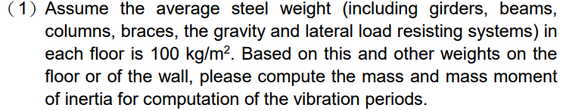



Moment of inertia



MRF

* 由柱剪力估算出所需柱尺寸大小
* 須滿足強柱弱梁
* Story drift <= 0.005
* 流程：用 excel選 b/t通過的斷面讓 ETABS auto select (初步評估) => 抓 lateral force => 回去 excel 計算 => 再回去 ETABS 指定計算出來的斷面 => 確認 lateral force 差不多，層間位移 check ok.

|  |  |  |
| --- | --- | --- |
| Story | Beam | Column |
| 3F~RF | H500×200×12×22 | H584×400×16×32 |
| 1F~2F | H500×250×12×22 | H620×400×22×50 |

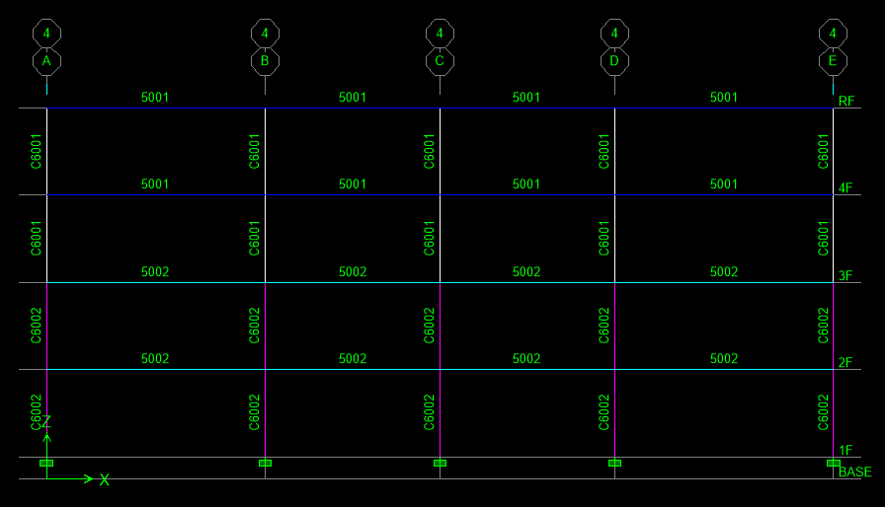

EBF

* Brace 設pin。
* 假設 EBF 吃到所有該方向 lateral force 的 1/4 進行初步的尺寸評估。
  + link 取 1 m。
  + 假設 brace 吃掉所有 lateral force。
* 確認 $lateral force=column shear+brace*cosθ$ 有沒有和一開始假設得差不多。如果沒有的話，抓 lateral force => 回去 excel 計算 => 再回去 ETABS 指定計算出來的斷面 => 確認 lateral force 差不多，層間位移 check ok.
* 最後得到 EBF 只有吃到1/12 的力

**Link**

|  |  |  |  |  |  |  |
| --- | --- | --- | --- | --- | --- | --- |
| Story | selected section | Vp (tf) | Mp (tf-m) | link type | Vn(tf) | DCR |
| RF | **H400x200x8x13** | 59 | 4244 | shear | 59 | 0.21 |
| 3F | **H400x200x8x13** | 59 | 4244 | shear | 59 | 0.24 |
| 2F | **H400X300X12X22** | 85 | 9487 | shear | 85 | 0.33 |
| 1F | **H400X300X12X22** | 85 | 9487 | shear | 85 | 0.30 |

**Brace**

|  |  |  |  |
| --- | --- | --- | --- |
| Brace Demand | | | |
| Story | Vult (tf) | Mult (tf-m) | Pult (tf) |
| RF | 88.86 | 4443.12 | 129.89 |
| 3F | 88.86 | 4443.12 | 129.89 |
| 2F | 126.88 | 6343.92 | 185.45 |
| 1F | 126.88 | 6343.92 | 185.45 |

|  |  |  |  |
| --- | --- | --- | --- |
| Brace Design Check | | | |
| Story | selected section | Pn (tf) | DCR |
| RF | **H400x200x10x15** | 255.36 | 0.982 |
| 3F | **H400x200x10x15** | 255.36 | 0.982 |
| 2F | **H400x300x10x20** | 474.81 | 0.834 |
| 1F | **H400x300x10x20** | 474.81 | 0.834 |

**Outside Beam**

|  |  |  |  |
| --- | --- | --- | --- |
| Outside Beam Demand | | | |
| Story | Vult (tf) | Mult (tf-m) | Pult (tf) |
| RF | 78.20 | 4443.12 | 75.27 |
| 3F | 78.20 | 4443.12 | 75.27 |
| 2F | 111.65 | 6343.92 | 107.47 |
| 1F | 111.65 | 6343.92 | 107.47 |

|  |  |  |  |  |
| --- | --- | --- | --- | --- |
| Outside Beam Design Check | | | | |
| Story | selected section | Pn (tf) | Mn (tf-m) | DCR |
| RF | **H400x200x8x13** | 244.79 | 4243.64 | 0.79 |
| 3F | **H400x200x8x13** | 244.79 | 4243.64 | 0.79 |
| 2F | **H400X300X12X22** | 555.59 | 9487.53 | 0.40 |
| 1F | **H400X300X12X22** | 555.59 | 9487.53 | 0.40 |

**Column**

|  |  |  |
| --- | --- | --- |
| Column Demand | | |
| Story | Vult (tf) | Pult (tf) |
| RF | 78.20 | 114.30 |
| 3F | 78.20 | 114.30 |
| 2F | 111.65 | 163.20 |
| 1F | 111.65 | 163.20 |

|  |  |  |  |
| --- | --- | --- | --- |
| Column Design Check | | | |
| Story | selected section | Pn (tf) | DCR |
| RF | **H350x350x12x19** | 550.81 | -0.017 |
| 3F | **H350x350x12x19** | 550.81 | 0.150 |
| 2F | **H400x400x21x22** | 813.43 | 0.210 |
| 1F | **H400x400x21x22** | 813.43 | 0.372 |

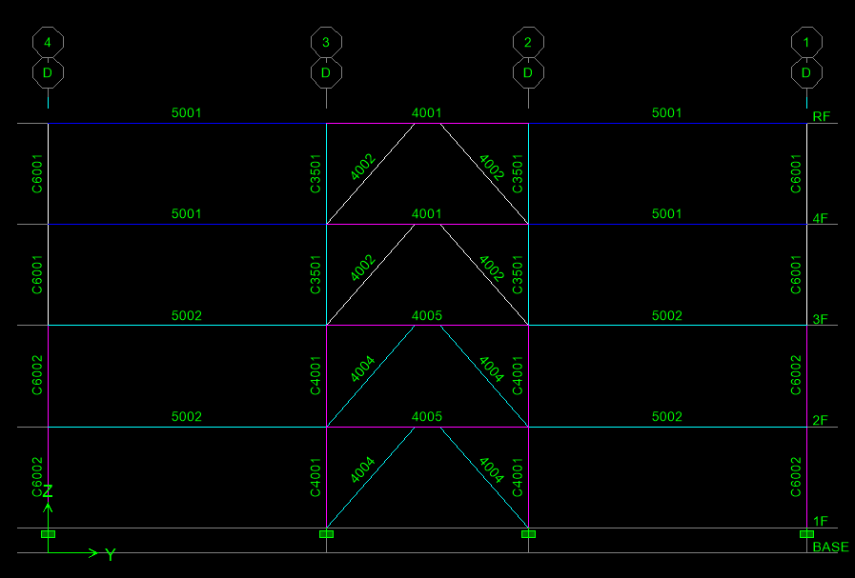

BRB

ETABS 設定紀錄

* Brace 設pin
* 假設 BRBF 吃到所有該方向 lateral force 的 1/4 進行初步的尺寸評估。
* 確認 $lateral force=column shear+brace*cosθ$ 有沒有和一開始假設得差不多。如果沒有的話，抓 lateral force => 回去 excel 計算 => 再回去 ETABS 指定計算出來的斷面 => 確認 lateral force 差不多，層間位移 check ok.
* 最後得到 BRBF 吃到3/8 的力

**Brace**

|  |  |  |  |  |  |
| --- | --- | --- | --- | --- | --- |
| BRB Design | | | | | |
| Story | Core section (mm) | | Ac (m2) | 0.9FyAc (tf) | DCR |
| RF | **130** | **130** | 169 | 501.93 | 0.109 |
| 3F | **130** | **130** | 169 | 501.93 | 0.213 |
| 2F | **140** | **140** | 196 | 582.12 | 0.215 |
| 1F | **140** | **140** | 196 | 582.12 | 0.219 |
| Story | Brace length (m) | Tmax(tf) | Cmax(tf) |
| RF | 565.69 | 928.01 | 1020.81 |
| 3F | 565.69 | 928.01 | 1020.81 |
| 2F | 565.69 | 1076.28 | 1183.90 |
| 1F | 565.69 | 1076.28 | 1183.90 |

**Beam**

|  |  |  |  |  |
| --- | --- | --- | --- | --- |
| Beam Demand | | | | |
| Story | Tmax (tf) | Cmax (tf) | Maximum Axial Force | Mmax (tf-m) |
| RF | 928.01 | 1020.81 | 689.01 | 13124.08 |
| 3F | 928.01 | 1020.81 | 689.01 | 13124.08 |
| 2F | 1076.28 | 1183.90 | 799.09 | 15220.83 |
| 1F | 1076.28 | 1183.90 | 799.09 | 15220.83 |

|  |  |  |  |  |
| --- | --- | --- | --- | --- |
| Beam design | | | | |
| Story | Selected Section | Pn(tf) | Mn(tf-m) | DCR |
| RF | **H500×350×28×50** | 1471.53 | 29683.50 | 0.988 |
| 3F | **H500×350×28×50** | 1471.53 | 29683.50 | 0.988 |
| 2F | **H700×350×28×50** | 1642.89 | 45853.50 | 0.900 |
| 1F | **H700×350×28×50** | 1642.89 | 45853.50 | 0.900 |

**Column**

|  |  |  |
| --- | --- | --- |
| Story | Tmax (tf) | Cmax (tf) |
| RF | 928.01 | 1020.81 |
| 3F | 928.01 | 1020.81 |
| 2F | 1076.28 | 1183.90 |
| 1F | 1076.28 | 1183.90 |

|  |  |  |  |
| --- | --- | --- | --- |
| Story | selected section | Pn (tf) | DCR (tension) |
| RF | **H442×400×22×36** | 1187.27 | 0.00 |
| 3F | **H442×400×22×36** | 1187.27 | 0.72 |
| 2F | **H700×700×32×50** | 2918.50 | 0.58 |
| 1F | **H700×700×32×50** | 2918.50 | 0.92 |

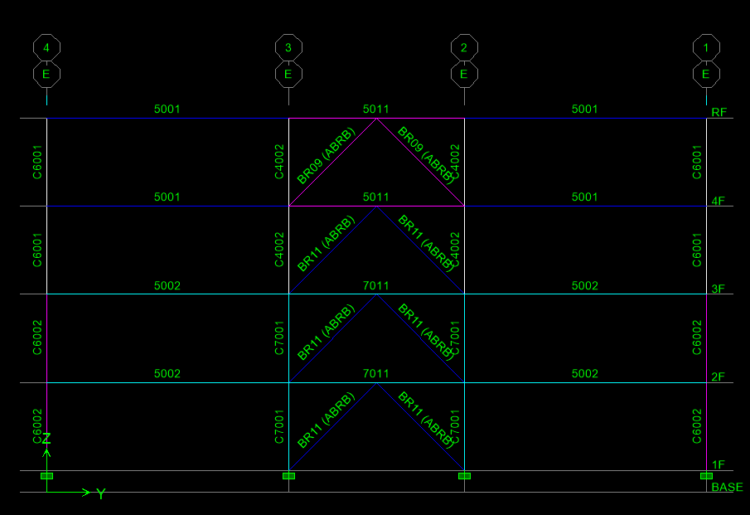

**Story Drift**

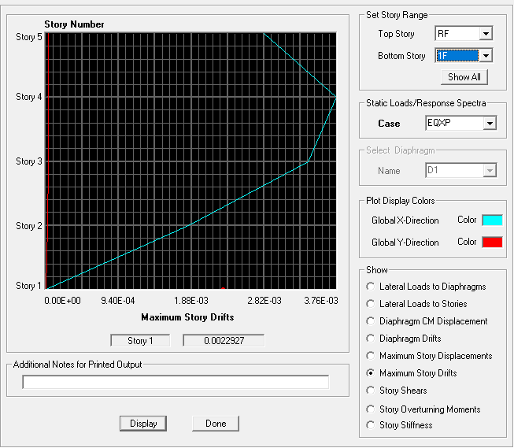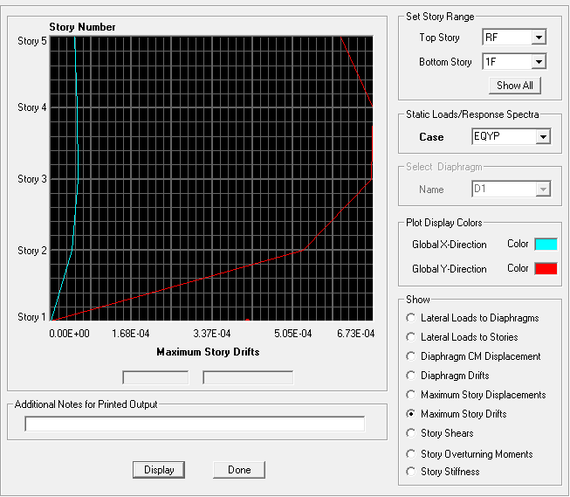

**Vibration period of structure**

|  |  |  |
| --- | --- | --- |
| Mode | Period (sec) |  |
| 1 | 1.0082 |  |
| 2 | 0.3261 |  |
| 3 | 0.3019 |  |
| 4 | 0.2564 |  |
| 5 | 0.1479 |  |
| 6 | 0.1202 |  |

**Code Base Shear**





**Average steel weight ($tf/m^{2}$)**

