Seismic Design of Steel Structures HW#03 R05521203張世昇

1.

Mode A:

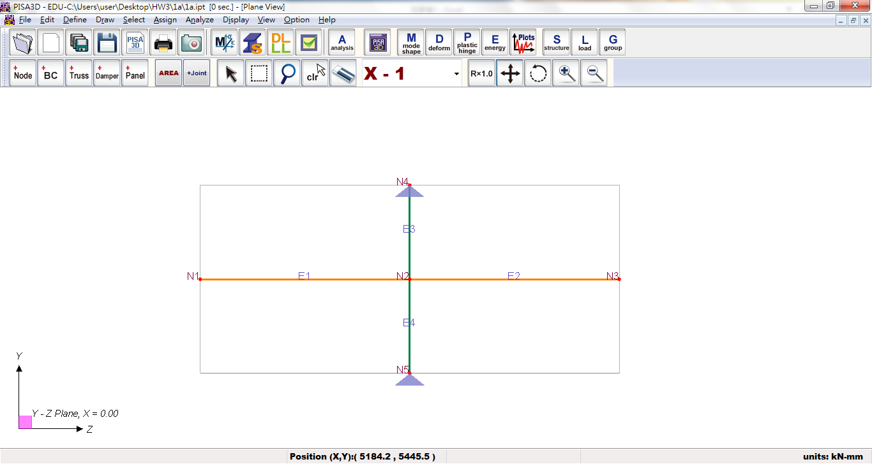

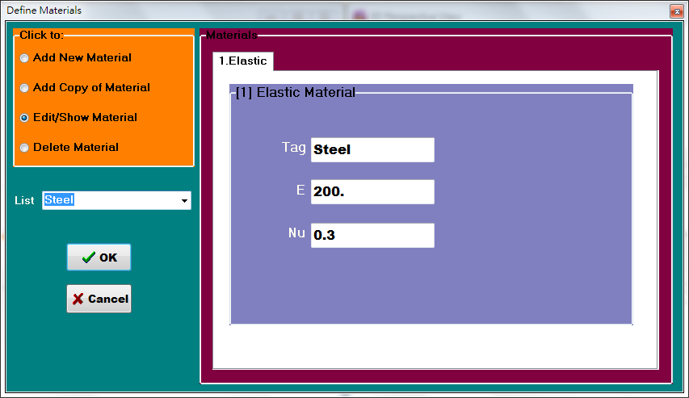

Material

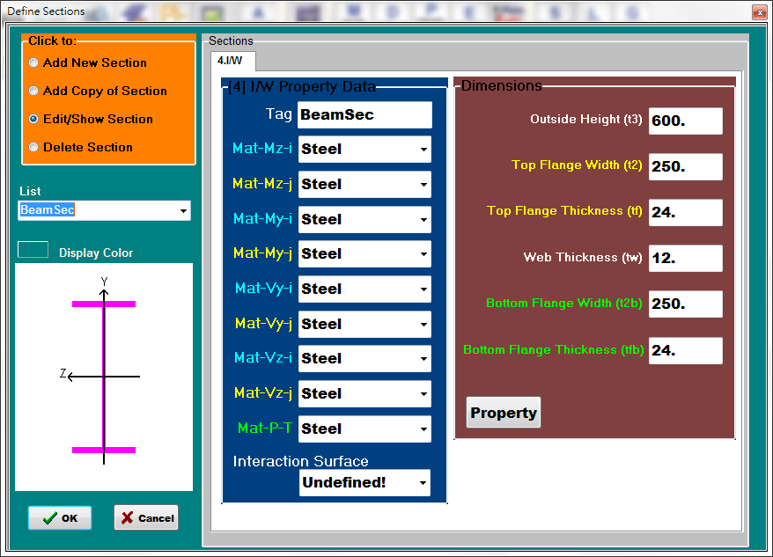 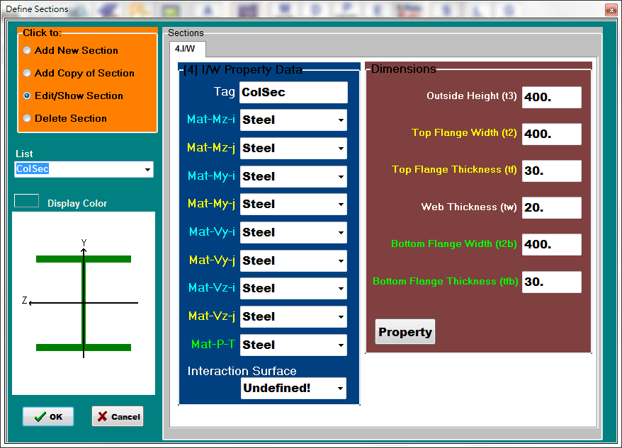

Beam section Column section

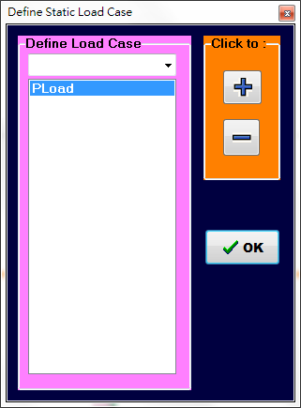

Load case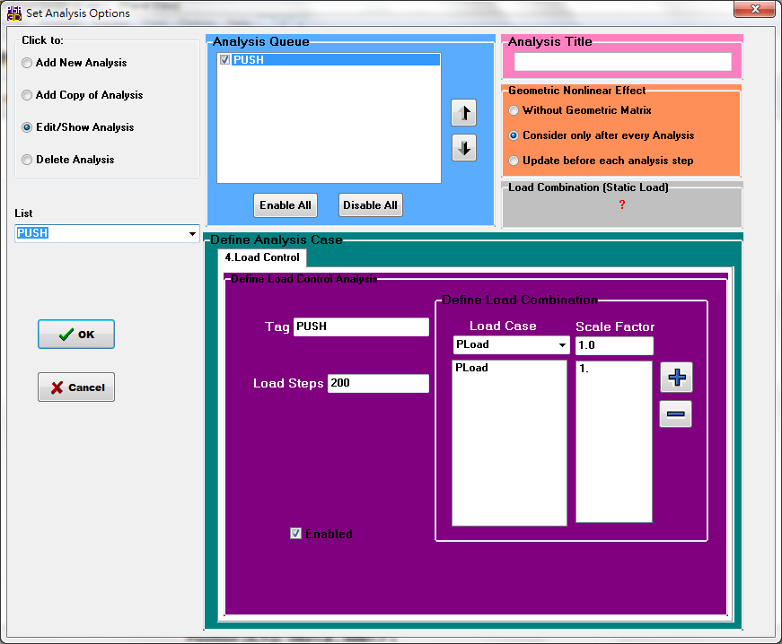

Analysis setting

(1a1) consider shear deformation

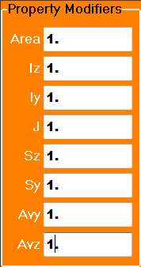

Section property setting

Total displacement:

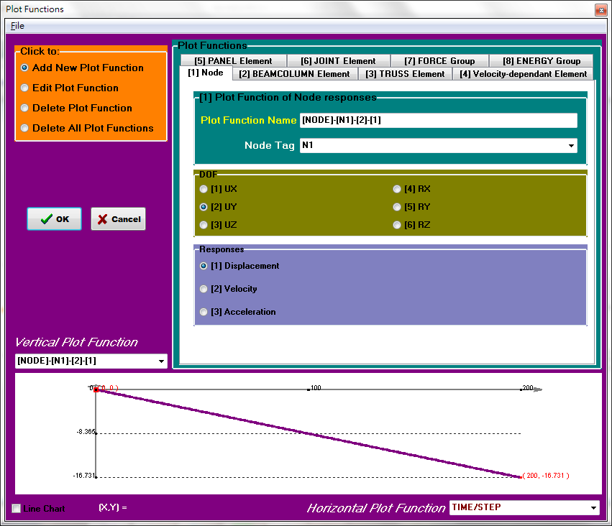

Displacement of Node 2 in Rx:

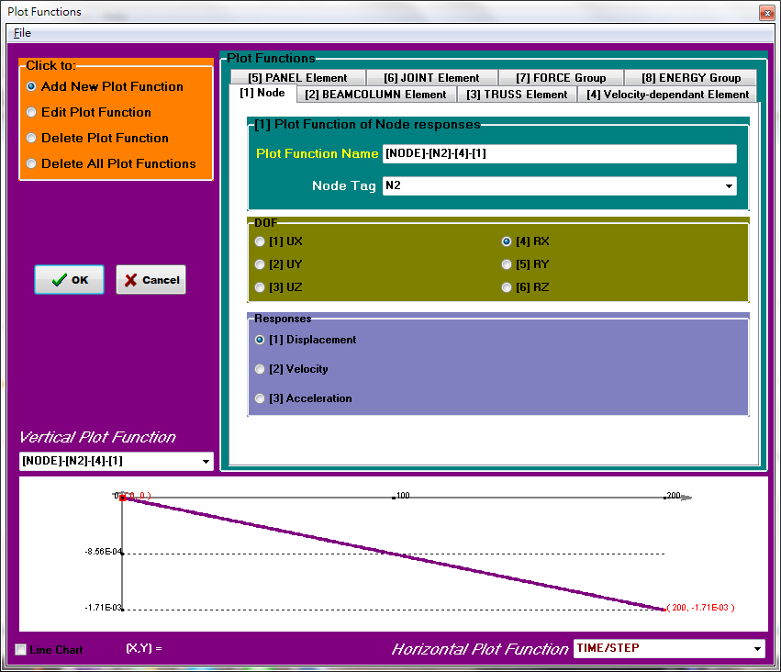

Total elastic displacement = 16.731mm

Column contribution = 1.71×10-3×4000=6.84mm

Beam contribution = 16.731-6.84=9.891mm

(1a2) neglect shear deformation

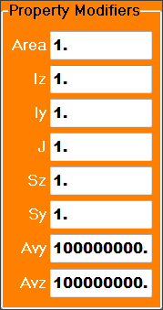

Section property setting

Total displacement:

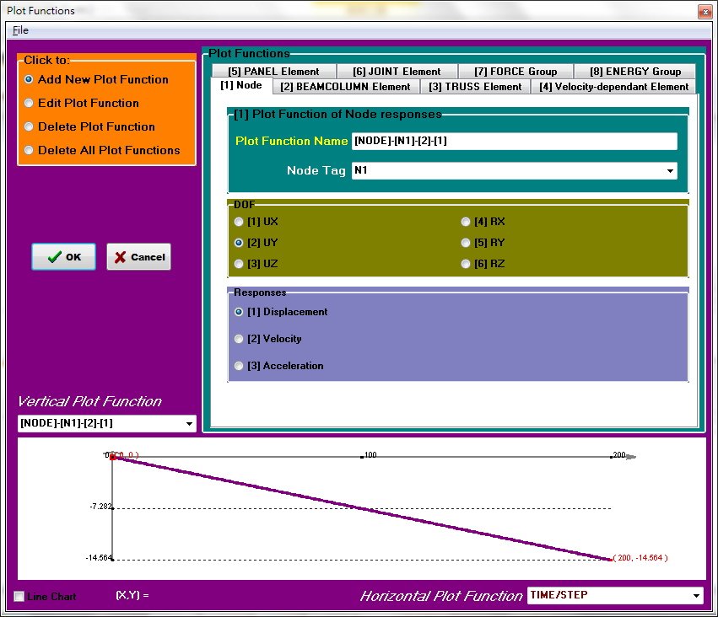

Displacement of Node 2 in Rx:

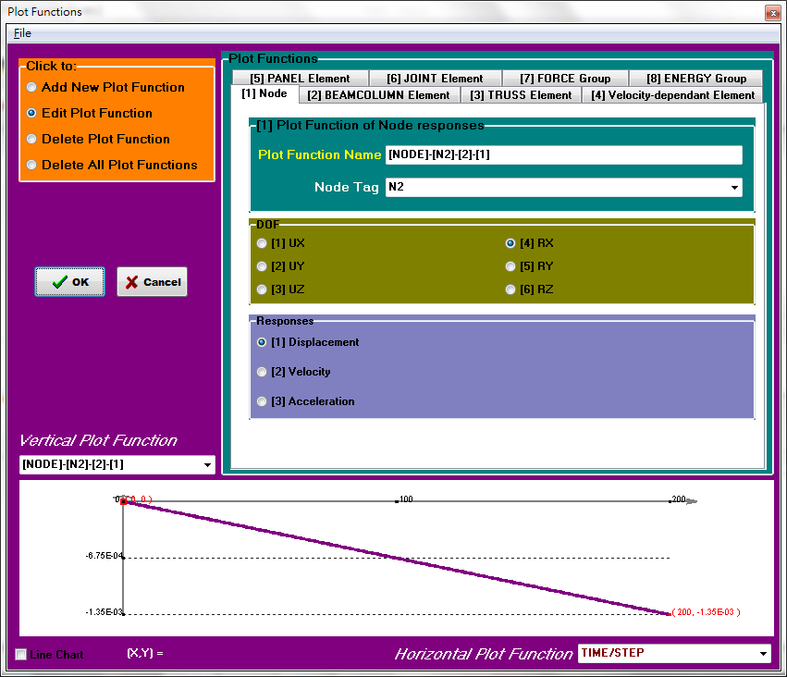

Total elastic displacement = 14.564mm

Column contribution = 1.35×10-3×4000=5.4mm

Beam contribution = 14.564-5.4=9.164mm

(1b)

(1b1)Using current Taiwanese seismic steel building codes:











Model B:

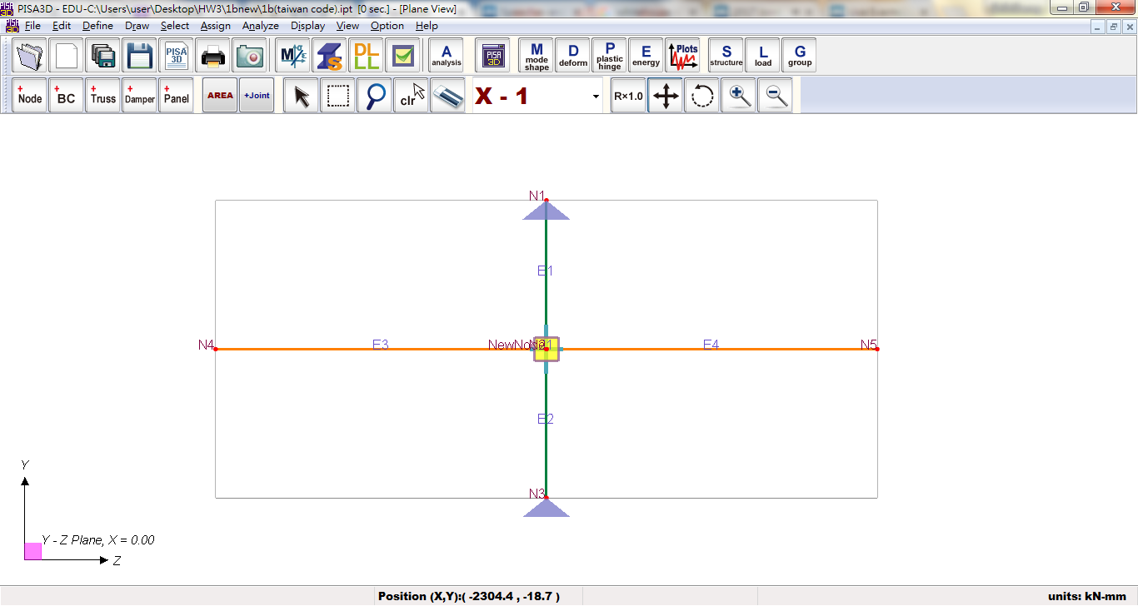

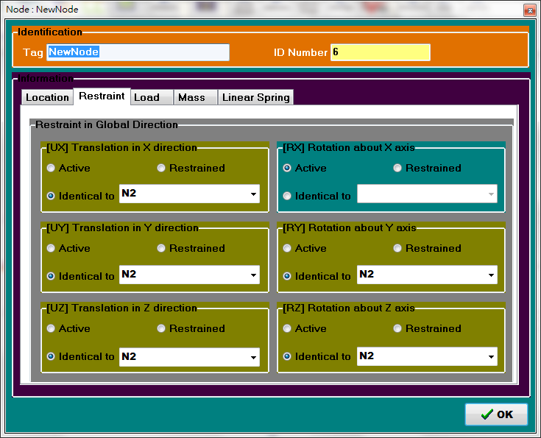

Degree of freedom for new node

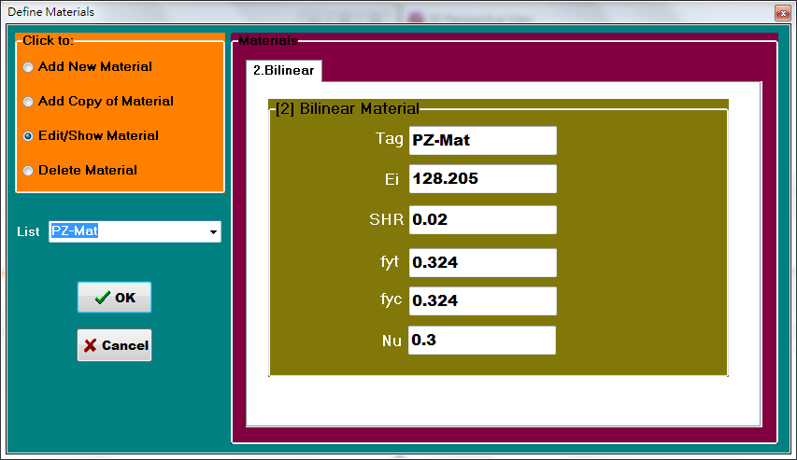

Panel Zone Material

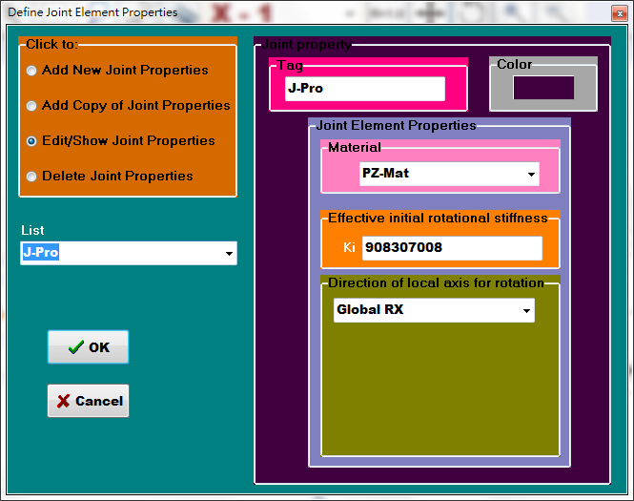

Joint Property

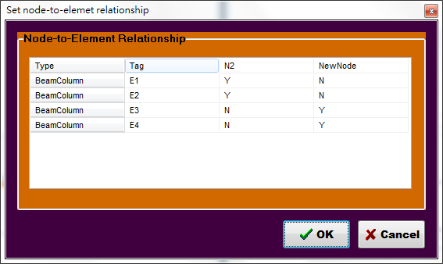

Node-to-element relationship

(1b1.1) consider shear deformation

Total displacement:

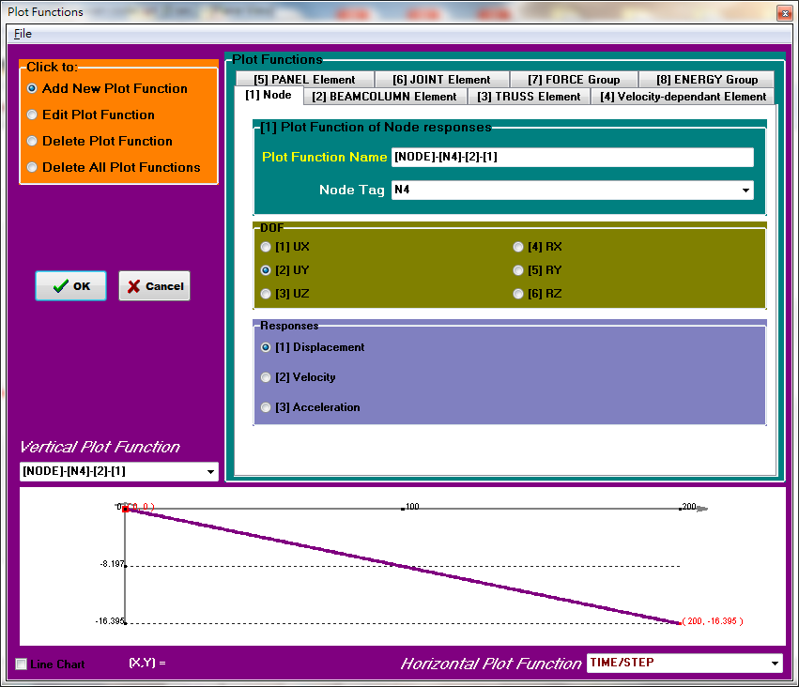

Displacement of Node 2 in Rx:

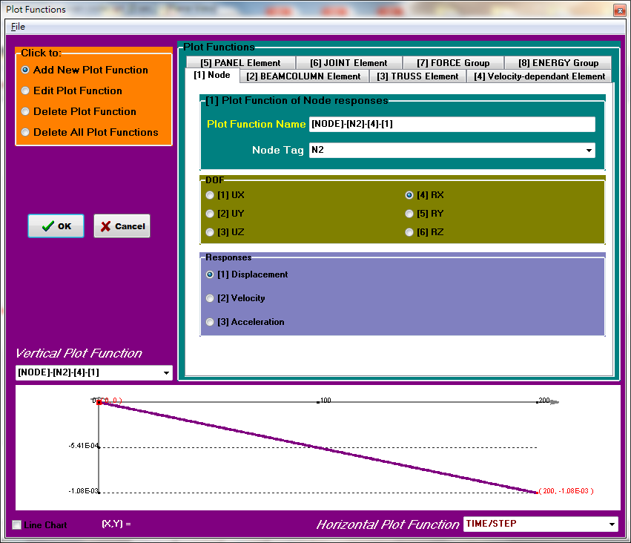

Displacement of New Node in Rx:

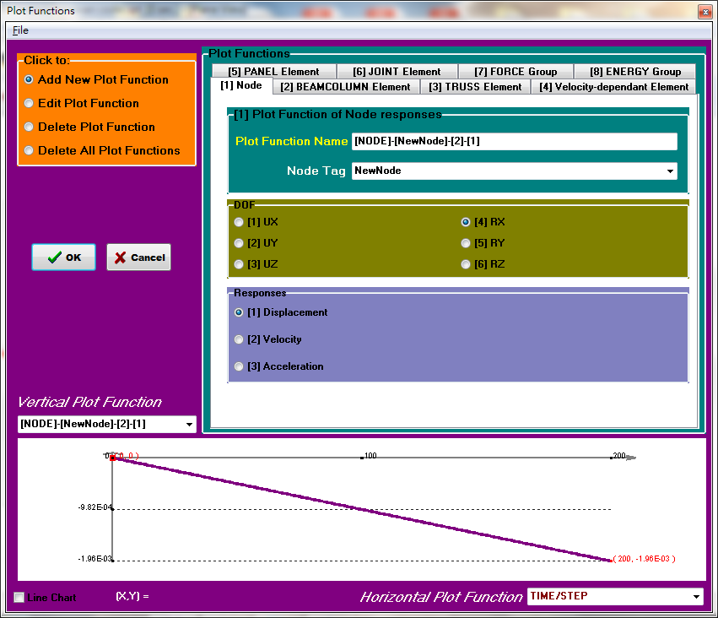

Total elastic displacement = 16.395mm

Column contributionΔc= 1.08×10-3×4000=4.32mm

Panel Zone contributionΔPZ = 1.96×10-3×4000-1.08×10-3×4000=3.52mm

Beam contributionΔb= 16.395-7.84=8.555mm

(1b1.2) neglect shear deformation

Total displacement:

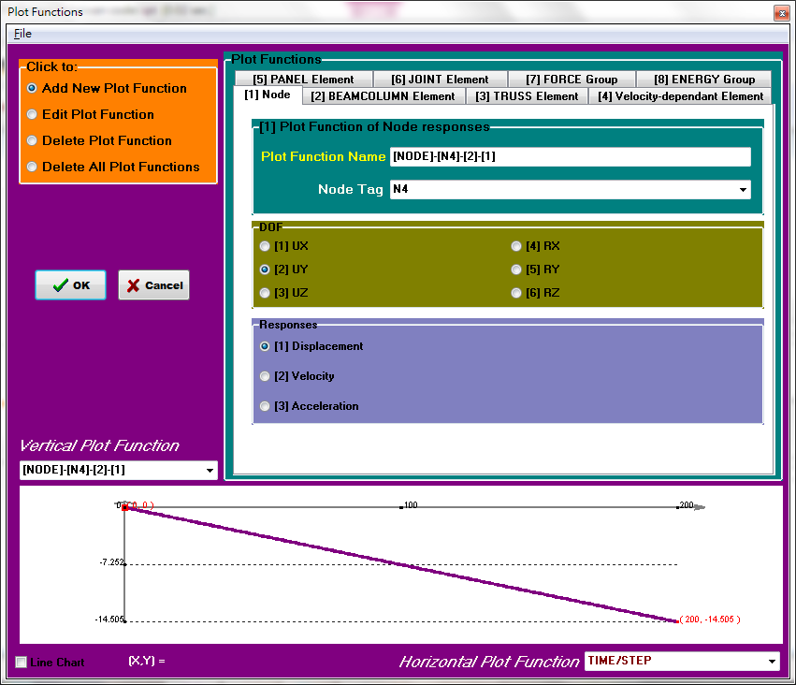

Displacement of Node 2 in Rx:

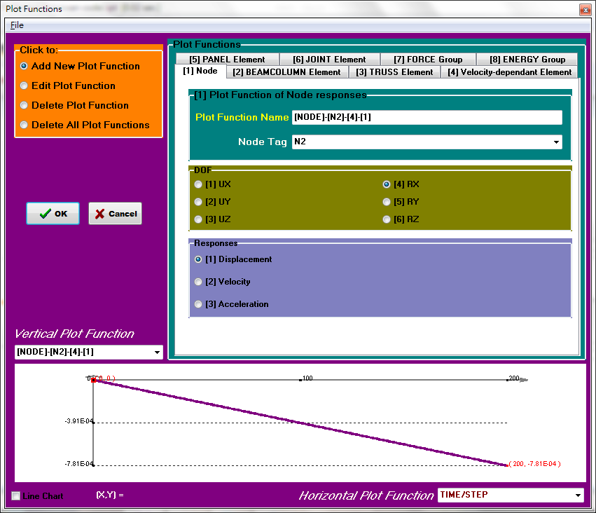

Displacement of New Node in Rx:

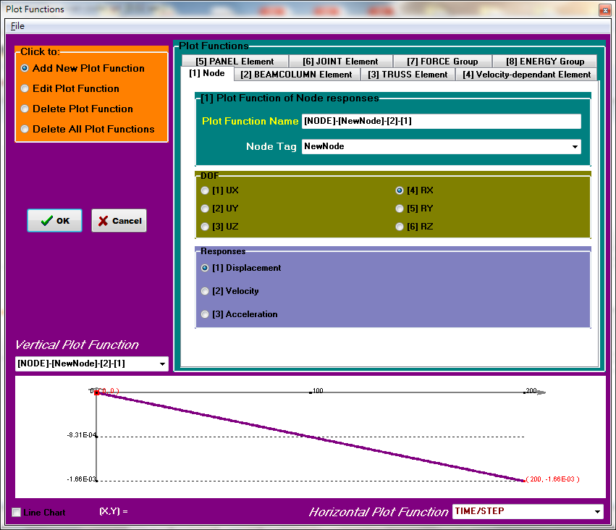

Total elastic displacement = 14.505mm

Column contributionΔc= 7.81×10-4×4000=3.124mm

Panel Zone contributionΔPZ = 1.66×10-3×4000-7.81×10-4×4000=3.516mm

Beam contributionΔb= 14.505-6.64=7.865mm

(1b2)Using 2010 AISC seismic steel building codes:











Model C:

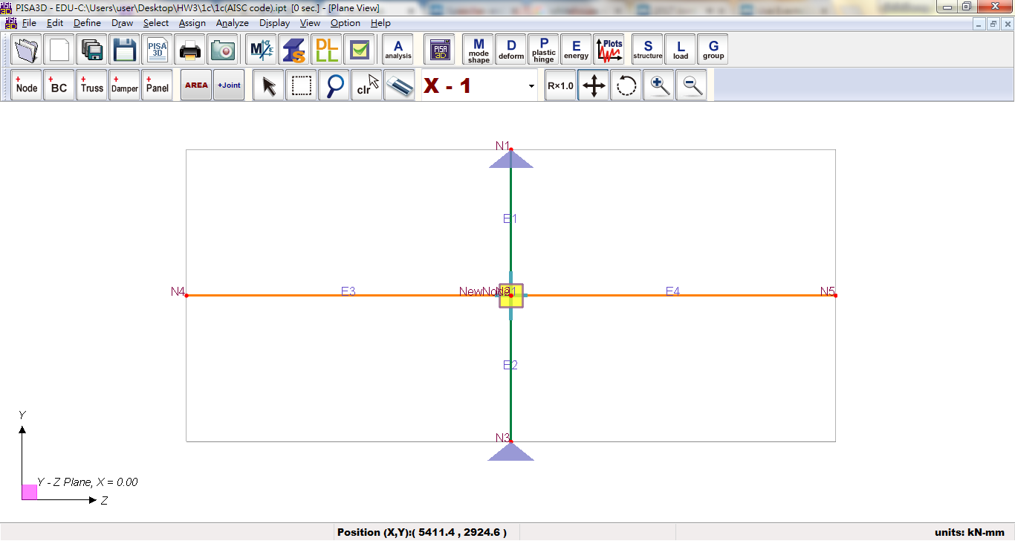



Degree of freedom for new node



Panel Zone Material

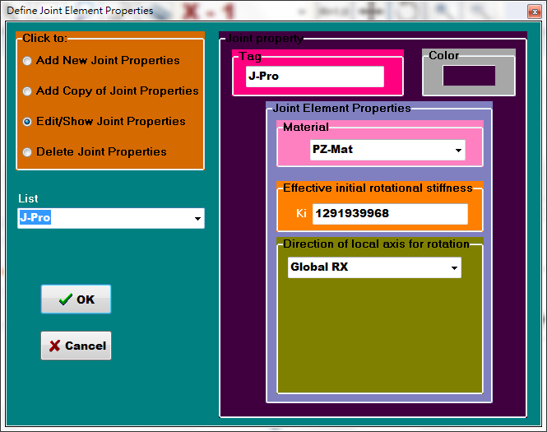

Joint Property



Node-to-element relationship

(1b2.1) consider shear deformation

Total displacement:

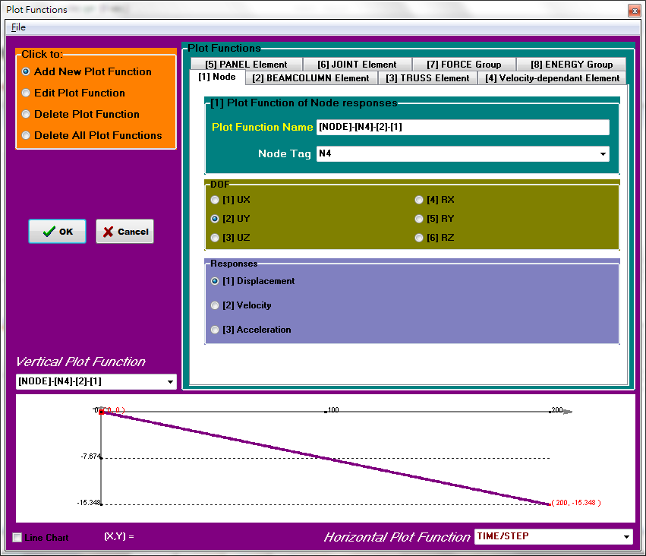

Displacement of Node 2 in Rx:

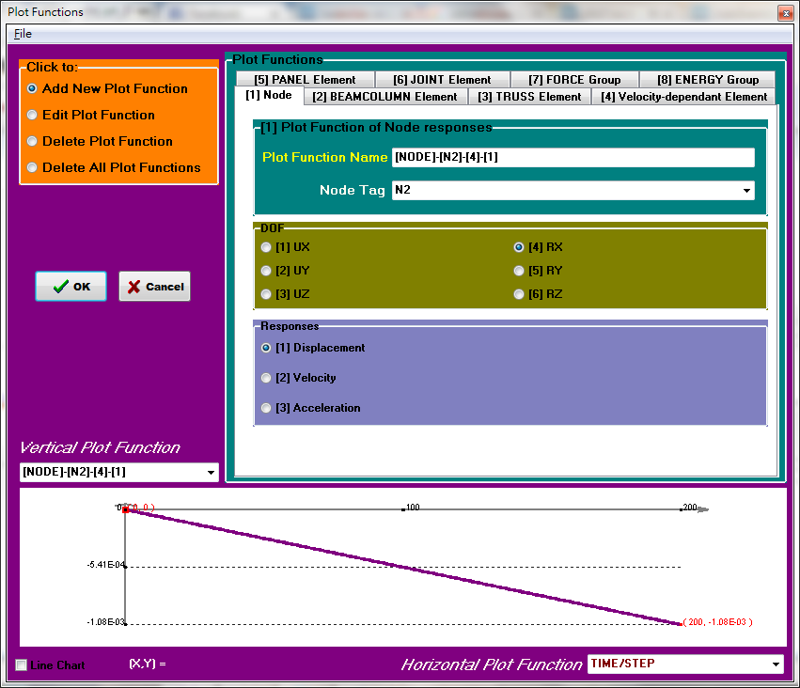

Displacement of New Node in Rx:

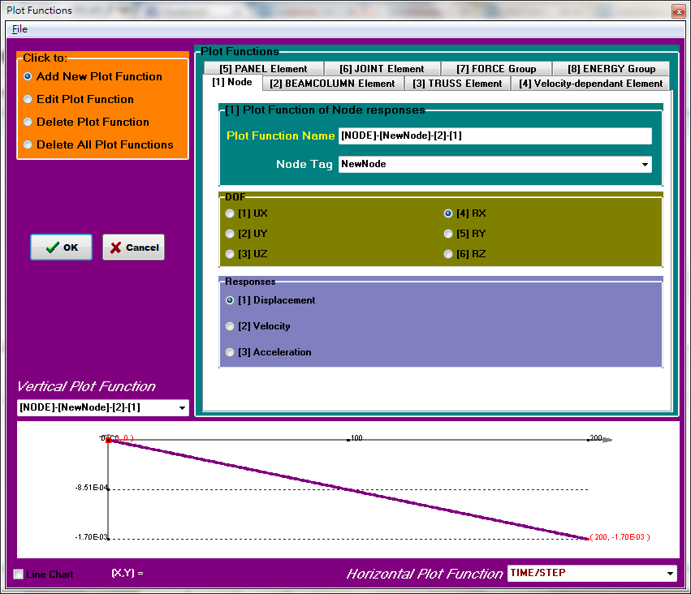

Total elastic displacement = 15.348mm

Column contributionΔc= 1.08×10-3×4000=4.32mm

Panel Zone contributionΔPZ = 1.7×10-3×4000-1.08×10-3×4000=2.48mm

Beam contributionΔb=15.348-6.8=8.548mm

(1b2.2) neglect shear deformation

Total displacement:

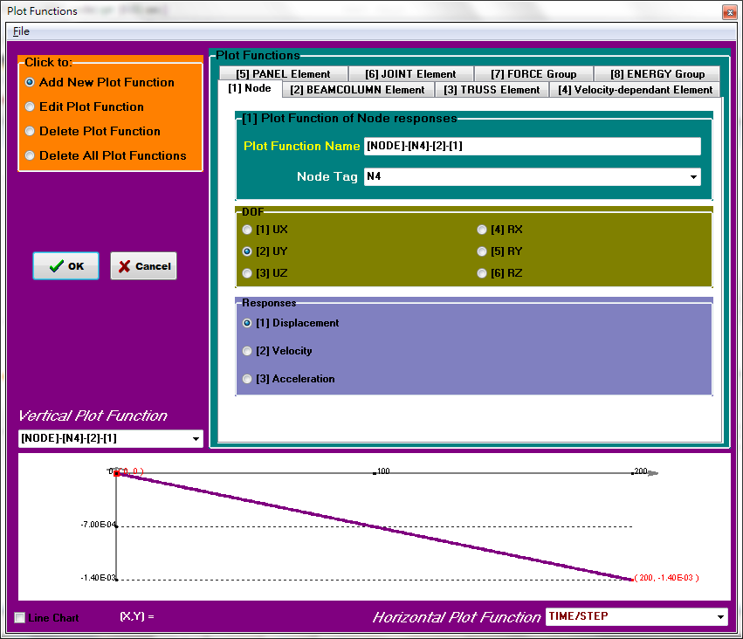

Displacement of Node 2 in Rx:

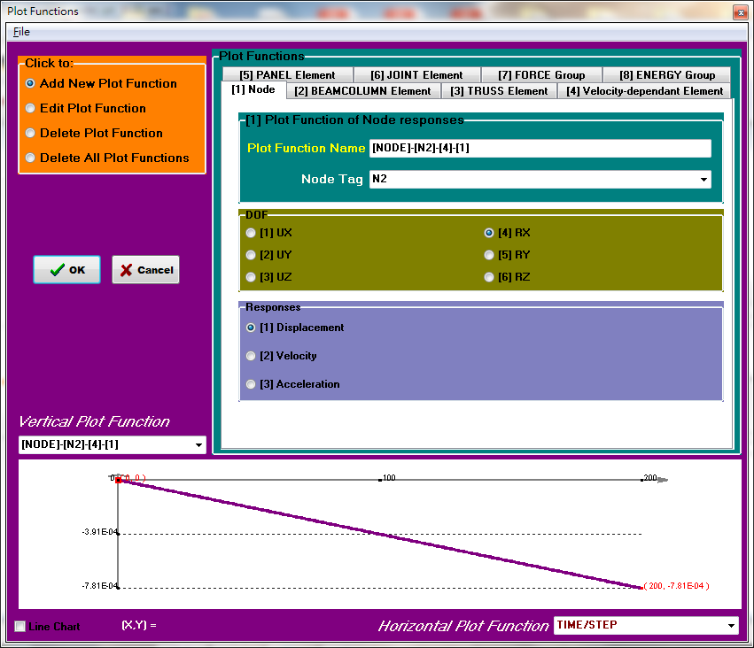

Displacement of New Node in Rx:

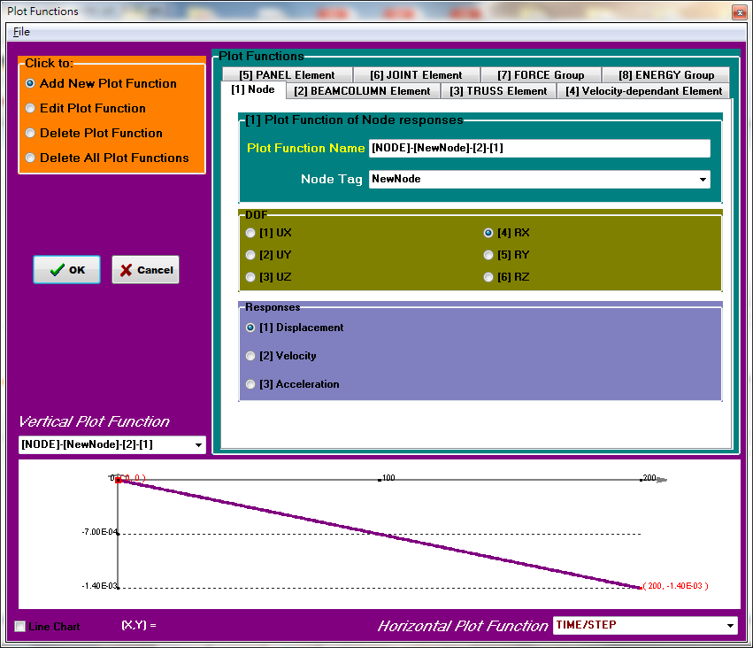

Total elastic displacement = 13.459mm

Column contributionΔc= 7.81×10-4×4000=3.124mm

Panel Zone contributionΔPZ = 1.4×10-3×4000-7.81×10-4×4000=2.476mm

Beam contributionΔb= 13.459-5.6=7.859mm

※Conclusion and Discussion:

Calculated by PISA 3D:

|  |  |  |  |  |  |  |  |
| --- | --- | --- | --- | --- | --- | --- | --- |
| Consider Shear deformation | PISA  3D | Neglect Panel Zone | | Taiwan Code | | AISC Code | |
| Displacement (mm) | Percentages (%) | Displacement (mm) | Percentages (%) | Displacement (mm) | Percentages (%) |
| Beam | 9.891 | 59.1 | 8.555 | 52.2 | 8.548 | 55.7 |
| Column | 6.84 | 40.9 | 4.32 | 26.3 | 4.32 | 28.1 |
| Panel Zone | x | x | 3.52 | 21.5 | 2.48 | 16.2 |
| total | 16.731 | 100 | 16.395 | 100.0 | 15.348 | 100.0 |
| Neglect Shear deformation | PISA  3D | Neglect Panel Zone | | Taiwan Code | | AISC Code | |
| Displacement (mm) | Percentages (%) | Displacement (mm) | Percentages (%) | Displacement (mm) | Percentages (%) |
| Beam | 9.164 | 62.9 | 7.865 | 54.2 | 7.859 | 58.4 |
| Column | 5.4 | 37.1 | 3.124 | 21.5 | 3.124 | 23.2 |
| Panel Zone | x | x | 3.516 | 24.2 | 2.476 | 18.4 |
| total | 14.564 | 100.0 | 14.505 | 100.0 | 13.459 | 100.0 |

Hand calculation:

|  |  |  |  |  |  |  |
| --- | --- | --- | --- | --- | --- | --- |
| PISA  3D | Neglect Panel Zone | | Taiwan Code | | AISC Code | |
| Displacement (mm) | Percentages (%) | Displacement (mm) | Percentages (%) | Displacement (mm) | Percentages (%) |
| Beam | 9.16 | 62.9 | 7.856 | 52.6 | 7.856 | 56.9 |
| Column | 5.4 | 37.1 | 3.751 | 25.1 | 3.751 | 27.2 |
| Panel Zone | x | x | 3.322 | 22.3 | 2.197 | 15.9 |
| total | 14.56 | 100 | 14.929 | 100.0 | 13.804 | 100.0 |

1. 從以上結果可以發現，若考慮剪力變形的影響，PISA 3D 所分析出來的值較手算出來的值大，若忽略剪力變形則結果相當接近。
2. 考慮Panel Zone的影響可以發現Panel Zone對於變位的貢獻量約為20%左右，並使得柱和梁的貢獻量下降，因此不可以忽略Panel Zone的貢獻。但可以發現不考慮Panel Zone的模型所分析出來的變位量較大，所以在不考慮Panel Zone 的狀況下所得到的結果較為保守。
3. 若考慮Panel Zone的狀況下，可以發現根據AISC的規範所求得PZ doubler Plate 的厚度較厚，所以求得的變位較小。

2.

(2a)

Model

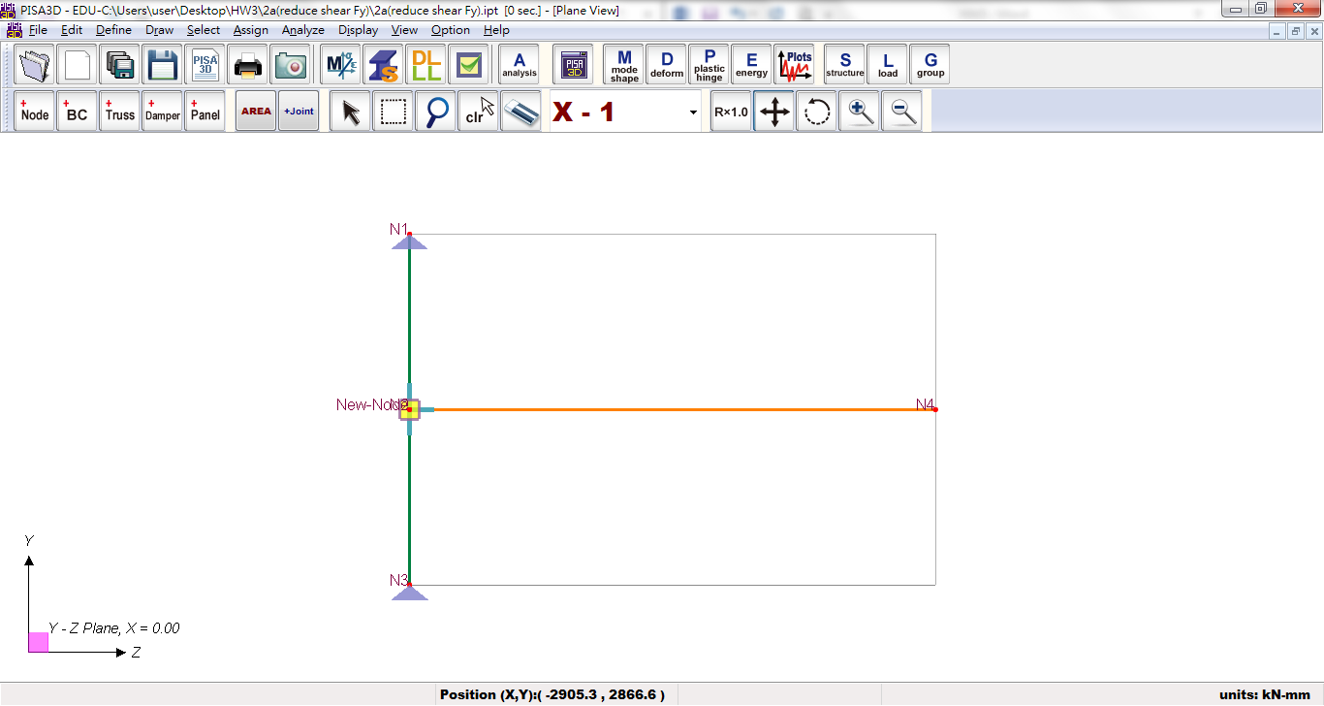

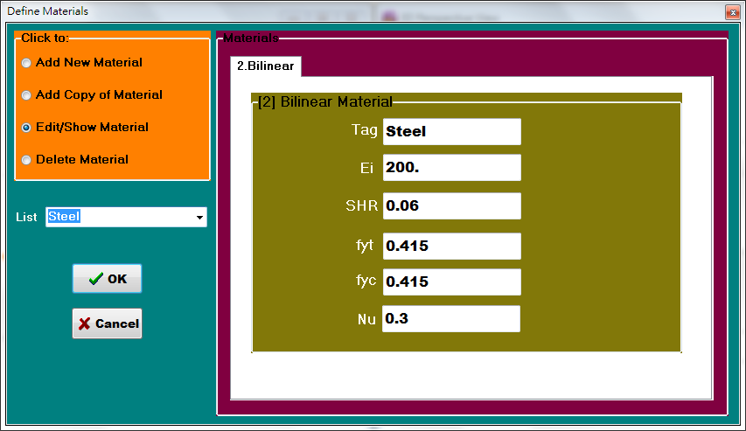

Material property for tension or compression yielding

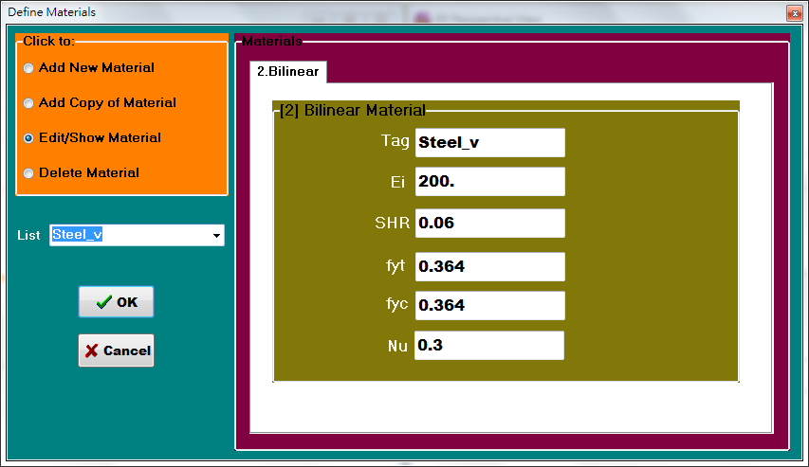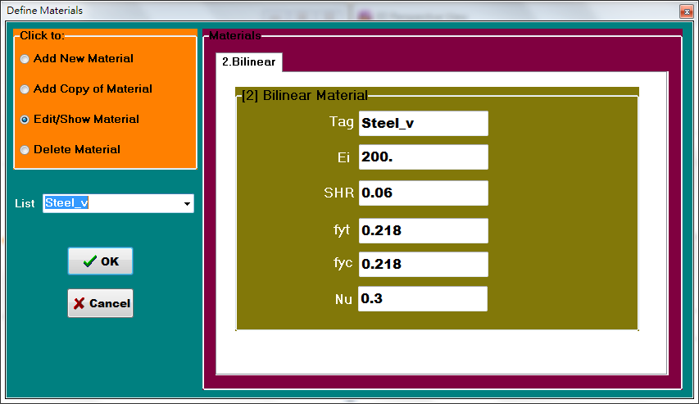

Shear yielding shear yielding with reduction factor 0.6











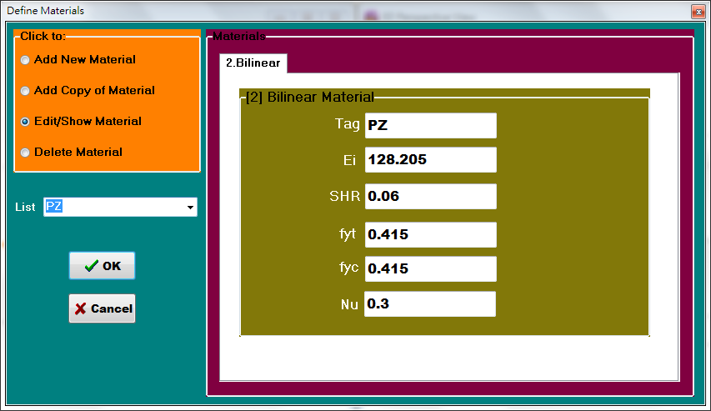

Material property for panel zone

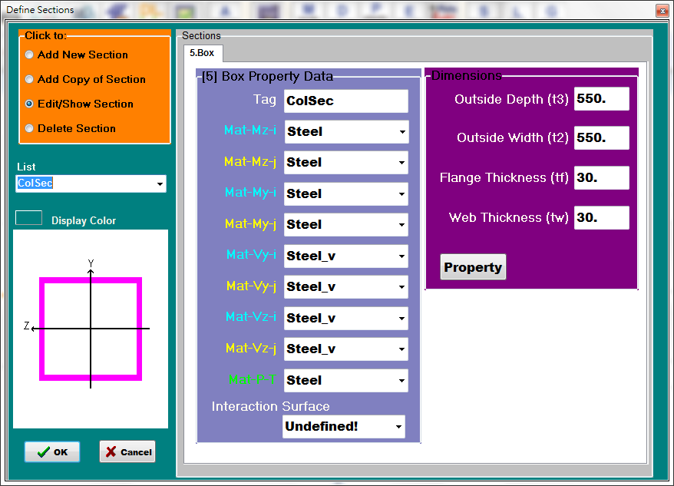

Column section

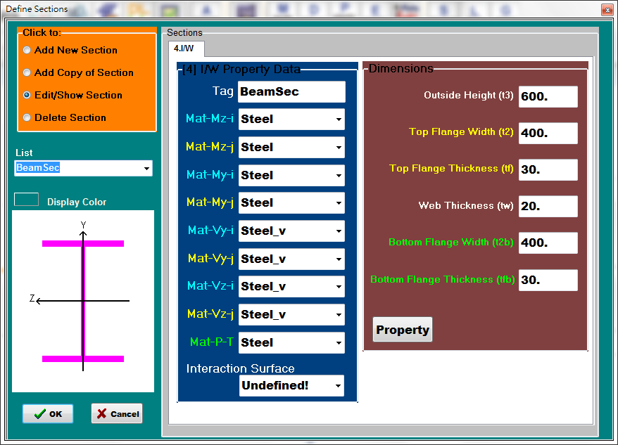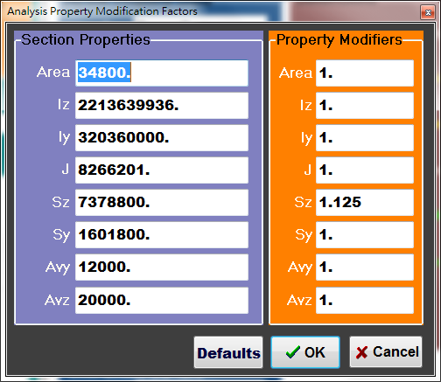

Beam section with Sz=1.125

Panel Zone joint setting

Offset rigid end element: beam 275mm 、 column 300mm

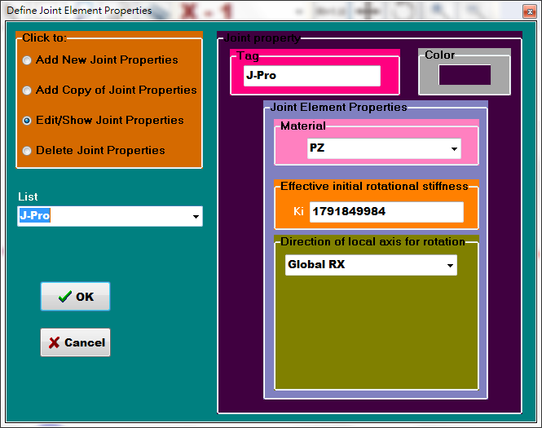

Joint property

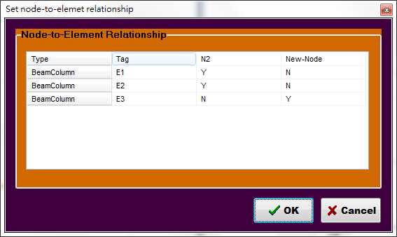

Node-to-element relationship

Analysis setting:

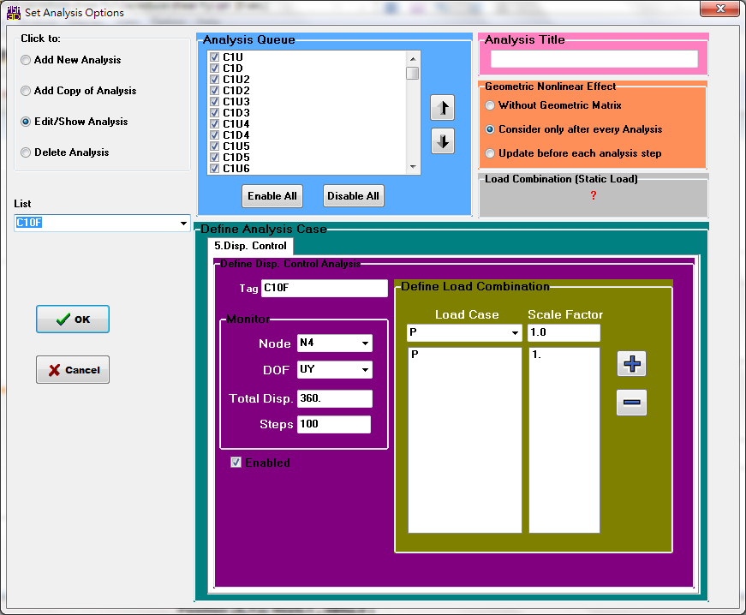

Conclusion:

(2b)

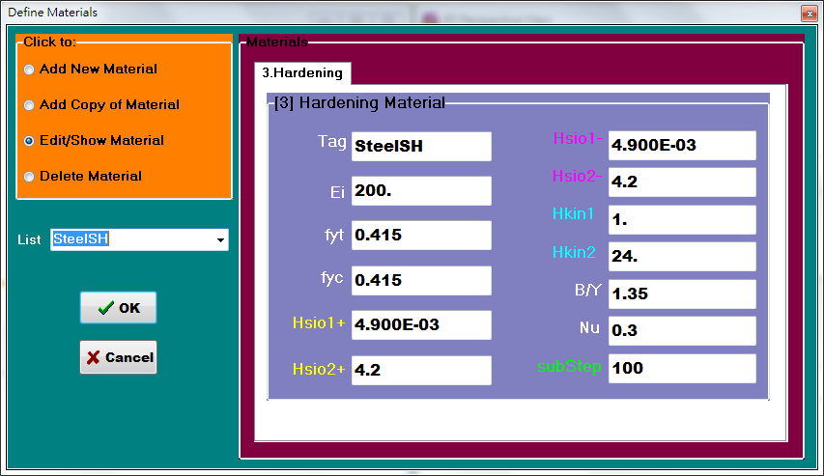

Material property for tension or compression yielding

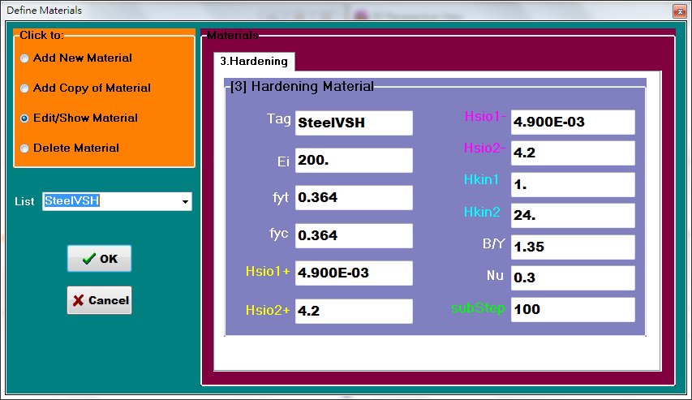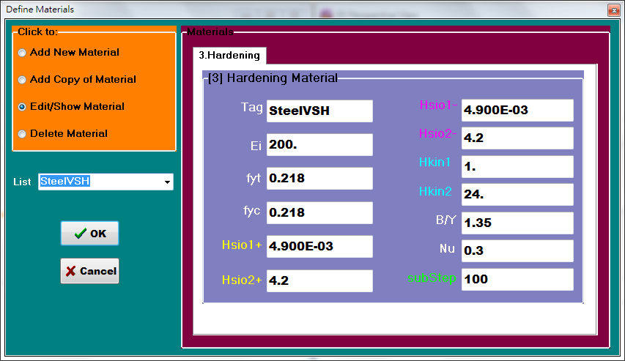

Shear yielding shear yielding with reduction factor 0.6

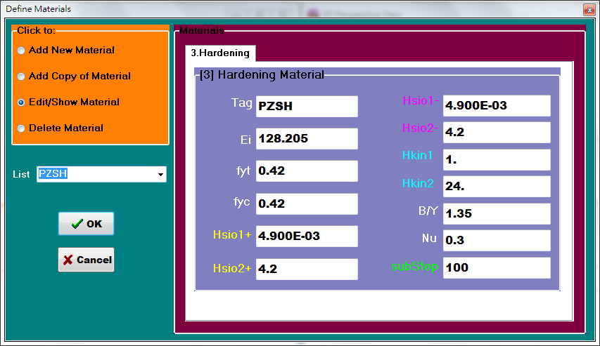

Material property for panel zone

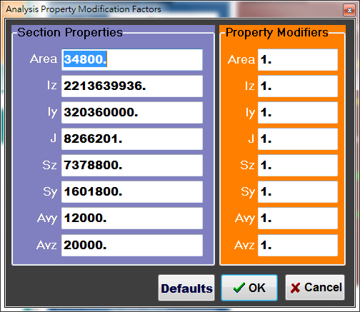

Beam section with Sz=1.125

Conclusion:

(2c)

1. 利用strain hardening材料進行模擬，其結果與bilinear材料相比之下，其分析結果較實驗結果相近，遲滯迴圈也更為飽滿。
2. strain hardening材料在設定方面較為麻煩，要不斷調整材料參數進行擬合。
3. 由分析結果來看Panel Zone及column並不會進入非彈性階段，而Beam進入非彈性階段。
4. 從結果來看不管是利用strain hardening材料還是bilinear材料在圖中的第二、四象限擬合可以加強，strain hardening材料可以調整參數Hkin2來修改線段轉彎處擬合的效果，但亦會造成迴圈旋轉，因此仍須調整其他參數來修正，例如減少Hkin1迴圈使斜率降低，加大Hsio2使斜率變大。
5. PISA 3D對於panel zone貢獻的部分有很好模擬的結果，由分析結果圖和實驗相比結果相當一致。
6. 另外，在剪力降伏強度設定上不管有無折減成60%，其分析結果並不會有影響。