高鋼Hw3 R06521219 高翊書

**1.**

**a.**

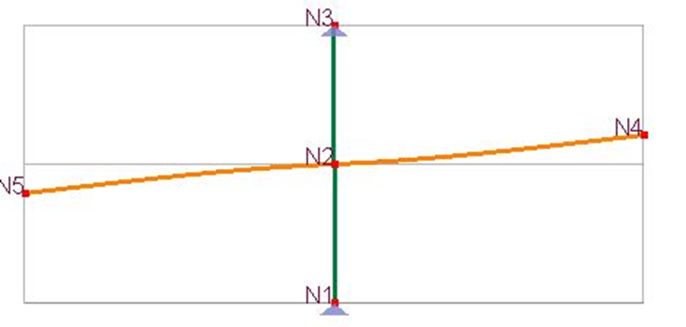

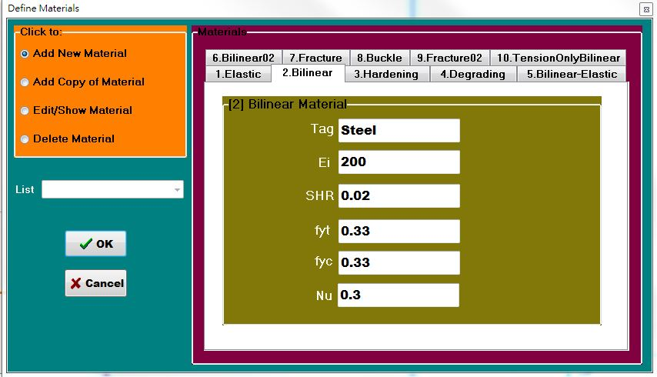

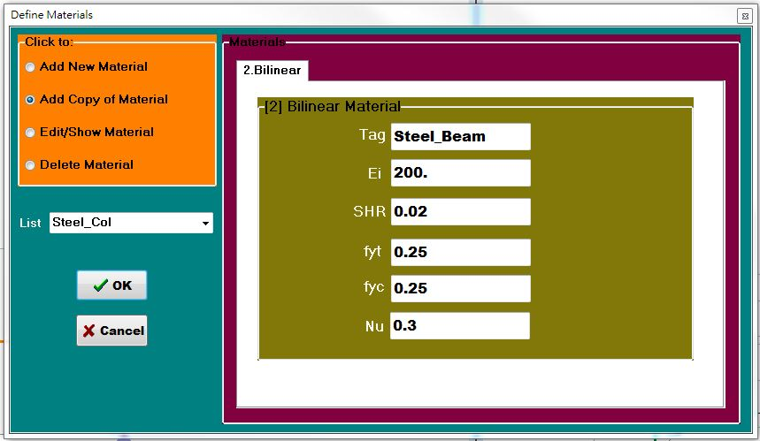

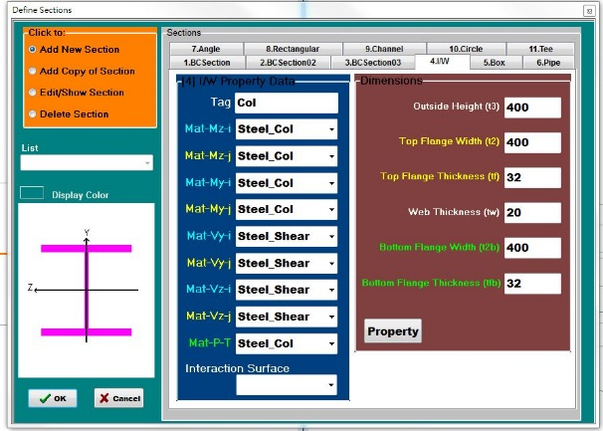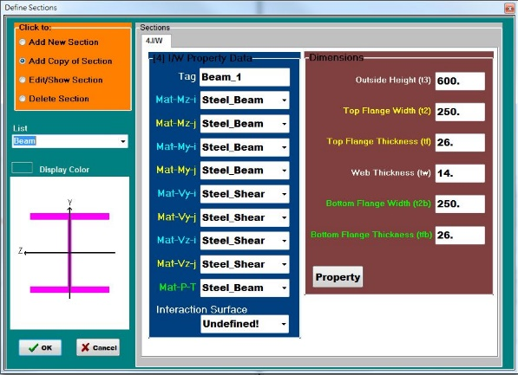

Displacement of Node 4

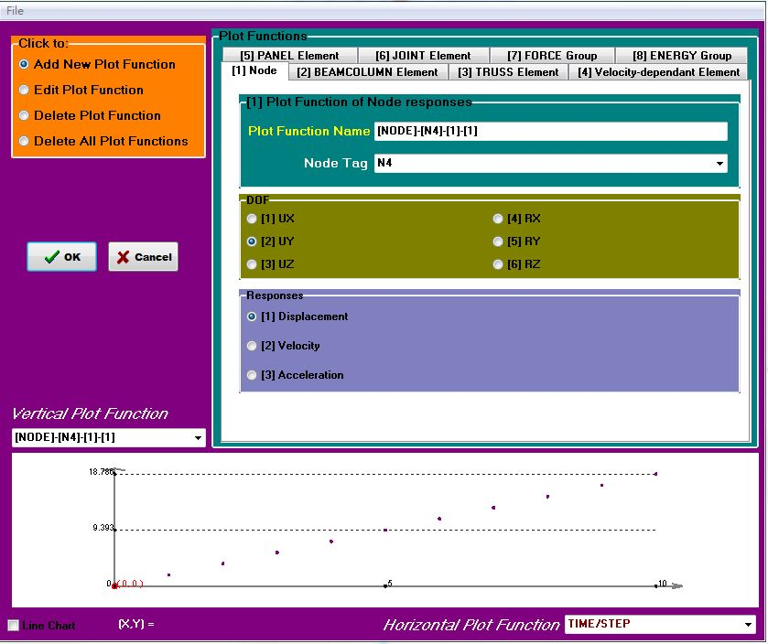

Rotation of Node 2

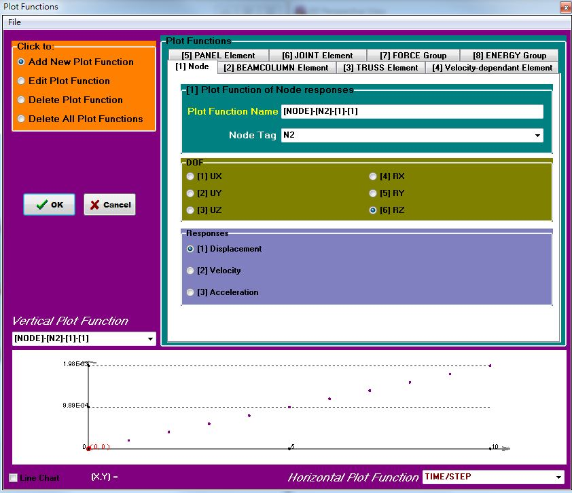

|  |  |
| --- | --- |
| L_Beam(mm) | 4000 |
| Disp(mm) | 18.786 |
| Rotation | 0.00198 |

|  |  |  |
| --- | --- | --- |
| Model A | PISA 3D | |
| Disp(mm)_ | Percentage(%) |
| Column | 7.92 | 42.16% |
| Beam | 10.866 | 57.84% |
| Total | 18.786 | 100.00% |

**b_1 Taiwan**



 



|  |  |
| --- | --- |
| E | 200 |
| G | 76.92307692 |
| Double T | 22 |
| Tpz | 42 |
| K | 930461538.5 |
| M | 2395008 |
| Fy | 0.5148 |

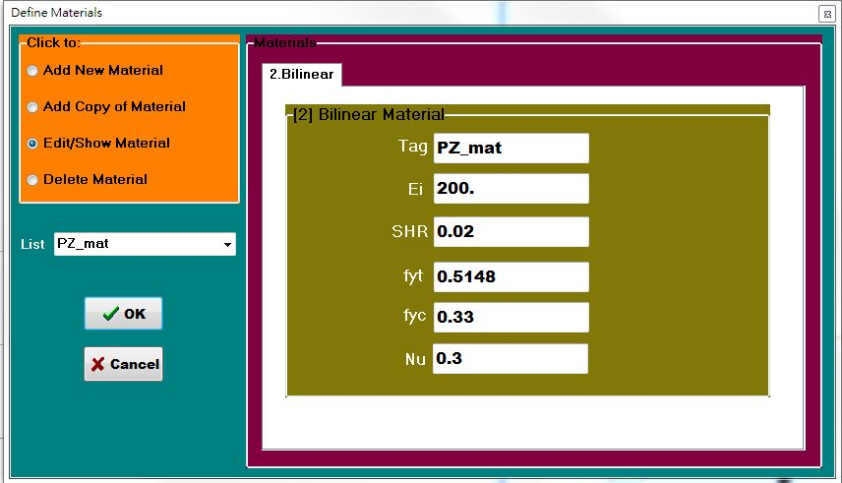

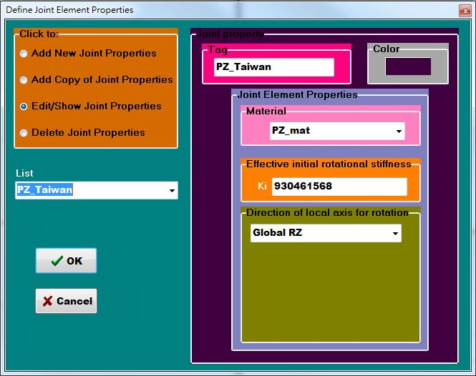

Displacement of Node 4

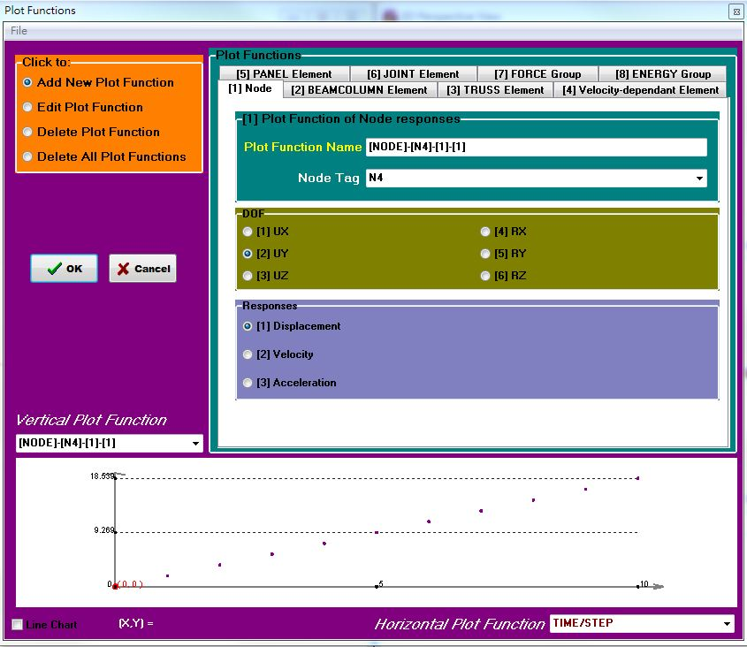

Rotation of Node 2

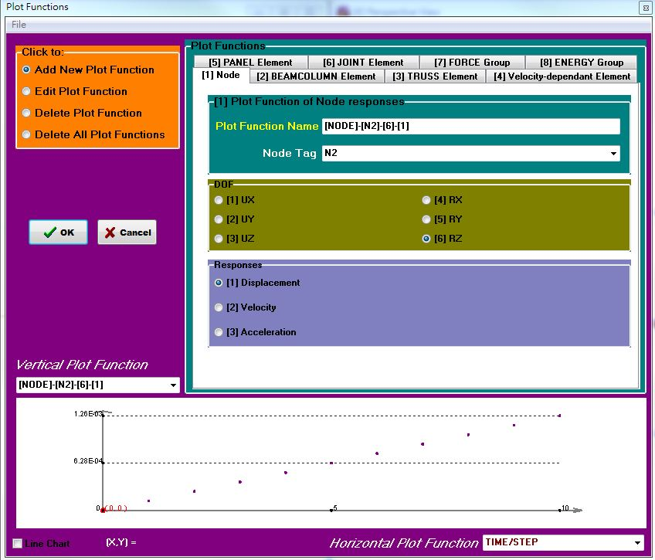

Displacement of New_Node

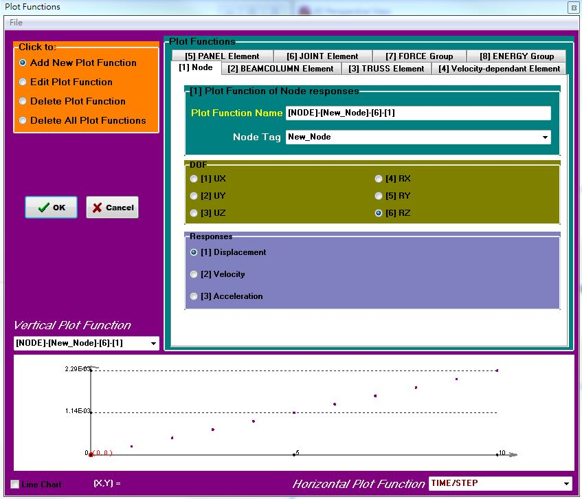

|  |  |
| --- | --- |
| L_Beam(mm) | 4000 |
| Disp | 18.539 |
| Rotation_N2 | 0.00126 |
| Rotation_New | 0.00229 |







|  |  |  |
| --- | --- | --- |
| Model B  (Tw) | PISA 3D | |
| Disp(mm)_ | Percentage(%) |
| Column | 5.04 | 27.19% |
| Beam | 9.379 | 50.59% |
| PZ | 4.12 | 22.22% |
| Total | 18.539 | 100.00% |

**b_2 AISC**



 



|  |  |
| --- | --- |
| E | 200 |
| G | 76.92307692 |
| Double T | 45 |
| Tpz | 65 |
| K | 1440000000 |
| M | 3706560 |
| Fy | 0.5148 |



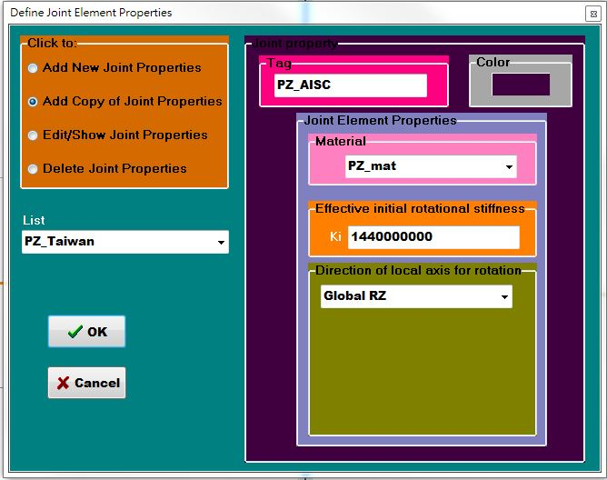

Displacement of Node 4

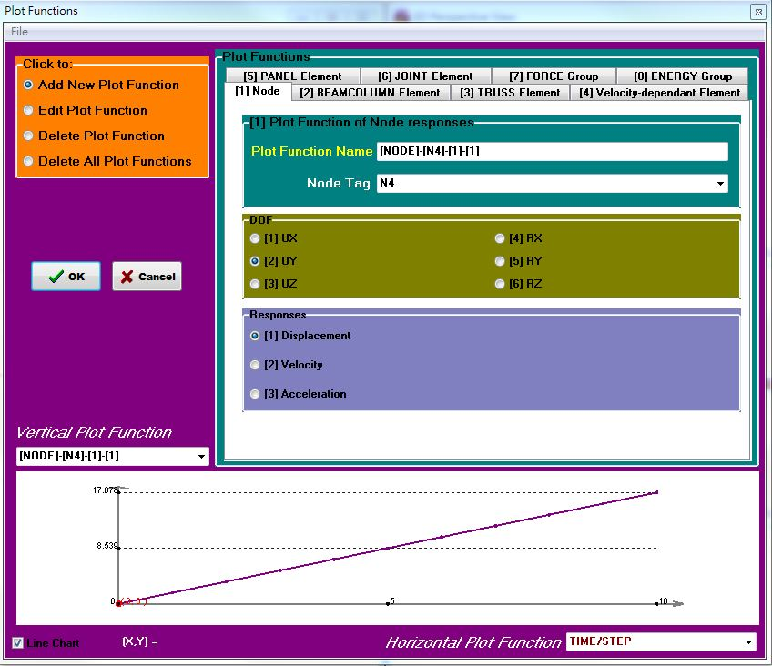

Rotation of Node 2

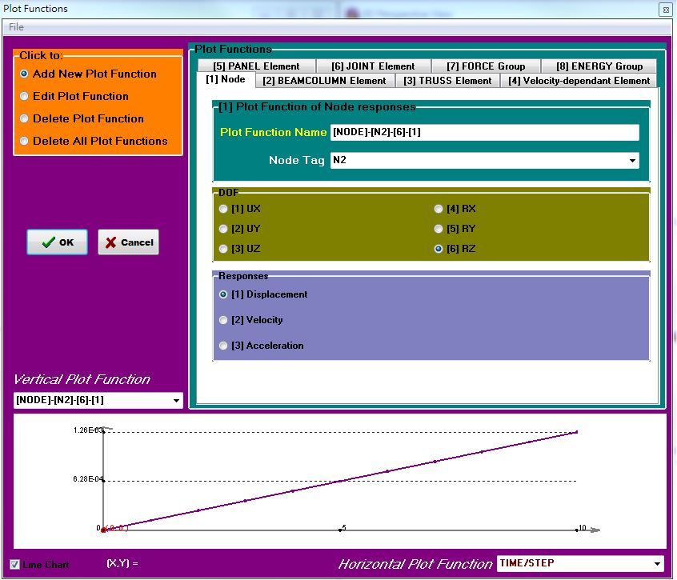

Displacement of New_Node

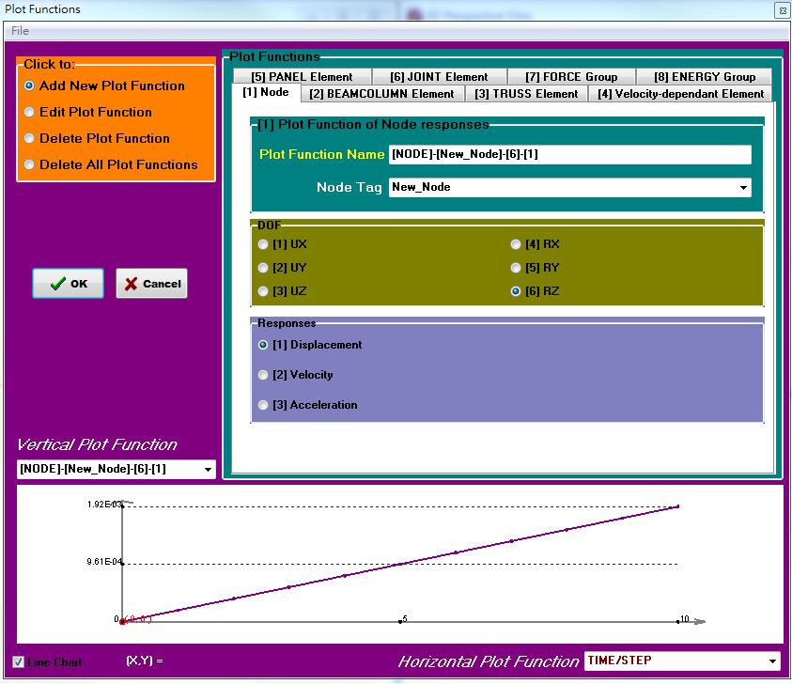

|  |  |
| --- | --- |
| L_Beam(mm) | 4000 |
| Disp | 17.078 |
| Rotation_N2 | 0.00126 |
| Rotation_New | 0.00192 |

|  |  |  |
| --- | --- | --- |
| Model C  (AISC) | PISA 3D | |
| Disp(mm)_ | Percentage(%) |
| Column | 5.04 | 27.19% |
| Beam | 9.398 | 50.69% |
| PZ | 2.64 | 14.24% |
| Total | 17.078 | 92.12% |

**Dicuss**

1. 模型裡有考慮剪力變型，因此可能較手算稍大。若要調整，可以到斷面的Property裡面更改Avy Avz，調到極大則代表忽略剪力變形。
2. PZ的貢獻是22.22%跟14.24%，代表不可忽略剪力變形
3. Model B跟Model C是有PZ跟Rigid End Zone的影響，然而跟Model A差異沒有太大的原因是，考慮Rigid End Zone會使disp變小，考慮PZ會使disp變大，所以使Model A接近Model B跟Model C。因此不考慮Rigid End Zone的Model比只單看Rigid End Zone的Model還要來得準確。
4. AISC因為PZ厚度較厚，因此貢獻較少。

**2**

**a**









|  |  |
| --- | --- |
| E | 200 |
| G | 76.92307692 |
| Tpz | 60 |
| K | 1791855204 |
| M | 4612235.294 |
| Fy | 0.5148 |

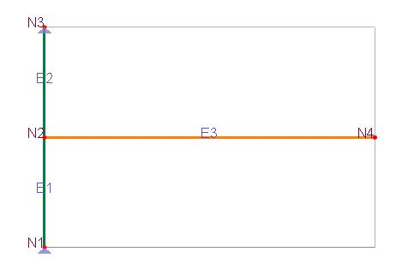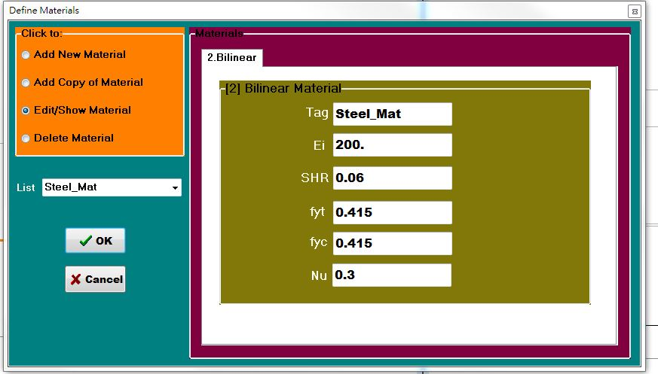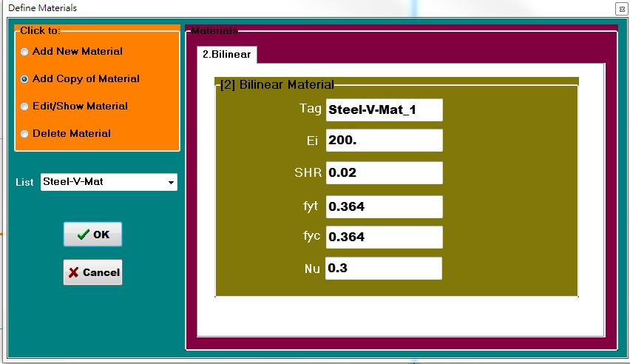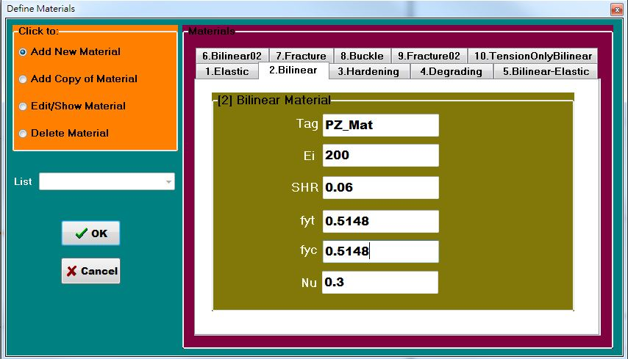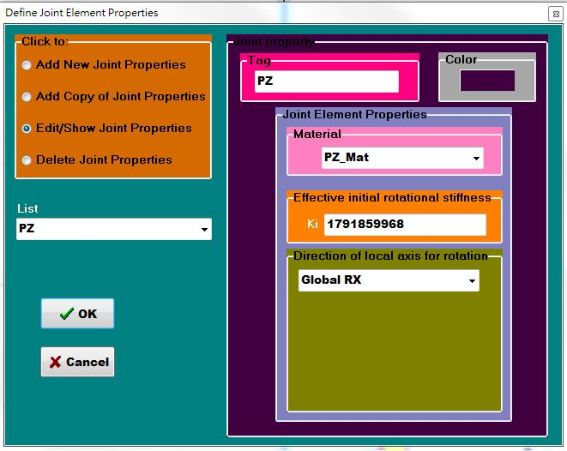

Set Cyclic Disp.

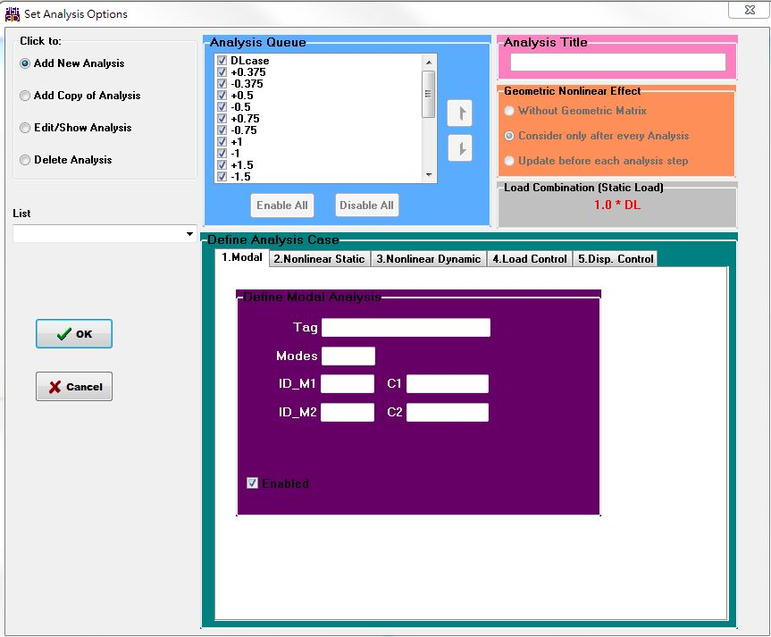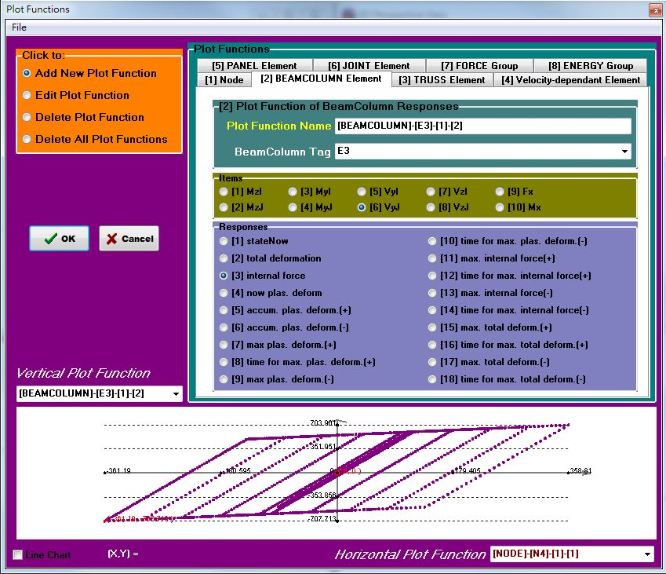

V vs θ_total

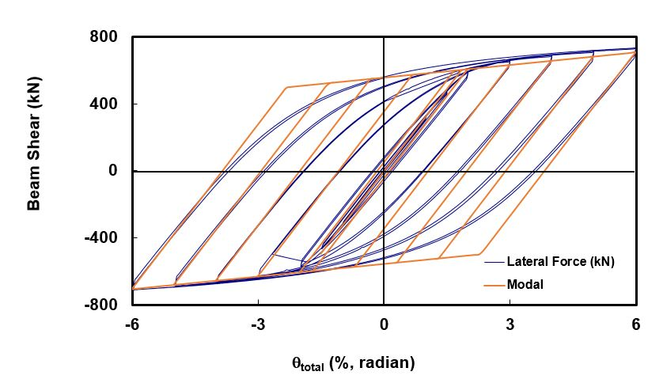

V vs Disp_total

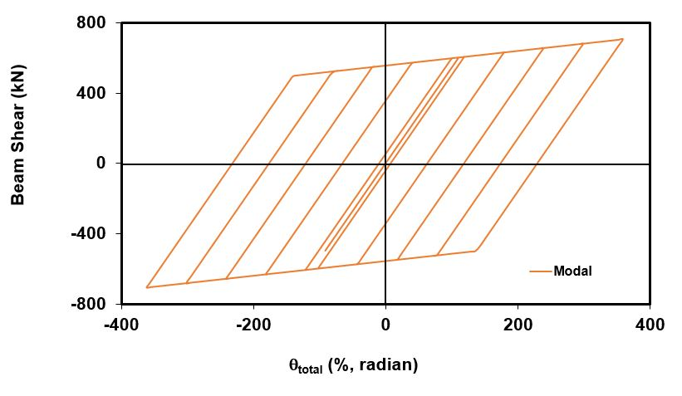

V vs θ_col

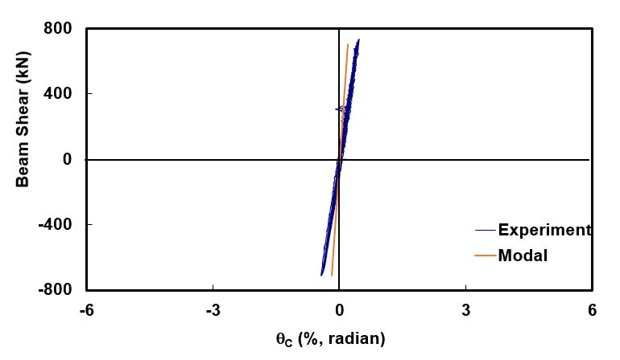

V vs θ_pz

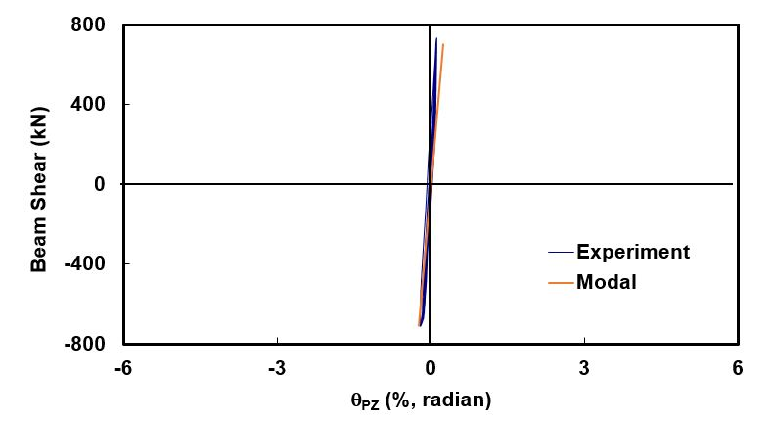

V vs θ_beam

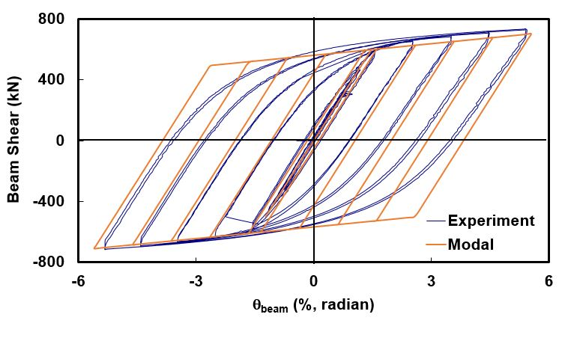

**b**

把斷面Sz改回原本的1

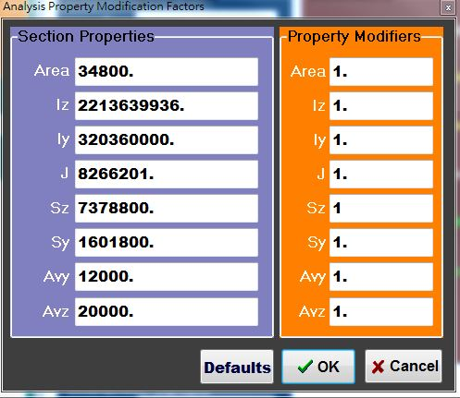

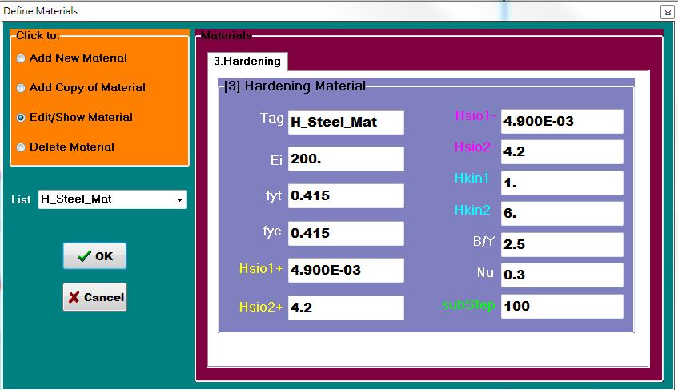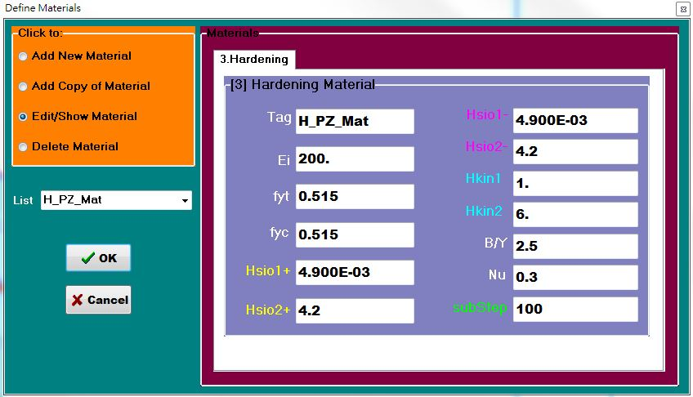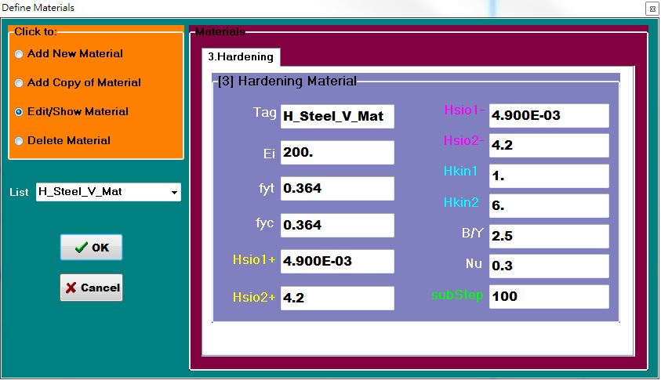

改變右邊七個參數 調整到與實驗Cylic相似

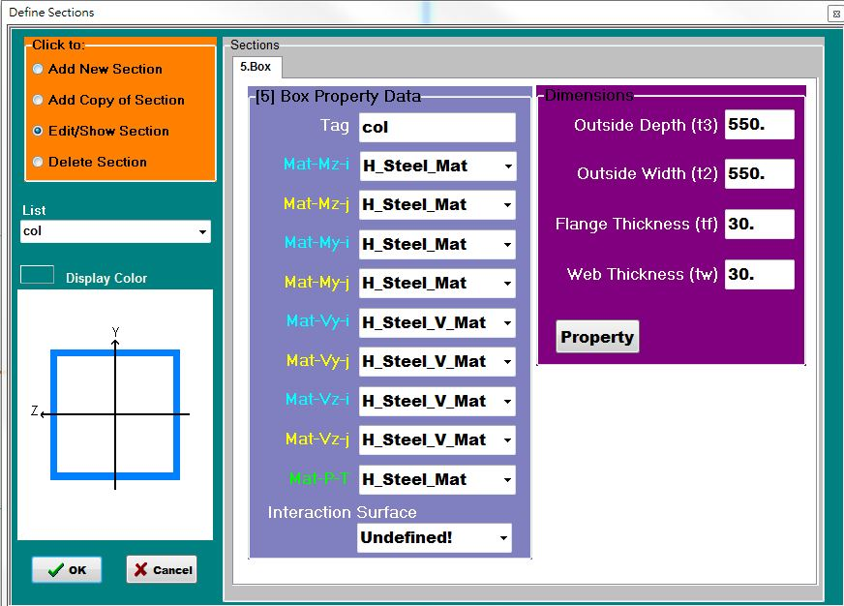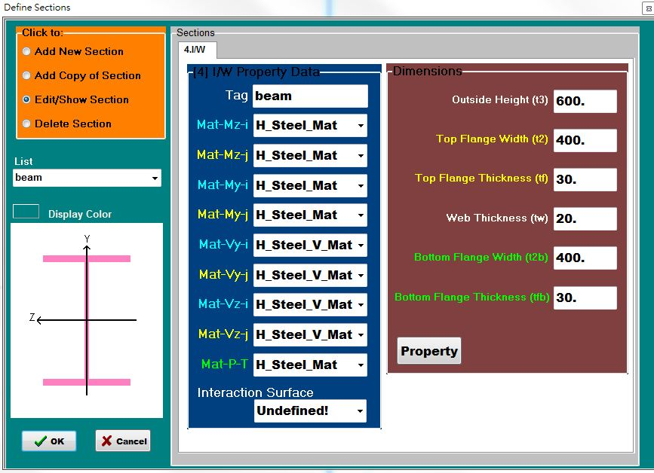

V vs θ_total

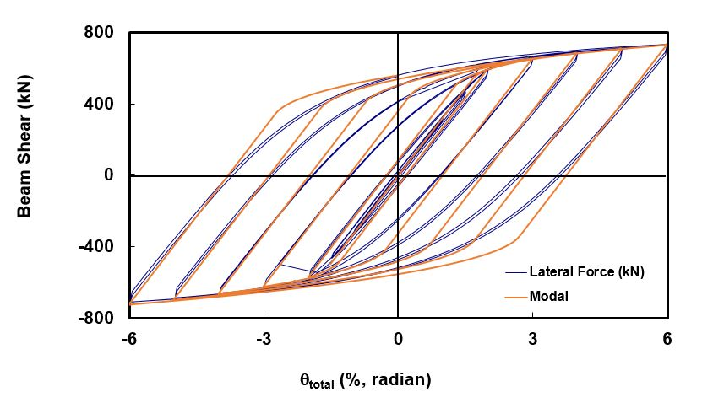

V vs Disp_total

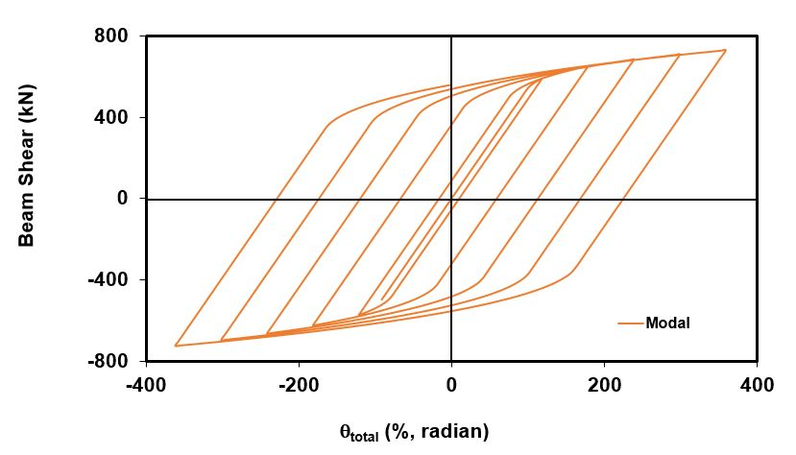

V vs θ_col

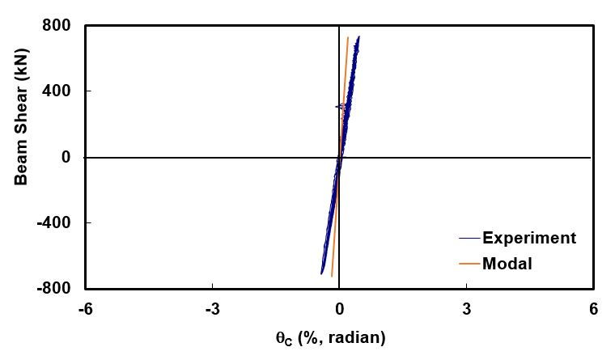

V vs θ_pz

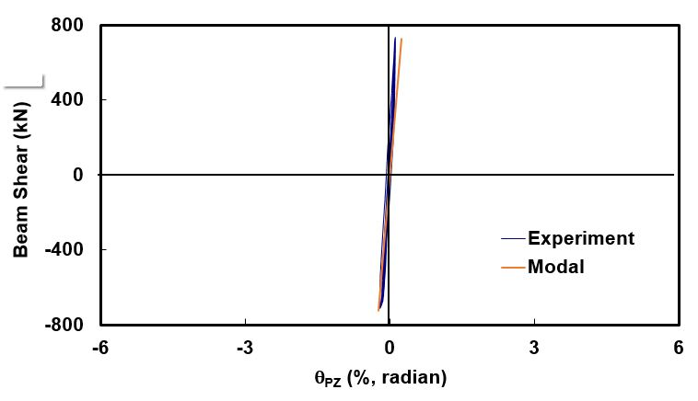

V vs θ_beam

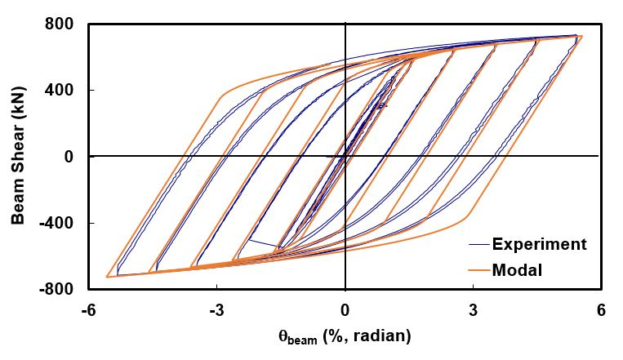

**C**

**Discuss**

1. Hardening的材料參數較多，因為是較不直觀的數值模型，所以參數要多調整幾次，才可以match。
2. Hardening的模型比Bilinear的模型更接近實驗值，Hardening從圖形上看出有逐漸降伏的趨勢，雖然調整過數次，還是不太能實驗遲滯迴圈的收縮，但顯然比Bilinear更接近真實情況。
3. 從θ_pz、θ_col、θ_beam看出只有θ_beam進入降伏階段而有殘留應變。雖然θ_pz、θ_col的模擬跟實驗沒有到很Match，但是因為一小一大的誤差加上沒有降伏所以貢獻量較小，使θ_beam有不錯的擬合。因再把剪力變形排除。