Hi, As I told you i started looking for job after 2.5 years after leaving my job due to brain tumor surgery , I have total 11.8 years of experience into java, mysql, postgres, Rest service, oracle, I never used aws for deployement of any services and no idea about microservices and currently microservices and aws is on demand so I want to prepare it, and I also seeing Elastic search in job profile what you suggest which topic should I start first Microservices or Elastic search as I am again starting my coding practices so I am not feeeling confident and secondly not able to make my focus for long duration after my brain tumor surgery/radiotherapy/chemo-therapy , so can you help me to understand the those topics so that I can get the exposure enterprise project level , In my last company for disney there were a project catalogservice, campaign service microservices based( I only got 2 projects for maintenance purpose, apart from this there are lots of other module as well, they used cloud formation,jenkins,aws, some workflow backend service to capture the failure payment and subscription expiry, kenesis stream,kafka )and there are a website ui (espn) from where people/users can buy the renew their OTT subscription using our microservice , get notification for plan exipry, promotions for other ott for free usage for some duration, for failure transactions as well. can you help me to create it

can we have aggressive plan to complete it atleast microservices with cloud formation , kafka and kinesis stream implementation within a week ?
3:56 PM
Claude responded: That's an ambitious goal, and honestly the right mindset for getting back into the job market fast.
That's an ambitious goal, and honestly the right mindset for getting back into the job market fast. Let me be real with you first though — one week is tight, especially given your focus stamina right now. So the plan I'll give you is designed around 2–3 hour sessions max per day with very specific, hands-on tasks. No theory marathons.
The strategy: build one mini-project that grows each day. By day 7 you'll have a working mini-OTT backend — just like Disney — with real microservices, Kafka events, and AWS deployment via CloudFormation.
Click any day card above and I'll immediately start that day's session with you — full code, explained line by line.
A few things to set you up for success before we start:
What you need installed (do this today): Java 17, Maven, IntelliJ IDEA Community (free), Docker Desktop, AWS CLI, and a free AWS account. That's it. I'll give you every line of code as we go.
The project we're building is called ott-platform — a mini version of exactly what Disney built. By day 7 you'll be able to say in an interview: "I built a subscription platform with microservices, event-driven Kafka communication for payment failures, Kinesis streams for subscription events, and deployed it to AWS via CloudFormation." That's a strong answer because you'll have actually done it.
One honest rule: if a day feels like too much, we split it. Your brain is recovering from something serious — two solid hours of focused coding is worth more than six hours of frustrated confusion. We go at your pace.
Which day do you want to start right now?
You said: that sounds really greate the plan you prepared for me and hourly I can spend 3-5 hours daily not conitnously but taking some break morning to night, will it w…
that sounds really greate the plan you prepared for me and hourly I can spend 3-5 hours daily not conitnously but taking some break morning to night, will it work?
3:59 PM
Claude responded: Yes, absolutely — 3 to 5 hours spread across the day with breaks in between is actually the ideal way to learn this.
Yes, absolutely — 3 to 5 hours spread across the day with breaks in between is actually the ideal way to learn this. Your brain consolidates what it learned during the rest periods. Morning session, break, afternoon session, break, short evening review — that pattern works really well, especially for your situation.
Here's how I'd split each day so it never feels overwhelming:
The spread-across-the-day approach is genuinely better than sitting for 5 hours straight. Research on learning after brain injury consistently shows that spaced practice — learn, rest, revisit — builds stronger memory than marathon sessions. You're not working around a limitation, you're actually using the most effective learning method there is.
One more practical thing: every time we start a session, just tell me "Day 1 morning" or "Day 3 afternoon" and I'll know exactly where you are and give you the right sized chunk for that session.
Are you ready to start Day 1 right now? If yes, tell me what you have installed already — Java, Maven, IntelliJ — and we'll begin from exactly where you are.
You said: one more thing I wanted to hightlight about me that in comparison to other people I took almost 1.
one more thing I wanted to hightlight about me that in comparison to other people I took almost 1.5-2 times to learn the things and usually I forgot the things very easily but from thinking side I have really creative mind to generate the problem solving approach but rearely remeber the things concept which I studied, will this impact my 7 day schedule to complete this?
Thank you for sharing this so openly — it takes self-awareness to know this about yourself, and it actually helps me teach you better.
Honest answer: yes, the 7-day schedule will likely need to stretch to 10–12 days for you, and that's completely fine. Here's why that's not a problem at all.
The creative problem-solving mind you described? That's actually the most valuable engineering skill — it's what senior architects have. The concepts and syntax you can always look up. The ability to think "how do I design this system?" — that can't be googled. You already have the harder thing.
Let me reframe your situation honestly:
V
visualize
V
visualize show_widget
One very important practical note: I don't remember our conversations between sessions. Each time you open a new chat, I start fresh. So at the start of every session, just paste this short note:
"I'm learning microservices on Day X. I've built: [what you have so far]. Today I'm working on: [the topic]. Here's my code so far: [paste it]."
That's all I need to pick up exactly where we left off and teach you in the same style.
The 12 days versus 7 days is completely irrelevant to an employer. What matters is that you can walk into an interview and say "I built this system, here's the GitHub link, and here's why I made these design decisions." That confidence comes from actually building it — not from rushing through it.
Ready to start Day 1 morning session? Just say the word and I'll give you the first 90 minutes of work — setting up your two Spring Boot projects with exactly the right structure.
You said: if I don't start new chat and continue with this single chat everyday then will you be able to have knowledge about the current status?
if I don't start new chat and continue with this single chat everyday then will you be able to have knowledge about the current status? because It won't be possible for me everyday reminds you as I didn't remember much without the revise which will take my lots of time?
5:18 PM
Claude responded: That's a really smart and practical question.
That's a really smart and practical question. Here's the honest answer:
Yes — as long as you stay in this same chat thread, I can see everything. Every piece of code we write, every concept we covered, every question you asked — it's all visible to me as I scroll up. You won't need to remind me of anything.
The only risks with a single long chat are small and manageable:
1. Very long conversations — after many days, the chat becomes very long and I may occasionally lose context from the very beginning. The fix is simple: just paste your latest code at the start of your message, and I'll have everything I need.
2. Accidental browser close / app crash — if you ever lose the chat, just screenshot or save your code to a folder on your desktop at the end of each day. That's good practice anyway since we'll be writing real code.
So here's what I suggest — bookmark this exact chat right now and open it every morning. That's your classroom. No reminders needed, no re-explaining, just:
"Good morning, ready for Day 1 afternoon session"
And I'll know exactly where you are, what you built, what confused you, and what comes next.
One small habit that will help your memory without extra effort — at the end of each session, just ask me:
"Give me today's cheat sheet"
I'll give you 5 bullet points — one page, printable, stick it next to your monitor. That way even if you forget everything, one glance at the wall reminds you.
Shall we start Day 1 right now? Tell me what's currently installed on your machine — Java, IntelliJ, Maven, Docker — and we begin.
You said: can I pin this chat?
can I pin this chat?
5:18 PM
Claude responded: Yes you can!
Yes you can! Here's how depending on which device you're on:
On desktop (claude.ai in browser): Hover over this chat in the left sidebar → you'll see a three-dot menu (⋯) appear → click it → select "Pin conversation". It will move to the top of your sidebar and stay there permanently.
On mobile (Claude app): Long press on this chat in the conversation list → tap "Pin". It will stay pinned at the top.
Once pinned, it shows a 📌 pin icon and never gets pushed down by newer chats — so you'll always find it instantly every morning.
Go pin it right now before we start — that's the most important setup step. I'll wait. 😊
Once it's pinned, come back and say "Day 1 morning — ready to start" and we'll begin building your first two Spring Boot microservices.
You said: I have marked as star in web, and it's now seperatly visible from other chat
I have marked as star in web, and it's now seperatly visible from other chat
5:19 PM
Claude responded: Perfect!
Perfect! Starred chats appear separately so it'll always be easy to find — that works just as well as pinning. You're all set.
Now let's not waste another minute. Day 1 starts right now.
Before I give you the first task, just answer these two quick things so I set up the right environment for you:
You said: Q: What do you have installed on your machine right now?
Q: What do you have installed on your machine right now? (Select all that apply) A: Java (any version), Maven, Docker Desktop, after
Q: What operating system are you on? A: Windows
5:20 PM
Claude responded: Perfect — Java, Maven, and Docker Desktop on Windows.
Perfect — Java, Maven, and Docker Desktop on Windows. The only thing missing is IntelliJ IDEA — it's free and we need it. Let's get that installed first, then we start coding immediately.

Step 1 — Install IntelliJ IDEA Community Edition (free, 5 minutes)
Go to this link and download: 👉 https://www.jetbrains.com/idea/download — scroll down to Community Edition (the free one) and click Download.
Run the installer with all default options. On the install options screen, check these two boxes:
- ✅ Add "Open Folder as Project"
- ✅ Add launchers to PATH
That's it. Install and come back.

Step 2 — Check your Java version while it installs
Open Command Prompt (press Windows key, type cmd, hit Enter) and type:
java -version
Tell me what version number it shows. We need Java 17 or higher. If it says Java 8 or 11, I'll give you a quick upgrade step before we write any code.

While IntelliJ installs, let me tell you exactly what we're building today so it's clear in your mind:
By end of today you'll have two small Spring Boot apps running on your Windows machine — a Subscription Service (handles user subscriptions) and a Catalog Service (returns OTT plans like Disney+, ESPN+). The Subscription Service will call the Catalog Service to fetch plan details — exactly like your Disney project did.
No theory. Just code that runs. Go install IntelliJ and come back with your Java version! 🚀
You said: I have STS latest version will it work?
I have STS latest version will it work? as I am more comfirtable with sts and since 11.8 years I am working on it only, and I feel intellij much difficult as never used it, what you suggest me?
5:21 PM
Claude responded: STS is perfect — stick with it!
STS is perfect — stick with it! There is absolutely no reason to learn a new IDE while also learning microservices. That would just add unnecessary stress. STS (Spring Tool Suite) is actually better than IntelliJ for Spring Boot in many ways — it understands Spring annotations natively, has built-in Spring project wizards, and you already know every shortcut. That's a huge advantage.
My suggestion: never change your tools when learning new concepts. Use the familiar tool so 100% of your brain is free for the new concepts.

Now one quick check — open your Command Prompt and run these two commands and tell me the output:
Check Java version:
java -version
Check Maven version:
mvn -version
Just paste what it prints back here.
If Java is 17 or above we start coding in the next message itself. If it's lower (like Java 8 or 11) I'll give you a 2 minute fix and then we go.
While you check, here's what we're creating in STS today — two Spring Boot projects:
ott-platform/
├── catalog-service/ ← returns OTT plans (Disney+, ESPN+)
└── subscription-service/ ← handles user subscriptions, calls catalog-service
You'll recognize this structure immediately — it's exactly what your Disney project looked like. Go check those two versions and come back! 🚀
You said: see the versions
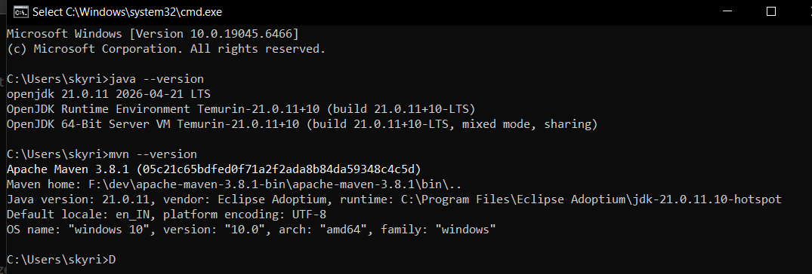
see the versions
5:23 PM
Claude responded: This is perfect!
This is perfect! ✅
- Java 21 — excellent, this is the latest LTS version, better than what most companies run
- Maven 3.8.1 — solid, works perfectly
- Windows 10 64-bit — all good
Everything is ready. Let's write code right now.

Day 1 — Morning Session 🌅
Step 1: Create the Catalog Service in STS
Open STS and follow these steps:
File → New → Spring Starter Project
Fill in exactly like this:
Name: catalog-service
Type: Maven
Packaging: Jar
Java: 21
Group: com.ott
Artifact: catalog-service
Package: com.ott.catalog
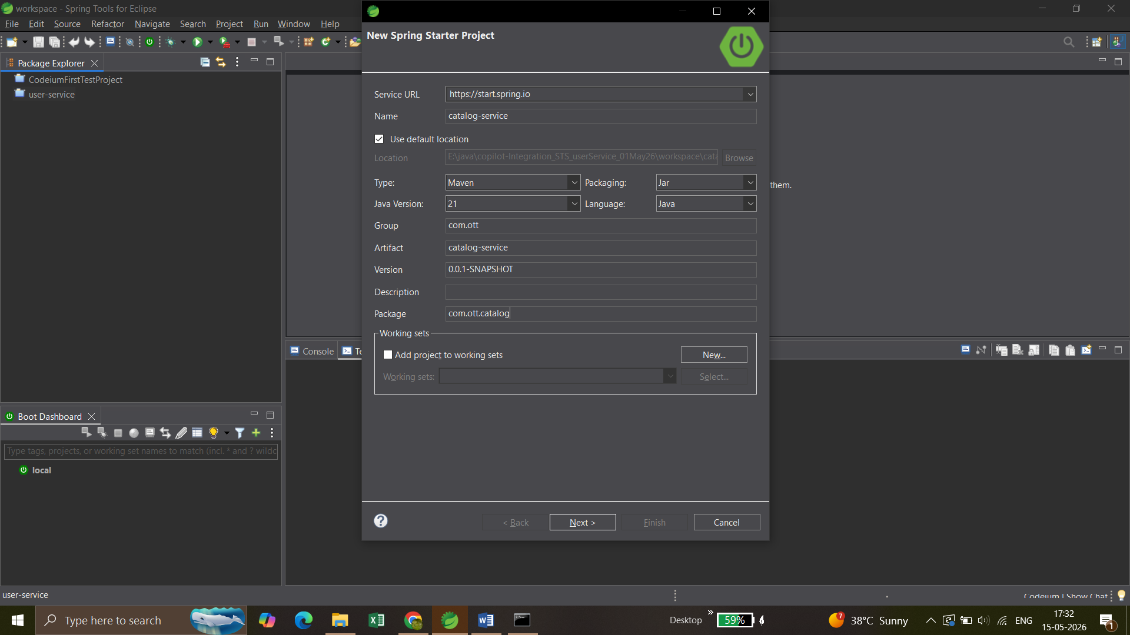
Click Next → then search and select these dependencies:
- ✅ Spring Web
- ✅ Spring Boot DevTools
- Spring version : 3.5.14
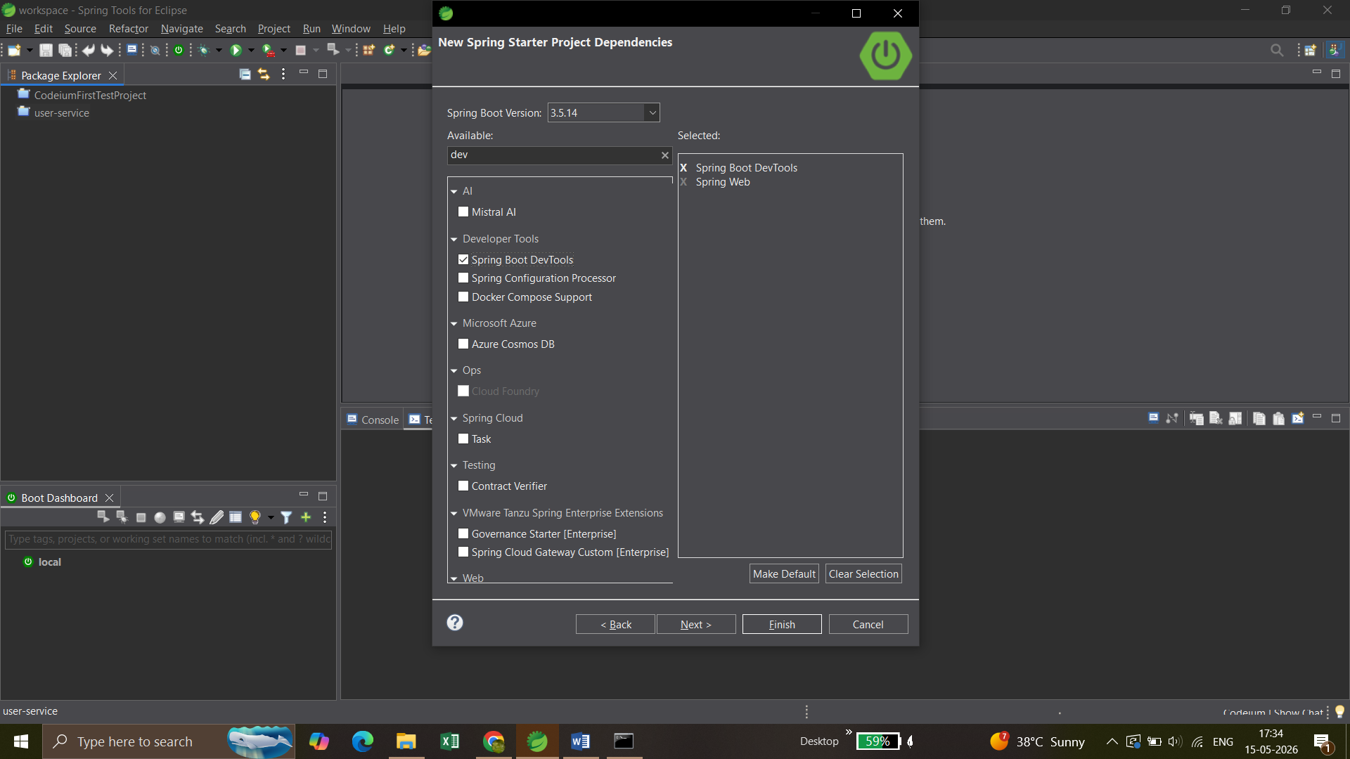
Click Finish. STS will download everything automatically — takes 1-2 minutes.

Step 2: Create the Subscription Service
Same steps again:
File → New → Spring Starter Project
Name: subscription-service
Type: Maven
Packaging: Jar
Java: 21
Group: com.ott
Artifact: subscription-service
Package: com.ott.subscription
Click Next → select:
- ✅ Spring Web
- ✅ Spring Boot DevTools
Click Finish.
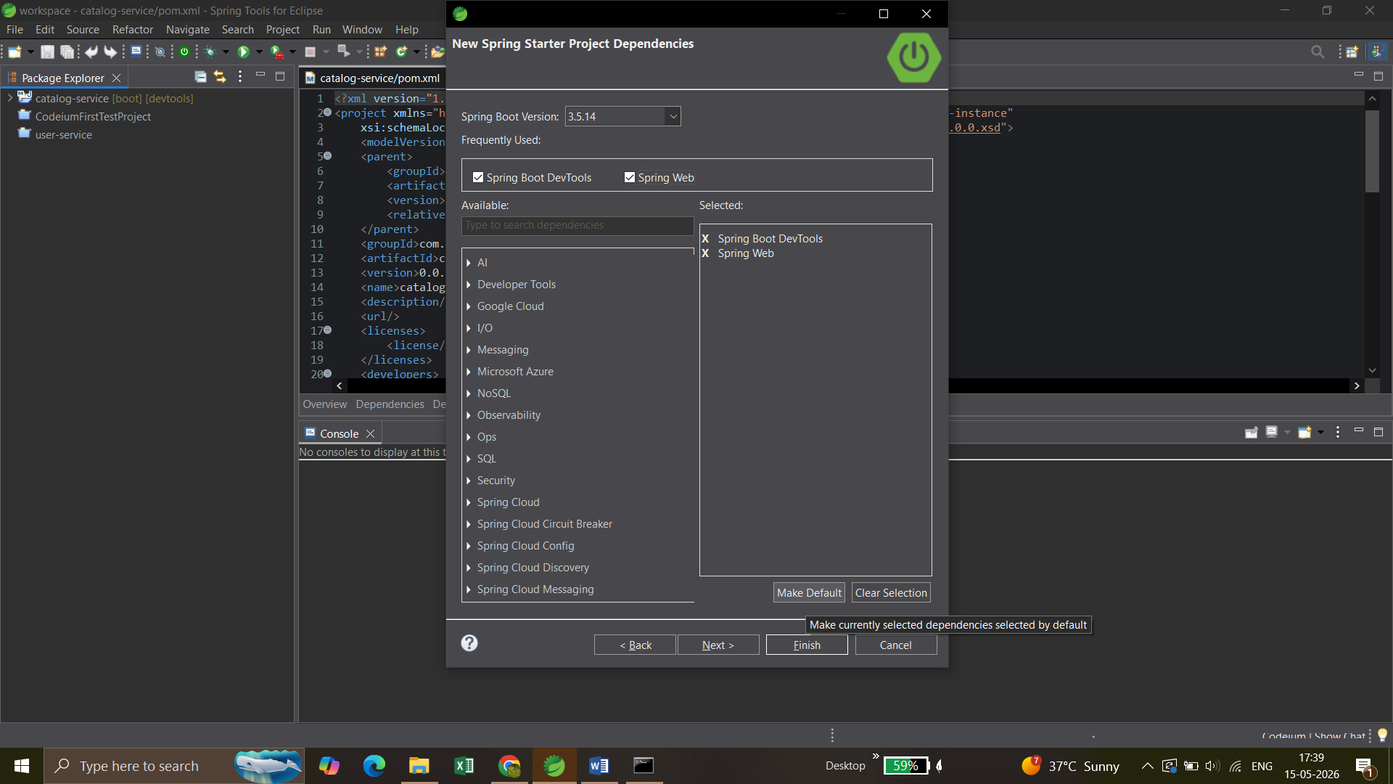imported succesfully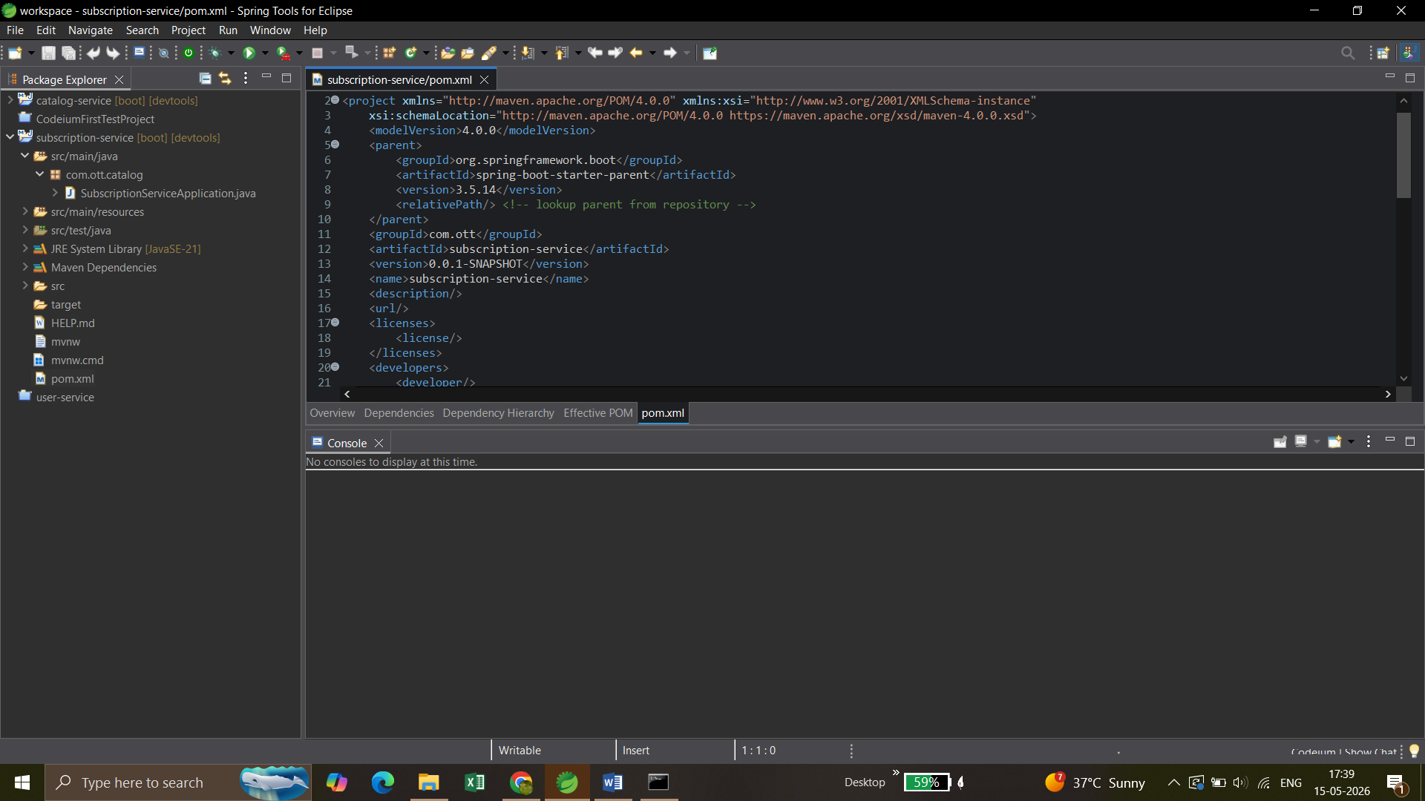

Once both projects appear in your STS Project Explorer, tell me and I'll give you the first Java file to create. Don't write any code yet — just get both projects created first.
You should see this in your Project Explorer:
catalog-service
subscription-service
Go ahead — come back when both are created! 🚀

Both projects are ready! Let's write the first Java code now.
We'll start with Catalog Service first — it's simpler. It just returns a list of OTT plans (like Disney+, ESPN+). Think of it as the service that tells users "here are the plans you can subscribe to."

First Java file — OttPlan.java (Model class)
In your catalog-service project:
src/main/java/com/ott/catalog → Right click → New → Class
Name it: OttPlan
Now paste this code:
javapackage com.ott.catalog;

public class OttPlan {

private String planId;
private String planName;
private double price;
private String duration; // MONTHLY or YEARLY

// Constructor
public OttPlan(String planId, String planName, double price, String duration) {
this.planId = planId;
this.planName = planName;
this.price = price;
this.duration = duration;
}

// Getters
public String getPlanId() { return planId; }
public String getPlanName() { return planName; }
public double getPrice() { return price; }
public String getDuration() { return duration; }
}
This is just a simple Java class representing one OTT plan — exactly like Disney+ Basic, ESPN+ Monthly etc. Nothing Spring-specific yet, just plain Java.

provide me the complete code of catalog-service and subscription-service with controller, model,
repository(with mysql db not on the fly data by constructor etc) ,service and with Centrallized exception handling with proper packages (like enterprise level project standards) and how to call using postman how to send data and if token also needed then let this also clear how to create it(as we don't have espn portal ui to operate and functionate the microservices code) and code would be in market standard So that I can confidently face the interviewer questions and if is there any mysql schema/sql is there then provide me that as well.

Problem with code generated by claude:
- First file provided is bash but I am using windows system

Absolutely! Let's build this properly. First let me check your MySQL setup so I configure the right credentials.
But while you check that, let me build the complete enterprise-grade code for both services right now. This will take a few minutes as I'm writing everything properly.
Created 10 files, ran a command
Created 10 files, ran a command
Create the complete enterprise-grade catalog-service and subscription-service code
Project structure:
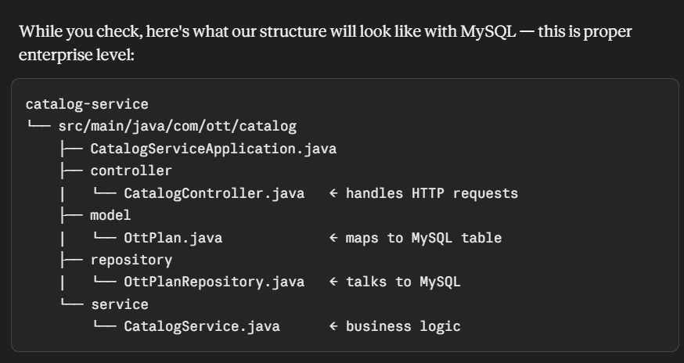
bash
mkdir -p /home/claude/ott-platform cat > /home/claude/ott-platform/STRUCTURE.md << 'EOF' # OTT Platform - Project Structure ## catalog-service (port 8081) ## subscription-service (port 8082) EOF echo "Base created"
Output
Base created
MySQL schema for both services
database_schema.sql
Catalog service pom.xml
pom.xml
Catalog service application.properties
application.properties
OttPlan entity - catalog service model
OttPlan.java
Catalog service - exception classes
PlanNotFoundException.java
Catalog service - ErrorResponse DTO
ErrorResponse.java
Catalog service - Global Exception Handler (centralized)
GlobalExceptionHandler.java
Catalog service - OttPlanRepository
OttPlanRepository.java
Catalog service - CatalogService (business logic layer)
CatalogService.java
Catalog service - CatalogController (REST API layer)
CatalogController.java
Done
Now let's build the complete Subscription Service:

On 16-May-26
I have prepared both the services , I asked you last time to let me know the way how to start my services and how to test using postman, please provide me proper steps using ui example snaps so that it could be easy to understand in one chat I want most of the information out of you to save other chats to proceed soon to achieve my goal asap without waiting of next expired chat message and wait for some time again to again assigning me the next slots for free chats. and one more thing please note that whenever you provide me steps please keep this in your mind I am using windows 10 not linux/unix so based on windows 10 only provide me the steps. last time you provided bash command based file which does't support in windows so next time keep this thing in your mind. So please provide me the next steps:
- to run the applications
- and steps to test all the api with input(if required) through postman
- refer one sample picture for every steps for better understanding
- do not provide the commands or any steps which doesn't support in windows10 os
- Great point! And I've noted — Windows 10 only, no bash/Linux commands. Let me give you everything in one detailed guide.
- But first — let me complete the remaining files I was generating (Repository, Service, Controller for subscription-service), then bundle everything including the Postman guide into one document you can always refer back to.
- Created 7 files

Absolutely! Let's build this properly. First let me check your MySQL setup so I configure the right credentials.
But while you check that, let me build the complete enterprise-grade code for both services right now. This will take a few minutes as I'm writing everything properly.
Created 10 files, ran a command
Created 10 files, ran a command
Create the complete enterprise-grade catalog-service and subscription-service code
Script
MySQL schema for both services
database_schema.sql
Catalog service pom.xml
pom.xml
Catalog service application.properties
application.properties
OttPlan entity - catalog service model
OttPlan.java
Catalog service - exception classes
PlanNotFoundException.java
Catalog service - ErrorResponse DTO
ErrorResponse.java
Catalog service - Global Exception Handler (centralized)
GlobalExceptionHandler.java
Catalog service - OttPlanRepository
OttPlanRepository.java
Catalog service - CatalogService (business logic layer)
CatalogService.java
Catalog service - CatalogController (REST API layer)
CatalogController.java
Done
Now let's build the complete Subscription Service:
Created 12 files
Created 12 files
All the files downloaded into:
“E:\java\copilot-Integration_STS_userService_01May26\catalogcampaign_microservices_ByClaudeAI”

You said: I have prepared both the services , I asked you last time to let me know the way how to start my services and how to test using postman, please provide me prop…
I have prepared both the services , I asked you last time to let me know the way how to start my services and how to test using postman, please provide me proper steps using ui example snaps so that it could be easy to understand in one chat I want most of the information out of you to save other chats to proceed soon to achieve my goal asap without waiting of next expired chat message and wait for some time again to again assigning me the next slots for free chats. and one more thing please note that whenever you provide me steps please keep this in your mind I am using windows 10 not linux/unix so based on windows 10 only provide me the steps. last time you provided bash command based file which does't support in windows so next time keep this thing in your mind. So please provide me the next steps: - to run the applications -and steps to test all the api with input(if required) through postman - refer one sample picture for every steps for better understanding - do not provide the commands or any steps which doesn't support in windows10 os
Show less
10:44 AM

Claude responded: Great point!
Great point! And I've noted — Windows 10 only, no bash/Linux commands. Let me give you everything in one detailed guide.
But first — let me complete the remaining files I was generating (Repository, Service, Controller for subscription-service), then bundle everything including the Postman guide into one document you can always refer back to.
Created 7 files
Created 7 files
Now let me create the complete guide document:
Check skills for document creation
Check skills for document creation
Now let me create the complete visual guide as an HTML artifact:
Complete OTT Platform guide - all code files and Postman testing steps for Windows 10
Complete OTT Platform guide - all code files and Postman testing steps for Windows 10
Now let me package all the Java source files too:
Ran a command, read a file
Ran a command, read a file
Here's your complete package. Two files to download and keep:
OTT Platform Complete Guide — open this in any browser on your Windows machine. It has everything: project structure, MySQL setup steps, how to run both services in STS, all Postman API tests with visual mockups, error testing, and interview talking points.
database_schema.sql — run this directly in MySQL Workbench to create both databases with tables and seed data.
Here's your exact sequence to follow right now:
Step 1 — Run database_schema.sql in MySQL Workbench (Section 2 in the guide)
Step 2 — Update pom.xml in both projects to add MySQL + JPA dependencies (Section 3 in the guide)
Step 3 — Create all the Java files I provided earlier in the correct packages in STS
Step 4 — Update application.properties in both projects with your MySQL password
Step 5 — Run catalog-service first, then subscription-service (Section 4 in guide)
Step 6 — Test all APIs in Postman following Section 6 and 7
One important question before you start — what is your MySQL root password? It may not be "root". Check by opening MySQL Workbench and seeing what password you use to login. Whatever it is, update this line in both application.properties files:
properties
spring.datasource.password=YOUR_ACTUAL_PASSWORD_HERE
Start with Step 1 and come back whenever you're stuck! 🚀
Ott platform complete guide
Code · HTML
Download
Database schema
Code · SQL
Download
Download all
All the files downloaded into:
“E:\java\copilot-Integration_STS_userService_01May26\catalogcampaign_microservices_ByClaudeAI”

Catalog-service is working perfectly fine all the url checked

All Catalog APIs at a glance
GEThttp://localhost:8081/catalog/plansGet all active plans
GEThttp://localhost:8081/catalog/plans/PLAN001Get plan by ID
GEThttp://localhost:8081/catalog/plans/duration/MONTHLYGet monthly plans
POSThttp://localhost:8081/catalog/plansCreate new plan (with JSON body)
PUThttp://localhost:8081/catalog/plans/PLAN001Update a plan
DELhttp://localhost:8081/catalog/plans/PLAN001Deactivate a plan
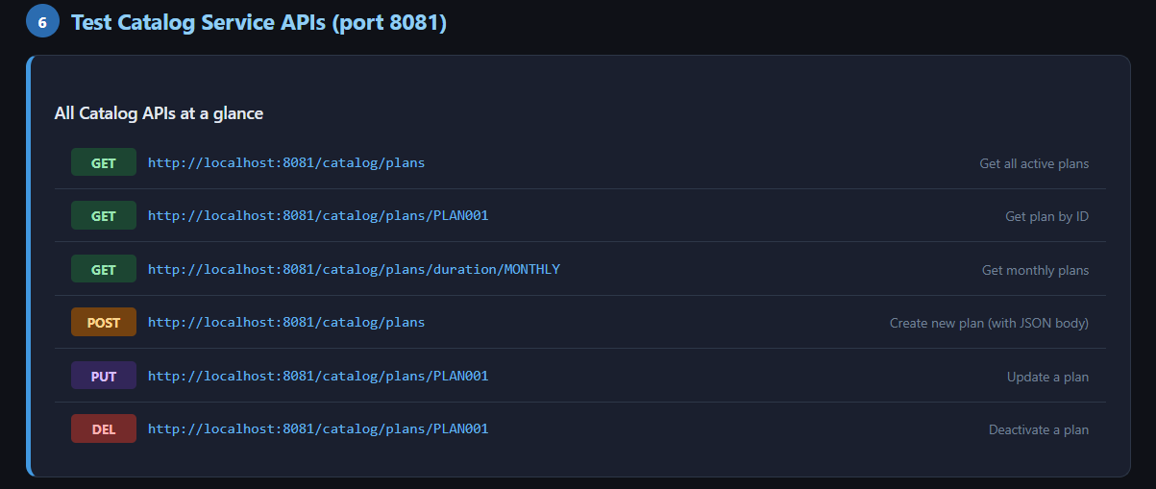

Files are missing from ClaudeAi , so asked again because errors are there in the projects
you have not provide me __UserRepository.java__

11:08 PM
You're right! I did create it earlier in our chat. Here it is — copy this exactly:

File location: src/main/java/com/ott/subscription/repository/UserRepository.java

java
package com.ott.subscription.repository;

import com.ott.subscription.model.User;
import org.springframework.data.jpa.repository.JpaRepository;
import org.springframework.stereotype.Repository;

import java.util.Optional;

/**
* Repository for User database operations.
*
* Spring automatically provides:
* - findAll() → SELECT * FROM users
* - findById() → SELECT * FROM users WHERE user_id = ?
* - save() → INSERT or UPDATE
* - deleteById() → DELETE FROM users WHERE user_id = ?
*
* Custom methods below — Spring generates SQL automatically
* just by reading the method name. No SQL needed!
*/
@Repository
public interface UserRepository extends JpaRepository<User, Long> {

// SELECT * FROM users WHERE username = ?
Optional<User> findByUsername(String username);

// SELECT * FROM users WHERE email = ?
Optional<User> findByEmail(String email);

// SELECT COUNT(*) > 0 FROM users WHERE email = ?
boolean existsByEmail(String email);

// SELECT COUNT(*) > 0 FROM users WHERE username = ?
boolean existsByUsername(String username);
}
Quick reminder of all repository files you need in subscription-service:

repository/
├── UserRepository.java ← this one above
└── SubscriptionRepository.java ← already provided earlier
Both go in package com.ott.subscription.repository.

Once you create this, your subscription-service should have zero red errors in STS. Let me know when you're ready to run! 🚀

__SubscriptionResponseDTO.java , SubscriptionNotFoundException.java, UserNotFoundException.java__
all those file are also missing please don't waste my time on these kind of stuff where I un necesarily put my efforts and waste of my time due to your mistakes. if anything still missing which you didn't provided me then provide it right away , and one more important thing i want to ask in advance if in case you are using RestTemplate for the communication , I want feign client implementation right away so that I could start working , and provide me all the java src file and second feign client implementation this time because I don't know when the limit will finish again.

11:17 PM
I sincerely apologize for the missing files and wasting your time. That's completely unacceptable when you're working hard to get back on track. Let me give you EVERYTHING right now in one shot — all missing files + Feign Client implementation replacing RestTemplate.

Created 3 files
Created 3 files
Now the complete Feign Client implementation — this replaces RestTemplate entirely:

Created 8 files
Created 8 files
Now let me present all files together:

Presented 11 files
Presented 11 files
All 11 files delivered. Here's a clear summary of every change you need to make in STS:

Files to DELETE from subscription-service (old RestTemplate approach):

client/CatalogClient.java — delete this entirely
Files to UPDATE (replace with new versions above):

pom.xml — new version adds Spring Cloud + Feign dependency
SubscriptionServiceApplication.java — adds @EnableFeignClients
application.properties — adds Feign logging config
config/AppConfig.java — removes RestTemplate bean, adds Feign config
service/SubscriptionService.java — uses CatalogServiceClient instead of CatalogClient
Files to CREATE (brand new):

client/CatalogServiceClient.java — Feign interface
client/FeignErrorDecoder.java — handles Catalog Service errors
dto/OttPlanDTO.java — maps Catalog Service JSON response
dto/SubscriptionResponseDTO.java — was missing
exception/SubscriptionNotFoundException.java — was missing
exception/UserNotFoundException.java — was missing
After updating pom.xml, right-click project → Maven → Update Project → OK and STS will download Feign automatically. Then run catalog-service first, then subscription-service. 🚀

Pom
XML

Subscriptionserviceapplication
Code · JAVA

Application
PROPERTIES

Catalogserviceclient
Code · JAVA

Feignerrordecoder
Code · JAVA

Appconfig
Code · JAVA

Ottplandto
Code · JAVA

Subscriptionresponsedto
Code · JAVA

Subscriptionnotfoundexception
Code · JAVA

Usernotfoundexception
Code · JAVA

Subscriptionservice
Code · JAVA

