INTRO TO ABLETON LIVE

Welcome to Ableton Live and the wonderful world of music production!

A brief intro - Ableton Live (or just ‘Ableton’ or just ‘Live’ for short) is a kind of software known as a **DAW - Digital Audio Workstation.** Other common DAW’s include Logic and ProTools, though there are numerous others (Renoise, Reason, Digital Performer, Reaper, etc). What sets Ableton apart is that it’s designed for both **production** and **performance**. Within electronic music, production refers to composing music in the traditional sense - crafting sounds, arranging and layering various instruments, creating a progression of elements. Performance refers to the live generation, mixing and manipulation of sound. These tasks can help support and reinforce each other.

Ableton has two views for these tasks. The first view, in which the program opens up, is the **Session View**. Session view allows us to **trigger** (play) **clips** back. Let’s see how that works.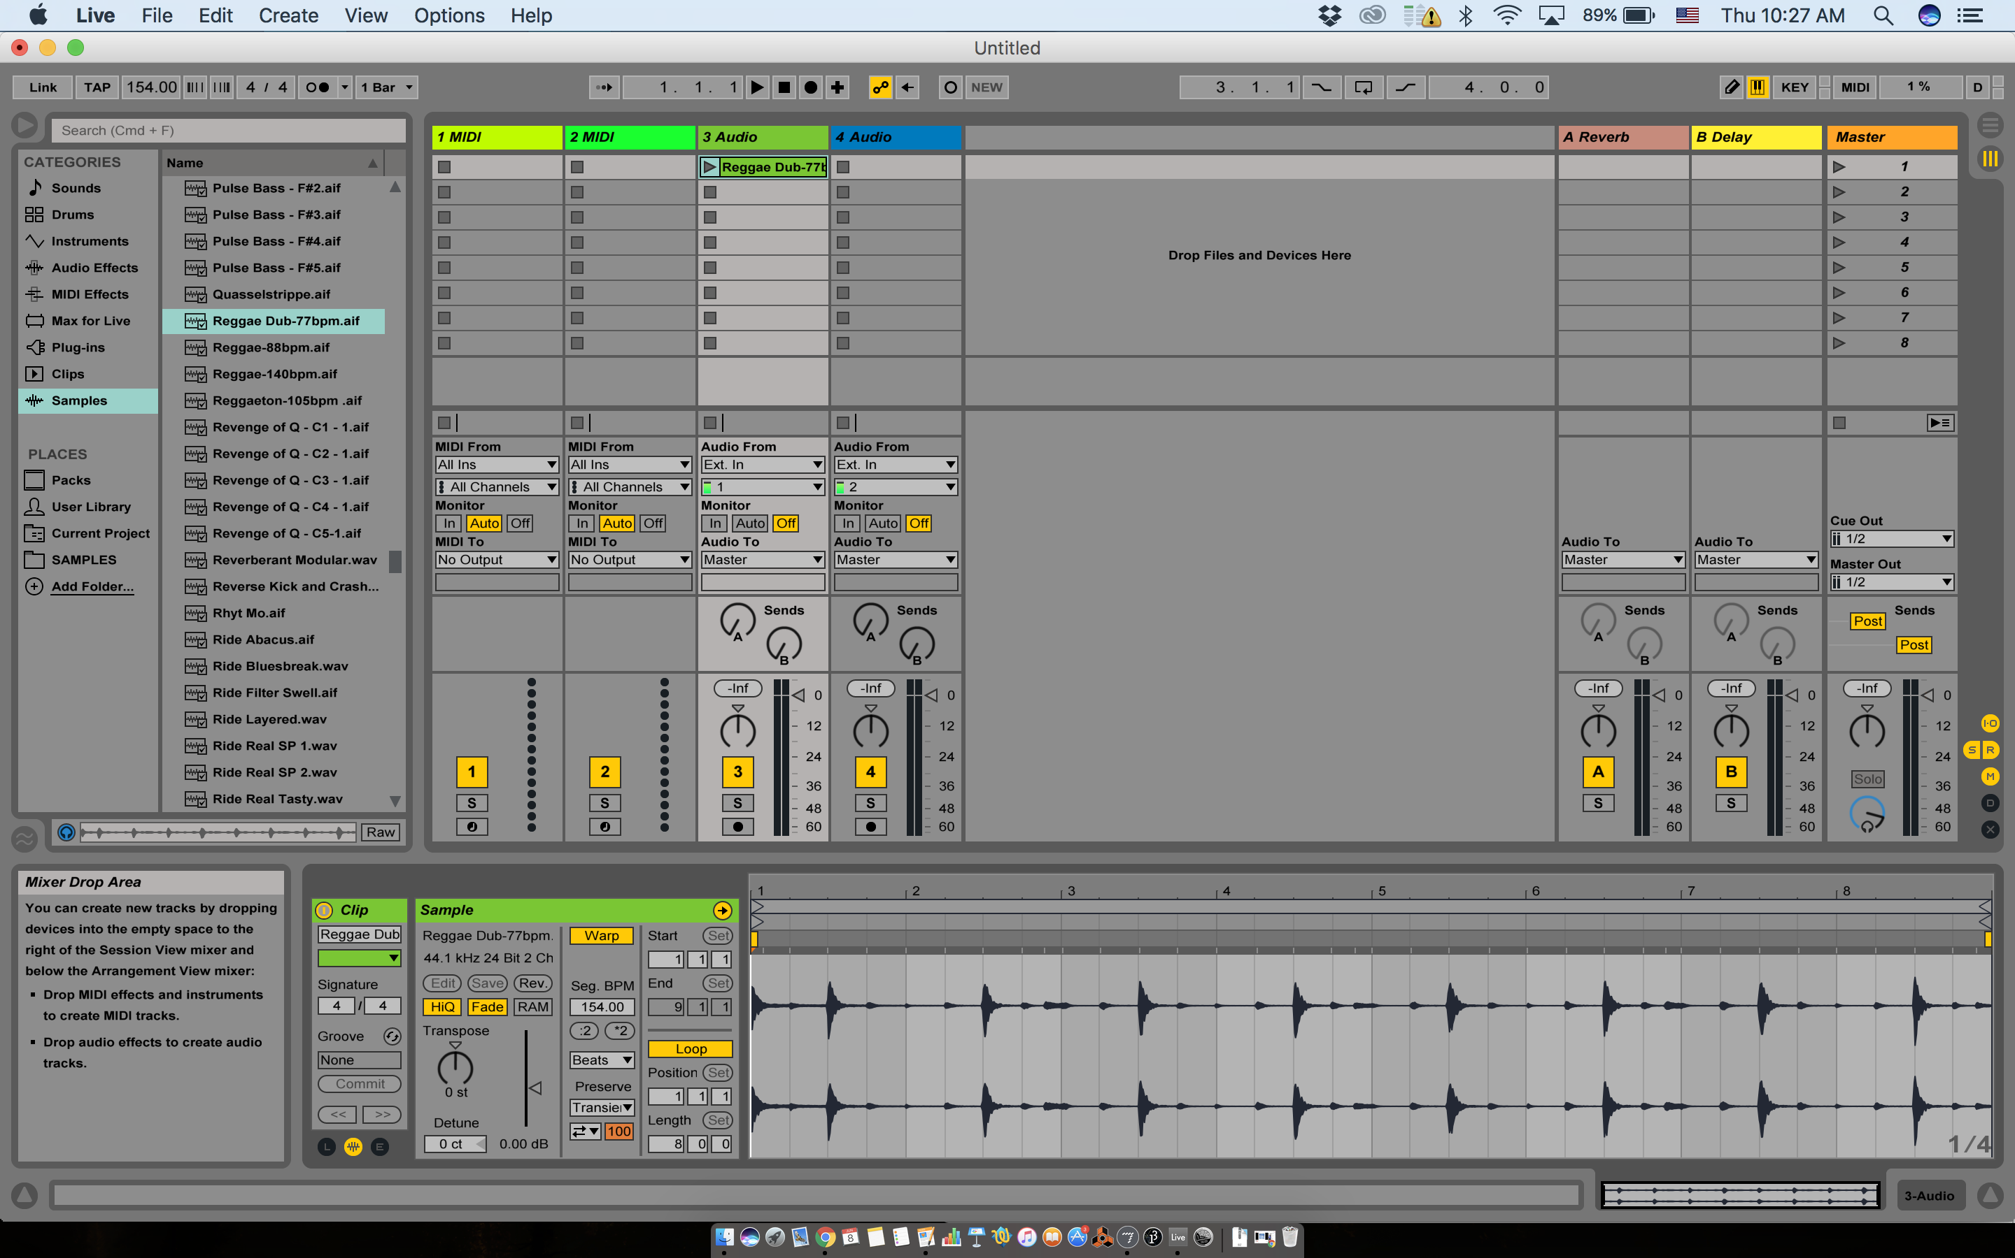

There’s a lot on our screen! Don’t let that overwhelm you. We’ll focus on one thing at a time, and before you know it, you’ll be making *colossal beats****.***

Look at the column labeled ‘3 Audio’, this is an **Audio Track**. We can play back **samples** (in Ableton these are called clips) from the audio track - these can be of any length, from whole songs to extremely short hits.

How to load samples? Just drag and drop! But it’s good to keep your samples organized. Ableton comes with some samples, you can find these on the left in your **browser** window. You can also create and add your own folders here. Try adding some sounds into Audio 3 and Audio 4.

In the top left, we have some **global parameters** (that is, settings which effect our entire set) that will partially control our sample playback.

We have our **time signature**, our **tempo,** and our **global quantization** (see if anyone needs explanation of what tempo or time signature refer to)**.** We can also use **TAP** to tap out a tempo - this is useful if you are jamming with other people. Quantization determines allows our clips to be triggered according to a certain subdivision. Try triggering your clips by hitting the launch button on the left of the clip (looks like a triangle or play button). Change your quantization settings and see how this affects playback.

As we move through this information, if you need a remind of what something does, take a look at the bottom left corner of the screen, this is your **Info View** screen and will tell you what your mouse is hovering over. Great for learning the program!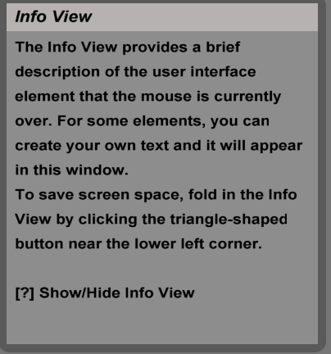

Back to our samples - your now have two samples playing together. You can change the volume with the **track volume** control at the bottom. You can change their **panning** (whether it’s coming from left or right speaker) using the **track pan** knob next to the volume slider. We’ll come back to panning later on when we talk more about mixing.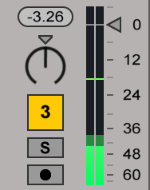

In our **Clip View** at the bottom of the page, we can find ways of changing the playback of our sample. This can vary from subtle tweaks, to otherworldly manipulations. Let’s tour our clip view.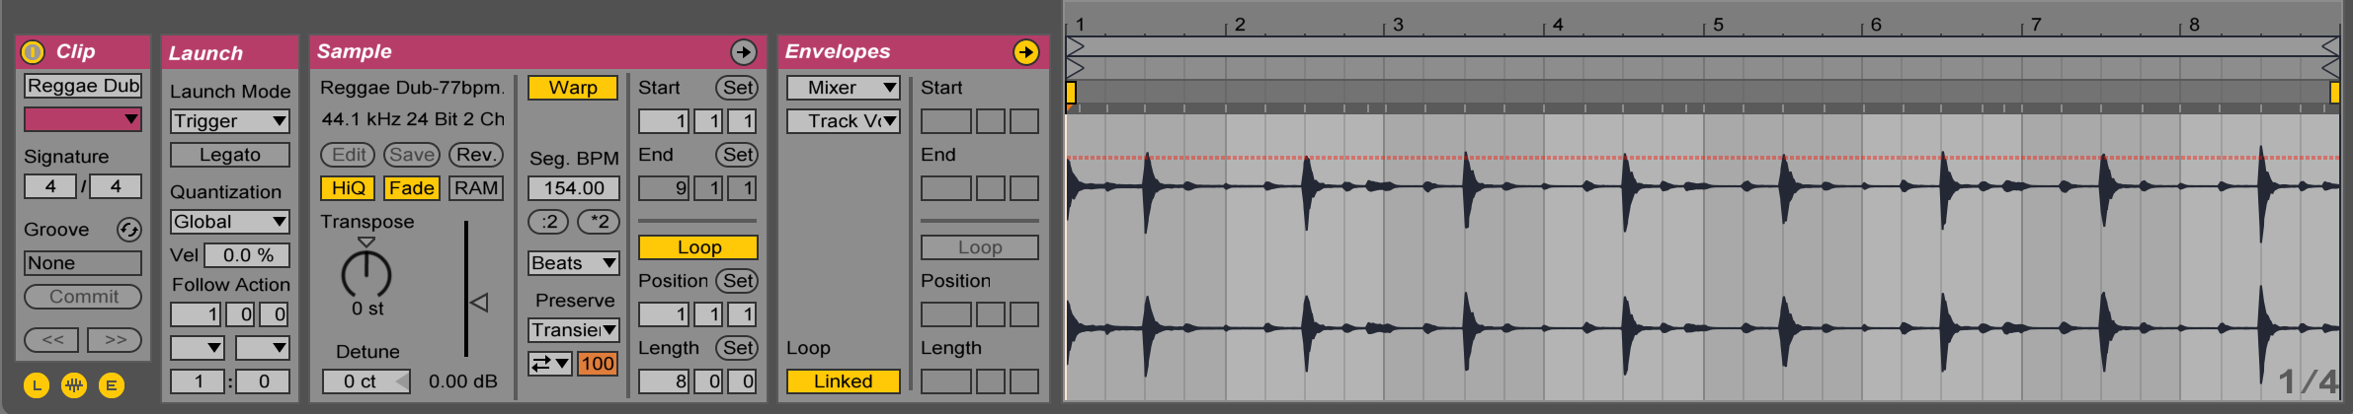

In the bottom left you can toggle your different menus **Launch**, **Sample**, and **Envelopes**. For now, we will focus just on our sample page.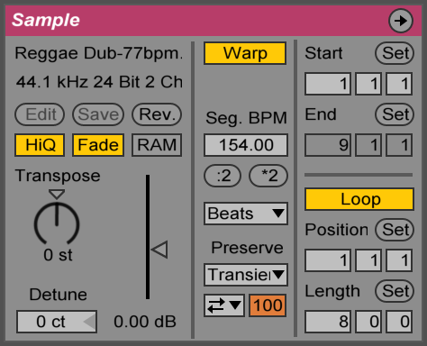

The sample page allows us to **transpose** (change the pitch of our sample), **warp** (change the length of our sample), **reverse, loop,**  and set the **start position** and **loop length & position**. The different warp settings each have their own character, and are suitable for different kinds of samples. For example, the **Beats** setting is suitable for rhythmic, percussion material, while the **texture** or **tones** setting might be more suitable for synth or pad sounds. Play around and see what you can come up with. It’s OK for it to be weird!

We can also apply **Audio Effects** to our track for added depth and sound design capabilities. There’s lots of effects to choose from! We will explore their unique flavors and uses in upcoming lessons. A wonderful way to learn though is to simply explore, so perhaps take a few minutes dropping in effects and changing around parameters to see what you can come up with. Some effects are far more common than others. Try playing with **Autofilter, Reverb** and **Simple Delay.** You can find the effects at the bottom of the screen where our clip view was. If you want to see the clip view, double click the clip. If you want to see the effects, double click the Audio track.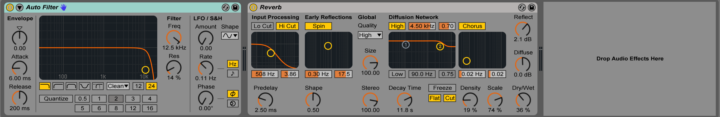

So now we are triggering clips, warping sounds, playing with levels, panning, and effects. But it’s all so fleeting and transient - that perfectly expressive mouse movement which opened the low pass filter at just the right time, it’s lost forever, swept up in the tide of time’s unrelenting river of impermanence…right?

Not quite! The beauty of Ableton is its combination of the Session View’s freedom and improvisatory structure with the compositional powers of the **Arrangement View**. Let’s hit Tab and switch over to the Arrangement View.

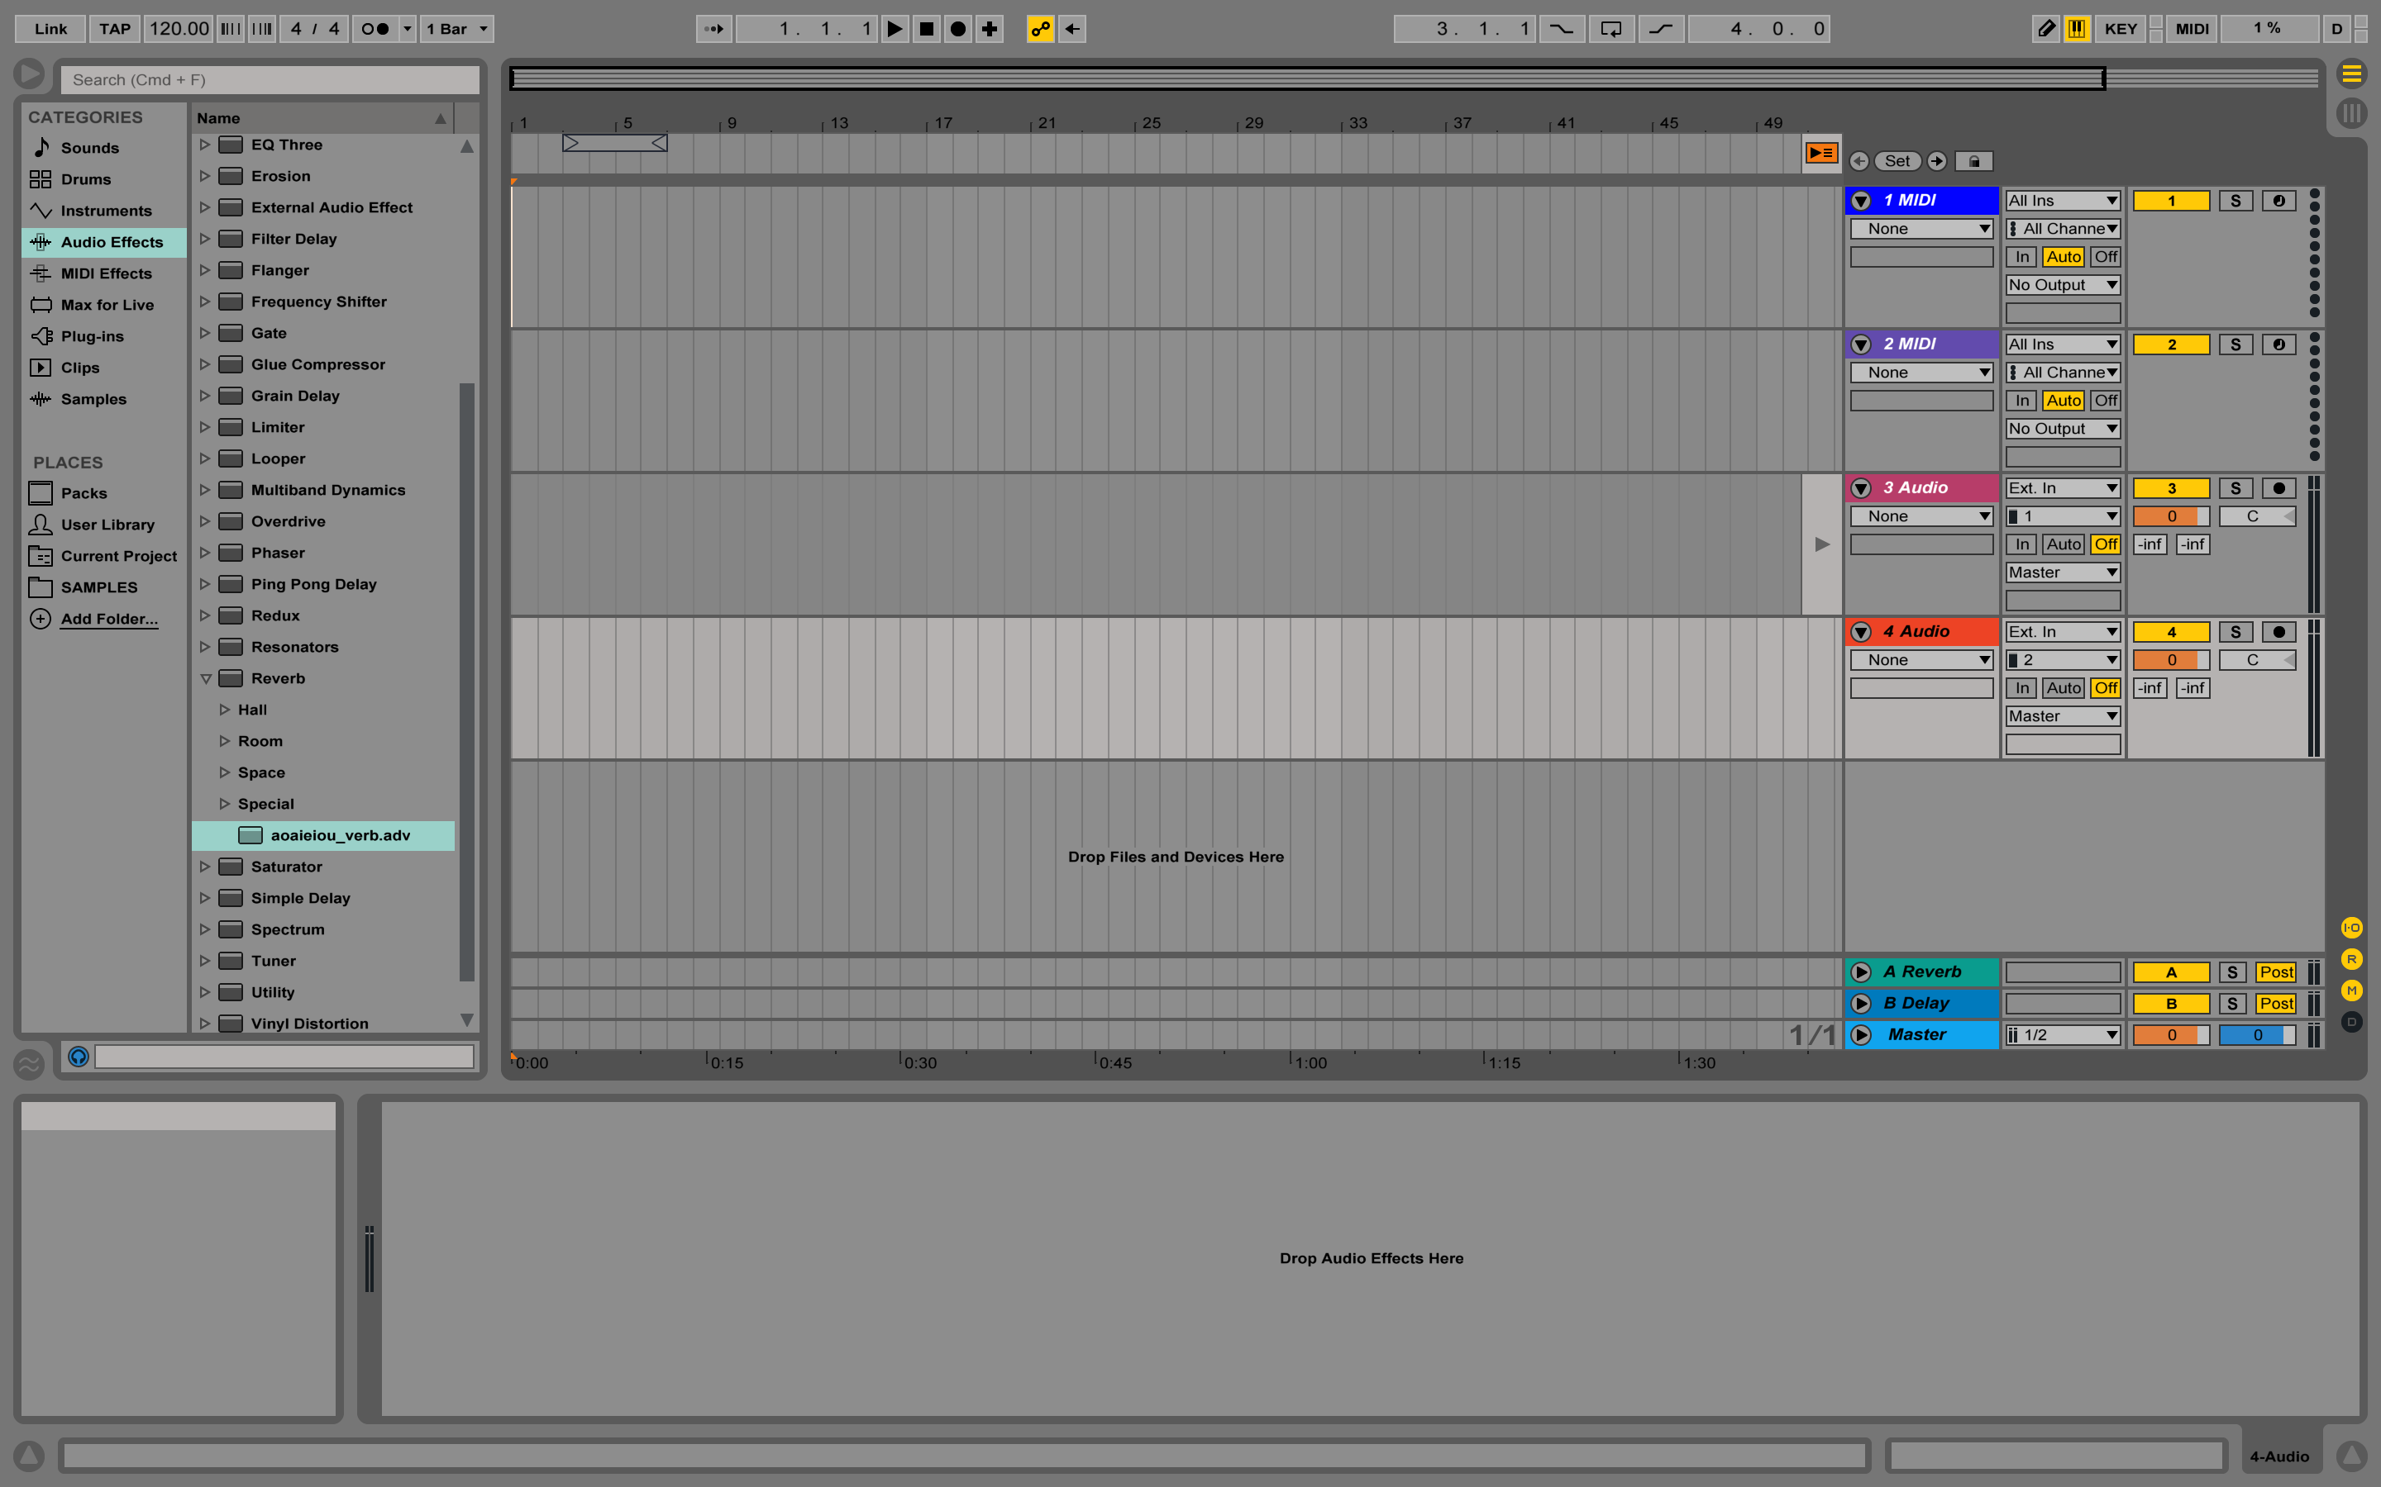

The Arrangement View is like a score for a classical music piece. Each track is like a different instrument in the orchestra. Let’s record a few looping samples and effect tweaks. We can do this by hitting the record button at the top of the screen, and arming the automation record (the two circles next to the arrow on the right).



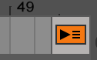

After you’ve recorded, your recordings will look transparent. This is because the settings of the Session View and Arrangement View are not the same. We can revert back to the Arrangement View settings by hitting the small orange button in the top right.

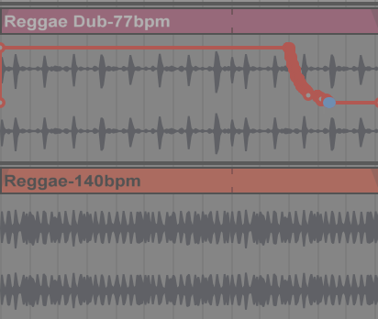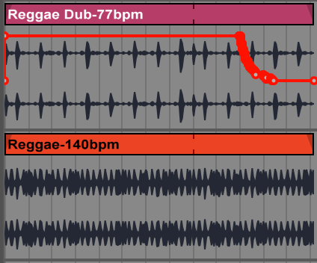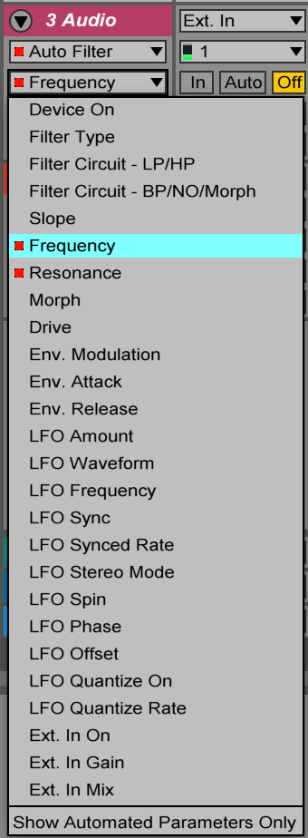

To your right, you get a list of possible effect parameters to edit. Those which have been changed have a red square next to them. This allows you to use the Clip View to play things spontaneously, then use the Arrangement View to refine your gestures and sequencing. Clip View is also a nice way to keep track of sample material, which you can then copy/paste into your Arrangement View. Let’s explore this for a bit.

Lastly, we will look at **MIDI**. MIDI stands for **Musical Instrument Digital Interface** and is a a communication protocol for playing notes on electronic instruments. You can think of MIDI as the notes in a score, and your synthesizer as the instrument. Using the same MIDI notes, synthesizers can be swapped out, giving you lots of freedom in sound design and arrangement.

Ableton has numerous digital instruments, some of which we will explore in the coming weeks. For now, let’s start with **Analog**, a **subtractive synthesizer** that is a standard inclusion in Ableton Live. We control the parameters of the synthesizer in the effects view at the bottom of the screen.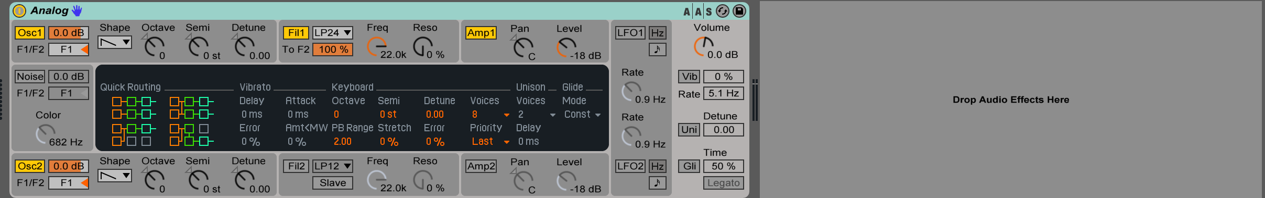

Audio effects, like in our Audio tracks, can be added to MIDI tracks.

Ableton allows you to use your computer’s keyboard like a MIDI piano. We can turn that on and off by using the yellow keyboard button in the top right of the screen.

By arming our MIDI track in the Mixer area, and hitting the record button at the top, we can record what we play into our MIDI track.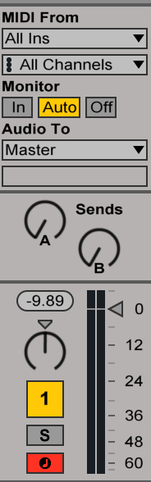

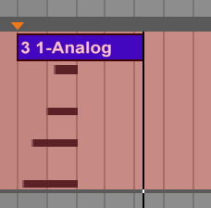

By double-clicking this, we are shown our **piano roll**, which shows the notes that we’ve played, their length and their **velocity** (volume). This is like the score of a player piano

We can edit our MIDI notes by using the mouse to drag, drop, lengthen, etc. You can also hit cmd+B to enter **Draw mode** and draw the MIDI notes directly to the MIDI clip.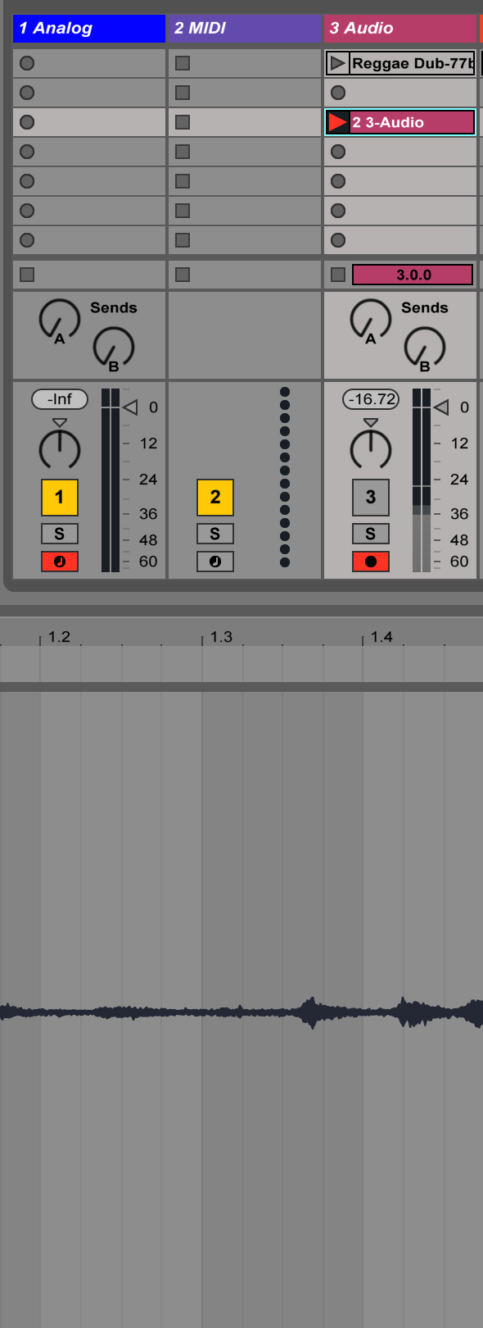

Lastly, both MIDI and Audio clips can be recorded into the Session View by arming the record button in the Mixer area, then hitting the circular button in th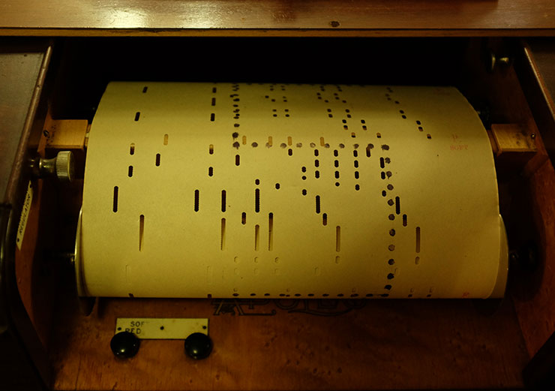e clip slot.

This gives us a lot to work with so far! We can now load and edit sample in audio tracks, add effects, record MIDI, and navigate between our Session and Arrangement View. We will learn more details of MIDI instruments, use of effects, compositional techniques and much more in coming lessons. Happy music making!