MIDI & SAMPLING CONTINUED

A quick review of what we’ve covered so far:

1. The different uses of Ableton’s Session and Arrangement View
2. The browser window,
3. Sample editor window
4. How to add effects
5. How to record MIDI and audio in both the Session and Arrangement View
6. How to sequence effects

Let’s take a look at a very common instrument in Ableton to help deepen our knowledge of both MIDI and sampling. Introducing….

# SIMPLER

In your browser window, go to “Instruments” and select Simpler. Drag and drop this onto a MIDI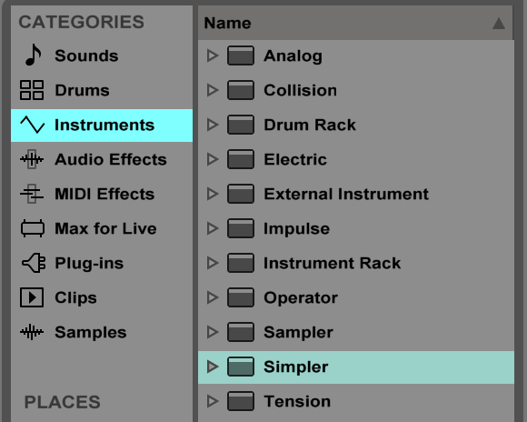 track.

Then drag a sample onto the Simpler instrument in the bottom of the screen where the instrument appeared. Let’s use a percussion loop for this lesson.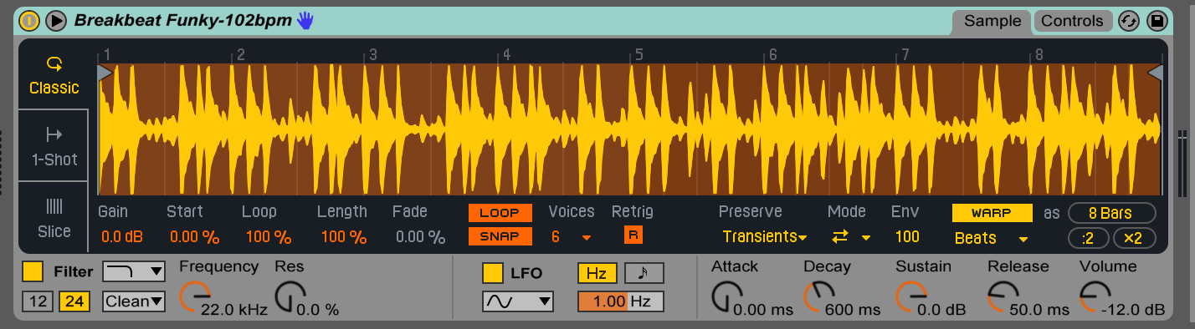

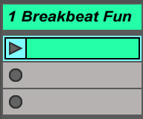

In the Session View, double click to a clip slot to create a new clip.

In the piano roll at the bottom of the screen, start drawing piano notes in or you use your keyboard to play notes (remember, you can switch between click and draw mode by hitting Cmd+B on a Mac. You can also toggle these modes at the top right of the screen.

Experiment with placing notes in the piano roll. Come up with a pattern that you enjoy. We will come back to the piano roll soon; for now let’s take a closer look at some of the parameters available to us in the Simpler instrument.

There are two windows for the Simpler instrument: our Sample window and Controls window, which you toggle between in the top right hand corner.

In our Sample window, we can control our sample start, length, loop length, warp and warp parameters, as well as our playback type. Try changing between the three different playback types on the left. 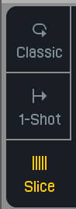

Classic can play back samples **polyphonically**, meaning the sample can be played onto of itself (think of a guitar, which can sound multiple pitches at once).

One shot is **monophonic**, so only one sample can be played at a time. Thisis suitable for drum samples (we will look at this further in the drum rack).

Slice allows one to chop the sample up; this has been used to tremendous effect in hiphop for several decades (<https://www.youtube.com/watch?v=O5azBmHDQvY>)

Play with these sample types. Create a beat that you enjoy.

This kind of instrument (one that uses audio and re-itches it for playback) is known as a **sampler**.

# ENVELOPE SEQUENCING

In our clip editor, let’s take a look at the envelope box (navigate there by clicking the E circle at the bottom of our clip editor).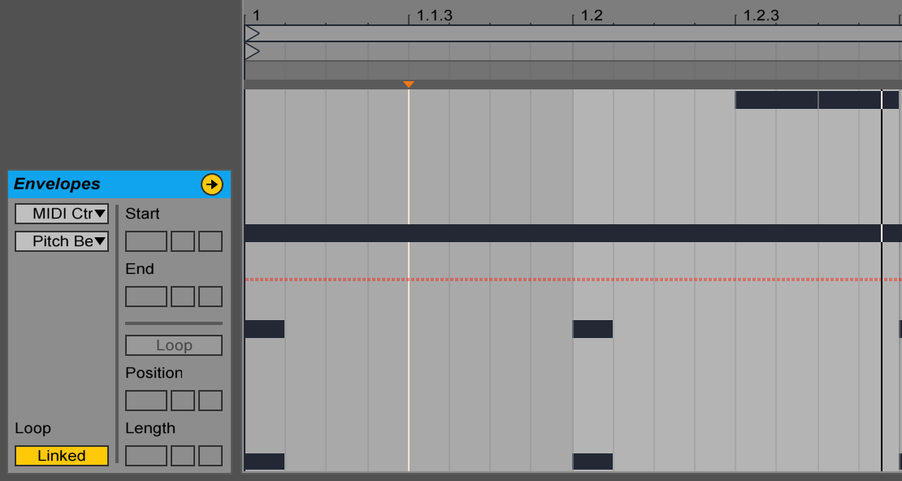

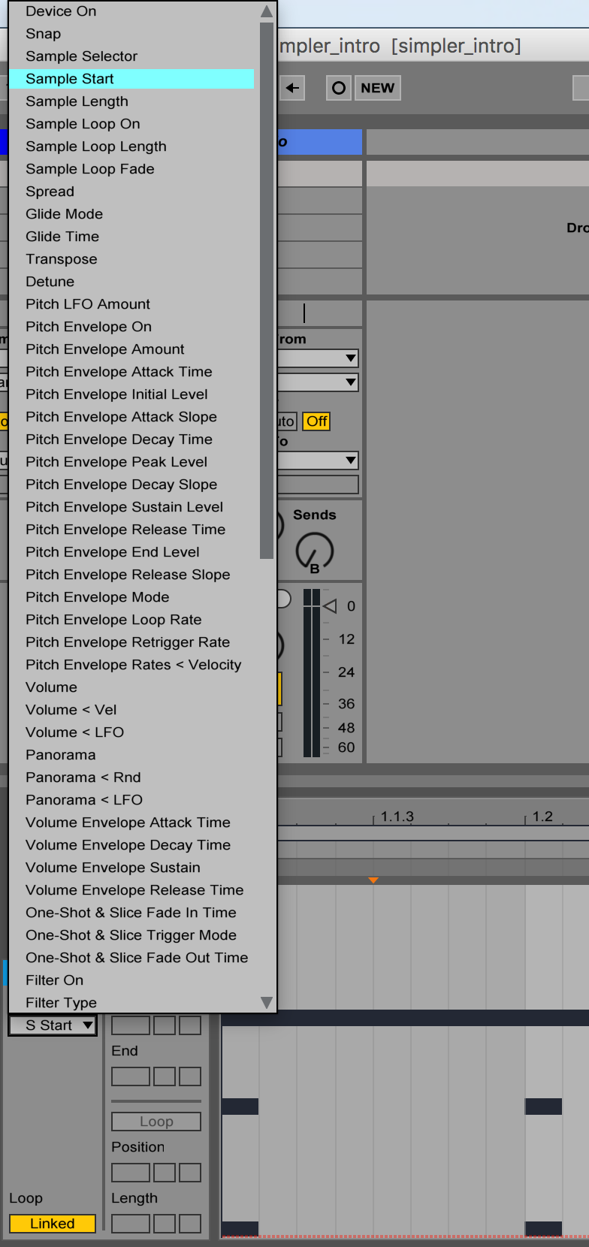

This view gives us tremendous sequencing power for each individual clip. Click the scroll down menu that says “MIDI Ctrl” and select the name of your sample. Click the menu beneath it, you will see a long list of options. These are all different parameters within our Simpler instrument. In this way, clips can contain sequencing information the same way the Arrangement view can.

So when would you use the clip sequencer and the arrangement view’s sequencer? The clip’s sequencer is good to create distinct, looping patterns. The Arrangement view is more suitable for longer form composition. Let’s explore sequencing in the clip for a bit.

Let’s choose Sample Start from our parameter list.

Add some sequencing to this parameter. Double click your track and see how the Sample Start parameter is moving on the Simpler instrument.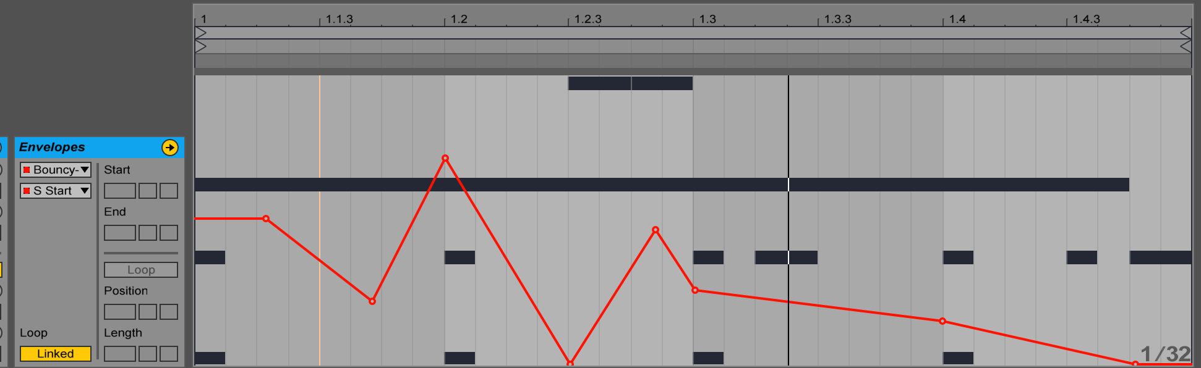

Create a new clip, draw in a bar of sixteenth notes, then sequence your Sample Start from 0-100% over the course of the bar.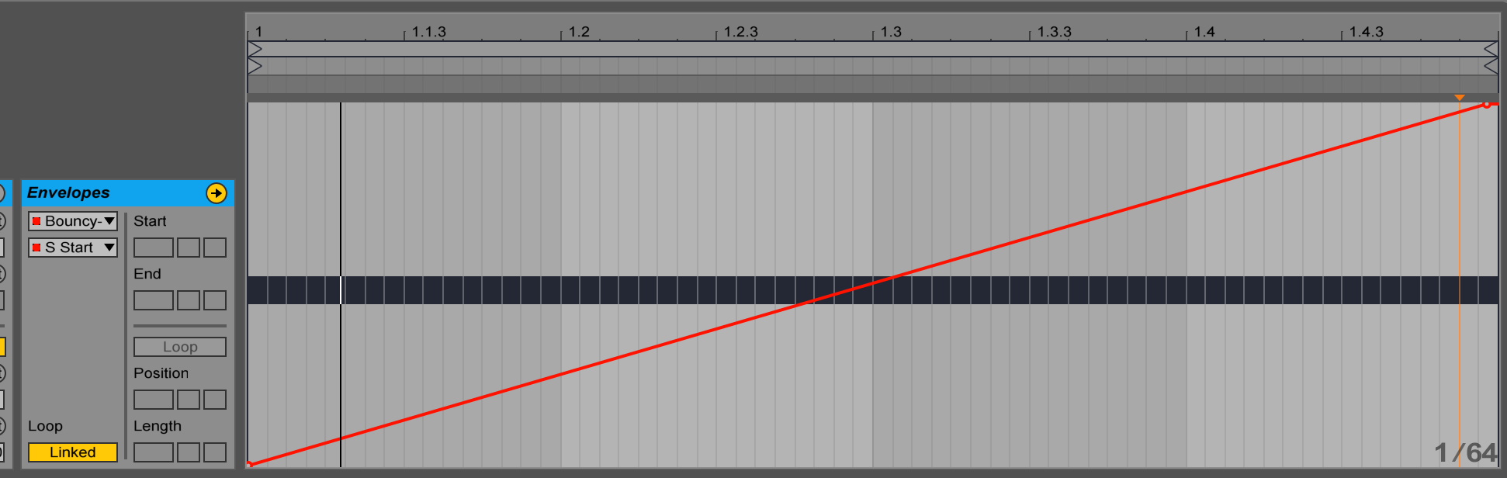

Notice how similar this sounds to your original sample. Now try creating ‘plateaus’ within the Sample Start time for a glitchy, roll effect.

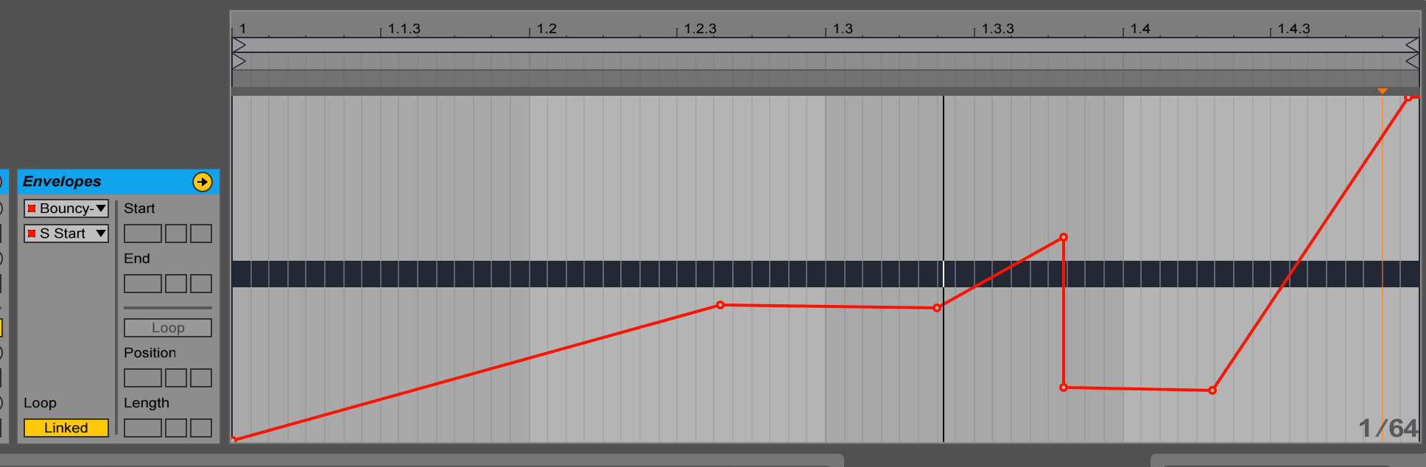

Let’s try sequencing a different parameter. Perhaps Filter Frequency?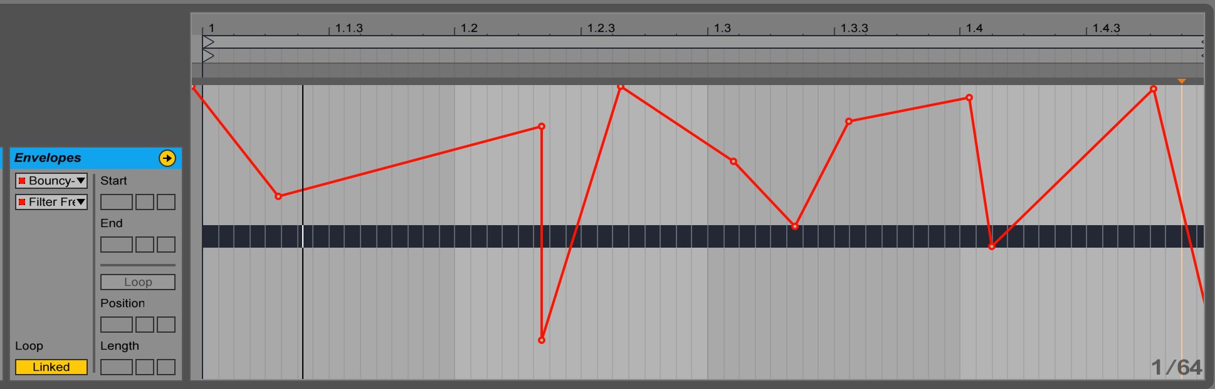

We can also change the length of the effect sequencing in the clip so that it’s different than the length of the clip. This can create interesting phasing patterns between effects. In the Envelopes window, change the toggle under ‘Loop’ from ‘Linked’ to ‘Unlinked’.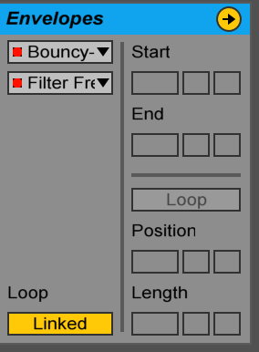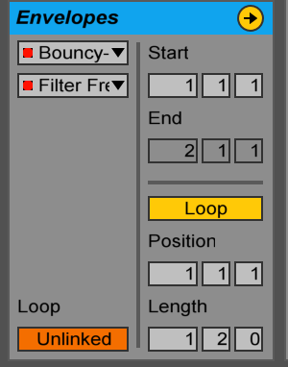

Try changing the length from 1 0 0 to something different. The length is measured thus:

**BARS : BEATS : SUBDIVISIONS**

Let’s exit our envelope window and return to the Notes window. Try clicking the **:2 *2 Rev Inv Legato** and **Dupl Loop** to see what happens and how your loops changes. What have you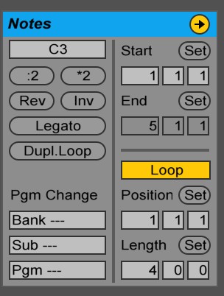 noticed?

This provides you with many ways to create variation between your clips. You can duplicate clips, create slight changes (to envelopes, notes, looping, length, etc), and then dynamically switch between them for very flexible jamming. You can choose when the clips are triggered using the **quantization menu** in the top right, which we had mentioned last class.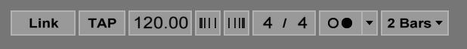

If you want to link clips together, or create probabilistic triggering of clips, you can explore the Launch window by hitting the L at the bottom of the Clip View. Let’s put that aside for now, however, and return to our instrument.

# SIMPLER FOR MELODIC PARTS

Now that we have some rhythm, lets see how we can use Simpler to create a melody, and in doing so, reveal some fundamentals of sound design.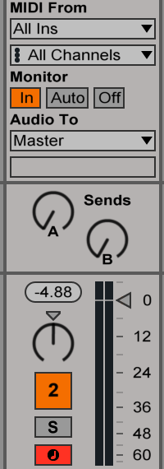

Create a new MIDI track, or just use the second MIDI track that’s provided (To create a new MIDI track on a Mac, hit Shift-Cmd-T or right click and select create new MIDI track). Drag and drop a **pitched** sample onto the Simpler (pitched being any sample that has a definite fundamental frequency to it, in the provided Ableton samples, the fundamental frequency is written to the side of the sample name).

Use your keyboard to record a MIDI track, listening to your beat as you do so. Be sure to hit “In” on your mixer. You can also use the metronome in the top right instead of, or in conjunction with, your rhythmic part. You can use the X + Z keys to switch between octaves for the computer keyboard. Feel free to record multiple takes.



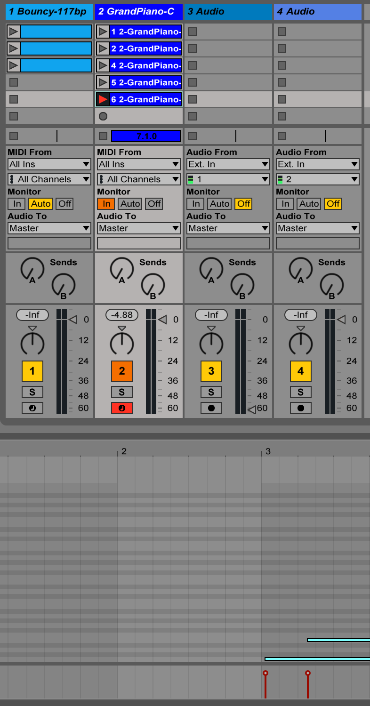

Edit your recorded MIDI notes - copy/paste, move notes around, draw in new notes, delete old ones, shift the timing. If you want to **quantize** (move everything onto the beat) what you just recorded, first select the notes you’d like to quantize, then hit Shift-Cmd-U (Mac) to bring up your quantize menu, choose the parameters that you feel are suitable, and hit OK. It’s nice to not fully quantize everything, so that there is an element of humanness left within the recorded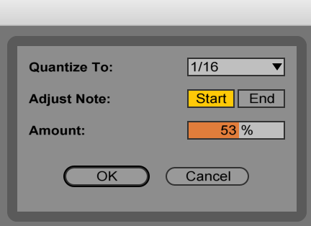 material.

Try recording multiple melodic clips, and playing them back with multiple rhythmic clips. See how the patterns can combine together. While you do this, hit the Record button so that you record these variations in the Arrangement View.

# CONTROL WINDOW

Let’s return to our melodic Simpler part. Change the window to the ‘Controls’ window. On the left, we have our filter. Try moving this around. You can change the filter type at the bottom of the screen. Filter options include **low-pass, high-pass, band-pass, band-cut,** and **morph** (goes between low and high pass). Try choosing these different filter types and changing them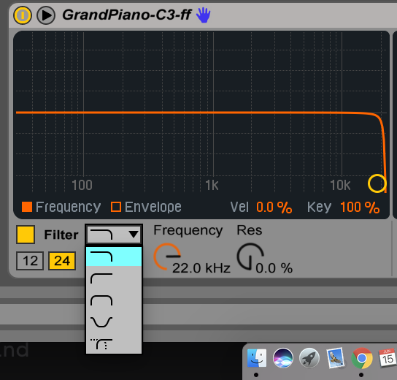 as you play your clip back.

To the right of this filter, we have our **LFO** - Low Frequency Oscillator. The LFO allows us to use a signal (oscillator) to change a parameter over time. This allows part of our effect processing to be **generative**, so that we don’t have to sequence every parameter change. Try changing the parameters of the LFO, such as the speed, waveform, and the parameters its controlling (filter, pitch, pan, volume). It can make your sounds really come alive!

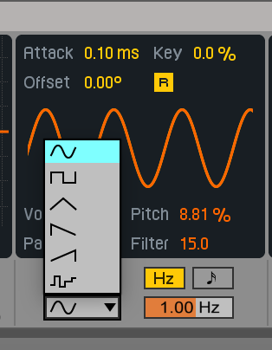

To the right of the LFO, you have your **Amplitude Envelope.** Try moving around the yellow boxes to change your **attack** (length of the sound to onset)**, decay** (length sound takes to drop down to sustain level)**, sustain** (how loud the sound is when it’s held)and **release** (how long the sound takes to reach zero amplitude). Other parameters include **pan**, **spread** (creates a **wider stereo image**), and mapping % for **velocity** (from MIDI) to **volume.** Experiment with this, notice how dramatically amplitude envelopes can shape the character of your sound.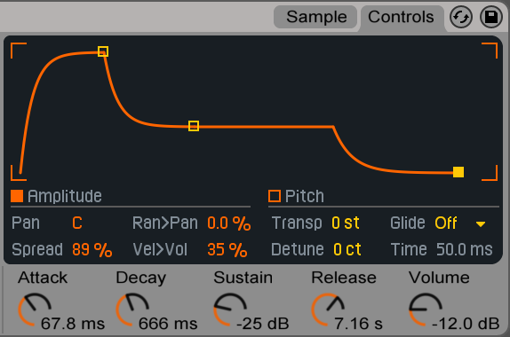

We can also click the box next to Pitch to show our pitch envelope. The parameters below pitch can control the instrument’s tuning (use **transpose** for changes in pitch by semitones; use **detune** for changes in pitch by cents (1/100th of a semitone)).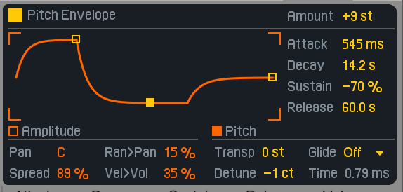

Lastly, if we return to our filter section, and click the orange box next Envelope, we come to our **filter envelope**. This can help shape the onset of our filter, which adds another layer of subtlety and dynamism to our sound.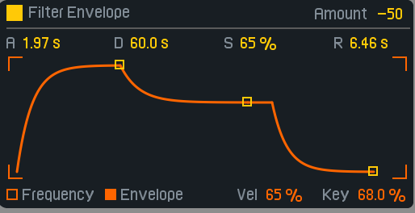

# SAMPLE WINDOW

This is nearly a full overview of everything within Simpler’s Controls menu, but there’s more yet in the Sample window! We can cover this briefly. Returning to the sample window, notice at the bottom of the screen you have your filter controls, your LFO controls as well as your amplitude envelope ADSR controls. This can allow you to stay primarily on the Sample page, without having to switch back and forth between the pages so frequently.



Above that, you have general controls for your sample, including start position, length, loop %, and warp type (the warp type is the same as an audio clip, which we covered last lesson).

Lastly, you can change the sample start/end points and the warp markers manually by editing the sample itself. If you right click the sample, you can also quickly edit it through **reversing, cropping** (shortening), and **normalizing** (setting the highest amplitude to 1, and scaling everything accordingly).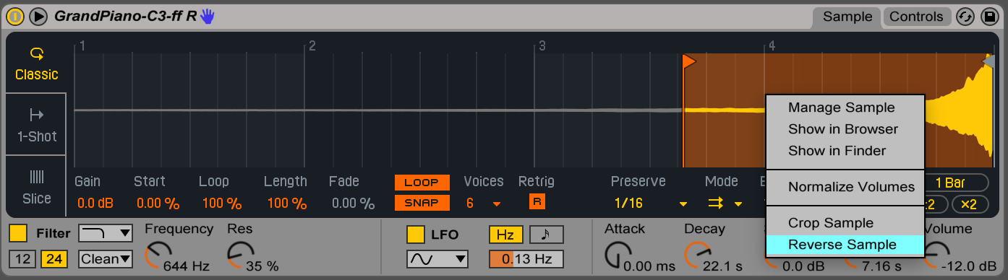

# DRUM RACK

If you want to use many Simplers, where each MIDI key can become its own Simpler, check out the Drum Rack. This allows us to create **drum kits** using multiple Simplers.

Let’s drag and drop the Drum Rack instrument from the instrument browser to create a new Drum Rack. Then load a few kick and percussion samples into its pads by dragging a dropping.

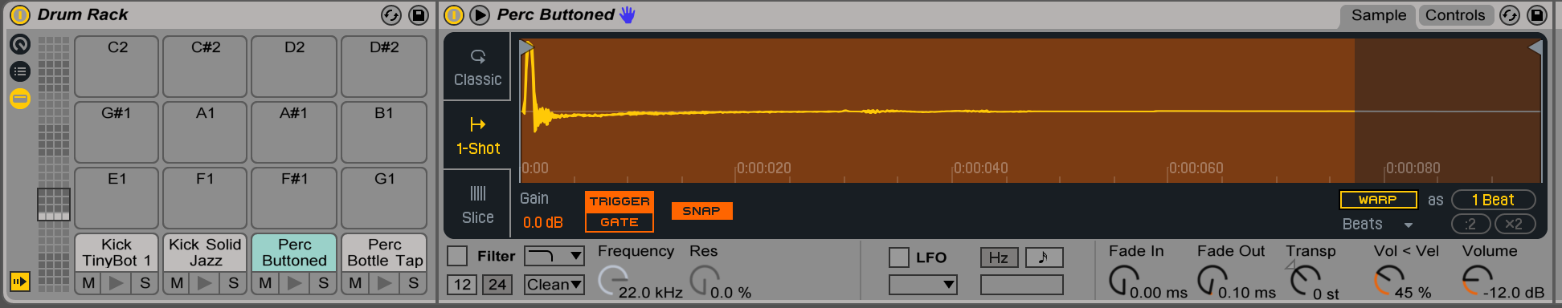

Notice that the filter, LFO, and warping are turned off by default for our sample. This helps conserve CPU power when you have many different samples loaded up.

Now that we have our percussion loop, and our melodic part, lets add a drum rack loop by recording a new clip. You can use your keyboard or key in the parts as you’d like.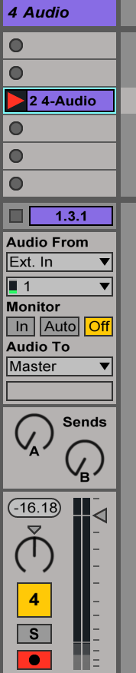

# RECORDING YOUR OWN AUDIO

You are well on your way to making a *phat track!*

But for those who have proficiency in acoustic instruments, how to integrate that into our live set? We can record using an audio track (as we saw in Lesson 1) by hitting the red arm button in our Mixer section and then hitting the circle in our clip slot. Once the clip is recorded, you can drag and drop it into a Simpler instrument.

Try recording your voice, or a friend’s voice, throwing it into a Simpler and manipulating the sound - play with the start time, filtering, envelope, create harmonies, slice it up and create beats - the possibilities are endless!

For next class, use as many Simplers as you’d like to create a track. Looking forward to hearing everyone’s work!