BASIC EFFECTS

A quick review of the last lesson:

1. Simpler is a dynamic MIDI based sampler useful for both rhythm and melody.
2. Clips can contain effect sequencing through the envelope window.
3. Simpler has a built in filter, which has different modes and parameters.
4. Simpler has a built in LFO for generative changes in the sound.
5. Pitch and amplitude envelopes can help shape the sound in Simpler.
6. The Drum Rack is an array of Simpler instruments, useful for creating drum kits.
7. You can record your own audio and use this as the sample material.

For this lesson, we will cover a wide swath of the effects available in Ableton Intro (other versions of Ableton contain an extended library of effects, but when just beginning, the effects available in the intro version are enough).

# AUTO FILTER

There are several effects which are indispensable to a wide variety of musical gestures and genres - filters are one such effect. From the wah-wah effect of guitar pedals , to the squelchy formants of acid house (<https://www.youtube.com/watch?v=j0YyBp8ZyeE>), filters have a wide range of applicability and aesthetics.

To understand the function of a filter, it’s important to first understand a bit about how audio works. (THIS SECTION REQUIRES THE FULL VERSION OF LIVE WITH THE *SPECTRUM* INSTRUMENT. ALTERNATIVELY, THE SAME PRINCIPLES COULD BE DEMONSTRATED IN MAX USING THE [spectroscope~] )

## EXPLANATION OF FREQUENCY SPECTRUM

What is that makes my voice different from your voice? A guitar string different from a violin string? A snare drum different from a firework? This quality of sound, that which is not amplitude, duration, or pitch, is called **timbre** - the unique and definitive color of a sound. This is why a cello will sound like a cello no matter the pitch - even if it’s playing the same frequency for the same length of time as a trombone, it will still sound like a cello and the trombone will sound like a trombone.

What gives a sound its timbre? The answer lies in the **frequency spectrum**. Let’s listen to a sine tone (play sine tone). Believe it or not, all sounds, no matter the timbre, are made from an infinite number of sine tones. Sounds crazy, right? (We will look at this more in a few weeks when we cover additive synthesis). This has been proven by a French mathematician named Joseph Fourier (the mathematics of which we don’t have to cover for this class). How does this relate to timbre? Well, timbre is determined by a sound’s spectrum, which is comprised of the sum of this infinite number of sine tones, with each sine tone at a vary frequency and amplitude.

To demonstrate this let’s compare the frequency spectrum of two different synthesizer sounds: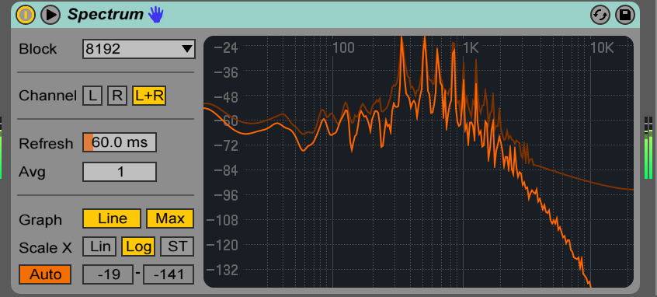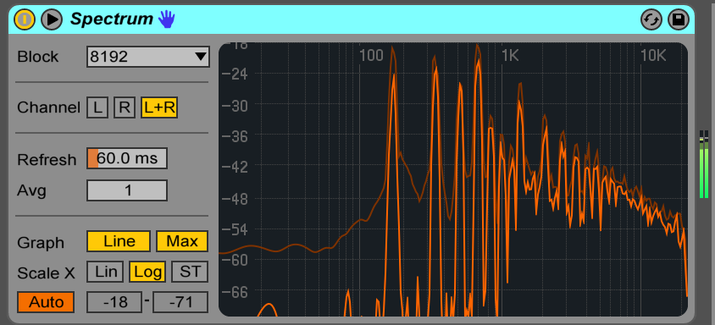

You can see that even though the two notes are the same, their frequency spectrums look different. This graph shows the amplitude of the component sine tones of the sound’s timbre. You can see with the first, **brighter**, synthesizer, there is more energy in the upper partials, and less energy in the low end. The second, **darker** sound has a steeper cutoff in the upper frequencies and some noise in the low end.

## FILTER TYPES

What a filter does it cut away part of the frequency spectrum, thereby dramatically (or at times subtly) reshaping a sound’s timbre. Let’s look at how the timbre changes in our first sound we use a low pass filter (the default mode for Auto Filter).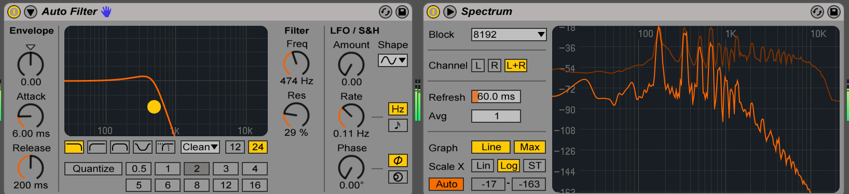

Notice how the upper frequencies have been attenuated. Let’s try our different filter modes (**low pass, high pass, band pass, notch, morph)**.

High pass (cuts away lower frequencies):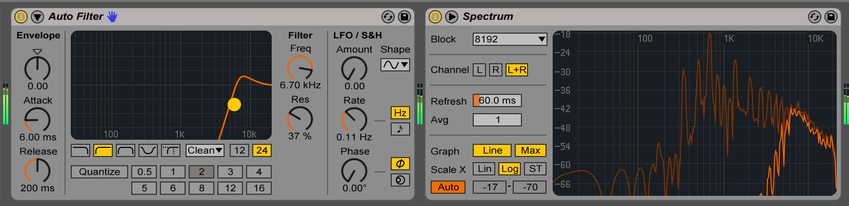

Band pass (only lets through a frequencies in a certain range, like a combined high and low pass filter):

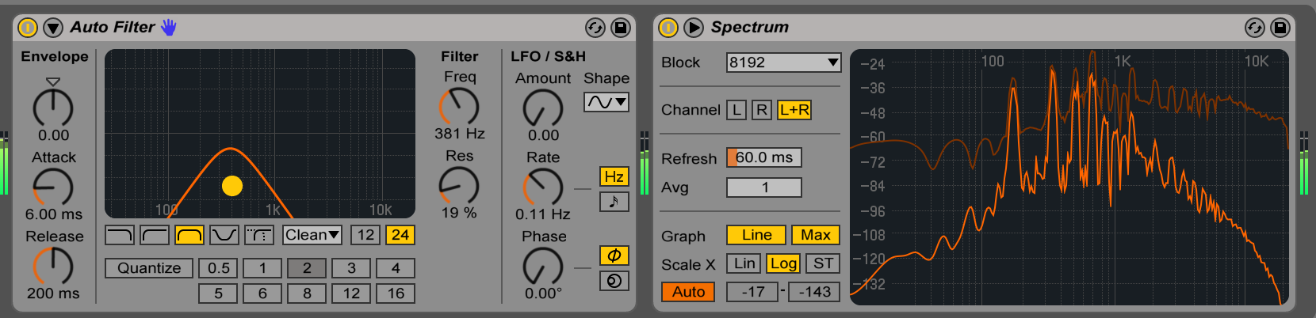

Notch (the opposite of a bandpass, only filters out a small frequency region):

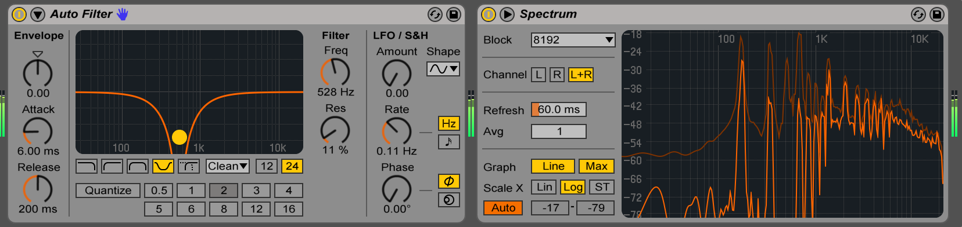

Morph (dynamically changes between low<->notch<->highpass):

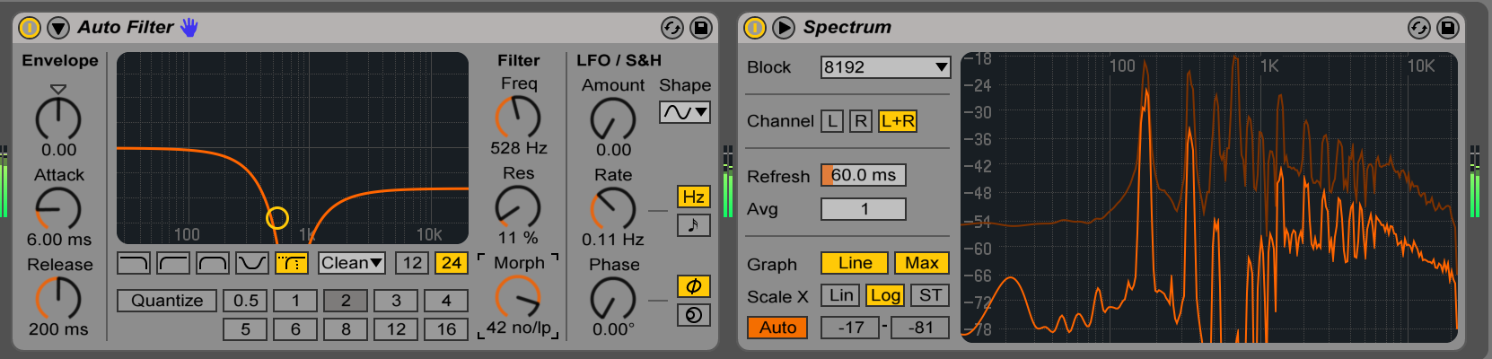

There are a few other functions to the auto filter. Let’s briefly explore these.

On the right of the graphic control, you have the frequency and **Q** (which you are controlling graphically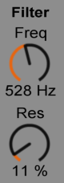 as well). **Q** creates a sharpness to the filter at its cutoff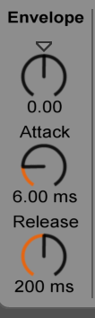 frequency. High Q values can create **formants** (areas in the frequency spectrum of higher amplitude within a sound - this is what creates vowel sounds).

To the left of the graphic control, you have the **envelope** parameters. This connects the incoming sound’s loudness to the filter frequency. The attack and decay determine how quickly the envelope moves up and down according to the amplitude.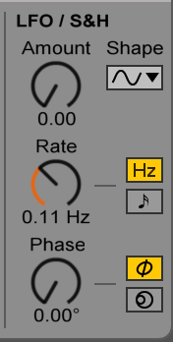

On the far right you have control over an LFO (recall our LFO from Simpler) which controls frequency. The bottom phase/spin control changes the behavior of the LFO for the right and left channels, where phase changes the peak/trough of the two channels, and spin detunes the channels.

Let’s play around with these controls for a bit and see what kind of behavior we can come up! Remember that you can change sequencing in your clip with the Envelope window to loop effect changes, or you can record the changes into your Arrangement window. Also, note that the Arrangement window can be looped by using this screen at the top:

# EFFECT CONTROLS

Before we go on, a quick note on the buttons at the top of your effects:

The button on the far left turns the effect **on/off**. It’s best to turn an effect off when not using it, since this helps save processing power. You can also use this to experiment with how your track sounds with/without an effect.

The triangle to right of the on/off button is for **sidechaining**. This allows the effect to be controlled by the amplitude of another track. Only some effects have this capability. We will explore this further when looking at mixing and mastering.

On the far right (the icon that looks like a floppy disk) is the **save** button. You can save your own preset if you particularly like the effect settings you’ve come across. Just to the left of that is the **hot-swap** button to quickly try out other effects in place of our effect.

# DELAY

Another effect that is used extensively in all kinds of musical contexts is **delay**. Ableton features two kinds of delays: **Simple Delay** and **Ping Pong Delay**. Today we’ll take a look at Simple Delay.

Let’s first turn off our autofilter from our track by clicking the on/off button. We will get back to it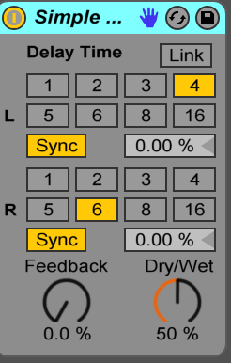 later.

Taking a look at Simple Delay we see that is quite….simple.

There is an independent delay time, counted in 16th notes, for both the left and right channels. Microadjustments can be made to the delay time using the 0.00% next to the sync button. **Feedback** controls how much of the delayed signal gets sent back into the delay. The signal path for a delay looks like this: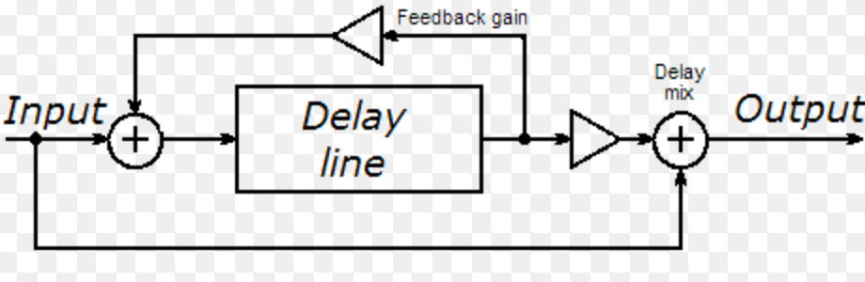

Feedback is what creates the ‘echo’ effect within a delay. What are the parallels between a physical echo and a delay with feedback? (A physical echo is delaying the sound by a set amount based on distance, with each reverberation of the sound being decreased in amplitude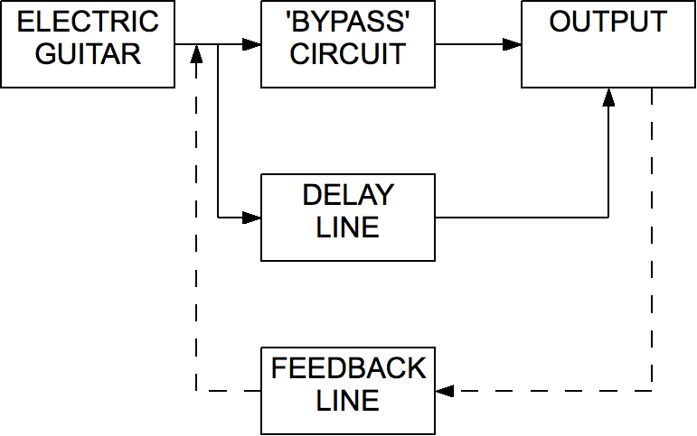 as it bounces off the physical structure).

**Dry/wet** controls how much of the signal gets sent through the delay, and how much of the signal bypasses the delay. With our feedback, each channel’s **signal** **flow** would like this:

The delay times for the two channels can also be linked with the button at the top, or synced/unsynced from the tempo using the sync button. Play around with this to get a sense of how the delay sounds using various settings.

# PARALLEL VS. SERIES PROCESSING

Whether effects are in **series** or **parallel** will shape the sound in certain ways. For effects in series, the audio is sent first to one effect, then to the other, then to another, etc., so that the changes from one effect get passed to the next effect. For effects that are in series, the order of the effects will change the quality of sound. Right now, our delay and filter are set up in series. Try placing the filter before the delay, and manipulating the delay with a high feedback on the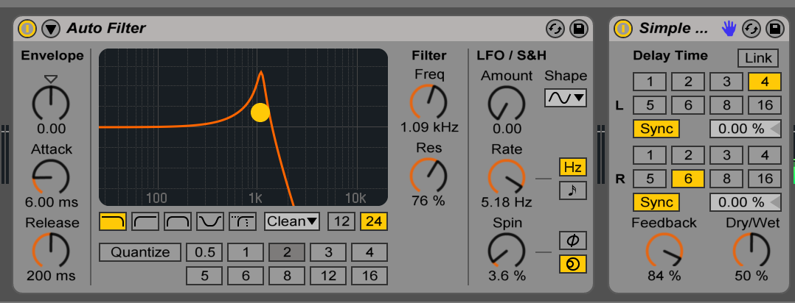 delay.

Now try changing the order. Did you hear any difference? Why do you think there is this difference? (Since changes in the filter are sent into the delay in the first series configuration, the sound of the delay is changed by the filter manipulation).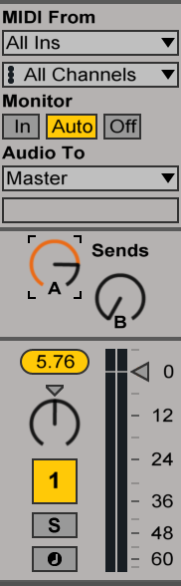

For parallel processing, the two effects are processed separately and simultaneously. We can do the with **sends/returns/auxillary channels** (these are multiple ways of saying the same thing). Within Live Intro, each project can have up to 4 aux channels. By default, our project starts with two. You can see how much of the audio is sent to the aux channel in the mixer view, above the gain slider.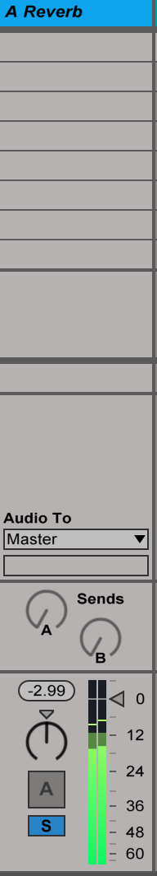

Try turning up **Send A**. What do you hear? By default, send A is reverb, an effect which simulates the sound of a certain space. The aux channels are on the right hand side of the Session View. Try soloing this channel by hitting the S button, notice the quality of this sound. Unsolo the sound and compare the two. Sends are very useful for mixing and creating greater depth with the sound. We will explore this more in the future when looking at mixing/mastering.

# REVERB

Since we’ve turned up the send on our reverb, let’s take a look at what our reverb effect can do. There are numerous parameters for our Reverb, each connected with some representation of what the sound will be like inside a physical space. It’s good practice to refer to the info window in the bottom left of the screen to get an idea of what all the controls do. In addition, simply exploring and tweaking can give one an intuitive feeling for how the effect can be varied.

Before we look at all the parameters of reverb, we should ask how is it that sound behaves in a room? What is happening to sound as we sit here, in this room, talking? What is sound anyways? Sound can be defined as **compression** and **rarefaction** of air molecules. Here are two illustrations to demonstrate this behavior: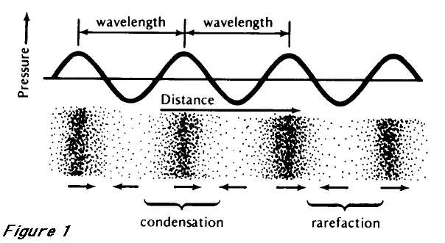

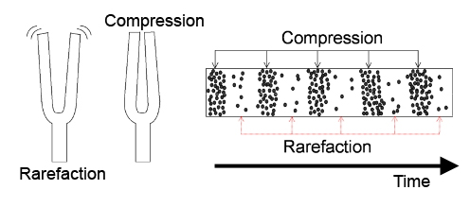

Within an enclosed physical space, the patterns of compression and rarefaction (i.e. the sound waves) bounce off the walls, dampening their energy and being reflected onto other walls, further dampening their energy and creating more reflections. In a way, a room can be thought of as a complex, intertwined series of delays and filters. Our reverb has multiple controls for the characteristics of the delays and filters.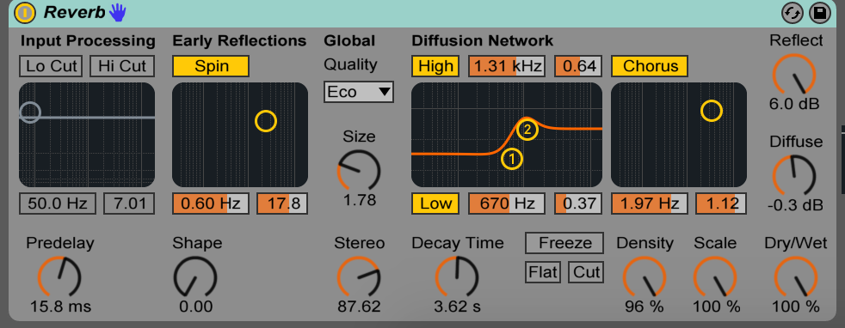

Since there are so many parameters, each one will be touched on just briefly. Let’s begin with the various dial controls, which mostly are used to control the delay parameters.

**Predelay** determines how long until the first reflection; **shape** tapers the gain on early reflections; **quality** determines the delay algorithm, trading processing power for sound quality; s**tereo** creates more of a difference between the right and left channels; **decay time** has a very distinct effect on the length of the sound’s decay; **freeze** sustains the reverb endlessly; **density** can be imagined as changed the material the sound reflects off of, with higher values creating greater reflectivity; **scale** determines the number of later reflections; **reflect** controls the gain of the early reflections; **diffuse** controls the gain of the later reflections; **dry/wet** is the same as the dry/wet for delay.

The graphic controls begin with filtering the input sound for the **input processing**, changing the coloring of the incoming sound; **early reflections** slowly modulates the amplitude of early reflections; **diffusion network** applies filtering to later reflections; **chorus** adds a chorus effect, which is a slowly modulating series of delays with short delay time, which creates a sense of the sound being ‘thicker’ or ‘soupier’ than before.

Reverb can be used in moderation to add depth and space to your sound, or it can be used in excess for a heavily processed, spaced-out sound. The choice is your’s! The beauty of these effects is the vast array of the aesthetic results they can lead to, from slight coloring to total warping.