MIXING, MASTERING, PLUGINS

Let’s briefly review last lesson. We learned:

1. Autofilter, its various modes and parameters
2. What the frequency spectrum is and how filtering changes it
3. How to save, swap turn on/off effects
4. Simple Delay and its parameters
5. The difference between parallel and series processing
6. The nature of sound and how it behaves within a space
7. Reverb and its different parameters

In addition, using the basic knowledge you have of Ableton, you have been able to begin making your own musical creations. Beyond finding cool sounds and making interesting sequences, one crucial stage to producing music is the process of **mixing** and **mastering**. Mixing refers to finding a proper balance between all the component parts of a track. What instruments do you want to be prominent? What do you want to be subtle? Which channel is louder for what instrument? These decisions will all contribute to the final feel of a track, and be one of the component factors in giving a producer or composer his ‘sound’.

Mastering is the process of getting a track to be playable on all kinds of system. The speakers from an iPhone 4 are very different from the speakers at Berghain. Mastering involves the application of certain effects, alongside judicious mixing, to fill out the frequency spectrum, thereby making one’s track convincing no matter the playback conditions.

Both mixing and mastering are fundamentally ways of changing the loudness of our sound. The two effects we will look at today, the **equalizer** and **compressor**, are both means of changing loudness.

# PLUGINS

The clever marketing team at Ableton Live refrained from including within the Intro package a crucial effect for mixing and mastering - the parametric EQ (known in Ableton Live as EQ8). 沒關係！This can be easily remedied by using **plugins**. Plugins refer to either **VST**s (Virtual Studio Technology - Windows and Mac) or **AU**s (Audio Units - Mac), which are software-based audio tools that can be used within our DAW. These tools span every kind of audio application you may need, every color and variety of synthesizers and effects. For this tutorial we will just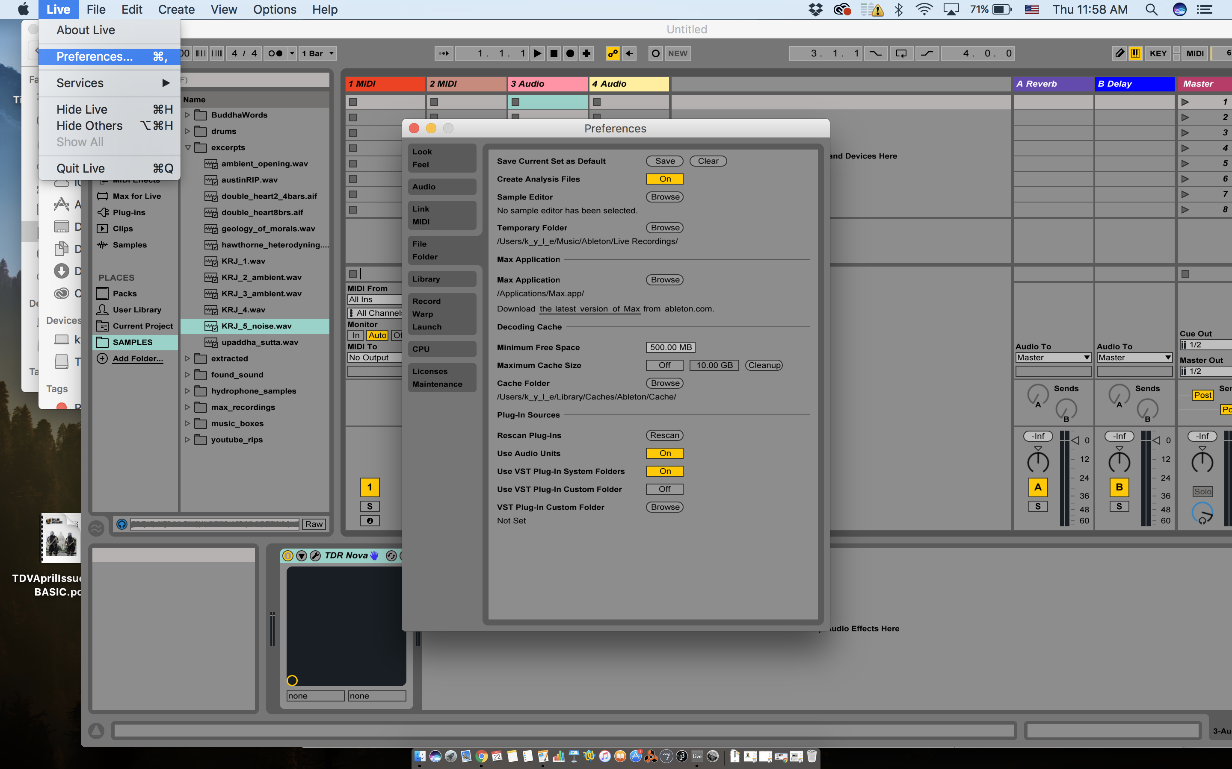 use the TDR Nova EQ (available for free for both Mac OS X and Windows), but it’s good to know that plugins exist and can be used to infinitely expand the palette of your DAW.

TDR Nova EQ has already been installed on these computers, but if you want to add your own VST or EQ, you can go to the Live menu -> Preferences -> File Folder and make sure that you have the proper folders indicated for VST and AU (if on Mac).

# EQUALIZATION

So what is this mysterious plugin TDR Nova EQ and why do we want to use it? Well, an **equalizer** (or EQ for short) is a series of filters that are useful for helping shape the frequency spectrum of a sound, cutting out unwanted portions, reducing overly amplified parts of the spectrum and boosting parts that one seeks to highlight (note that our ears are more sensitive to **boosting** levels than to **attenuating** levels. When trying to subtly blend the component parts of a track, it’s best to start through reduction rather than boosting). Let’s see what this sounds like.

Let’s experiment a bit with this process. Load up the Simpler preset *Glas Filtered Verb Noise****.*** Turn down the filter cutoff, resonsane, and reverb amount so that all we have is something resembling white noise (which gives us a frequency spectrum of even distribution). Click on the tool icon of the TDR Nova EQ effect to open up its GUI:

Explore moving the blue dots label I, II, III, and IV. Notice how this changes the sound. What do you think the X and Y axes represent for this GUI?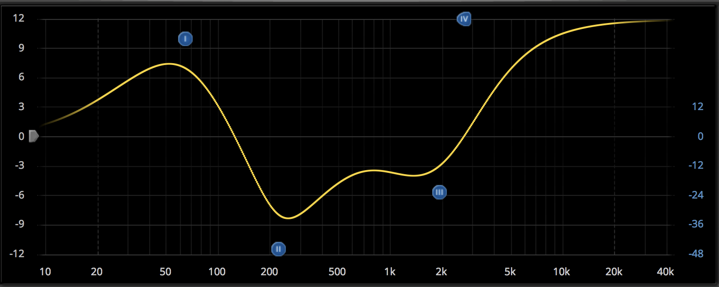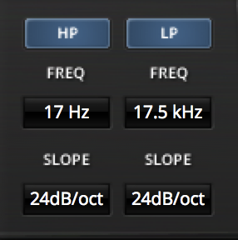

The blue dots are known as a **parametric EQ**, these create formants in the sound. They can be imagined as bandpass or notch filters which can be dynamically interpolated between and which are mixed with the rest of the sound. Equalizers often also have low pass and high pass filters, or shelving filters (more on these later). You can find the LP and HP filter in the bottom left of TDR Nova.

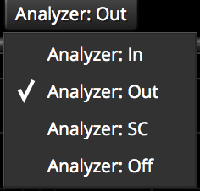

In the top right, there is an ‘Analyzer’ menu. As guessed, the X-axis for our GUI represents frequency, and the Y-axis represents decibels (loudness). We can turn on Analyzer to see directly how our equalization is affecting the frequency spectrum. Try it out!

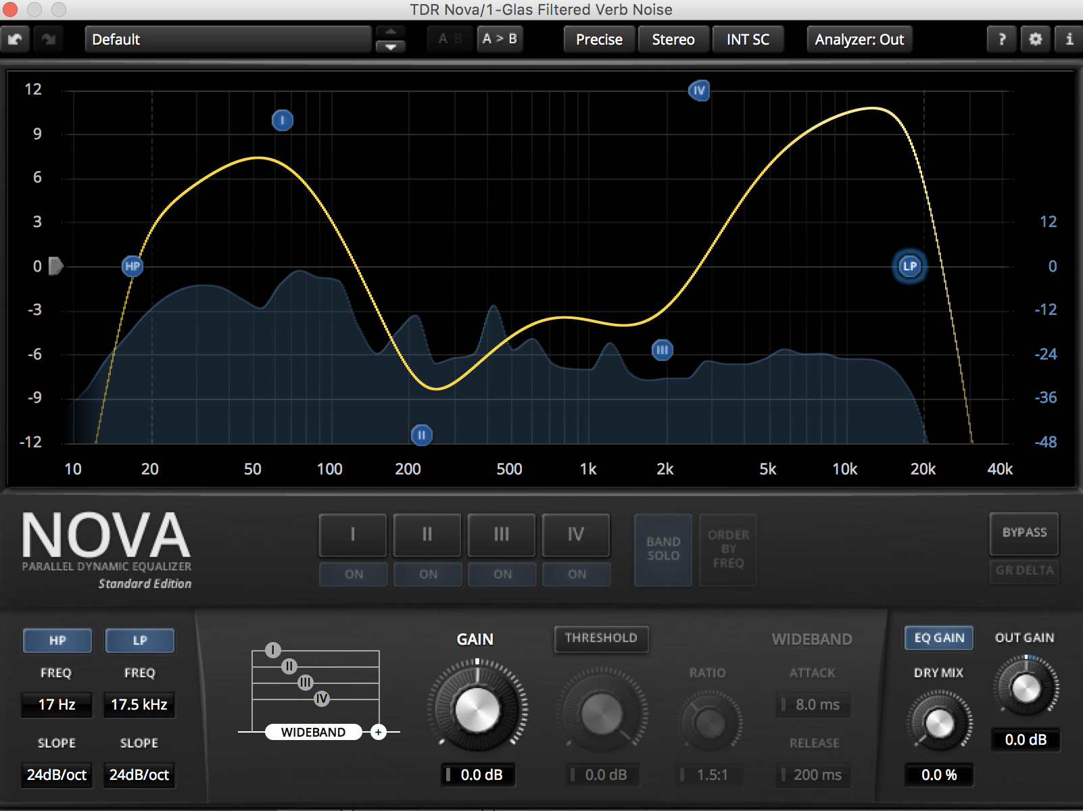

Let’s check out some of the parameters for our EQ. When we click on the grey I, II, III and IV buttons, we will get controls at the bottom of the screen that look like this: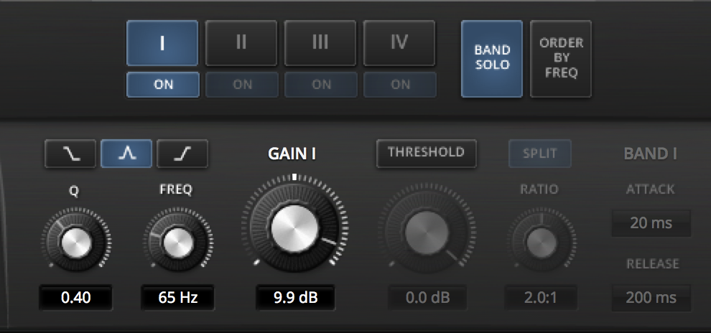

On the left, we have our Q and Frequency (like in our Autofilter) for our parametric EQ. We can change the parametric EQ to a **low-shelving filter** or **high-shelving filter** by clicking the buttons above the Q and Freq knobs. This creates an overall boost or reduction for all frequencies either above or below a given frequency. This boost or reduction can be controlled with our **gain** knob. To the right, we can click the threshold to turn on a **multi-band compressor**. What does that even mean? I am glad you asked.

# COMPRESSORS

Alongside equalizers, compressors are a primary tool for mixing and mastering. Compressors work by measuring the amplitude of an incoming signal, and decreasing the amplitude of the sound when it exceeds a given **threshold**. The rate at which the amplitude is decreased is known as the **ratio**. This **flattens** (thus the name ‘compressor’) the sound by making the louder portions closer in amplitude to the softer portions. After compression, the overall gain can be boosted to bring the sound back to its original peak amplitude.

Within Ableton Live, we can use the aptly named **Compressor** effect for compression.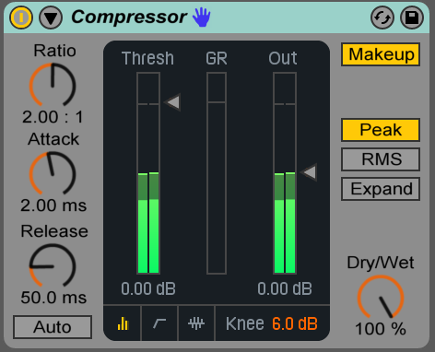

Let’s take a gander at the parameters for our compressor. As you can see, we have the above mentioned **ratio, threshold,** and **output** **gain**. In addition, we can adjust the **attack** and **release** to change how quickly the amplitude attenuation is applied and released. Having long attack values is useful when you want to preserve the initial character of a sound (such as the strike of a kick drum, or a piano hit); short attack values are useful when you are looking to soften and smooth out a sound’s initial attack (to perhaps take the bite away from a snare).

On the right, the **makeup** button automatically adjusts the output volume to some degree, serving essentially as a responsive gain stage (this is applied prior to the Out boost). **Peak** and **RMS** are two different methods of measuring amplitude. Peak looks at the overall peak amplitude of a signal with a short period of time. This is useful for compressing sounds that have momentary bursts of sound. RMS stands for **Root Mean Square**, and this method of measuring the amplitude squares the amplitude, then finds the mean of the square root. This is because the amplitude originally fluctuates between -1 and 1, so finding the RMS allows one to account for the highest amplitude, regardless of its polarity. This is useful for longer, sustained sounds (instruments as opposed to percussion). Lastly, **Expand** inverts the function of the compressor, so that when a sound rises above the threshold, its amplitude *increases* according to the ratio.

By clicking the arrow at the top, we can create **sidechain compression**, which allows the behavior of our compressor to be determined by a different audio track. This is frequently used in hiphop and dance music to create a ‘pumping’ effect between the bass and kick. Since both the bass and kick occupy the same frequency region, sidechain compression is very useful technique to balance these two competing elements. It has its own distinct aesthetic, and can be heard very clearly by artists such as Flying Lotus (<https://www.youtube.com/watch?v=XUEOSi6Xa3Y>). Notice how everything ‘bounces' with the kick within this track. In a sense, our track is breathing with the kick drum - very useful for bass-heavy music. We can use the filter within our sidechain compression to isolate the kick if we are working with a mixed drum track. Let's play around with this.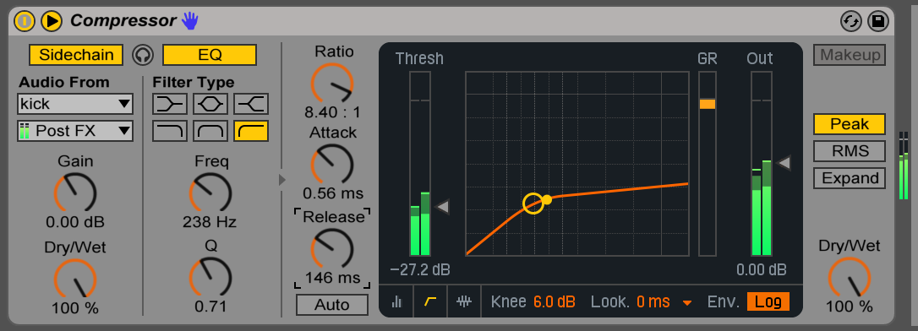

# MIXING

Mixing refers to the balance between sounds and instruments within a song. Mixing is largely dependent on the aesthetic, genre and intended venue for the track. Classical music is mixed with a large **dynamic range**, meaning there is a significant difference between the softest and loudest part of the track. Pop and dance music, however, tends to be heavily compressed with a minimal dynamic range as to give it more presence when played on the radio. Outside of the ultimate feel of a mix, the levels should also vary through out the course of a track to bring instruments/sounds to the **foreground** or **background**. Another factor is considering the venue for your music. For instance, classical music will most likely be listened to on a home speaker system while casually sipping tea and discussing nuances of Immaneul Kant, while dance music will probably be blasted through stacked Function-1 speakers and subs into writhing, ecstatic bodies brimming with entheogen-induced transcendence.

The ultimate aim of mixing is to balance the frequency spectrum, cutting portions that are too loud and raising parts that are too soft. The chart on the following page gives one a sense of where each instrument ‘lives’ inside the frequency spectrum. A more complete version of this chart can be found here: <http://i36.photobucket.com/albums/e45/Hellpig/music/EQ_chart_1680-1050-1.gif> Using the analyzer within an EQ is a good way to get a visual representation for the frequency distribution in the sound, but it’s best practice to be dependent on one’s ears. Jason Corey, a professor from University of Michigan, put together a fantastic, free piece of software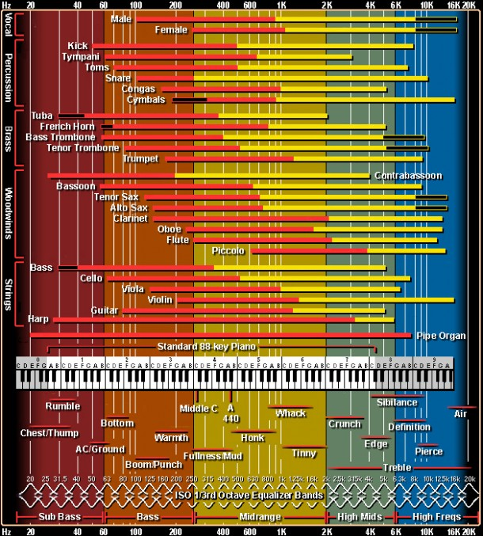 to train one’s ears: [https://sites.google.com/a/umich.edu/jason-corey/technical-ear-training](http://www.apple.com) Ear training is different than the classical tradition of dictation, interval recognition, etc. One has to be sensitive to the frequency spectrum and minute differences in its gain and attenuation.

# RESONANT FREQUENCIES

Another crucial factor in the process of mixing is one’s monitors and the room in which the sound is heard.To understand this, let’s examine a bit more closely the physical phenomenon of sound. How is it that instruments produce a pitch? All instruments create their pitch via vibration - a wind instrument vibrates the air directly, while a string vibrates the air around it. The pitch of this sound is determined by the rate of vibration, which in turn is determined by the length of the vibrating body. The longer the vibrating body, the longer the wave it produces, and longer waves have a lower a frequency. This is why a bass produces a lower pitch than a violin, or why a flute makes a higher sound than a bass clarinet. When you press a fret on a string instrument, you are shortening the length of the string, creating a shorter vibrational pattern and therefore a higher pitch. When you remove fingers from a clarinet, you are similarly creating a shorter vibration within the clarinet’s body, resulting in a higher pitch. The length of the vibrating body determines the **resonant frequency**.

This phenomenon is not limited to instruments; in fact, any space has a resonant frequency. In a sense, this very room is a giant instrument body, but the vibration within it are not consistent enough, nor of enough force, to make it resonate. If it were to resonate, the fundamental pitch would also be below our range of hearing. However, the **harmonics** would be audible if given enough force. Alvin Lucier, a great musical innovator and sound artist from the 20th century, beautifully elucidated this principle in his work ‘I Am Sitting in a Room’ (<https://www.youtube.com/watch?v=fAxHlLK3Oyk>).

Speakers and rooms all have their own resonant frequencies. These can be dampened by padding the walls with absorbent material. These resonant frequencies will slightly color the sound, giving it a different hue when played in different spaces and out of different systems. This why for mixing, it is important to play your material on a number of devices and in a number of spaces to make sure that, no matter the conditions, the mix comes through and is aesthetically convincing.

# MASTERING

Mastering refers to the process of polishing a song after mixing, performing final EQ tweaks, compression and gentle effects. Mastering does not seek to change the content of the song, but rather to fill it out, refine it and make it shine. Mastering is like the varnish of a track, giving it durability and a polished veneer. Mastering is performed on the **master track**, that is the track on the far right of Ableton that all the other tracks get sent to. Mastering tends to take advantage of several audio effects, including compression, EQ, reverb and limiting. The first three effects can be put in different order (depending on the desired aesthetic), while a limiter is always placed last to ensure that the audio does not **clip** (exceed 1 or -1 in its levels).

Compression on the master track should be subtle, with an attack around 30ms, a release of 1 second or so, a low ratio, and a mid-high threshold. There’s often lots of power in kicks, so it can be good to filter out kicks using sidechain compression on the master track, such as the settings below. Keep in mind, mastering compression should be subtle. It should make your song loud, but not overwhelming.

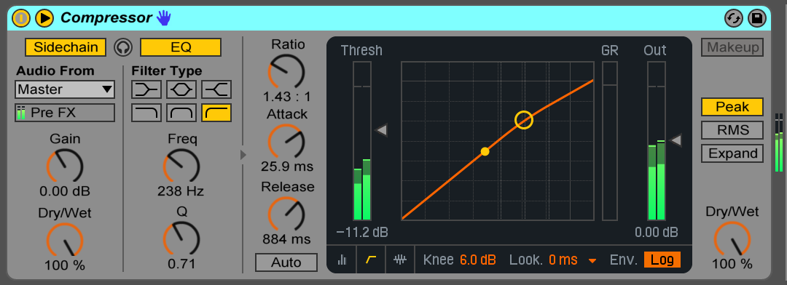

Similarly, EQ should be approached subtly, creating slight attenuation or boost on the master track within the needed frequency ranges. Placing compression after the EQ will create a fuller sound, while placing the EQ after the compression creates a greater dynamic range.

Light reverb can also be placed on the master track. Since reverb is imitating a physical space, this in a sense this puts your track within a ‘place’. This should be used very delicately, as heavy reverb can sound mushy and wash out the sound. However, it can also produce ethereal and majestic sonic palettes (<https://www.youtube.com/watch?v=adaTEdqR4xI&index=2&list=PL_iwfULh3WioPueRg_riCWLndCi2nXW_O>).

Lastly, we can use a **limiter** to prevent peaks. Limiters are specific compression settings that prevent the music from exceeding a certain level by turning the ratio to infinite. If there are pops or clicks that cause your master to track to go ‘red’, a limiter can help catch those. A limiter can also be used to boost the overall level of your track. As with all mastering effects, be careful with overuse of limiting as you don’t want to ‘squish’ your track too heavily and lose all of its dynamic range. The ‘Brick Wall’ preset for Ableton’s compressor is designed for limiting.