Decoding individual dairy cow feeding behaviour narratives using data streams collected from an automatic feeding system
Kehan Sheng¹, Borbala Foris^{1,2}, Daniel M. Weary¹, Marina A.G. von Keyserlingk¹
¹Animal Welfare Program, Faculty of Land and Food Systems, The University of British Columbia, 2357 Main Mall, Vancouver, BC, V6T 1Z6, Canada
²Animal Welfare Science Unit, University of Veterinary Medicine, Veterinärpl. 1, Vienna, 1210, Austria
Corresponding author email: marina.vonkeyserlingk@ubc.ca

Abstract
Individual animals living in the same environment differ consistently in how they feed, drink, and compete for resources, yet most data analysis still relies on group-level comparisons that obscure meaningful individual differences. Electronic feeding and drinking systems make it possible to characterize individual behavioral strategies within their natural social groups, without isolating animals for personality testing, reducing time and labor costs. Using 107 lactating Holstein dairy cows tracked over 207 days, we extracted 16 behavioral variables from electronic feed bin and water trough data, capturing conventional metrics (feeding and drinking intake, duration and meal frequency) alongside exploratory behavior (non-nutritive visits), social competition (agonistic replacement events), and indicators of feed quality upon access (e.g., proportion of fresh feed remaining upon arrival). Bayesian mixed-effects models quantified repeatability (between-individual variation in average behavioral expression) and predictability (between-individual variation in within-individual consistency). Variables capturing exploratory behavior, social competition, and water drinking duration showed the greatest and most consistent among-individual variation, while daily feed intake was among the least discriminating, suggesting individuals converge to similar intakes through strikingly different strategies. Principal component analysis with varimax rotation followed by k-means clustering on the eight variables with the highest repeatability and among-individual variation identified four behavioral profiles: “typical” cows (the unremarkable majority, frequently displaced at the bins), “dominant” cows (initiating many replacements with efficient, uninterrupted meals), “heavy drinkers” (many long drinking visits spread across the day), and “fragmented, restless feeders” (many short, interrupted visits with frequent agonistic interactions). These results show that data streams from electronic feeders and drinkers can be used to build individual behavioral profiles that would be largely invisible when using generic group-level analyses. This framework may help future research in identifing which cows are most susceptible to negative impacts in competitive feeding environments. To make this approach reproducible and accessible across species and systems, we developed moo4feed (https://www.skysheng.io/moo4feed/), an open-source R package designed to extract individual behavioral variables from raw electronic feeder and drinker data.
Keywords: repeatability, reproducibility, precision livestock farming, behavioral monitoring, individual differences

1. Introduction
That animals vary in their personalities has long been accepted (Slater, 1981), and this concept has gained traction in farmed animals (Finkemeier et al., 2018) alongside a renewed emphasis on consistent individual differences in animal welfare research (Richter and Hintze, 2019). This shift in focus from the group to the individual recognizes that identical environments can affect animals within a group differently (pigs: Lawrence et al., 1991; beef cattle: Creamer and Horback, 2024; dairy cattle: Brasier et al., 2023). In most dairy production systems in the Northern hemisphere, lactating cows are housed intensively, managed in groups, and fed a total mixed ration (TMR) distributed once or twice daily (DeVries et al., 2003). Although farms aim to maximize milk production through precision feeding and improved dry matter intake (DMI), the DMI of group-housed cows is shaped by the feeding behavior of individuals within the group, which is in turn modulated by environment, management, health, and social interactions (Grant and Albright, 1995). Cattle exhibit personality-related variability in feeding behavior (reviewed in Neave et al., 2018) and develop different strategies to cope with social and environmental challenges (Foris et al., 2021).
Personality has been defined as consistent responses in the behavior of individual animals across contexts and over time (Réale et al., 2007). Most traditional personality tests work by isolating animals to assess their choices and motivations (Dawkins, 2021). The problem is that how an animal expresses its personality can look quite different depending on whether it’s alone or in a social group (see review by Webster and Ward, 2011). This has led to growing criticism of traditional personality testing approaches: not only because they may fail to capture how animals actually behave in social settings (Biro, 2012), but also because the measures themselves tend to be inconsistent (Finkemeier et al., 2018). The same limitations apply to studies of social competition at the feed bunk, which have historically relied on live observation or video coding (Færevik et al., 2010; Huzzey et al., 2012; e.g., Phillips and Rind, 2001). Both approaches are labor-intensive and require extensive training to achieve acceptable intra- and inter-observer reliability (Huzzey et al., 2014). In contrast, data-driven approaches using longitudinal sensor-derived measurements allow researchers to characterize behavior by observing animals in their home pens with herd mates (Carslake et al., 2022a; Setser et al., 2024). It has been argued that incorporating these continuous data streams could automate and revolutionize personality assessment in farm animals (Setser et al., 2024).
Electronic feeding systems are well-suited to this approach. The Insentec Roughage Intake Control (RIC) system (Hokofarm Group, Marknesse, The Netherlands) has been validated (Chapinal et al., 2007) and is used at research facilities worldwide (New Zealand: Biswas et al., 2022; United States: Allwardt et al., 2017; Canada: Huzzey et al., 2014; Germany: Foris et al., 2021). While the primary purpose of these systems is to monitor feed intake, each visit is also automatically logged with its location, start time, and duration (Neave et al., 2018). From these basic data streams, researchers have derived additional behavioral measures, including replacements at the feed bunk (Huzzey et al., 2014), dominance relationships (Sheng et al., 2024), and synchronous feeding (Foris et al., 2021).
Recent work has begun to apply multi-level modeling to these longitudinal data streams (Hertel et al., 2020) to quantify behavioral type (an individual’s average expression of a behavior), repeatability (consistent among-individual differences), and predictability (individual differences in within-individual consistency) (dairy cows: Thomas et al., 2024; dairy calves: Carslake et al., 2022b; Occhiuto et al., 2022). However, most of this research has prioritized simple metrics such as daily feeding duration captured from neck-mounted sensors (e.g., Thomas et al., 2024). The raw data from electronic feeders contain considerably more information: how feed availability along the bunk evolves through the day, when and where a cow chooses to eat relative to that availability, whether she visits the feeding area without consuming feed (non-nutritive visits), and how often she switches bins within a meal. These higher-resolution measures may capture aspects of individual feeding and social strategies that daily summaries cannot.
To date, however, no comprehensive and accessible framework exists for extracting these higher-resolution behavioral variables from raw electronic feeder data. Data cleaning rules also differ across labs and are rarely shared in a reusable form, which limits both reproducibility across studies and the routine application of these measures in dairy research. A framework that automates this extraction would allow individual animals to be characterized routinely within groups, including those who may be more susceptible to distress due to maladaptive feeding or social strategies.
The primary aim of this study was to quantify individual-level behavioral consistency and among-individual differences in dairy cattle feeding and social behaviors captured from an electronic feeding system, using repeatability and predictability to identify which behaviors are most informative for characterizing individual differences. A secondary aim was to identify distinct behavioral profiles based on the most consistent among-individual differences, to demonstrate how these measures can be used to characterize the diversity of feeding and social strategies present within a herd. To make these analyses reproducible and to enable broader application of the approach across species and researchers with varying technical backgrounds, we developed moo4feed (https://www.skysheng.io/moo4feed/), an easy-to-use open-source R package that processes raw electronic feeder and drinker data, extracts both standard and higher-resolution behavioral variables.

3. Methods

3.1 Animals, Housing, and Data Collection
Data were collected as part of a larger study described in detail by Sheng et al. (2024). Briefly, 159 lactating Holstein dairy cows (12 primiparous, 147 multiparous; parity = 3.0 ± 1.1; mean ± SD) were enrolled over a 10-month period (July 2020 to May 2021) at The University of British Columbia (UBC) Dairy Education and Research Centre in Agassiz, BC, Canada. All procedures were approved by the UBC Animal Ethics Committee (protocol A19-0299). Cows were housed in a dynamic group of 48 in a pen equipped with 48 sand-bedded lying stalls, 30 electronic feed bins, and 5 electronic water bins (Insentec, Hokofarm, Emmeloord, the Netherlands). The electronic bins identified individual cows via radio frequency identification and recorded the cow identification, bin number, visit start and end times, and start and end weight of the feed or water in the bin for each visit (Chapinal et al., 2007). Cows were milked twice daily and total mixed ration was delivered twice daily while cows were away for milking. On average, every 16 ± 3 d, 6 ± 2 cows were removed from the pen and replaced with new animals (i.e., regrouping event); individual cows remained in the trial for an average of 86 ± 54 d. Farm staff performed daily health checks, and a trained observer scored locomotion weekly using a 5-level scale (Flower and Weary, 2006) to identify lame cows. A portion of the data gathered in this research was previously published at Sheng et al. (2024).

3.2 Data Cleaning and Filtering
All data preparation and analysis were conducted using R (version 4.3.1; R Core Team (2025)). To ensure that the data we analyze reflect the behavioural baseline patterns of cows when they are healthy and not in estrus, we applied stricter data cleaning and filtering criteria that extended beyond the data cleaning procedure described in our previous work (Sheng et al., 2024). Starting from 14,728 cow-days across 159 cows and 306 d, exclusions were applied at two levels. At the individual level, data were removed for specific cows on days affected by:
- health events, including illness episodes when cows were moved to the sick pen and when cows received veterinary treatment while remaining in the pen (e.g., mastitis, fever, injury), with a buffer period around each event (7 days before and 7 days after the recorded events) to account for potential behavioural changes during the prodromal and recovery periods (16 cows across 120 days, 197 cow-days).
- lameness, defined as two consecutive weekly locomotion scores >= 3 (Eriksson et al., 2020; Flower and Weary, 2006), with all days during the lame period removed until the cow was scored as sound again, plus a 7-d buffer before lameness onset (48 cows across 227 days, 679 cow-days).
- the first and last day each cow was present in the group, as data on these days would be incomplete (159 cows across 43 days, 285 cow-days).
- days when farm staff recorded interference with individual cows due to lose of ear tags, hoof trimming or other routine husbandry procedures, as these events may temporarily alter behaviour through handling stress or cows being away from the electronic feed and water bins for extended period of times (9 cows across 22 days, 24 cow-days).
- days when cows were not confirmed pregnant, as reproductive status (e.g., bred, fresh, open) may influence behaviour through oestrous cycling and associated hormonal fluctuations; only cow-days where the reproductive status was recorded as pregnant were retained (87 cows across 207 days, 2,695 cow-days removed).
At the herd level, data were removed for all cows on days affected by:
- estrus events, as any cow in heat potentially disturb the behaviour of all other cows in the group (55 estrus events, 2,381 cow-days).
- technical disruptions to the electronic feeders and drinkers, including equipment breakdowns, compressor failures, power outages, missing data, and severe weather events that compromised bin function (28 d, 1,281 cow-days).
- regrouping events when the herd dynamics is destabilized (16 events, 674 cow-days).
After filtering, 107 cows with sufficient data across 207 days (10-130 days of observation per cow), 6226 unique cow-days were retained.

3.3 Behavioral Variable Extraction
To process the raw feeding and drinking data and extract meaningful behavioral variables, we developed an open-source R package, ‘moo4feed’ (https://www.skysheng.io/moo4feed/), which provides a standardized, customizable workflow for handling electronic feed and water bin data. The package supports five areas of analysis used in this study: (1) data processing, configuration, and quality control; (2) agonistic replacement detection; (3) non-nutritive visit detection; (4) feed availability estimation; and (5) meal clustering. All thresholds and processing parameters described below are user-configurable to cater to different farm setups; the values reported here are those used in the present study. Full documentation, including additional functionalities not used here (e.g., pairwise synchronicity analysis), please refer to the package website.
Table 1: Automated quality control checks applied to raw visit data from electronic feed and water bins. Dashes (—) indicate that threshold id data-driven, no hard-coded numerical threshold applies. Action: Flag = abnormal record is retained and marked for researchers to review in the daily quality control report; Correct = the record is automatically corrected; Remove = the record is deleted from the dataset. For negative weight corrections, intake is recalculated from the corrected weights (start weight − end weight); if the recalculated intake remains negative, the record is removed. All flagged records are retained in the final dataset; the flagging procedure functions as a warning system rather than a data filter.
Check | Description | Feed threshold | Water threshold | Action
Expected cow count | Fewer cows detected than expected, indicating potential lost ear tags | — | — | Flag
Double detections | Same cow recorded at two bins simultaneously, or multiple cows recorded at the same bin simultaneously, indicating potential bin malfunction | — | — | Flag and correct
Negative duration or intake | Visit records with negative duration or intake values | — | — | Flag and remove
Negative weight | Negative start or end weight measurements in the bin | — | — | Correct to 0
Large single-visit intake | Unrealistically large intake per visit | >8 kg | >30 L | Flag
No afternoon feeding or drinking | Cow did not feed or drink after noon, potentially due to a lost ear tag or illness | — | — | Flag
Low or no bin traffic | Bins with unusually low traffic or no visits, indicating potential equipment malfunction | — | — | Flag
Long visit duration | Implausibly long visit duration | >2,000 s | >1,800 s | Flag
High intake rate | Excessively high intake rate per visit | >0.008 kg/s | >0.35 L/s | Flag
Low daily visit count | Fewer than 10 visits recorded, suggesting a potentially incomplete day | <10 visits | <10 visits | Flag
Abnormal daily intake | Abnormally low or high total daily intake | <35 or >75 kg/d | <60 or >180 L/d | Flag
Data Processing, Configuration and Quality Control. Raw visit data were converted into a standardized format, with each record capturing the cow’s identity, the bin number, visit start and end times, and the start and end weights of feed or water in the bin. Only days for which both feeder and drinker data files were available were retained. Daylight saving time transitions were detected and corrected automatically based on the timezone. During fall-back transitions (when clocks move back one hour, causing chronological order of visits within the repeated hour to be ambiguous), we removed all visits from the duplicated hour, since it is not possible to determine the true chronological order, and adjusts subsequent timestamps accordingly. During spring-forward transitions (when clocks move forward by one hour), visit timestamps are shifted forward by one hour for the remainder of the day. Records were then passed through a sequence of automated quality control checks, summarized in Table 1.
Flagged records were compiled into a daily report and sent to the researchers and students working on the farm at the time of data collection, alerting them to inspect the electronic bins and record any abnormal events (manually noted events are listed in Section 3.2). Following these initial checks, multivariate outlier detection was performed using a k-nearest neighbor (KNN) algorithm (Malini and Pushpa, 2017) applied to scaled visit duration, intake, and intake rate. Unlike rectangular cutoffs based on standard deviations of each variable independently, the KNN approach operates in multidimensional space and flags visits that are unusual in combination even when plausible on any single dimension. In this study, k = 50, and the flagging thresholds were set such that 0.04% of feed visits and 0.1% of water visits were identified as outliers.
After cleaning, feed and water datasets were combined, and six conventional daily behavioral variables were calculated per cow: total daily feed intake (kg), total daily feeding duration (s), total feeding visits, total daily water intake (L), total daily drinking duration (s), and total drinking visits.
Agonistic Replacement Detection. Replacements at the feed bins were identified using a validated algorithm following the method described by Huzzey et al. (2014) and Foris et al. (2019). A replacement was recorded when one cow (the actor) entered a feed bin within 26 seconds of another cow (the reactor) leaving that same bin, serving as a proxy for the actor physically pushing the reactor away from the bin. Replacement events were discarded if the presumed actor was already feeding at a different bin at the time the reactor exited, as this would indicate that the reactor likely left voluntarily rather than being displaced (Foris et al., 2019). Daily agonistic behavior was summarized into two variables: (vii) total number of times the focal cow acted as the actor (displacing another cow from a bin) per day, and (viii) total number of times the focal cow acted as the reactor (being displaced from a bin) per day.
Non-nutritive Visit Detection. A visit was classified as non-nutritive if the cow’s measured intake did not exceed the calibration error of the electronic feeders and drinkers (0.5 kg), meaning the cow visited a bin that contained feed but did not eat anything. This yielded one daily-level variable: (ix) total number of non-nutritive feed visits per cow per day.
Feed Availability Estimation. Feed delivery events were automatically identified when at least three bins showed a start-weight increase of ≥5 kg within a one-hour window (deliveries on our farm never exceeded one hour). The 5 kg threshold filtered out small spurious weight increases from occasional bin malfunctions or human disturbance (e.g., start-weight increase due to someone leaning on a bin), and requiring at least three bins to increase concurrently further reduced false positives, since these artifacts rarely affect multiple bins at once. All detected delivery times were manually verified by the researchers to confirm accuracy. This allowed us to summarize the frequency of feed deliveries throughout the day and the amount of feed added to each bin during each delivery. By combining delivery records with visit-level bin weight data, we then estimated how much feed remained in each bin at the moment a cow arrived. This produced one variable: (x) median proportion of feed remaining in the bin at visit start (%), calculated as the daily median across all of a cow’s feed bin visits. The median was used in place of the mean because the underlying distributions are often skewed and do not meet normality assumptions. This variable indicates whether a cow consistently arrived at bins with ample fresh feed or tended to access nearly depleted bins, helping flag individuals that may be socially disadvantaged and forced to eat leftover feed.
Meal Clustering and Analysis. Individual feed bin visits were grouped into meals using a density-based clustering algorithm: DBSCAN (Khan et al., 2014), which identifies clusters of temporally close visits based on two parameters: a maximum time gap between consecutive visits within a meal (the meal criterion), and a minimum number of visits required to form a meal. The meal criterion was determined in a data-driven manner rather than using a fixed interval (e.g., 60 or 90 minutes), which may not account for differences among farms, data collection methods, and individual animals’ differences.
To derive the meal criterion, we first extracted all inter-visit intervals (i.e., the time gaps between consecutive feed bin visits from the same animal) pooled across all animals and days. Because these gap times are highly right-skewed (most gaps are short, but a few are very long), a log transformation was applied before fitting a two-component Gaussian Mixture Model (GMM) (Tolkamp et al., 1998). The two components naturally capture two distinct populations of gaps: short within-meal pauses and longer between-meal gaps. The meal criterion was then set to the point where the two fitted distributions intersect. In this study, a single meal criterion was derived based on the inter-visit intervals distribution for all animals and days; the package supports finer granularity (animal-specific or animal-day-specific meal thresholds) and alternative gap-distribution methods, but these were not used here. Meals were required to contain a minimum of two visits. The DBSCAN algorithm then assigned each visit to a meal cluster or flagged it as an isolated, unclustered visit. Timeline visualizations of the resulting meal clusters were generated and visually inspected for each animal-day to confirm clustering quality (example: https://www.skysheng.io/moo4feed/articles/meal_clustering.html).
Once visits were grouped into meals, meal-level variables were computed by aggregating visit-level data within each meal and then summarizing across all meals within each cow-day. This step yielded six meal-level variables: (xi) total number of meals per day, (xii) median meal duration (s), (xiii) median number of visits per meal, (xiv) median feed intake per meal (kg), (xv) median percentage of time spent feeding per meal, calculated as the proportion of the meal’s total duration during which the cow was actively occupying a feed bin (total visit time ÷ meal duration × 100%), and (xvi) median number of non-nutritive visits per meal.
In total, 16 behavioral variables were included in the statistical analyses described in Section 3.4: six basic daily feeding and drinking variables (i–vi), two daily agonistic variables (vii–viii), one non-nutritive visit variable (ix), one feed availability variable (x), and six meal-level variables (xi–xvi). These variables were selected because they capture biologically meaningful aspects of individual feeding, drinking, exploration and social strategies. We do not claim that this set is exhaustive; other variables could be derived from the same data streams. The ‘moo4feed’ package and the analytical framework described in Section 3.4 are designed to accommodate additional variables, and we encourage future researchers to extend this set and evaluate which further metrics may be informative for individual profiling.

3.4 Statistical Analysis
We used Bayesian mixed-effects models to quantify repeatability and predictability. All models were fitted using the brms R package (Bürkner, 2017), which implements Bayesian regression models via the Stan programming language.
Variable distribution assessment. Before fitting any models, we examined the distribution of each behavioral variable by plotting histograms on both the raw and log-transformed scale. For each variable, we computed skewness, the proportion of zero values, and conducted Shapiro-Wilk normality test. This informed the likelihood family selected for each Bayesian model: variables with approximately symmetric distributions were modeled using a Gaussian likelihood (feed intake, feeding duration, water intake, median percentage of time spent feeding per meal, median proportion of feed remaining when cow starts feeding), while strongly right-skewed variables were modeled using a lognormal likelihood (number of feeding visits, drinking duration, number of drinking visits, total meals, median meal duration, median visits per meal, median feed intake per meal, number of non-nutritive visits, median non-nutritive visits per meal, total actor events, and total reactor events). Three variables modeled with a lognormal likelihood (median non-nutritive visits per meal, total actor events, and total reactor events) were shifted by adding a constant of 1 prior to model fitting, given that the lognormal distribution requires strictly positive values and each of these variables contained zero values. Posterior estimates for these variables were shifted back to the original scale for interpretation.
Repeatability. For each of the 16 behavioral variables, a Bayesian mixed model was fitted:
$$\text{response}∼\text{DIM}+\text{parity}+{\text{THI}}_{\text{mean}}+\text{poly}\left(\text{month}, 2\right)+\left(1∣\text{cow}\right)$$
where DIM (days in milk), parity, and mean daily THI were fixed effects controlling for changes in physiological state and thermal environment, a second-degree polynomial of calendar month captured seasonal trends, and cow identity was a random intercept. Default brms priors were used. MCMC sampling used 4 chains with 1,000 warmup iterations; total iterations ranged from 6,000 to 17,000 per variable to ensure convergence.
Among-individual variation was quantified using two metrics derived from posterior draws: repeatability (R) and the coefficient of individual variation (CVi) (Hertel et al., 2020). R is the proportion of total variance attributable to between-cow differences:
$$R=\frac{\text{var.cow}}{\text{var.cow}+\text{var.res}}$$
where $\text{var.cow}$ is the posterior variance of the cow-level random intercept and $\text{var.res}$ is the residual variance. R is thus confounded by the within-individual variance. A high value of R could mean cows differ a lot from each other, or simply mean that each cow is very consistent within herself. To resolve this ambiguity, we also computed CVi, which calculates among-individual spread relative to the population mean, independently of within-individual consistency:
$$\text{CVi}=\frac{\sqrt{\text{var.cow}}}{\overset{‾}{y}}$$
where $\overset{‾}{y}$ is the mean of the response variable. For lognormal models, CVi was instead computed as
$$\sqrt{exp\left(\text{var.cow}\right)−1}$$
to place the estimate on the original data scale. CVi is interpretable across behaviors with different units and facilitates comparison across studies. Model convergence was assessed via R-hat (< 1.01), Bulk- and Tail-Effective Sample Size (ESS), trace plots, and posterior predictive checks (Gabry et al., 2019; Vehtari et al., 2021). Individual-level posterior distributions were visualized using ridge plots ordered by each cow’s posterior mean (Hertel et al., 2020).
Predictability. Within-individual variance was quantified using a double hierarchical generalized linear model (DHGLM) implemented in brms. In addition to modeling the mean response, brms allows a variance structure to also be imposed on the residual variance (i.e., within-individual variance). Each DHGLM extended the repeatability model by adding a cow-level random effect to the residual variance, partitioning it per individual so that cows with high residual variance are identified as more unpredictable than cows with low residual variance:
$$\text{sigma}∼\left(1∣\text{cow}\right)$$
Population-level predictability was summarized using two metrics derived from the posterior SD of the cow-level random effect in the sigma sub-model ($\text{sd.sigma.cow}$). The residual intra-individual variability (rIIV) captures how much cows differ from one another in their within-individual consistency (Hertel et al., 2020):
$$\text{rIIV}=exp{\left(\text{sd.sigma.cow}\right)}^{2}$$
We also computed the coefficient of variation of predictability (CVP), which can be used to compare predictability across different behavioural traits and studies, independent of the scale of the trait:
$$\text{CVP}=\sqrt{exp\left({\text{sd.sigma.cow}}^{2}\right)−1}$$
Both rIIV and CVP are monotonic transformations of the same parameter ($\text{sd.sigma.cow}$). We report both because rIIV has a direct biological interpretation as a fold-ratio in residual SD across individuals, whereas CVP provides a standardized, scale-free quantity for comparison across traits and studies. MCMC sampling settings were identical to those used for the repeatability models.
A high CVP value means that cows differ considerably from each other in how consistent their day-to-day behavior is: for example, some cows may eat nearly the same amount of feed every day, while others fluctuate substantially. A low CVP value means that cows are similar to each other in their predictability: whether that means all cows are highly consistent, or all cows are highly variable, there is little difference between individuals in their within-individual consistency.
Behavioral variable clustering. To organize the 16 behavioral variables by how informative they are for individual profiling, we applied k-means clustering (k = 3, 50 random starts) to the posterior mean CVi and R values for each variable, after scaling both dimensions. All variables have low predictaibility values, thus measures of predictability were not used in behavioral variable clustering. The number of clusters (k = 3) was determined by researcher judgment based on visual inspection of the CVi and R distributions. The three clusters were labeled by descending R and CVi: Cluster 1 (high R, high CVi: traits in which cows differ substantially in their individual average behavioral expression relative to the herd mean, and those individual differences are consistent over time); Cluster 2 (high R, low CVi: traits in which individual differences are consistent over time, but the variation among cows is small relative to the herd mean); and Cluster 3 (low R, low CVi: traits in which cows show little variation relative to the herd mean, and what little variation exists is not consistent over time). We used only the variables in Cluster 1 for the downstream cow clustering, as they were deemed as the most informative for individual cow profiling.
Individual-level behavioral profiles. For each cow and each behavioral variable in Cluster 1, we extracted the individual intercept from the posterior distribution: the population intercept plus each cow’s random effect (back-transformed to the original scale for lognormal models). This represents a cow’s average behavioral type (i.e., a cow’s typical expression of their behavior). For example, for daily feed intake modeled with a Gaussian likelihood, if the population intercept is 50 kg and cow A’s random effect is 20 kg, cow A’s individual intercept would be 70 kg, representing her typical daily feed intake after accounting for DIM, parity, THI, and seasonal effects.
PCA and cow clustering using k-means. To synthesize the multi-dimensional behavioral profiles into a small number of interpretable dimensions and identify distinct cow types, we applied principal component analysis (PCA) with varimax rotation (Budaev, 2010) to the matrix of individual intercepts for the Cluster 1 variables (one row per cow, one column per variable). For example, if Cluster 1 contained 8 variables and the study retained 107 cows, the PCA input would be a 107 × 8 matrix where each entry is the individual intercept (extracted as described above) for one cow on one behavioral variable. The number of components retained was chosen to explain at least 80% of the cumulative variance (Cangelosi and Goriely, 2007).
Following PCA, cows were grouped into behavioral types by applying k-means clustering to the retained rotated component scores. The optimal number of clusters $k$ was determined using the silhouette method (Rousseeuw, 1987), evaluated across 100 independent runs with different random seeds, each using 100 random centroid initializations for stability. For each run, the value of $k$ yielding the highest mean silhouette score was selected, and the $k$ chosen most frequently across all seeds was used for the final clustering. The mean silhouette score $\overset{‾}{s}$ across all cows serves as an overall measure of cluster quality, reflecting both within-cluster cohesion and between-cluster separation. The resulting clusters were visualized using component score biplots and an interactive 3D scatter plot for exploration of cow clusters across three principal components.

3.5 Reproducible Data Science Workflow and Software
To support full transparency and reproducibility, all data processing, variable extraction, and analytical steps were implemented in the moo4feed R package https://www.skysheng.io/moo4feed/, which is publicly available with detailed tutorials. The functions implemented in this R package have been thoroughly tested with 96% code coverage (code coverage report: https://app.codecov.io/gh/skysheng7/moo4feed). This R package enables researchers to replicate our variable extraction pipeline on their own datasets and to extend the approach to additional behavioral measures. The source code and example data included in the R package is hosted on GitHub: https://github.com/skysheng7/moo4feed.git. We used the newly developed R package to extract the behavioral variables described in Section 3.3 and conduct all statistical analyses described in Section 3.4, data and code for all the data analysis are available at: https://github.com/skysheng7/competition_dominance_analysis.git. We have also used Borealis to archive the R package at: https://doi.org/10.5683/SP3/LF4DRO and data analysis code at: https://doi.org/10.5683/SP3/K6J350.

4. Results
Throughout this section, all repeatability and predictability measures (R, CVi, CVP, and rIIV) are reported as posterior means followed by their 95% credible intervals (CrIs) in square brackets.

4.1 Among-Individual Variation: Repeatability and CVi
Because R is confounded by within-individual variance (Section 3.4), we use the coefficient of individual variation (CVi) as the primary metric for comparing the magnitude of among-individual differences across the 16 behavioral variables, and we report R alongside CVi as a reference for how reliably those differences persist from day to day (Table 1, Figure 1).
Among all variables, the total number of non-nutritive visits showed the largest relative among-individual variation (CVi = 0.53 [0.45, 0.61]), meaning that on average, cows differ from one another by more than half the population mean in how often they visit a feed bin without eating. The total number of actor events (CVi = 0.47 [0.40, 0.54]) and the median number of non-nutritive visits per meal (CVi = 0.44 [0.38, 0.51]) were also highly variable across individuals, indicating that agonistic and non-nutritive visiting frequencies are the most individually distinguishing behaviors in this herd among all variables we evalauted. At the other end of the spectrum, the percentage of meal time spent actively feeding (CVi = 0.09 [0.08, 0.10]) and daily feed intake (CVi = 0.10 [0.08, 0.11]) showed the smallest relative variation, meaning cows are nearly indistinguishable from one another on these dimensions.
Repeatability (R) provides complementary but not redundant information. Daily water drinking duration had the highest R (0.74 [0.69, 0.79]), followed by daily feeding visits (R = 0.68 [0.62, 0.74]) and the total number of non-nutritive visits (R = 0.64 [0.58, 0.70]). The lowest R values were observed for the median proportion of feed remaining when a cow arrived at a bin (R = 0.21 [0.16, 0.26]), median feed intake per meal (R = 0.29 [0.23, 0.36]), and median meal duration (R = 0.31 [0.25, 0.38]).
As articulated in Section 3.4, R and CVi do not always rank traits the same way. The clearest example is the median percentage of meal time spent feeding, which has a moderately high R (0.59 [0.53, 0.66]) but the lowest CVi of all 16 variables (0.09 [0.08, 0.10]). The high R values are not driven by high among-individual variation, instead it is driven by the low within-individual variance. In other words, each cow is very consistent within themselves from day to day, so R ($R=\frac{\text{var.cow}}{\text{var.cow}+\text{var.res}}$) is inflated by low residual (within-individual) variance rather than by high among-individual variance. Variables ranked near the top on both R and CVi (e.g., the total number of non-nutritive visits, water drinking duration), represent the most useful candidates for individual profiling, since cows both differ meaningfully from one another and behave consistently enough for those differences to be detectable from repeated observations.

Table 1. Repeatability (R), coefficient of individual variation (CVi), coefficient of variation of predictability (CVP), and residual intra-individual variability (rIIV) for the 16 behavioral variables. Values are posterior means with 95% credible intervals in brackets. Cell color encodes the posterior mean within each metric (darker = higher). Rows are grouped by behavioral category.
Category | Variable | R [95% CI] | CVi [95% CI] | CVP [95% CI] | rIIV [95% CI]
Feeding | Daily feed intake | 0.39 [0.32, 0.46] | 0.10 [0.08, 0.11] | 0.22 [0.18, 0.26] | 1.55 [1.44, 1.68]
 | Daily feeding duration | 0.56 [0.49, 0.63] | 0.14 [0.12, 0.15] | 0.17 [0.14, 0.21] | 1.41 [1.32, 1.50]
 | Daily feeding visits | 0.68 [0.62, 0.74] | 0.29 [0.25, 0.34] | 0.17 [0.14, 0.20] | 1.41 [1.32, 1.50]
 | Median % feed remaining | 0.21 [0.16, 0.26] | 0.13 [0.11, 0.15] | 0.17 [0.14, 0.20] | 1.40 [1.31, 1.50]
Drinking | Daily water intake | 0.55 [0.48, 0.62] | 0.14 [0.12, 0.15] | 0.18 [0.14, 0.21] | 1.42 [1.33, 1.51]
 | Daily drinking duration | 0.74 [0.69, 0.79] | 0.39 [0.34, 0.45] | 0.20 [0.16, 0.23] | 1.48 [1.38, 1.58]
 | Daily drinking visits | 0.55 [0.48, 0.62] | 0.28 [0.24, 0.32] | 0.17 [0.14, 0.20] | 1.40 [1.31, 1.49]
Meal patterns | Total meals | 0.38 [0.32, 0.45] | 0.15 [0.13, 0.17] | 0.14 [0.10, 0.17] | 1.31 [1.23, 1.40]
 | Median meal duration | 0.31 [0.25, 0.38] | 0.18 [0.16, 0.21] | 0.11 [0.07, 0.14] | 1.23 [1.16, 1.31]
 | Median visits per meal | 0.52 [0.45, 0.59] | 0.33 [0.28, 0.38] | 0.10 [0.07, 0.12] | 1.21 [1.15, 1.28]
 | Median intake per meal | 0.29 [0.23, 0.36] | 0.18 [0.15, 0.21] | 0.21 [0.17, 0.25] | 1.51 [1.40, 1.63]
 | Median feeding % per meal | 0.59 [0.53, 0.66] | 0.09 [0.08, 0.10] | 0.21 [0.17, 0.25] | 1.52 [1.40, 1.63]
Non-nutritive behavior | Non-nutritive visits | 0.64 [0.58, 0.70] | 0.53 [0.45, 0.61] | 0.21 [0.17, 0.24] | 1.51 [1.40, 1.62]
 | Median non-nutritive per meal | 0.56 [0.49, 0.62] | 0.44 [0.38, 0.51] | 0.08 [0.05, 0.11] | 1.17 [1.11, 1.24]
Social dominance | Total actor events | 0.50 [0.43, 0.57] | 0.47 [0.40, 0.54] | 0.22 [0.18, 0.25] | 1.53 [1.42, 1.65]
 | Total reactor events | 0.44 [0.37, 0.51] | 0.38 [0.32, 0.43] | 0.15 [0.12, 0.19] | 1.35 [1.27, 1.44]

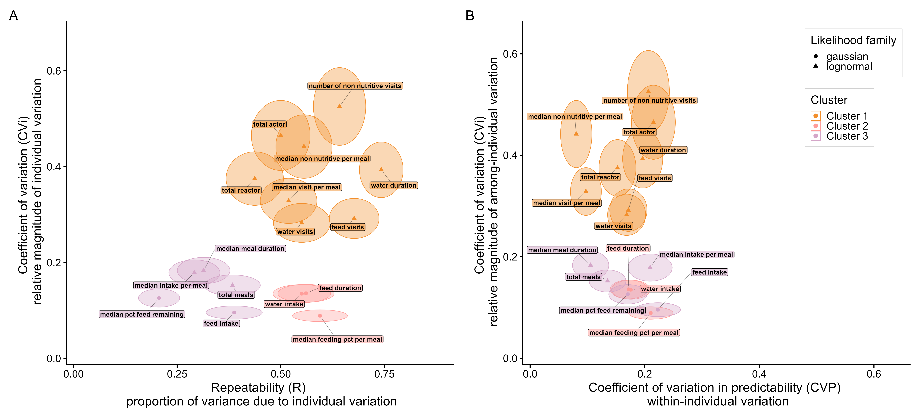
Figure 1: Between- and within-individual variation in the 16 behavioral variables. (A) Repeatability (R) vs coefficient of individual variation (CVi). (B) Coefficient of variation of predictability (CVP) vs CVi. Each point is a behavioral variable; ellipses show 95% credible intervals on both axes. Points are coloured by the 3-cluster k-means solution of Section 4.3 (Cluster 1 = high R, high CVi; Cluster 2 = high R, low CVi; Cluster 3 = low R, low CVi). Point shape distinguishes the likelihood family used for the mixed model.

4.2 Within-Individual Variation: Predictability
We use the coefficient of variation of predictability (CVP) as the primary metric for cross-trait comparisons of predictability, and report rIIV alongside to provide a biological anchor for these values: it expresses how many times more variable the least-predictable cows are compared to the most-predictable cows.
Variables related to meal-patterns were the most predictable. The median number of non-nutritive visits per meal (CVP = 0.08 [0.05, 0.11]; rIIV = 1.17 [1.11, 1.24]), median visits per meal (CVP = 0.10 [0.07, 0.12]; rIIV = 1.21 [1.15, 1.28]), and median meal duration (CVP = 0.11 [0.07, 0.14]; rIIV = 1.23 [1.16, 1.31]) had the lowest CVP values, meaning individual cows expressed these behaviors at a similar level of behvioral consistency within themselves aross different days, and cows differed little from one another in how predictable they were. The corresponding rIIV values indicate that the least-predictable cows showed only about 1.2 times more variable than most-predictable cows for these behaviors. In contrast, daily feed intake (CVP = 0.22 [0.18, 0.26]; rIIV = 1.55 [1.44, 1.68]), total number of actor events (CVP = 0.22 [0.18, 0.25]; rIIV = 1.53 [1.42, 1.65]), and the median percentage of meal time spent feeding (CVP = 0.21 [0.17, 0.25]; rIIV = 1.52 [1.40, 1.63]) had the highest CVP, indicating moderately higher individual variation in within-individual behaviour consistency: some cows were more consistent than others in these behaviors, with the least-predictable cows being roughly 1.5 times as more variable than the most-predictable cows. Nevertheless, all 16 variables displayed relatively low CVP and rIIV values overall. As shown in Figure 1 B, distinguishing among the 16 variables based on CVP alone is difficult, as they cluster within a narrow range of CVP ≤ 0.22.

4.3 Classifying Behavioral Variables
We grouped the 16 variables into 3 clusters based on their R and CVi values using K-means (Figure 1 A).
Behavior Cluster 1 — high R, high CVi contained 8 variables: number of non nutritive visits, total actor, median non nutritive per meal, water duration, total reactor, median visit per meal, feed visits, water visits. Cows in this cluster differed widely from one another in their average behavioral expression, and these differences remained stable over time. In other words, each cow had a distinctive and repeatable behavioural signature. These variables are the most useful for characterising individual behavioural profiles.
Behavior Cluster 2 — high R, low CVi contained 3 variables: feed duration, water intake, median feeding pct per meal. Individual differences were again consistent over time, but the spread of individual differences across the herd was narrow relative to the herd mean.
Behavior Cluster 3 — low R, low CVi contained 5 variables: median meal duration, median intake per meal, total meals, median pct feed remaining, feed intake. Cows showed little variation from one another in these behaviours, and what variation did exist was inconsistent across days. This pattern suggests these behaviours are driven more by day-to-day environmental conditions (e.g., feed availability, group dynamics) than by stable individual tendencies.

4.4 Identifying Cow Types via PCA
We applied PCA with varimax rotation to the intercepts (average individual cow’s behaviour expression) of the 8 Behavior Cluster 1 variables. 3 components were retained to meet the ≥80% cumulative-variance criterion (Cangelosi and Goriely, 2007), together explaining 86.1% of the total variance (Table 2, Figure 2). Rotated Component (RC) 1 explained the largest share of variance (51.6%), driven primarily by non-nutritive behavior and feeding patterns. RC2 explained 21.3% of variance and was most strongly associated with drinking patterns. RC3 captured the remaining variance, primarily related to agonistic behavior (actor and reactor events).

Table 2. Varimax-rotated PCA loadings for the 8 Behavior Cluster-1 intercept variables.
Variable | RC1 | RC2 | RC3
number of non nutritive visits | 0.96 | 0.02 | 0.06
total actor | 0.51 | 0.30 | -0.57
median non nutritive per meal | 0.97 | -0.01 | 0.07
water duration | -0.08 | 0.89 | -0.17
total reactor | 0.36 | 0.16 | 0.82
median visit per meal | 0.94 | -0.04 | 0.08
feed visits | 0.96 | 0.05 | 0.07
water visits | 0.08 | 0.91 | 0.21

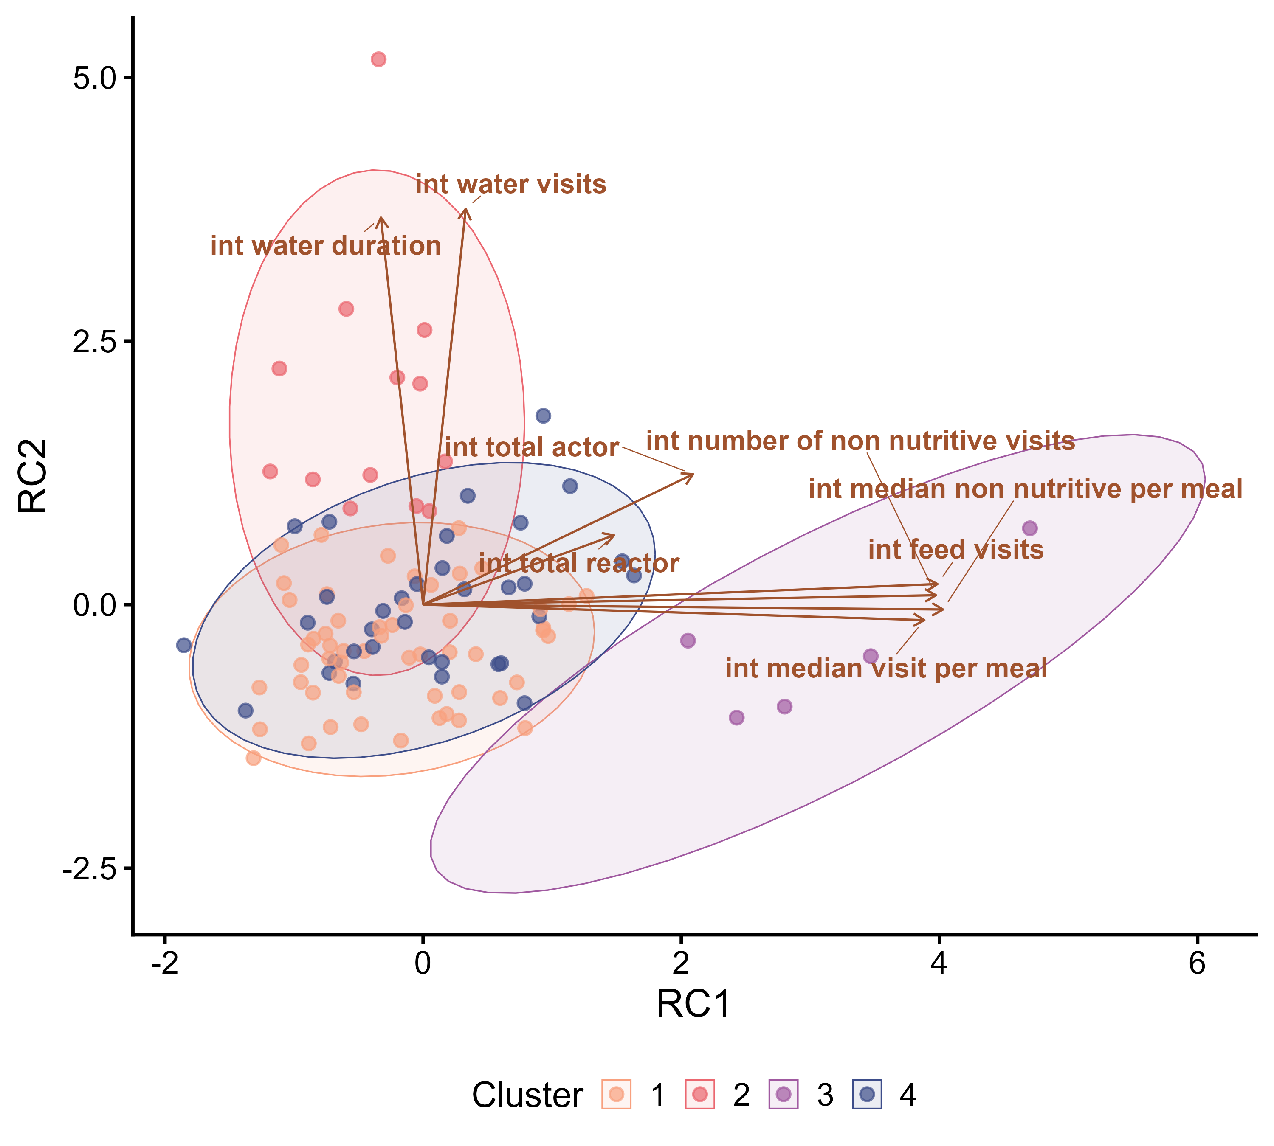  (a) RC1 vs RC2 | 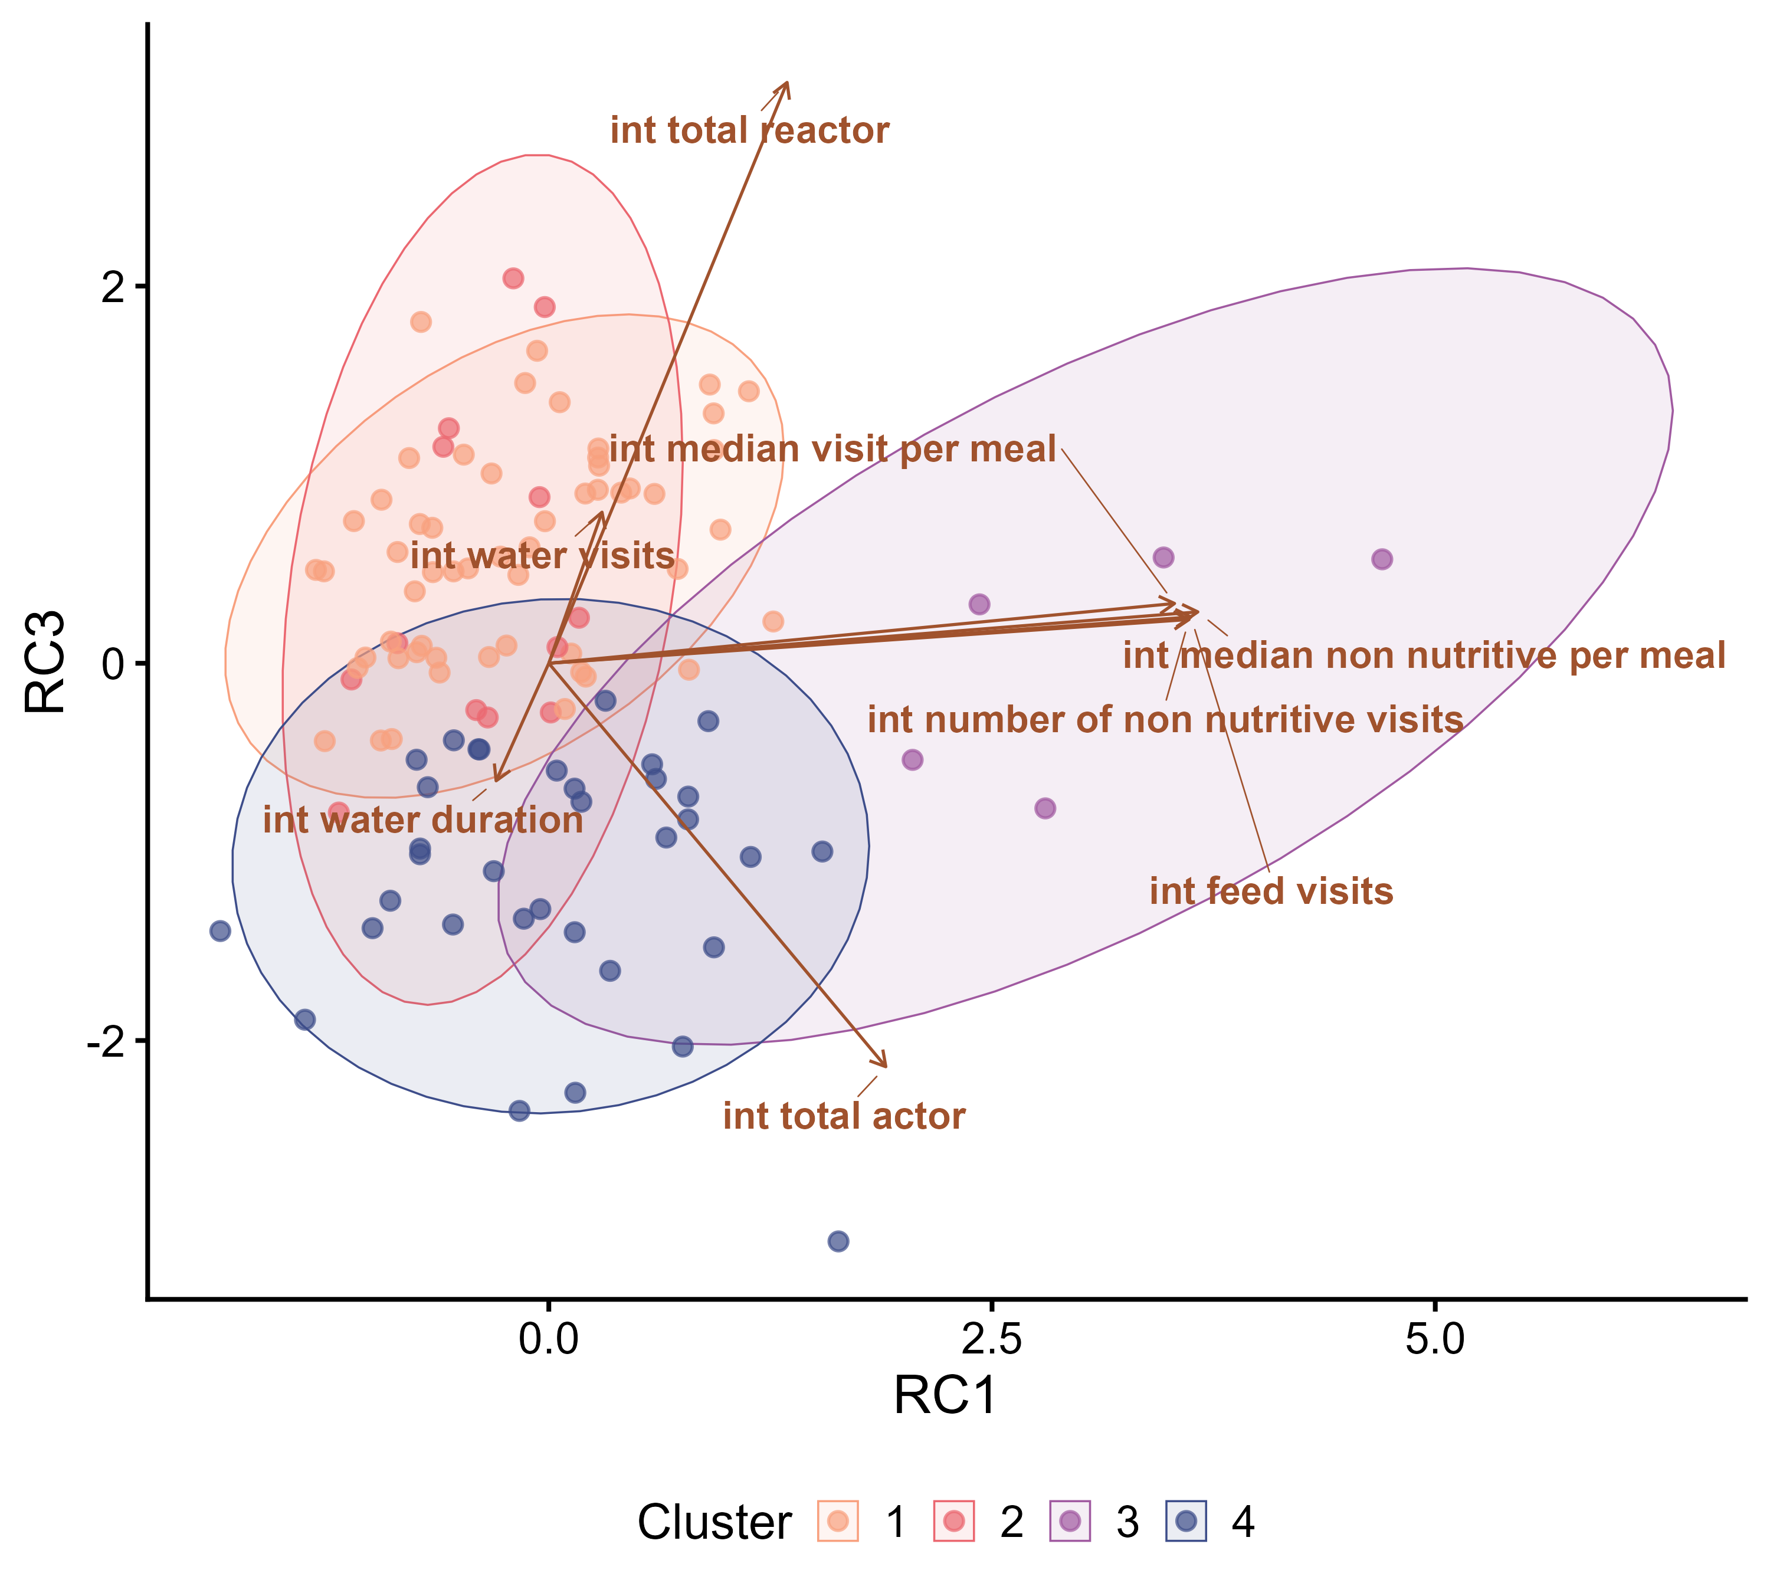  (b) RC1 vs RC3
Figure 2: PCA biplots using the intercepts of Cluster-1 variables. Left: Rotated Component (RC)1 vs RC2. Right: RC1 vs RC3. Each point is a cow, coloured by k-means cluster assignment; arrows represent variable loadings scaled to the score space. Ellipses show 95% confidence regions around each cluster centroid.

K-means clustering on the 3 retained rotated components after PCA, with $k$ selected by the silhouette method, identified k = 4 as the optimal number of cow clusters. The mean silhouette width of the final clustering was 0.30, indicating reasonably well-defined groupings. An interactive visualization of the 4 clusters of cows in the 3D space, colored by cluster assignment, is available at https://www.skysheng.io/moo4feed_decoding_animal/.
Cow Cluster 1 — “typical subordinate” cows (n = 55, ~51% of the herd, the largest group). Cows in this cluster sit near the herd average on RC1 (mean score = -0.21) and slightly below average on RC2 (-0.41), but score noticeably high on RC3 (0.58). These cows are replaced from feed bins (reactor events) more often than they replaced others (actor events), and have slightly low drinking activity (Figure 2 A). Cows in this cluster are the unremarkable majority of the herd: they feed, drink, and take their meals within typical ranges, but routinely yield the bin to more dominant penmates.
Cow Cluster 2 — “heavy drinkers” (n = 13, ~12%). Cows in this cluster are distinguished by a very high RC2 score (1.91), driven by both long daily drinking duration and more drinking visits per day, while showing slightly lower than herd average RC1 (-0.39) and slightly higher than herd average RC3 (0.46) (Figure 2 A). These cows express substantially high drinking activity even after we controled for DIM and THI. They have relatively low feeding activity, and get replaced slightly more often than they replace others.
Cow Cluster 3 — “fragmented, restless feeders” (n = 5, ~5%, the smallest group). This small group of extreme individuals scores very high on RC1 (3.09), driven by a combination of many feed visits per day, many non-nutritive visits, and highly fragmented meals (many short visits per meal, with repeated head-in/head-out events rather than sustained feeding). RC2 (-0.43) is slightly below average, and RC3 (0.03) score is very close to the herd average. These cows have relatively low drinking activity, repeatedly switch among bins in search of preferred feed, even though there is feed remaining in the bins they visited. This cluster contains only a handful of cows, it captures the behavioral tail of the distribution rather than a common type.
Cow Cluster 4 — “dominant” cows (n = 34, ~32%, the second-largest group). These cows show average RC1 (0.03) and RC2 (0.00) scores but a strongly negative RC3 score (-1.12), meaning they initiate many more replacement events than they receive (Figure 2 B). Their feeding, drinking behaviors, and meal patterns are otherwise unremarkable. This cluster represents the socially dominant cows of the herd. These cows likely benefit from preferential access to feed bins.

4.6 Individual Cow Stories
We selected one cow from each of the 4 clusters (cows 7068, 7150, 5042, 5120) and describe their individual stories through their average behavioral expression compared to the herd. All behavioral values reported below are posterior means of each cow’s behavioral type (i.e., her individual intercept from the mixed models in Section 4.1), so they represent the cow’s typical day-to-day expression after accounting for DIM and THI. Percentiles are calculated within the herd on those same posterior means.
Cow 7068 — a “typical subordinate” (Cluster 1). Cow 7068 is almost never the one replacing others at the feed bin (daily actor events: 9.12, 4th percentile of the herd) but is very frequently replaced by others (daily reactor events: 52.56, 90th percentile). Despite routinely being replaced at the bin, she still achieves one of the highest daily feed intakes in the herd (daily feed intake: 71.01, 91th percentile). She did not maintain the high feed intake through visiting the feed bins more often. Her feeding visits per day (78.85, 29th percentile) are actually below the herd median. She maintained high feed intake through a highly efficient feeding strategy. When she does enter a bin, she stays for a long time feeding. Her daily feeding duration is long (388.2 min, 87th percentile), and a very high fraction of her meal time is spent with her head down actually feeding rather than waiting next to the bin (median percentage of time spent feeding per meal: 90.45%, 92th percentile). This is combined with a high median intake per meal (9.55 kg, 84th percentile). Consistent with this feeding style, her non-nutritive behavior is low (daily non-nutritive visits: 31.82, 31th percentile) and her drinking profile is unremarkable (daily drinking duration: 11.2 min, 52th percentile; daily drinking visits: 7.71, 36th percentile). In short, cow 7068 rarely wins social encounters, but she compensates by making each meal count and spending more time feeding.
Cow 7150 — a “heavy drinker” (Cluster 2). Cow 7150’s daily drinking duration (35.0 min, 100th percentile) and daily drinking visits (22.27, 100th percentile) are the highest in the herd, which are several times higher than the herd mean. Although she visits the water bins often and for extended period of time, her daily water intake (50.89 kg, 25th percentile) is actually below the herd median. She simply keep returning to the drinkers throughout the day in many short bouts. Her feeding-related variables are within the normal range (feeding visits per day: 98.08, 57th percentile; median visits per meal: 10.67, 37th percentile). Similar to her drinking style, when she visits the feed bins, only a small fraction of meal time is spent actually feeding (median percentage of time spend feeding per meal: 76.15%, 16th percentile) and her median intake per meal is considerably low (6.81 kg, 13th percentile). Her non-nutritive behavior (daily non-nutritive visits: 45.95, 60th percentile; median non-nutritive per meal: 4.77, 46th percentile) is close to the herd average. Socially she initiates somewhat more replacements than the typical cow (daily actor events: 33.79, 78th percentile) while being replaced at a near-average rate (daily reactor events: 36.61, 57th percentile). Her daily feed intake (65.17 kg, 50th percentile) sits right at the herd median, consistent with her overall-average feeding profile. What places her in this cluster is her distinctive drinking style: many long drinking visits spread across the day.
Cow 5042 — a “fragmented, restless feeder” (Cluster 3). Cow 5042 is the most extreme individual in the herd on nearly every RC1 variable, and illustrates the fragmented-feeder profile. Her feeding visits per day (205.63, 100th percentile), median visits per meal (30.54, 100th percentile), daily non-nutritive visits (161.71, 100th percentile), and median non-nutritive visits per meal (22.32, 100th percentile) are all at or near the herd maximum. She visits bins constantly and pulls her head in and out of bins many times per meal. Although her meals are unusually long (median meal duration: 92.0 min, 98th percentile), only a tiny fraction of that time is actually spent feeding (median feeding % per meal: 57.21%, 1th percentile, essentially the lowest in the herd), meaning that on average, she spent about half of her meal time standing and waiting next to the feed bins instead of actually occupying a feed bin. Her cumulative daily feeding duration ends up low (310.5 min, 8th percentile). Surprisingly, her daily feed intake is still high (72.50 kg, 94th percentile), and her median intake per meal is near the top of the herd (10.43 kg, 97th percentile), meaning that even during brief head-down moments she managed to consume a lot of feed. She is also highly socially active, appearing as both an actor (48.73, 98th percentile) and a reactor (62.67, 99th percentile) far more often than typical, suggesting that her fragmented feeding style is accompanied by (and possibly driven by) frequent agonistic interactions at the feeding area. Her drinking behavior is within the normal range. Her daily drinking duration (13.7 min, 76th percentile) is modestly above the herd median, and she has relatively more drinking visits per day than average cow (11.87, 88th percentile). Cow 5042’s time at the feeding area is made up of many short, interrupted visits rather than sustained feeding. But when she manage to occupy a feed bin, she eats fast.
Cow 5120 — a “dominant” cow (Cluster 4). Cow 5120 frequently replaces herdmates from feed bins (daily actor events: 37.80, 90th percentile) and is almost never replaced herself (daily reactor events: 12.53, only the 3rd percentile). Her meal structure reflects the feeding style of a cow that does not have to compete for access: she takes a typical number of feeding visits per day (89.57, 40th percentile) and spreads them into a typical number of meals (median visits per meal: 12.49, 53th percentile). Each of her meal is efficient, a moderately high fraction of meal time is spent actually occupying a feed bin (median percentage of time spent feeding per meal: 84.94%, 65th percentile), yielding an above-average median intake per meal (9.55 kg, 85th percentile) and a high daily feed intake (69.60, 81th percentile). Her non-nutritive behavior is on the lower side (daily non-nutritive visits: 33.50, 35th percentile; median non-nutritive per meal: 4.24, 38th percentile), and her drinking profile is unremarkable (daily drinking duration: 12.4 min, 66th percentile; daily drinking visits: 9.00, 56th percentile). Cow 5120 is straightforward and efficient. When she wants to feed, she goes directly to the bin she wants, replacing whoever is there. Her feeding time is largely uninterrupted by other cows.

4. Discussion

Interpretation of Results
[What do your results mean? Connect back to research questions]

[Research Question 1]: [Restate question]
[Discuss what your results tell us about this question]

[Research Question 2]: [Restate question]
[Continue for each research question]

Implications

Theoretical Implications
[How your findings contribute to theory]

Practical Implications
[How your findings can be applied in practice]

Methodological Implications
[What your work means for how research should be conducted]

Comparison with Prior Work
[How your results relate to existing literature]

Confirmatory Findings
[Where your results support existing work]

Novel Contributions
[Where your results extend or challenge existing knowledge]

Limitations
[Honest assessment of study limitations]

Methodological Limitations
[Limitations in your approach]

Scope Limitations
[Boundaries of your findings]

Data Limitations
[If applicable]

Threats to Validity
[Potential issues that could affect your conclusions]

Internal Validity
[Issues within your study]

External Validity
[Generalizability concerns]

Future Research Directions
[What should be done next]
- [Direction 1]: [Description and rationale]
- [Direction 2]: [Description and rationale]
- [Direction 3]: [Description and rationale]

5. Conclusion
In this study, we show that data streams collected from automatic feeding and drinking systems contain rich biological information that can be used to decode individual behavioral narratives. Using dairy cows as an example, we demonstrate that animals living in the same environment differ consistently and substantially from one another across feeding, drinking, and social behaviors. Variables capturing exploratory behavior, social competition at the feed bunk, and water drinking duration showed the greatest and most consistent among-individual variation. Daily feed intake was among the least discriminating, suggesting that individuals converge to similar daily intakes through strikingly different strategies. Using behaviors showing consistent among-individual differences, we identified four distinct behavioral profiles that would be largely invisible to analyses relying on basic measures such as daily feed intake and feeding duration alone. The open-source moo4feed R package provides a standardized and reproducible pipeline for extracting these variables from electronic feeder and drinker data already collected across many production systems, enabling individual-level behavioral profiling as a practical foundation for disease and distress monitoring in farm animals and beyond.

6. Acknowledgements
This project is funded by a Natural Sciences and Engineering Research Council (NSERC) Discovery Grant (RGPIN-2021-02848; Ottawa, ON, Canada) awarded to MvK. KS also received funding from the Pei-Huang Tung and Tan-Wen Tung Graduate Fellowship (Vancouver, BC, Canada), Elizabeth R. Howland Fellowship (Vancouver, BC, Canada), Wilson Henderson Fellowship (Vancouver, BC, Canada), Hugo E Meilicke Memorial Fellowship (Vancouver, BC, Canada), and Mary and David Macaree Fellowship (Vancouver, BC, Canada). We extend our gratitude to the members of the UBC Animal Welfare Program, with special mention of Mohammad W. Sahar for his data collection efforts during this trial, and Kratika Rathi, Nicole Lopez, Colombe Tolokin for their invaluable contribution to the R package development. We thank Dr. Tiffany Timbers for her guidance and support throughout the R package development, the development of the project follows the best practices outlined in the book: Reproducible and Trustworthy Workflows for Data Science by Tiffany Timbers, Joel Ostblom, and Florencia D’Andrea. We also thank the team of students and staff at the UBC Dairy Education and Research Centre in Agassiz, BC, Canada. Data collection and experimental procedures were approved by the UBC Animal Ethics Committee (protocol number A19-0299).

7. Declaration of Generative AI and AI-assisted technologies in the writing process.
During the preparation of this work the first author used Anthropic Claude to rephrase portions of the manuscript. After using this tool/service, all authors reviewed and edited the content as needed. Collectively all authors take full responsibility for the content of the publication.

8. CRediT authorship contribution statement
Kehan Sheng: Writing – original draft, Visualization, Validation, Supervision, Software, Project administration, Methodology, Investigation, Formal analysis, Data curation, Conceptualization. Borbala Foris: Writing – review & editing, Supervision, Project administration, Methodology, Conceptualization. Daniel M. Weary: Writing – review & editing, Supervision, Project administration, Methodology, Funding acquisition, Conceptualization. Marina A.G. von Keyserlingk: Writing – review & editing, Supervision, Project administration, Methodology, Funding acquisition, Conceptualization.

9. Declaration of competing interest
The authors declare that they have no known competing financial interests or personal relationships that could have appeared to influence the work reported in this paper.

References
Allwardt, K., Ahlberg, C., Broocks, A., Bruno, K., Taylor, A., Place, S., Richards, C., Krehbiel, C., Calvo-Lorenzo, M., DeSilva, U., VanOverbeke, D., Mateescu, R., Goad, C., Rolf, M.M., 2017. Technical note: Validation of an automated system for monitoring and restricting water intake in group-housed beef steers1,2. Journal of Animal Science 95, 4213–4219. https://doi.org/10.2527/jas.2017.1593
Biro, P.A., 2012. Do rapid assays predict repeatability in labile (behavioural) traits? Animal Behaviour 83, 1295–1300.
Biswas, A., Khan, A., Luo, D., Jonker, A., 2022. Methane emissions in growing heifers while eating from a feed bin compared with 24-hour emissions and relationship with feeding behavior. JDS Communications 3, 255–259. https://doi.org/10.3168/jdsc.2021-0184
Brasier, J.E., Schwanke, A.J., DeVries, T.J., 2023. Effects of dairy cows’ personality traits on their adaptation to an automated milking system following parturition. Journal of Dairy Science 106, 7191–7202. https://doi.org/10.3168/jds.2022-23176
Budaev, S.V., 2010. Using principal components and factor analysis in animal behaviour research: Caveats and guidelines. Ethology 116, 472–480.
Bürkner, P.-C., 2017. Brms: An r package for bayesian multilevel models using stan. Journal of statistical software 80, 1–28.
Cangelosi, R., Goriely, A., 2007. Component retention in principal component analysis with application to cDNA microarray data. Biology direct 2, 2. https://doi.org/10.1186/1745-6150-2-2
Carslake, C., Occhiuto, F., Vázquez-Diosdado, J.A., Kaler, J., 2022a. Indication of a personality trait in dairy calves and its link to weight gain through automatically collected feeding behaviours. Scientific Reports 12, 19425.
Carslake, C., Occhiuto, F., Vázquez-Diosdado, J.A., Kaler, J., 2022b. Repeatability and predictability of calf feeding behaviors—quantifying between-and within-individual variation for precision livestock farming. Frontiers in Veterinary Science 9, 827124.
Chapinal, N., Veira, D., Weary, D., Von Keyserlingk, M., 2007. Validation of a system for monitoring individual feeding and drinking behavior and intake in group-housed cattle. Journal of dairy science 90, 5732–5736.
Creamer, M., Horback, K., 2024. Consistent individual differences in behavior among beef cattle in handling contexts and social-feed preference testing. Applied Animal Behaviour Science 276, 106315. https://doi.org/10.1016/j.applanim.2024.106315
Dawkins, M.S., 2021. The science of animal welfare: Understanding what animals want. Oxford University Press.
DeVries, T.J., Keyserlingk, M.A.G. von, Beauchemin, K.A., 2003. Short communication: Diurnal feeding pattern of lactating dairy cows. Journal of Dairy Science 86, 4079–4082. https://doi.org/10.3168/JDS.S0022-0302(03)74020-X
Eriksson, H.K., Daros, R.R., Keyserlingk, M.A. von, Weary, D.M., 2020. Effects of case definition and assessment frequency on lameness incidence estimates. Journal of dairy science 103, 638–648.
Færevik, G., Jensen, M.B., Bøe, K.E., 2010. The effect of group composition and age on social behavior and competition in groups of weaned dairy calves. Journal of Dairy Science 93, 4274–4279. https://doi.org/10.3168/jds.2010-3147
Finkemeier, M.-A., Langbein, J., Puppe, B., 2018. Personality research in mammalian farm animals: Concepts, measures, and relationship to welfare. Frontiers in veterinary science 5, 131.
Flower, F., Weary, D., 2006. Effect of hoof pathologies on subjective assessments of dairy cow gait. Journal of dairy science 89, 139–146.
Foris, B., Haas, H.G., Langbein, J., Melzer, N., 2021. Familiarity influences social networks in dairy cows after regrouping. Journal of Dairy Science 104, 3485–3494. https://doi.org/10.3168/jds.2020-18896
Foris, B., Thompson, A., Von Keyserlingk, M., Melzer, N., Weary, D., 2019. Automatic detection of feeding-and drinking-related agonistic behavior and dominance in dairy cows. Journal of dairy science 102, 9176–9186.
Gabry, J., Simpson, D., Vehtari, A., Betancourt, M., Gelman, A., 2019. Visualization in Bayesian workflow. Journal of the Royal Statistical Society: Series A (Statistics in Society) 182, 389–402. https://doi.org/10.1111/rssa.12378
Grant, R.J., Albright, J.L., 1995. Feeding behavior and management factors during the transition period in dairy cattle. Journal of Animal Science 73, 2791–2803. https://doi.org/10.2527/1995.7392791x
Hertel, A.G., Niemelä, P.T., Dingemanse, N.J., Mueller, T., 2020. A guide for studying among-individual behavioral variation from movement data in the wild. Movement ecology 8, 30.
Huzzey, J.M., Grant, R.J., Overton, T.R., 2012. Short communication: Relationship between competitive success during displacements at an overstocked feed bunk and measures of physiology and behavior in holstein dairy cattle. Journal of Dairy Science 95, 4434–4441. https://doi.org/10.3168/jds.2011-5038
Huzzey, J., Weary, D., Tiau, B., Von Keyserlingk, M., 2014. Automatic detection of social competition using an electronic feeding system. Journal of dairy science 97, 2953–2958.
Khan, K., Rehman, S.U., Aziz, K., Fong, S., Sarasvady, S., 2014. DBSCAN: Past, present and future, in: The Fifth International Conference on the Applications of Digital Information and Web Technologies (ICADIWT 2014). IEEE, pp. 232–238.
Lawrence, A.B., Terlouw, E.M.C., Illius, A.W., 1991. Individual differences in behavioural responses of pigs exposed to non-social and social challenges. Applied Animal Behaviour Science 30, 73–86. https://doi.org/10.1016/0168-1591(91)90086-D
Malini, N., Pushpa, M., 2017. Analysis on credit card fraud identification techniques based on KNN and outlier detection, in: 2017 Third International Conference on Advances in Electrical, Electronics, Information, Communication and Bio-Informatics (AEEICB). IEEE, pp. 255–258.
Neave, H.W., Costa, J.H.C., Weary, D.M., von Keyserlingk, M.A.G., 2018. Personality is associated with feeding behavior and performance in dairy calves. Journal of Dairy Science 101, 7437–7449. https://doi.org/10.3168/jds.2017-14248
Occhiuto, F., Vázquez-Diosdado, J.A., Carslake, C., Kaler, J., 2022. Personality and predictability in farmed calves using movement and space-use behaviours quantified by ultra-wideband sensors. Royal Society Open Science 9, 212019.
Phillips, C.J.C., Rind, M.I., 2001. The effects on production and behavior of mixing uniparous and multiparous cows. Journal of Dairy Science 84, 2424–2429. https://doi.org/10.3168/jds.S0022-0302(01)74692-9
R Core Team, 2025. R: A language and environment for statistical computing. R Foundation for Statistical Computing, Vienna, Austria.
Réale, D., Reader, S.M., Sol, D., McDougall, P.T., Dingemanse, N.J., 2007. Integrating animal temperament within ecology and evolution. Biological reviews 82, 291–318.
Richter, S.H., Hintze, S., 2019. From the individual to the population – and back again? Emphasising the role of the individual in animal welfare science. Applied Animal Behaviour Science 212, 1–8. https://doi.org/10.1016/j.applanim.2018.12.012
Rousseeuw, P.J., 1987. Silhouettes: A graphical aid to the interpretation and validation of cluster analysis. Journal of computational and applied mathematics 20, 53–65. https://doi.org/10.1016/0377-0427(87)90125-7
Setser, M.W., Neave, H., Costa, J., 2024. Individuality of calves: Linking personality traits to feeding and activity daily patterns measured by precision livestock technology. Journal of Dairy Science 107, 3235–3251.
Sheng, K., Foris, B., Krahn, J., Weary, D.M., Keyserlingk, M.A. von, 2024. Redefining dominance calculation: Increased competition flattens the dominance hierarchy in dairy cows. Journal of Dairy Science 107, 7286–7298.
Slater, P.J.B., 1981. Individual differences in animal behavior, in: Bateson, P.P.G., Klopfer, P.H. (Eds.), Perspectives in Ethology: Volume 4 Advantages of Diversity. Springer US, Boston, MA, pp. 35–49. https://doi.org/10.1007/978-1-4615-7575-7_2
Thomas, M., Occhiuto, F., Green, M., Vázquez-Diosdado, J.A., Kaler, J., 2024. Repeatability and predictability of lying and feeding behaviours in dairy cattle. Preventive Veterinary Medicine 233, 106357.
Tolkamp, B., Allcroft, D., Austin, E., Nielsen, B.L., Kyriazakis, I., 1998. Satiety splits feeding behaviour into bouts. Journal of Theoretical Biology 194, 235–250.
Vehtari, A., Gelman, A., Simpson, D., Carpenter, B., Bürkner, P.-C., 2021. Rank-normalization, folding, and localization: An improved $\hat{R}$ for assessing convergence of MCMC (with discussion). Bayesian Analysis 16, 667–718. https://doi.org/10.1214/20-BA1221
Webster, M.M., Ward, A.J., 2011. Personality and social context. Biological reviews 86, 759–773. https://doi.org/10.1111/j.1469-185X.2010.00169.x

