Test case:Source based load balancing functionality on WAN interface.

Aim
Verify Source based load balancing functionality on WAN interface.

Test Setup:
Here is the network topology for the test setup:
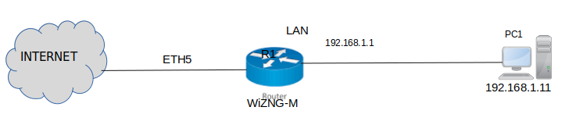

WiZ M Configuration:

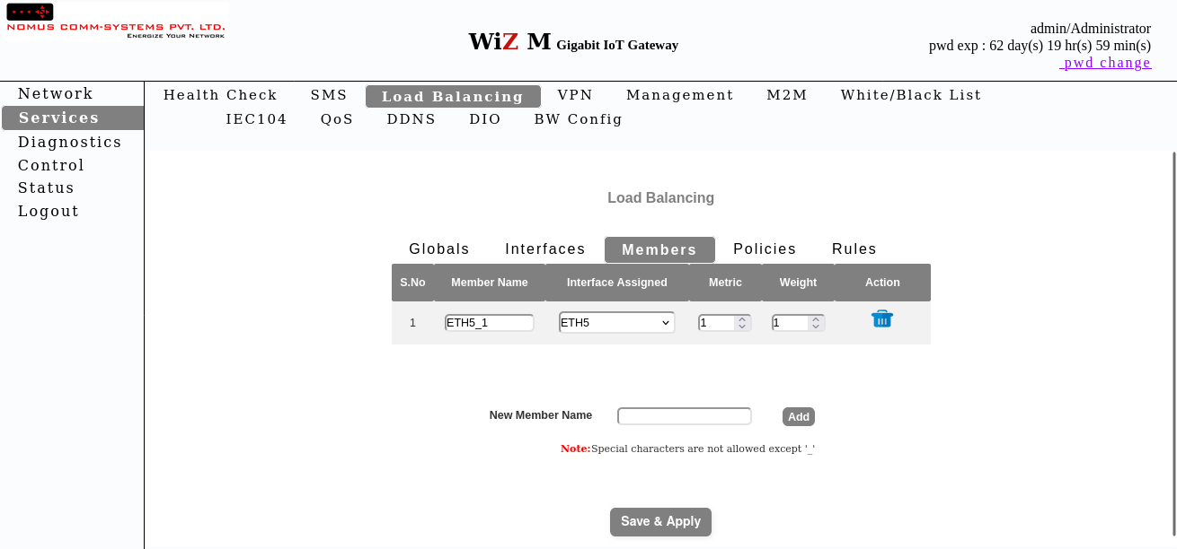

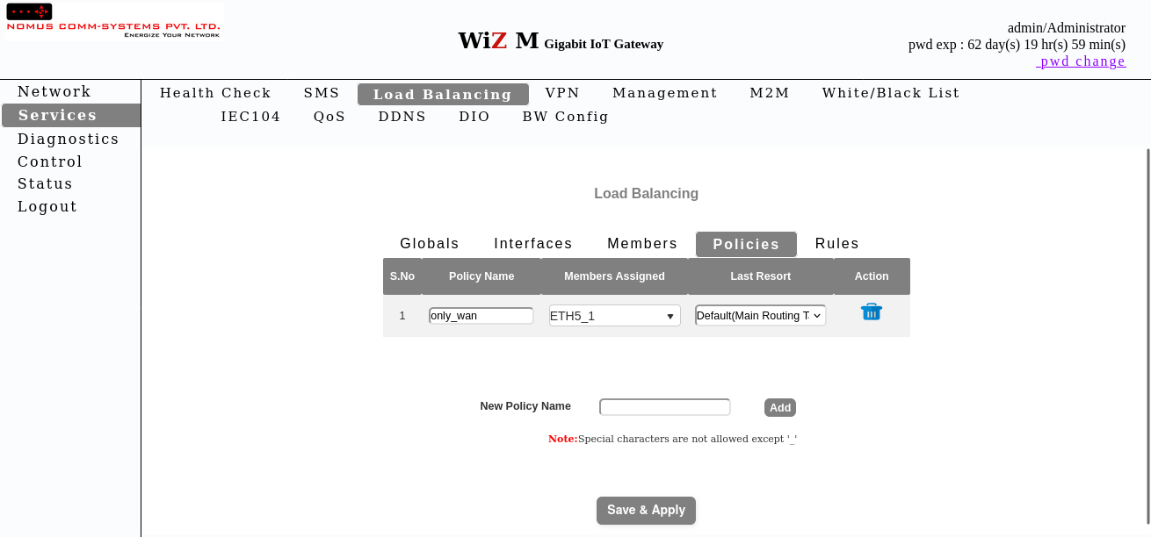

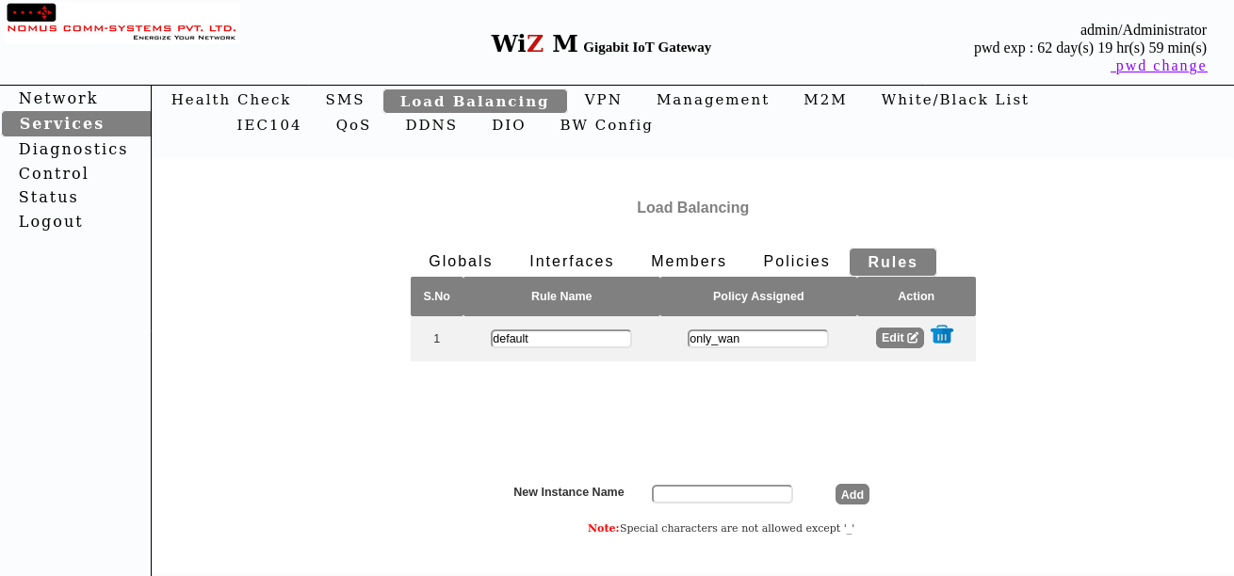

Test Procedure:
- Configure global_Enable and interface_Enable to 'enable'.
- Set tracking_ip, tracking_reliability, ping_count, ping_timeout, ping_interval, interface_down, interface_up.
- Verify table data in Interfaces page.
- Check status page.
- Disable global_Enable and interface_Enable.
- Verify updated table data and status.

Expected Output
The expected output for the test case is as follows:
- Family column shows 'ipv4'.
- Enabled column shows 'enable' initially, 'disable' after reconfiguration.
- Status page reflects configuration changes.

Observation
The Observation for the test case is as follows:
- Table data matches expected values.
- Status page updates correctly.
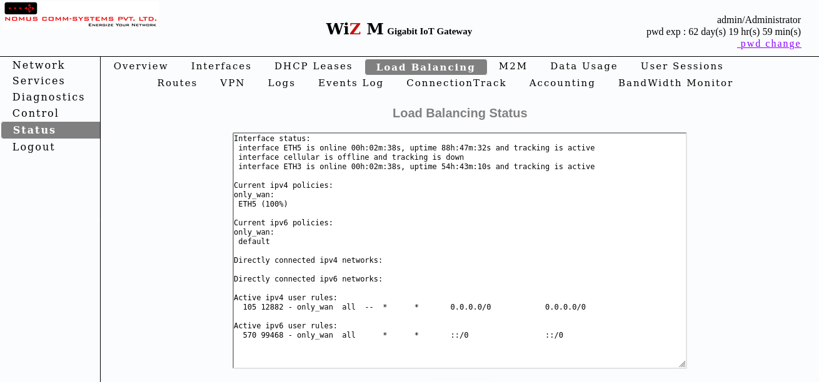

Actual Output
The actual output obtained during testing is as follows:
- Load balancing settings successfully applied with global_Enable and interface_Enable set to 'enable'.Interfaces table shows Family column as: ipv4.Interfaces table shows Enabled column as: enable.Status page confirms load balancing is active with enabled settings.

Result
All load balancing configurations and verification completed successfully.

PC1
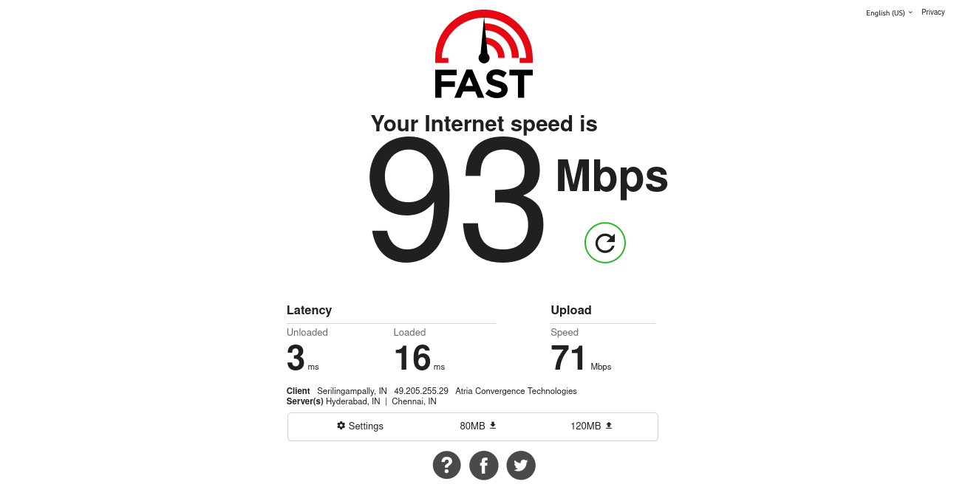

Socket Result

