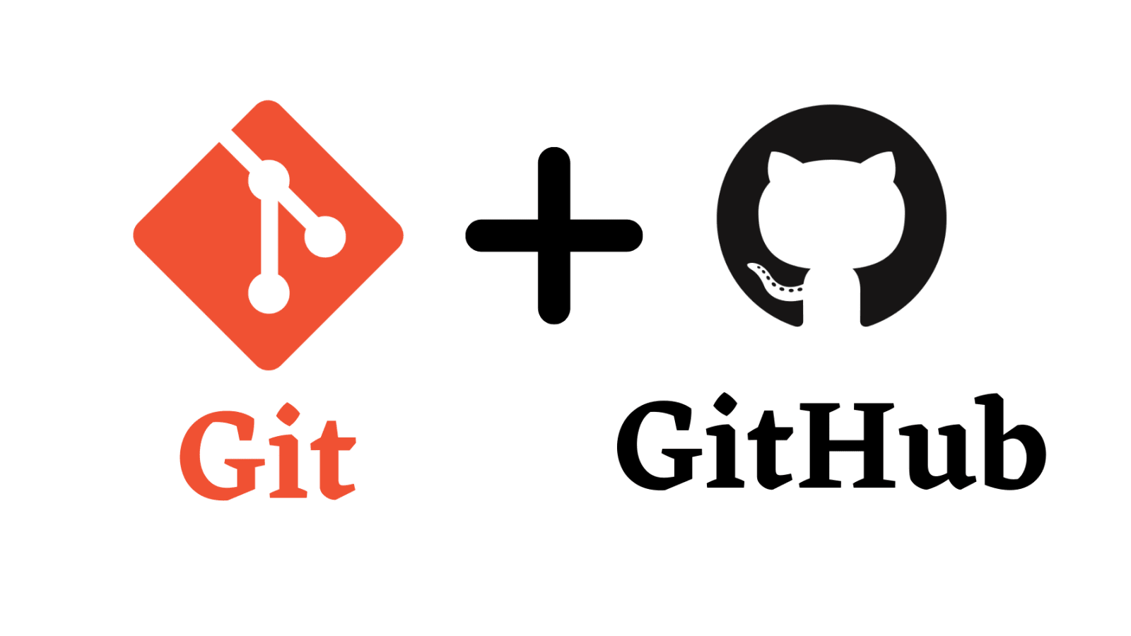 by [Daya Shankar](mailto:dayashankar2001@gmail.com)

Resources:

* <https://www.youtube.com/watch?v=8JJ101D3knE&ab_channel=ProgrammingwithMosh>
* <https://www.youtube.com/watch?v=vwj89i2FmG0&ab_channel=Telusko>
* <https://www.youtube.com/watch?v=Ez8F0nW6S-w&ab_channel=ApnaCollege>
* <https://www.youtube.com/watch?v=apGV9Kg7ics&ab_channel=KunalKushwaha>
* Angela
* Mosh Paid <https://t.me/moshgitcourse>

# Version Control System

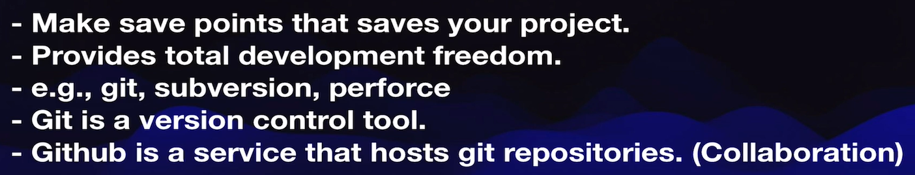

# 

# Local Implementation of GIT

Local Repository

| **For** | **command** | **Where** |
| --- | --- | --- |
| Initialize local git repository | git init | Inside working dir |
| To see what’s currently inside your staging area | git status |  |
| To add files in staging area | git add “filename”  git add . |  |
| To remove everything from staging area | git rm –cached -r . |  |
| Commit changes (save points) | git commit -m “message” |  |
| See what commit we have made | git log |  |
| see the difference  current version(which is not committed yet) and the last save point in our Git repo | git diff “filename” |  |
| rollback to previous version | git checkout “filename” |  |

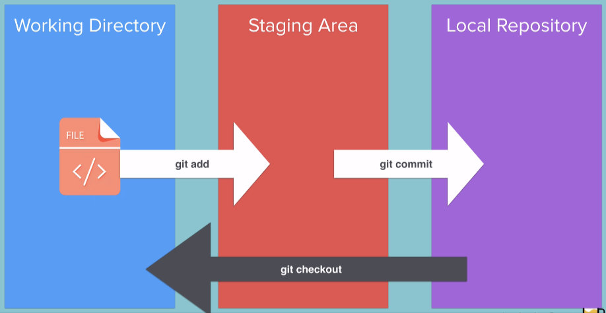

**Inside Local Repo (folder after git init)**  
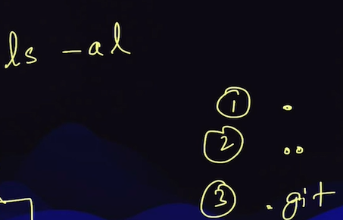

# Remote Repository

connect local and remote repo

| to create a remote repo | git remote add origin “url” |  |
| --- | --- | --- |
| to add repo in main branch of github | git branch -M main |  |
| push local repo to remote repo | git push -u origin main | origin - remote repo  master - branch |

# 

# Gitignore

if you don’t want to commit secrets file(api key,...), utility files

then we use gitignore\

1. create a .gitignore file in the working directory
2. Write the filename which you want to ignore for staging area(comminting)
3. After that, when you commit changes some files will we ignored to commit

<https://github.com/github/gitignore>

# Cloning

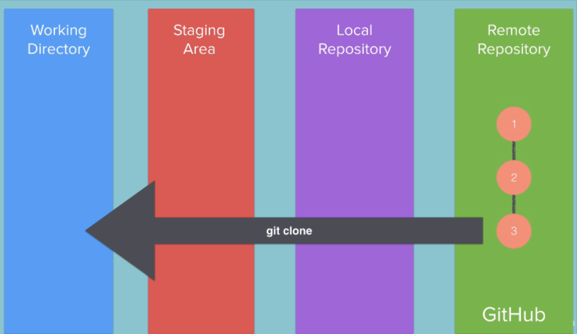

| git clone "url" |
| --- |

# Branching and Merging

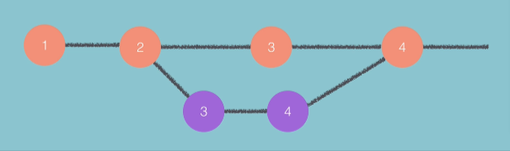

| see the branches | git branch |  |
| --- | --- | --- |
| create new branch | git branch “branch-name” |  |
| switch to different branch | git checkout “branch-name” |  |
| merge sub-branch to master-branch | git merge “sub-branch-name” | command this from master branch |
|  |  |  |

# Optional Git Challenge

If you want to dive deeper into Git, including learning about Cherry-Picking, Git Rebase and more I recommend completing the challenges here:

<https://learngitbranching.js.org/>

# Fork and Pull request

Fork means cloning someone remote repo to your account as remote repo

Pull request means pulling changes from another’s person remote repo to our remote repo

