Question 1: What is HTTP? How does it work? Give appropriate example?

HTTP (Hypertext Transfer Protocol) is an application protocol that defines the rules for communication between web browsers (clients) and web servers. It is the foundation of data communication on the World Wide Web. When you type a URL in your web browser or click on a link, HTTP is responsible for fetching the requested web page and displaying it in your browser.

Here's a simplified overview of how HTTP works:

* Client Request: When you enter a URL or click on a link, your web browser (the client) sends an HTTP request to the web server. The request includes the URL of the resource (such as a web page) that you want to retrieve.
* Server Response: The web server receives the request and processes it. It locates the requested resource and prepares an HTTP response. The response includes the requested resource, along with relevant headers and status codes.
* Transmission: The server sends the HTTP response back to the client over the internet. The response is divided into small packets of data for efficient transmission.
* Client Processing: The web browser (client) receives the response and starts processing it. It reads the response headers to determine the status of the request (e.g., success, redirection, error). If the response is successful (status code 200), the browser proceeds to render the requested resource (e.g., HTML page).
* Resource Rendering: The client browser parses the HTML, executes any embedded scripts, fetches additional resources (e.g., images, stylesheets) referenced in the HTML, and combines them to render the complete web page.

Here's an example to illustrate the process:

Let's say you enter the URL "[http://www.example.com](http://www.example.com/)" in your web browser.

Client Request: The browser creates an HTTP GET request and sends it to the web server at "[www.example.com](http://www.example.com/)".

Server Response: The web server receives the request, processes it, and prepares an HTTP response. It includes the HTML content of the requested web page, along with appropriate headers like "Content-Type" indicating that it is an HTML document.

Transmission: The server sends the HTTP response back to the client browser over the internet.

Client Processing: The browser receives the response and starts processing it. It reads the response headers, checks the status code (e.g., 200 OK), and proceeds to render the web page.

Resource Rendering: The browser parses the HTML, retrieves any additional resources (e.g., images, stylesheets) referenced in the HTML by sending separate HTTP requests for each resource, and combines them to render the complete web page.

This is a simplified explanation of the HTTP process, but it gives you an idea of how HTTP enables communication between clients and servers on the web.

Question 2:

Web Design is crucial for creating user-friendly and accessible websites. Let's discuss two important aspects of web design: effective navigation and browser compatibility.

Effective Navigation: Effective navigation is essential to ensure that users can easily move through a website and find the information they need. Here are some considerations for effective navigation in web design:

a. Clear and Consistent Structure: The navigation should have a clear and consistent structure throughout the website. Use logical categories and organize the navigation menu in a hierarchical manner, making it easy for users to understand and navigate.

b. Intuitive Labels: Use descriptive and intuitive labels for navigation links. Avoid jargon or ambiguous terms that might confuse users. The labels should accurately represent the content or functionality they lead to.

c. Visible and Accessible: The navigation should be prominently placed on the website and easily visible to users. It is typically placed in the header or sidebar. Additionally, ensure that the navigation is accessible to all users, including those with disabilities, by adhering to web accessibility guidelines.

d. Responsive Design: With the increasing use of mobile devices, responsive design is crucial. Design your navigation to be responsive, adapting to different screen sizes and orientations. Consider using techniques like hamburger menus or expanding navigation to conserve screen space on mobile devices.

e. Breadcrumbs: Breadcrumbs provide users with a clear path of their location within a website's hierarchy. They allow users to navigate back to higher-level pages easily. Breadcrumbs are particularly useful for websites with deep content structures or e-commerce sites with multiple categories.

Browser Compatibility: Browser compatibility refers to designing and developing websites that work consistently and accurately across different web browsers. Here are some considerations for achieving browser compatibility:

a. Cross-Browser Testing: Test your website on different web browsers, including popular ones like Google Chrome, Mozilla Firefox, Safari, and Microsoft Edge. This helps identify any rendering or functionality issues specific to particular browsers.

b. Progressive Enhancement: Adopt a progressive enhancement approach by building the core functionality of your website to work on all browsers, including older versions. Then, enhance the experience for modern browsers by leveraging newer technologies and features.

c. Standard Compliance: Ensure that your website adheres to web standards and follows best practices. Use valid HTML, CSS, and JavaScript code that is compatible across browsers. Avoid browser-specific code or non-standard features that may cause compatibility issues.

d. Graceful Degradation: Plan for graceful degradation, which means designing your website to function well on older browsers with limited capabilities. Ensure that even if some advanced features or styles are not supported, the basic functionality and content of the website are still accessible.

e. Regular Updates: Stay informed about browser updates and new technologies to ensure your website remains compatible. As new browser versions are released, test your website to ensure it works correctly and make necessary updates if required.

By prioritizing effective navigation and ensuring browser compatibility, web designers can create user-friendly websites that provide seamless experiences for users across different devices and browsers.

Question 5:

In JavaScript, an event is an action or occurrence that takes place in the browser, such as a mouse click, keyboard input, page load, or element interaction. JavaScript provides the ability to listen for and handle these events, allowing you to add interactivity and responsiveness to your web pages. When an event occurs, JavaScript can trigger specific functions or code to execute in response.

Here are some major events in JavaScript:

Click Event: Occurs when the user clicks on an element.

Keydown Event: Fires when a key on the keyboard is pressed down.

Mouseover Event: Triggers when the mouse pointer moves over an element.

Submit Event: Fires when a form is submitted.

Load Event: Occurs when a web page or external resource finishes loading.

Resize Event: Triggered when the browser window is resized.

Focus and Blur Events: Fired when an element gains or loses focus.

Scroll Event: Occurs when the user scrolls the web page.

Mouseout Event: Triggered when the mouse pointer moves out of an element.

Here's an example that demonstrates the use of the click event:

HTML:

## <button id="myButton">Click me!</button>

## // Get a reference to the button element

## const button = document.getElementById('myButton');

## // Add a click event listener to the button

## button.addEventListener('click', function() {

## // Code to execute when the button is clicked

## console.log('Button clicked!');

## });

Question 6:

Meta tags are HTML elements that provide metadata about a web page. They are placed within the **<head>** section of an HTML document and are not displayed on the actual web page but serve various purposes for search engines, social media platforms, and web browsers.

Here are a few common meta tags and their meanings:

**<title>**: Specifies the title of the web page, which appears as the title in the browser's title bar or tab. It is also displayed as the title of the search engine results for that page.

**<meta name="description" content="Description of the web page">**: Provides a brief description of the web page's content. Search engines often display this description in search results.

**<meta name="keywords" content="keyword1, keyword2, keyword3">**: Specifies a list of keywords relevant to the web page's content. This tag was more important in the past, but nowadays, search engines rely less on it for ranking purposes.

**<meta name="author" content="Author's Name">**: Identifies the author of the web page.

Question 7 :

XML (Extensible Markup Language) is a markup language that defines a set of rules for encoding documents in a format that is both human-readable and machine-readable. It is commonly used for storing and transporting data in a structured manner.

Here's an example of an XML file that could be used to store a semester mark sheet:

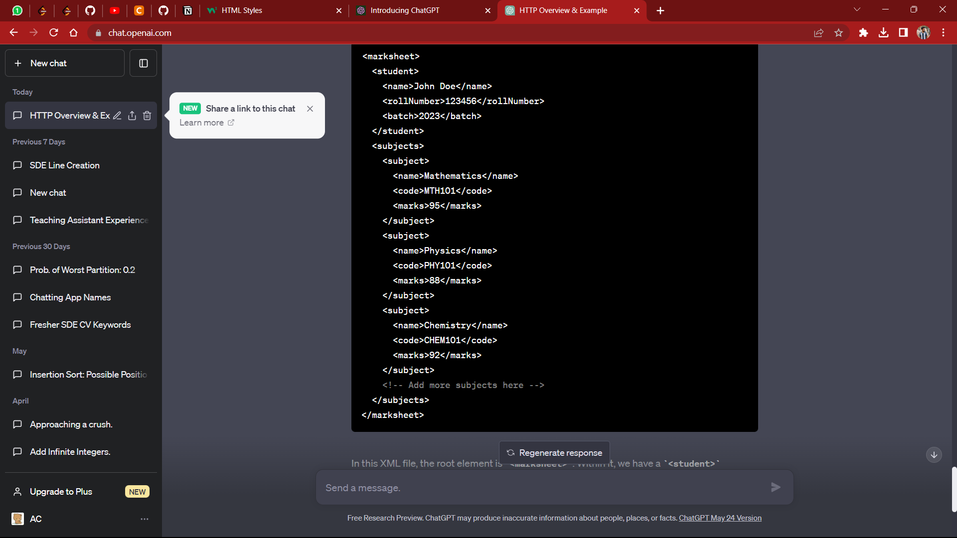

n this XML file, the root element is **<marksheet>**. Within it, we have a **<student>** element that contains details about the student, such as their name, roll number, and batch.

The **<subjects>** element holds the individual **<subject>** elements. Each **<subject>** element represents a specific subject and contains sub-elements like **<name>**, **<code>**, and **<marks>** to store the subject's name, code, and marks, respectively.

You can expand this XML structure by adding more **<subject>** elements for other subjects and include additional information as needed.

By organizing data in this structured format, XML enables easy parsing and manipulation of information. It provides a flexible and extensible way to store and exchange data between different systems and platforms.

Queswtion 8 :

To display the XML mark sheet in XHTML table form using XSLT, you can create an XSL file that transforms the XML data into an XHTML table structure. Here's an example of an XSL file that accomplishes this:

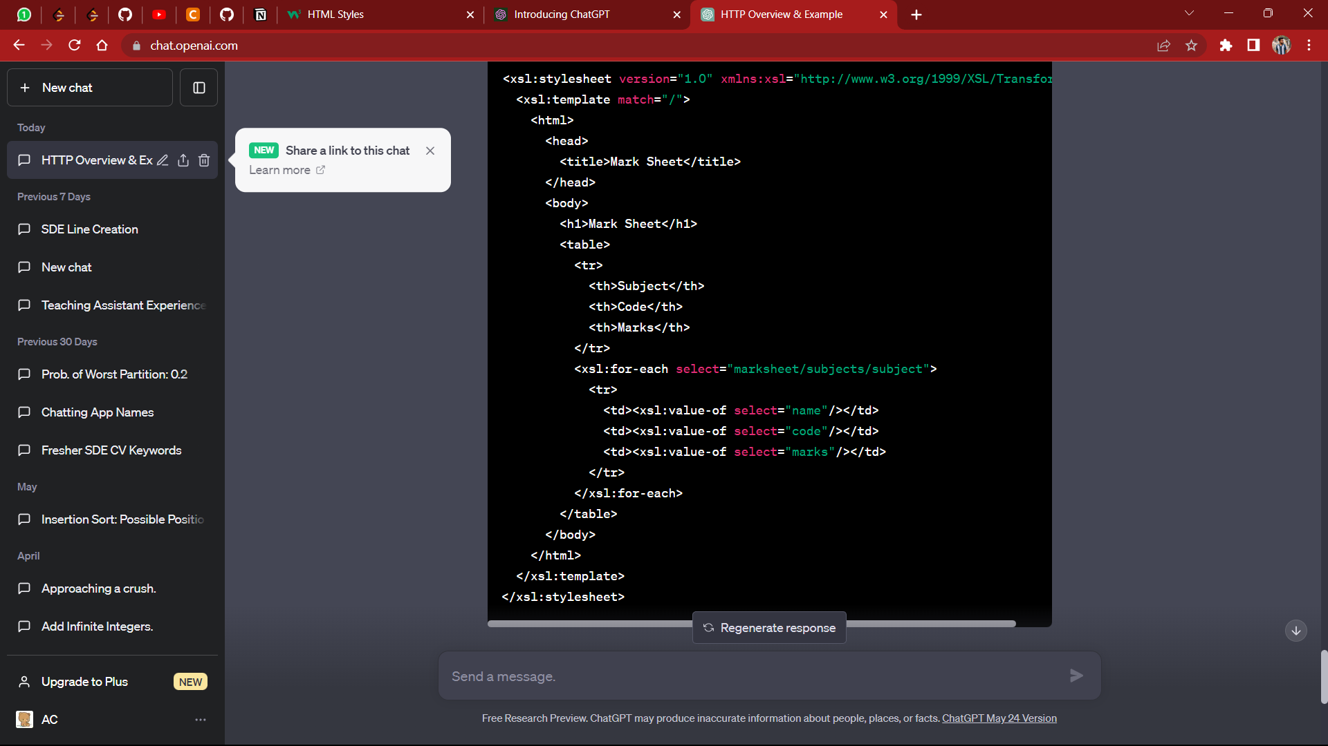

In this XSL file, we define the XSLT stylesheet using the **<xsl:stylesheet>** element and specify the XSLT version and XML namespace.

The **<xsl:template match="/">** element defines the root template that matches the root node of the XML document.

Within the template, we construct the XHTML structure using HTML elements. In this example, we create an HTML table with a header row and iterate over each **<subject>** element using **<xsl:for-each>**. Inside the loop, we access the values of **<name>**, **<code>**, and **<marks>** using **<xsl:value-of>** and place them in the respective table cells.

When you apply this XSL file to the XML mark sheet, it will generate an XHTML table representation of the mark sheet. The resulting HTML table will display the subjects, their codes, and marks in a structured manner.

Note: To apply the XSL transformation to the XML document, you can use an XSLT processor or a web browser that supports XSLT transformations.

Question 9:

A web server is a software application that serves web pages and other resources to clients (web browsers) over the internet or a local network. It plays a crucial role in the functioning of the World Wide Web by handling incoming requests from clients and delivering the requested content.

The primary roles and responsibilities of a web server include:

* Serving Web Pages: Web servers are responsible for delivering web pages and resources (such as HTML, CSS, images, and JavaScript files) to clients in response to HTTP requests.
* Processing Requests: Web servers receive incoming requests from clients and process them based on the requested resource, method (e.g., GET, POST), headers, and other parameters. They handle routing, access control, authentication, and other request processing tasks.
* Content Storage and Management: Web servers store and manage the content of websites, including web page files, images, videos, and other assets. They organize and provide access to these files based on the requested URLs.
* Protocol Support: Web servers support various protocols, primarily the HTTP (Hypertext Transfer Protocol) and its secure version, HTTPS. They handle the negotiation, encryption, and secure transmission of data between clients and servers.
* Performance Optimization: Web servers often employ caching techniques to improve performance by storing frequently accessed resources and delivering them quickly to clients, reducing the need to retrieve the same resources repeatedly.

Question 10:

i) **<optgroup>**: The **<optgroup>** element is used within the **<select>** element in HTML to group related **<option>** elements together. It provides a way to categorize and organize options within a dropdown list.

Here's an example of how **<optgroup>** can be used:

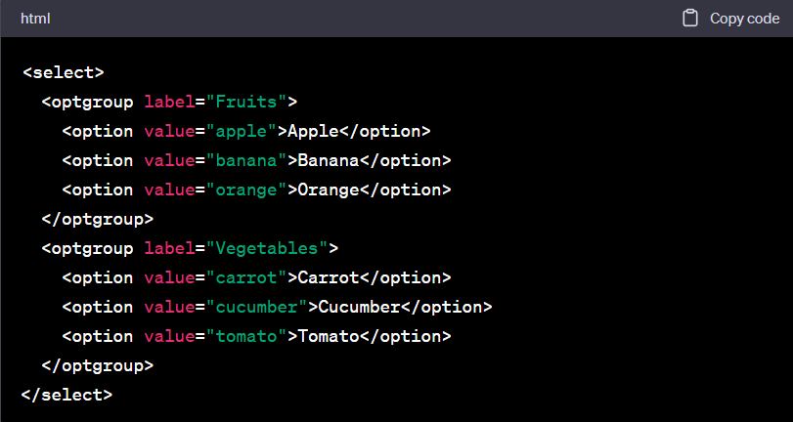

In this example, we have a **<select>** element with two **<optgroup>** elements. The first **<optgroup>** has the label "Fruits," and it contains three **<option>** elements representing different fruits. The second **<optgroup>** has the label "Vegetables," and it contains three **<option>** elements representing different vegetables.

When rendered in a web browser, the dropdown list will display the options grouped under their respective optgroups. This provides visual organization and makes it easier for users to locate and select the desired option.

ii) **<span>**: The **<span>** element is an inline-level element in HTML used to apply styling or to group inline elements together for styling or scripting purposes. It does not have any inherent semantic meaning but provides a way to target specific portions of text or elements within a larger block of content.

Here's an example of how **<span>** can be used:

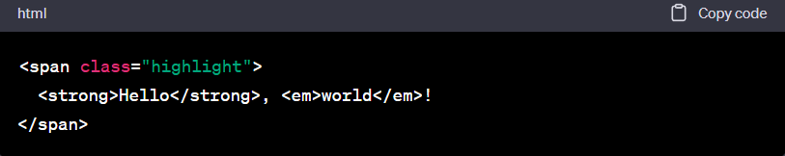

In this case, the **<span>** element is given a **class** attribute, which can be targeted in CSS or JavaScript to apply specific styles or functionality to the content within the **<span>**.

Overall, the **<span>** element is a versatile tool for targeting specific portions of text or inline elements and applying styling or scripting to them, offering more control over the appearance and behavior of web content.

Question 11:

CSS (Cascading Style Sheets) is a style sheet language used to describe the presentation and visual styling of HTML and XML documents. It allows web designers to control the layout, colors, fonts, and other visual aspects of web pages, creating a visually appealing and consistent user experience across different devices and browsers.

CSS Types:

* Inline CSS: Inline CSS is applied directly to individual HTML elements using the **style** attribute. For example:

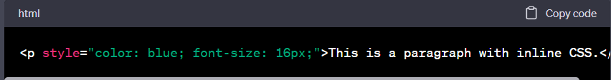

* Internal CSS: Internal CSS is defined within the **<style>** tags in the **<head>** section of an HTML document. It applies styles to specific HTML elements or classes within the document. For example:

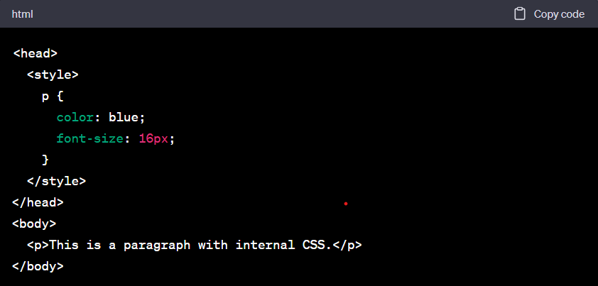

* External CSS: External CSS is defined in a separate CSS file with a **.css** extension. It is linked to the HTML document using the **<link>** tag in the **<head>** section. This approach allows multiple HTML pages to share the same styles, promoting code reusability and easier maintenance. For example:

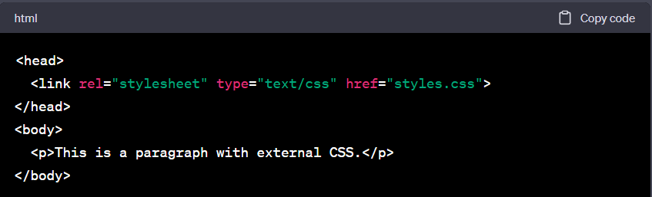

Box Model: The CSS Box Model describes the structure of an HTML element by dividing it into several parts, or boxes. These boxes include content, padding, border, and margin, each having its own properties and dimensions. The Box Model is essential for understanding and controlling the layout and spacing of elements on a web page.

The components of the Box Model are:

* Content: It represents the actual content of the element, such as text or images.
* Padding: Padding is the space between the content and the element's border. It can be set using the **padding** property and affects the size of the element's background.
* Border: The border surrounds the padding and content of an element. It can be customized with properties like **border-width**, **border-color**, and **border-style**.
* Margin: The margin is the space between the element's border and other elements on the page. It provides spacing between elements. The **margin** property controls its size.

Here's an example that demonstrates the Box Model:

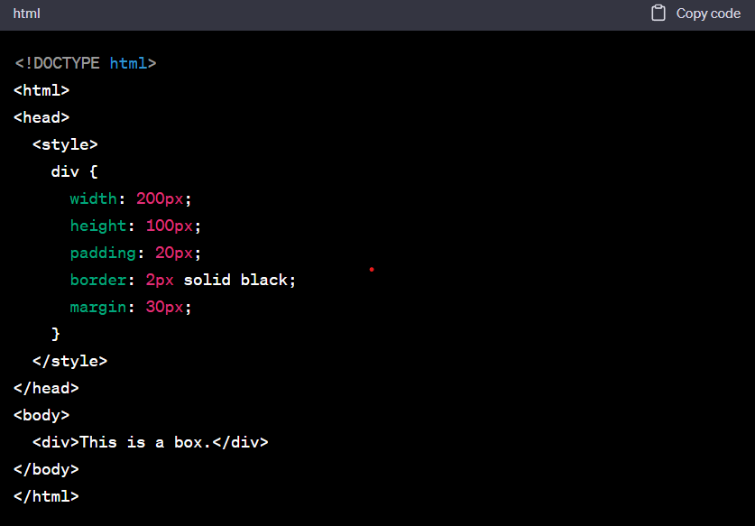

In this example, we have a **<div>** element styled with CSS properties related to the Box Model. It has a width and height of 200 pixels and 100 pixels, respectively. The **padding** property adds 20 pixels of space inside the element's border. The **border** property sets a solid black border with a thickness of 2 pixels. The **margin** property adds 30 pixels of space outside the element's border.

Understanding the Box Model allows you to precisely control the size, spacing, and overall layout of elements on your web page by adjusting the content, padding, border, and margin properties.

Question 12:

Differences between client-side and server-side scripting languages:

Client-side scripting languages:

* Execution: Client-side scripts are executed on the user's web browser.
* Purpose: They are primarily used to enhance the user interface and interactivity of web pages.
* Interaction: They can directly interact with the Document Object Model (DOM) of the web page.
* Access: They have limited access to the user's device and resources due to security restrictions imposed by the browser.
* Examples: JavaScript, HTML, CSS.

Server-side scripting languages:

* Execution: Server-side scripts are executed on the web server before the web page is sent to the user's browser.
* Purpose: They are used for generating dynamic content, interacting with databases, handling form submissions, and performing complex server-side operations.
* Interaction: They can interact with databases, file systems, and other server resources.
* Access: They have more extensive access to the server's resources and can perform tasks that require server-level permissions.
* Examples: PHP, Python (with frameworks like Django), Ruby (with frameworks like Ruby on Rails).

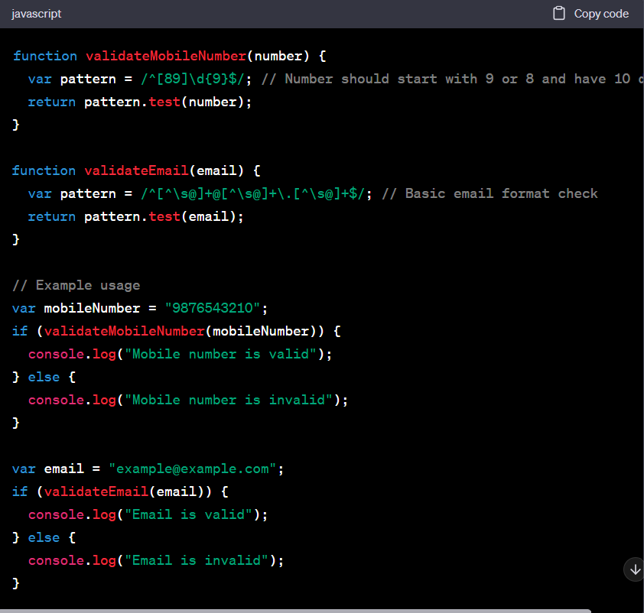

In the JavaScript code above, we define two functions: **validateMobileNumber()** and **validateEmail()**. These functions use regular expressions to perform basic validation checks.

The **validateMobileNumber()** function checks if the mobile number starts with either 9 or 8 and has a total of 10 digits.

The **validateEmail()** function checks for a basic email format with the presence of an "@" symbol and a domain with at least one "." character.

We then provide example usage, where we validate a given mobile number and email address using the respective functions and log the result to the console.

i) Justify it: "HTTP is called a stateless protocol."

HTTP (Hypertext Transfer Protocol) is referred to as a stateless protocol because it does not maintain any persistent connection or state information between requests and responses. Each request-response cycle is independent and self-contained.

Justification:

* No Server-Side Memory: The server does not store any information about previous requests from a client. It treats each request as a new and independent request.
* Stateless Nature: HTTP does not remember any data or state between requests. Each request is processed individually, without any knowledge of prior requests.
* Scalability: The stateless nature of HTTP allows for better scalability because servers can process requests independently and in parallel, without the need to manage and maintain client-specific state information.

The statelessness of HTTP simplifies the server's task by not requiring it to track and manage client states. However, it also means that if the server needs to maintain any session-specific or stateful information, additional mechanisms like cookies or session management techniques are required.

ii) How to open a link in a new browser window?

To open a link in a new browser window, you can use the **target** attribute in the HTML **<a>** (anchor) tag. The **target** attribute specifies where to open the linked document.

Here's an example:

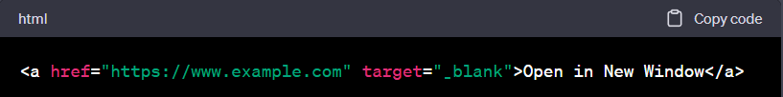

In this example, the **href** attribute specifies the URL of the link, and the **target** attribute is set to "_blank". The "_blank" value indicates that the linked document should open in a new browser window or tab, depending on the user's browser settings.

iv) Difference between JavaScript and Java:

JavaScript:

1. JavaScript is a scripting language primarily used for client-side web development.
2. It is interpreted by the browser and runs on the client-side.
3. JavaScript is dynamically typed, allowing flexible variable types.
4. It has a focus on manipulating and interacting with the Document Object Model (DOM) of web pages.
5. JavaScript is primarily used for enhancing user interactivity and providing dynamic content on websites.

Java:

1. Java is a general-purpose programming language that can be used for various applications, including web development, mobile app development, and desktop software development.
2. It is compiled into bytecode and runs on a Java Virtual Machine (JVM), making it platform-independent.
3. Java is statically typed, meaning variables must have a specific type declared.
4. It has a wide range of application domains, including enterprise software, Android app development, and more.
5. Java is known for its robustness, scalability, and extensive libraries and frameworks.

v) Difference between DTD and XML Schema:

* DTD (Document Type Definition):
* DTD is a markup declaration language used to define the structure, elements, and attributes of an XML document.
* It uses a set of declarations and rules to validate the structure and data of an XML document.
* DTD has a simpler syntax compared to XML Schema.
* DTD does not support data types and advanced validation features like XML Schema.
* It has been used for a long time and has wide support across various XML processing tools.

XML Schema:

* XML Schema is an XML-based alternative to DTD for defining the structure, data types, and constraints of an XML document.
* It provides a more powerful and expressive way to define complex data structures and validate XML documents.
* XML Schema supports data typing, allowing you to specify the types of elements and attributes, such as strings, numbers, dates, etc.
* It offers advanced validation features like defining constraints, specifying default values, and creating reusable types.
* XML Schema has a more verbose and complex syntax compared to DTD.
* It is the recommended choice for defining XML document structures and validating XML data in modern XML applications.

Question 13:

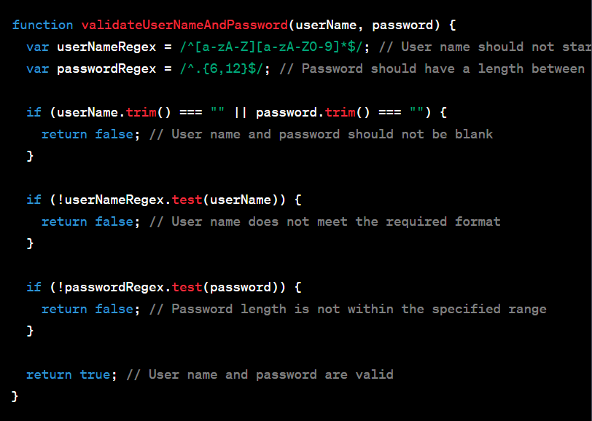

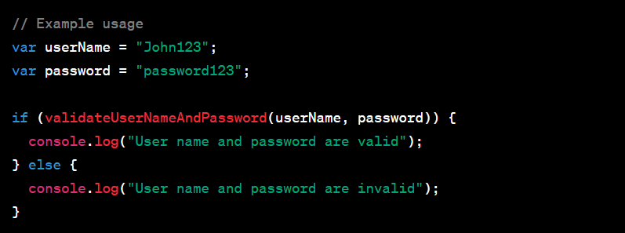

Question 14 :

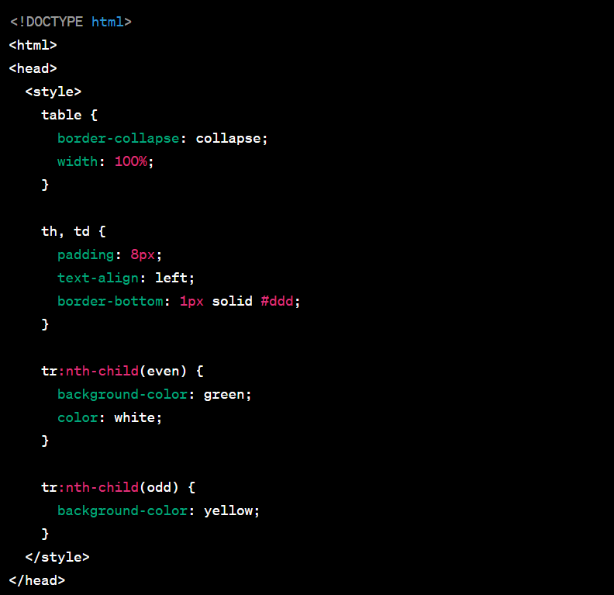

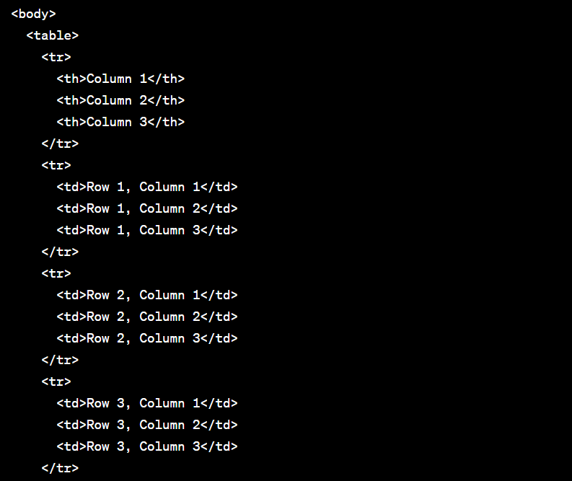

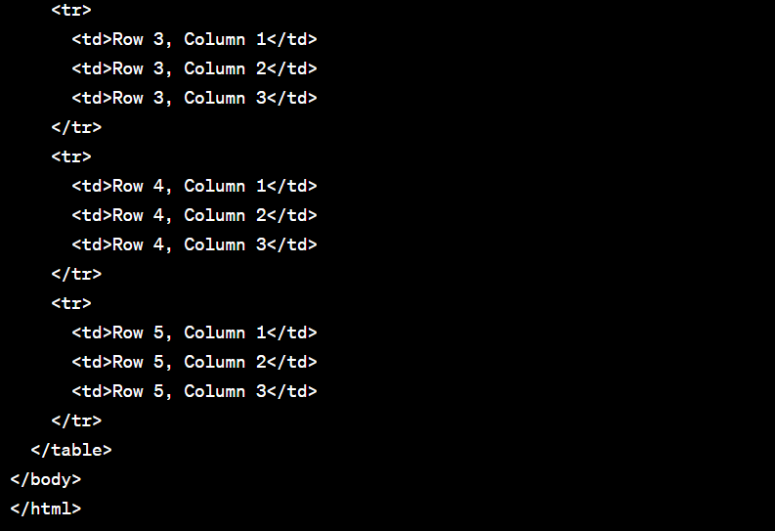

Question 15 :

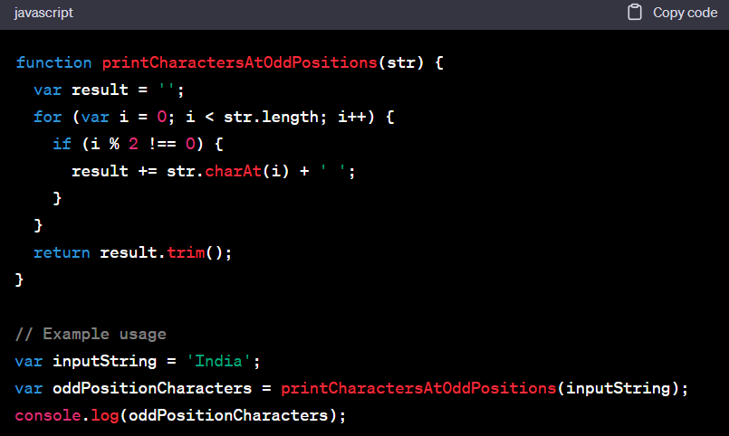

Question 17:

XSL (Extensible Stylesheet Language) is used to transform XML documents into different formats, such as HTML, PDF, or plain text. XSL consists of various elements that enable the manipulation and presentation of XML data. Three commonly used XSL elements are **<xsl:value-of>**, **<xsl:for-each>**, and **<xsl:sort>**.

**<xsl:value-of>**: The **<xsl:value-of>** element is used to extract the value of a selected node in the XML document and output it in the transformed result. It is commonly used to display data or assign values to variables.

Example: Suppose we have an XML document containing information about a book:

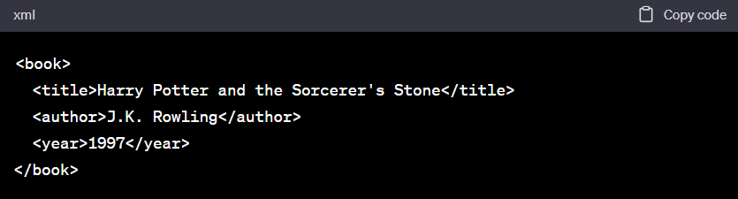

We can use **<xsl:value-of>** to extract and display the title of the book in an 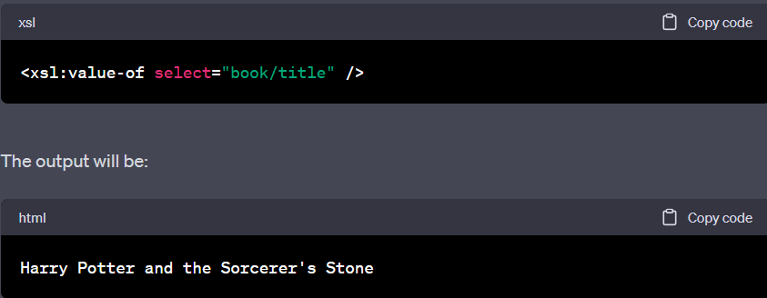

**<xsl:for-each>**: The **<xsl:for-each>** element allows iteration over a set of selected nodes in the XML document. It is used to apply a template or perform actions on each selected node individually.

Example: Suppose we have an XML document with multiple book elements:

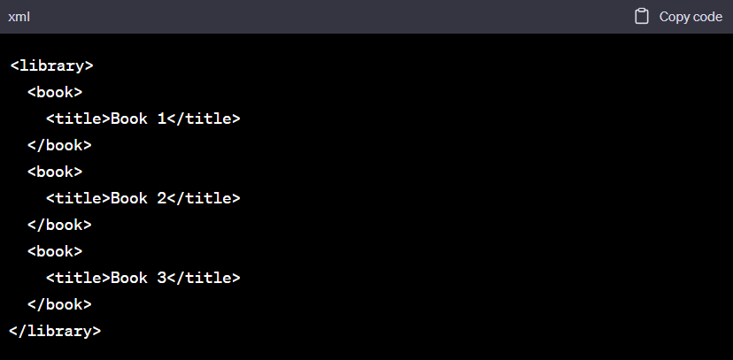

We can use **<xsl:for-each>** to iterate over each book element and display the title of each book in an HTML output:

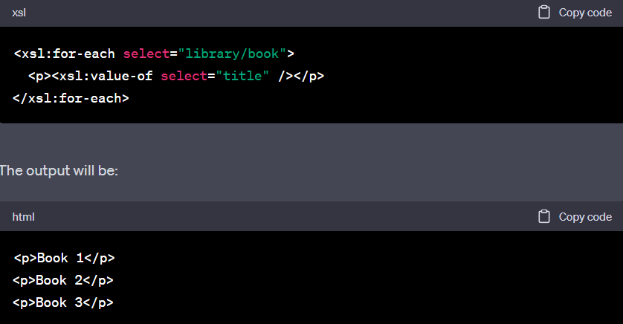**<xsl:sort>**: The **<xsl:sort>** element is used to sort the selected nodes based on a specified criterion. It is often used in conjunction with **<xsl:for-each>** to display data in a specific order.

Example: Suppose we have an XML document with a list of names:

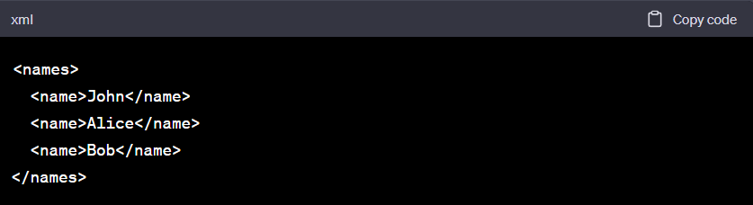

We can use **<xsl:sort>** to sort the names in alphabetical order before displaying them in an HTML output:

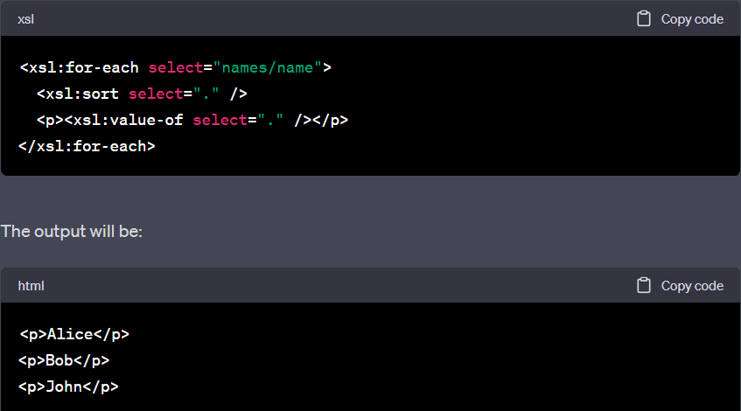In this example, the **<xsl:sort>** element is used to sort the names before displaying them.

These XSL elements provide powerful tools for extracting, iterating, sorting, and presenting XML data in a transformed output. They offer flexibility and control over the transformation process, enabling the creation of customized representations of XML documents.

Question 18 :

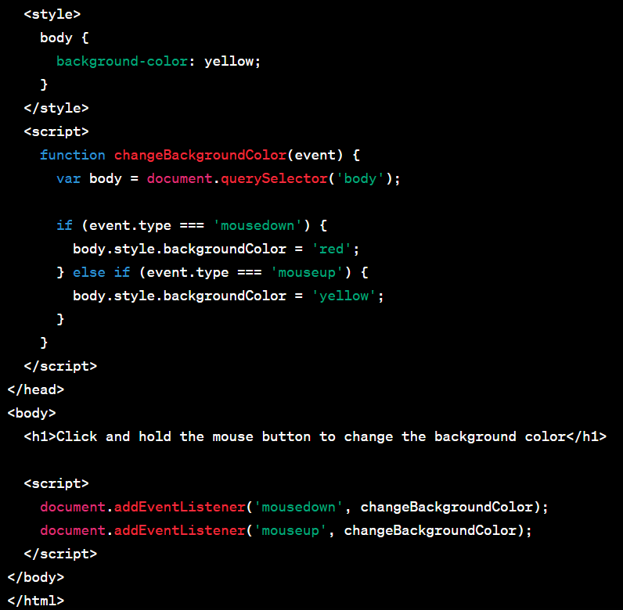

Question 19:

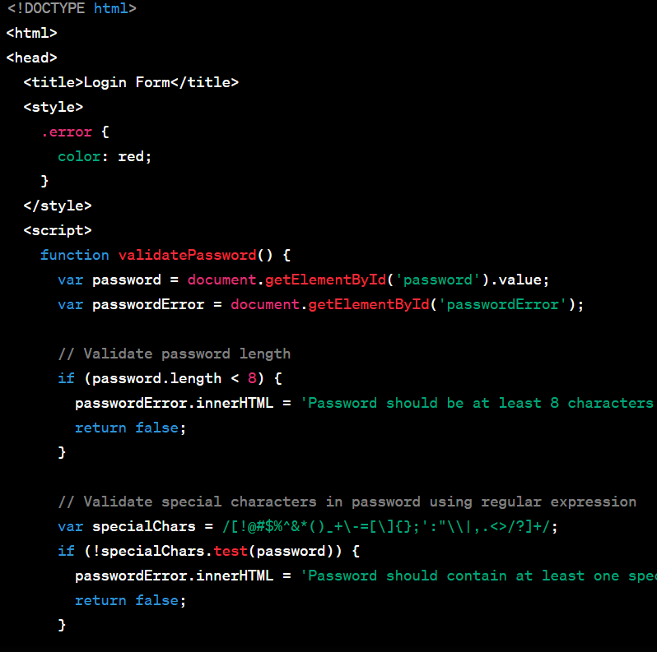

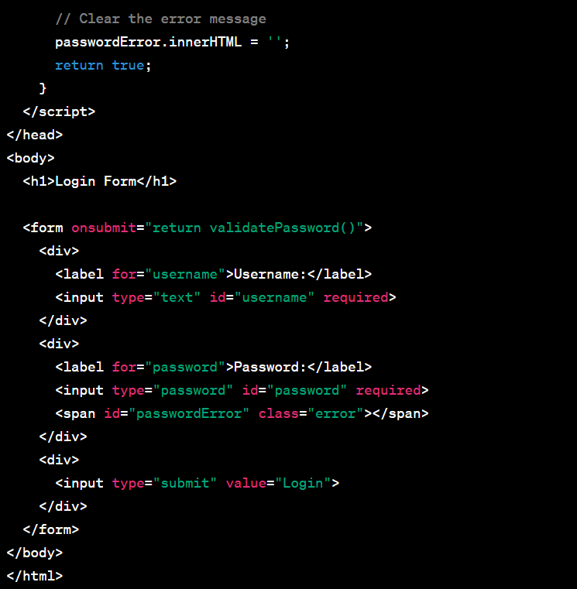

Questio 20 : covered already

Email validation