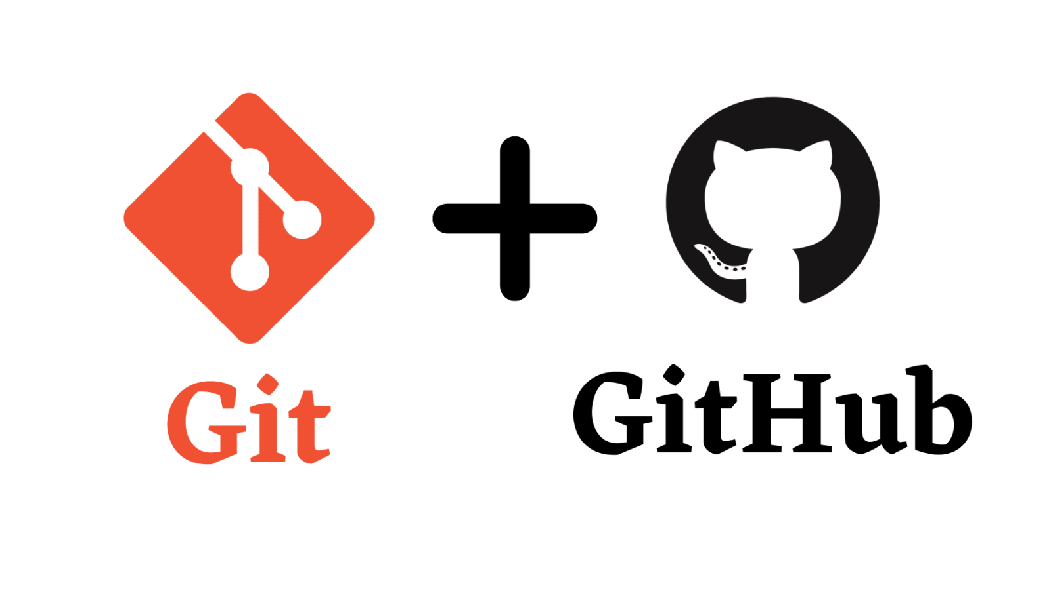 by Daya Shankar

Resources:
- https://www.youtube.com/watch?v=8JJ101D3knE&ab_channel=ProgrammingwithMosh
- https://www.youtube.com/watch?v=vwj89i2FmG0&ab_channel=Telusko
- https://www.youtube.com/watch?v=Ez8F0nW6S-w&ab_channel=ApnaCollege
- https://www.youtube.com/watch?v=apGV9Kg7ics&ab_channel=KunalKushwaha
- Angela
- Mosh Paid https://t.me/moshgitcourse

Version Control System
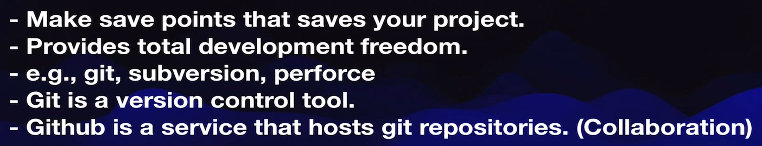

Local Implementation of GIT
Local Repository

For | command | Where
Initialize local git repository | git init | Inside working dir
To see what’s currently inside your staging area | git status
To add files in staging area | git add “filename”  git add .
To remove everything from staging area | git rm –cached -r .
Commit changes (save points) | git commit -m “message”
See what commit we have made | git log
see the difference  current version(which is not committed yet) and the last save point in our Git repo | git diff “filename”
rollback to previous version | git checkout “filename”

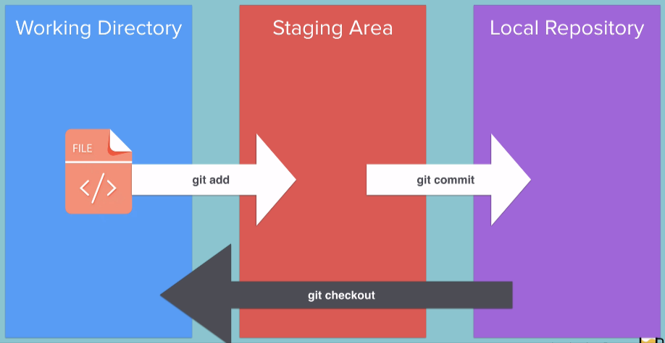

Inside Local Repo (folder after git init)
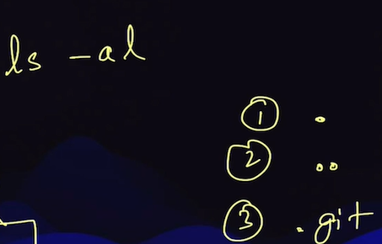

Remote Repository

connect local and remote repo

to create a remote repo | git remote add origin “url”
to add repo in main branch of github | git branch -M main
push local repo to remote repo | git push -u origin main | origin - remote repo  master - branch

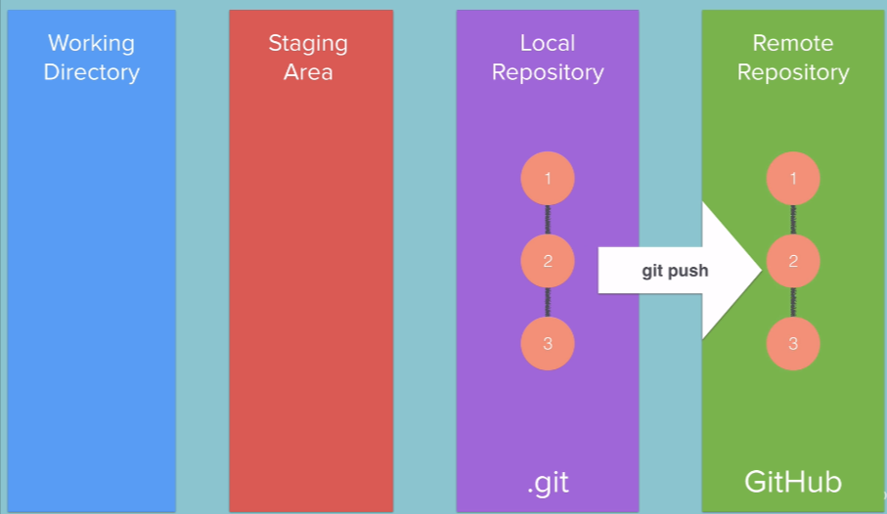

Gitignore
if you don’t want to commit secrets file(api key,...), utility files
then we use gitignore\

- create a .gitignore file in the working directory
- Write the filename which you want to ignore for staging area(comminting)
- After that, when you commit changes some files will we ignored to commit

https://github.com/github/gitignore

Cloning
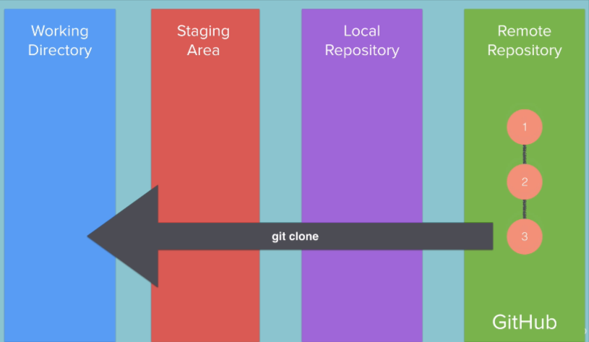

git clone "url"

Branching and Merging
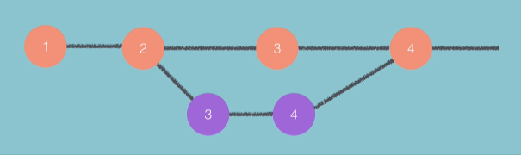

see the branches | git branch
create new branch | git branch “branch-name”
switch to different branch | git checkout “branch-name”
merge sub-branch to master-branch | git merge “sub-branch-name” | command this from master branch

Optional Git Challenge
If you want to dive deeper into Git, including learning about Cherry-Picking, Git Rebase and more I recommend completing the challenges here:
https://learngitbranching.js.org/

Fork and Pull request
Fork means cloning someone remote repo to your account as remote repo
Pull request means pulling changes from another’s person remote repo to our remote repo

