Query 1: Write a query to display name, job, hiredate and employee number for each employee with employee number appearing first.

Solution

SELECT empno, ename, job, hiredate FROM emp;
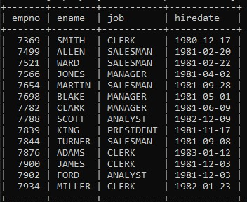

Query 2: Write a query to display unique jobs from the employee table.

Solution

SELECT DISTINCT job FROM emp;
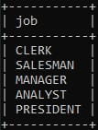

Query 3: Write a query to display name concatenated by a job separated by a comma.

Solution

SELECT CONCAT(ename, ", ", job) FROM emp;
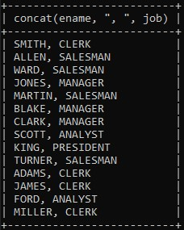

Query 4: Write a query to display the name and salary of employees earning more than $2850.

Solution

SELECT ename, sal FROM emp WHERE sal > 2850;
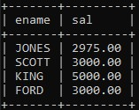

Query 5: Write a query to display the name and department number for employee number 7900.

Solution

SELECT ename, deptno FROM emp WHERE empno = 7900;
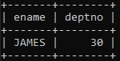

Query 6: Write a query to display the name and salary of all employees whose salary is not in the range of $1500 and $2850.

Solution

SELECT ename, sal FROM emp WHERE sal NOT BETWEEN 1500 AND 2850;
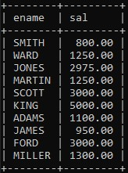

Query 7: Write a query to display the name and department number of all employees in departments 10 and 30 in alphabetical order by name.

Solution

SELECT ename, deptno FROM emp WHERE deptno = 10 OR deptno = 30 ORDER BY ename;
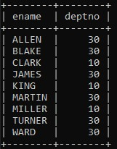

Query 8: Write a query to display the name and salary of employees who earned more than $1500 and are in department number 10 or 30.

Solution

SELECT ename, sal FROM emp WHERE sal > 1500 AND (deptno = 10 OR deptno = 30);
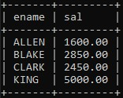

Query 9: Write a query to display the name and hire date of every employee who was hired in 1981.

Solution

SELECT ename, hiredate FROM emp WHERE hiredate LIKE "1981%";
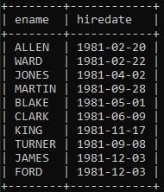

Query 10: Write a query to display the name and job of all employees who do not have a manager.

Solution

SELECT ename,job FROM emp WHERE NOT (job='Manager');;
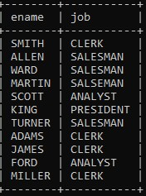

Query 11: Write a query to display the name, salary and commission for all employees who earn commission. Sort the data in descending order of salary.

Solution

SELECT ename, sal, comm FROM emp WHERE (comm IS NOT NULL) AND (comm <> 0.00) ORDER BY sal DESC;
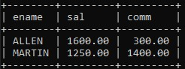

Query 12: Write a query to display the names of all employees where the third letter of their name is A.

Solution

SELECT ename FROM emp WHERE ename LIKE "__A%";
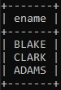
Query 13: Write a query to display the names of all employees that have two R's or A's in their name and are in department number 30 or their manager is 7788.

Solution

SELECT ename FROM emp WHERE ((ename LIKE "%A%A%" OR ename LIKE "%R%R%") AND deptno = 30) OR mgr = 7788;
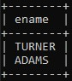

Query14. Write a query to display the name, job and salary of all employees whose job is clerk or analyst, and their salary are not equal to 1000, 3000 or 5000.

Solution

SELECT ename, job, sal FROM emp WHERE (job = "clerk" OR job = "analyst") AND (sal NOT IN (1000, 3000, 5000));
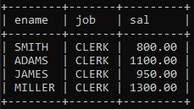

Query15. Write a query to display the name, salary and commission of all employees whose commission amount is greater than their salary increased by 5%.

Solution

SELECT ename, sal, comm FROM emp WHERE comm > sal * 1.05;
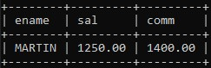

Query16. Write a query to display a current date.
Solution

SELECT CURDATE();
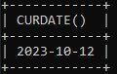

Query17. Write a query to display employee number, name, salary, salary increased by 15% expressed as a whole number.

Solution

SELECT empno, ename, sal, (sal * 1.15) AS aggr_sal FROM emp;
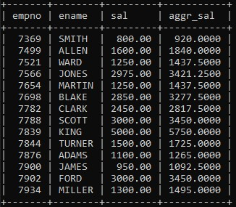

Query18. Write a query to display the employee number, name, salary, salary increased by 15% expressed as a whole number and increase in salary.

Solution

SELECT empno, ename, sal, (sal * 1.15) AS aggr_sal, ((sal * 1.15)-sal) AS incr_sal FROM emp;
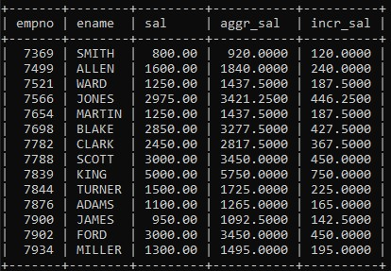

Query19.Write a query to display the following for each employee: -

<ename> earns <salary> monthly but wants <3 times salary>. Label the column as Dream Salary.

Solution

SELECT CONCAT(ename, " earns ", sal, " but wants ", 3 * sal) AS "Dream Salary" FROM emp;
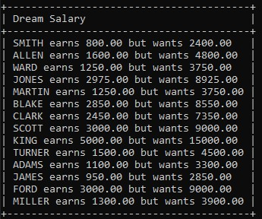
Query20.Write a query to display the employees name with the first letter capitalized and all other letters lower case and length of their name for all employees whose name start with J, A and M.

Solution

SELECT CONCAT(UPPER(SUBSTRING(ename, 1, 1)), LOWER(SUBSTRING(ename, 2))) AS "Employee Name" FROM emp WHERE (ename LIKE "J%" OR ename LIKE "A%" OR ename LIKE "R%");
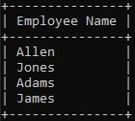

Query21. Write a query to display the name, department name, department number for all employees.

Solution

SELECT e.ename AS "Employee Name", d.dname AS "Department Name", d.deptno AS "Department Number" FROM emp e JOIN dept e ON e.deptno = d.deptno;
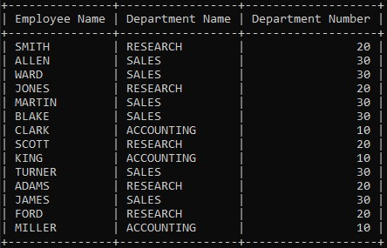

Query22. Write a query that displays the unique listing of all jobs that are in department 30.

Solution

SELECT DISTINCT job FROM emp WHERE deptno = 30;
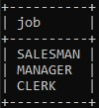

Query23. Write a query to display the employee name, department name and location for all employees who earn a commission.

Solution

SELECT e.ename AS "Employee Name", d.dname AS "Department Name", d.loc AS "Department Location" FROM emp e JOIN dept d ON e.deptno = d.deptno;
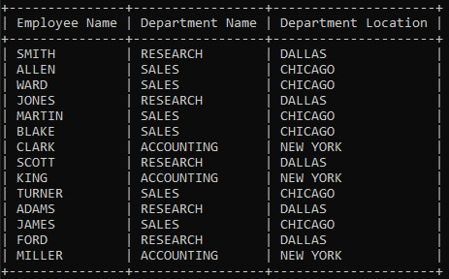

Query24. Write a query to display the employee name and department name for all employees who have 'A' in their name.

Solution

SELECT e.ename AS "Employee Name", d.dname AS "Department Name" FROM emp e JOIN dept d ON e.deptno = d.deptno WHERE e.ename LIKE "%A%";
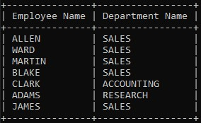

Query25. Write a query to display the name, job, department number and department name for all employees who work at location DALLAS.

Solution
SELECT e.ename AS "Employee Name", e.job AS "Job", d.deptno AS "Department Number", d.dname AS "Department Name" FROM emp e JOIN dept d ON e.deptno = d.deptno WHERE d.loc = "DALLAS";
