II. REASONING AND MATHEMATICAL ABILITY

Direction 41 - 45: Each question is followed by two statements, I and II. Answer the questions using the following instructions.Mark
(1). if the question can be answered by one of the statements alone, but cannot be answered by using the other statement alone.
(2) .if the question can be answered by using either statement alone.
(3). if the question can be answered by using both the the statements together, but cannot be answered by using either statement alone.
(4. if the question cannot be answered even by using both the statements together.

41. Is x greater than y?
I. x + y = 16
II. x + 2P = 5, y + P = 20

42. What is the distance of the point (x, y) from the origin?
I. x² + y² = 16
II. x = 4, y = 0

43. What is the value of x – y – z?
I. x, y, z are either 1 or 0
II. x²+y²+z²= 1

44.. What is the number k?
I. One-fourth of the number exceeds (1/5) of its succeeding number by 3.
II. k is a positive integer.

45. What is length of the side of an equilateral triangle formed by a wire?
I. The total length of the wire is divisible by 3.
II. The area of the rectangle formed by the same wire is twice the area of the square formed by the wire.

Directions for Q46-48: Read the statements and answer the question given below
There are three different books i.e. Poetry, Fiction, Non Fiction written by three different authors i.e. Vikram Chandra, V.S. Naipul, Vikram Seth and are published by different publishers Penguin, Harper Collins, Oxford. Following information is also given.
I. Vikram Chandra’s work is not published by Harper Collins.
II. Fiction work is not published either by Oxford University Press or Harper Collins.
III. V. S. Naipaul and Vikram Seth are not interested in doing non-fiction work.
IV. Poetry is not by Vikram Seth.

46. Harper Collins publishes
(1) non-fiction (2) fiction
(3) poetry (4) Cannot be determined

47. Vikram Chandra’s work is published by
(1) Penguin (2) Harper Collins
(3) Oxford University Press (4) Cannot be determined

48. Which of the following is a correct combination?
(1) Vikram Chandra – Poetry – Harper Collins
(2) V. S. Naipaul – Non-fiction – Penguin
(3) Vikram Seth – Fiction – Oxford University Press
(4) None of the above

Direction for questions 49 to 54: Given below are some series of numbers or letters. One member of the series is missing form the list marked as ‘?’. From the alternatives given for each question, select the correct
one.

49. 1W 2V 3U 5T ? 13R
(1) 11Q (2) 8X (3) 9S (4) 8S

50. HV GT FR EP DN ?
(1) EM (2) CW (3) CL (4) CM

51. I M Q ?
(1) T (2) W (3) Z (4) U

52. 258 130 66 ? 18 10
(1) 34 (2) 32 (3) 36 (4) 40

53. D F I M R ?
(1) S (2) X (3) Y (4) V

54. 2 3 4 6 8 ? 16 24
(1) 14 (2) 11 (3) 13 (4) 12

55. The letters ‘n a b m o d i n t’ are in disorder. If they are arranged in a proper order, they from a name of a game. Its first and last letter is
(1) a, d (2) m, t
(3) b, n (4) a, d

56. A person first goes West then turn, to his right. After several steps, he again turn, to the right and then finally turns to the left. In which direction is the man standing now ?
(1) East (2) West
(3) North (4) South

57. Statement I : All men are thiests
Statement II : No theist is a cat
Which of the following can be inferred from above statements :
(1) Some men are theists (2) Some theists are cats
(3) No cat is a theist (4) None of the above

58. Four fifth of a number is 10 more than two third of the number. The number is :
(1) 45 (2) 55
(3) 60 (4) 75

59. The difference between 272 and 20% of 172 is :
(1) 237.6 (2) 287.4
(3) 157.8 (4) None of the above

60. Statement : Should corporal punishment be legally banned in schools?
Which of the following assumption are valid for above statement :
Assumption I : Yes, these punishments are cruel
Assumption II : No, these punishments are given to maintain discipline
(1) Only I (2) Only II
(3) Both I and II (4) Neither I nor II

61. Arrange the following word in the order of dictionary
(i)Practice
(ii)Practicable
(iii)Practical
(iv)Practise
(1) (i), (ii), (iii) & (iv) (2) (i), (iii), (iv) &(ii)
(3) (ii), (iii), (i) & (iv) (4) (iii), (ii), (iv) & (i)

62. If the letters of ‘TELEPHONE’ are arranged as ‘ETELHPNOE’ then ‘ENVELOPE’ is arranged as :
(1) VNEEPOEL (2) LOEVNEPE
(3) NEEVOLEP (4) None of the above

63. Which of the following is different from others :
Marathi, Kannada, Sanskrit, Telugu
(1) Marathi (2) Kannada
(3) Sanskrit (4) Telugu

64. BEH, KNQ, TWZ, _ _ _
(1) CDE (2) RSU
(3) CFI (4) XAW

65. In an examination, 52% of the candidates failed in English, 42% in mathematics and 17% in both. The number of those who passed in both the subjects is :
(1) 83% (2) 23%
(3) 64% (4) 55.5%

66. Which of the following is a leap year ?
(1) 1998 (2) 1994
(3) 1990 (4) 1988

67. Arun said, “This girl is the wife of the grandson of my mother.” Who is Arun to the girl ?
(1) Father (2) Grandfather
(3) Father-in-law (4) None of the above

68. The average age of a cricket team is 27 years. Two players with 24 years of age are replaced by new players of 23 and 28 years of age. What is the average age of team now?
(1) 27 (2)26 (3)24 (4)28

70. Mr. V & Mr. A start from fixed point Mr. V moves 3 km north and turns right and then covers 4 km. Mr. A moves 5 km west and turns right and walks 3 km. The distance between Mr. V and Mr A is now :
(1) 10 km (2) 9 km (3) 7 km (4) 6 km

71. The distance of two stations X and Y is 220 kms. train starts from X to Y at a speed of 80 km per hour. After 30 minutes another train start from Y to X at a speed of 100 km per hour. Find out the distance from X where both the train cross.
(1) 120 km (2) 130 km (3) 140 km (4) 150 km

72. If February 1, 1996 is Wednesday, what day is March 3, 1996 ?
(1) Monday (2) Sunday
(3) Saturday (4) Friday

73. Arrange in the ascending order :
I. City II. District III.Village IV.State
(1) III, II, I, IV (2) I, II, III, IV
(3) II, I, III, IV (4) IV, II, I, III

74. Two vessels having same quantity of mixture of milk and water contain part milk respectively. If both the vessels are emptied in a new vessel then the ratio of milk to water in new vessel is :
(1) 3 : 13 (2) 4 : 5
(3) 7 : 9 (4) 3 : 5
75. A number whose fifth part increased by 5 equals its fourth part diminished by 5, is :
(1) 160 (2) 180
(3) 200 (4) 220
76. Rahul ranked ninth from the top and thirty eighth from the bottom in a class. How many students are there in the class ?
(1) 45 (2) 46
(3) 47 (4) 48

77. Find the remainder when 7¹³ + 1 is divided by 6
(1) 2 (2) 5
(3) 4 (4) 9

Instructions for Q 78-80: Interpret the pie chart
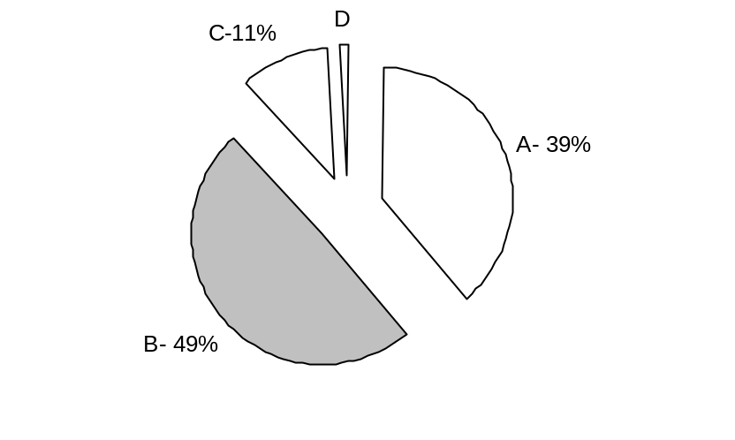

A= Raw Material Costs
B= Packing Material Costs
C= Fixed Manufacturing Costs
D= Labour Costs

78. Find the value of ‘D’
(1) 5 % (2) 11%
(3) 1 % (4) None of these
79. If the total cost of production is 128.3 lacs, what is the share of packing costs alone?
(1) 58 lacs (2) 39.5 lacs
(3) 57 lacs (4) 50.7 lacs
80. Out of the total cost of Production, Packing and Raw material cost together represent Rs____?
(1) 88 lacs (2) 111 lacs
(3) 113.3 lacs (4) None of the above

