List of Formulae

Trigonometry

- 2π radian = 360°
- sin² A+cos² A = 1
- 1+ tan² A = sec² A
- 1 + cot² A = cosec² A
- sin (- θ) = - sin θ cos (- θ) = cos θ
- sin (90 - θ) = cos θ cos (90 - θ) = sin θ
- sin (90 + θ) = cos θ cos (90 + θ) = - sin θ
- sin (180 - θ) = sin θ cos (180 - θ) = - cos θ
- sin 2A = 2 sin A cos A

Statistics
- The sum of the first n natural numbers, 1 + 2 + 3 +…+ n = 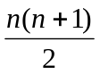

Mensuration
- Area of a triangle =  Base × Height
- Area of a triangle = 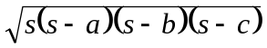 Where 2s = a + b + c
- Area of an equilateral triangle = 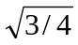(side)²

- Area of a rectangle = Length × Breadth

- Area of a parallelogram = Base × Altitude
- Area of a rhombus = (product of diagonals)
- Area of a trapezium = (Altitude) × (sum of parallel sides)

- Circumference of a circle = 2r

- Area of a circle = r²

- Total surface area of cuboid with sides l, b, h = 2 (lb + bh +lh)
Volume of cuboid = lbh , Surface area of cube = 6 (side)²

- Cylinder
Curved surface area = 2 rh ; Total surface area = 2 r² + 2rh
Volume = r²h
- Cone
Vertical height = h ; Slant height = ; Area of curved surface = r
Total surface area = r² +r Volume=1/3 r²h

- Sphere
Surface area = 4r² ; Volume = 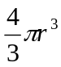

Geometry

- The sum of two sides of a triangle is greater than the third.
- The sum of the interior angles of a polygon of n sides = (n – 2) π.
- The angle inscribed in any semicircle is π/2.
- Two tangents can be drawn from any external point to a circle. These are equal in length.
- Angles in alternate segments are equal.
- Angles in equal segments are equal.

Algebra

- A² – B² = (A – B) (A + B)
- (A + B)² = A² + 2 AB + B²
- (A - B)² = A² – 2 AB + B²
- (A + B + C)² = A² + B² + C² + 2 (AB + BC + CA)

- Quadratic Equations - Any equation of the form ax² + bx + c = 0, a 0, is known as a quadratic equation. Its roots are given by 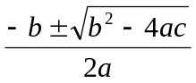
Sum of the roots = - b/a , Product of the roots = c/a
Nature of the roots depends on the quantity D = b² – 4ac, which is known as the
Discriminant.

Arithmetic
- 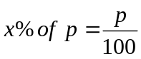 ; Profit = S.P. – C.P. ; Loss = C.P. – S.P.

- Simple Interest = 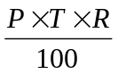 ; Where P = principal, T = time, in years, R = rate

Compound interest = A – P ; Where A = P 