MOTOROLA (NOIDA/HARDWARE DIVISION)

1.using 2:1 Mux and one inverter make XOR gate.
2.using 2:1 MUX make a transparent latch(D f/f).
3. Design a ckt such that

f(CLK_out)=2f(CLK_in)
ckt is=>
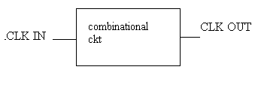

4.
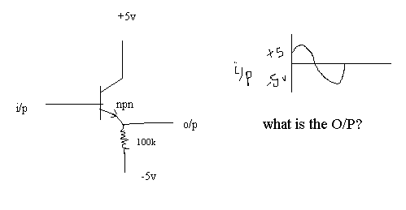

5.
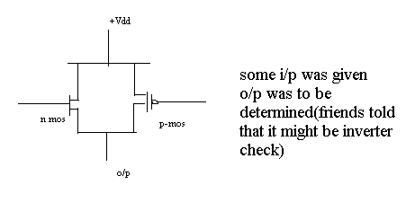

6.
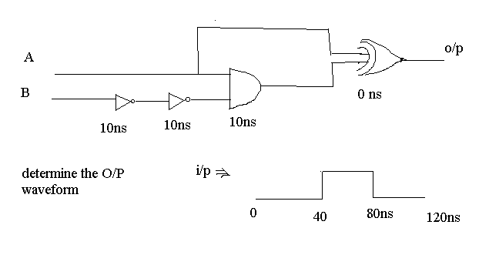

7.
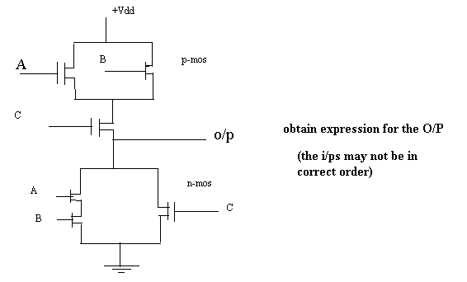

8.
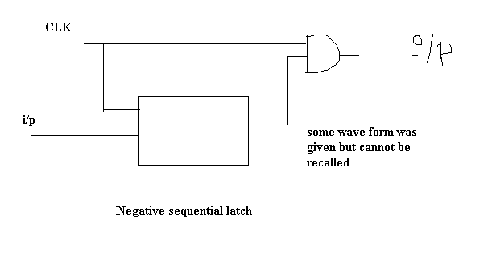

Rest 3-questions were from c-mos ckts
One question on ‘glitch’(we were unable to understand what it is).
Problems on set-up time and hold-time of latchs.

