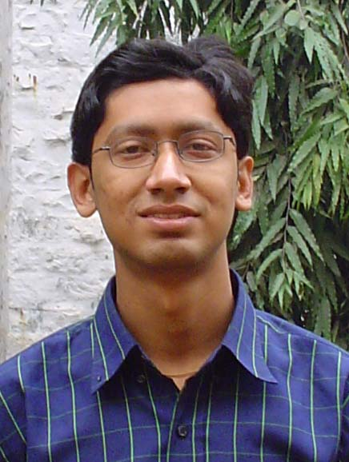
ARIJIT GANGULY
“Sur Mandir”, G-46,
Bengali Colony, Mahavir
Enclave, Palam
New Delhi – 110 045
Phone: 011-25034466
Cell Phone: 98110 17814
E-mail: ari_dumca@yahoo.co.in
arijit.ganguly@csdu.org

Objective
I bring along a strong grasp of fundamentals in Computers Science, an aptitude for team work, a zest for challenges and an enthusiastic desire to learn all I can. I would like to be part of an organization which would give me an opportunity to grow and put the aforementioned qualities to use.

Personal Profile
Date of Birth : 2nd June 1981
Gender : Male
Nationality : Indian
Father’s Name : Mr. P. Ganguly
Father’s Occupation : Journalist

Academic Record

Degree | Year | School/College | Board/University | Percentage
AISSE (10th) | 1997 | Raisina Bengali School, New Delhi | CBSE | 79.4 %
AISSCE (12th) | 1999 | Raisina Bengali School, New Delhi | CBSE | 82.2 %
B.Sc. (Hons.) Electronics | 1999-2002 | Sri Venkateswara College | Delhi University | 75.6 %
Higher National Diploma in Computing | 1999-2000 | School of Computer and Information Sciences | IGNOU | 65.6%
Bachelors in Information Technology | 1999 – 2002 | School of Computer and Information Sciences | IGNOU | 63.6%
Master of Computer Applications | 2002-2005 | Department of Computer Science | Delhi University | 75.6 % (Till 3rd semester)

Awards and Achievements
- Secured 2nd prize in overnight website designing event “Midnight Run” at Wizebyte 2k4, an all India Technical Festival held at IMT, Ghaziabad.
- Secured 2nd prize in Incremental Hacking Event at WIzebyte 2k4 held at IMT, Ghaziabad.
- Secured 3rd prize in Unique e-idea event “Eureka” at WIzebyte 2k4 held at IMT, Ghaziabad.
- Secured 1st prize in on the spot coding event “Kodarjunas” held at the all India technical symposium 2004 organised by LBSIM, IP University.
- Secured 2nd prize in Construct IT (System Analysis and Design) at Tech-Tornado 2003, SNDT Mumbai
- Secured 1st prize in Ad Sense (Marketing Event) at Tech-Tornado 2003, an All India Level Technical Conference cum Festival held at SNDT University, Mumbai.
- Secured 2nd prize in Ad Sense (Marketing Event) at WIzebyte 2k4 held at IMT, Ghaziabad.
- School Topper in Science in class 10th exams.
- Received Merit Certificate in Erose Scholarship Open Exam in 1998-99.
- Among the top rankers all-throughout schooling.

Software Exposure
Operating Systems : Windows 9x, 2000 & XP, Linux, MS-DOS
Programming Languages : 8085/86 Assembly, C, C++, Java(elementary), Visual C++, Visual Basic, LISP(elementary)
DBMS : Oracle, MS-Access
Application Packages : MS-Office, Adobe Photoshop, CorelDRAW
Web Designing : HTML, Microsoft ASP, XML(elementary), Frontpage and Dreamweaver MX
Web servers : IIS 5.0 and Apache.

Projects Undertaken
- Implementation of a Web Database using Oracle : Simulation of a music download site “mewzik.com” for online information on music and MP3 downloads using Object Oriented Database Management System.
- Implementation of unix shell with some basic functionalities and special focus on the ls command.
- Client-Server File Transfer Protocol : Implementation using TCP/IP protocol stack and socket programming in Linux.
- University Database Management System : Automation of a university’s database concerning students, faculty, courses, colleges etc., using Visual Basic as front-end and ORACLE as back-end.
- Nursery Writing : Demonstration of drawing of letters, numbers and figures using WIN32 API in VC++.
- System Analysis and Design: Automation of Driving License Authority using procedural techniques.
- B-Tree Indexes for Files : Implementation in C++.
- MS-DOS File System (FAT-12) : Simulation in C++.
- Graphical representation of the solar system: depicting moving planets around the sun, asteroids and meteors using C++.
- Implementation of Various Algorithms: on searching, sorting, and graphs; such as Kruskal’s Minimum Spanning Tree (MST) algorithm using Disjoint Sets, Dijkstra Shortest Path Problem.
- Presentations: on Cable Television, Connected dominant Sets, Log Structured File System and Leadership.

Work Experience
Technical Administrator in India Press International Television Network Private Limited (an audio visual production company) since February 2001.

Areas of Interest
- Networks
- DBMS
- Operating Systems
- Data Structures

Extra Curricular Activities
- Development and Maintenance of the official website of University of Delhi MCA.
- Have done titling for television serials which were aired on Doordarshan.
- School captain in Table Tennis for 2 consecutive years and have won various competitions which include zonal level matches.
- Active member of house activities in the school and participated in various inter-house matches.
- ‘Rajya Puraskar’ holder in Bharat Scouts and Guides.

Hobbies
- Listening to music
- Playing cricket & table tennis
- Graphic designing in Photoshop, CorelDRAW
- Quiz

ARIJIT GANGULY

