- Given a set of words one after another, give me a data structure
so that you'll know whether a word has appeared already or not.
Answer: I suggested various alternatives. But he kept helping me and finally, we came up with an array of pointers to 26-trees (each node of the tree has 26 children). Store every word as a path from the root to a leaf with pointers in the correct places. For example, hello would be stored as - pointer from 'h' index of the root array to a node which had a pointer from 'e' index of its array to a node which had a pointer from 'l' index of the array.. and so on. This is both time and space efficient.

- Find if a number is divisible my 3, without using %,/ or *. You can use atoi().

- Two integers A and B are given, find the no of bits that need to be flipped in A to get B. ( xor a and b and count the number of bits)

- Write a Rotate function for rotating elements in an array, using a reverse function.

- Given 2 binary trees T1 and T2 with same set of nodes, show how you can transform one in to the other?

- Give an algorithm to transform a binary tree T1 into another binary tree T2?

- How do you convert the parent-child tree to a child-sibling tree (assume the tree is a binary tree)?

- Two binary trees T1 and T2 are isomorphic if T1 can be transformed into T2 swapping left and right children of the nodes in T1.Give an algorithm to report whether 2 given binary trees are isomorphic.

- Analyze the complexity of the above algorithm and report whether there exists a linear solution to it?

- Write a algo that takes a sorted array of Comparables called array[] and a Comparable e and returns true if e is in the array, false otherwise. Your algorithm must make no more than O(log n) comparisons in the worst case. [5 marks]

- Write a algo that takes two sorted unique-valued arrays of Comparables called a[] and b[], and returns a (unique-valued and sorted) merged array. Specificially, the returned array should be sorted, be the exact length to accomodate its elements, contain all elements that were in a[] and b[], and only contain unique elements (if an element is in both a[] and b[] then it appears only once in the returned array). [6 marks]

- LU decomposition method is computationally more efficient than Naïve Gauss elimination for solving
  - a single set of simultaneous linear equations
  - multiple sets of simultaneous linear equations with different coefficient matrices and same right hand side vectors.
  - multiple sets of simultaneous linear equations with same coefficient matrix and different right hand side vectors.
  - less than ten simultaneous linear equations.

- The lower triangular matrix [L] in the [L][U] decomposition of matrix given below
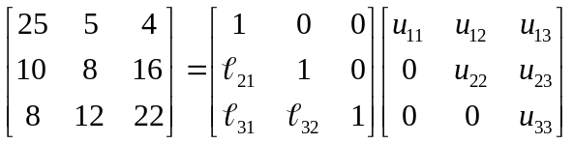 is
(A) 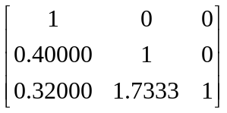

(B) 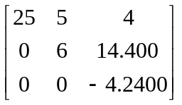

(C) 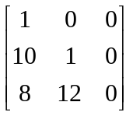

(D) 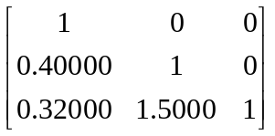

- The upper triangular matrix [U] in the [L][U] decomposition of matrix given below
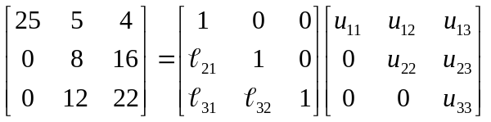
is

(A) 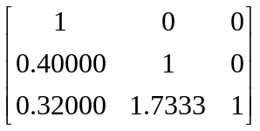

(B) 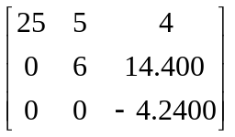

(C) 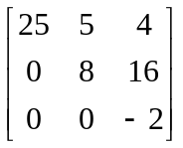

(D) 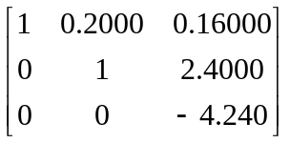

- For a given 20002000 matrix [A], assume that it takes about 15 seconds to find the inverse of [A] by the use of the [L][U] decomposition method, that is, finding the [L][U] once, and then doing forward substitution and back substitution 2000 times using the 2000 columns of the identity matrix as the right hand side vector. The approximate time, in seconds, that it will take to find the inverse if found by repeated use of Naive Gauss Elimination method, that is, doing forward elimination and back substitution 2000 times by using the 2000 columns of the identity matrix as the right hand side vector is
- 300
- 1500
- 7500
- 30000

- The algorithm in solving the set of equations [A][X] = [C], where [A] = [L][U] involves solving [L][Z] = [C] by forward substitution. The algorithm to solve [L][Z]=[C] is given by

(A) 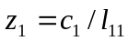
for i from 2 to n do
sum = 0
for j from 1 to i do
sum = sum +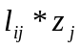
end do
z_{i} = (c_{i} – sum) / l_{ii}
end do

(B)
for i from 2 to n do
sum = 0
for j from 1 to (i-1) do
sum = sum +
end do
z_{i} = (c_{i} – sum) / l_{ii}
end do

(C)
for i from 2 to n do
for j from 1 to (i-1) do
sum = sum +
end do
z_{i} = (c_{i} – sum) / l_{ii}
end do

(D) for i from 2 to n do
sum = 0
for j from 1 to (i-1) do
sum = sum +
end do
z_{i} = (c_{i} – sum) / l_{ii}
end do

- To solve boundary value problems, finite difference method is used resulting in simultaneous linear equations with tri-diagonal coefficient matrices. These are solved using the specialized [L][U] decomposition method. The set of equations in matrix form with a tri-diagonal coefficient matrix for
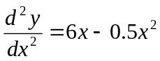, 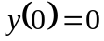, 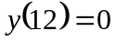,
using finite difference method with a second order accurate central divided difference method and a step size of 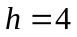 is
- 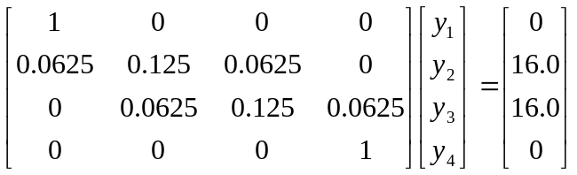
- 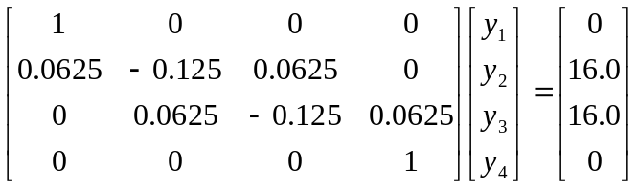
- 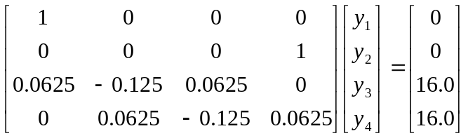
- 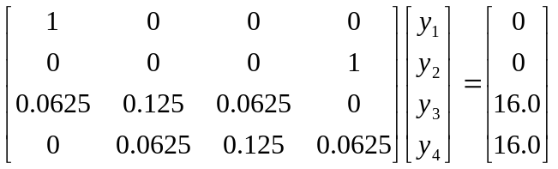

- Write an algorithm that takes an array of Objects as an argument and returns an array of the same length but with the elements in reverse order.

- Write an algorithm that takes an array of Objects called o[] and returns a single String containing the string representations of every second element (starting at index 0) of o[].

- Write a Java function that takes an array of Objects called o[] and returns a newly allocated array, of length ⎡(o.length)/2⎤, filled with references to the first half of the elements of o[].

- Write a Java function that takes an array of Comparables and returns true if the array is sorted in ascending order, otherwise false.

- Write a Java function that takes a sorted array of Comparables and returns true if the array is sorted in ascending order, and false if it is sorted in descending order.
- Write a Java function that takes a sorted array of Comparables called array[] and a Comparable e and returns true if e is in the array, false otherwise. Your algorithm must make no more than O(log n) comparisons in the worst case. [Java solution]
- Write a Java function that takes two sorted unique-valued arrays of Comparables called a[] and b[], and returns a (unique-valued and sorted) merged array. Specificially, the returned array should be sorted, be the exact length to accomodate its elements, contain all elements that were in a[] and b[], and only contain unique elements (if an element is in both a[] and b[] then it appears only once in the returned array). [Java solution]
- Write a Java function that takes two sorted unique-valued arrays of Comparables called a[] and b[], and returns a (unique-valued and sorted) array of all elements in a[] that do not appear in b[]. Specifically, the returned array should be sorted, be the exact length to accommodate its elements, contain all elements that were in a[] but not in b[], and only contain unique elements (each element appears only once in the returned array).

- Inserting an element into an arbitrary array of length n that is full requires how many copy operations and how many comparisons between elements in the worst case? (Assume you must add it to the array and cannot simply return an error message.)
(a) O(log n) copy operations and O(n) comparisons between elements
(b) O(n) copy operations and O(1) comparisons between elements
(c) O(1) copy operations and O(log n) comparisons between elements
(d) O(n) copy operations and O(n) comparisons between elements
(e) none of the above

- Finding and removing an element (by copying succeeding elements down one index) from an array (sorted in ascending order) of length n that is full requires how many copy operations and how many comparisons between elements in the worst case? (Assume that the element appears in the array.)
(a) O(log n) copy operations and O(n) comparisons between elements
(b) O(n) copy operations and O(1) comparisons between elements
(c) O(1) copy operations and O(log n) comparisons between elements
(d) O(n) copy operations and O(n) comparisons between elements
(e) none of the above

- Adding an element to an array that does not allow duplicates requires how many comparisons between elements in the worst case?
(a) O(n) comparisons between elements
(b) n - 1 comparisons between elements
(c) O(log n) comparisons between elements
(d) ^{n}/₂ comparisons between elements
(e) none of the above

- What is the output of the following tester program for MyQueue and MyStack?
MyQueue q;
MyStack s;
q = new MyQueue();
s = new MyStack();
s.push(new Integer(5));
s.push(new Integer(6));
s.push(new Integer(7));
System.out.print(s.pop());
q.enqueue(s.pop());
q.enqueue(new Integer(5));
q.enqueue(new Integer(6));
System.out.print(q.dequeue());
s.push(q.dequeue());
System.out.print(s.pop());
System.out.print(s.pop());
(a) 5675
(b) 5567
(c) 7655
(d) 7556
(e) none of the above

- What is the worst-cost complexity of the following algorithm. Model: assume that variables take up zero space, that assignment statements take one unit of TIME each, that print statements take one unit of TIME each, and that all other statements and operations take zero TIME. Measures: measure TIME.
public static void example(Object a[], Object b) {
/* This is not a useful comment.
*/
int count; // a counter
count = 0;
while (count < a.length) {
if (!a[count].equals(b)) {
System.out.print(a[count].toString());
a[count] = b;
}
count++; // this is equivalent to "count = count + 1"
}
}
(a) O(log n), where n is the length of the array
(b) (^{n}/₂) + n + 1 = (³/₂)n + 1, where n is the length of the array
(c) O(n), where n is the length of the array
(d) all of the above
(e) none of the above

- A binary search algorithm can be used to successfully find the location of a value that is stored in any array.
- True
- False
Answer: b)

- If a binary search of an array A between left and right terminates with left>right
- No action is taken
- The value we are searching for is at A[mid]
- The value we are searching for is not in the array
- An error has occurred
- None of the above
Answer: c)

- The two initial values passed to the secant algorithm for root finding do not have to bracket the root.
- True
- False
Answer: a).

- The Newton-Raphson algorithm for root finding is guaranteed to converge to a root.
- True
- False
Answer: b)

- Suppose we have an array containing the following values:

10 8 6 20 4 22 3 1

Suppose you use a bubble sort algorithm to sort these values in increasing order. After five iterations of the bubble sort algorithm with right to left passes over the array, how will the values in the array be arranged?

- 4 6 8 10 20 22 3 1
- 1 3 4 6 8 22 20 10
- 1 3 4 6 8 10 20 22
- 6 8 10 20 1 3 4 23
- None of the above
Answer: c)

- Suppose we have an array containing the following values:

10 8 6 20 4 22 3 1

Suppose you use an insertion sort algorithm to sort these values in increasing order. After five iterations of the insertion sort algorithm, how will the values in the array be arranged?

- 4 6 8 10 20 22 3 1
- 1 3 4 6 8 22 20 10
- 1 3 4 6 8 10 20 22
- 6 8 10 20 1 3 4 23
- None of the above
Answer: a)

- Suppose we have an array containing the following values:

10 8 6 20 4 22 3 1

Suppose you use a selection sort algorithm to sort these values in increasing order. After five iterations of the selection sort algorithm, how will the values in the array be arranged?

- 4 6 8 10 20 22 3 1
- 1 3 4 6 8 22 20 10
- 1 3 4 6 8 10 20 22
- 6 8 10 20 1 3 4 23
- None of the above
Answer: b)

- How many steps does the following algorithm take (using Big-O notation)?
for (i=0; i<N; i++)
for (j=i+1; j<N*N; j++)
if (A[i] > A[j])
swap( A[i], A[j] );

  - O(N)
  - O(N²)
  - O(N³)
  - O(N!)
  - None of the above
Answer: c)

- A perfect number is a positive integer that equals the sum of all of its divisors (other than the number itself). For example 6, 28 and 496 are perfect numbers because:
6 = 1 + 2 + 3
28 = 1 + 2 + 4 + 7 + 14
496 = 1 + 2 + 4 + 8 + 16 + 31 + 62 + 124 + 248

Write an algo to find the smallest perfect number that is strictly greater than N.

- In combinatorial mathematics, the Catalan numbers form a sequence of natural numbers that occur in various counting problems.

The Catalan sequence can be defined as follows:
The zeroth element of the series is: C₀ = 1
Subsequent elements are defined as:
C_{n+1} = 2 * (2 * n + 1) * C_{n} / (n + 2)

The first numbers in the sequence are
1, 1, 2, 5, 14, 42, 132, 429, 1430, 4862, 16796, 58786, 208012, …

Write a algo which prints this Catalan sequence from the zeroth number up to the n^{th} number in the sequence, where n is a user-input value

Your program must contain and use a function which returns the n^{th} number in the Catalan sequence. Its declaration must look like the following (and nothing else):
int catalan(int n){
// Your function's body goes here.
}

Your main function should first ask the user what the value of n is, it should then have a loop which goes from 0 to n (inclusively) in steps of 1, calls your Catalan function for each of these values, and prints the return value of this Catalan function to the screen.

Bonus: If you write a correct recursive definition of the Catalan function, you will receive bonus points. Note that you should first write a non-recursive Catalan function (for the non-bonus), and then write a recursive version of it.

- Suppose that we want to create a heap where each node contains information of some data type. What additional factor is required for the data type?
Short Answers
Section 10.1
Heaps
- A heap is a binary tree where the entries can be compared using the usual six comparison operations (that form a total order semantics). Write the two rules that the binary tree must follow in order for the structure to actually be a heap.
Give two different reasons to explain why the following binary tree is not a heap:
- 91
- / \
- 77 46
- / \ \
- 68 81 11
- Draw a new heap that is created by inserting 82 into the following heap:
- 910
- / \
- 77 66
- / \ / \
- 68 1 3 11
- Draw a new heap that is created by removing one item from the following heap:
- 910
- / \
- 77 66
- / \ / \
- 68 1 3 11
- Suppose that you are performing a reheapification downward. Write a precise condition that describes the situation that causes the reheapification to stop.
- Suppose that you are performing a reheapification upward. Write a precise condition that describes the situation that causes the reheapification to stop.
- Suppose that a non-leaf node in a B-tree contains 42 entries. How many children does the node have?
Short Answers
Section 10.2
B-Trees
- Draw an example of a B-tree with four nodes and seven integer entries. The value of MINIMUM is 1 for this tree.
- Draw a new B-tree that is created by inserting 82 into the following B-tree. For this example, the minimum number of items in each node is 1. Note that the rightmost leaf starts with two entries, 71 and 93.
- 56
- / \
- 7 66
- / \ / \
- 2 8 63 71 and 93
- Draw a new B-tree that is created by deleting 63 from the following B-tree. For this example, the minimum number of items in each node is 1. Note that the rightmost leaf starts with two entries, 71 and 93.
- 56
- / \
- 7 66
- / \ / \
- 2 8 63 71 and 93
- Suppose that a B-tree is declared so that MAXIMUM (the maximum number of items in a node) is 84. What is the value of MINIMUM (the minimum number of items in a non-root node)?
- Suppose that a B-tree is declared so that MAXIMUM (the maximum number of items in a node) is 84. Write one clear sentence to describe why each node's data array is set up to hold up to 85 items (one more than MAXIMUM).
- Suppose that a and b are two positive integers and n is some non-negative number. Write an equation to show the relationship between log base a of n and log base b of n. Give a derivation to show that the relationship is valid.
Short Answers
Section 10.3
Trees, Logs, and
Time Analysis

Multiple Choice
- What feature of heaps allows them to be efficiently implemented using a partially filled array?
Multiple Choice
Section 10.1
Heaps
  - A. Heaps are binary search trees.
  - B. Heaps are complete binary trees.
  - C. Heaps are full binary trees.
  - D. Heaps contain only integer data.
- If a heap is implemented using a partially filled array called data, and the array contains n elements (n > 0), where is the entry with the greatest value?
  - A. data[0]
  - B. data[n-1]
  - C. data[n]
  - D. data[2*n + 1]
  - E. data[2*n + 2]
- Select the true statement about the worst-case time for operations on heaps.
  - A. Niether insertion nor removal is better than linear.
  - B. Insertion is better than linear, but removal is not.
  - C. Removal is better than linear, but insertion is not.
  - D. Both insertion and removal are better than linear.
- Suppose that we have implemented a priority queue by storing the items in a heap (using an array for the heap items). We are now executing a reheapification upward and the out-of-place node is at data[i] with priority given by data[i].priority. Which of the following boolean expressions is TRUE to indicate that the reheapification IS NOT YET DONE.
  - A. (i > 0)
  - B. (data[(i-1)/2].priority < data[i].priority)
  - C. (i > 0) && (data[(i-1)/2].priority < data[i].priority)
  - D. (i > 0) || (data[(i-1)/2].priority < data[i].priority)
- Suppose that we have implemented a priority queue by storing the items in a heap. We are now executing a reheapification downward and the out-of-place node has priority of 42. The node's parent has a priority of 72, the left child has priority 52 and the node's right child has priority 62. Which statement best describes the status of the reheapification.
  - A. The reheapification is done.
  - B. The next step will interchange the two children of the out-of-place node.
  - C. The next step will swap the out-of-place node with its parent.
  - D. The next step will swap the out-of-place node with its left child.
  - E. The next step will swap the out-of-place node with its right child.
- Which formula is the best approximation for the depth of a heap with n nodes?
  - A. log (base 2) of n
  - B> The number of digits in n (base 10)
  - C. The square root of n
  - D. n
  - E. The square of n
- Which statement is true for a B-tree?
Multiple Choice
Section 10.3
B-trees
  - A. All entries of a node are greater than or equal to the entries in the node's children.
  - B. All leaves are at the exact same depth.
  - C. All nodes contain the exact same number of entres.
  - D. All non-leaf nodes have the exact same number of children.
- Suppose that a non-leaf node in a B-tree has 41 entries. How many children will this node have?
  - A. 2
  - B. 40
  - C. 41
  - D. 42
  - e. 82
- Suppose that a B-tree has MAXIMUM of 10 and that a node already contains the integers 1 through 10. If a new value, 11, is added to this node, the node will split into two pieces. What values will be in these two pieces?
  - A. The first piece will have only 1 and the second piece will have the rest of the numbers.
  - B. The first piece will have 1 through 5 and the second piece will have 6 through 11.
  - C. The first piece will have 1 through 5 and the second piece will have 7 through 11.
  - D. The first piece will have 1 through 6 and the second piece will have 7 through 11.
  - E. The first piece will have 1 through 10 and the second piece will have only 11.
- Suppose that X is a B-tree leaf containing 41 entries and having at least one sibling. Which statement is true?
  - A. Any sibling of X is also a leaf.
  - B. Any sibling of X contains at least 41 entries.
  - C. The parent of X has exactly 42 entries.
  - D. X has at least 41 siblings.
- Suppose you run a O(log n) algorithm with an input size of 1000 and the algorithm requires 110 operations. When you double the input size to 2000, the algorithm now requires 120 operations. What is your best guess for the number of operations required when you again double the input size to 4000?
Multiple Choice
Section 10.3
Trees, Logs,
and Time Analysis
  - A. 130
  - B. 140
  - C. 150
  - D. 160
  - E. 170
- Tree algorithms typically run in time O(d) . What is d?
  - A. The depth of the tree.
  - B. The number of divisions at each level.
  - C. The number of entries in each node.
  - D. The number of nodes in the tree.
  - E. The total number of entries in all the nodes of the tree.

