ST microelectronics (26th Sept. 2002, IIT Kanpur)
1.Draw Vo

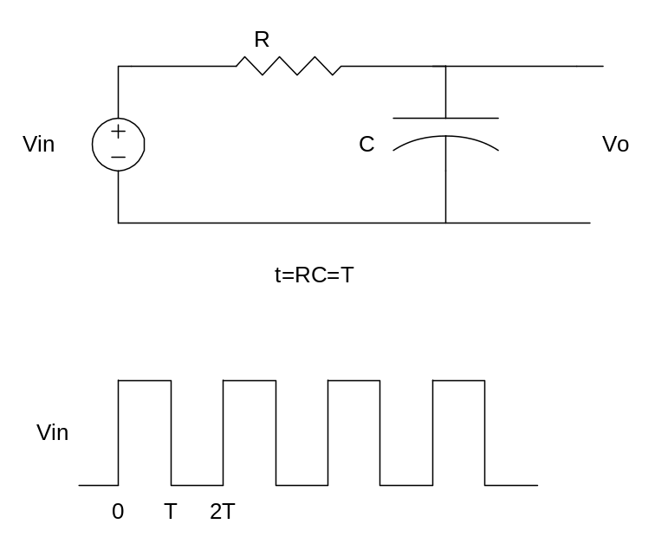

2. Draw Vo. Initially Vo is at +5V.
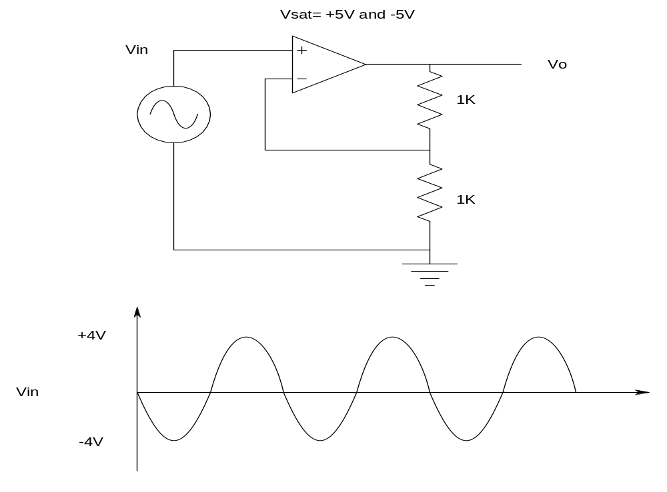

3.Draw Thevenin Equivalent.
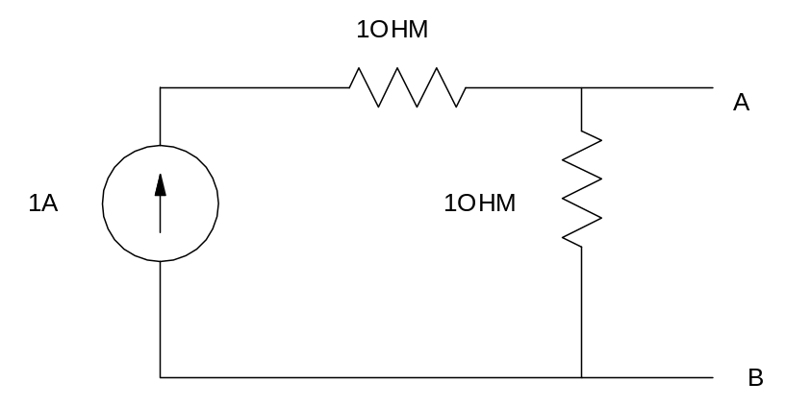

4. Find Gain Vo/Vin
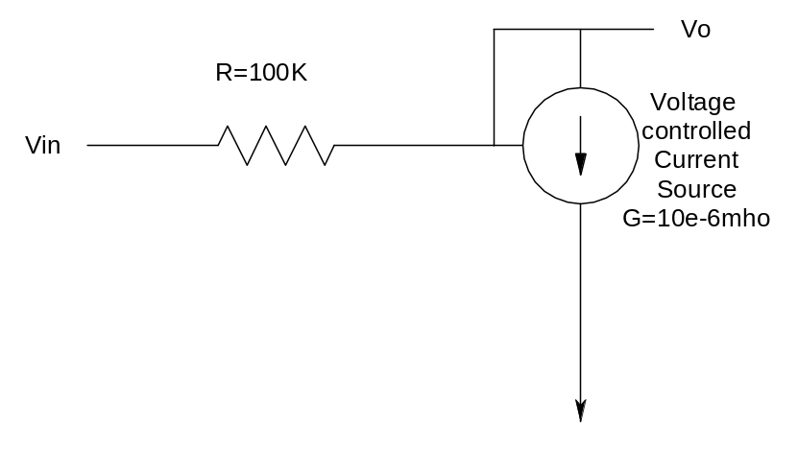

5. Draw VR and VL.

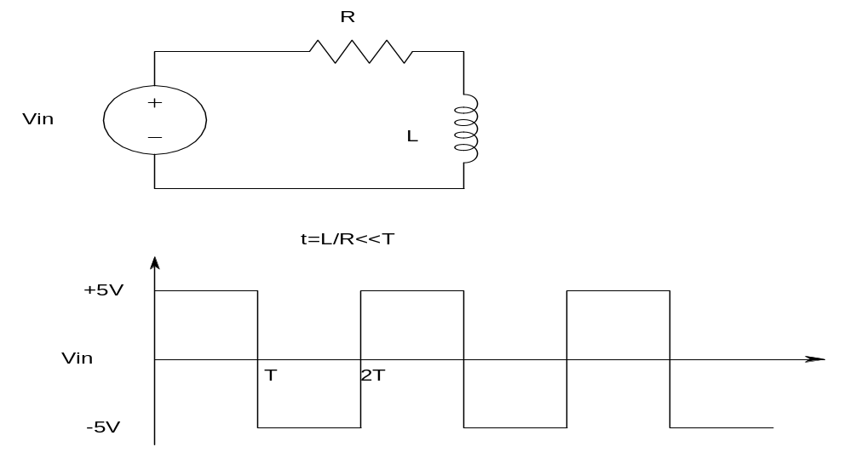
6.FIND LOGIC Z.
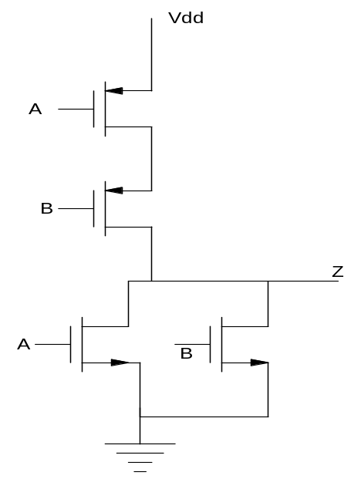

7. FIND LOGIC Z
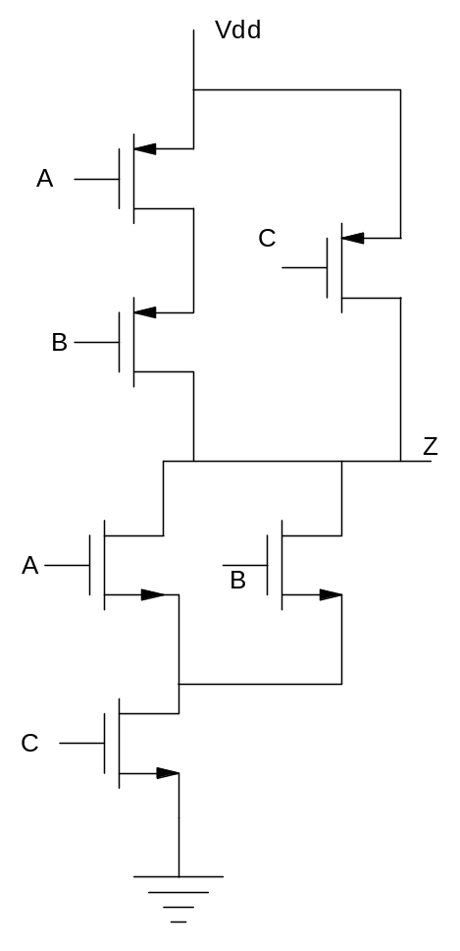

8. Make a divide by 3 counter for given i/p using D FF and Gates.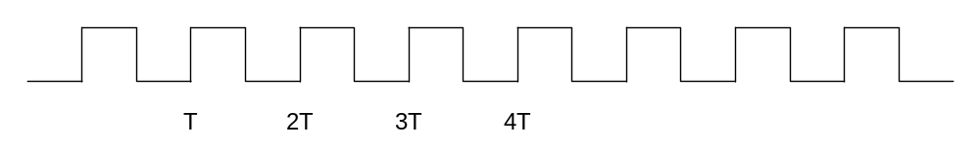

9.Make JK FF using D FF.

10. This ckt is
(a) Low Pass (b) High Pass
(c) Band Pass (d) Notch Filter

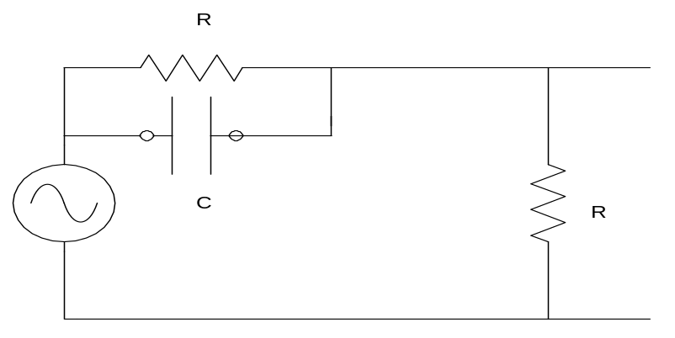
11. find ABC after 3clocks
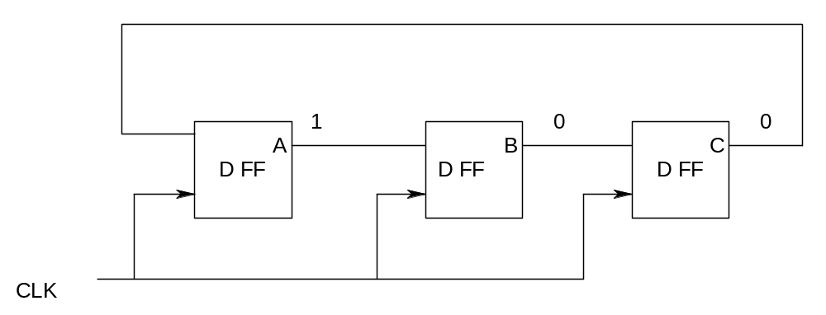

12. Make Pseudo Logic for Z using AND-OR-INVERT for statement given below.
If A=1 then Z=A+B
Else Z=D+E

